TOPIC: Beauty and skincare e-shop

HOW TO RUN:
1.OLTP.sql: script to create tables in oltp database
2.fromCSVtoOLTP.sql: script to load data from csv files to oltp database.
The script contains multiple lines like:
D:/csv/AvailabilityStatuses.csv
Before running the script, please replace D:/csv/ with the actual route to csv files.
3.OLAP.sql: script to create tables in olap database (runs in olap database)
4.ETL.sql: script to run in olap database to move data from oltp database to olap database
Script starts with connection to oltp database using dblink and ends with disconnection
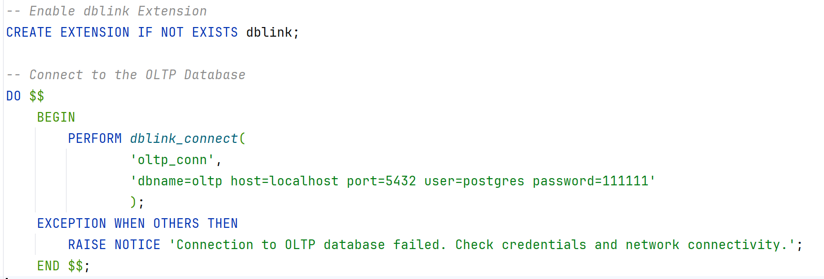
Before running the script please replace values in this line with the actual data:
'dbname=oltp host=localhost port=5432 user=postgres password=111111'

5. Pictures with schemas of tables are in files oltp.jpeg / olap.jpeg or oltp.drawio / olap.drawio

6. PowerBI is connected to the view (view.sql)

7. Queries examples are in file 5.Queries.sql

COMMENTS ON STEPS OF TASK:
- OLTP:
13 tables in total.
Brands Table
- One-to-Many: With Products table, where one brand can have multiple products via BrandID.
Categories Table
- One-to-Many (Self-Referential): A category can have subcategories via ParentCategoryID, or it can have no parent (ParentCategoryID is NULL for top-level categories).
- One-to-Many: With the Products table, where one category can have multiple products via CategoryID.
PaymentMethods Table
- One-to-Many: With Orders table, where one payment method can be used in multiple orders via PaymentMethodID.
OrderStatuses Table
- One-to-Many: With Orders table, where one order status can be applied to multiple orders via OrderStatusID.
AvailabilityStatuses Table
- One-to-Many: With Products table, where one availability status can apply to multiple products via AvailabilityStatusID.
Products Table
- One-to-Many: With OrderDetails table, where one product can appear in multiple order details via ProductID.
- One-to-Many: With ProductProperties table, where one product can have multiple properties via ProductID.
- One-to-Many: With Reviews table, where one product can have multiple reviews via ProductID.
ProductProperties Table
- One-to-Many: With the Products table, where each product can have multiple properties via ProductID. Each row in ProductProperties represents a single property of a product.
Promotions Table
- One-to-Many: With Orders table, where one promotion can apply to multiple orders via PromotionID.
Orders Table
- One-to-Many: With OrderDetails table, where one order can have multiple order details via OrderID.
OrderDetails Table
- Many-to-One: With Orders table, where multiple order details belong to one order via OrderID.
- Many-to-One: With Products table, where multiple order details can refer to one product via ProductID.
Addresses Table
- One-to-One: With Users table, where one address is associated with one user via AddressID.
Users Table
- One-to-One: With Addresses table, where each user is associated with one address via AddressID.
- One-to-Many: With Orders table, where one user can place multiple orders via UserID.
- One-to-Many: With Reviews table, where one user can write multiple reviews via UserID.
Reviews Table
- Many-to-One: With Users table, where multiple reviews can be written by one user via UserID.
- Many-to-One: With Products table, where multiple reviews can refer to one product via ProductID.

- OLAP:
3 facts and 10 dimensions

FactSales Table
Captures sales data at the order level, including metrics such as total quantity, total revenue, and discounts applied. This table aggregates sales transactions for each order.
Key Metrics:
  - TotalQuantity: Total items sold in the order.
  - TotalRevenue: Total revenue generated after discounts for the order.
  - TotalDiscount: Total discount applied to the order.
Business Questions:
  - What is the total revenue generated during a specific time period (e.g., monthly, quarterly)?
  - What is the total number of items sold across all orders?
  - Which payment methods generate the highest revenue?
  - How do order statuses (e.g., completed, canceled) affect total revenue?
FactOrderDetails Table
Provides granular details about each product included in an order, capturing metrics such as quantity, unit price, and line total for each product.
Key Metrics:
  - Quantity: The quantity of the product sold in the order.
  - UnitPrice: Price per unit of the product at the time of the order.
  - LineTotal: Total revenue for this product line (Quantity * UnitPrice).
Business Questions:
  - What is the total revenue generated by individual products or categories?
  - How many units of a specific product were sold during a time period?
  - Which products contribute the most to revenue within orders?
FactPromotionEffectiveness Table
Tracks the performance of promotions over a defined time period, summarizing metrics such as total customers, total orders, total revenue, and total quantity sold under a promotion.
Key Metrics:
  - TotalCustomers: Number of unique customers who used the promotion.
  - TotalOrders: Number of orders where the promotion was applied.
  - TotalRevenue: Revenue generated from orders using the promotion.
  - TotalDiscount: Total discount provided under the promotion.
  - TotalQuantity: Total quantity of items sold with the promotion.
Business Questions:
  - Which promotions generated the highest revenue or customer engagement?
  - How do promotions impact customer behavior, such as average order value?

SCD type 2 (includes RecordStartDate, RecordEndDate, IsActive):
- DimCustomer
- DimProduct

Example how SCD works:

- After data was loaded for the first time from csv to oltp db and then to olap db
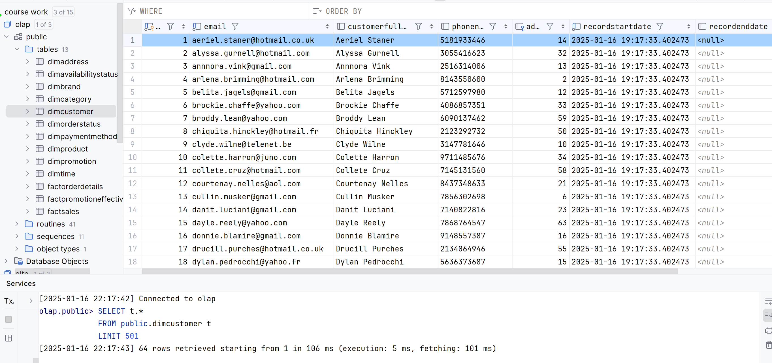
- Change user name, for example, in Users.csv
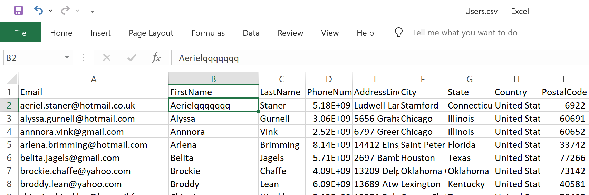

- Run script to load from csv to oltp and then script etl
