RAG - Retrieval Augmented Generation

we add context to the prompt from side data we search in.

Auto-Regressive and Auto-Encoding

Auto-Regressive - LLMs predict the future token from the past.
Auto-Encoding - LLMs produce outputs based on full inputs

Auto-Encoding LLMs
Applications include classification and sentiment analysis
Also used to calculate vector embeddings representing an input as a list of numbers (vector)
Examples include BERT from google and OpenAIEmbeddings from OpenAI

Can represent a character, token, word, sentence or entire document.
A point in multi dimensional space with thousands of dimensions
Understanding of the text, similar inputs have close vectors in space
Supports vector math with the famous example “King - Man + Woman = Queen”

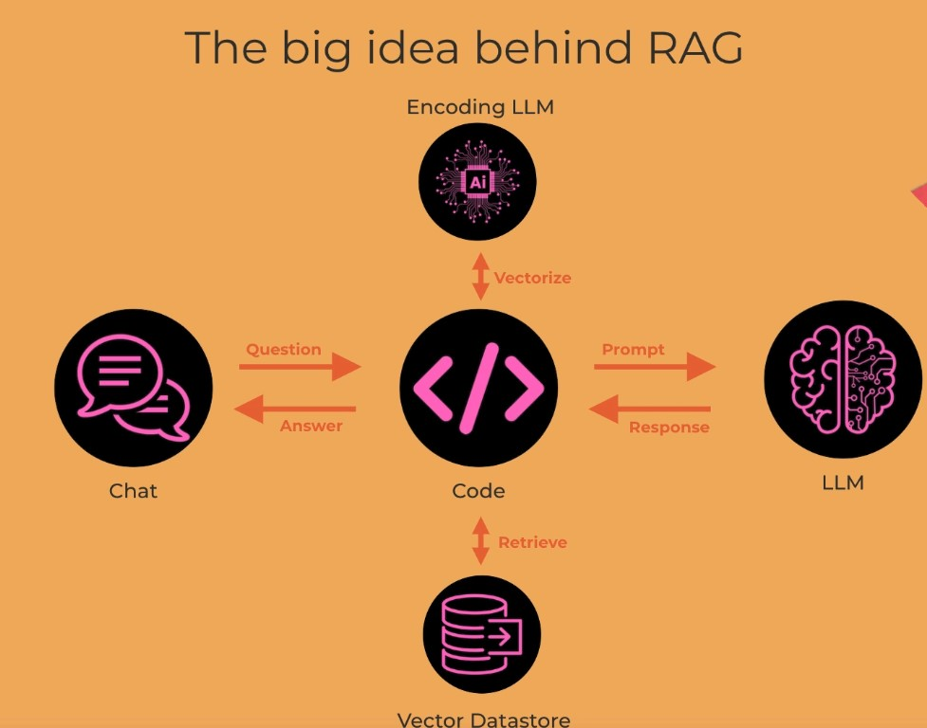

LangChain

LangChain - OpenSource framework launched on Oct. 22
Provides common interface for interacting with many LLMs
includes its own declarative language: LangChain Expression Language (LCEL)
Greatly simplifies the creation of applications using LLMs and reduces time to market
Wrapper code above LLMs allows easy swap
As LLMs API has matured, the need for framework like LangChain has decreased.

We will use LC to load our knowledge base and apply RAG:
- Read in the documents in all folders
- Add meta-data to the documents
- Break down the contents overlapping chunks

Vectors embedding models:
- The simplest is the bag of words that just counts each word/token and increase its counter in its index in the vector, no order is saved, Also, no meaning understanding as there are several meaning to the same word sometimes)
- words2vec - NN (2013)
- BERT - from google (2018) a transformer arch.
- OpenAIEmbedding - (2024) the latest and greates

Chroma was the first of vector data store.
There are several data store for RAG like Chroma of LangChian and also FAISS (Facebook AI Similarity Search)

Key abstractions of LangChain for several main things:
- LLM
- Retriever - Chroma creates such an object
- Memory
One thing to notice, the chat function we had so far used the history parameter (with the current use message), but here, due to memory object the history is maintained by LangChain

LCEL (Lang Chain Expression Language)
LCEL is a declarative language that can be used as an alternative to the code approach.
Describing what you want to achieve in a yaml file, arguably, not much easier than coding directly.

How LC is working behind the scenes?
We can use callbacks to see what was done behind the scenes to output prompt details.
Diagnosing a common problem - the right chunks are not being provided to the model.
Fixing the problem - chunking differently providing more chunks
Demystifying LC - it’s actually not hard to build RAG directly.

In the day 5 notebook there is an example of a question that model doesn’t know the answer about. To solve this, we can play with the size of the chunks (whole documents or smaller chunks). Or even simpler by playing with the chunk size.
In the example, we control the amount of chunks that are sent in (k). we can specify it in the retriever.
More context is generally a good thing. But there are models that it may confuse them as they go deep on the prompt.

Challenge, build some API to be able to read your emails in gmail or slack and build from it your data store for you agent. Google drive, Docs (with MS Office)

Another option is to have Llama .cpp locally in order not to have to work on the cloud with your data. if we have a concern that OpenAPIEmbedding may vectorize our data and out it somewhere.

