**Question 1 – Blackjack**

1. The problem described as a Markov decision process –

Each state consists of two variables $s=(X,Y)$ where $X$ represents the sum of the player’s cards and $Y$ represents the first dealer’s cards.

The player is initially dealt with two cards therefor the minimal value of $X$ is $4$ (two $2$ s). The maximal sum the player can reach without losing the game is $X=21$. The dealer’s first card is between $Y=2$ and $Y= 11$.

Overall the state space is- $\left|S\right|=\left|X\right|∙\left|Y\right|\underset{\begin{matrix}4≤X≤21 \\ 2≤Y≤11\end{matrix}}{\underbrace{=}}18∙10=180$

In addition, there are three terminal states - $\{Win,Loss,Draw\}$ therefore - $\left|S\right|=183$.

The action space is $A=\{hit,stick\}$.

The reward for each state is 0 except for the terminal states where –

$r\left(Win\right)=1 , r\left(Loss\right)=-1,r\left(Draw\right)=0$

We do not discount ($γ = 1$).

Since the dealer’s policy is given (and independent on the players sum), we can calculate the probability of the final sum of cards for the dealer- marked $Y_{tot}$.

$$f(\left(X,Y),a\right)=\left\{ \begin{aligned}\begin{matrix}Loss \\ \begin{matrix}Win \\ Draw\end{matrix}\end{matrix} \begin{matrix}a=stick and X<Y_{tot} \\ \begin{matrix}a=stick and X>Y_{tot} \\ a=stick and X=Y_{tot}\end{matrix}\end{matrix} \\ (X_{n}+B,Y_{n}) a=hit and X+B≤21 &&&& \\ Loss a =hit and X+B>21 \end{aligned}\right.$$

Where B is the value of the card added (generated every time $a=hit$) and is distributed (independent of $X,Y$) -

$$P\left(B\right)=\left\{\begin{aligned}\frac{1}{13} B∈\{2,3,4,5,6,7,8,9,11\} \\ \frac{4}{13} B=10\end{aligned}\right.$$

Both $P(B)$ and $P(Y_{tot}|Y)$ can be initially calculated. The problem’s transition probabilities based on these distributions will be-

$$P\left(Loss | (X,Y),stick\right)=P_{Y_{tot}}(X<Y_{tot}|\left(X,Y\right))$$

$$P\left(Win | (X,Y),stick\right)=P_{Y_{tot}}\left(X>Y_{tot} | \left(X,Y\right)\right)+P_{Y_{tot}}\left(\underset{marked: Y_{tot}=22}{\underbrace{Y_{tot}>21}} | Y\right)$$

$$P\left(Draw | (X,Y),stick\right)=P_{Y_{tot}}(X=Y_{tot}|\left(X,Y\right))$$

$$P\left(X_{n}+B | (X,Y),hit\right)=P_{B}\left(B\right)*l_{B≤21-X|X}$$

$$P\left(Loss | (X,Y),hit\right)=P_{B}\left(B>21-X|X\right)$$

All other transitions are with zero probability.

1. As described in section a, initially we shall calculate the probabilities of the total sum reached for the dealer - $Y_{tot}|Y$.

The possible values of $Y_{tot}|Y$ are (based on the given policy) – $Y_{tot}|Y∈\left[17,22\right]$

Where $Y_{tot}=22$ is the case where $Y_{tot}>21$.

The result after applying the given policy -

$$\boxed{P\left(Y_{tot} | Y\right) | 17 | 18 | 19 | 20 | 21 | >{21}_{Loss for Dealer}}$$

$$Y = 2 | 0.121 | 0.125 | 0.119 | 0.114 | 0.108 | 0.414$$

$$Y = 3 | 0.116 | 0.121 | 0.116 | 0.11 | 0.105 | 0.432$$

$$Y = 4 | 0.113 | 0.116 | 0.112 | 0.107 | 0.102 | 0.45$$

$$Y = 5 | 0.103 | 0.113 | 0.109 | 0.104 | 0.099 | 0.472$$

$$Y = 6 | 0.135 | 0.103 | 0.103 | 0.098 | 0.094 | 0.468$$

$$Y = 7 | 0.356 | 0.135 | 0.075 | 0.075 | 0.071 | 0.288$$

$$Y = 8 | 0.117 | 0.356 | 0.126 | 0.066 | 0.066 | 0.268$$

$$Y = 9 | 0.109 | 0.117 | 0.348 | 0.117 | 0.058 | 0.251$$

$$Y = 10 | 0.102 | 0.109 | 0.109 | 0.34 | 0.109 | 0.23$$

$$Y = 11 | 0.095 | 0.102 | 0.102 | 0.102 | 0.333 | 0.266$$

Now we have all the needed possibilities distributions in order to solve the Bellman Equations –

For terminal states –

$$V_{n}\left(Win\right)=r\left(Win\right)=1$$

$$V_{n}\left(Loss\right)=r\left(Loss\right)=-1$$

$$V_{n}\left(Draw\right)=r\left(Draw\right)=0$$

For non- terminal states -

$$V_{n+1}\left(X,Y\right)=\max_{a∈\left\{hit,stick\right\}}\left\{\underset{=0 for all non terminal states}{\underbrace{r\left(\left(X,Y\right),a\right)}}+\sum_{s^{'}}{V_{n}\left(s^{'}\right)∙P\left(s^{'} | \left(X,Y\right),a\right)}\right\}=$$

$$=\max_{a∈\left\{hit,stick\right\}}\left\{\underset{V\left(Win\right)}{\underbrace{1}}*P\left(Win | \left(X,Y\right),a\right)+ \underset{V\left(Loss\right)}{\underbrace{-1}}*P\left(Loss | \left(X,Y\right),a\right)+\underset{V\left(Draw\right)}{\underbrace{0}}*P\left(Draw | \left(X,Y\right),a\right)+\sum_{B=2}^{11}{V_{n}\left(\left(X+B,Y\right)\right)*P\left(X_{n}+B | \left(X,Y\right),a\right)}\right\}$$

$$=\max\left\{\begin{aligned}\underset{a=stick}{\underbrace{P\left(Win | \left(X,Y\right),stick\right)- P\left(Loss | \left(X,Y\right),stick\right)}}, \\ \underset{a=hit}{\underbrace{\sum_{B=2}^{11}{V_{n}\left(X+B,Y\right)*P\left(X_{n}+B | \left(X,Y\right),hit\right)}-P\left(Loss | \left(X,Y\right),hit\right)}}\end{aligned}\right\} =$$

$$=\max\left\{\begin{aligned}\underset{a=stick}{\underbrace{P_{Y_{tot}}\left(X>Y_{tot} | \left(X,Y\right)\right)-P_{Y_{tot}}\left(X<Y_{tot} | \left(X,Y\right)\right)}} \\ \underset{a=hit}{\underbrace{\sum_{B=2}^{\min\left(11,21-X\right)}{V_{n}\left(X+B,Y\right)*P_{B}\left(B\right)}-P_{B}\left(B>21-X|X\right)}}\end{aligned}\right\}=$$

$$=max\left\{\begin{aligned}\underset{a=stick}{\underbrace{P_{Y_{tot}}\left(X>Y_{tot} | \left(X,Y\right)\right)-P_{Y_{tot}}(X<Y_{tot}|\left(X,Y\right))}} \\ \underset{a=hit}{\underbrace{\sum_{B=2}^{min⁡(11,21-X)}{V_{n}\left(X+B,Y\right)*P_{B}\left(B\right)}-\sum_{B=21-X+1}^{11}{P_{B}\left(B\right)}}}\end{aligned}\right\}$$

After running the VI algorithm for $N→∞$ iterations we converge to an optimal value $V^{*}$.

For example, after $N=40$ iterations –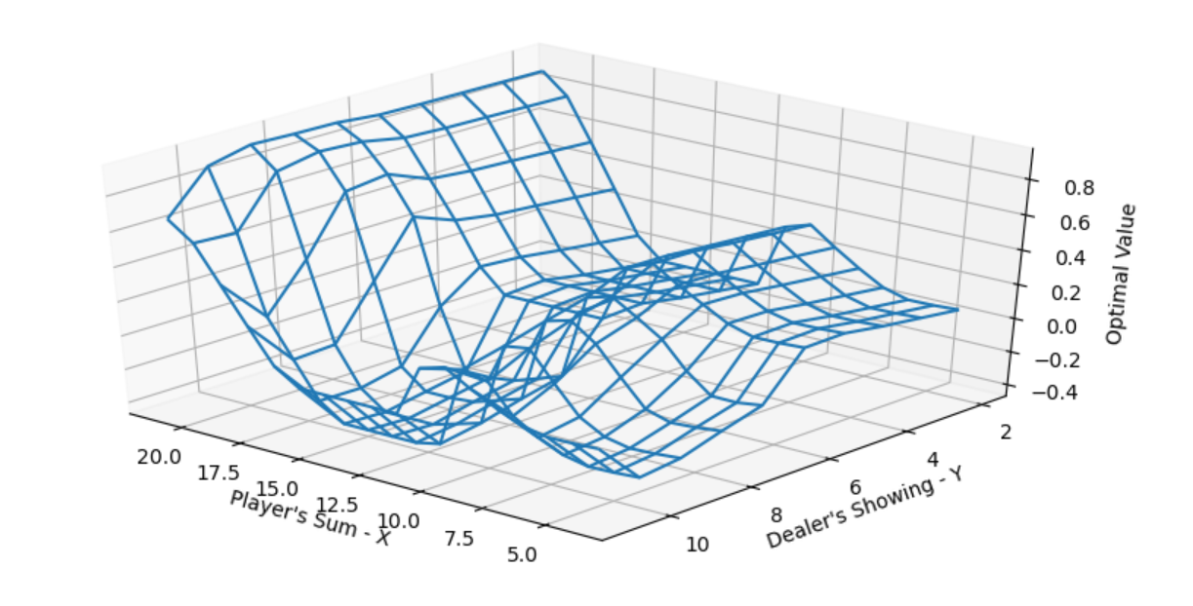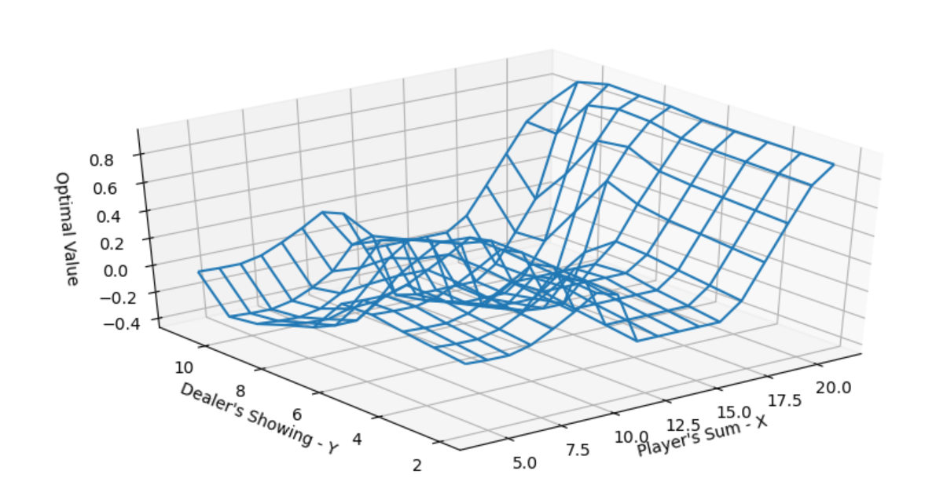

1. After obtaining the optimal value - $V^{*}$ we must now derive an optimal policy. By using the Greedy operator-

$$π\left(X,Y\right)=Greedy{\left(V^{*}\right)}_{X,Y}=argmax_{a∈\left\{hit,stick\right\}}\left\{\underset{=0 for non-terminal states}{\underbrace{r\left(\left(X,Y\right),a\right)}}+\sum_{s^{'}}{P\left(s^{'} | \left(X,Y\right),a\right)V^{*}\left(s^{'}\right)}\right\}$$

$$=argmax_{a∈\left\{hit,stick\right\}} \left\{\underset{a=hit}{\underbrace{\begin{aligned}\underset{a=stick}{\underbrace{P_{Y_{tot}}\left(X>Y_{tot} | \left(X,Y\right)\right)-P_{Y_{tot}}(X<Y_{tot}|\left(X,Y\right))}} \\ \sum_{B∈[2,min⁡(11,21-X)]}{P_{B}\left(B\right)∙V^{*}\left(X+B,Y\right)}-\sum_{B∈[max\left(11,21-X\right),11]}{P_{B}\left(B\right)}\end{aligned}}}\right\}$$

We receive the following result (plot of the minimal value of X for which the policy choses action ‘stick’):

