Proceedings of IMEC 2019

International Mechanical Engineering Congress (IMEC-2019),

29th November- 1st December 2019, NIT Tiruchirappalli, India.

IMEC2019-xx-xxxx

**Analysis of cutting forces in Helical Ball end milling process using deep learning**

Author1a*, Author2b,

a Department of Mechanical Engineering, NIT Trichy

b Department of Mechanical Engineering, NUS Singapore

* Corresponding author email: vedha@nitt.edu

**ABSTRACT**

In this paper, variation of cutting forces and corresponding torque exerted on tool with respect to cutting parameters for ball end milling process is analysed using deep neural network. A neural network was fabricated to predict cutting forces in all three orthogonal directions for a given set of cutting parameters. Analysis was done by varying axial depth of cut and feedrate while keeping all other parameters constant, because the variation of cutting forces was most significant for these two parameters. For generating data CutPro simulation software was used along with AutoIT to automatically vary the parameters and simulate. Finally, after proper tuning of hyperparameters of the neural network, maximum percent deviation of predicted values over test dataset was brought down to less than 5 percent.

**INTRODUCTION**

Machining is the most widespread metal shaping process in mechanical manufacturing industry. Machining is a subtractive process where a raw material is turned into a desired product by removing the material around it. The study of forces generated during machining, Workpiece and tool material, tool and workpiece geometry, machine parameter settings influence the process efficiency and output quality.

Titanium alloys find a wide application field in many industries, especially in space, aviation, biomedical, automotive and oil industries, due to high strength-weight ratio, superior corrosion resistance, low young modulus and biocompatibility properties of these materials. About 70% by weight of titanium-based alloys are used in the aero-space industry [1]. Ti-6Al-4V alloy was specifically developed for applications demanding exceptional mechanical and chemical properties at elevated temperatures. Ti-6Al-4V alloy is particularly known to exhibit high strength to density ratios and good corrosion resistance properties. Titanium alloy is difficult to machine due to high chemical reactivity, generation of high cutting forces during milling, low thermal conductivity, high rigidity.

Many researchers have given their insights in understanding machining of Titanium alloy and effects of cutting parameters on the cutting forces. Rashid et al [1] conducted the research on T-6Cr-5Mo-5V-4Al beta aluminium alloy using Laser-assisted Machining [LAM]. The findings revealed that LAM significantly reduced cutting force within a certain range of cutting parameters. Niu et al [2] found that resultant cutting force increased with cutting speed in face milling process of TC6 alloy. Szymon Wojiciechowski et al [3] proposed a cutting force model for ball end mill for finishing operation which includes influence of surface inclination and cutter runout. Research revealed that cutter's run out and surface inclination angle have significant influence on the cutting forces, both in the quantitative and qualitative aspect. S.Sun et al, M. Brandt et al, M.S Dargusch et al [4] observed chip formation with dynamic cutting force measurements under different cutting speeds, feed rates, and depth of cuts. Both segmented and continuous chip formation of one cut at larger feed rates and lower cutting speeds were observed. A cyclic force produced during formation of segmented chips and the force frequency was the same as the chip segmented frequency. The peak of the cyclic force when producing segmented chips was 1.18 times that producing the continuous chip. The cyclic force frequency increased linearly with cutting speed and decreased inversely with feed rate. The cutting force increased with the feed rate and depth of cut at constant cutting speed due to the large volume of material being removed. n cutting force with increasing cutting speed was attributed to the strain rate hardening at low and high strain rates, respectively. The decrease in cutting force with increasing cutting speed outside these speed ranges was due to the thermal softening of the material.

**DATA GENERATION**

Axial Depth of Cut [ADOC] was varied from 1mm to 1.9mm in the steps of 0.02mm and Feedrate was varied from 0.200 mm/flute to 0.290 mm/flute in steps 0.01 mm/flute.

For various Combination of Feed rate and ADOC, time domain simulations were conducted and instantaneous forces (Feed, Axial, Normal) and instantaneous torque values were stored in excel Files. A total of 600 files were generated for various combinations of cutting parameters. RMS values for Feed Force, Normal Force, Axial Foce.

**CUTTING CONDITIONS CONSIDERED**

Ti-6Al-4V machining simulation was carried out on CUT-PRO simulation software. A 4-Flute Ball. End Mill tool with constant helix was chosen for slotting operation

**Geometrical Parameters of the tool are as follows:**

|  |  |
| --- | --- |
| Parameter | Value |
| Diameter | 20 mm |
| Length | 150 mm |
| Flute Height | 10 mm |
| Helix Angle | 300 |
| Rake Angle | 50 |

|  |  |
| --- | --- |
| Property | Value |
| Hardness | 340HB |
| Density | 4.706g/cm3 |
| Thermal Conductivity | 6.000W/m-K |
| Young’s Modulus | 1.15*1011 N/m2 |
| Tensile Strength | 9*108 N/m2 |
| Yield Strength | 8.30 *108 N/m2 |
| Shear Strength | 7.60 *108 N/m2 |

**Workpiece for the Simulation was Ti-6Al-4V alloy which has the following Properties**

|  |  |
| --- | --- |
| Parameter | Value |
| Spindle Direction | Clockwise |
| Milling Mode | Slotting |
| RPM | 300 |
| Number of revolutions | 1 |
| Sampling Frequency | 10 |

**Other cutting parameters were taken as follows:**

**DEFINING INPUT AND OUTPUT VARIABLES**

Input variables- ADOC, Feedrate.

Output variables- Ffeed, Fnormal, Faxial.

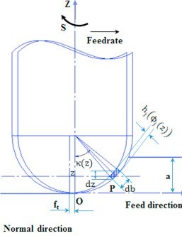

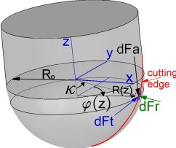

Figure 1: Pictorial representation of input and output variables

|  |  |
| --- | --- |
| a | Depth of cut [mm] |
| ft | Feed/Tooth |
| hj(ϕj(z)) | Instantaneous chip thickness at immersion angle (ϕj) [mm] |
| db | Chip Width [mm] |
| dz | Differential ADOC [mm] |

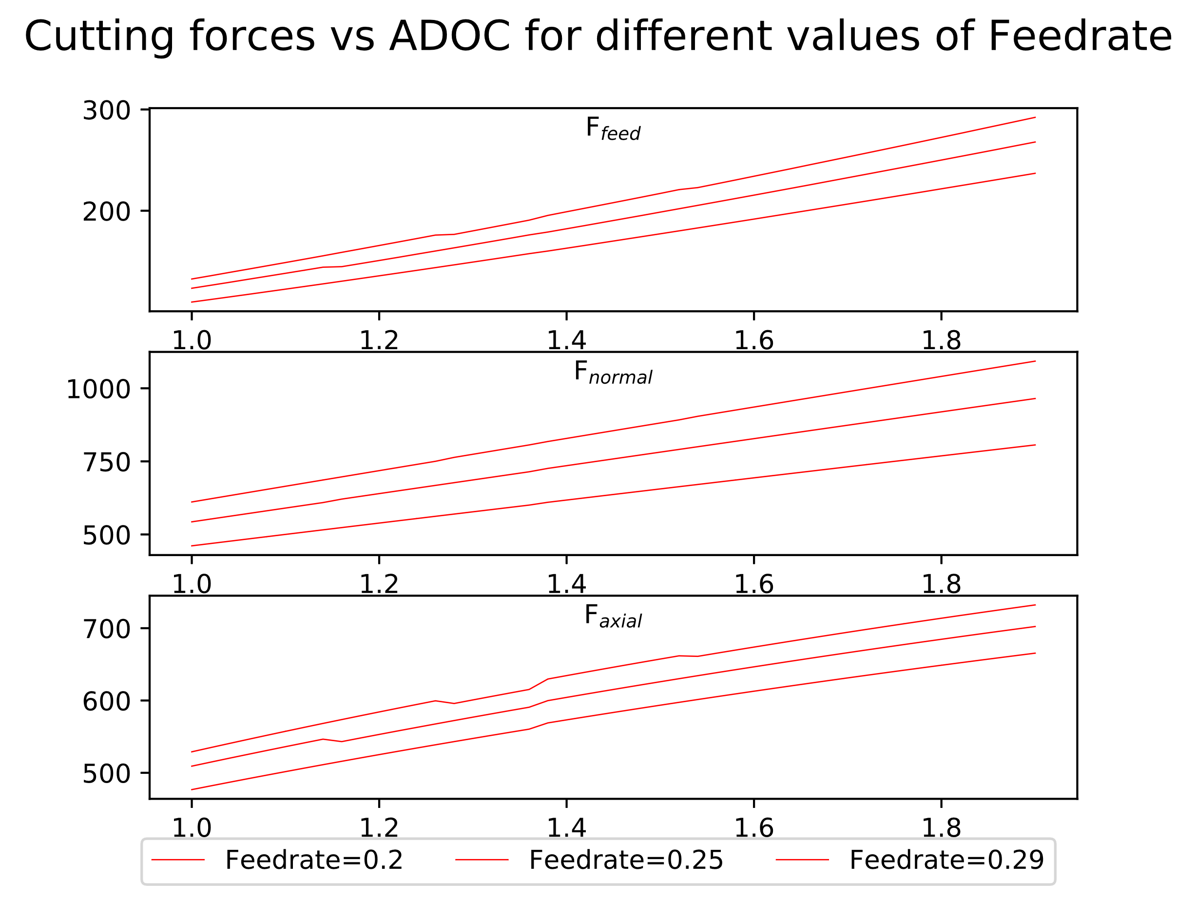In the following figures, actual variation in cutting forces with respect to the cutting parameters (axial depth of cut and feedrate) is shown.

Figure :Cutting forces vs ADOC for 3 different values of Feedrate

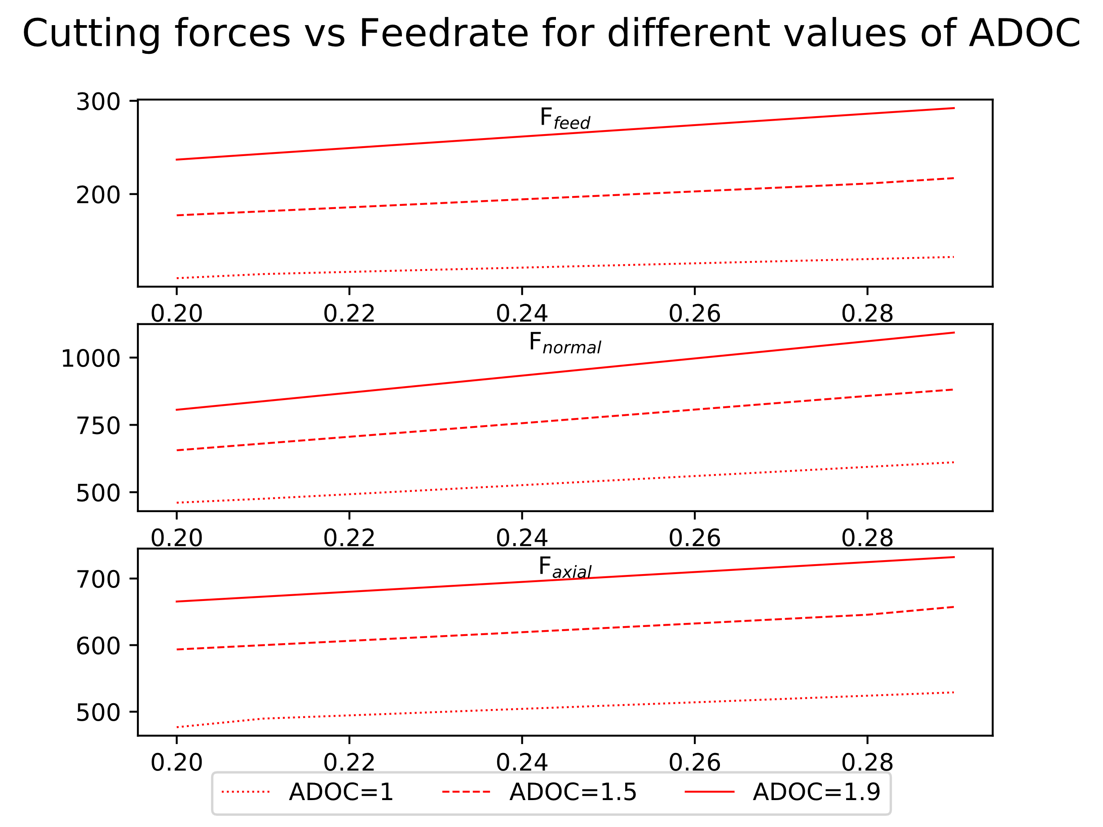

Figure : Cutting forces vs Feedrate for 3 different values of ADOC

From figures 2 and 3 it can be observed that maximum variation is in the normal/radial direction, while in other two directions amount of variation is similar, although magnitude of axial force is much more than that of feed /tangential force.

**NEURAL NETWORK ARCHITECTURE**

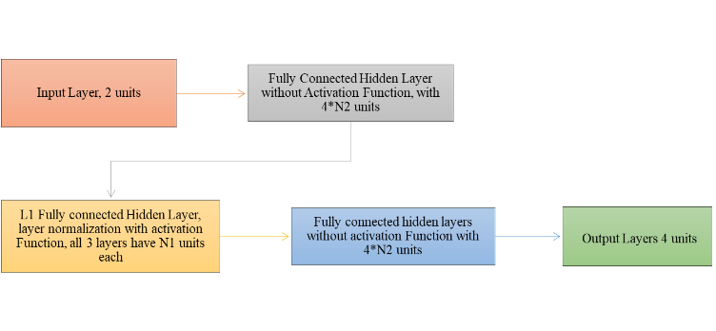1. **Neural network to be used for learning**.

Figure : Neural network structure, showing details of each layer

2. **Layer Normalisation** [8].

Output of normalisation layer is given by $\overline{z_{i}^{l}}$:

$\overline{z_{i}^{l}}=\frac{z_{i}^{l}-μ{\left[z_{i}\right]}^{l}}{\sqrt{Var{\left[z_{i}\right]}^{l}+ϵ}}*γ+β$

$μ{\left[z_{i}\right]}^{l}=\left(\frac{1}{H}\right)\sum_{i=1}^{H}{z_{i}^{l}}$, $Var{\left[z_{i}\right]}^{l}=\left(\frac{1}{H}\right)\sum_{i=1}^{H}{{\left(z_{i}^{l}-μ^{l}\right)}^{2}}$

where, $z_{i}^{l}$ is the value at ith hidden unit of lth layer and H is the number of hidden units in a layer. All the hidden units in a layer share the same normalization terms $μ{\left[z_{i}\right]}^{l}$ and $Var{\left[z_{i}\right]}^{l}$, but different training datapoints have different normalization terms. γ and β are learnable parameters.

3. **Activation function** [9] – PReLU

PReLU() = *max*(0,)+a0∗*min*(0,)

where, a0 is a learnable parameter.

4. **Loss function** - Mean squared percent error.

$$\left(\frac{1}{N}\right)\sum_{j=1}^{N}{\sum_{i=1}^{6}{{\left(\frac{{act}_{ij}-{pred}_{ij}}{{act}_{ij}}*100\right)}^{2}}}$$

Where, N is the number training examples, actij is actual value of ith output of jth training example and predij is predicted value of ith output of jth training example.

5. **Adam optimizer** [10] used for minimising the loss, betas = {0.9, 0.999}, along with mini-batch gradient descent.

6. Choice of activation function, loss function and optimizer was made after training and evaluating some simple neural networks on small dataset. It was observed that PReLU, mean squared percent error and Adam gave best results. Layer normalisation did not significantly improve the accuracy; however, it still gave positive results.

**TRAINING THE NEURAL NETWORK**

1. Various models were trained on each of the above cases by tuning following hyperparameters:

I. **L1** = Number of hidden layers with layer normalisation and activation.

II. **N1** = Number of units in “**L1**” hidden layers.

III. **N2** = Parameter defining number of units in remaining hidden layers.

IV. **Initial LR** = Initial learning rate.

V. **Update period =** Number of iterations after which the learning rate will be updated.

VI. **Update factor =** Factor by which to divide on each update.

2. For tuning the hyperparameters mentioned above, several models were trained by randomly sampling the values of each hyperparameter from a certain interval best suited for that hyperparameter. Sampling interval of all hyperparameters was narrowed down over subsequent iterations, around the region giving best performance for finer tuning.

|  |  |
| --- | --- |
| Hyperparameters | Values |
| # Training datapoints |  |
| # Iterations | 10,000 |
| Initial LR | 0.01 |
| Update period | 5,000 |
| Update factor | 2 |

3. Dataset generated earlier was shuffled and then datapoints were randomly selected from it, to generate training and validation datasets. Models were trained over training dataset and then, validation dataset was used to pick the best model. Finally, the model that performed best on the validation dataset was evaluated on the test dataset and results are tabulated in the next sections. After training few simple models, following values of learning rate parameters, mini-batch size number of mini-batches, number of iterations, etc. worked best:

**4.** Models were trained using Pytorch [11] on NVIDIA GeForce GTX 1060 6GB GPU.

**RESULTS OBTAINED AFTER TRAINING**

1. After training several models, neural network similar to the following architecture worked best for amount of data that was generated for training. For the given values of hyperparameters deviation of the worst datapoint among the validation dataset was brought down to less than 5 percent:

**L1** = 3, **N1** = 270, **N2** = 3

|  |  |  |
| --- | --- | --- |
| Output | Mean Percent deviation | Max. Percent deviation |
| Ffeed | 0.022 | 0.115 |
| Fnormal | 0.020 | 0.110 |
| Faxial | 0.021 | 0.111 |

2. Apart from the training and validation dataset a separate dataset was also generated to report the results. In the following table, maximum and mean percent deviations of predicted values from actual values is written:

3. Following graphs show predicted values plotted against actual curves of cutting forces vs Axial depth of cut and federate. From this graphical comparison we can see that the accuracy is more than sufficient for any practical purposes.

**OBSERVATIONS**

**CONCLUSION**

**FURTHER APPLICATIONS**

**REFERENCES**