**Title of the Paper**

**Author1 Name a*, Author2 Name b, Author3 Name a**

a Department of 1st Author, Name of Organisation, City, State, Country

b Department of 2nd Author, Name of Organisation, City, State, Country

* *corresponding author e-mail*: abcd@xyz.com

Abstract

*The matter included in this template file is only for understanding the type of fonts and the style of formatting in the different sections to be used for preparing the full length paper (manuscript), as per which the full length paper must be submitted for consideration in International Conference on Advancements and Futuristic Trends in Mechanical and Materials Engineering. The citations and the other matter do not belong to the organizing team or to the Society of Materials and Mechanical Engineers. The addition of ceramic reinforcements such as carbides and oxides to form metal matrix composites enhances the properties such as strength, wear resistance, and high-temperature durability. In this study, composite tool electrodes were prepared to investigate their performance in electrical discharge machining (EDM) process. Experiments were performed by using these tools on an EDM with selected input parameters on AISI D3 die steel work piece. The microstructures of the machined surfaces and tool electrodes were analyzed by using a scanning electron microscope (SEM). Microstructure analysis reveals the presence of micro-holes and cavities on the machined surfaces. Depth of re-solidified layer increases with the increase of gap current due to deposition of material from tool electrode to the work-piece surface during machining.*

***Keywords****: Electrical Discharge Machining, Composite Tool, Microstructure, Scanning Electron Microscope.*

# 1. Introduction

A robot is a programmable machine that can perform variety of tasks depending upon the requirements and the programming. …………………… ………….. ………. ……….. …… .. .. … …. …. …. … . . .. … .. …………………………………………………………….. …. …………. ……………. …………. ………… …………… ………….. ……………. …………… ………….. ……………… …………. .. . . ……… . …………………………. ………………. …………………………………………………………….. …. …………. ……………. …………. ………… …………… ………….. ……………. …………… ………….. ……………… …………. .. . . ……… . …………………………. ………………. … ….. …… ……. …… …… ….. [1].

Rapidly changing …………………………………………………………….. …. …………. ……………. …………. ………… …………… ………….. ……………. …………… ………….. ……………… …………. .. . . ……… . …………………………. ………………. … ….. …… ……. …… …… ….. [2].

Moreover, …………………………………….. …. …………. ……………. …………. ………… …………… ………….. ……………. …………… ………….. ……………… …………. .. . . ……… . …………………………. ………………. … ….. …………… ………….. ……………. …………… ………….. ……………… …………. .. . . ……… . …………………………. ………………. … ….. …… ……. …… …… ….. important role in the modularity and re-utilisation [1].

# 2. Heading

As shown in Fig. 1, it can be clearly seen that .. … .. .. … …. …. …. … . . .. … .. … … ……………………………………………………….. …. …………. ……………. …………. ………… …………… ………….. ……………. …………… ………….. ……………… …………. .. . . ……… . …………………………. ………………. …… . . . ……………… ………….. ………. ……….. …

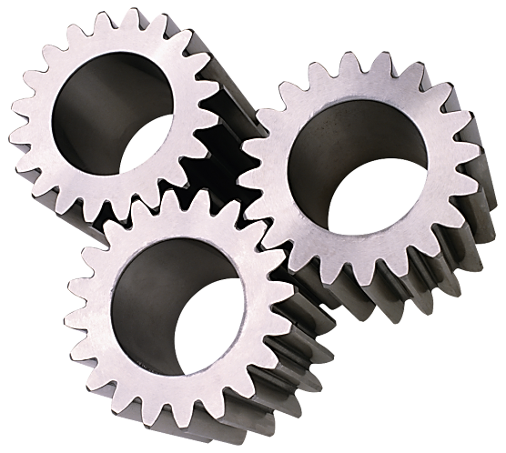

**Fig. 1: Working of gear assembly.**

.. … .. .. … …. …. …. … . . .. … .. … … ……………………………………………………….. …. …………. ……………. …………. ………… …………… ………….. ……………. …………… ………….. ……………… …………. .. . . ……… . …………………………. ………………. …… . . …………………… ………….. ………. ……….. …

.. … .. .. … …. …. …. … . . .. … .. … … ……………………………………………………….. …. …………. ……………. …………. ………… …………… ………….. ……………. …………… ………….. ……………… …………. .. . . ……… . …………………………. ………………. …… . . …………………… ………….. ………. …………. .. .. .. … .. .. … … … … … … … …. .. .. … .. .. … ..

The micro-hardness values as observed during testing are encapsulated in Table 1.

**Table 1: Micro-hardness of tested samples.**

|  |  |
| --- | --- |
| **Sample No.** | **Micro-hardness (Hv)** |
| 1 | 810 |
| 2 | 650 |
| 3 | 890 |
| 4 | 690 |

# 3. Discussion

A robot is a …………………… ………….. ………. ……….. ….. … .. .. … …. …. …. … . . .. … .. … … ……………………………………………………….. …. …………. ……………. …………. ………… …………… ………….. ……………. …………… ………….. ……………… …………. .. . . ……… . …………………………. ………………. [3]. Due to high load carrying capacities and …………………… ………….. ………. ……….. …

.. … .. .. … …. …. …. … . . .. … .. … … ……………………………………………………….. …. …………. ……………. …………. ………… …………… ………….. ……………. …………… ………….. ……………… …………. .. . . ……… . …………………………. ………………. [4].

# 4. Conclusion

A robot is a …………………… ………….. ………. ……….. ….. … .. .. … …. …. …. … . . .. … .. … … ……………………………………………………….. …. …………. ……………. …………. ………… …………… ………….. ……………. …………… ………….. ……………… …………. .. . . ……… . …………………………. ………………. . …………………… … … .. … … …. … …. …. ….

.. … .. .. … …. …. …. … . . .. … .. … … ……………………………………………………….. …. …………. ……………. …………. ………… …………… ………….. ……………. …………… ………….. ……………… …………. .. . . ……… . …………………………. ………………. .

…. …………. ……………. …………. ………… …………… ………….. ……………. …………… ………….. ……………… …………. .. . . ……… . …………………………. ………………. . Due to high load carrying capacities and ……………………

.. … .. .. … …. …. …. … . . .. … .. … … ……………………………………………………….. …. …………. ……………. …………. ………… …………… ………….. ……………. …………… ………….. ……………… …………. .. . . ……… . …………………………. ………………. .

# References

1. Kumar, P. and Sidhu, B.S., *Characterization and High-Temperature Erosion Behaviour of HVOF Thermal Spray Cermet Coatings.* Journal of Materials Engineering and Performance, 2015. **25**(1): p. 250-258.
2. Womersley, D., *Technical Report-Thermal Spraying and Powder Spray Welding Processes for the Hardfacing of Grey Cast Iron.* Materials & Design, 1990. **11**(3): p. 153-155.
3. Youwen, L. and Weiping, L., *Development of Chinese Electrostatic Precipitator Technology*, in *Electrostatic Precipitation: 11th International Conference on Electrostatic Precipitation, Hangzhou, 2008*, K. Yan, Editor. 2008, Springer Berlin Heidelberg: China. p. 3-11.
4. Kun, H. and Xue-song, M., *The Ammonia Injection System on the Flue Gas Duct before the Electrostatic Precipitator Inlet in Zhangjiang Orimulsion Power Plant*, in *International Conference on Power Engineering-2007*, Hangzhou, Editor. 2007: China. p. 684-688.