Table 1 Hyperparameters of the neural network that were tuned while training the model

|  |  |
| --- | --- |
| L1 | Number of hidden layers with layer normalisation and activation. |
| N1 | Number of units in “L1” hidden layers. |
| N2 | Parameter defining number of units in remaining hidden layers. |
| Initial learning rate | Initial learning rate. |
| Update period | Number of iterations after which the learning rate will be updated. |
| Update factor | Factor by which to divide on each update. |

Table 2 Deep Learning model training parameters

|  |  |
| --- | --- |
| # Validation datapoints | 1,000 |
| # Iterations | 30,000 |
| Initial LR | 0.01 |
| Update period | 5,000 |
| Update factor | 5 |

Table 3 Models selected after training. # Training examples = n*2m, where n = # mini-batches, m = mini-batch size. Iteration over n mini-batches, i.e. whole training set, was considered as one iteration.

|  |  |  |
| --- | --- | --- |
|  | Model 1 | Model 2 |
| L1 | 3 | 7 |
| N1 | 173 | 207 |
| N2 | 3 | 3 |
| # Training Datapoints | 2*211 | 20*211 |

Table 4 Training results for Dataset 1.

|  |  |  |  |  |
| --- | --- | --- | --- | --- |
| Output | Mean Percent deviation | | Max. Percent deviation | |
| Model 1 | Model 2 | Model 1 | Model 2 |
| β1 | 0.022 | 0.011 | 0.115 | 0.106 |
| β2 | 0.020 | 0.008 | 0.110 | 0.071 |
| β3 | 0.021 | 0.009 | 0.111 | 0.052 |
| δ21 | 0.016 | 0.012 | 0.172 | 0.101 |
| δ31 | 0.024 | 0.013 | 0.317 | 0.255 |
| δ32 | 0.012 | 0.007 | 0.159 | 0.083 |

Table 5 Training results for Dataset 2.

|  |  |  |  |  |
| --- | --- | --- | --- | --- |
| Output | Mean Percent deviation | | Max. Percent deviation | |
| Model 1 | Model 2 | Model 1 | Model 2 |
| β1 | 0.019 | 0.011 | 0.130 | 0.079 |
| β2 | 0.018 | 0.010 | 0.130 | 0.046 |
| β3 | 0.019 | 0.010 | 0.123 | 0.054 |
| δ21 | 0.013 | 0.009 | 0.090 | 0.050 |
| δ31 | 0.019 | 0.009 | 0.169 | 0.051 |
| δ32 | 0.010 | 0.005 | 0.055 | 0.037 |

Table 6 Trained over Dataset 1 and Evaluated over Dataset 2

|  |  |  |  |  |
| --- | --- | --- | --- | --- |
| Output | Mean Percent deviation | | Max. Percent deviation | |
| Model 1 | Model 2 | Model 1 | Model 2 |
| β1 | 12.922 | 19.327 | 26.671 | 40.068 |
| β2 | 7.082 | 12.582 | 19.416 | 31.156 |
| β3 | 3.737 | 8.609 | 13.828 | 23.150 |
| δ21 | 1.866 | 8.318 | 7.643 | 21.166 |
| δ31 | 2.919 | 7.453 | 7.816 | 20.621 |
| δ32 | 1.331 | 4.310 | 3.593 | 11.100 |

Table 7 Trained over Dataset 2 and Evaluated over Dataset 1

|  |  |  |  |  |
| --- | --- | --- | --- | --- |
| Output | Mean Percent deviation | | Max. Percent deviation | |
| Case 1 | Case 2 | Case 1 | Case 2 |
| β1 | 10.620 | 4.630 | 94.813 | 57.242 |
| β2 | 6.181 | 1.808 | 58.538 | 19.544 |
| β3 | 4.826 | 1.361 | 45.678 | 10.128 |
| δ21 | 7.060 | 3.664 | 121.945 | 80.435 |
| δ31 | 9.475 | 4.975 | 202.181 | 134.401 |
| δ32 | 3.174 | 1.408 | 43.375 | 27.963 |

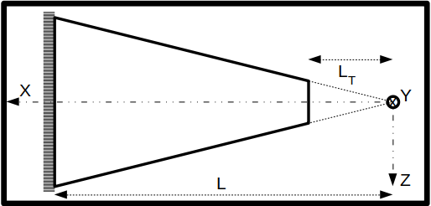

Figure 1 Tapered truncated cantilever beam structure

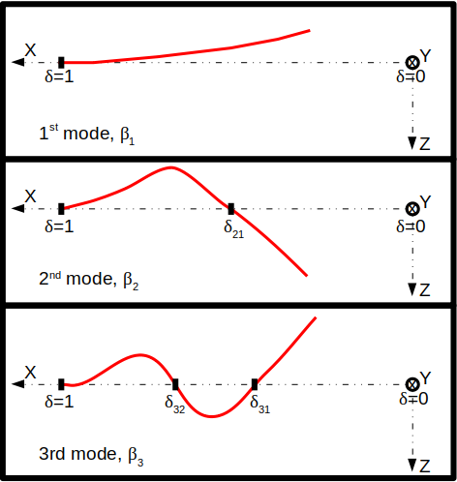

Figure 2 Pictorial representation of output variables.

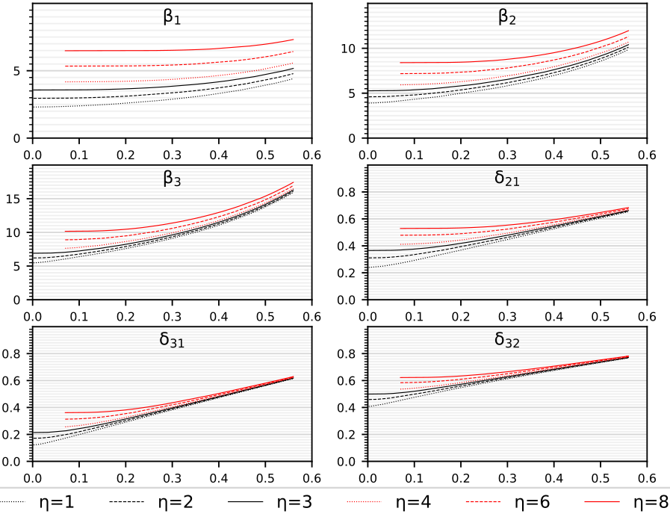

Figure 3 Actual variation of output values with respect to δ0 for 6 different values of η.

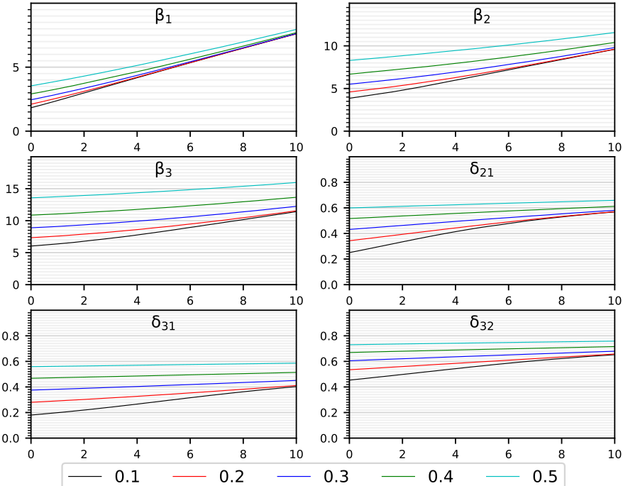

Figure 4 Actual variation of output values with respect to η for 5 different values of δ0.

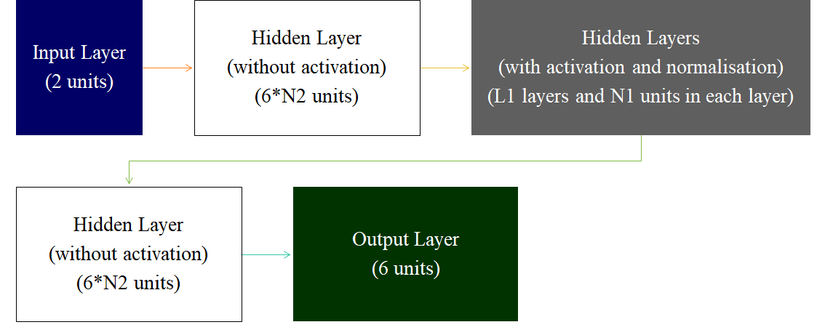

Figure 5 Neural network architecture

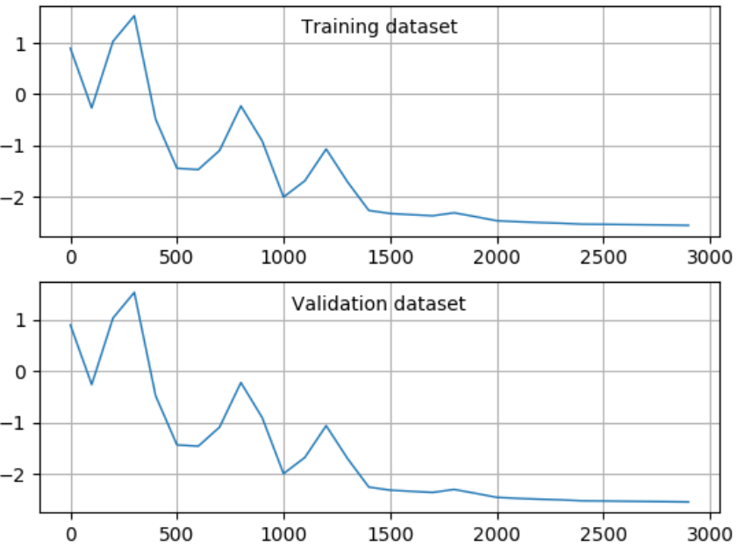

Figure 6 Mean squared error on log10 scale vs no. of iterations.

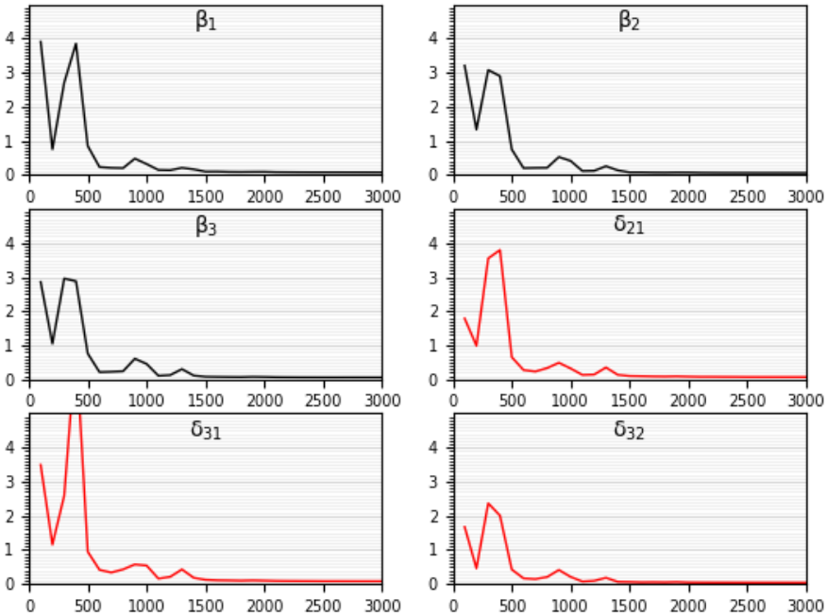

Figure 7 Validation dataset- 99th percentile error vs no. of iterations.

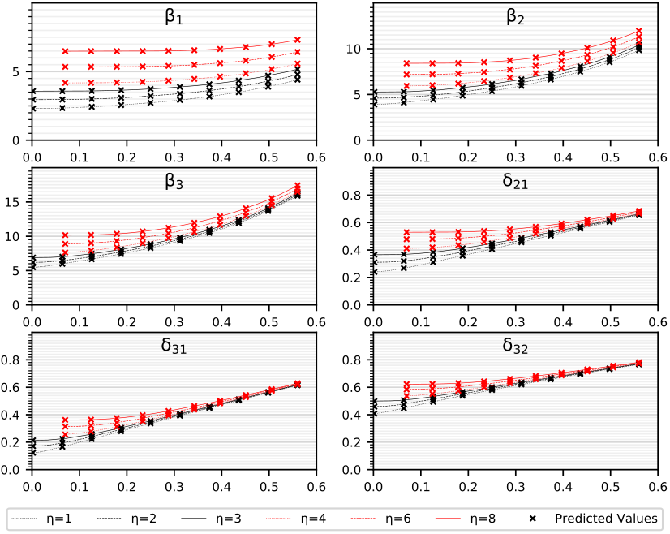

Figure 8 Comparison between actual and predicted values of output variables for six different values of η. Continuous lines denote actual variation of output variables and predicted values are shown using markers.

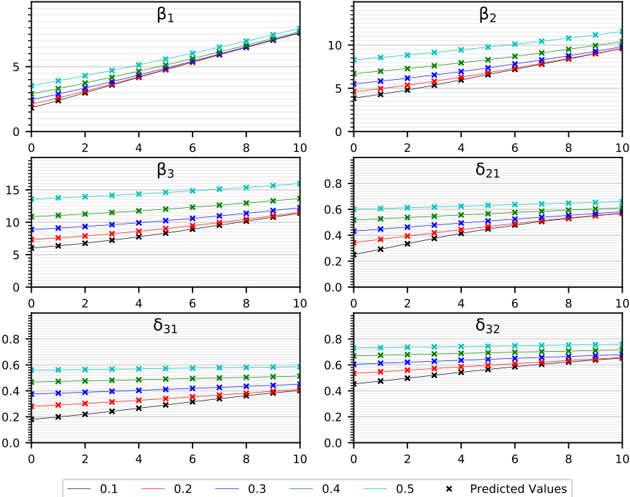

Figure 9 Comparison between actual and predicted values of output variables for five different values of δ0. Continuous lines denote actual variation of output variables and predicted values are shown using markers.

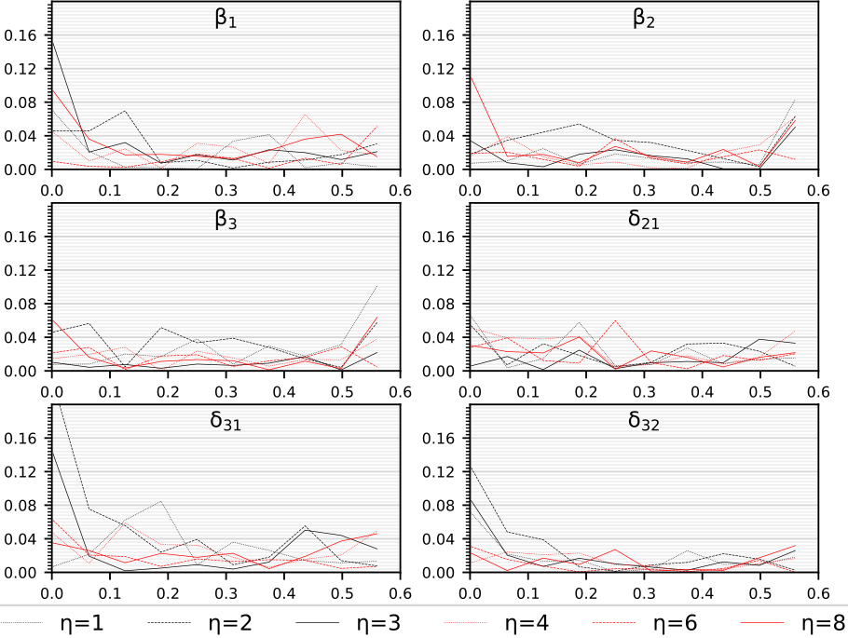

Figure 10 Percent deviation of predicted values from actual values vs δ0 for six different values of η.

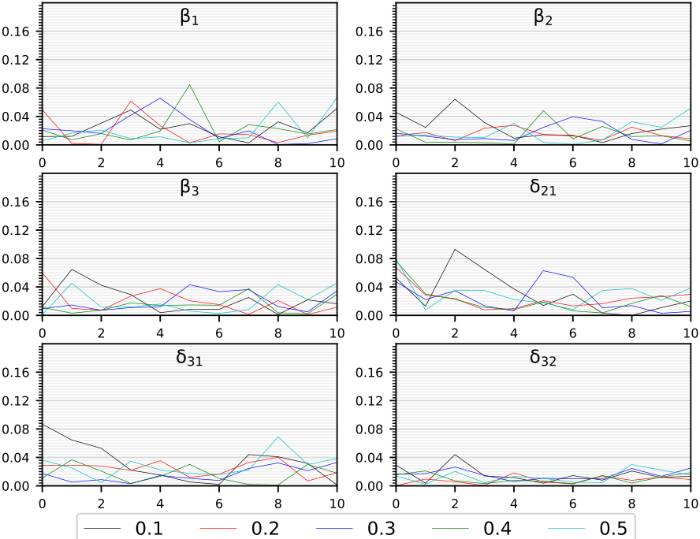

Figure 11 Percent deviation of predicted values from actual values vs η for five different values of δ0.

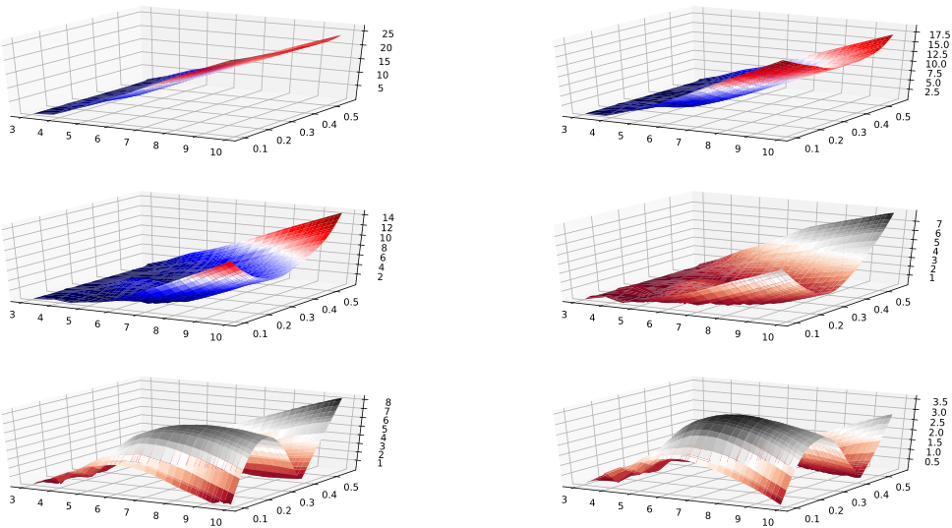

Figure 12 Percent deviation vs η and δ0 when trained Model 1 on Dataset 1 and evaluated over unseen data range (Dataset 2).

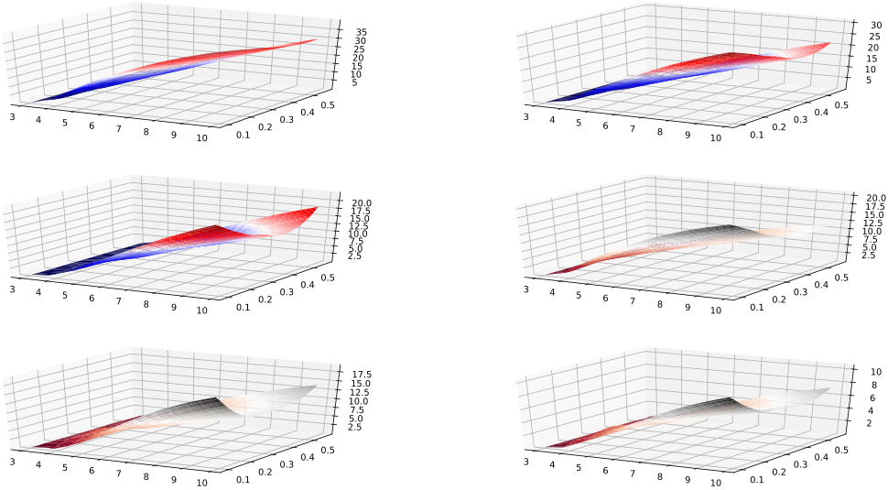

Figure 13 Percent deviation vs η and δ0 when trained Model 2 on Dataset 1 and evaluated over unseen data range (Dataset 2).

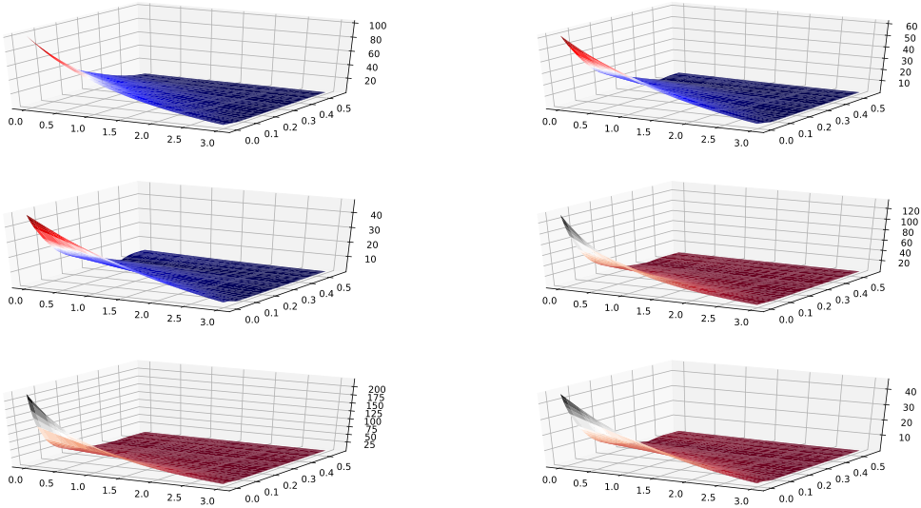

Figure 14 Percent deviation vs η and δ0 when trained Model 1 on Dataset 2 and evaluated over unseen data range (Dataset 1).

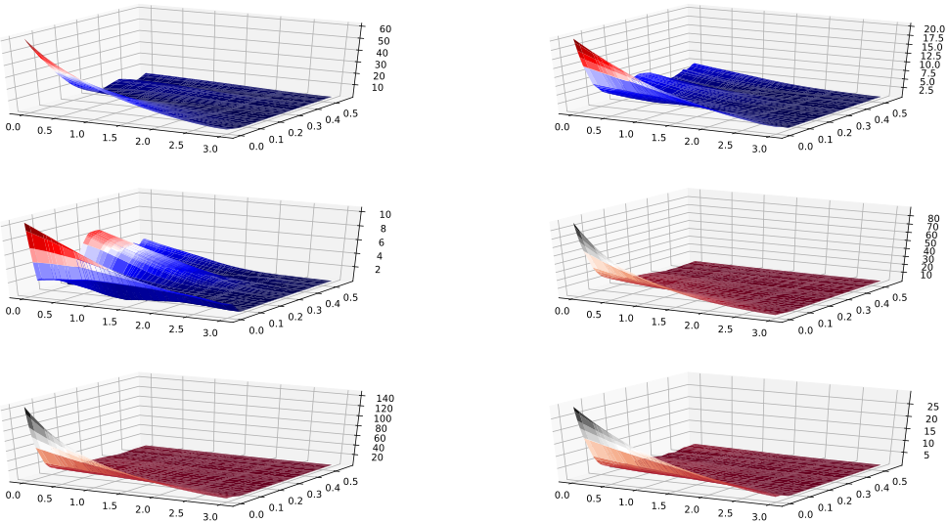

Figure 15 Percent deviation vs η and δ0 when trained Model 2 on Dataset 2 and evaluated over unseen data range (Dataset 1).