# LABORATORY EXERCISE6

# COURSE ENROLLMENT SYSTEM

**Learning Objectives**

By the end of this laboratory exercise, students should be able to:

* Design and create a new database table to manage relationships between users and courses.
* Implement server-side logic for handling course enrollments.
* Display user-specific data (enrolled courses) in a dashboard.
* Utilize jQuery and AJAX to create a dynamic, seamless user experience without page reloads.
* Understand and implement basic foreign key relationships in a web application.

**Prerequisite student experiences and knowledge**

Before starting this exercise, students should have:

* Completed Laboratory Exercise 5 (Admin and Student Dashboards).
* A solid understanding of the MVC architecture in CodeIgniter.
* Proficiency in writing database queries using CodeIgniter's Query Builder.
* Basic knowledge of SQL relationships (one-to-many).
* Familiarity with jQuery syntax and the concept of AJAX.
* Ability to create and style front-end components with Bootstrap.

**Background**

A core feature of any Learning Management System (LMS) is the ability for students to enroll in available courses. This involves creating a relationship between the **users** table (students) and the **courses** table. This relationship is typically stored in a pivot table. To enhance user experience, the enrollment process should be dynamic, allowing students to join courses without refreshing the page. This is achieved using jQuery AJAX to send a request to the server in the background, providing immediate feedback to the user.

**Materials/Resources**

* **Personal Computer with Internet Access**
* **XAMPP/WAMP/LAMP server installed**
* **CodeIgniter Framework (latest version)**
* **Visual Studio Code or any code editor**
* **Git and GitHub Account**
* **Web Browser (Chrome, Firefox, etc.)**

**Laboratory Activity**

**Step 1: Create a Database Migration for the Enrollments Table**

1. Create a new migration file for the **enrollments** table.

Run: php spark make:migrationCreateEnrollmentsTable

1. Open the newly created file in app/Database/Migrations/.
2. In the up() method, define the table with the following fields:
   * id (primary key, auto-increment)
   * user_id (int, foreign key to **users** table)
   * course_id (int, foreign key to **courses** table)
   * enrollment_date (datetime)
3. In the down() method, define how to drop the table.
4. Run the migration: php spark migrate.

**Step 2:Create the Enrollment Model**

1. Navigate to app/Models/ and create a file named EnrollmentModel.php.
2. Create a model class with methods to:

* enrollUser($data): Insert a new enrollment record.
* getUserEnrollments($user_id): Fetch all courses a user is enrolled in.
* isAlreadyEnrolled($user_id, $course_id): Check if a user is already enrolled in a specific course to prevent duplicates.

**Step 3: Modify the Course Controller**

1. Open your Course.php controller (or create it if it doesn't exist).
2. Add a new method, enroll(), to handle the AJAX request.

* This method should:
* Check if the user is logged in.
* Receive the **course_id** from the POST request.
* Check if the user is already enrolled.
* If not, insert the new enrollment record with the current timestamp.
* Return a JSON response indicating success or failure.

**Step 4: Update Student Dashboard View**

1. Open/Check the student dashboard view file.
2. Create a section to **Display Enrolled Courses**. Use a Bootstrap list group or cards to iterate over and display the courses returned by **EnrollmentModel::getUserEnrollments()**.
3. Create another section for**Available Courses**. Display a list of courses with an **Enroll** button next to each.

**Step 5: Implement AJAX Enrollment**

1. In the **Available Courses** section of the dashboard, add a **data_course_id** attribute to each **Enroll** button containing the specific course ID.
2. Include the jQuery library in your view if it's not already included.
3. Write a jQuery script that:

* Listens for a click on the **Enroll** button.
* Prevents the default form submission behavior.
* Uses **$.post()** to send the **course_id** to the /course/enroll URL.
* On a successful response from the server:
* Displays a Bootstrap alert message.
* Hides or disables the **Enroll** button for that course.
* Updates the **Enrolled Courses** list dynamically without reloading the page.

**Step 6: Configure Routes**

1. Update app/Config/Routes.php to include a route for the enrollment action.

**$routes->post('/course/enroll', 'Course::enroll');**

**Step 7: Test the Application Thoroughly**

1. Log in as a student.
2. Navigate to the student dashboard.
3. Click the **Enroll** button on an available course and verify:

* The page does not reload.
* A success message appears.
* The button becomes disabled or disappears.
* The course appears in the **Enrolled Courses** list.

**Step 8: Push to GitHub**

1. Commit your changes with a descriptive message.
2. Push your changes to your GitHub repository.

**Step 9: Vulnerable Checking**

1. Test for Authorization Bypass
   * Log out of the application and attempt to directly access the enrollment endpoint via Postman or browser console by sending a POST request to /course/enroll with a course_id parameter.
   * Verify that the server returns an unauthorized error instead of processing the enrollment.
2. Test for SQL Injection
   * While logged in, use browser developer tools to modify the AJAX request and change the course_id value to 1 OR 1=1.
   * Check if the application properly validates the input and prevents SQL injection attacks.
3. Test for CSRF (Cross-Site Request Forgery)
   * Check if your enrollment form includes CSRF protection tokens.
   * Verify that CodeIgniter's CSRF protection is enabled in app/Config/Security.php.
   * Attempt to make an enrollment request without a valid CSRF token and confirm it is rejected.
4. Test for Data Tampering
   * As a student, try to enroll another user in a course by modifying the user ID in the request.
   * Verify that the server-side code uses the logged-in user's session ID rather than trusting client-supplied user IDs.
5. Test for Input Validation
   * Attempt to enroll in non-existent courses by sending invalid course_id values.
   * Verify that the application properly validates that the course exists before creating an enrollment.

Output / Results

* Screenshot of your database's **enrollments** table structure (phpMyAdmin or equivalent).
* A screenshot of the student dashboard showing the **Available** and **Enrolled Courses** sections is attached.
* A screenshot of the browser's developer tools (Network tab) shows the successful AJAX POST request and response when enrolling in a course.
* A screenshot of the GitHub repository with the latest commit for this exercise.

**QUESTIONS:**

1. What is the purpose of the **enrollments** table? Why is it necessary, instead of just adding a **course_id** column to the **users** table?   
     
   The enrollments table serves as a junction table in a many-to-many relationship between users and courses, enabling students to enroll in multiple courses and courses to have multiple enrolled students, which is more flexible and scalable than adding a single course_id column to the users table that would restrict each user to only one course enrollment.
2. Explain the role of the **isAlreadyEnrolled()** method in the Model. What potential issue does it prevent?   
     
    The isAlreadyEnrolled() method in the EnrollmentModel checks if a user is already enrolled in a specific course by querying the enrollments table for matching user_id and course_id, preventing duplicate enrollments that could lead to data inconsistencies, redundant records, or user confusion about their enrollment status.
3. Describe the client-side and server-side steps when students click the **Enroll** button until they receive confirmation.  
     
    When a student clicks the Enroll button, client-side JavaScript sends an AJAX POST request to the /course/enroll endpoint with the course_id; server-side, the controller validates the AJAX request, checks user login, sanitizes the course_id, verifies the course exists, confirms the user isn't already enrolled, inserts a new enrollment record if valid, and returns a JSON response; client-side, upon success, displays an alert, disables the button, adds the course to the enrolled list, and removes it from available courses.

**Output / Results**

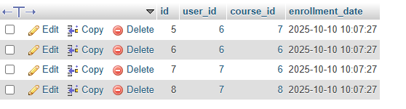

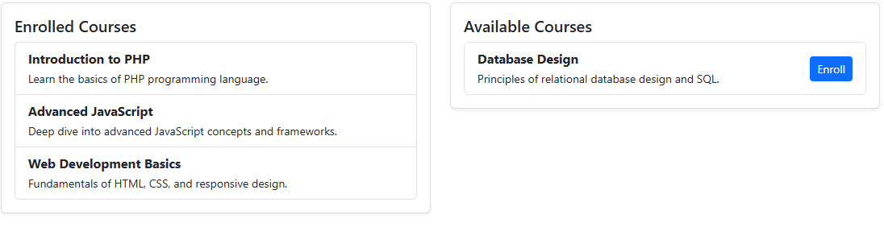

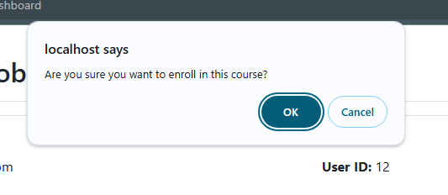

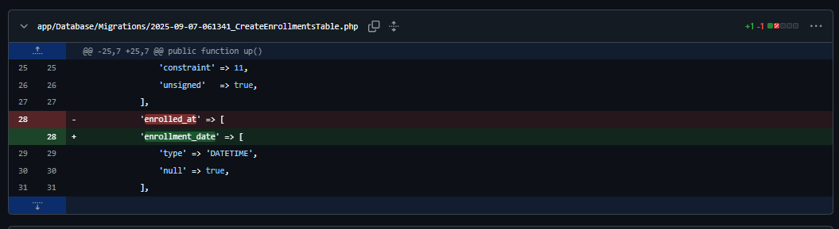

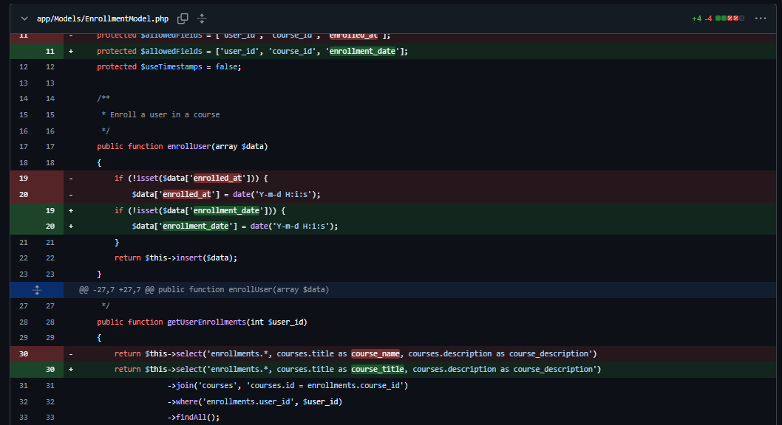

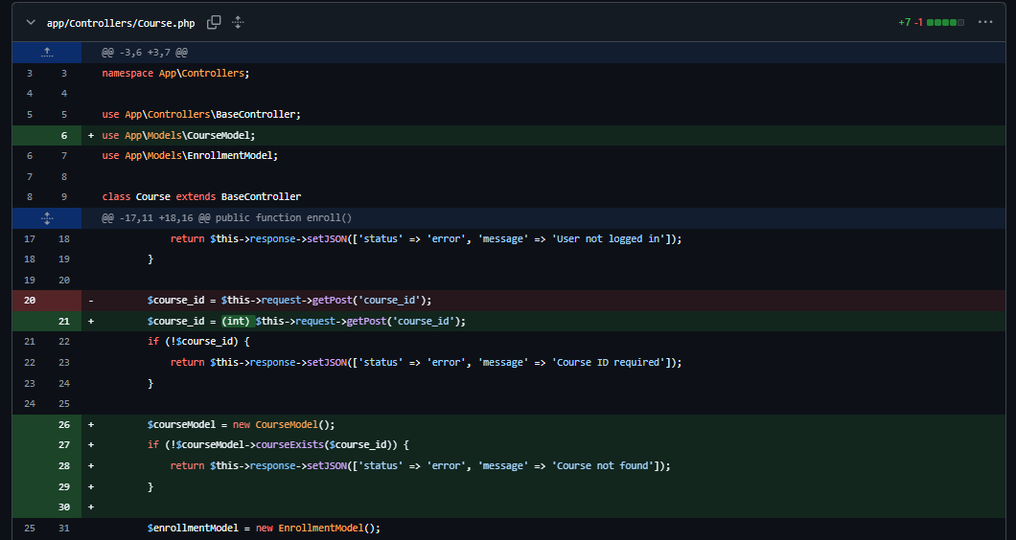

**Conclusion**system effectively implements a many-to-many relationship between users and courses, ensuring data integrity through validation checks and providing a seamless user experience via AJAX enrollment with real-time dashboard updates.