DevOps Notes 2
Docker Insallaton & Docker commands 2
Docker Installation:a 2
Basic Commands 2
Images 2
Volumes 5
Networking 5
Containers 5
Eg:1 Mounting a Local Directory 7
Eg:2 Mounting a File 7
Eg:3 Using Docker Volumes 7
Logs & Monitoring 8
Commit Commands 8
Logs Comamnds 8
DockerFiles 9
Docker-Compose Installation: 12
Docker Compose Commands 13
Practise: docker-compose.yml 16
Example1: ubuntu container 17
Example2: ubuntu container with volumes 17
Example 3: Volume managed by docker 18
Example 4: with network and volumes on composefile 18
Docker Swarm 20

DevOps Notes

Docker Insallaton & Docker commands

Docker Installation:
Installing Docker on Amazon Linux (Amazon Linux 2 or Amazon Linux 2023, ….)
- #sudo yum update -y
- #sudo yum install docker -y
- #service docker status
- #systemctl status docker
- #service docker start
- #systemctl start docker

Basic Commands
- #docker --version → Check Docker version
- #docker -v → Check Docker version
- #docker info → Display system-wide information
- #docker help → Show help for Docker commands
- #docker login → login to docker hub account

Images
- #docker images → List all images
- #docker image ls → List all images
- #docker pull <Image_Name>:<Tag> → Download an image from Docker Hub
Eg: #docker pull nginx:latest
Eg: #docker pull ubuntu:20.04
- #docker history <Image_Name>:<Tag> → Shows layer history with size and command
- #docker inspect <Image_Name>:<Tag> → Detailed JSON metadata, including layers
- #docker build -t <Image Name>:<Tag> . → Build image from Dockerfile
Eg: #docker build -t yndurgarao1/image1:0.1 .
.(dot) ==> Represents current working directory where Docker file present
-t ==> Tag image with Image Name:tag
- #docker build -f <Docker_File_Name> -t <Image_Name>:<Tag> .
Eg: #docker build -f Dockerfile1 -t yndurgarao1/myimage:0.1 .
-f Dockerfile1 → Specifies the Docker file to use. By default, Docker looks for Dockerfile, but here you’re explicitly pointing to Dockerfile1
-t yndurgarao1/myimage:0.1 → Tags the image with a name (yndurgarao1/image01) and version (0.1).
yndurgarao1 → it is the repository/name space (your Docker Hub username)
myimage → t is the image name.
0.1 → it is the tag (version)
- #docker build --no-cache -t <Image_Name>:<Tag> .
--no-cache:
Ignores all cached layers and rebuilds everything fresh.
Useful when debugging Dockerfile changes or ensuring you’re not reusing stale layers.
- #docker build --pull -t <Image_Name>:<Tag> .
Pull ==. Always pull latest base image
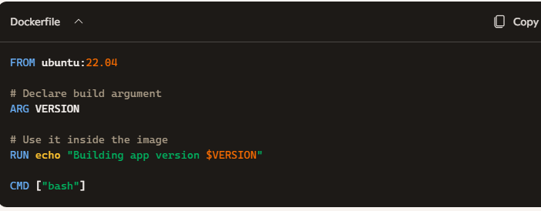
- #docker build --build-arg VERION=1.0 -t <Image_Name>:<tag> .

- #docker build <Repo_URL>#<Branch> -t <Image_Name>:<Tag>
#branch:dir → optional fragment specifying:
branch → which branch to use (e.g., main, dev).
dir → subdirectory inside the repo containing the Dockerfile.
Eg: #docker build https://github.com/yndurgarao1/docker_ynd.git#main -t myimage466:0.1
Repo URL
Branch name
Eg: #docker build https://github.com/yndurgarao1/docker_ynd.git#docker:Docker/Docker_File -t image_folder:0.1

Docker file path
- #docker rmi <Image Name>:<tag> → Remove an image
Eg: #docker rmi ubuntu:20.04
Eg: #docker rmi nginx
- #docker rmi $(docker images -q) → To remove unused images
docker images -q → lists all image IDs on the host (quiet mode).
$(...) → command substitution; passes those IDs as arguments.
- #docker push <Image_Name>:<Tag>
Eg: #docker push my_image:0.1

Volumes
- #docker volume ls → List volumes
- #docker volume create <Volume_Name> → Create a volume
Eg: #docker volume create volume1
- #docker volume inspect <Volume_Name> → Inspect volume details
Eg: #docker volume inspect volume1
- #docker volume rm <Volume_Name> → Remove a volume
Eg: #docker volume rm volume1
- #docker volume prune
Removes all dangling volumes (volumes not attached to any container).
Prompts for confirmation unless you add -f (force).

Networking
Bridge network → default, single‑host communication.
Overlay network → multi‑host, used in Swarm.
- #docker network ls → List networks
- #docker network create <Network Name> → Create a new network
Eg: #docker network create Network1
- #docker network inspect <Network Name> → Inspect network details
Eg: #docker network inspect Network1
- #docker network rm <Network Name> → Remove a network
Eg: #docker network rm network1
- #docker network prune → removes unused network

Containers
- #docker ps → List running containers
- #docker ps -a → List all containers (including stopped)
- #docker run hello-world
docker run → starts a new container.
hello-world → the image name. If it’s not already on your system, Docker will automatically pull it from Docker Hub.
- #docker run -it <Image Name> /bin/bash → Run container interactively
Eg: #docker run -it nginx /bin/bash
- #docker start <Container_Name or Container_ID> → Start a stopped container
- #docker stop <Container_Name or Container_ID> → Stop a running container
- #docker pause <Container_Name or Container_ID> → Pause the running container
- #docker unpause <Container_Name or Container_ID> → Unpause the paused container
- #docker rm <Container_Name or Container_ID> → Remove the stopped container
- #docker rm $(docker ps -aq) → Removes all stopped containers

- #docker run -dit --name <Container name> <Image_Name>:<tag>
-d (detached mode) → Runs the container in the background. You won’t see logs directly in your terminal, but the container keeps running.
-i (interactive mode) → Keeps STDIN open, even if not attached. Useful when you want to interact with the container later.
-t (pseudo-TTY) → Allocates a terminal inside the container. This makes it possible to run commands interactively.
--name <Container name> → Assigns a custom name to the container.
<Image name>:<tag> → Specifies the image and version (tag) to use.
Eg: #docker run -dit --name my_container ubuntu:20.04
- #docker run -dit --name <Container Name> -p <Host Port>:<Container Port> <Image_Name>:<Tag>
-p Maps a port on your host machine to a port inside the container.
Host Port: The port you’ll use on your local machine.
Container Port The port the application inside the container listens on.
- #docker run -dit --name <Cont_Name> -v <Host Path>:<Cont_Path> <Image_name>:<Tag>
Cont Container
-v Mounts a directory or file from your host machine into the container.
Host Path Path on your local machine.
Cont_Path Path inside the container where it will be accessible.
- #docker run --rm alpine echo "Hello Kadali" ==> Run and auto‑remove after execution

Eg:1 Mounting a Local Directory
- #docker run -dit --name my_nginx -p 8080:80 -v /home/user/html:/usr/share/nginx/html nginx:latest
Maps host port 8080 → container port 80.
Mounts the local directory /home/user/html into the container at /usr/share/nginx/html.
Any changes you make in /home/user/html on your host will reflect inside the container.

Eg:2 Mounting a File
- #docker run -dit --name my_app -v /home/user/config.json:/app/config.json my_image:latest
Mounts a single file config.json from the host into the container at /app/config.json

Eg:3 Using Docker Volumes
Instead of host paths, you can use named volumes:
- #docker run -dit --name my_db -v my_volume:/var/lib/mysql mysql:8.0
Creates/uses a Docker-managed volume named my_volume.
Mounts it into the container at /var/lib/mysql for persistent database storage.
Why Use Volumes?
- Persistence: Data survives container restarts/removals.
- Sharing: Multiple containers can share the same data.
- Flexibility: Easily swap configs or code without rebuilding images.
- #docker run hello-world
hello-world: A very small Docker image provided by Docker Hub. Its only job is to print a message confirming that Docker is functioning
docker run: Creates and starts a new container
- #docker exec -it <container name> /bin/bash
docker exec: Executes a command inside an already running container.
-i: Keeps STDIN open (interactive).
-t: llocates a pseudo-terminal (TTY).
/bin/bash The command to run inside the container. In this case, it starts a Bash shell.
- #docker run -dit --name cont1 --network ynd_network -v /home/ec2-user/durga:/renuka -p 8866:80 nginx:latest

Logs & Monitoring
- #docker logs <Container_Name or Container_ID> → View container logs
- #docker logs -f <Container_Name or Container_ID> → To view logs
- #docker logs -t <Container_Name or Container_ID> → to view logs with time stamp
- #docker logs --tail 100 <Container_Name or Container_ID>
- #docker logs --since 10m <Container_Name or Container_ID>
- #docker logs --until 2026-04-23T08:00:00 <Container_Name or Container_ID>
- #docker stats <Container_Name or Container_ID> → Show resource usage of containers
- #docker inspect <Container_Name or Container_ID> → Detailed info about container
- #docker stats → to see real time container statitics
- #docker stats --no-stream
- #docker top <Container_Name Or ID>

Commit Commands
- #docker commit <Container Name> <New_Image_name>:<Tag>
- #docker commit -a <author name> -m <commt message> <Container Name> <New Image Name>:<Tag>

Logs Comamnds
- # docker logs -f my_nginx
-f Follow logs in real-time (like tail -f).
- #docker logs --tail 50 my_nginx
--tail 50 Show only the last N lines
- #docker logs -t my_nginx
-t Show timestamps with log entries.
- #docker stats <Container Name>
Shows stats only for the container named.
- #docker stats
shows live resource usage for all running containers.
- #docker inspect <Image Name>
- #docker inspect <Container_name>
- #docker inspect volume <Volume_Name>
- #docker exec -it <container name> /bin/bash
docker exec Executes a command inside an already running container.
-i → Keeps STDIN open (interactive).
-t → Allocates a pseudo-terminal (TTY).
<container name> → The name or ID of the container you want to access.
/bin/bash → Starts the Bash shell inside the container.

- #docker run -dit --name cont1 --network network1 ubuntu:latest
docker run → Starts a new container.
-dit → Runs in detached mode (-d),
keeps STDIN open (-i),
and allocates a terminal (- t).
--name cont1 → Names the container cont1.
-network network1 → Connects the container to a user-defined Docker network called network1.
ubuntu:latest → Uses the latest Ubuntu image from Docker Hub

DockerFiles
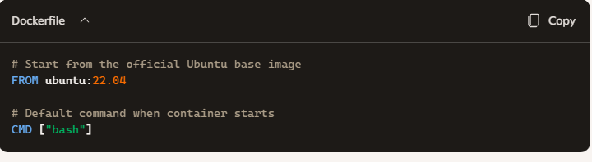

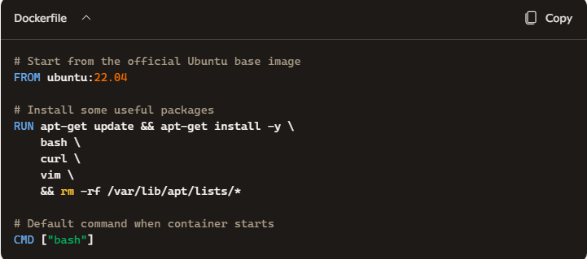

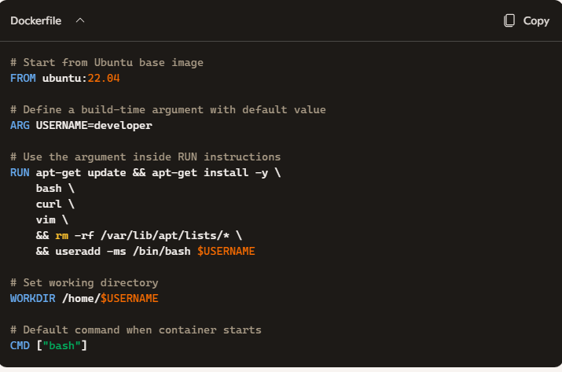
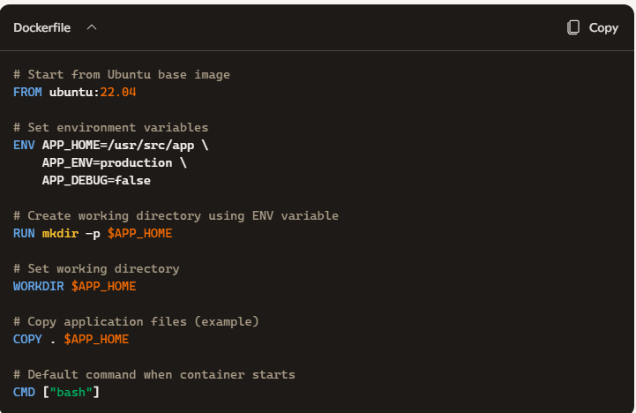

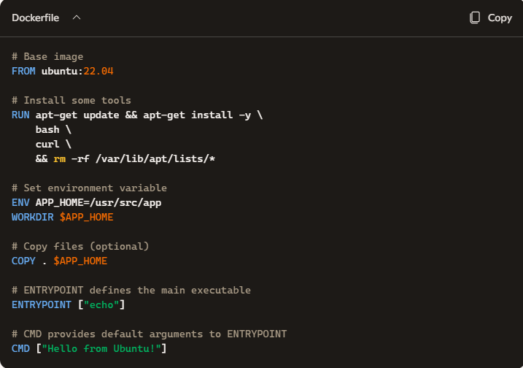

Docker-Compose Installation:
- Download the latest binary:
# sudo curl -L "https://github.com/docker/compose/releases/download/v2.27.0/docker-compose-$(uname -s)-$(uname -m)" -o /usr/local/bin/docker-compose
- Apply executable permissions:
#sudo chmod +x /usr/local/bin/docker-compose
- Verify:
#docker-compose –version

Docker Compose Commands
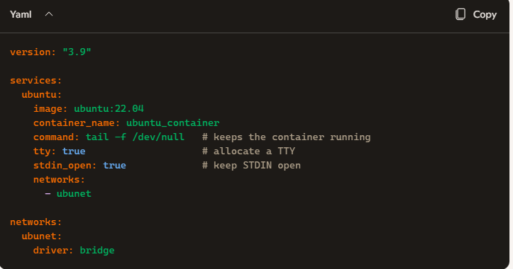
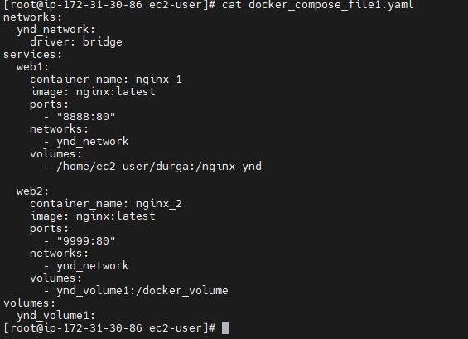

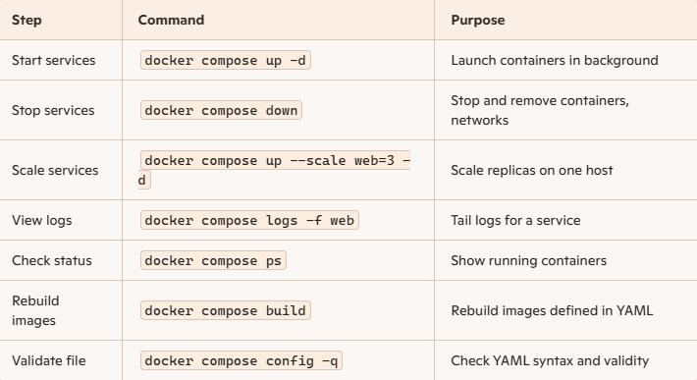
- #docker-compose config --services ==> list down the services mentioned in docker-compose.yaml file
- #docker-compose up -d
docker-compose → Uses the docker-compose.yml file in the current directory to define services, networks, and volumes.
up → Builds, (re)creates, starts, and attaches to containers defined in the Compose file.
-d (detached mode) → Runs containers in the background, freeing your terminal.
- #docker-compose down
  - Stops containers defined in docker-compose.yml.
  - Removes containers, networks, and default volumes created by docker-compose up.
  - Leaves images intact (unless you specify otherwise).
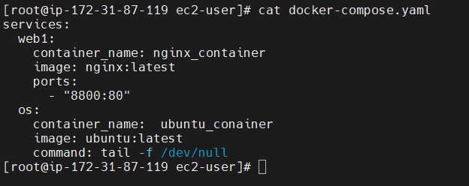
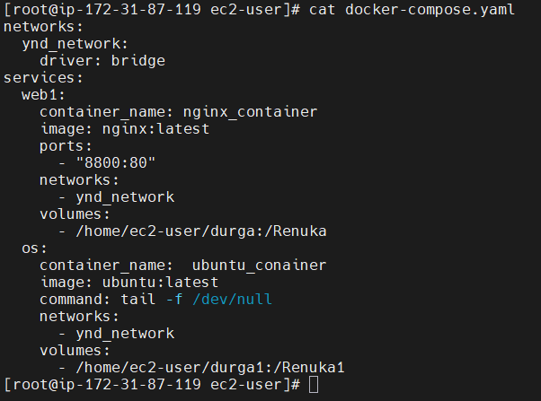
- #docker-compose up -d <New_Service_Name> ==> Modified yaml on new service
- #docker-compose ps → List running cotainers of docker-compose.yaml
- #docker-compose ps <Service_name>
- #docker-compose stop
- #docker-compose restart
- #docker-compose logs
- #docker-compose pause
- #docker-compose unpause
- #docker-compose ls

Practise: docker-compose.yml
[root@ip-172-31-84-120 ec2-user]# cat docker-compose.yaml
networks:
ynd_network:
driver: bridge
services:
web1:
container_name: nginx_container
image: nginx:latest
networks:
- ynd_network
ports:
- "8000:80"
volumes:
- /home/ec2-user/durga:/ynd
ubuntu_OS:
container_name: ubuntu_container
image: ubuntu:latest
command: tail -f /dev/null # keeps the container running
tty: true # allocate a TTY
stdin_open: true # keep STDIN open
networks:
- ynd_network
volumes:
- /home/ec2-user/durga:/ynd

Example1: ubuntu container
#cat docker-compose.yml
services:
ubuntu:
image: ubuntu:22.04
container_name: ubuntu_container
command: sleep infinity # Keeps container alive
tty: true # Allows interactive terminal sessions
restart: always

Explanation
image: ubuntu:22.04 → Pulls the official Ubuntu 22.04 image.
command: sleep infinity → Prevents the container from exiting immediately.
tty: true → Lets you attach an interactive shell (docker compose exec ubuntu bash).
restart: always → Ensures the container restarts automatically if stopped.

# docker-compose config –services Prints the names of all services defined in the Compose file
==================================================================

Example2: ubuntu container with volumes
# cat docker-compose-example1.yml
services:
Base_Image:
image: ubuntu:latest
container_name: Ubuntu_Container
command: sleep infinity # Keeps container alive
tty: true # Allows interactive terminal sessions
restart: always
volumes:
- /root/durga:/ynd

# docker-compose -f docker-compose-example1.yml up -d
Explanation:
-f docker-compose-example1.yml → Use a specific Compose file named docker-compose- example1.yml instead of the default docker-compose.yml.

Example 3: Volume managed by docker
services:
ubuntu:
image: ubuntu:22.04
container_name: ubuntu_volume_example
command: tail -f /dev/null # keeps container running
volumes:
- mydata:/app/data # named volume → container path
volumes:
mydata: # Docker manages this volume
==================================================================

Example 4: with network and volumes on composefile
[root@ip-172-31-81-229 ec2-user]# cat docker-compose.yml
networks:
ynd_network:
driver: bridge
volumes:
ynd_volume:
services:
web:
container_name: nginx_container
image: nginx:latest
networks:
- ynd_network
ports:
- "6677:80"
volumes:
- ynd_volume:/durga
==================================================================
- #docker-compose up -d --build <Service_Name> ==> to remodify existing service
- #docker-compose config --services ==> to list services under docker-compose.yaml file
- #docker-compose down ==> to stop and remove containers under docker-compose.yaml file
- #docker-compose stop <Service_Name> ==> to stop specific service
- #docker-compose rm <Service_Name> ==> to remove specific service container in docker-compose.yaml
- # docker-compose -f docker-compose-example1.yml ps list running containers
- # docker-compose -f docker-compose-example1.yml logs -f View logs
- # docker-compose -f docker-compose-example1.yml down Stop and clean up
- # docker-compose -f docker-compose-example1.yml up -d --build if you’ve changed Dockerfiles or dependencies, use:
- # docker-compose down -v → Also remove volumes.
- # docker-compose down --rmi all → Remove images built by Compose
- # docker-compose logs → View logs from all services.
- # docker-compose logs -f → Follow logs live.
- # docker-compose start → Start existing containers.
- # docker-compose stop → Stop services without removing containers.
- # docker-compose restart → Restart services.
- # docker-compose run <service> <command> → Run a one-off command in a new container.
- # docker-compose build → Build or rebuild service images.
- # docker-compose pull → Pull service images from registry.
- # docker-compose push → Push built images to registry.
- # docker-compose images → List images used by services.

Docker Swarm
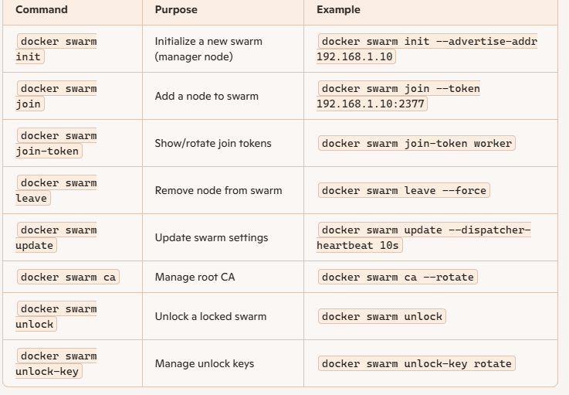
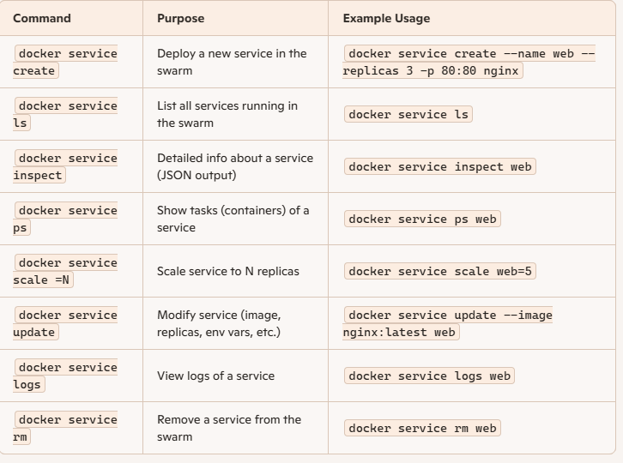
- #docker node ls ==> It lists all nodes participating in the swarm, showing their role, availability, and status.
- #docker swarm join-token worker ==> to get the worker token
- #docker swarm join-token manager ==> to get manager token
- #docker swarm leave ==> to remove a node from a Docker Swarm cluster. [in worker node we need to execute]
- #docker node demote <node_id> ==> Node becomes a worker and no longer participates in Raft [need to be executed in manager node ]
- #docker node rm <node_id> ==> to remove the worker node [we need to execute in manager node]
- #docker service create --name <Service_Name> --replicas <Number> -p Container_Port: Actual_Port <Image_Name>:<Tag>
Eg: #docker service create --name my_service --replicas 4 -p 8800:80 nginx:latest
docker service create → Deploys a new service in the swarm.
--name nginx_service → Names the service.
--replicas 5 → Ensures 5 identical containers (tasks) are running across the swarm cluster.
-p 8080:80 → Maps host port 8080 to container port 80.
nginx:latest → Uses the official Nginx image.
- #docker service ls ==> to list the service name
- #docker service ps <Service_name> ==> to list running services information
- #docker service scale <Service_Name>=<Number> ==> to scale up or down
Eg: #docker service scale my_service=7
- #docker service inspect <Service_Name> ==> to get more info aboyt service
- #docker service update --image nginx:alpine <Service_name> ==> to update exiting service by latest image
- #docker service rm <Service_name> ==> to remove the service
- #docker node promote <node_id> ==> to promote as manager
- #docker node demote <node_id> ==> to deprmote as worker from manager or reachable
- #docker service update --rollback <service_name> ==> it will roll back to previous image
- #docker service update --force <Service_Name> ==>redeploys without spec change.

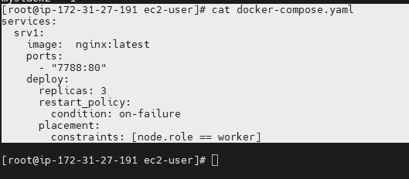

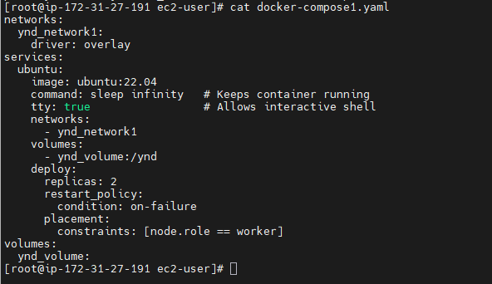

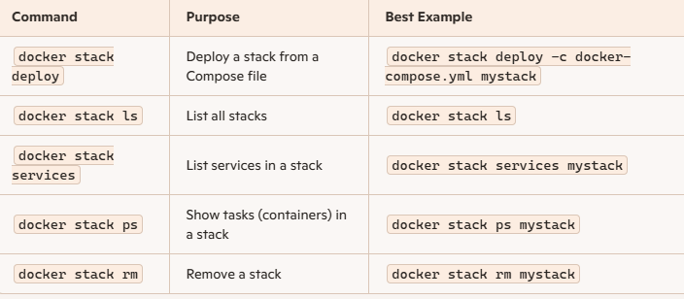

- #docker stack deploy -c docker-compose.yaml stack1
docker stack deploy → Deploys a stack (multi‑service application) into Docker Swarm.
-c docker-compose.yml → Specifies the Compose file that defines services
mystack → The name of the stack; all services will be grouped under this name.
- #docker stack ls ==> it will display the information about stacks present
- #docker stack services <Stack_Name>
- #docker stack ps <Stack _Name>
- #docker stack rm mystack
- #docker service scale <stack_name>_<Service_name>=<Scaling number>
Eg: #docker service scale mystack1_srv1=6

