Kubernetes

Pod Creation:
#kubectl run <Pod_Name> --image <Image_Name>:<Tag>
#kubectl get pods lists Pods in the current Kubernetes namespace.
#kubectl get pods --output wide
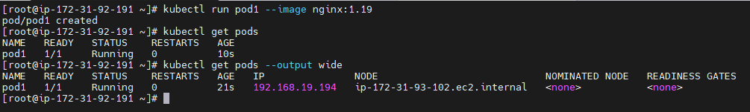

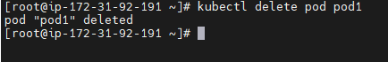
#kubectl delete pod <Pod_Name> To delete the pod
#kubectl run pod1 –image nginx:1.19 --port 80
#kubectl describe pod <Pod_name>

Pod:
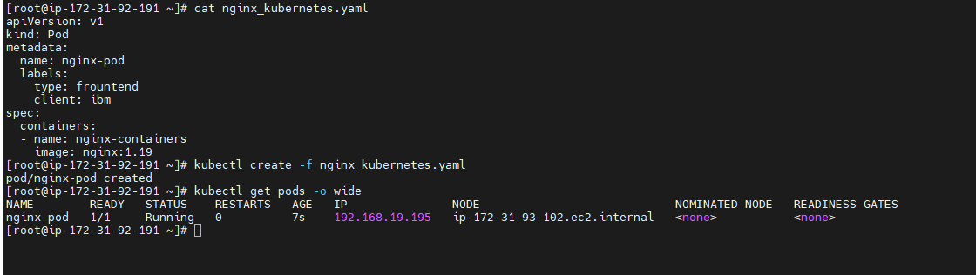

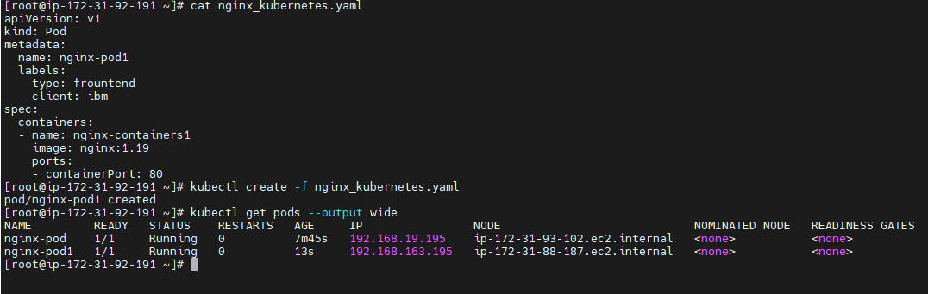

ReplicaSet
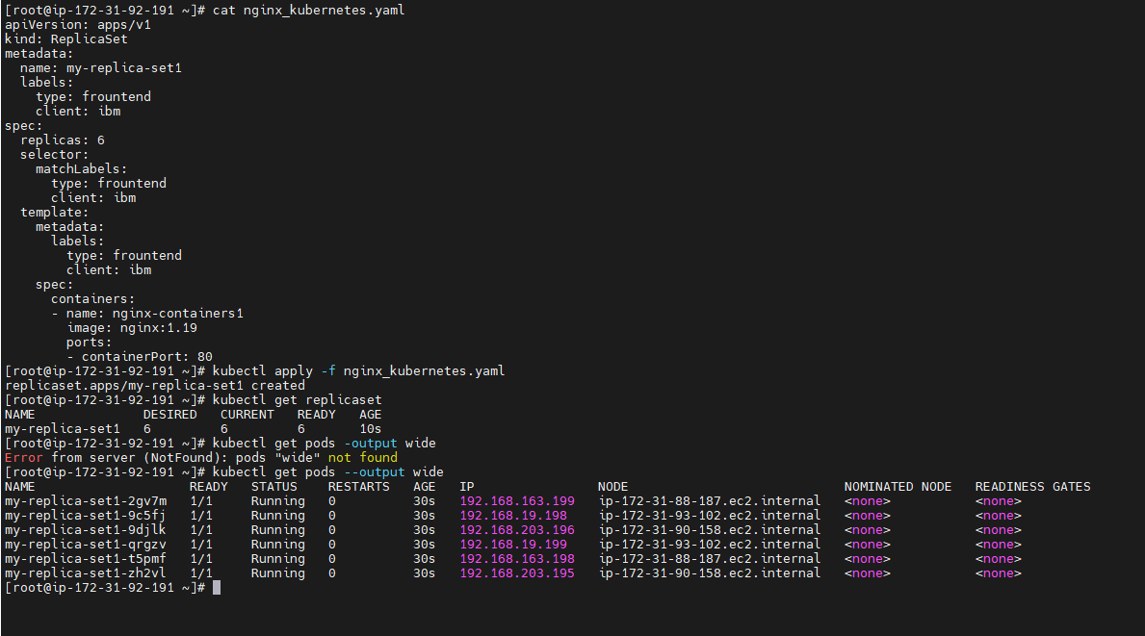
To scale pods
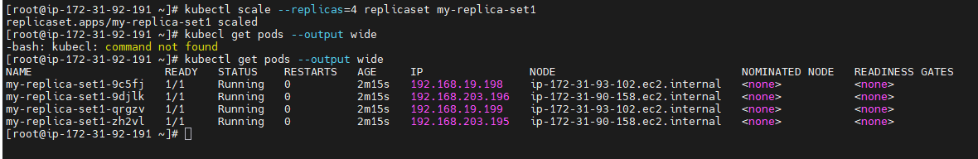

#kubectl edit replicaset <replica_set_name>

Deployment:
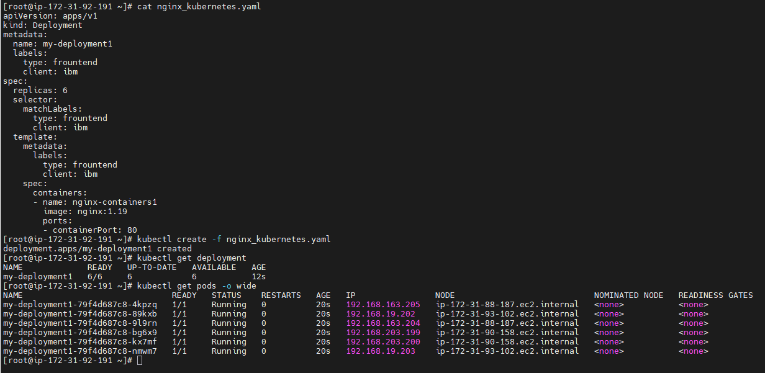
Auto Scaling:
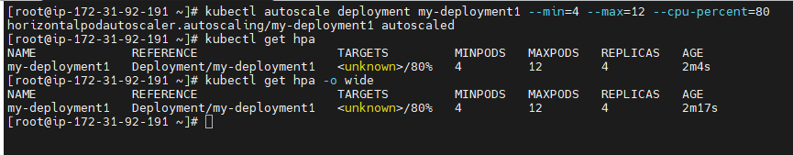

Update image
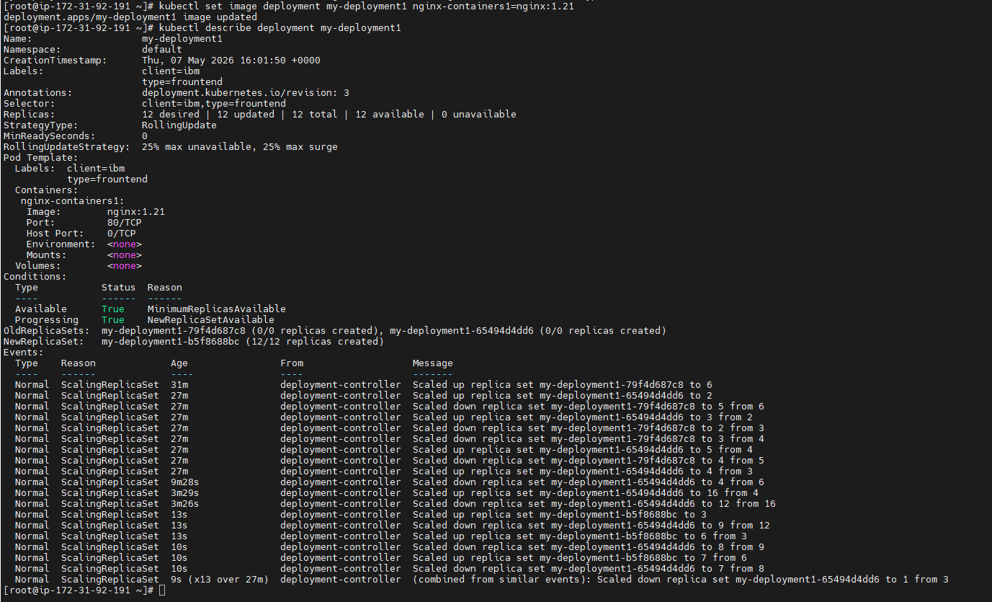
Roll out to Previous image:
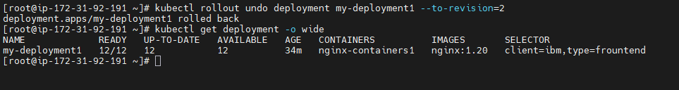
Difference between Replica Set and Deployment under kind
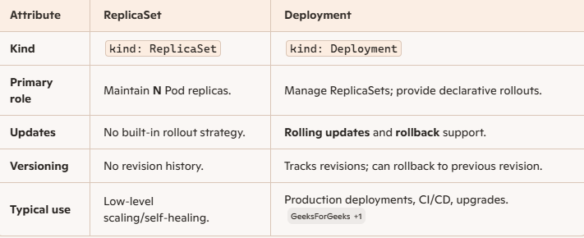

Service:
