Docker Notes 3
Virtualization 3
Contanerization: 3
Docker 3
Docker Installation: 3
Basic Docker Commands 3
Docker Images 4
Docker Volumes 8
Docker Networking 8
Containers 9
Eg:1 Mounting a Local Directory 11
Eg:2 Mounting a File 12
Eg:3 Using Docker Volumes 12
Why Use Volumes? 12
To Login to Container: 12
Docker Logs & Monitoring 13
To Commit Docker container changes as new image 13
Inspect Docker resources 13
DockerFiles 14
Example 1: Ubuntu Container 14
Example 2: Using WORKDIR and COPY 14
Example 3: Environment Variables 14
Example 4: ENTRYPOINT vs CMD 14
DockerFile Commands 15
Docker-Compose 16
Docker-Compose Installation 16
Docker-Compose File-1 16
Docker-Compose File-2 17
Docker-Compose Commands 18
Docker-Compose File3 19
Docker-Compose-File4: ubuntu container with volumes 19
Docker-Compose-File5: Volume managed by docker 20
Docker-Compose-File6: with network and volumes on composefile 20
Docker Swarm 22
Docker Swarm - yaml File 24

Docker Notes

Virtualization
It is a technology that creates virtual versions of the computer resources such as hardware resources, operating system, storage devices, network resources. It is likely to create a software based replica of a physical machine allowing you t run multiple isolated environments on the same hardware or across a distributes system.

Contanerization:
It is a light-weight form of virtualization that allows to run application and their dependencies in isolated containers. Each container shares the same operating system kernel but it is isolated from other containers.

Docker
Docker is an open-source platform that lets you build, package, and run applications inside containers. Containers are lightweight, portable, and ensure your app runs the same way across different environments

Docker Installation:
Installing Docker on Amazon Linux (Amazon Linux 2 or Amazon Linux 2023, ….)
- #sudo yum update -y
- #sudo yum install docker -y ==> Docker installation
- #service docker status ==> Check Docker Service s running or not
- #systemctl status docker
- #service docker start
- #systemctl start docker

Basic Docker Commands
- #docker --version ==> Check Docker version
- #docker -v ==> Check Docker version
- #docker info ==> Display system-wide information
- #docker help ==> Show help for Docker commands
- #docker login ==> login to docker hub account

Docker Images
- #docker images ==> To list images present
- #docker image ls ==> To list images present
- #docker pull <Image_Name>:<Tag> ==> Download image from Docker Hub
Eg: #docker pull nginx:latest
Eg: #docker pull ubuntu:20.04
- #docker history <Image_Name>:<Tag> ==> Shows layer history with size
- #docker inspect <Image_Name>:<Tag> ==> Detailed JSON metadata
- #docker build -t <Image Name>:<Tag> . ==> To build image from Docker file
Eg: #docker build -t yndurgarao1/image1:0.1 .
Explanation:
.(dot) ==> Represents current working directory where Docker file present
-t ==> Tag image with Image Name:tag
- #docker build -f <Docker_File_Name> -t <Image_Name>:<Tag> .
Eg: #docker build -f Dockerfile1 -t yndurgarao1/myimage:0.1 .
Explanation:
-f Dockerfile1 ==> Specifies the Docker file to use. By default, Docker looks for Docker file, but here you’re explicitly pointing to Dockerfile1
-t yndurgarao1/myimage:0.1 ==> Tags the image with a name and version
yndurgarao1 ==> it is the repository/name space (your Docker Hub username)
myimage → image name
0.1 → image tag version

- #docker build --no-cache -t <Image_Name>:<Tag> .
Explanation:
--no-cache ==> Ignores all cached layers and rebuilds everything fresh. Useful when debugging Dockerfile changes or ensuring you’re not reusing stale layers.
- Docker File to check latest base image version
DockerFile
FROM ubuntu:22.04
RUN apt-get update && apt-get install -y curl
CMD ["bash"]

#docker build --pull -t <Image_Name>:<Tag> .
Explanation
docker build ==> Builds a Docker image from a Dockerfile.
--pull ==> Forces Docker to always check and pull the latest version of the base image (e.g., ubuntu:22.04) even if a cached copy exists locally.
-t <Image_Name>:<Tag> ==> Tags the resulting image with a name and version. Example: myapp:1.0.
. ==> Build context is the current directory (where the Docker file and related files are located)

- Dockerfile example using ARG for build‑time arguments, which you can pass when running docker build
DockerFile
FROM ubuntu:22.04 # Base image
ARG APP_VERSION # Declare build-time arguments
ARG APP_ENV=production # default value
RUN echo "Application Version: $APP_VERSION" # Use ARG inside build steps
RUN echo "Environment: $APP_ENV" # Use ARG inside build steps
ENV VERSION=$APP_VERSION # Promote ARG to ENV if needed at runtime
ENV ENVIRONMENT=$APP_ENV # Promote ARG to ENV if needed at runtime
CMD ["bash"] # Example command

Pass arguments explicitly
#docker build --build-arg APP_VERSION=1.0 --build-arg APP_ENV=dev -t myapp:1.0 .
# Use default for APP_ENV
docker build --build-arg APP_VERSION=2.0 -t myapp:2.0 .

- #docker build <Repo_URL>#<Branch> -t <Image_Name>:<Tag>
Explanation:
branch:dir ==> optional fragment specifying
branch ==> which branch to use (e.g., main, dev).
Dir ==> subdirectory inside the repo containing the Dockerfile.
Eg:1 #docker build https://github.com/yndurgarao1/docker_ynd.git#main -t myimage466:0.1
Repo_URL: https://github.com/yndurgarao1/docker_ynd.git
Branch: main
Eg:2 #docker build https://github.com/yndurgarao1/docker_ynd.git#docker:Docker/Docker_File -t image_folder:0.1
Docker/Docker_File ==> folder in the git path for DockerFile
- #docker rmi <Image Name>:<tag> ==> Remove image
Eg: #docker rmi ubuntu:20.04
Eg: #docker rmi nginx
- #docker rmi $(docker images -q) ==> To remove unused images
docker images -q ==> lists all image IDs on the host (quiet mode).
- #docker push <Image_Name>:<Tag> ==> To push image to DockerHub Regristry
Eg: #docker push my_image:0.1

Docker Volumes
- #docker volume ls ==> To list volumes
- #docker volume create <Volume_Name> ==> To create volume
Eg: #docker volume create volume1
- #docker volume inspect <Volume_Name> ==> Inspect volume details
Eg: #docker volume inspect volume1
- #docker volume rm <Volume_Name> ==> To remove volume
Eg: #docker volume rm volume1
- #docker volume prune
Removes all dangling volumes (volumes not attached to any container).
Prompts for confirmation unless you add -f (force).

Docker Networking
● Bridge network ==> default, single host communication.
● Overlay network ==> multi-host network used in Docker swarm.
- #docker network ls ==> To list networks
- #docker network create <Network Name> ==> To create new network
Eg: #docker network create Network1
- #docker network inspect <Network Name> ==> To inspect network details
Eg: #docker network inspect Network1
- #docker network rm <Network Name> ==> To remove network
Eg: #docker network rm network1
- #docker network prune ==> To removes unused network

Containers
- #docker ps ==> To list running containers
- #docker ps -a ==> To list all containers (including stopped, paused, running)
- #docker run hello-world ==> To create docker container
Explanation:
docker run ==> To starts a new container.
hello-world ==> Image name. If it’s not already on your system, Docker will automatically pull it from Docker Hub.
- #docker run -it <Image Name> /bin/bash ==> Run container interactively
Eg: #docker run -it nginx /bin/bash
Note: Cont ==> Container
- #docker start <Cont_Name or Cont_ID> ==> To start a stopped container
- #docker stop <Contr_Name or Cont_ID> ==> To stop a running container
- #docker pause <Cont_Name or Cont_ID> ==> To Pause running container
- #docker unpause <Cont_Name or Cont_ID>==> Unpause the paused container
- #docker rm <Cont_Name or Cont_ID> ==> To remove the stopped container
- #docker rm $(docker ps -aq) ==> Removes all stopped containers

- #docker run -dit --name <Container name> <Image_Name>:<tag>
Explanation:
-d (detached mode) ==> Runs the container in the background. You won’t see logs directly in your terminal, but the container keeps running.
-i (interactive mode) ==> Keeps STDIN open, even if not attached. Useful when you want to interact with the container later.
-t (pseudo-TTY) ==> Allocates a terminal inside the container. This makes it possible to run commands interactively.
--name <Container name> ==> Assigns a custom name to the container.
<Image name>:<tag> ==> Specifies the image and version (tag) to use.
Eg: #docker run -dit --name my_cont ubuntu:20.04
- #docker run -dit --name <Cont_Name> -p <Host_Port>:<Cont_Port> <Image_Name>:<Tag>
Explanation:
-p ==> Maps a port on your host machine to a port inside the container.
Host_Port ==> The port you’ll use on your local machine.
Cont_Port ==> The port the application inside the container listens on.

- #docker run -dit --name <Cont_Name> -v <Host_Path>:<Cont_Path> <Image_name>:<Tag>
Explanation:
-v ==> Mounts a directory or file from your host machine into the container.
Host_Path ==> Path on your local machine.
Cont_Path ==> Path inside the container where it will be accessible.
- #docker run --rm alpine echo "Hello Kadali" ==> Run and autoremove after execution
- #docker run -dit --name cont1 --network ynd_network -v /home/ec2-user/durga:/renuka -p 8866:80 nginx:latest
- #docker run -dit --name cont1 --network network1 ubuntu:latest
Explanation:
docker run ==> Starts a new container.
-dit ==> Runs in detached mode (-d),
keeps STDIN open (-i),
and allocates a terminal (- t).
--name cont1 ==> Names the container cont1.
-network network1 ==> Connects the container to a user-defined Docker network called network1.
ubuntu:latest ==> Uses the latest Ubuntu image from Docker Hub

Eg:1 Mounting a Local Directory
- #docker run -dit --name my_nginx -p 8080:80 -v /home/user/html:/usr/share/nginx/html nginx:latest
Explanation:
- Maps host port 8080 ==> Container port 80.
- Mounts local directory /home/user/html into the container at /usr/share/nginx/html.
- Any changes you make in /home/user/html on your host will reflect inside the container.

Eg:2 Mounting a File
- #docker run -dit --name my_app -v /home/user/config.json:/app/config.json my_image:latest
- Mounts a single file config.json from the host system into the container at /app/config.json

Eg:3 Using Docker Volumes
Instead of host paths, you can use named volumes:
- #docker run -dit --name my_db -v my_volume:/var/lib/mysql mysql:8.0
- Creates or uses a Docker-managed volume named my_volume.
- Mounts it into the container at /var/lib/mysql for persistent database storage.

Why Use Volumes?
- Persistence: Data survives container restarts/removals.
- Sharing: Multiple containers can share the same data.
- Flexibility: Easily swap configs or code without rebuilding images.

To Login to Container:
- #docker exec -it <Cont_Name> /bin/bash
Explanation:
docker exec ==> Executes a command inside an already running container.
-i ==> Keeps STDIN open (interactive).
-t ==> Allocates a pseudo-terminal (TTY).
/bin/bash ==> The command to run inside the container. In this case, it starts a Bash shell.

Docker Logs & Monitoring
- #docker logs <Cont_Name or Cont_ID> ==> To view container logs
- #docker logs -f <Cont_Name or Cont_ID> ==> To view logs
- #docker logs -t <Cont_Name or Cont_ID> ==> to view logs with time stamp
- #docker logs --tail 100 <Cont_Name or Cont_ID>
- #docker logs --since 10m <Cont_Name or Cont_ID>
- #docker logs --until 2026-04-23T08:00:00 <Cont_Name or Cont_ID>
- #docker stats <Cont_Name or Cont_ID> ==> Show resource usage of containers
- #docker inspect <Cont_Name or Cont_ID> ==> Detailed info about container
- #docker stats ==> to see real time container statitics
- #docker stats --no-stream
- #docker top <Cont_Name Or Cont_ID>

To Commit Docker container changes as new image
I created a container and done some changes in top of that container I want to reuse that change when I am building a new container.
- #docker commit <Cont_Name> <New_Image_name>:<Tag>
- #docker commit -a <author name> -m <commt message> <Container Name> <New Image_Name>:<Tag>

Inspect Docker resources
- #docker inspect <Cont_Name> ==> To Inspect docker container
- #docker inspect <Image_Name> ==> To Inspect docker image
- #docker inspect <Volume_Name> ==> To inspect docker volume
- #docker inspect <Network_Name> ==> To inspect docker network

DockerFiles

Example 1: Ubuntu Container
FROM ubuntu:20.04 # Start from Ubuntu base image
RUN apt-get update && apt-get install -y curl # Run update and install curl
CMD ["echo", "Hello from Ubuntu container!"] # Default command

Example 2: Using WORKDIR and COPY
FROM python:3.9 # Start from Python base image
WORKDIR /app # Set working directory
COPY . /app # Copy local files into container
RUN pip install -r requirements.txt # Install dependencies
CMD ["python", "app.py"] # Run application

Example 3: Environment Variables
FROM node:16
WORKDIR /usr/src/app
COPY package*.json ./
RUN npm install
COPY . .
ENV PORT=3000 # Set environment variable
EXPOSE 3000
CMD ["node", "server.js"]

Example 4: ENTRYPOINT vs CMD
FROM alpine:latest
RUN apk add --no-cache curl # Install curl
ENTRYPOINT ["curl"] # Define entrypoint
CMD ["--help"] # CMD provides default arguments

DockerFile Commands
- FROM ==> base image
- RUN ==> execute commands during build
- WORKDIR ==> set working directory
- COPY ==> copy files into container
- ENV ==> set environment variables
- CMD ==> default command
- ENTRYPOINT ==> fixed executable
Difference Between CMD and ENTRYPOINT:
The key difference is that CMD provides default commands or arguments that can be fully overridden at runtime, while ENTRYPOINT defines the main executable that always runs, with runtime arguments only appended.The key difference is that CMD provides default commands or arguments that can be fully overridden at runtime, while ENTRYPOINT defines the main executable that always runs, with runtime arguments only appended.
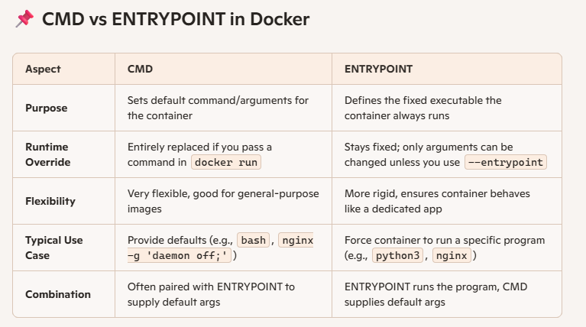

Docker-Compose
Docker Compose is a tool for defining and running multi-container Docker applications. Instead of manually starting containers one by one, you describe your entire stack in a YAML file (docker-compose.yml) and bring it up with a single command.

Docker-Compose Installation
- Download the latest binary:
# sudo curl -L "https://github.com/docker/compose/releases/download/v2.27.0/docker-compose-$(uname -s)-$(uname -m)" -o /usr/local/bin/docker-compose
- Apply executable permissions:
#sudo chmod +x /usr/local/bin/docker-compose
- Verify:
#docker-compose –version

Docker-Compose File-1

version: "3.9"
services:
ubuntu:
image: ubuntu:22.04
container_name: ubuntu_container
command: sleep infinity # Keeps container alive
tty: true # Allows interactive terminal sessions
restart: always

#docker-compose -f Docker-Compose.yaml up -d
Here Docker-Compose.yaml ==> Docker-Compose yaml file
image: ubuntu:22.04 ==> Pulls the official Ubuntu 22.04 image.
command: sleep infinity ==> Prevents the container from exiting immediately.
tty: true ==> Lets you attach an interactive shell (docker compose exec ubuntu bash).
restart: always ==> Ensures the container restarts automatically if stopped.

Docker-Compose File-2
services:
ubuntu:
image: ubuntu:22.04
container_name: ubuntu_service
command: sleep infinity
tty: true
volumes:
- ubuntu_data:/data # Named volume
networks:
- mynet
nginx:
image: nginx:latest
container_name: nginx_service
ports:
- "8080:80"
volumes:
- web_content:/usr/share/nginx/html # Named volume
networks:
- mynet
volumes:
ubuntu_data: # Docker-managed volume
web_content: # Docker-managed volume
networks:
mynet:
driver: bridge

#docker-compose -f Docker-Compose-File2 up -d

Docker-Compose Commands
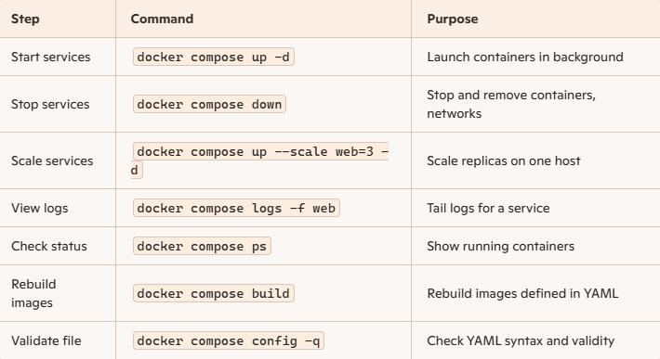
- #docker-compose config --services ==> list down the services mentioned in docker-compose.yaml file
- #docker-compose up -d
docker-compose ==> Uses the docker-compose.yml file in the current directory to define services, networks, and volumes.
up ==> Builds, (re)creates, starts, and attaches to containers defined in the Compose file.
-d (detached mode) ==> Runs containers in the background, freeing your terminal.
- #docker-compose down
  - Stops containers defined in docker-compose.yml.
  - Removes containers, networks, and default volumes created by docker-compose up.
  - Leaves images intact (unless you specify otherwise).
- #docker-compose up -d <New_Service_Name> ==> Modified yaml on new service
- #docker-compose ps ==> List running cotainers of docker-compose.yaml
- #docker-compose ps <Service_name>
- #docker-compose stop
- #docker-compose restart
- #docker-compose logs
- #docker-compose pause
- #docker-compose unpause
- #docker-compose ls

Docker-Compose File3
#cat docker-compose.yml
services:
ubuntu:
image: ubuntu:22.04
container_name: ubuntu_container
command: sleep infinity # Keeps container alive
tty: true # Allows interactive terminal sessions
restart: always

Explanation
image: ubuntu:22.04 ==> Pulls the official Ubuntu 22.04 image.
command: sleep infinity ==> Prevents the container from exiting immediately.
tty: true ==> Lets you attach an interactive shell (docker compose exec ubuntu bash).
restart: always ==> Ensures the container restarts automatically if stopped.

- # docker-compose config –services ==> Prints the names of all services defined in the Compose file

Docker-Compose-File4: ubuntu container with volumes
# cat docker-compose-example1.yml
services:
Base_Image:
image: ubuntu:latest
container_name: Ubuntu_Container
command: sleep infinity # Keeps container alive
tty: true # Allows interactive terminal sessions
restart: always
volumes:
- /root/durga:/ynd

- # docker-compose -f Docker-Compose-File4.yml up -d
Explanation:
-f docker-compose-example1.yml ==> Use a specific Compose file named Docker- Compose-File4.yml instead of the default docker-compose.yml.

Docker-Compose-File5: Volume managed by docker
services:
ubuntu:
image: ubuntu:22.04
container_name: ubuntu_volume_example
command: tail -f /dev/null # keeps container running
volumes:
- mydata:/app/data # named volume → container path
volumes:
mydata: # Docker manages this volume

Docker-Compose-File6: with network and volumes on composefile
[root@ip-172-31-81-229 ec2-user]# cat docker-compose.yml
networks:
ynd_network:
driver: bridge
volumes:
ynd_volume:
services:
web:
container_name: nginx_container
image: nginx:latest
networks:
- ynd_network
volumes:
- ynd_volume:/durga

- #docker-compose up -d --build <Service_Name> ==> to remodify existing service
- #docker-compose config --services ==> to list services under docker-compose.yaml file
- #docker-compose down ==> to stop and remove containers under docker-compose.yaml file
- #docker-compose stop <Service_Name> ==> to stop specific service
- #docker-compose rm <Service_Name> ==> to remove specific service container in docker-compose.yaml
- # docker-compose -f docker-compose-example1.yml ps ==> list running containers
- # docker-compose -f docker-compose-example1.yml logs -f ==> To View logs
- # docker-compose -f docker-compose-example1.yml down ==> Stop and clean up
- # docker-compose -f docker-compose-example1.yml up -d --build ==> if you’ve changed Dockerfiles or dependencies, use:
- # docker-compose down -v ==> Also remove volumes.
- # docker-compose down --rmi all ==> Remove images built by Compose
- # docker-compose logs ==> View logs from all services.
- # docker-compose logs -f ==> Follow logs live.
- # docker-compose start ==> Start existing containers.
- # docker-compose stop ==> Stop services without removing containers.
- # docker-compose restart ==> Restart services.
- # docker-compose run <service> <command> ==> Run a one-off command in a new container.
- # docker-compose build ==> Build or rebuild service images.
- # docker-compose pull ==> Pull service images from registry.
- # docker-compose push ==> Push built images to registry.
- # docker-compose images ==> List images used by services.

Docker Swarm
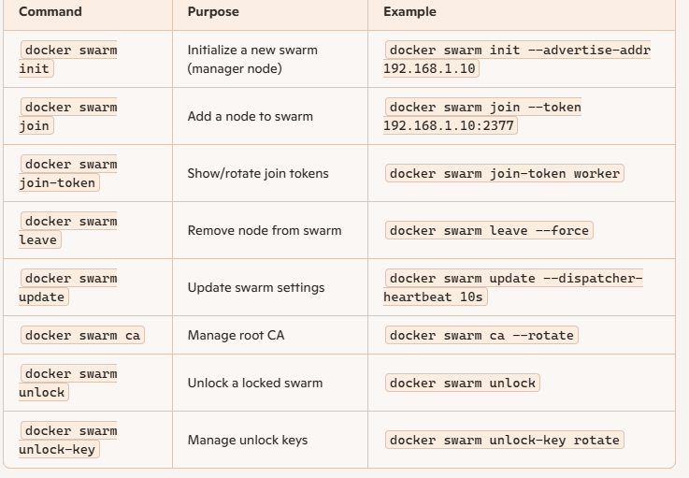
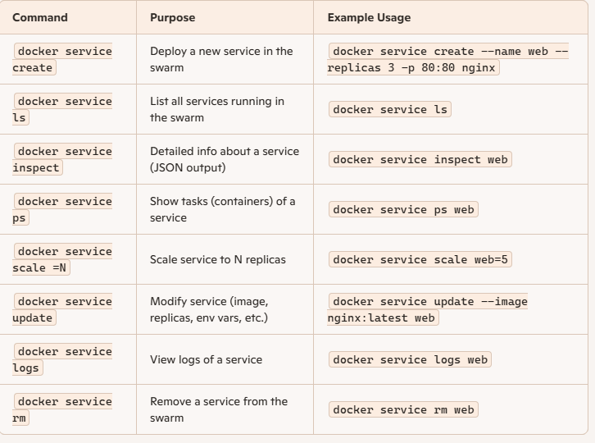
- #docker node ls ==> It lists all nodes participating in the swarm, showing their role, availability, and status.
- #docker swarm join-token worker ==> to get the worker token
- #docker swarm join-token manager ==> to get manager token
- #docker swarm leave ==> to remove a node from a Docker Swarm cluster. [in worker node we need to execute]
- #docker node demote <node_id> ==> Node becomes a worker and no longer participates in Raft [need to be executed in manager node ]
- #docker node rm <node_id> ==> to remove the worker node [we need to execute in manager node]
- #docker service create --name <Service_Name> --replicas <Number> -p Container_Port: Actual_Port <Image_Name>:<Tag>
Eg: #docker service create --name my_service --replicas 4 -p 8800:80 nginx:latest
docker service create ==> Deploys a new service in the swarm.
--name nginx_service ==> Names the service.
--replicas 5 ==> Ensures 5 identical containers (tasks) are running across the swarm cluster.
-p 8080:80 ==> Maps host port 8080 to container port 80.
nginx:latest ==> Uses the official Nginx image.
- #docker service ls ==> to list the service name
- #docker service ps <Service_name> ==> to list running services information
- #docker service scale <Service_Name>=<Number> ==> to scale up or down
Eg: #docker service scale my_service=7
- #docker service inspect <Service_Name> ==> to get more info aboyt service
- #docker service update --image nginx:alpine <Service_name> ==> to update exiting service by latest image
- #docker service rm <Service_name> ==> to remove the service
- #docker node promote <node_id> ==> to promote as manager
- #docker node demote <node_id> ==> to depromote as worker from manager or reachable
- #docker service update --rollback <service_name> ==> it will roll back to previous image
- #docker service update --force <Service_Name> ==>redeploys without spec change.

Docker Swarm - yaml File
services:
web:
image: nginx:latest
ports:
- "8080:80"
deploy:
replicas: 3
placement:
constraints: [node.role == worker]
networks:
- frontend
volumes:
- web_content:/usr/share/nginx/html
db:
image: mysql:5.7
environment:
MYSQL_ROOT_PASSWORD: example
deploy:
replicas: 1
placement:
constraints: [node.role == manager]
networks:
- backend
volumes:
- db_data:/var/lib/mysql
networks:
frontend:
driver: overlay
backend:
driver: overlay
volumes:
web_content:
db_data:

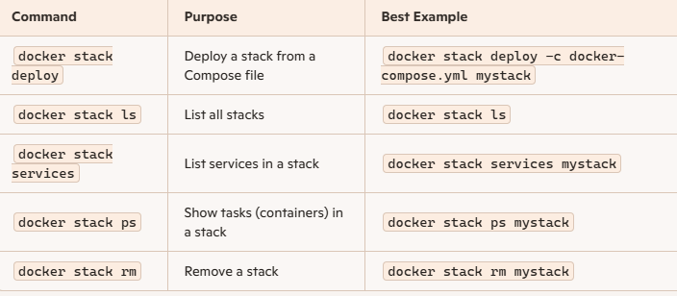

- #docker stack deploy -c docker-compose.yaml stack1
docker stack deploy ==> Deploys a stack (multi‑service application) into Docker Swarm.
-c docker-compose.yml ==> Specifies the Compose file that defines services
mystack ==> The name of the stack; all services will be grouped under this name.
- #docker stack ls ==> it will display the information about stacks present
- #docker stack services <Stack_Name>
- #docker stack ps <Stack _Name>
- #docker stack rm mystack
- #docker service scale <stack_name>_<Service_name>=<Scaling number>
Eg: #docker service scale mystack1_srv1=6

