Volumes:

EBS (Elastic Block Storage)
Before Attaching volume to EC2 Instance

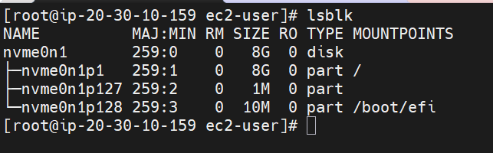

After attaching volume to EC2 Instance

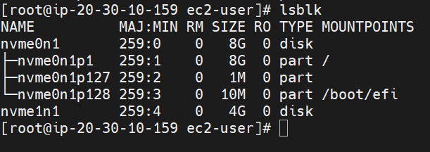

To check File system for Volumes

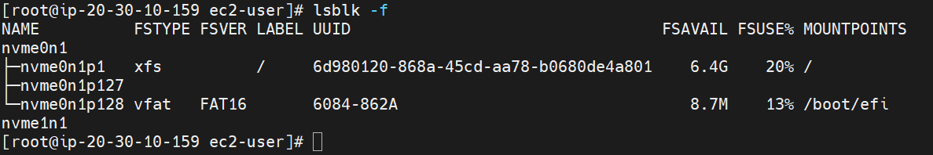

To check volume name

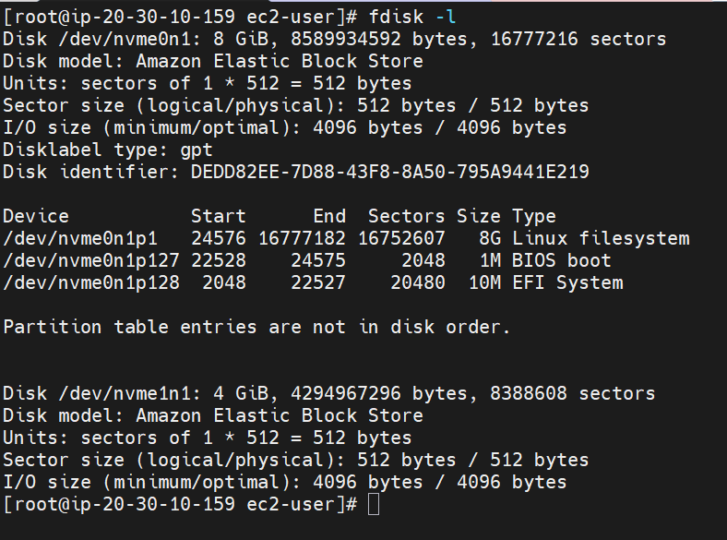

To create file system for new added volume

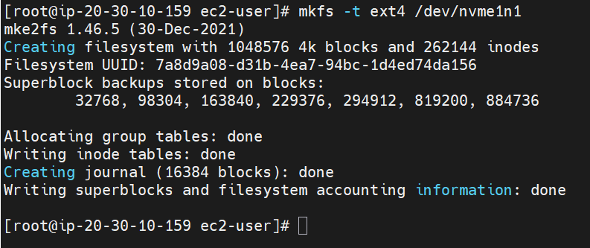

To check file system for newly added volume

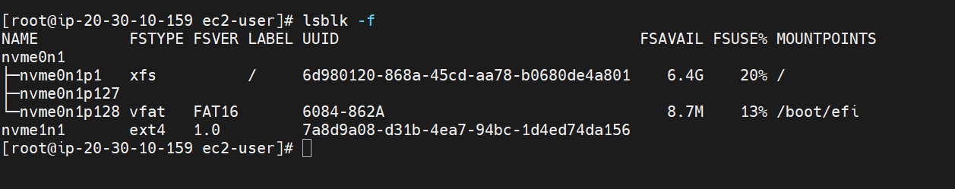

#mkdir /ynd

Create Mount point for new volume atached

To check mount point

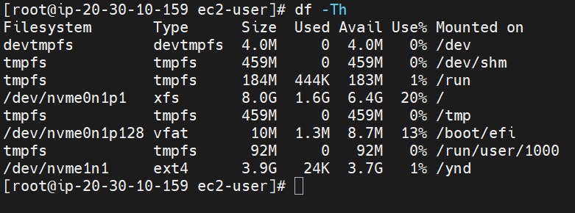

Once mount point is created this file will be created

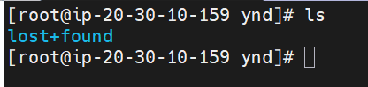

Once we restart the EC2 instance mount point will be lost as it Is not permanently mounted

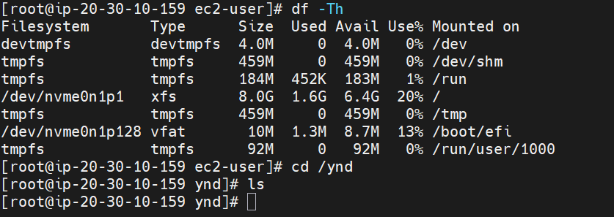

To get permanent mount on the EC2 Instance we need to add n /etc/fstab

Added below entry details in /etc/fstab

#vi /etc/fstab
==========================================
/dev/nvme1n1 /ynd ext4 defaults 0 0
==========================================

Once we restart the EC2 Instance also mount point will exit

Increasing volume on existing volume:
With out formatting the exiting data, re-sizing the volume

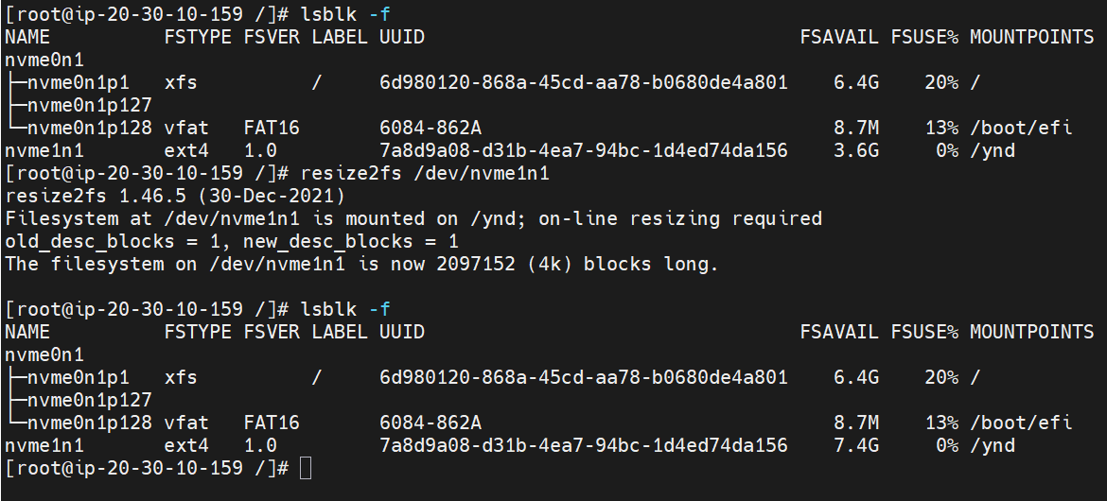

Formatting the exiting data in that volume and re-sizing

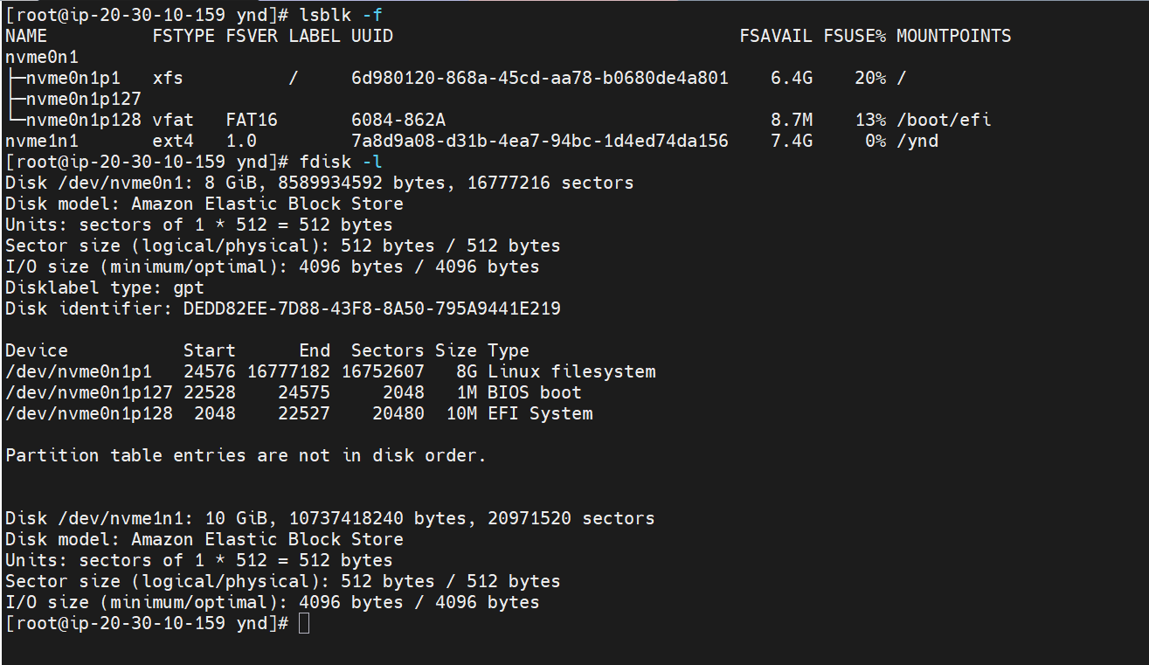

#sudo umount /ynd
#sudo mkfs -t ext4 /dev/nvme1n1 ==> if data is present it wll delee completely.

Note:
- An EBS volume that is already attached to one EC2 instance cannot be simultaneously attached to another EC2 instance.
- EBS Volume and EC2 instance should in same availability zone
- Exception: If you enable Multi-Attach (only supported for certain io1/io2 volumes), then the same volume can be attached to multiple EC2 instances within the same Availability Zone.
- Best practice: For shared storage across multiple EC2s, consider Amazon EFS or FSx, rather than relying on EBS multi-attach.

To Create Partition into Sub Partition:
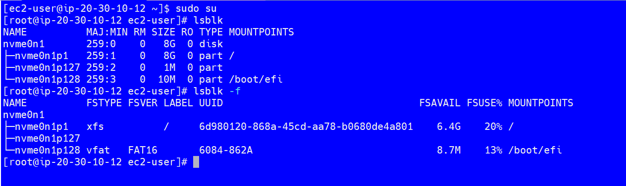

Adding Volume to EC2 Instance ( 6GB EBS Volume )

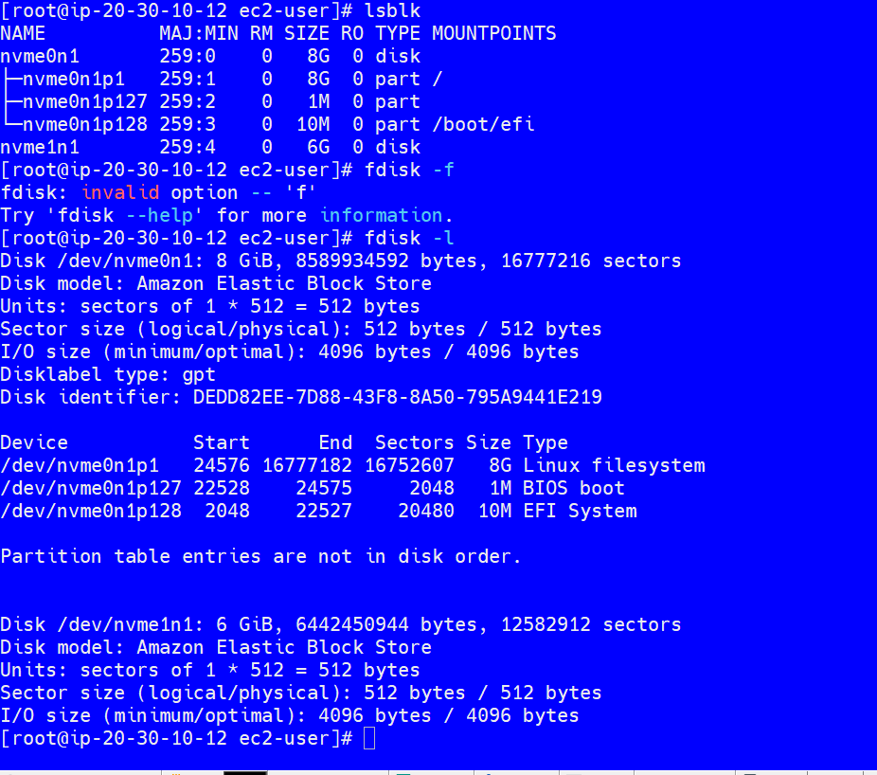

#sudo lsblk /dev/nvme1n1
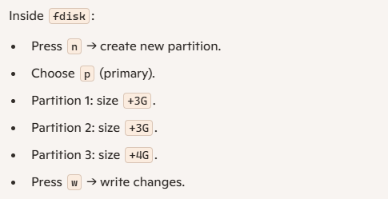

I want to increase specific partition
#sudo growpart /dev/nvme1n1 2
#sudo resize2fs /dev/nvme1n1p2

EFS ( Elastic File storage )

s

