Kubernetes Document
Kubernetes Document 1
Kubernetes Cluster Setup with Kubeadm : 1
AWS Setup: 1
VPC Creation: 1
Internet Gateway Creation: 3
Subnet Creation : 4
Routing Tables: 5
Security Group: 7
Master Node Security Group: 7
Worker Node Security Group Creation : 9
EC2 Instance Creation : 11
Below Command need to be executed in master node 15
Execute Below Command in Worker nodes: 16
In Worker Nodes: 16

Kubernetes Cluster Setup with Kubeadm :

AWS Setup:

VPC Creation:
AWS ==> Resources ==> VPC

Click on Your VPC

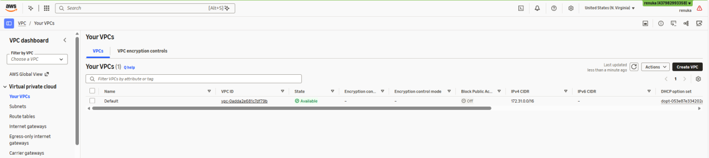

Click on Create VPC

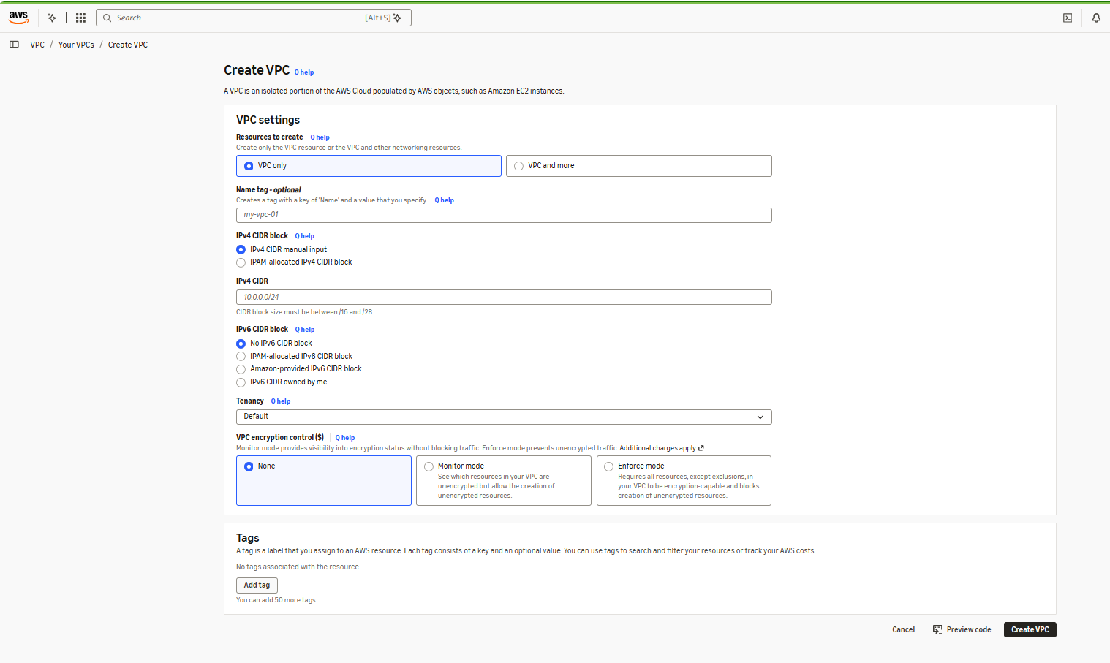

Provide the details in respective filed

- Name Tag
- IPv4 CIDR Block

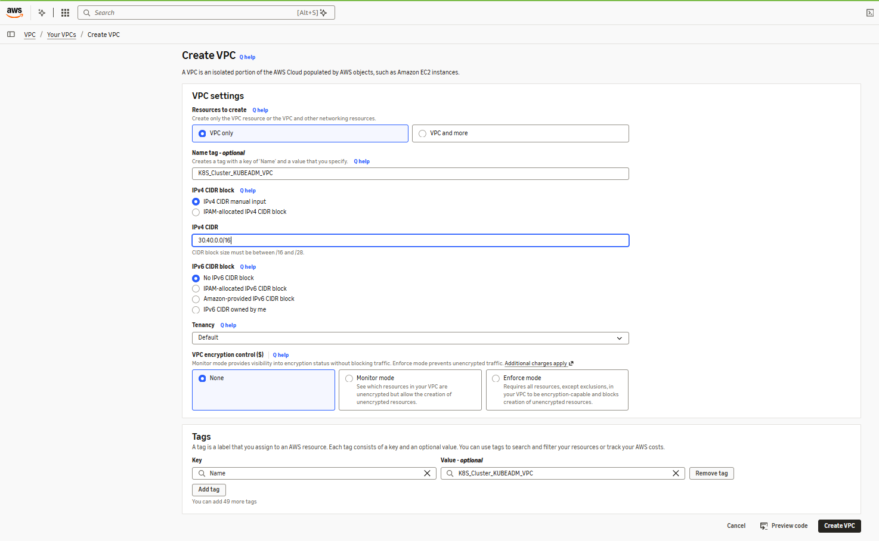

Click on Create VPC

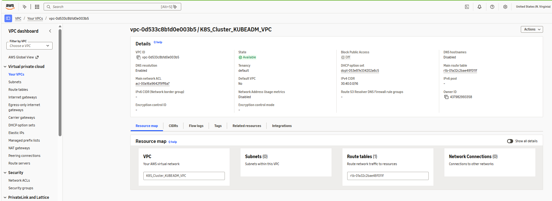

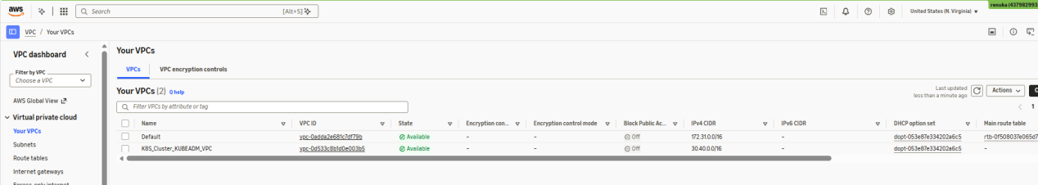

Internet Gateway Creation:
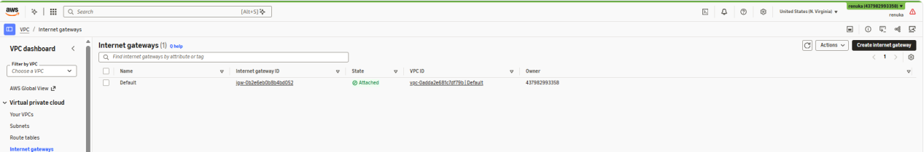

Click on Create Internet gateway
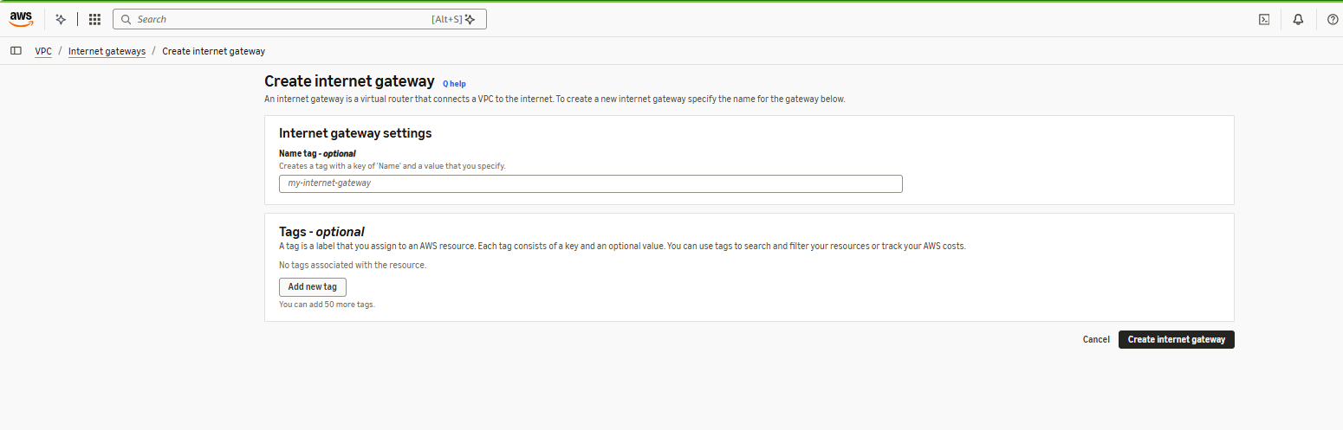

Provide details

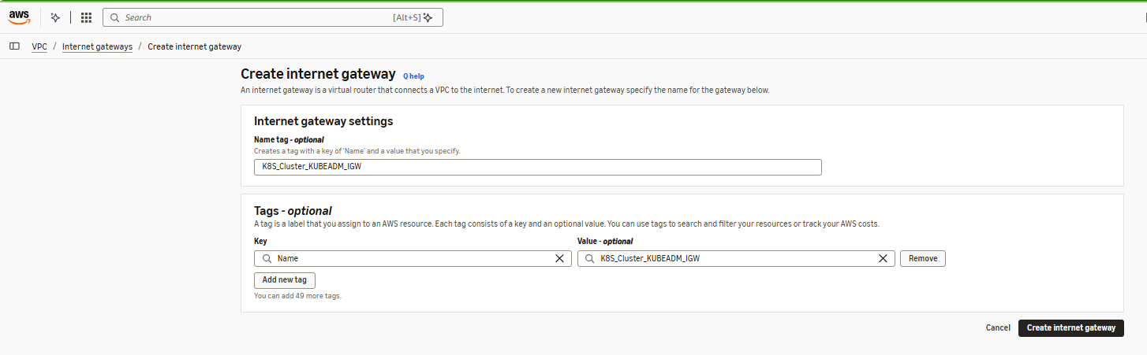

Click on Create Internet gateway

Once Internet gateway is created by default it will be detached mode

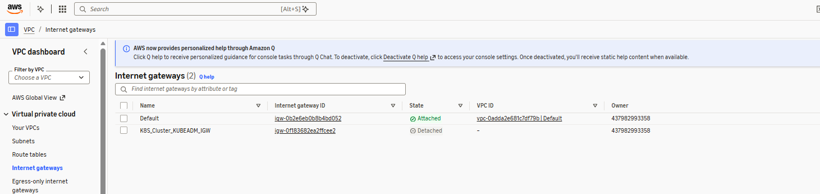

Select the Internet gateway and attach VPC

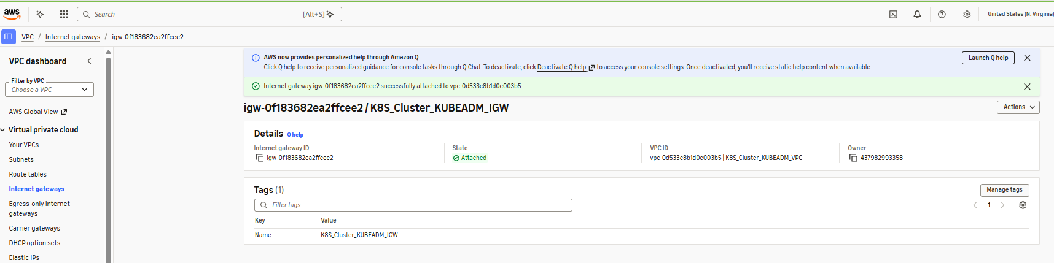

Subnet Creation :
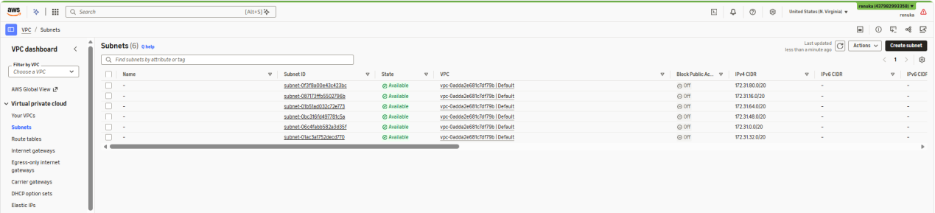

Click on Create Subnet

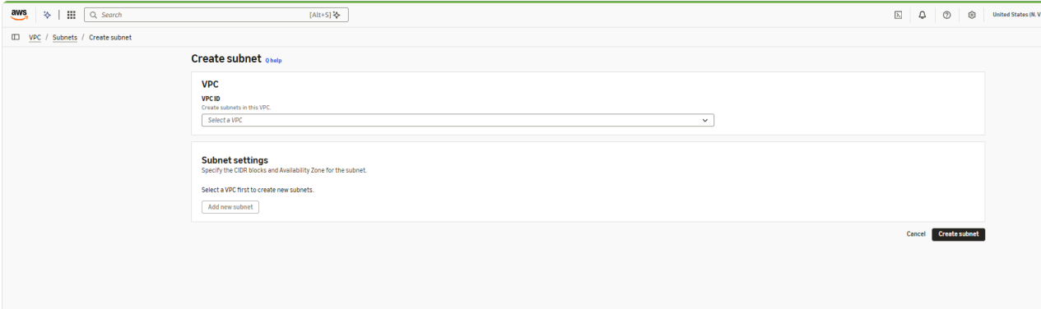

Select VPC and provide details
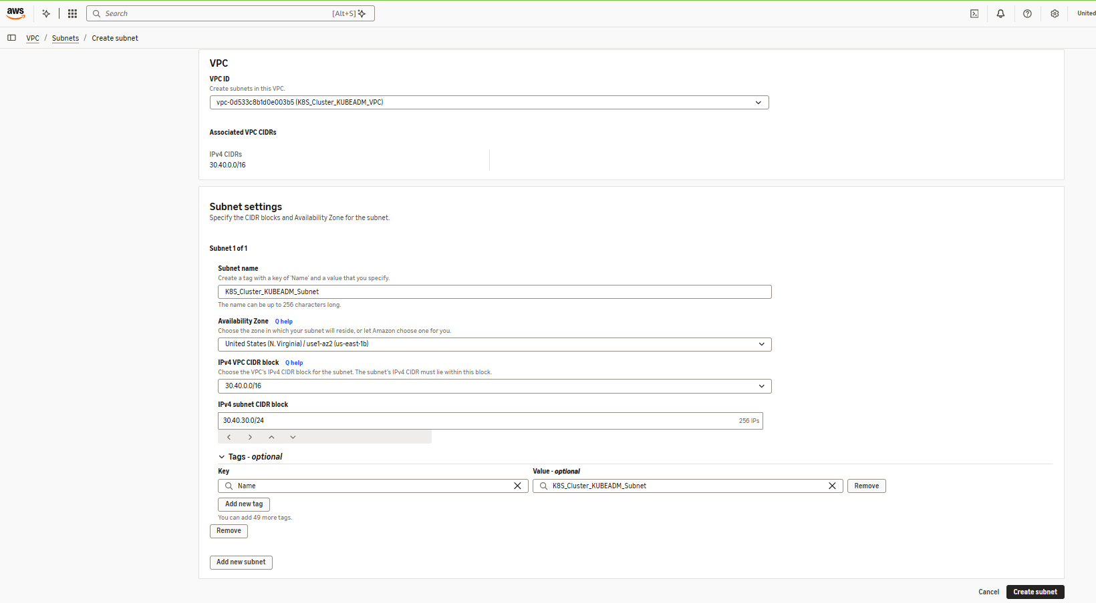

Click on Create Subnet

Routing Tables:
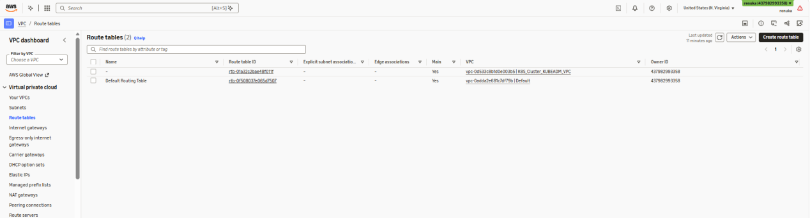

When VPC is created by default routing table will be created that routing table is Main Routing table

Select the relevant VPC of the routing table

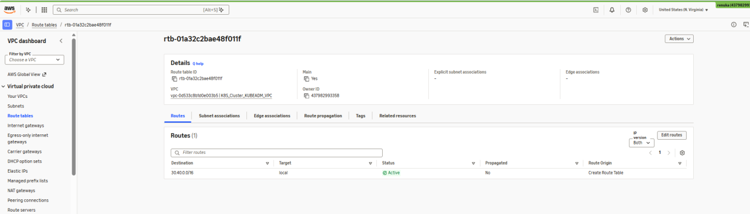

Click on edit routes and attach Internet gateway for traffic to be allowed

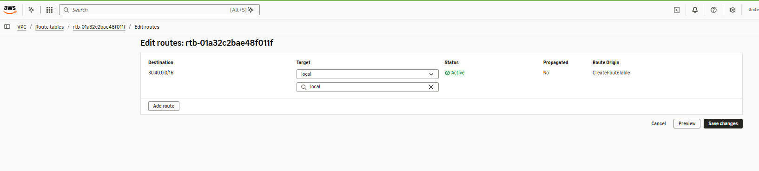

Click on Add Route

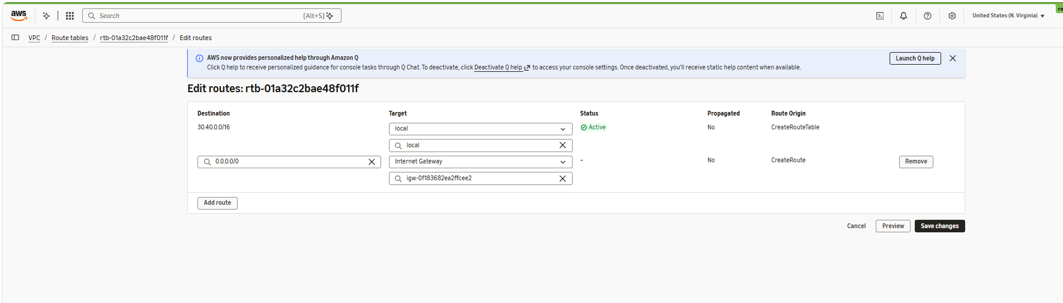

Click on Save changes

Click on Subnet Association

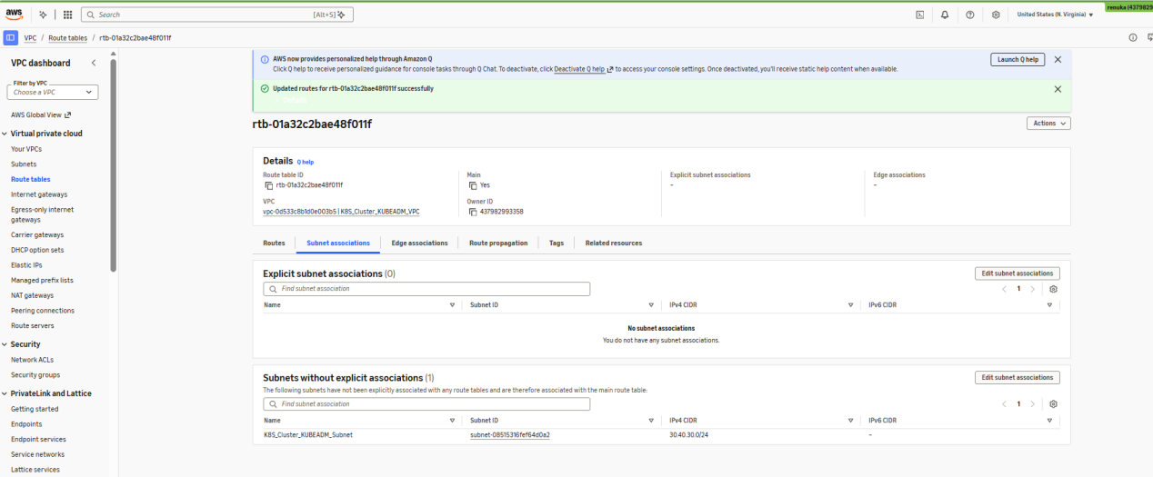

Click on Explicit subnet associations and attach subnet

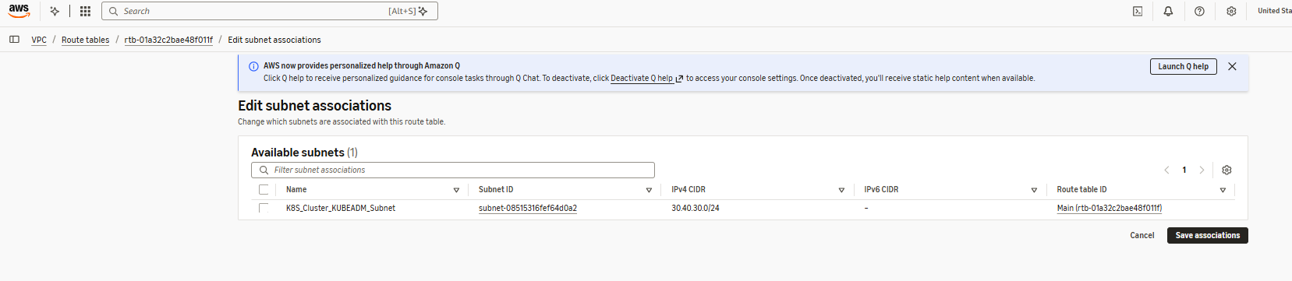

Select the Subnet and click on save changes

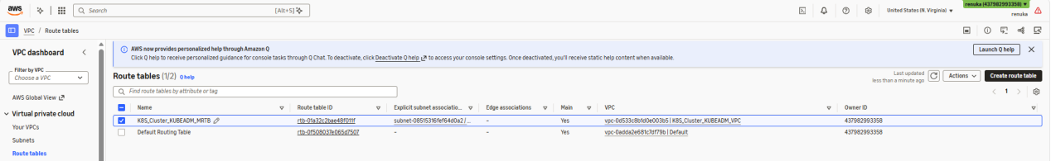

Security Group:

Master Node Security Group:
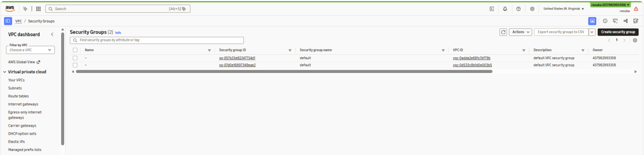

Click on create security group

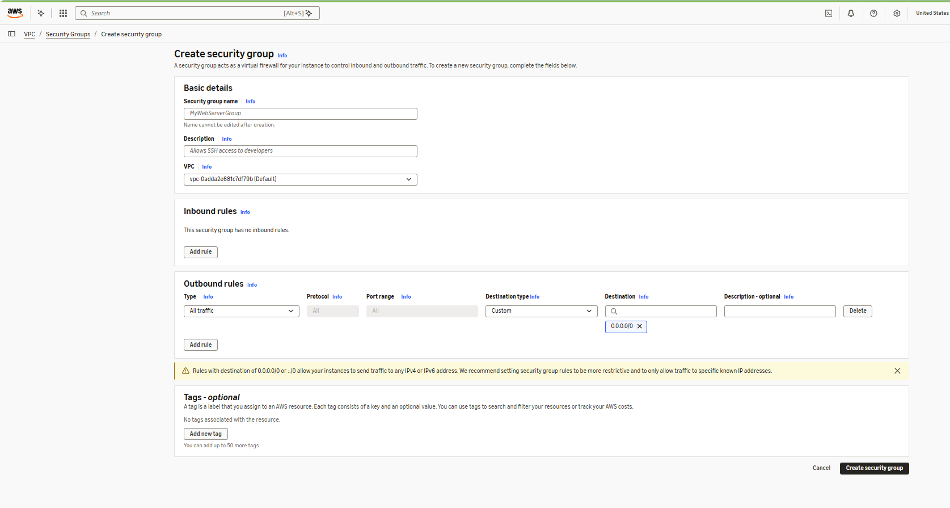

Provide details

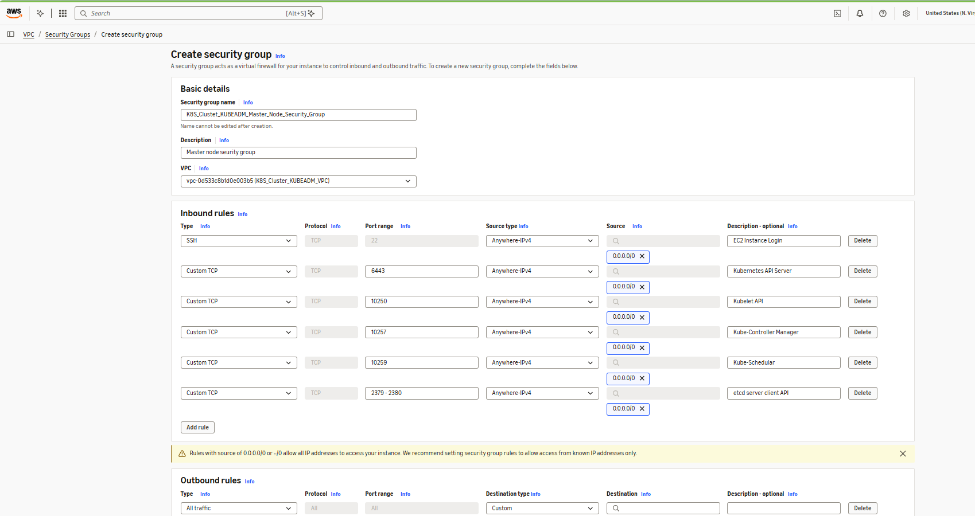

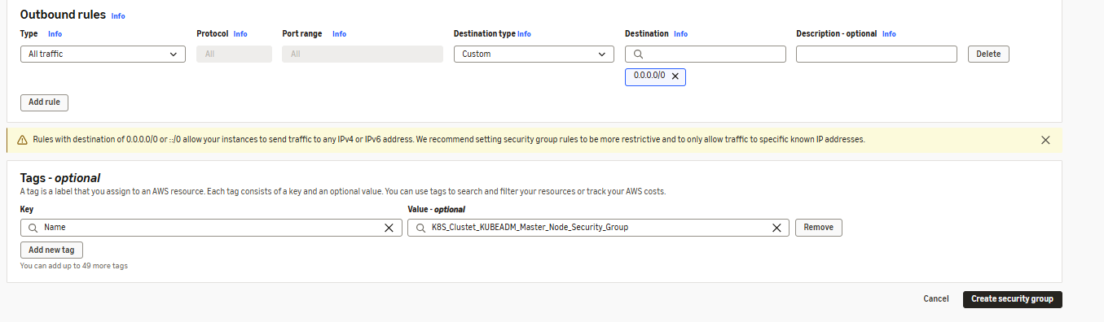

Click on Create Security group

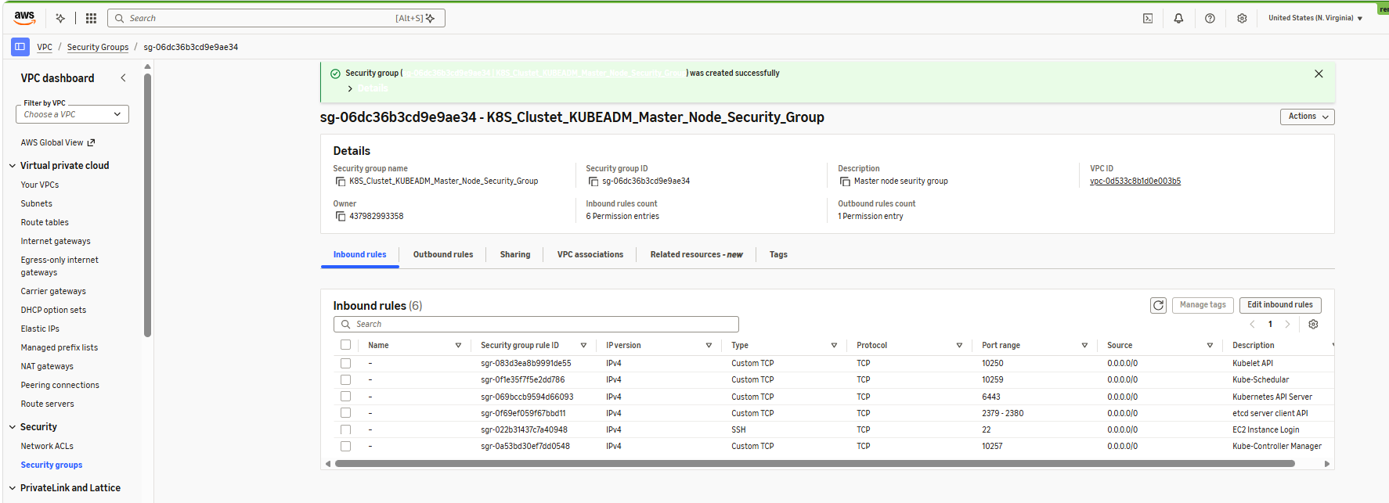

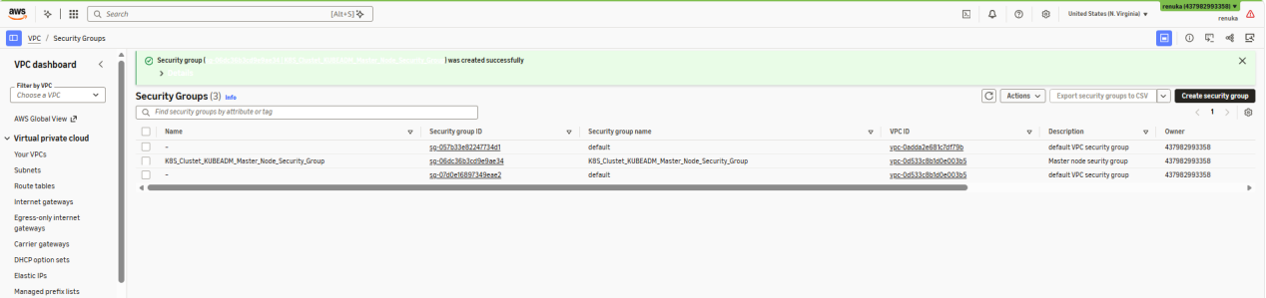

Worker Node Security Group Creation :
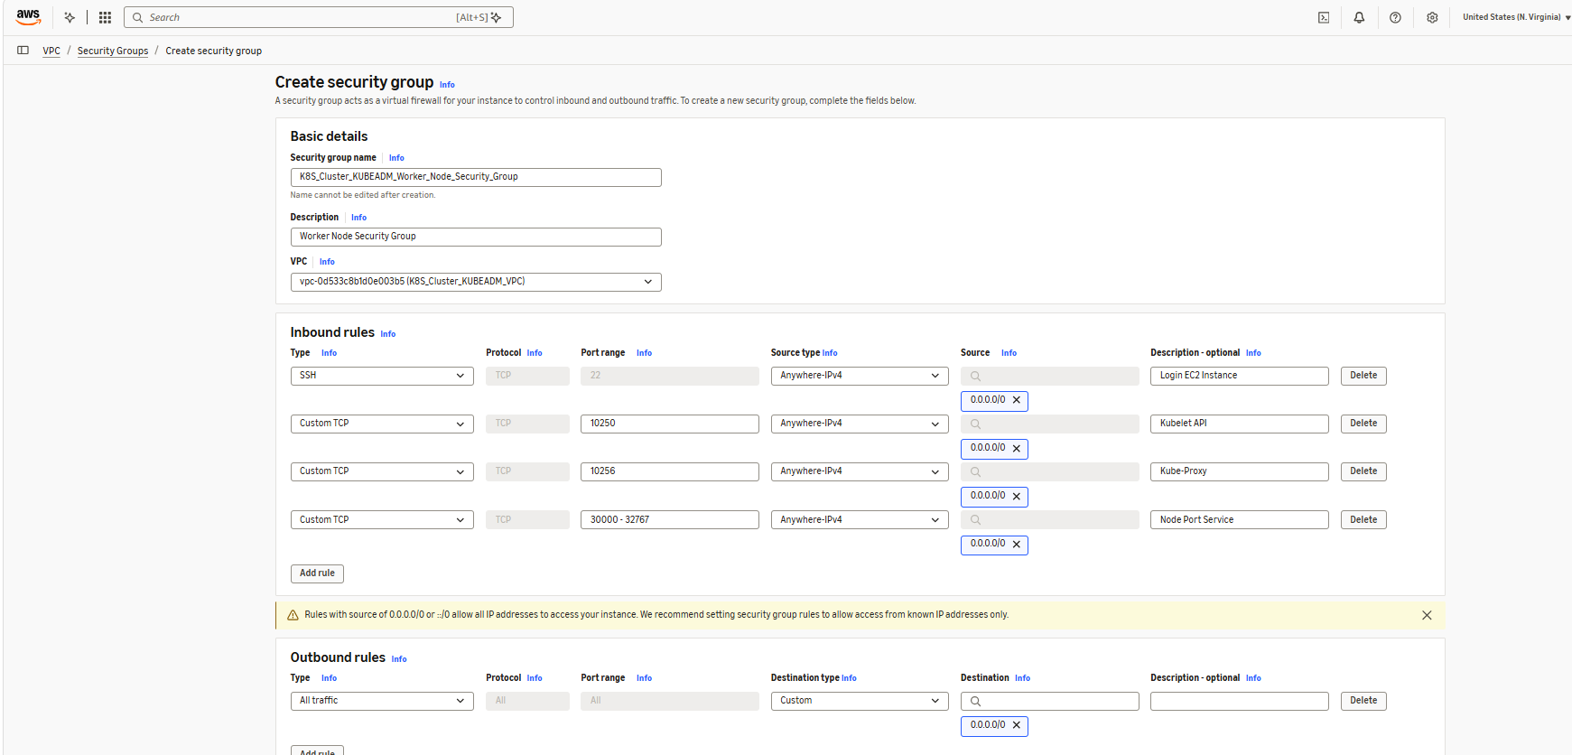
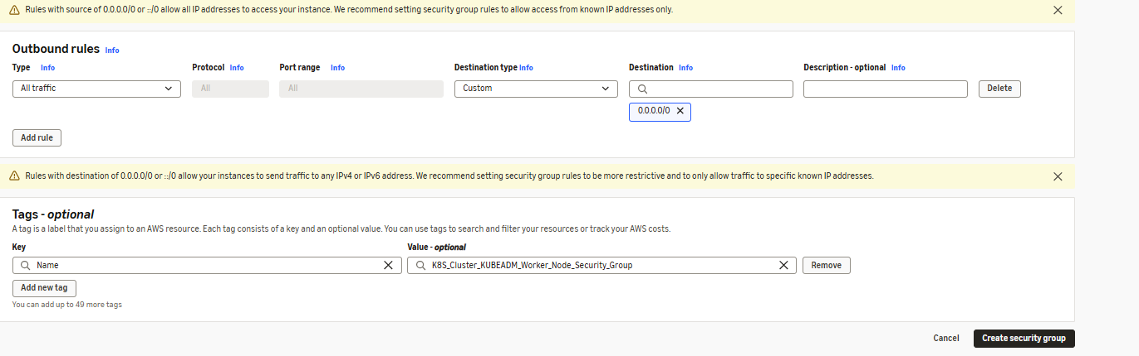

Click on Create Security group

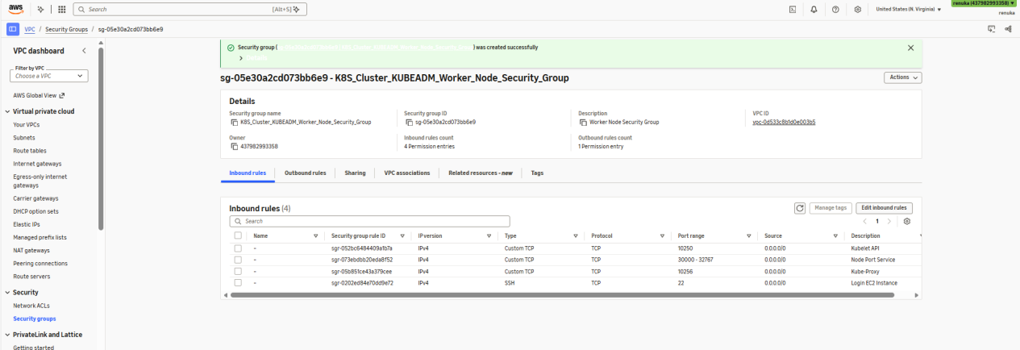

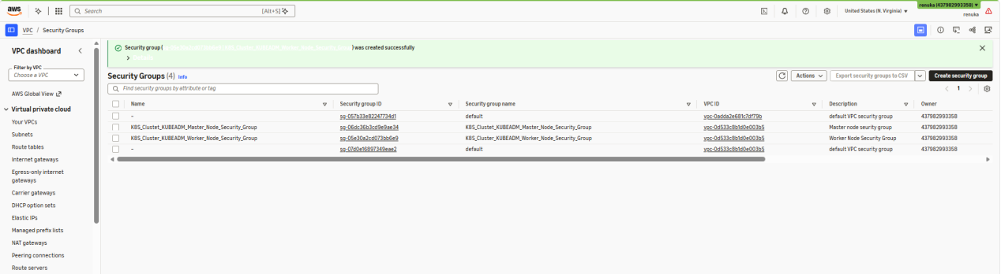

EC2 Instance Creation :
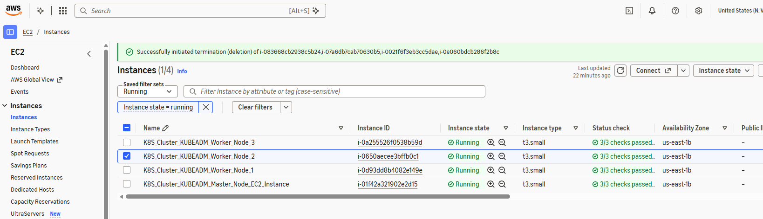

Common Steps for Master Node & Worker Node :

Note : Change the host names and reboot the system

#hostname ==> to see hostname
#hostnamectl set-hostname <new host name>
Eg: #hostnamectl set-hostname master-node
#sudo reboot

#sudo su ==> switch t root user

#yum update -y ==> to update package repository
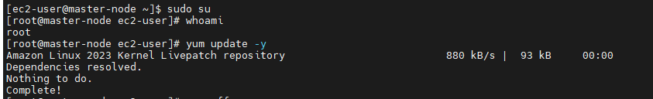

#swapoff -a

#yum install -y iproute-tc

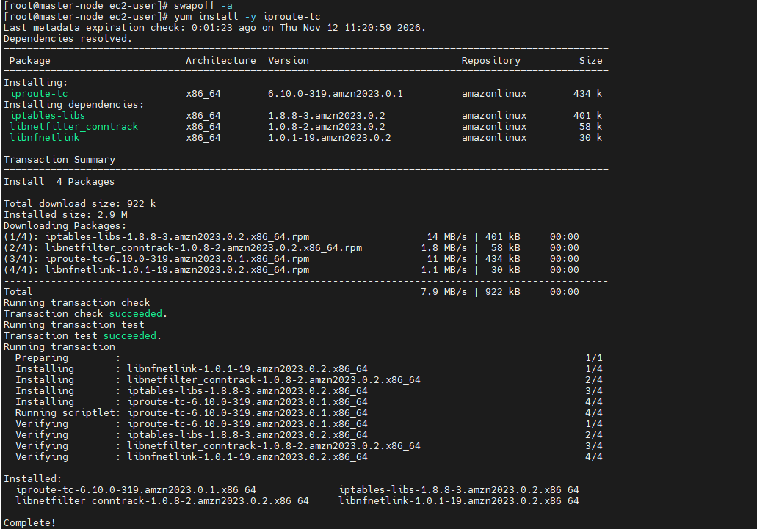

#modprobe overlay

#modprobe br_netfilter

#cat <<EOF | sudo tee /etc/modules-lod.d/ksc.conf
Overlay
br_netfilter
EOF

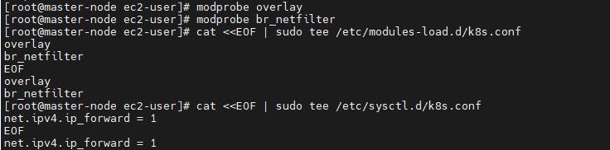

#sysctl --system

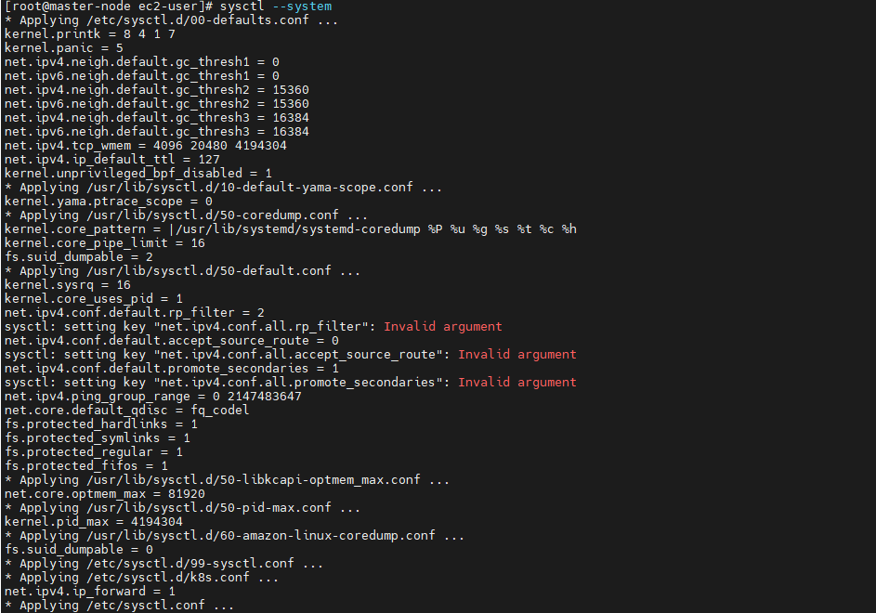

#CRIO_VERSION=v1.36
#cat <<EOF | tee /etc/yum.repos.d/cri-o.repo
[cri-o]
name=CRI-O
baseurl=https://download.opensuse.org/repositories/isv:/cri-o:/stable:/$CRIO_VERSION/rpm/
enabled=1
gpgcheck=1
gpgkey=https://download.opensuse.org/repositories/isv:/cri-o:/stable:/$CRIO_VERSION/rpm/repodata/repomd.xml.key
EOF

#KUBERNETES_VERSION=v1.36
#cat <<EOF | tee /etc/yum.repos.d/kubernetes.repo
[kubernetes]
name=Kubernetes
baseurl=https://pkgs.k8s.io/core:/stable:/$KUBERNETES_VERSION/rpm/
enabled=1
gpgcheck=1
gpgkey=https://pkgs.k8s.io/core:/stable:/$KUBERNETES_VERSION/rpm/repodata/repomd.xml.key
EOF

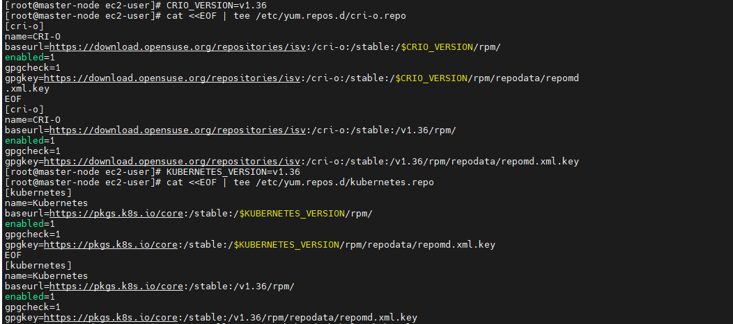

#yum install -y crio kubeadm kubelet kubectl
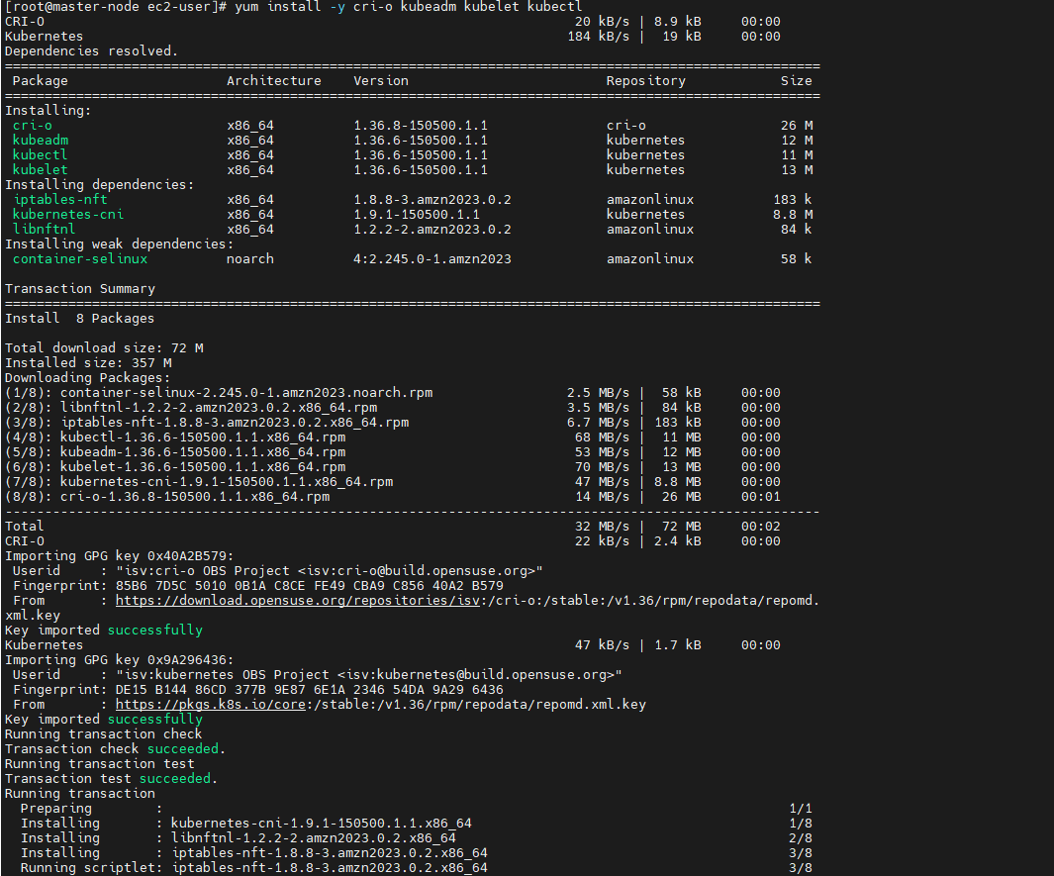
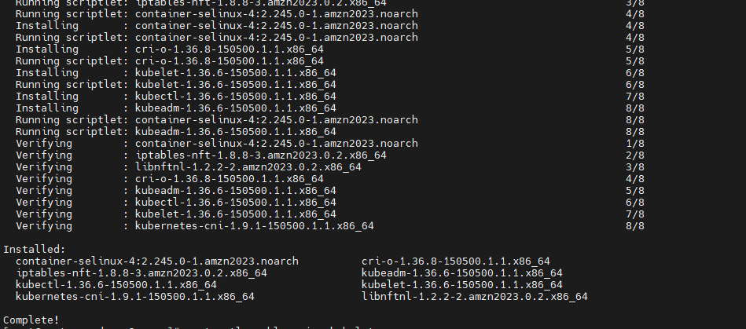

#systemctl enable crio

#systemctl enable kubelet

#systemctl start crio kubelet

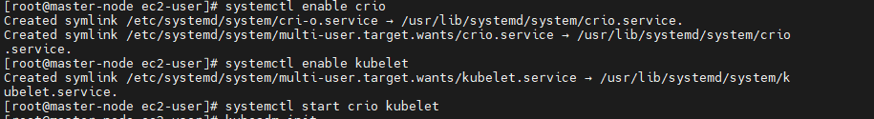

Below Command need to be executed in master node
#kubeadm init

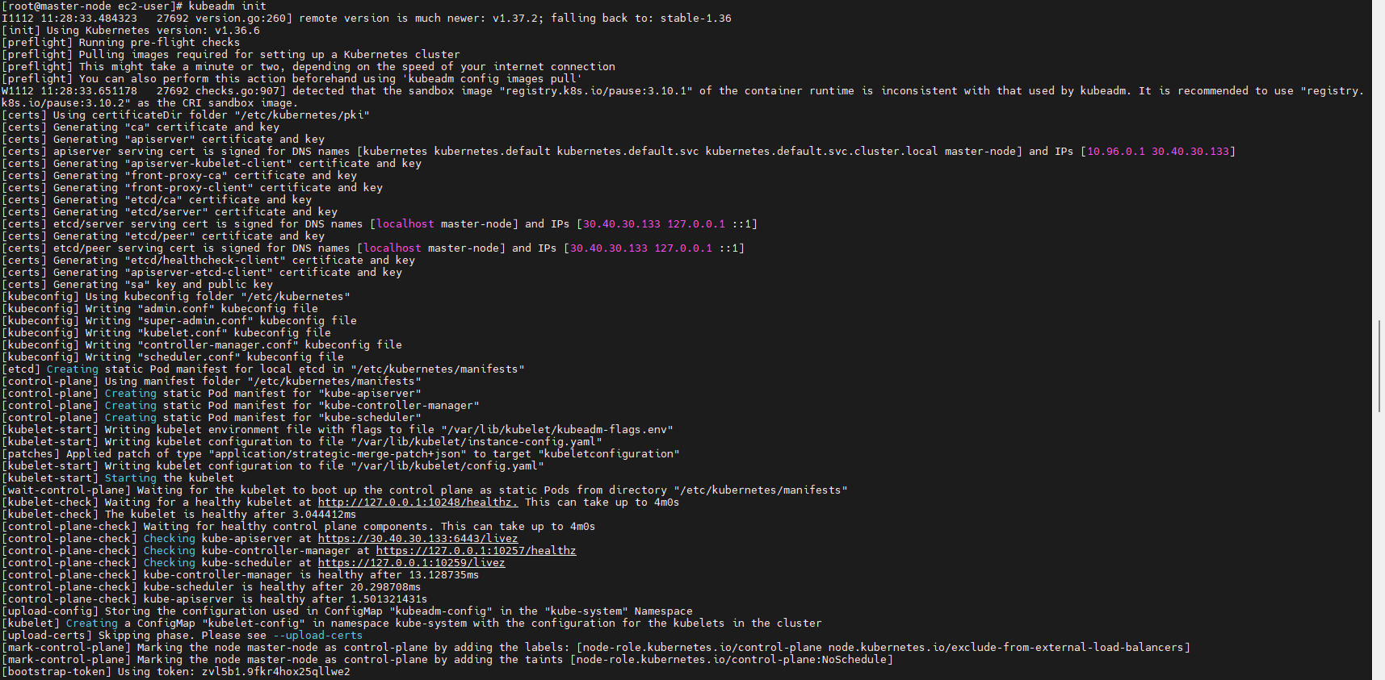

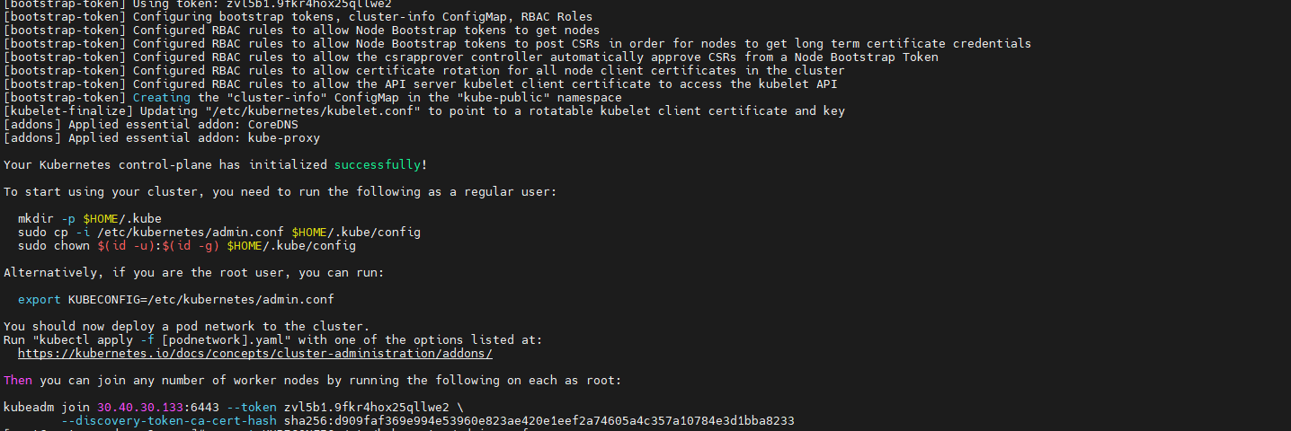

#export KUBECONFIG=/etc/kubernetes/admin.conf

#echo “export KUBECONFIG=/etc/kubernetes/admin.conf” >> .bash_profile

Execute Below Command in Worker nodes:
Worker Node toke will be generated when kubeadm initialized in master node copy the token and execute in worker node

#kubeadm join <master-node-private-ip-addr:6443> --token xxxxxx --discvery-token-ca-cert-hash xxxx
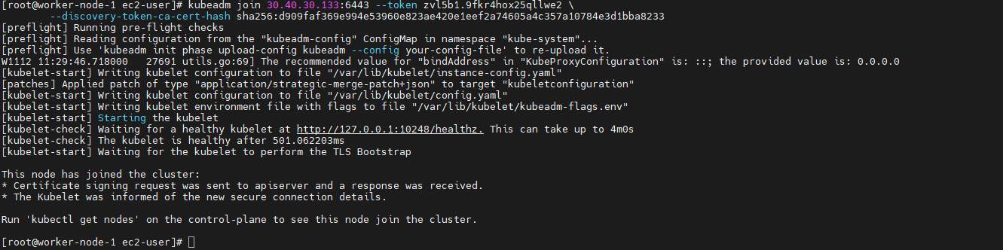

In Worker Nodes:
#kubectl get nodes --output wide ==> to see nodes information status

#kubectl apply -f https://raw.githubusercontent.com/projectcalico/calico/v3.33.0/manifests/calico.yaml

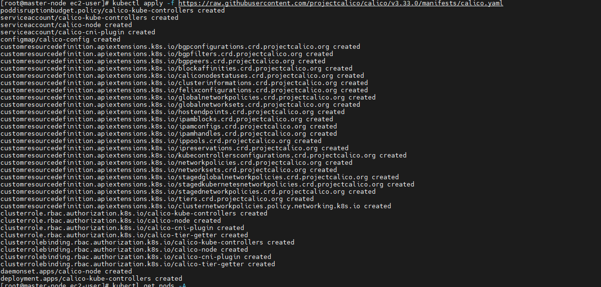

#kubectl get pods -A



