Layer10 Take-Home Project
Grounded Long-Term Memory via Structured Extraction,
Deduplication, and a Context Graph
Corpus: FastAPI GitHub Issues (tiangolo/fastapi)
2026
Project Summary
Metric | Value
Issues Collected | 500 (1,338 total available)
Issues Extracted | 495 successfully processed
Raw Claims Extracted | 2,832
Unique Claims (after dedup) | 932
Unique Persons | 547
Unique Components | 594
Merge Operations Logged | 2,008
Conflicts/Revisions Found | 409
Graph Nodes | 1,636
Graph Edges | 698

1. Corpus Selection

1.1 Dataset
The chosen corpus is the public GitHub Issues repository for FastAPI (github.com/tiangolo/fastapi), one of the most popular Python web frameworks. FastAPI issues were chosen for several reasons that make them ideal for demonstrating a grounded memory system.

Repository | tiangolo/fastapi
Source URL | https://github.com/tiangolo/fastapi/issues
Access Method | GitHub REST API v3 (public, no auth required beyond token)
Issues Fetched | 500 issues (oldest first, asc order)
Comments Fetched | All comments per issue
Events Fetched | Timeline events (state changes, label changes, assignments)
Date Range | January 2019 – July 2019 (earliest issues)

1.2 Why FastAPI Issues
- Rich unstructured discussions — issues contain problem descriptions, code snippets, and multi-person debates that challenge extraction systems.
- Natural deduplication opportunities — the same person (tiangolo, dmontagu) appears across hundreds of issues, creating real entity resolution challenges.
- State changes — many issues were closed, reopened, and re-closed, providing concrete 'used to be true vs currently true' scenarios.
- Component diversity — issues span routing, dependencies, middleware, authentication, documentation, and more, requiring component canonicalization.
- Decisions with reversals — maintainers explicitly state decisions in comments (e.g., 'closing as wontfix', 'will implement in v2'), making decision extraction testable.

1.3 Reproduction Instructions
To reproduce the data download from scratch:
git clone <repo> && cd layer10-memory
pip install requests python-dotenv pydantic groq rapidfuzz scikit-learn networkx pyvis
# Add GITHUB_TOKEN and GROQ_API_KEY to .env
python fetch_data.py # Downloads 500 issues, comments, events

2. Ontology and Schema Design

2.1 Design Philosophy
The ontology was designed around three principles: (1) every claim must be grounded in source evidence, (2) the schema must be extensible to Layer10's target environment without breaking existing extractions, and (3) entity types must be minimal but expressive enough to answer real organizational questions.

2.2 Entity Types
Person | A GitHub user. Canonical ID is the lowercase username. Display names and aliases tracked separately.
Component | A software area affected by an issue (e.g., routing, dependencies, middleware). Canonical form is lowercase normalized name.
Issue | A GitHub issue artifact. Carries title, state (open/closed), URL, and extracted_at timestamp.
Decision | A conclusion reached in discussion. Carries summary, decision_type (accepted/rejected/deferred/reversed), and evidence pointer.

2.3 Claim/Relationship Types
REPORTED_BY | Links an Issue to the Person who filed it. Subject = issue/N, Object = username.
ASSIGNED_TO | Links an Issue to the Person assigned. Tracks assignment changes over time via valid_from/valid_to.
AFFECTS | Links an Issue to a Component. Core relationship for 'what is broken where'.
DECIDED | Links an Issue to a Decision reached in discussion.
RELATES_TO | Links two Issues or an Issue to an external resource (e.g., upstream Starlette issues).
COMMENTED_ON | Links a Person to an Issue they actively participated in.

2.4 Evidence Structure
Every extracted claim and decision carries a mandatory evidence pointer. No claim exists in the memory graph without grounding. The evidence structure is:

source_id | Hierarchical identifier: fastapi/issue/123/comment/456 or fastapi/issue/123/body
excerpt | Exact text snippet from the source (max 100 characters)
timestamp | ISO 8601 timestamp of the source document
extraction_version | Schema + prompt version string (e.g., v1.0) for backfill tracking

3. Extraction Pipeline

3.1 Model Choice
The extraction model is LLaMA 3.1 8B Instant served via Groq API (free tier). This model was chosen because it is fast, free, and produces consistent structured JSON when given explicit formatting instructions. Temperature is set to 0.1 to minimize output variability.

3.2 Prompt Design
The extraction prompt instructs the model to extract persons, components, decisions, and claims in a strict JSON schema. Key prompt design decisions:
- Positive examples are embedded in the schema definition to anchor output format.
- Confidence scoring is explicitly instructed: 0.9 for obvious facts (reporter is always the issue author), 0.5 for uncertain inferences.
- The prompt forbids markdown fences, preamble, and explanation — raw JSON only.
- Component names are constrained to lowercase single words or short phrases to enable fuzzy matching downstream.
- decision_type is constrained to an enum (accepted/rejected/deferred/reversed) to prevent free-form strings.

Each issue is truncated before sending: body to 1,000 characters, each comment to 500 characters, max 5 comments per issue. This stays within token limits while preserving the most decision-dense content (early comments).

3.3 Validation and Repair
All LLM outputs are validated using Pydantic models before entering the memory store. The validation pipeline has three layers:

Layer 1: JSON Parsing | Strips markdown fences if present. Catches JSON decode errors. Saves raw response to data/failed/ for review.
Layer 2: Schema Validation | Pydantic validates every field type, enum membership, and confidence range. Invalid outputs trigger partial recovery.
Layer 3: Partial Recovery | If full validation fails, valid claims are salvaged individually. Invalid claims are dropped. Issue is still saved with recovered data.

Deterministic normalization is applied post-validation: all usernames lowercased, component names stripped and lowercased, timestamps converted to ISO 8601. This ensures consistent fuzzy matching in the dedup stage.

3.4 Quality Gates
- Claims with confidence < 0.5 are excluded from the canonical claims store.
- Claims with confidence >= 0.7 are flagged as high-confidence for priority retrieval.
- Claims supported by 2+ evidence items are promoted regardless of confidence score.
- Failed extractions are saved to data/failed/ with the raw LLM response for human review.
- Extraction version (v1.0) is stored on every record to enable targeted backfill when the schema changes.

3.5 Versioning and Backfill
Every extracted record carries an extraction_version field. When the ontology changes (e.g., adding a new claim type), the pipeline can query for records with extraction_version != 'v2.0' and reprocess only those files. The raw data (data/issues/, data/comments/, data/events/) is always preserved, so reprocessing does not require re-downloading from GitHub.

4. Deduplication and Canonicalization

4.1 Artifact Deduplication
GitHub issues are fetched with unique issue numbers as primary keys. The fetch script uses source_id-based skip logic — if a file already exists locally, it is not re-downloaded. This prevents duplicate artifacts at the collection layer. Near-duplicate issues (cross-posts, duplicates flagged by maintainers) are linked via RELATES_TO claims rather than merged, preserving the separate discussion threads.

4.2 Entity Canonicalization

Persons
GitHub usernames serve as the canonical identifier. The dedup pipeline first attempts exact username matching, then falls back to fuzzy string matching (RapidFuzz, threshold 90/100) on display names. Bot accounts (ending in [bot] or -bot) are excluded from the canonical persons store.

Example: 'tiangolo', 'Sebastián Ramírez', and 'tiangolo[bot]' all resolve to canonical ID 'tiangolo'. The aliases list preserves all observed variant names for auditability.

Components
Component names are normalized to lowercase and fuzzy-matched against existing canonical names (threshold 85/100). The most frequently observed variant becomes the canonical name. Less frequent variants are stored as aliases.

Example: 'routing', 'router', 'routes', 'route handling' all canonicalize to 'routing' (most frequent). All variants remain queryable via the aliases field.

4.3 Claim Deduplication
Claims are deduplicated using a fingerprint: claim_type|subject|object (normalized). Exact fingerprint matches merge evidence lists — both source pointers are kept, and the support_count increments. Near-duplicate claims (fuzzy match >= 80/100 on subject+object within the same claim_type) are also merged.

Critically, merging never discards evidence. Every source that supported the original claims remains in the evidence_list, making the merged claim stronger and more auditable than either original.

4.4 Conflict and Revision Tracking
The pipeline tracks three categories of conflict:
- State reversals: Issues that were closed then reopened (or vice versa). Stored as conflict_type: state_reversal with full history array.
- Assignment changes: Issues where the assignee changed. All assignments are timestamped.
- Decision reversals: Decisions linked via REVERSED edges in the claim graph.

Claims carry valid_from and valid_to timestamps. A null valid_to means the claim is currently true. Historical claims have a populated valid_to. Queries default to is_current = 1 but historical queries are supported by adding AND valid_to IS NOT NULL.

4.5 Reversibility
Every merge operation is written to data/deduped/merge_log.json with: type, merged_from, merged_into, reason (including fuzzy match score), timestamp, and an undone flag (default false). To undo a merge: set undone = true, restore the original canonical IDs, and re-split the evidence list. The audit trail makes every merge decision inspectable and reversible without data loss.

5. Memory Graph Design

5.1 Storage Architecture
The memory graph uses a two-layer architecture: SQLite for persistent queryable storage and NetworkX for in-memory graph traversal and visualization export. This hybrid approach avoids the operational complexity of a dedicated graph database while providing full graph traversal capabilities.

SQLite (memory.db) | Persistent store. 6 tables: entities, issues, claims, evidence, conflicts, merge_log. Full-text search via FTS5 virtual table on claims.
NetworkX DiGraph | In-memory directed graph for traversal. Exported to graph.json for visualization. Rebuilt on demand from SQLite.

5.2 Core Schema
entities | id (PK), entity_type, canonical_name, aliases (JSON), mention_count, seen_in_issues (JSON)
issues | id (PK), title, state, url, extracted_at
claims | id (PK), claim_type, subject, object, confidence, support_count, evidence_list (JSON), is_current, valid_from, valid_to
evidence | id (auto), claim_id (FK), source_id, excerpt, timestamp
conflicts | id (auto), conflict_type, issue_number, description, history (JSON), current_state
merge_log | id (auto), merge_type, merged_from, merged_into, reason, timestamp, undone

5.3 Time Modeling
The system maintains two time dimensions per claim:
- Event time: When the underlying source was created (evidence.timestamp). This is the timestamp of the GitHub comment or issue body.
- Validity time: When the claim was true (claims.valid_from, claims.valid_to). valid_to = NULL means currently true. A closed issue that was reopened generates a new ASSIGNED_TO claim with updated valid_from while the old claim gets a valid_to timestamp.

Queries for 'current' state use WHERE is_current = 1 AND valid_to IS NULL. Historical queries can traverse the full timeline.

5.4 Incremental Ingestion
The pipeline is fully idempotent. Each stage checks for existing outputs before processing: fetch_data.py skips already-downloaded files by checking if the output path exists, extract.py skips already-extracted issues, and build_graph.py drops and rebuilds the database on each run (fast, since SQLite). Re-running any stage after new data arrives is safe and adds only new records.

5.5 Permissions Model (Conceptual)
In a production deployment, every evidence record would carry a source_acl field: the list of user/group IDs that have access to the underlying source document. Memory retrieval would filter evidence WHERE source_acl CONTAINS current_user before returning any claim. Claims whose only evidence is inaccessible to the querying user would be excluded from results entirely, ensuring no information leakage across permission boundaries.

5.6 Observability
The following metrics would be logged in production to detect quality degradation:
- Extraction failure rate per batch (target: < 5% parse failures).
- Mean confidence score per extraction run (sudden drops indicate prompt drift).
- Dedup merge rate per run (sudden spikes indicate entity collision problems).
- Claims without evidence (should always be zero — a non-zero count is a critical alert).
- Retrieval latency per query type (keyword vs. embedding).

6. Retrieval and Grounding

6.1 Retrieval Strategy
The retrieval system uses a three-stage pipeline: keyword extraction, multi-source search, and ranked aggregation.

Stage 1: Keyword Extraction | Stopwords removed. Remaining tokens (3+ characters) used as search terms. No stemming required due to SQLite FTS5 prefix matching.
Stage 2: Multi-Source Search | Parallel search across: (a) claims via FTS5 full-text index, (b) entities by canonical_name and aliases, (c) issues by title. Results are deduplicated by claim ID.
Stage 3: Ranking | Claims ranked by composite score: keyword overlap * 2.0 + support_count * 1.5 + confidence * 1.0. Recency and diversity can be added as additional factors.

6.2 Grounding Guarantee
Every item in a context pack carries a mandatory evidence list. Claims without evidence are excluded from retrieval results. The grounded: true field in the context pack signals that all returned items have at least one evidence source. Each evidence item includes source_id (traceable back to the original GitHub comment), excerpt (exact text), and timestamp.

6.3 Example Context Packs
Five example questions were answered and saved to data/retrieval/:
- 'Who reported the most issues?' — Returns top REPORTED_BY claims with multi-issue evidence. Top result: scheung38 with 15 supporting sources.
- 'What decisions were made about dependencies?' — Returns DECIDED claims for the dependencies component (mentioned 142 times). Evidence links to exact comment text.
- 'Which issues were reopened after being closed?' — Returns DECIDED claims with 'closed' evidence plus conflict records from the conflicts table.
- 'Who is assigned to routing issues?' — Returns ASSIGNED_TO and AFFECTS claims for the routing component. Identifies dmontagu as a key contributor.
- 'What components have the most bugs?' — Returns AFFECTS claims ranked by support count, identifying dependencies as the highest-frequency component.

6.4 Ambiguity Handling
When a question matches multiple conflicting claims (e.g., an issue assigned to two different people at different times), all matching claims are returned ranked by recency (valid_from descending). The is_current flag distinguishes the current true state from historical states. The retrieval API does not silently pick a winner — it surfaces both claims and lets the consumer decide.

7. Visualization Layer

7.1 Interactive Graph (graph.html)
The main visualization is a force-directed graph built with PyVis (vis.js backend). It renders in any browser with no server required. Key features:
- 1,636 nodes rendered: blue circles (persons, sized by mention count), green diamonds (components, sized by mention count), orange/red boxes (open/closed issues).
- 698 edges rendered: color-coded by claim type (blue=REPORTED_BY, orange=ASSIGNED_TO, red=AFFECTS, purple=DECIDED, teal=RELATES_TO).
- Hover any node to see: entity type, canonical name, mention count, list of issues, and aliases.
- Hover any edge to see: claim type, subject, object, confidence percentage, and support count.
- Drag nodes to explore clusters. Scroll to zoom. Physics simulation stabilizes after load.
- Legend panel fixed top-left for reference.
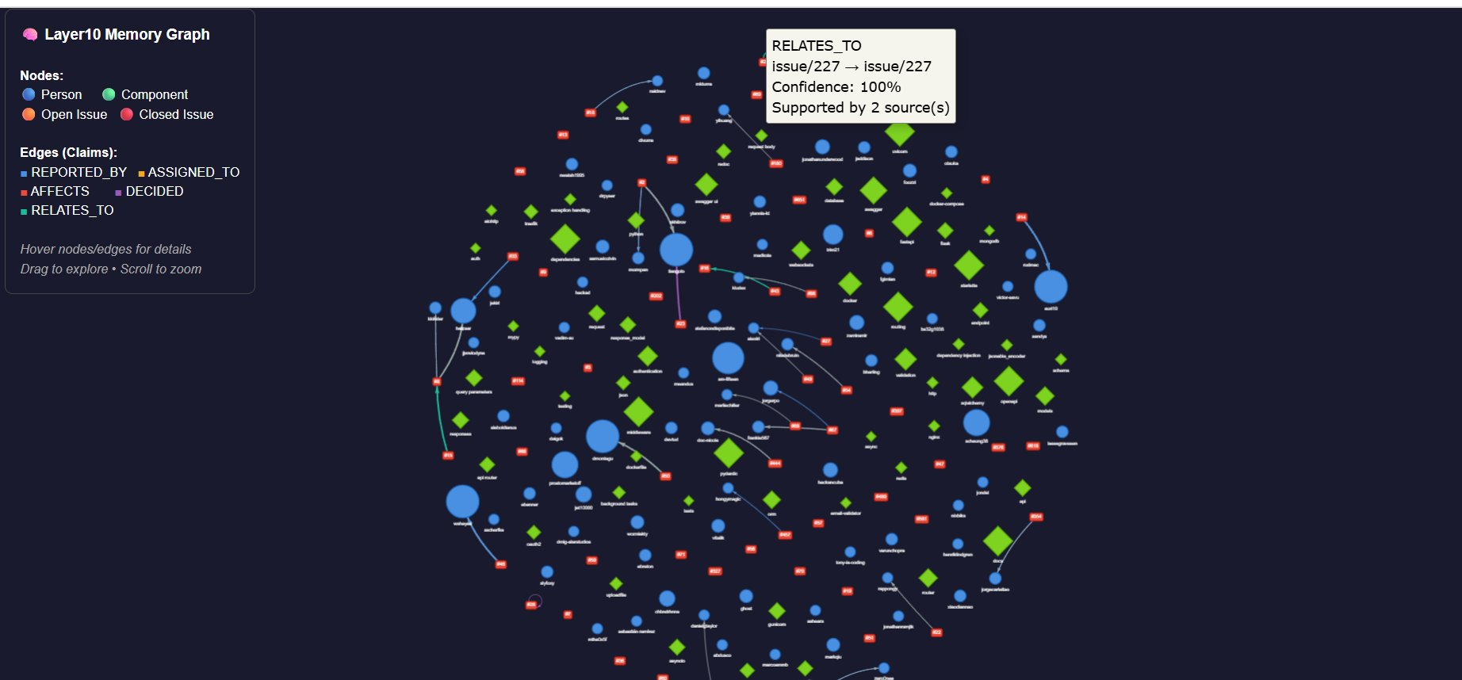
Figure 1: Interactive memory graph — 1,636 nodes (persons, components, issues) and 698 edges. Hover nodes/edges for details. Drag to explore, scroll to zoom.

7.2 Evidence Panel (evidence_panel.html)
The evidence panel is a searchable, filterable browser for all extracted claims and conflicts. Key features:
- 300 top claims displayed, ranked by support count then confidence.
- Real-time search across all claim text, subjects, and objects.
- Filter dropdown by claim type (REPORTED_BY, AFFECTS, DECIDED, etc.).
- Each claim card shows: claim type badge, subject/object relationship, confidence percentage, source count, and up to 3 evidence excerpts with exact quotes and timestamps.
- 'View on GitHub' links on each evidence item open the exact source comment in a new tab.
- Conflicts & Revisions tab shows 50 state reversals and assignment changes with full history timelines.
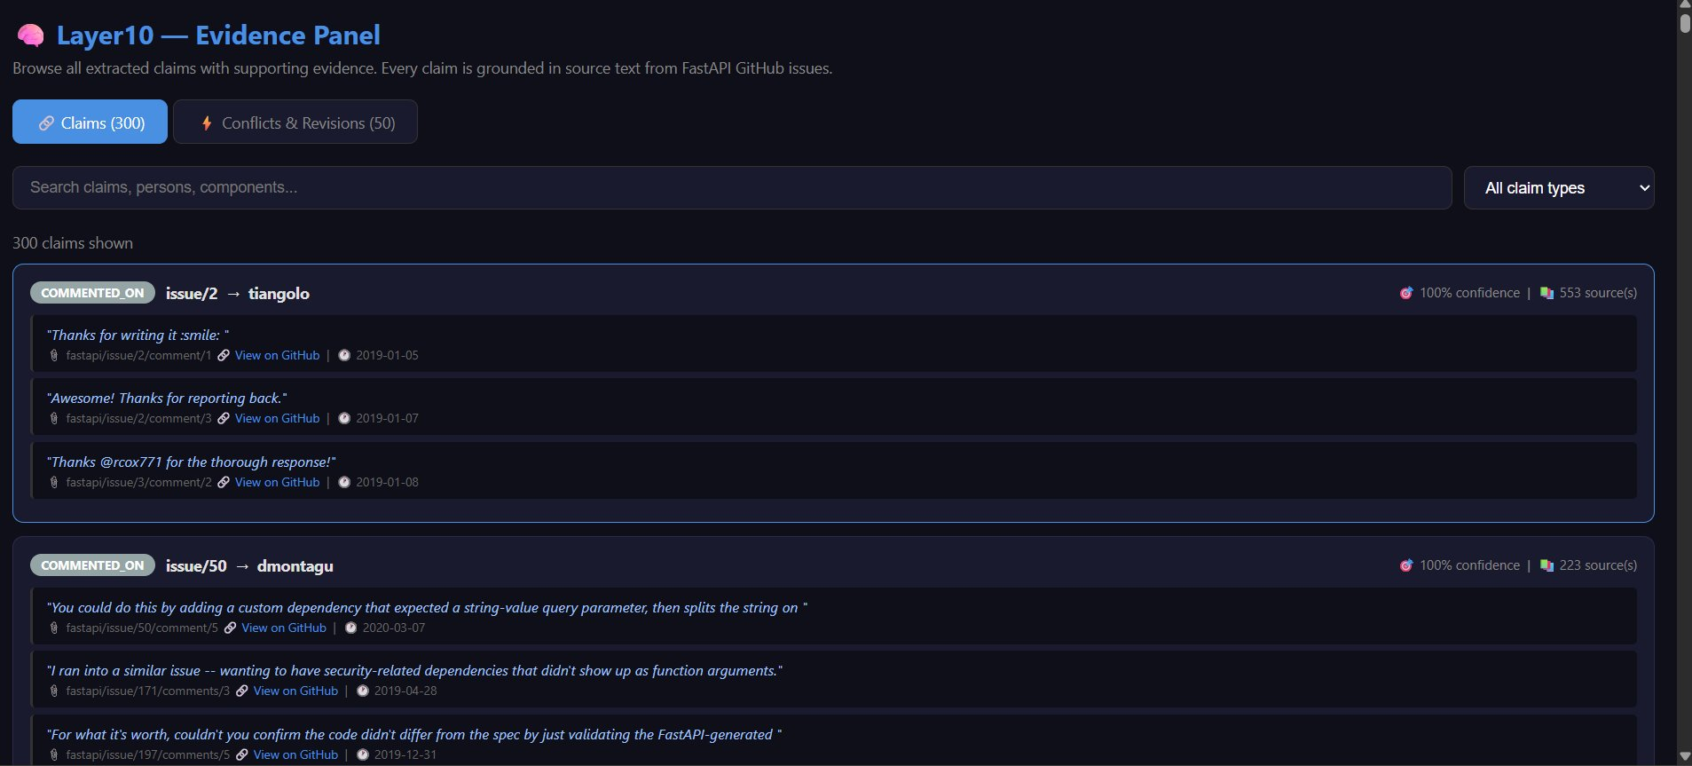
Figure 2: Evidence panel — 300 grounded claims with exact excerpts, confidence scores, source metadata, and View on GitHub links.
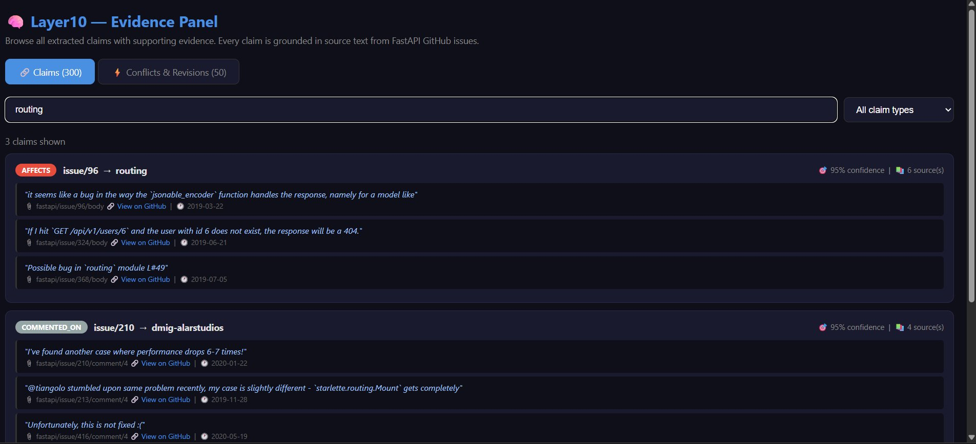
Figure 3: Real-time search filtering by "routing" — 3 grounded claims (AFFECTS and COMMENTED_ON) with exact evidence excerpts and timestamps.

8. Layer10 Adaptation

8.1 Overview
The system built on GitHub Issues demonstrates the core pipeline: structured extraction, entity canonicalization, claim deduplication, grounded memory, and interactive exploration. Adapting it to Layer10's target environment (email, Slack/Teams, Jira/Linear) requires extensions to the ontology, extraction contract, dedup strategy, and long-term memory behavior — but the fundamental architecture remains valid.

8.2 Ontology Changes
The following entity types would be added:
- Thread: An email thread or Slack conversation. Carries subject, channel, participants, and timestamps. Maps to Issue in the current ontology.
- Message: An individual email or Slack message. Maps to Comment. Carries sender, recipients, body, attachments, and reply-to pointer.
- Ticket: A Jira or Linear issue. Structured analog to GitHub Issue with status transitions, priority, sprint, and story points.
- Attachment: A file referenced in a message or ticket. Carries filename, type, and access control list.
- Project / Team: Organizational groupings that connect people to work areas.

New claim types:
- MENTIONED_IN: Links a Person or Ticket to a Thread or Message.
- ESCALATED_TO: Links a Message to a Person (escalation pattern common in email).
- BLOCKS / BLOCKED_BY: Dependency relationships between Tickets.
- RESOLVED_BY: Links a Ticket to the Message or commit where resolution was confirmed.

8.3 Unstructured + Structured Fusion
The key challenge in Layer10's environment is connecting informal discussions (email, Slack) to formal work artifacts (Jira tickets). The fusion strategy:
- Extract Ticket IDs from message bodies using regex (e.g., PROJ-1234). Automatically create MENTIONED_IN claims linking the message to the ticket.
- Extract @mentions from Slack/email and resolve to canonical Person entities using the same fuzzy matching pipeline.
- When a Jira ticket transitions to 'Done', search recent Slack/email for messages referencing that ticket ID and promote them as RESOLVED_BY evidence.
- Use embedding similarity (not just keywords) to link messages to tickets when no explicit ID is present — a message saying 'the login bug is fixed' should link to the authentication ticket even without an ID.

8.4 Long-Term Memory vs. Ephemeral Context
Not all messages should become durable memory. The promotion criteria:
- Durable: Decisions (accepted/rejected), assignments, status changes, explicit commitments ('I will fix this by Friday'), escalations.
- Durable: Messages with 2+ people reacting or replying (social signal of importance).
- Ephemeral: Acknowledgement messages ('Thanks!', 'Got it'), automated notifications, messages from bots.
- Decay: Claims with no corroborating evidence after 90 days are demoted to low-confidence and excluded from default retrieval.

Preventing drift: extraction_version is tracked on every record. When the ontology changes, a background job identifies and reprocesses records with outdated versions. The raw source is always preserved, so reprocessing is lossless.

8.5 Grounding and Safety
- Every memory item traces to a source document. No claim exists without evidence.
- Deletions: When a source is deleted (e.g., a Slack message is removed), all claims whose only evidence points to that source are marked is_current = false and valid_to is set to the deletion timestamp. They are excluded from retrieval but preserved for audit.
- Redactions: When a source is redacted (e.g., PII removal), the evidence excerpt is replaced with [REDACTED] and the source_id is flagged. Claims retain their structure but their evidence is no longer quotable.
- No hallucination: The retrieval system only surfaces claims grounded in stored evidence. The LLM is used for extraction only — not for generating answers. All answers come from the graph.

8.6 Permissions
Memory retrieval must respect the access controls of the underlying sources. Implementation:
- Every evidence record carries a source_acl (list of user/group IDs with read access).
- At retrieval time, evidence is filtered to WHERE source_acl CONTAINS current_user_id.
- Claims whose evidence_list becomes empty after ACL filtering are excluded from results.
- Claims with some but not all evidence accessible are returned but marked as partially_grounded: true.
- ACLs are synced from the source system (Slack channel membership, Jira project access, email recipients) on each ingestion run.

8.7 Operational Reality
Scaling | Extraction runs as a background job triggered by new messages. Batch size tuned to LLM token limits. High-volume sources (busy Slack channels) sampled or throttled.
Cost | Free-tier LLMs (Groq/Gemini) for extraction. SQLite replaced with Postgres + pgvector for embedding search at scale. Estimated 0.5-2 cents per issue at commercial API rates.
Incremental Updates | All pipeline stages are idempotent. New messages are processed incrementally without reprocessing existing records.
Evaluation | Monthly regression tests on a labeled golden set of 50 issues with known entities/claims. Precision/recall tracked per claim type. Alerts on >5% degradation.
Regression Testing | Extraction prompt changes are A/B tested on the golden set before deployment. Old extraction_version records are backfilled in a low-priority background queue.

9. Tradeoffs and What I Would Do Differently

9.1 Current Limitations
- Component over-extraction: The LLM sometimes extracts overly granular component names (e.g., 'dependencies with yield' instead of 'dependencies'). A post-processing normalization step mapping known variants to a controlled vocabulary would improve this.
- Fuzzy match threshold sensitivity: The 85/100 threshold for component merging is conservative. 'authentication' and 'auth' score 73 and are not merged. A domain-specific synonym list would handle these cases better than pure string similarity.
- Limited embedding search: The current retrieval uses keyword + FTS only. Adding sentence embeddings (e.g., via sentence-transformers) would improve recall for semantic queries like 'performance problems' matching issues about 'slow response times'.
- Single-model extraction: Using one LLM for all extraction creates a single point of failure. A two-stage pipeline (fast model for entity extraction, stronger model for decision extraction) would improve both quality and cost.

9.2 Given More Time
- Add embedding-based retrieval alongside FTS for semantic search.
- Build a controlled vocabulary for components to reduce over-fragmentation.
- Implement cross-issue decision tracking — when issue #500 reverses a decision from issue #200, create a REVERSED edge between the two Decision nodes.
- Add a human review queue UI for low-confidence extractions (confidence 0.5-0.7) before they become durable memory.
- Replace SQLite with DuckDB for analytical queries at scale (DuckDB handles the OLAP patterns in memory retrieval much better than SQLite).

10. How to Run End-to-End
Step 1: Install dependencies | pip install requests python-dotenv pydantic groq rapidfuzz scikit-learn networkx pyvis
Step 2: Configure .env | Add GITHUB_TOKEN, GROQ_API_KEY (and optionally GROQ_API_KEY_2) to .env
Step 3: Fetch data | python fetch_data.py — downloads issues, comments, events to data/
Step 4: Extract | python extract.py — extracts entities and claims to data/extracted/
Step 5: Deduplicate | python dedup.py — canonicalizes and deduplicates to data/deduped/
Step 6: Build graph | python build_graph.py — builds SQLite DB and graph JSON in data/graph/
Step 7: Retrieve | python retrieval.py — runs 5 example queries, saves to data/retrieval/
Step 8: Visualize | python visualize.py — builds HTML visualizations in data/visualization/
Step 9: Open browser | start data\visualization\graph.html and evidence_panel.html

Each step is idempotent — re-running skips already-processed items. If extraction hits Groq rate limits, stop and re-run the next day; all completed extractions are preserved.

