Вид в админке:

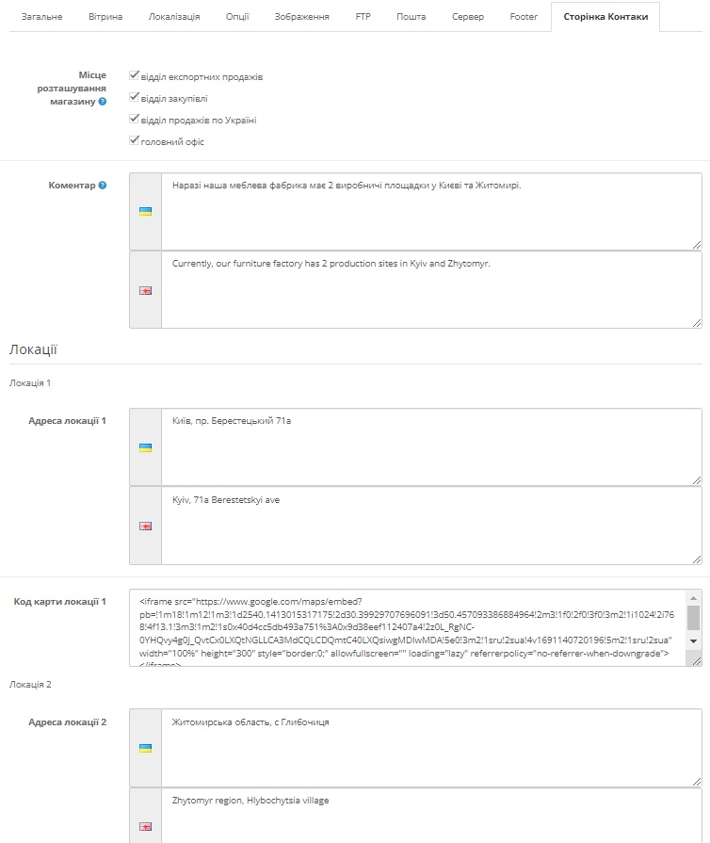

Вид на сайте:

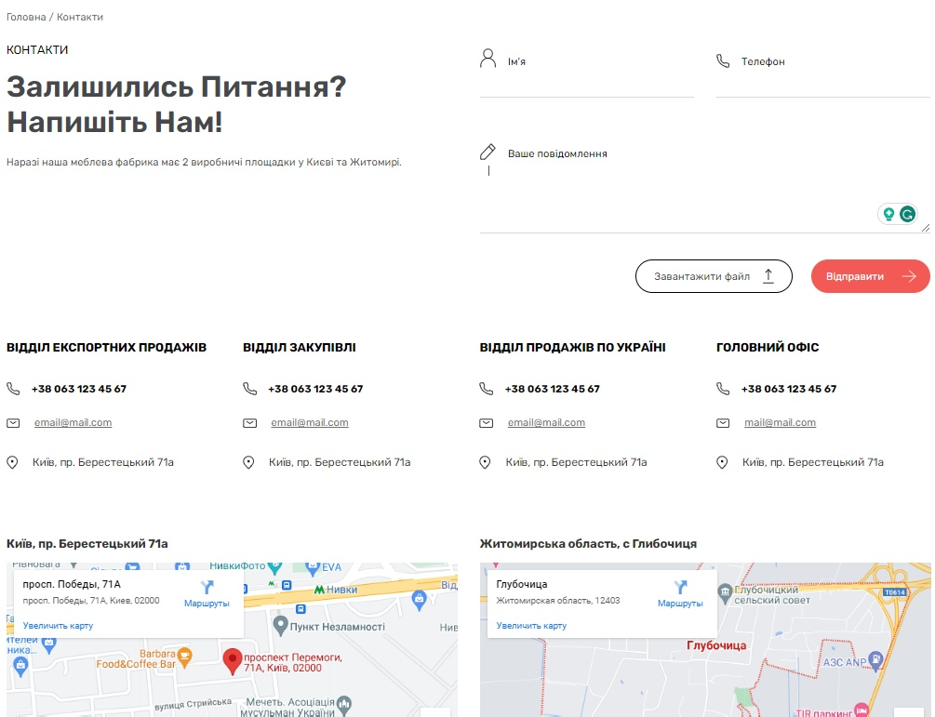

В Админ-панели

Открываем файл:

\admin\controller\setting\setting.php

Вставляем код:

$data['text_locations'] = $this->language->get('text_locations');

$data['text_location1'] = $this->language->get('text_location1');

$data['text_location1_address'] = $this->language->get('text_location1_address');

$data['text_location1_map'] = $this->language->get('text_location1_map');

$data['text_location2'] = $this->language->get('text_location2');

$data['text_location2_address'] = $this->language->get('text_location2_address');

$data['text_location2_map'] = $this->language->get('text_location2_map');

$data['entry_email_form'] = $this->language->get('entry_email_form');

$data['entry_facebook'] = $this->language->get('entry_facebook');

$data['entry_instagram'] = $this->language->get('entry_instagram');

$data['entry_image_logo'] = $this->language->get('entry_image_logo');

$data['entry_footer_text_left'] = $this->language->get('entry_footer_text_left');

$data['entry_footer_text_social'] = $this->language->get('entry_footer_text_social');

$data['tab_footer'] = $this->language->get('tab_footer');

$data['tab_contact'] = $this->language->get('tab_contact');

if (isset($this->error['email_form'])) {

$data['error_email'] = $this->error['email_form'];

} else {

$data['error_email'] = '';

}

if (isset($this->request->post['config_email_form'])) {

$data['config_email_form'] = $this->request->post['config_email_form'];

} else {

$data['config_email_form'] = $this->config->get('config_email_form');

}

if (isset($this->request->post['config_telephone'])) {

$data['config_telephone'] = $this->request->post['config_telephone'];

} else {

$data['config_telephone'] = $this->config->get('config_telephone');

}

if (isset($this->request->post['config_facebook'])) {

$data['config_facebook'] = $this->request->post['config_facebook'];

} else {

$data['config_facebook'] = $this->config->get('config_facebook');

}

if (isset($this->request->post['config_instagram'])) {

$data['config_instagram'] = $this->request->post['config_instagram'];

} else {

$data['config_instagram'] = $this->config->get('config_instagram');

}

if (isset($this->request->post['config_image'])) {

$data['config_image'] = $this->request->post['config_image'];

} else {

$data['config_image'] = $this->config->get('config_image');

}

if (isset($this->request->post['config_image_footer_logo'])) {

$data['config_image_footer_logo'] = $this->request->post['config_image_footer_logo'];

} else {

$data['config_image_footer_logo'] = $this->config->get('config_image_footer_logo');

}

if (isset($this->request->post['config_footer_text_left'])) {

$data['config_footer_text_left'] = $this->request->post['config_footer_text_left'];

} else {

$data['config_footer_text_left'] = $this->config->get('config_footer_text_left');

}

if (isset($this->request->post['config_footer_text_social'])) {

$data['config_footer_text_social'] = $this->request->post['config_footer_text_social'];

} else {

$data['config_footer_text_social'] = $this->config->get('config_footer_text_social');

}

$this->load->model('tool/image');

if (isset($this->request->post['config_image']) && is_file(DIR_IMAGE . $this->request->post['config_image'])) {

$data['thumb'] = $this->model_tool_image->resize($this->request->post['config_image'], 100, 100);

} elseif ($this->config->get('config_image') && is_file(DIR_IMAGE . $this->config->get('config_image'))) {

$data['thumb'] = $this->model_tool_image->resize($this->config->get('config_image'), 100, 100);

} else {

$data['thumb'] = $this->model_tool_image->resize('no_image.png', 100, 100);

}

$data['placeholder'] = $this->model_tool_image->resize('no_image.png', 100, 100);

if (isset($this->request->post['config_image_footer_logo']) && is_file(DIR_IMAGE . $this->request->post['config_image_footer_logo'])) {

$data['thumb_footer_logo'] = $this->model_tool_image->resize($this->request->post['config_image_footer_logo'], 100, 100);

} elseif ($this->config->get('config_image_footer_logo') && is_file(DIR_IMAGE . $this->config->get('config_image_footer_logo'))) {

$data['thumb_footer_logo'] = $this->model_tool_image->resize($this->config->get('config_image_footer_logo'), 100, 100);

} else {

$data['thumb_footer_logo'] = $this->model_tool_image->resize('no_image.png', 100, 100);

}

$data['placeholder_footer_logo'] = $this->model_tool_image->resize('no_image.png', 100, 100);

$this->load->model('localisation/language');

$data['languages'] = $this->model_localisation_language->getLanguages();

if (isset($this->request->post['config_admin_language'])) {

$data['config_admin_language'] = $this->request->post['config_admin_language'];

} else {

$data['config_admin_language'] = $this->config->get('config_admin_language');

}

if (isset($this->request->post['config_address_location1'])) {

$data['config_address_location1'] = $this->request->post['config_address_location1'];

} else {

$data['config_address_location1'] = $this->config->get('config_address_location1');

}

if (isset($this->request->post['config_address_location2'])) {

$data['config_address_location2'] = $this->request->post['config_address_location2'];

} else {

$data['config_address_location2'] = $this->config->get('config_address_location2');

}

if (isset($this->request->post['config_map_location1'])) {

$data['config_map_location1'] = $this->request->post['config_map_location1'];

} else {

$data['config_map_location1'] = $this->config->get('config_map_location1');

}

if (isset($this->request->post['config_map_location2'])) {

$data['config_map_location2'] = $this->request->post['config_map_location2'];

} else {

$data['config_map_location2'] = $this->config->get('config_map_location2');

}

Комментируем **$address**:

// if ((utf8_strlen($this->request->post['config_address']) < 3) || (utf8_strlen($this->request->post['config_address']) > 256)) {

// $this->error['address'] = $this->language->get('error_address');

// }

Открываем файл:

\admin\view\template\setting\setting.tpl

В форму после **$tab_server** вставляем код:

<li><a href="#tab-footer" data-toggle="tab"><?php echo $tab_footer; ?></a></li>

<li><a href="#tab-contact" data-toggle="tab"><?php echo $tab_contact; ?></a></li>

Также вставляем мои **custom поля**:

<div class="form-group required">

<label class="col-sm-2 control-label" for="input-address"><?php echo $entry_address; ?></label>

<div class="col-sm-10">

<?php foreach ($languages as $language) { ?>

<div class="input-group">

<span class="input-group-addon">

<img src="language/<?php echo $language['code']; ?>/<?php echo $language['code']; ?>.png" title="<?php echo $language['name']; ?>" />

</span>

<textarea name="config_address[<?php echo $language['language_id']; ?>]" placeholder="<?php echo $entry_address; ?>" rows="5" id="input-address-<?php echo $language['language_id']; ?>" class="form-control"><?php echo $config_address[$language['language_id']]; ?></textarea>

</div>

<?php } ?>

</div>

</div>

<div class="form-group">

<label class="col-sm-2 control-label" for="input-geocode"><span data-toggle="tooltip" data-container="#tab-general" title="<?php echo $help_geocode; ?>"><?php echo $entry_geocode; ?></span></label>

<div class="col-sm-10">

<input type="text" name="config_geocode" value="<?php echo $config_geocode; ?>" placeholder="<?php echo $entry_geocode; ?>" id="input-geocode" class="form-control" />

</div>

</div>

<div class="form-group required">

<label class="col-sm-2 control-label" for="input-email-form"><?php echo $entry_email_form; ?></label>

<div class="col-sm-10">

<input type="text" name="config_email_form" value="<?php echo $config_email_form; ?>" placeholder="<?php echo $entry_email_form; ?>" id="input-email-form" class="form-control" />

<?php if ($error_email) { ?>

<div class="text-danger"><?php echo $error_email; ?></div>

<?php } ?>

</div>

</div>

<div class="form-group required">

<label class="col-sm-2 control-label" for="input-email"><?php echo $entry_email; ?></label>

<div class="col-sm-10">

<input type="text" name="config_email" value="<?php echo $config_email; ?>" placeholder="<?php echo $entry_email; ?>" id="input-email" class="form-control" />

<?php if ($error_email) { ?>

<div class="text-danger"><?php echo $error_email; ?></div>

<?php } ?>

</div>

</div>

<div class="form-group required">

<label class="col-sm-2 control-label" for="input-telephone"><?php echo $entry_telephone; ?></label>

<div class="col-sm-10">

<input type="text" name="config_telephone" value="<?php echo $config_telephone; ?>" placeholder="<?php echo $entry_telephone; ?>" id="input-telephone" class="form-control" />

<?php if ($error_telephone) { ?>

<div class="text-danger"><?php echo $error_telephone; ?></div>

<?php } ?>

</div>

</div>

<div class="form-group">

<label class="col-sm-2 control-label" for="input-facebook"><?php echo $entry_facebook; ?></label>

<div class="col-sm-10">

<input type="text" name="config_facebook" value="<?php echo $config_facebook; ?>" placeholder="<?php echo $entry_facebook; ?>" id="input-facebook" class="form-control" />

</div>

</div>

<div class="form-group">

<label class="col-sm-2 control-label" for="input-instagram"><?php echo $entry_instagram; ?></label>

<div class="col-sm-10">

<input type="text" name="config_instagram" value="<?php echo $config_instagram; ?>" placeholder="<?php echo $entry_instagram; ?>" id="input-instagram" class="form-control" />

</div>

</div>

После <div class="tab-pane" id="tab-server"> вставляем код:

<div class="tab-pane" id="tab-footer">

<fieldset>

<legend><?php echo $text_footer; ?></legend>

<div class="form-group">

<label class="col-sm-2 control-label" for="input-image-footer-logo"><?php echo $entry_image_logo; ?></label>

<div class="col-sm-10"><a href="" id="thumb-image-footer-logo" data-toggle="image" class="img-thumbnail"><img src="<?php echo $thumb_footer_logo; ?>" alt="" title="" data-placeholder="<?php echo $placeholder_footer_logo; ?>" /></a>

<input type="hidden" name="config_image_footer_logo" value="<?php echo $config_image_footer_logo; ?>" id="input-image-footer-logo" />

</div>

</div>

<div class="form-group">

<div class="col-sm-12">

<div class="tab-pane">

<ul class="nav nav-tabs" id="languages">

<?php foreach ($languages as $language) { ?>

<li><a href="#language<?php echo $language['language_id']; ?>" data-toggle="tab"><img src="language/<?php echo $language['code']; ?>/<?php echo $language['code']; ?>.png" title="<?php echo $language['name']; ?>" /> <?php echo $language['name']; ?></a></li>

<?php } ?>

</ul>

<div class="tab-content">

<?php foreach ($languages as $language) { ?>

<div class="tab-pane" id="language<?php echo $language['language_id']; ?>">

<div class="form-group">

<label class="col-sm-2 control-label" for="input-description<?php echo $language['language_id']; ?>"><?php echo $entry_footer_text_left; ?></label>

<div class="col-sm-10">

<textarea name="config_footer_text_left[<?php echo $language['language_id']; ?>]" placeholder="<?php echo $entry_footer_text_left; ?>" id="input-description<?php echo $language['language_id']; ?>" class="form-control summernote"><?php echo isset($config_footer_text_left[$language['language_id']]) ? $config_footer_text_left[$language['language_id']] : ''; ?></textarea>

</div>

</div>

<div class="form-group">

<label class="col-sm-2 control-label" for="input-description<?php echo $language['language_id']; ?>"><?php echo $entry_footer_text_social; ?></label>

<div class="col-sm-10">

<textarea name="config_footer_text_social[<?php echo $language['language_id']; ?>]" placeholder="<?php echo $entry_footer_text_social; ?>" id="input-description<?php echo $language['language_id']; ?>" class="form-control summernote"><?php echo isset($config_footer_text_social[$language['language_id']]) ? $config_footer_text_social[$language['language_id']] : ''; ?></textarea>

</div>

</div>

</div>

<?php } ?>

</div>

</div>

</div>

</div>

</fieldset>

</div>

<div class="tab-pane" id="tab-contact">

<?php if ($locations) { ?>

<div class="form-group">

<label class="col-sm-2 control-label"><span data-toggle="tooltip" data-container="#tab-general" title="<?php echo $help_location; ?>"><?php echo $entry_location; ?></span></label>

<div class="col-sm-10">

<?php foreach ($locations as $location) { ?>

<div class="checkbox">

<label>

<?php if (in_array($location['location_id'], $config_location)) { ?>

<input type="checkbox" name="config_location[]" value="<?php echo $location['location_id']; ?>" checked="checked" />

<?php echo $location['name']; ?>

<?php } else { ?>

<input type="checkbox" name="config_location[]" value="<?php echo $location['location_id']; ?>" />

<?php echo $location['name']; ?>

<?php } ?>

</label>

</div>

<?php } ?>

</div>

</div>

<?php } ?>

<div class="form-group">

<label class="col-sm-2 control-label" for="input-comment"><span data-toggle="tooltip" data-container="#tab-general" title="<?php echo $help_comment; ?>"><?php echo $entry_comment; ?></span></label>

<div class="col-sm-10">

<?php foreach ($languages as $language) { ?>

<div class="input-group"><span class="input-group-addon"><img src="language/<?php echo $language['code']; ?>/<?php echo $language['code']; ?>.png" title="<?php echo $language['name']; ?>" /></span>

<textarea name="config_comment[<?php echo $language['language_id']; ?>]" rows="5" placeholder="<?php echo $entry_comment; ?>" id="input-comment-<?php echo $language['language_id']; ?>" class="form-control"><?php echo $config_comment[$language['language_id']]; ?></textarea>

</div>

<?php } ?>

</div>

</div>

<fieldset>

<legend><?php echo $text_locations; ?></legend>

<p><?php echo $text_location1; ?></p>

<div class="form-group">

<label class="col-sm-2 control-label" for="input-address-location1"><?php echo $text_location1_address; ?></label>

<div class="col-sm-10">

<?php foreach ($languages as $language) { ?>

<div class="input-group"><span class="input-group-addon"><img src="language/<?php echo $language['code']; ?>/<?php echo $language['code']; ?>.png" title="<?php echo $language['name']; ?>" /></span>

<textarea name="config_address_location1[<?php echo $language['language_id']; ?>]" rows="5" id="input-adress-location1-<?php echo $language['language_id']; ?>" class="form-control"><?php echo $config_address_location1[$language['language_id']]; ?></textarea>

</div>

<?php } ?>

</div>

</div>

<div class="form-group">

<label class="col-sm-2 control-label" for="input-address-location1"><?php echo $text_location1_map; ?></label>

<div class="col-sm-10">

<textarea name="config_map_location1" rows="5" placeholder="Код карти" id="input-adress-location1" class="form-control"><?php echo $config_map_location1; ?></textarea>

</div>

</div>

<p><?php echo $text_location2; ?></p>

<div class="form-group">

<label class="col-sm-2 control-label" for="input-address-location2"><?php echo $text_location2_address; ?></label>

<div class="col-sm-10">

<?php foreach ($languages as $language) { ?>

<div class="input-group"><span class="input-group-addon"><img src="language/<?php echo $language['code']; ?>/<?php echo $language['code']; ?>.png" title="<?php echo $language['name']; ?>" /></span>

<textarea name="config_address_location2[<?php echo $language['language_id']; ?>]" rows="5" id="input-adress-location2-<?php echo $language['language_id']; ?>" class="form-control"><?php echo $config_address_location2[$language['language_id']]; ?></textarea>

</div>

<?php } ?>

</div>

</div>

<div class="form-group">

<label class="col-sm-2 control-label" for="input-address-location2"><?php echo $text_location2_map; ?></label>

<div class="col-sm-10">

<textarea name="config_map_location2" rows="5" placeholder="Код карти" id="input-adress-location2" class="form-control"><?php echo $config_map_location2; ?></textarea>

</div>

</div>

</fieldset>

</div>

Для вывода панели редактирования текста в **textarea** нужно указать класс **summernote** и подключить файлы скриптов и стиля.

После блока с классом **container-fluid** вставляем код:

<script type="text/javascript" src="view/javascript/summernote/summernote.js"></script>

<link href="view/javascript/summernote/summernote.css" rel="stylesheet" />

<script type="text/javascript" src="view/javascript/summernote/opencart.js"></script>

В скрипт записываем код загрузки панели:

$('.summernote').summernote({

height: 100

});

Также добавим код показа выбранного языка с панелью редактирования при загрузке страницы:

$('#languages a:first').tab('show');

Открываем файл:

\admin\language\uk-ua\setting\setting.php

Вставляем код:

// Text

$_['text_footer'] = 'Footer';

// Entry

$_['entry_email_form'] = 'E-mail (відправка з форми сторінки Contact)';

$_['entry_email'] = 'E-mail (основний)';

$_['entry_facebook'] = 'Facebook';

$_['entry_instagram'] = 'Instagram';

$_['entry_image_logo'] = 'Логотип';

$_['entry_footer_text_left'] = 'Текс під Логотипом';

$_['entry_footer_text_social'] = 'Текст у блоці соцмереж';

Открываем файл:

\admin\language\uk-ua\uk-ua.php

Вставляем код:

// Tab

$_['tab_footer'] = 'Footer';

$_['tab_contact'] = 'Сторінка Контакти';

Для отображения нескольких офисов переходим *Система => Локализация => Местоположение* и создаём магазины.

Открываем файл:

Все переменные **fax** переименовываем в **email** в файлах:

\admin\controller\localisation\location.php

\admin\model\localisation\location.php

\admin\view\template\localisation\location_form.tpl

В файле:

\admin\view\template\localisation\location_form.tpl

Переписываем поля для **2-язычного** ввода:

<div class="form-group required">

<label class="col-sm-2 control-label" for="input-name"><?php echo $entry_name; ?></label>

<div class="col-sm-10">

<?php foreach ($languages as $language) { ?>

<div class="input-group"><span class="input-group-addon"><img src="language/<?php echo $language['code']; ?>/<?php echo $language['code']; ?>.png" title="<?php echo $language['name']; ?>" /></span>

<input type="text" name="description[<?php echo $language['language_id']; ?>][name]" placeholder="<?php echo $entry_name; ?>" id="input-name" class="form-control" value="<?php echo isset($description[$language['language_id']]) ? $description[$language['language_id']]['name'] : ''; ?>">

</div>

<?php if (isset($error_name[$language['language_id']])) { ?>

<div class="text-danger"><?php echo $error_name[$language['language_id']]; ?></div>

<?php } ?>

<?php } ?>

</div>

</div>

<div class="form-group required">

<label class="col-sm-2 control-label" for="input-address"><?php echo $entry_address; ?></label>

<div class="col-sm-10">

<?php foreach ($languages as $language) { ?>

<div class="input-group"><span class="input-group-addon"><img src="language/<?php echo $language['code']; ?>/<?php echo $language['code']; ?>.png" title="<?php echo $language['name']; ?>" /></span>

<textarea name="description[<?php echo $language['language_id']; ?>][address]" rows="5" id="input-address-<?php echo $language['language_id']; ?>" class="form-control"><?php echo isset($description[$language['language_id']]) ? $description[$language['language_id']]['address'] : ''; ?></textarea>

</div>

<?php if (isset($error_address[$language['language_id']])) { ?>

<div class="text-danger"><?php echo $error_address[$language['language_id']]; ?></div>

<?php } ?>

<?php } ?>

</div>

</div>

Открываем файл:

\admin\language\uk-ua\localisation\location.php

Добавляем переменную:

$_['entry_email'] = 'E-mail';

Далее в *phpMyAdmin* в таблице **oc_location** нужно переименовать столбец **fax** в **email**.

На сайте

Открываем файл:

\catalog\controller\information\contact.php

В массиве **$data['locations'][] = array()** переименовываем **fax** в **email**.

В отправку формы после **$mail->setText($text)** пишем:

if (isset($this->request->post['file'])) {

$mail->addAttachment(DIR_UPLOAD . $this->request->post['file']);

}

Вставляем код:

$data['text_upload_file'] = $this->language->get('text_upload_file');

$data['text_upload_loading'] = $this->language->get('text_upload_loading');

if (isset($this->error['phone'])) {

$data['error_phone'] = $this->error['phone'];

} else {

$data['error_phone'] = '';

}

Комментируем:

// if (isset($this->error['email'])) {

// $data['error_email'] = $this->error['email'];

// } else {

// $data['error_email'] = '';

// }

$data['address_location1'] = nl2br($this->config->get('config_address_location1')[$this->config->get('config_language_id')]);

$data['address_location2'] = nl2br($this->config->get('config_address_location2')[$this->config->get('config_language_id')]);

$data['map_location1'] = html_entity_decode($this->config->get('config_map_location1'), ENT_QUOTES, 'UTF-8');

$data['map_location2'] = html_entity_decode($this->config->get('config_map_location2'), ENT_QUOTES, 'UTF-8');

В функцию **validate()** вставляем код:

if ((utf8_strlen($this->request->post['phone']) < 4) || (utf8_strlen($this->request->post['phone']) > 20)) {

$this->error['phone'] = $this->language->get('error_phone');

}

Комментируем:

// if (!filter_var($this->request->post['email'], FILTER_VALIDATE_EMAIL)) {

// $this->error['email'] = $this->language->get('error_email');

// }

Вставляем функцию загрузки файла:

public function upload()

{

$this->load->language('tool/upload');

$json = array();

if (!empty($this->request->files['file']['name']) && is_file($this->request->files['file']['tmp_name'])) {

// Sanitize the filename

$filename = $this->request->files['file']['name'];

// Validate the filename length

if ((utf8_strlen($filename) < 3) || (utf8_strlen($filename) > 64)) {

$json['error'] = $this->language->get('error_filename');

}

// Allowed file extension types

$allowed = array();

$extension_allowed = preg_replace('~\r?\n~', "\n", $this->config->get('config_file_ext_allowed'));

$filetypes = explode("\n", $extension_allowed);

foreach ($filetypes as $filetype) {

$allowed[] = trim($filetype);

}

if (!in_array(strtolower(substr(strrchr($filename, '.'), 1)), $allowed)) {

$json['error'] = $this->language->get('error_filetype');

}

// Allowed file mime types

$allowed = array();

$mime_allowed = preg_replace('~\r?\n~', "\n", $this->config->get('config_file_mime_allowed'));

$filetypes = explode("\n", $mime_allowed);

foreach ($filetypes as $filetype) {

$allowed[] = trim($filetype);

}

if (!in_array($this->request->files['file']['type'], $allowed)) {

$json['error'] = $this->language->get('error_filetype');

}

// Check to see if any PHP files are trying to be uploaded

$content = file_get_contents($this->request->files['file']['tmp_name']);

if (preg_match('/\<\?php/i', $content)) {

$json['error'] = $this->language->get('error_filetype');

}

// Return any upload error

if ($this->request->files['file']['error'] != UPLOAD_ERR_OK) {

$json['error'] = $this->language->get('error_upload_' . $this->request->files['file']['error']);

}

} else {

$json['error'] = $this->language->get('error_upload');

}

if (!$json) {

$json['file'] = $file = $filename;

move_uploaded_file($this->request->files['file']['tmp_name'], DIR_UPLOAD . $file);

// Hide the uploaded file path so people can not link to it directly.

$this->load->model('tool/upload');

$json['code'] = $this->model_tool_upload->addUpload($filename, $file);

$json['success'] = $this->language->get('text_upload');

}

$this->response->addHeader('Content-Type: application/json');

$this->response->setOutput(json_encode($json));

}

Открываем файл:

\catalog\language\uk-ua\information\contact.php

Вставляем код:

$_['text_upload_file'] = 'Завантажити файл';

$_['text_upload_loading'] = 'Завантаження...';

Открываем файл:

\catalog\view\theme\default\template\information\contact.tpl

Вставляем код:

<?php echo $header; ?>

<section class="information-contact__section">

<div class="container">

<ul class="breadcrumb">

<?php foreach ($breadcrumbs as $breadcrumb) { ?>

<li><a href="<?php echo $breadcrumb['href']; ?>"><?php echo $breadcrumb['text']; ?></a></li>

<?php } ?>

</ul>

<div class="row"><?php echo $column_left; ?>

<?php if ($column_left && $column_right) { ?>

<?php $class = 'col-sm-6'; ?>

<?php } elseif ($column_left || $column_right) { ?>

<?php $class = 'col-sm-9'; ?>

<?php } else { ?>

<?php $class = 'col-sm-12'; ?>

<?php } ?>

<div id="content" class="<?php echo $class; ?>"><?php echo $content_top; ?>

<div class="row">

<div class="col-sm-6">

<div class="title-contact"><?php echo $heading_title; ?></div>

<div class="title_question"><?php echo $text_contact; ?></div>

<div class="comment"><?php echo $comment; ?></div>

</div>

<div class="col-sm-6">

<form action="<?php echo $action; ?>" method="post" enctype="multipart/form-data" class="form-horizontal" id="contact-form">

<div class="row">

<div class="col-sm-6">

<label class="control-label" for="input-name">

<div class="ico"><img src="/image/template/ico_name.svg"></div><?php echo $entry_name; ?>

</label>

<input type="text" name="name" value="<?php echo $name; ?>" id="input-name" class="form-control" />

<?php if ($error_name) { ?>

<div class="text-danger"><?php echo $error_name; ?></div>

<?php } ?>

</div>

<div class="col-sm-6">

<label class="control-label" for="input-phone">

<div class="ico"><img src="/image/template/ico_phone.svg"></div><?php echo $entry_phone; ?>

</label>

<input type="text" name="phone" value="<?php echo $phone; ?>" id="input-phone" class="form-control" />

<?php if ($error_phone) { ?>

<div class="text-danger"><?php echo $error_phone; ?></div>

<?php } ?>

</div>

</div>

<div class="row">

<div class="content-message">

<div class="col-sm-12">

<label class="control-label" for="input-enquiry">

<div class="ico"><img src="/image/template/ico_message.svg"></div><?php echo $entry_enquiry; ?>

</label>

<textarea name="enquiry" rows="5" id="input-enquiry" class="form-control"><?php echo $enquiry; ?></textarea>

<?php if ($error_enquiry) { ?>

<div class="text-danger"><?php echo $error_enquiry; ?></div>

<?php } ?>

</div>

</div>

</div>

<?php echo $captcha; ?>

<div class="buttons">

<button type="button" id="button-upload" data-loading-text="<?php echo $text_upload_loading; ?>" class="btn-upload">

<?php echo $text_upload_file; ?>

<svg width="15" height="19" viewBox="0 0 15 19" fill="none" xmlns="http://www.w3.org/2000/svg">

<path d="M1 18.1094H13.832" stroke="black" stroke-linecap="round" stroke-linejoin="round" />

<path d="M7.4165 13.832V1M7.4165 1L11.1592 4.74268M7.4165 1L3.67383 4.74268" stroke="black" stroke-linecap="round" stroke-linejoin="round" />

</svg>

<!-- <img src="/image/template/ico_upload.svg"> -->

</button>

<input type="hidden" class="name_file" name="file" value="" />

<span class="success"></span>

<button type="submit" class="btn-send"><?php echo $button_submit; ?> <img src='/image/template/ico_send.svg'></button>

</div>

</form>

</div>

</div>

<div class="row">

<?php if ($locations) { ?>

<div class="list-location">

<?php foreach ($locations as $location) { ?>

<div class="col-sm-3">

<div class="panel-title"><?php echo $location['name']; ?></div>

<div class="item-location">

<div class="telephone-location">

<img src="/image/template/ico_phone.svg">

<a href="tel:<?php echo str_replace(array(' ', '(', ')', '-'), '', $location['telephone']); ?>" class="phone-number"><?php echo $location['telephone']; ?></a>

</div>

<?php if ($location['email']) { ?>

<div class="email-location">

<img src="/image/template/icon_mail.svg">

<a href="mailto:<?php echo $location['email']; ?>"><?php echo $location['email']; ?></a>

</div>

<?php } ?>

<div class="address-location">

<img src="/image/template/ico_location.svg">

<?php echo $location['address']; ?>

</div>

</div>

</div>

<?php } ?>

</div>

<?php } ?>

</div>

<div class="list-locations">

<div class="row">

<div class="col-sm-6">

<div class="title-location">

<?php echo $address_location1; ?>

</div>

<div class="map-location">

<?php echo $map_location1; ?>

</div>

</div>

<div class="col-sm-6">

<div class="title-location">

<?php echo $address_location2; ?>

</div>

<div class="map-location">

<?php echo $map_location2; ?>

</div>

</div>

</div>

</div>

<?php echo $content_bottom; ?>

</div>

<?php echo $column_right; ?>

</div>

</div>

<style>

.information-contact__section {

padding-bottom: 79px;

}

.information-contact__section a::before {

display: none;

}

.information-contact__section a:hover {

text-decoration: underline;

}

#contact-form input,

#contact-form textarea {

border-radius: 0;

border: 0;

border-bottom: 1px solid #d9d9d9;

box-shadow: none;

}

#contact-form input {

height: 40px;

font-size: 16px;

}

#contact-form textarea {

resize: vertical;

}

#contact-form label {

height: 34px;

color: #000;

font-style: normal;

font-weight: 400;

font-size: 14px;

line-height: normal;

display: flex;

align-items: self-end;

gap: 16px;

}

.content-message {

margin-top: 50px;

}

#contact-form .buttons {

display: flex;

justify-content: end;

gap: 25px;

}

#button-upload {

padding: 14px 27px;

color: #353535;

font-family: 'SF UI Text', sans-serif;

font-style: normal;

font-weight: 400;

font-size: 14px;

line-height: normal;

border-radius: 22.5px;

border: 1px solid #000;

background: #fff;

display: flex;

align-items: center;

justify-content: center;

gap: 16px;

}

#button-upload svg path {

-webkit-transition: all 0.2s ease 0s;

-o-transition: all 0.2s ease 0s;

transition: all 0.2s ease 0s;

}

#button-upload:hover {

color: #fff;

border: 1px solid #fff;

background-color: #f55b53;

}

#button-upload:hover svg path {

stroke: #fff;

}

.btn-send {

padding: 14px 22px;

color: #fff;

font-style: normal;

font-weight: 400;

font-size: 14px;

background: #F55B53;

border-radius: 22.5px;

line-height: normal;

display: flex;

justify-content: center;

align-items: center;

gap: 24px;

}

.buttons {

margin-top: 35px;

margin-bottom: 63px;

}

.title-contact {

margin-bottom: 17px;

color: #000;

font-family: 'SF UI Text', sans-serif;

font-style: normal;

font-weight: 400;

font-size: 16px;

line-height: normal;

text-transform: uppercase;

}

.title_question {

margin-bottom: 13px;

color: #46484c;

font-family: 'Rubik', sans-serif;

font-style: normal;

font-weight: 600;

font-size: 40px;

line-height: normal;

}

.comment {

color: #4d4d4d;

font-family: 'Rubik', sans-serif;

font-style: normal;

font-weight: 400;

font-size: 14px;

line-height: 35px;

}

.panel-title {

margin-bottom: 37px;

color: #000;

font-family: 'Rubik', sans-serif;

font-style: normal;

font-weight: 700;

font-size: 16px;

line-height: normal;

text-transform: uppercase;

}

.telephone-location,

.email-location,

.address-location {

display: flex;

align-items: center;

gap: 16px;

}

.telephone-location {

margin-bottom: 29px;

}

.telephone-location a {

color: #000;

font-family: 'SF UI Text', sans-serif;

font-style: normal;

font-weight: 700;

font-size: 14px;

line-height: normal;

}

.email-location {

margin-bottom: 32px;

}

.email-location a {

color: #000;

font-family: 'SF UI Text', sans-serif;

font-style: normal;

font-weight: 400;

font-size: 14px;

line-height: normal;

}

.address-location {

color: #353535;

font-family: 'Nunito', sans-serif;

font-style: normal;

font-weight: 400;

font-size: 15px;

line-height: 24px;

}

.list-locations {

margin-top: 86px;

}

.title-location {

margin-bottom: 14px;

color: #353535;

font-family: 'Rubik', sans-serif;

font-style: normal;

font-weight: 700;

font-size: 16px;

line-height: 24px;

}

</style>

<script type="text/javascript">

<!--

$('button[id^=\'button-upload\']').on('click', function() {

var node = this;

$('#form-upload').remove();

$('body').prepend('<form enctype="multipart/form-data" id="form-upload" style="display: none;"><input type="file" name="file" /></form>');

$('#form-upload input[name=\'file\']').trigger('click');

$('#form-upload input[name=\'file\']').on('change', function() {

$.ajax({

url: 'index.php?route=information/contact/upload',

type: 'post',

dataType: 'json',

data: new FormData($(this).parent()[0]),

cache: false,

contentType: false,

processData: false,

beforeSend: function() {

$(node).button('loading');

},

complete: function() {

$(node).button('reset');

},

success: function(json) {

$('.text-danger').remove();

if (json['error']) {

$(node).parent().find('input').after('<div class="text-danger">' + json['error'] + '</div>');

}

if (json['success']) {

alert(json['success']);

$(node).parent().find('.success').html(json['file']);

$(node).parent().find('input.name_file').attr('value', json['file']);

}

},

error: function(xhr, ajaxOptions, thrownError) {

alert(thrownError + "\r\n" + xhr.statusText + "\r\n" + xhr.responseText);

}

});

});

});

//

-->

</script>

</section>

<?php echo $footer; ?>