General Phase

Login Page for Brihaspati

Entry Page

By Logging into the Login Page for user, User can access a secure environment to view courses, obtain course documents, view organization information and much more. User & Password window is opened where you have to fill correct super administrator name & password. Then click on Submit.

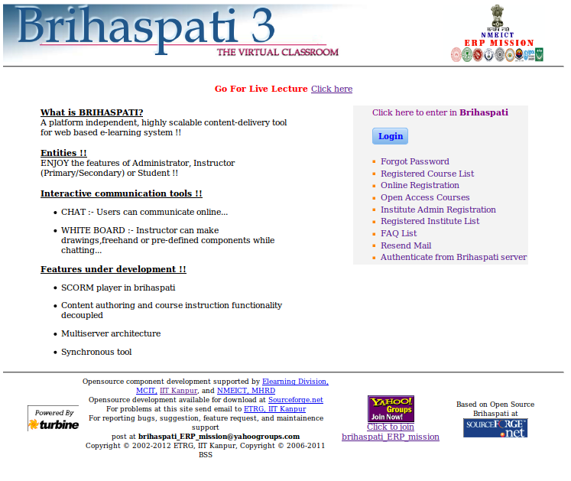

User & Password window is opened where you have to fill correct administrator name & password. Then click on Submit.
Find this page

Follow the steps below to open the Entry page.

Step1- Click Login
Step2- Click Forget Password
Step3-Click Registered Course list
Step4- Click Online Registration
Step5- Click Open Access Courses
Step6- Click Institute Admin Registration
Step7- Click Registered Institute List
Step8- Click FAQ List
Step9- Click Resend Mail
Step10- Click Authenticate From Brihaspati Server
Field

The table below details the entry fields on the Entry page.

Field | Description
Entry Page

User Name | Enter the User Name.
Password | Enter password. The password and User Name must be entered exactly to login. The maximum number of characters for the password should be 32. Passwords are case Sensitive.
Forget Password | Click the Forget password.
Registered Course list | Click the Registered Course list
Online Registration | Click the Online Registration.
Open Access Courses | Click the Open Assess Courses
Institute Admin Registration | Click the Institute Admin Registration.
Registered Institute List | Click the Registered Institute List.
FAQ List | Click the FAQ List.
Resend Mail | Click the Resend Mail.
Authenticate From Brihaspati Server | Click the Authenticate from brihaspati server.

Forgot Password

In this, Login Name has to be filled & you can get the new password.
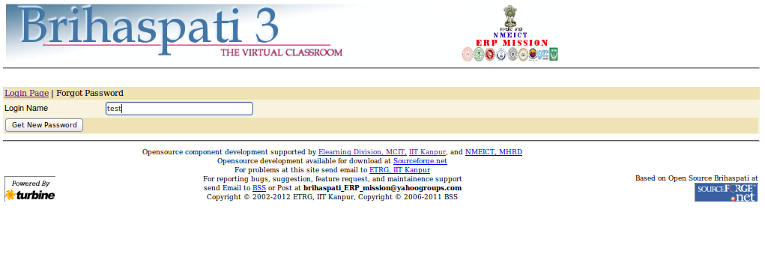

Registered Course list

Overview

When the user insert right user Id & password then page is opened where the following Options are viewed:-

Select value for listing, Search By Institute, Search by Course, Search Courses. Course Name, Institute Name, Status, Instructor Name, Instructor's Email. Anybody can send E-mails from here.

Because the Instructor’s E-mail Id is given with them. We can also view the first, previous, next & last page of it because pagination feature is available in Brihaspati. We can also select value for pagination to show the required number of courses from 10 to 50. We can also search courses by their Id, if we give the right Course Id only those Id's are viewed which are related to the given course Id.
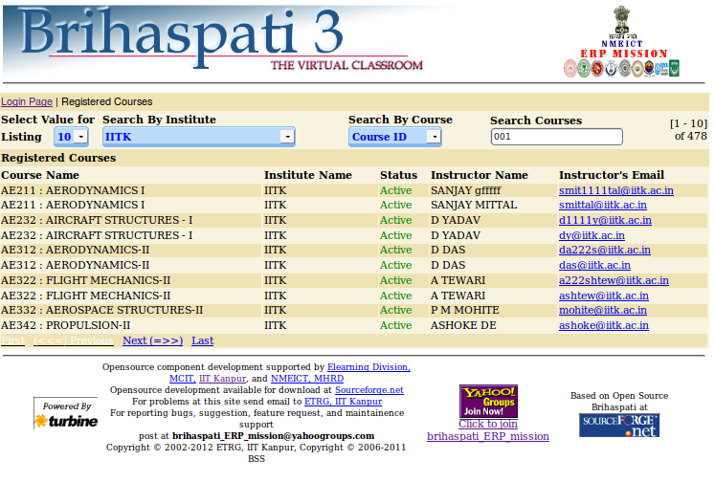
Online Registration
On Line User Registration:-
Student Registration:-
Please write your Email Id. Password, First Name , Last Name, Organization ,Select a Role , and Roll number if Student.
Select Institute Name-User select Institute Name.
Email-Write valid email address so that email reach to you.
Password- Write valid password.
First Name-Enter the first name.
Last Name-Enter the last name.
Organization- Enter the Organization.
Select Role-Please select a role from drop down list.
Student Program (If Student) - Please select a student program from drop down list.
Roll No (If Student) - Enter the Roll No.
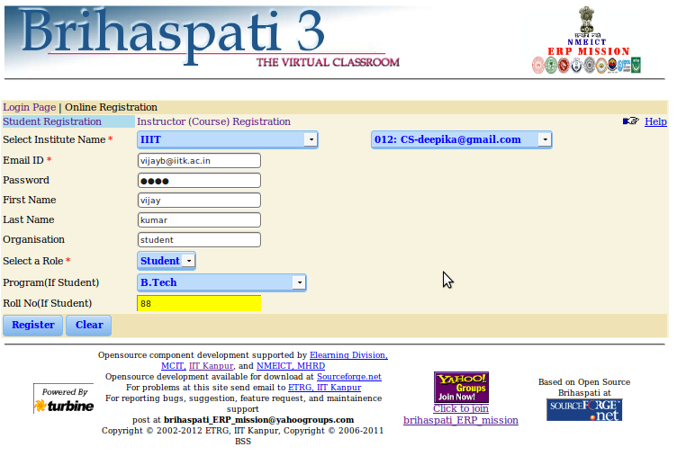
Open Access Courses
By Logging into the Login Page for Guest, User can access a secure environment to view courses, obtain course documents, view organization information and much more. User & Password window is opened where you have to fill correct User name is guest & password is guest. Then click on Submit.
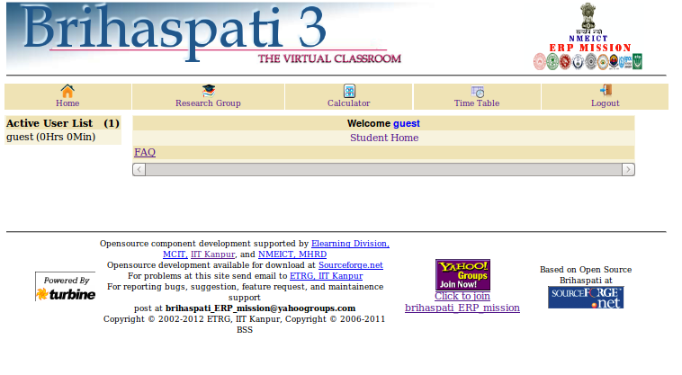

Institute Admin Registration
Institute Management
When we click on, “Institute Admin Registration” following page is opened and shows window:-
Please fill all Mandatory (*) field.
Institute Name- Write Institute name for example IITK or Indian Institute of Technology Kanpur ... etc.
Institute Address- Write Institute address.
City- Write city name where your institute belong.
Pin code- Write your six digit area pin code.
State- Write name of state.
Landline No- makes sure all the fields of land line no filled correctly.
Country Code- Write country code for example: - 91, etc
Note- Don't add + sign before country code.
Region Code- Write Region Code for example: - 0512, 0522, ...etc
Number- Write Phone Number for example: - 2597070, 2598759, ...etc
Institute Domain- Write domain name of your website for example iitk.ac.in, iitg.ac.in, ....etc
Type of Institute- Select any type Of institute from given option for example if your institute type is "govt." then select "govt." option.
Institute Website- Write your institute website name for example:- www.iitk.ac.in, ...etc
Admin's First Name- Write first name of institute admin.
Admin's Last Name- Write Last name of institute admin.
Admin's Designation- Write Admin's Designation.
Admin's Email- Write valid email address so that email reach to you and use as login name.
Admin's Password- Write secure password so that only institute admin used for login and access of content of brihaspati.
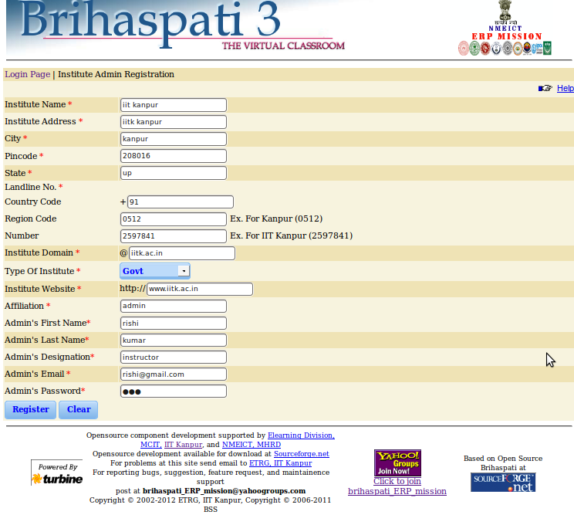

Fields
The table below details the fields on the Institute Admin Registration.
Field | Description
Institute Name | Enter the Institute Name for example IITK or Indian Institute Of Technology Kanpur, ... etc.
Institute Address | Enter Institute address.
City | Enter city name where your institute belong.
Pin code | Enter your six digit area pin code.
State | Enter name of state.
Landline No | Enter Land line number.
Country Code | Enter the country code for example :- 91,...etc
Region Code | Enter the Region Code for example :- 0512,0522, ...etc
Number | Enter the Phone Number for example :- 2597070,2598759, ...etc
Institute Domain | Enter the domain name of your website for example iitk.ac.in, iitg.ac.in, ....etc
Type Of Institute | Enter the any type Of institute from given option for example if your institute type is "govt." then select "govt." option.
Institute Website | Enter the institute website name for example:- www.iitk.ac.in, ...etc
Admin's First Name | Enter the first name of institute admin.
Admin's Last Name | Enter the Last name of institute admin.
Admin's Designation | Enter the Admin Designation.
Admin's Email | Enter valid email address so that email reach to you and use as login name.
Admin's Password | Enter secure password so that only institute admin used for login and access of content of brihaspati.

Registered Institute List
User can see Registered Institute.

Frequently Asked Questions (FAQ)
This page contains the list of all Categories by clicking the category you get the list of all FAQ's. And additional links for Adding, editing and deleting the FAQ.
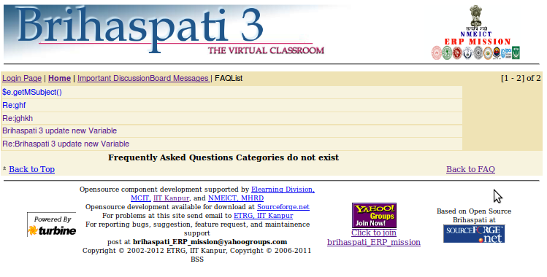

RESEND MAIL
If you have recently registered yourself or your institute on Brihaspati.
Or if you have updated your profile on Brihaspati. And you didn't get the confirmation mail
on the registered or updated email address. Then enter your email address in the input box and click on "Get New Mail" button. The confirmation mail will be resent to your email address.
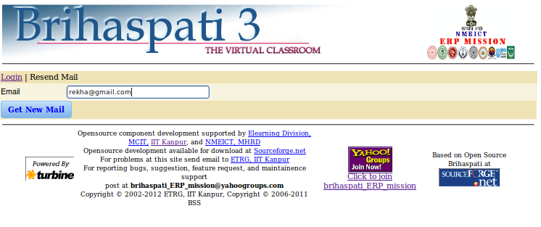

Authenticate From Brihaspati Server

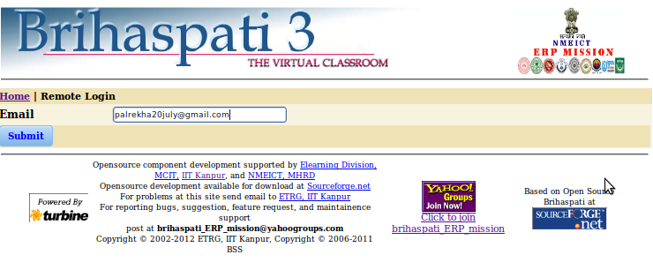

Change Password
Overview
Passwords can be changed from the Change Password page. The Change Password page is accessible through the Personal Information features. Each user must enter the old password and new password after then Retype New Password for the user.

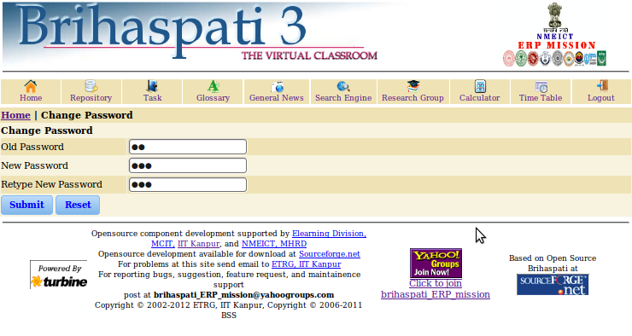
Find this page
Follow the steps below to open the Change Password page.
- Step1 Select Old Password
- Step2 Select New Password
- Step3 Select Retype New Password

Fields
The table below details the fields on the Change Password page.
Field | Description
Old Password | Enter a old password for the account.
New Password | Enter a New Password for the account. The password must be at least six characters and contain no spaces or special characters.
Retype Password | Enter a Retype password.

Secure your Password
Passwords enable users to access all of their personal information. To maintain security users should not use not share their password with others.

Chat
To save chat and white Board, you need to make some changes in java policy file.Download Java SE Runtime Environment.If chat applet cannot connect, change the password once to create account for chat. Change Password. To save chat and white Board, you need to make some changes in java policy file.

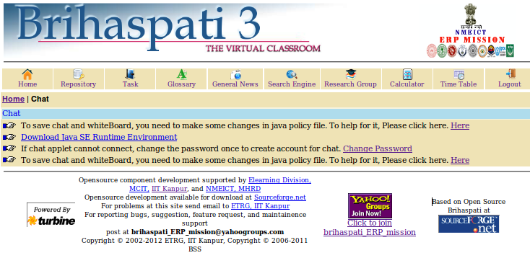

User Profile
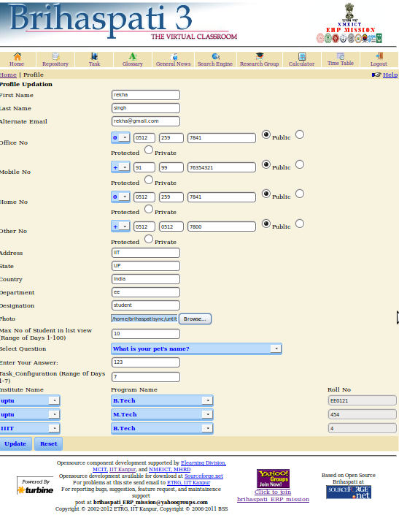

Fields:-
The table below details the fields on the Change Profile Page.
Field | Description
First Name | Enter First Name
Last Name | Enter Last Name
Alternate Email | Enter Alternate Email
Office No | Enter the office number.
Mobile No | Enter Mobile No.
Home No | Enter Home No
Other No | Enter Home No
Address | Enter Address
State | Enter State
Country | Enter Country
Department | Enter Department
Designation | Enter Designation
Photo | Enter Photo
Max No of Student in list view (Range of Days 1-100) | Enter Max No of Student in list view
Select Question | Select Question
Enter Your Answer | Enter Your Answer
Task_Configuration (Range 0f Days 1-7) | Enter Task Configuration(in Days)
Institute Name | Enter Institute Name
Program Name | Enter Program Name
Roll No. | Enter Roll No.

Institute wise Chat/Discussion Board
Please select the Institute wise Chat/Discussion Board.

General Discussion Board
The General Discussion Board is another be used to enhance a course Web site. Topics are posted to the General Discussion Board that course participants can reply to and converse about on-line. This feature is similar to the Lightweight Chat, but is designed for asynchronous use, meaning Students do not have to be online at the same time to have a conversation. An additional advantage of the General Discussion Board is that Student conversations are logged and organized. Conversations are grouped into threads that contain a main posting and all related replies for easy retrieval. We can also View messages & Compose message from this page. Work Group is also shown on this page.

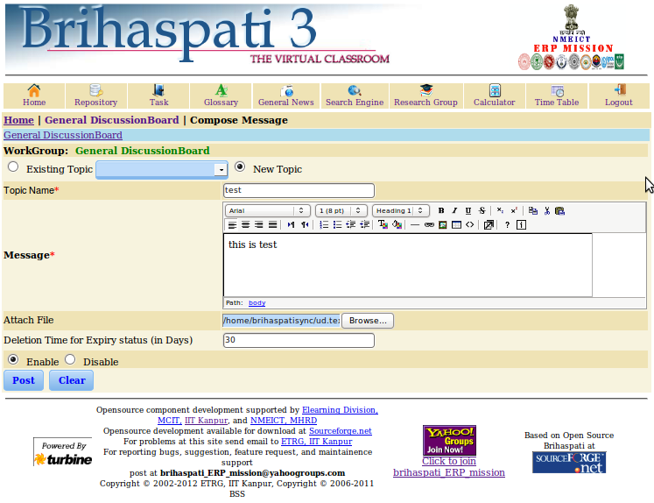

General Show Message:- The Sender Name, Posting Date, Subject, Task (View, Edit & Reply), Status & Expiry Date are shown. We can view all the messages from here & can also Delete, Edit & Reply them. We can also Compose message from here & can View Unread messages too.

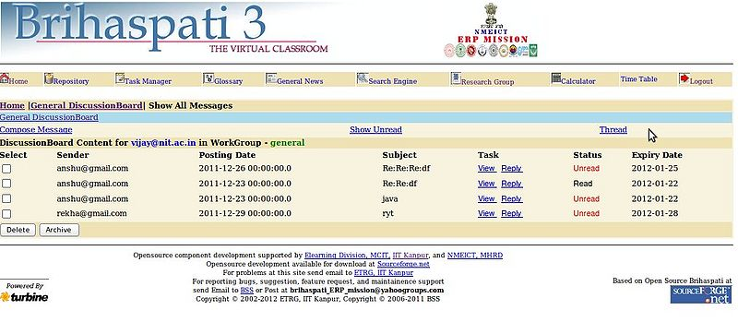

General Show Archive:-

We can view all the messages from here & can also Subject,Task.

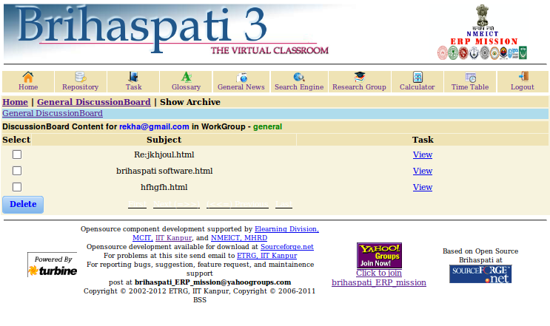

Compose Message
We can Compose & Send messages from here. Topic name have to be fill when we select new topic otherwise we can select from existing topic also. We can write message & can also attach files with the message and can also assign the deletion time for Expiry status (In Days).

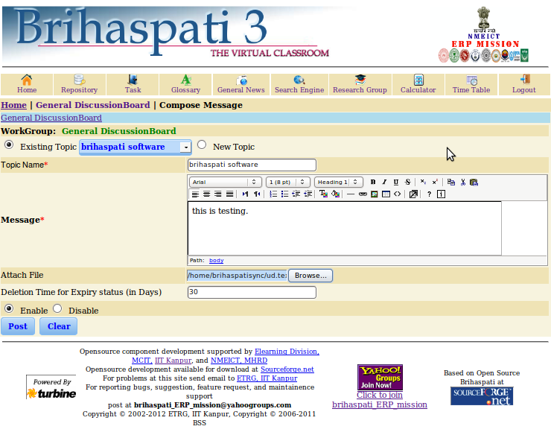

FAQ
We can view all the FAQ list.
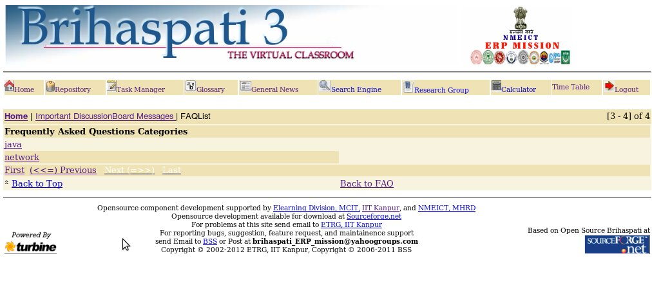

My Bookmarks
This page contains the Bookmarks which are created by student by this link student can access the Bookmarks.The page contains two links:
Add Bookmarks
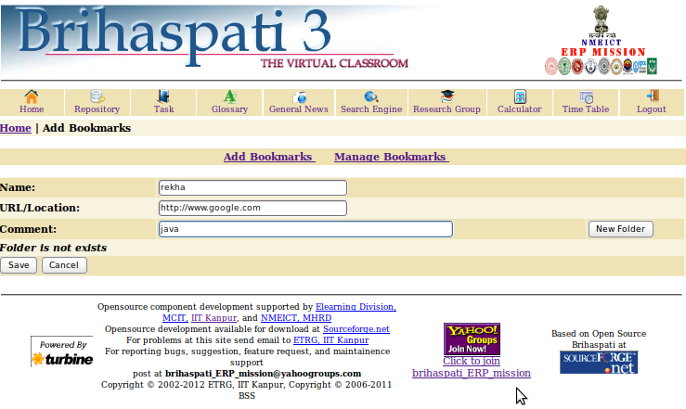

From here we can add bookmarks.
- Fields:-
The table below details the fields on the add bookmarks Page.
Field | Description
Name | Enter the Name
URL/Location | Enter URL and Location Ex. http://www.iitk.ac.in
Comment | Enter the comment.
New Folder | Enter a name for the new folder

Manage Bookmarks
View
By this link instructor can access the Bookmark.
Move
By this link Move the particular bookmark in any folder. by selecting the folder for moving the bookmark
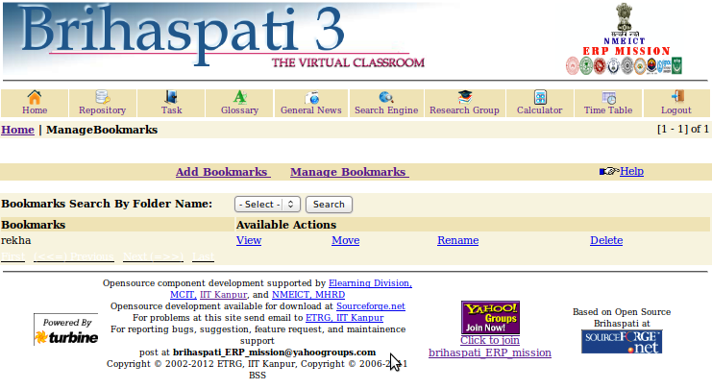

Rename
By this link Rename the particular bookmark.which you want to Rename.
Delete
By this link Delete the particular bookmark.which you want to remove.

Personal Area
When we click on Personal Area the new window is opened, the following links are given there:-
Find this page
Follow the steps below to open the Personal Area page.
- Private Area
- Shared Area
- Upload For Private Area

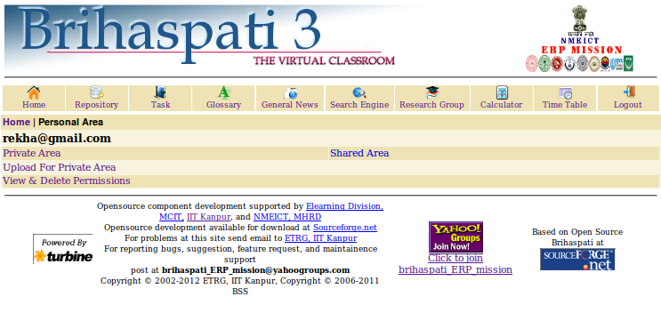
Fields
The table below details the fields on the Personal Area page.
Fields | Description
Private Area | List of Privates notes/Topic.
Shared Area | List of All Users.
Upload For Private Area | Click the Upload For Private Area.

Private Area
When we click on Private Area the new window is opened.

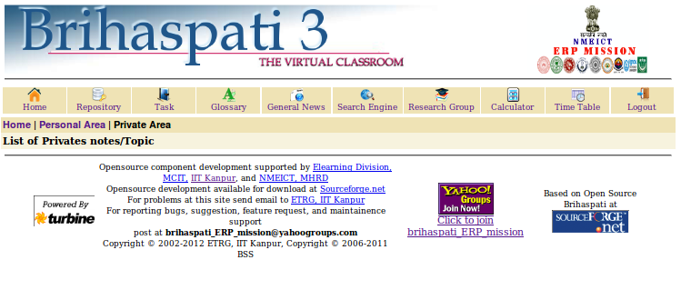
Shared Area
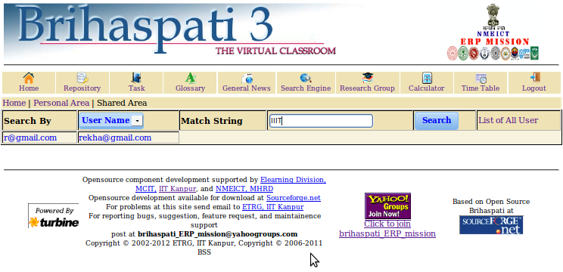
When we click on Shared Area, the List of all Users are shown. When we click on user, if the user have file, it shows list of files otherwise it shows the message User’s have no file in Shared area”.

Upload for Private Area :-

When we click Upload for Private area , the Existing Topic, New Topic &Topic Name is shown. We can attach the file through browse feature & Upload it. “Please make sure do not have “+” characters in uploading file’s name.
- Upload Content
In Course Content: - We get the “Topic Name “, & we can perform some actions on the topic such as:-

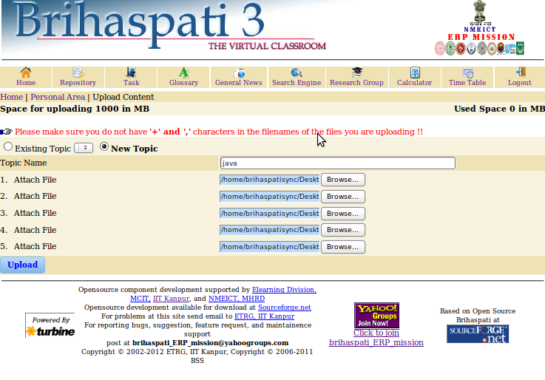

The uploading of file(s) confirmation is shown on the top of the window when any file has been uploaded.

Personal Calendar
The Calendar allows users to view Calendar items by Date, Time& Day, Week, Month, or Year. Users can also manage the following events through the Calendar: Upcoming and past events can be viewed daily, weekly, or monthly and organized into categories. When we click on “Personal Calendar” in Administrator’s Interface, the Calendar page is open with the chart of Holidays, Academic Events, Calendar, Current Date etc. are shown on this page.
- Pink colour:- Pink colour is showing “Academic Events”.
- Green colour:-Green colour is showing “Holidays (Restricted)”.
- Red colour:- Red colour is showing “All Sundays” in the Month.
- Blue colour:- Blue colour is showing “Normal Dates”.

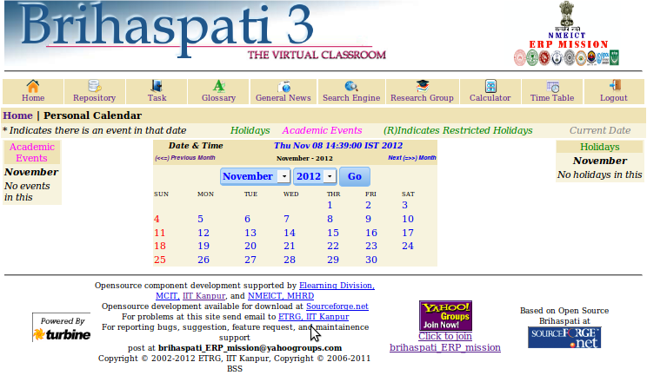
--> Current Day, Date & Time is shown on this page. We can also search the calendar for any month of the year.
--> When we click on the Academic Event: -
The Start Time, End Time, Details, Available Actions are shown.
--> When we click on the required Academic Event, then the specific Event's information will be opened we can delete any event from here & can add a new event also.And after filling these, we can reset &insert it.And when we add event the date with any event or holiday is shown with then “*“sign. And when we click on that date, we can access whole the information about that.
Find this page
Follow the steps below to open the Calendar page.
Step 1 Select Calendar.
Functions
To use the functions available on the Calendar page, follow the table below.
TO . . . | Click . . .
View events for a specific date and time | Select a Date and Time and the calendar will immediately display events for that Time.
Create an event and add it to the Calendar | Add Event to access the Add Event page.
View events by Day, Week, or Month | View events for the Current Day,  Current week or Current Month.
View event details | On a Calendar event to view details.
Remove an event | Remove an event from the Calendar page. This action is irreversible.

Brihaspati Global

Home Page
After Login the following “Home Page” is shown. And when we click on “Home”, then the same page is opened.

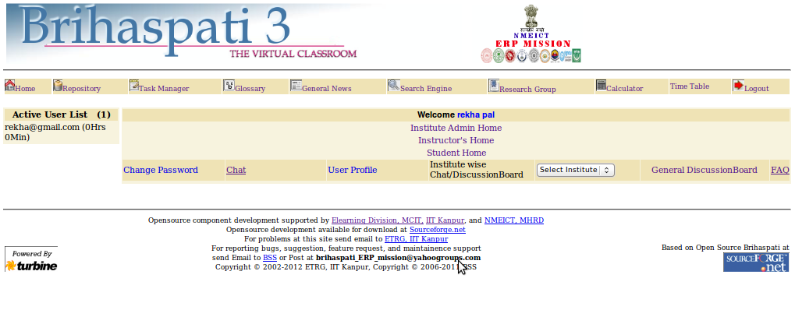

Repository

When we click on Repository, the repository browser is opened & Author Name, Contents of Author, Files of Topic are shown on this page. The authors list is viewed on screens we can select any author from here to view its contents & files of topic .When we click on any specific author name his contents are shown .When we click on any of his contents, the topic of files can be viewed on the screen.
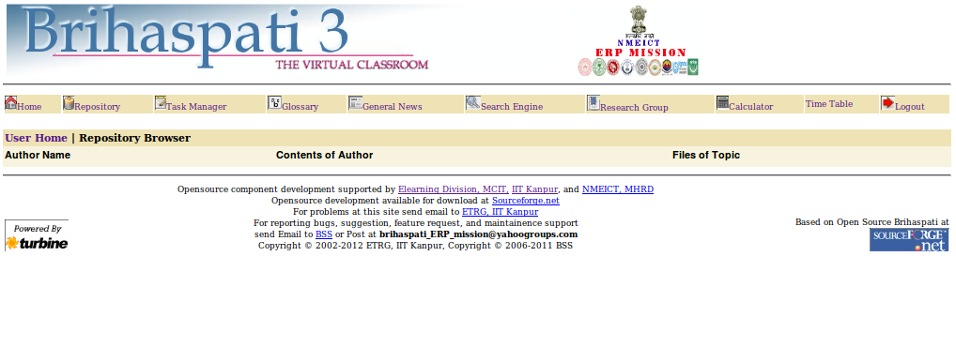

Task Manager

On this page, all the Tasks are shown, there actions which have to be performed on the particular task is shown, such as Delete, Edit & Move. And we can also Add Task from the given link on this page.
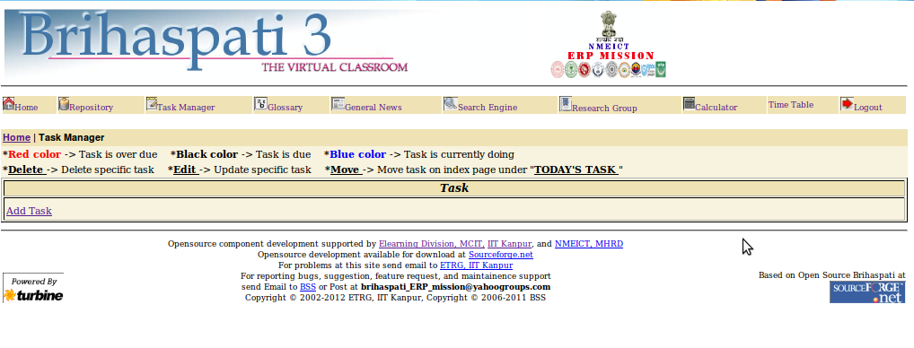

Note: - When the task name is shown with the Red colour, it means that “the task is Overdue”. When the task name is shown with the Blue colour, it means that “The task is due”. When the task is shown with the Black colour, it means that “The task is currently under process”.

Glossary

When we click on “Glossary”, page is opened and show link such as:- Search, Insert word and Delete/Edit links are shown on this page.

- Search Word
- Insert Word
- Delete/Edit

Search Word
By this link we can search word.

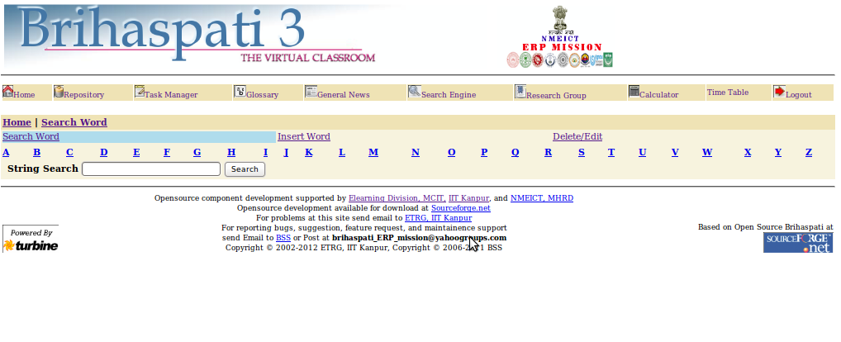

General News

When we click on General News: - The window opens where all the news topics are shown. We can view the required news by clicking on that particular news title. We can update the news by clicking on the Update link. When we click on particular News Title the window opens where the news description has been written and we can also delete or Update any news by clicking on the given link and also can add more news. When we click on news title the clicked title is shown with the”*” sign.

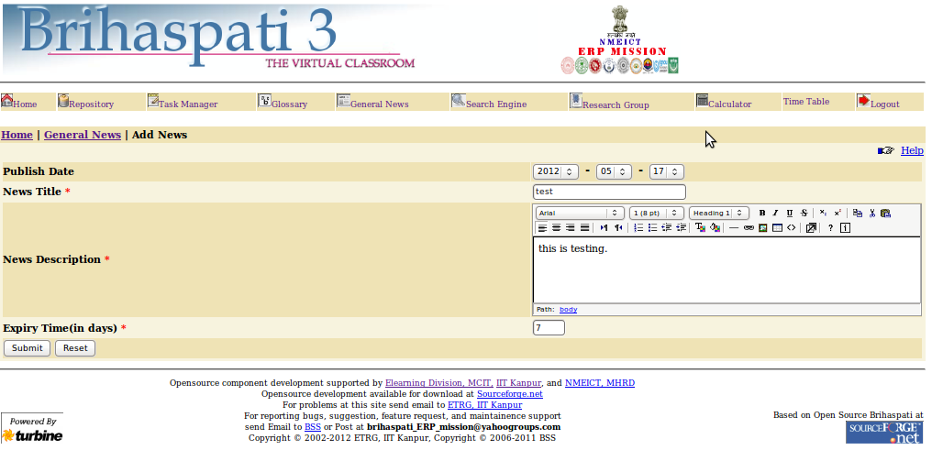

Search Engine

When we click on Search Engine: - Search the web option is there, we have to type the word which we want to search. We can search it by three options.

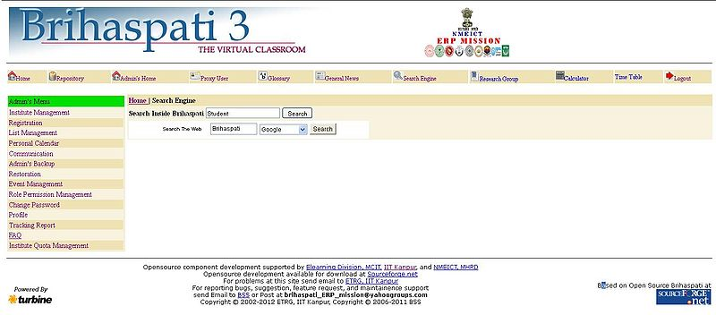

Research Group

This is the main page for Research Repository Group. Currently there are two links i.e. Create Research Repository and Research Repository Groups.
Create Research Repository
Research Repository Groups

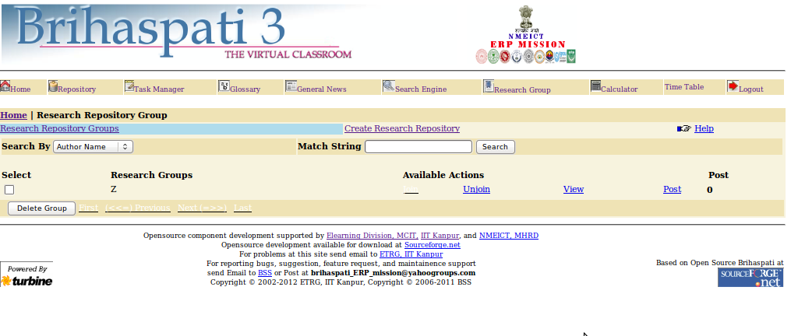

Calculator

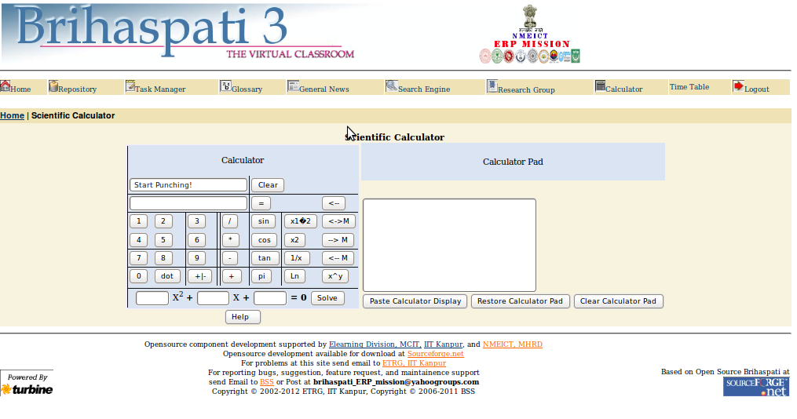
When we click on “Calculator”, then the scientific calculator is opened. We can perform any type of calculation with the help of this calculator.

Time Table
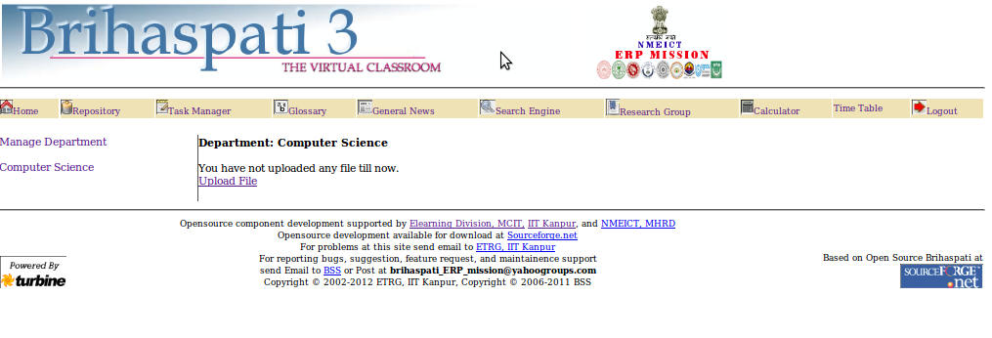

Log out

And we can Log out from Global student Home page by clicking on the “Log out” option which is provided on the Home Page of Global student. After clicking on it we come on Login page of “Brihaspati”.

