Student Home

Course Name

This is the first page in the sequence of pages which comes after the user enters into a particular course. This page contains navigational links for accessing other pages inside a particular course. The user session corresponding to a particular course starts here and remains valid till he comes out of the course.
The page has two types of links. The Course Managemant and Student Management and backup links are visible only if the user is an instructor in a particular course. Using these links he can manage course related and student related details in the course.
We can click on any specific Course and when we click it, the page opens where:-
Assignment, Course Content, Communication, Exam, Group management, Course Calendar, View Marks, Wiki, and Scorm Player .

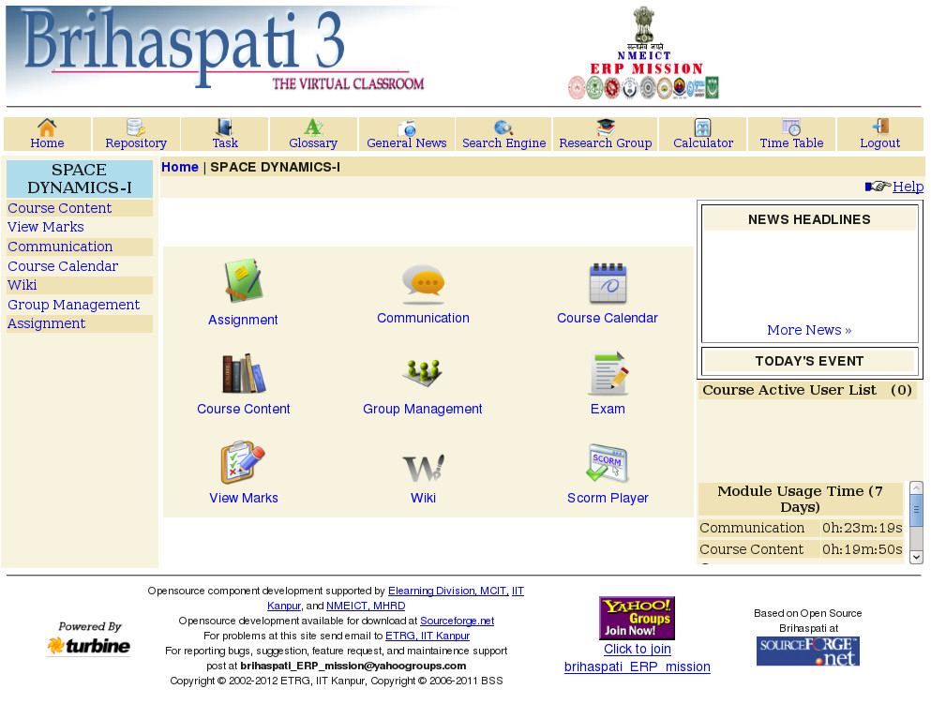

Find this page

Follow the steps below to open the Modules.

Modules

- Assignment
- Course Content
- Communication
- Group Management
- Course Calendar
- View Marks
- Exam
- Wiki
- Scorm Player

Fields

The table below details the fields on the Modules.

Modules | Description
Assignment | This is the main page for assignment..  - View Assignment/Answer  - Repost Answer
Course Content | This is the Course Content or navigating through the course. Course Content page there are 3 links i.e.  - Course Content  - Course Profile  - Upload Course Content
Communication | This is the Communication page there are 5 links i.e.  - Local Mail  - Chat  - Read Notice  - Discussion Board
Group Management | This is the Group Management page. Currently there are 2 links i.e.  - Join Group  - View Activity
Course Calendar | Enter the title of the event. This title will appear on the Calendar page at the date and time indicated on the Event Time fields Click the select date values or click the icon to select a date from the Personal calendar.
View Marks | Show the marks.
Wiki | Wiki is website which has RCS as database and allows its users to become its page authors. Wiki is course specific that is you can see only pages of that course in which you are registered
Exam | This page provides an interface by which A Student can Attempt any Quiz or Practice Quiz and can see Score Card and Grade Card.  - Score Card  - Grade Card  - Attempt Quiz  - Practice Quiz
Scorm Player | Student can scorm play.

Assignment
This is the main page for assignment. Currently there are 2 links i.e. View Assignment, Repost Answer.

The table below details the fields on the Assignment Page.

Fields | Description
View Assignment | Instructors and Students both have an access to this page.
Repost Answer | This page contains Topic name and Attach file option.

View Assignment

This is a link to view the assignment. Instructors and Students both have an access to this page. For viewing the Assignment, we have to select the Topic name.

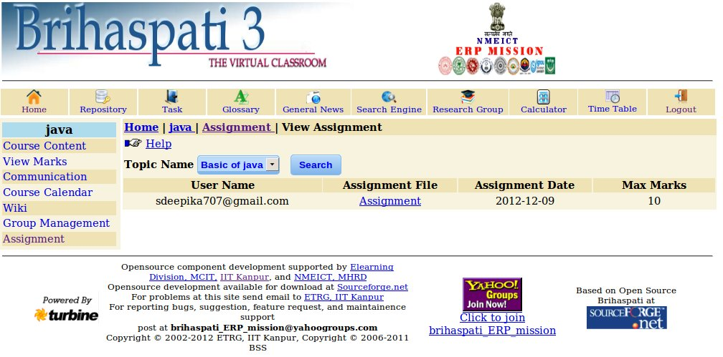

Repost Answer

This page contains topic name and Attach file option. If you have the permission to Resubmit Assignment.

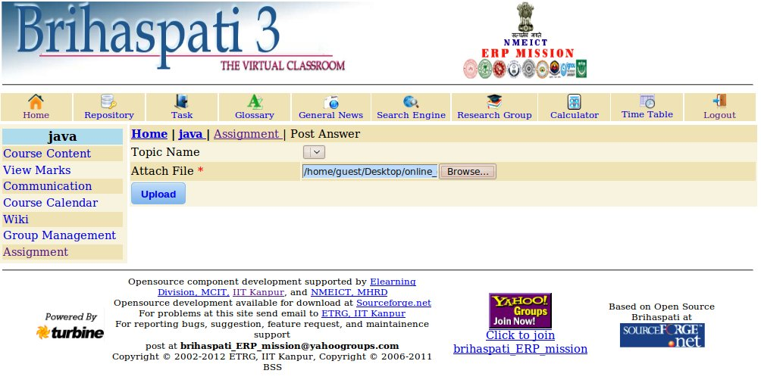

Course Content

This Page is the main page for navigating through Content material inside a particular Course.
The page Course Contains links for browsing through the Content material and additional links for editing and publishing the Content in case the user is an Instructor in the particular Course.
We get the “Topic Name “, & we can perform some actions on the topic Such as:-

Find this Page

Follow the steps below to open the Course Content page.

Step 1- Topic Name
Step 2- Available Action

Fields
The table below details the field on the Course Content page.

Field | Description
View | Click the view link.

View
When we click on any particular “Topic Name”, the description is shown & attach files are also shown which we can View or Download. And the Day, Date & Time with that particular File is also mentioned.

Course Profile
Course Management System is an information system that is used by Instructor to post information on the web without having to comprehend other computer languages. Course Management System gives an instructor a set of tools and a framework, which makes it easy to create online course content, and also afterward aiding the teaching of the course along with student interaction.

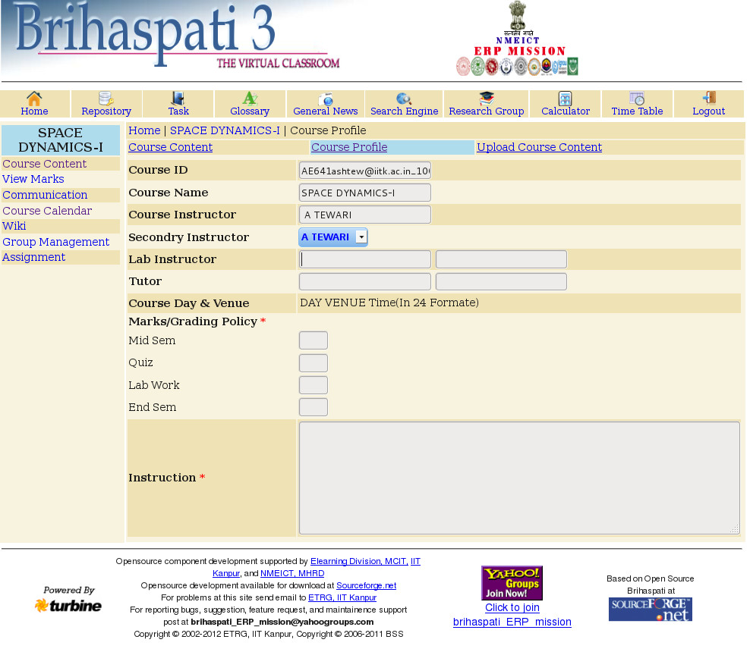

Upload Course Content
The upload page is available to the instructors in a particular course. This page provides an interface by which the instructor in a course can upload content material in his course. The instructor can choose to upload content for an existing topic or a new topic. There is a drop down list containing list of topics in the particular course. The instructor can choose one existing topic while uploading content. He can also create a new topic there itself by selecting new toipc. In this case he should give a valid topic name. The name of the topics inside a course should be unique.
The Instructor can also direct Publish the upload content by selecting the Publish checkbox. There is fascility for multiple file upload i.e.the instructor has the option of uploading more than one files in one go. This helps him in saving time.

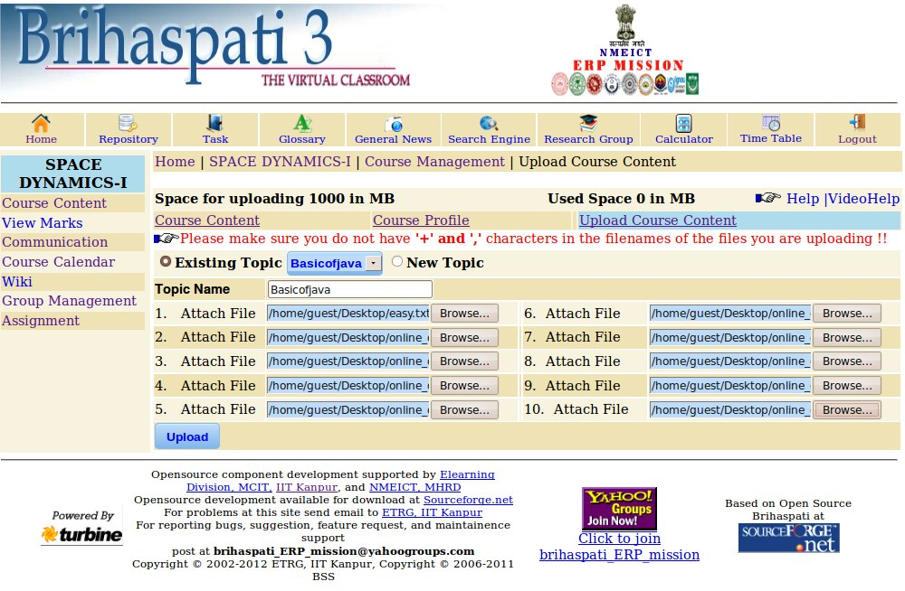

Fields

The table below details the fields on the Course Content Page.

Fields | Description
View | Click the view link.
Publish. | Click the Publish link.
Edit | Click the Edit link.
Delete | Click the Delete link.

View Content

When we click on any particular “Topic Name”, the description is shown & attach files are also shown which we can View or Download. And the Day, Date & Time with that particular File is also mentioned.

Communication

Instructors and students can view important messages from the institution staff and faculty on the Announcements page. Users can sort announcements by category (courses or institution) and post date. In addition, instructors can create and post announcements for the students in their Brihaspati.
Students are encouraged to communicate with fellow classmates and Instructors as part of the learning process. The Communication Center allows users to:

Find this page:-

Follow the steps below to open the Module.

Module:-

- Local Mail
- Chat
- Read Notices
- Discussion Board

Module | Description
Local Mail | Click the Local Mail.
Chat | Click the Chat.
Read Notices | Click the Notices.
Discussion Board | Click the Discussion Board.

Local Mail

Click Local Mail on the Course menu or from the Communication.

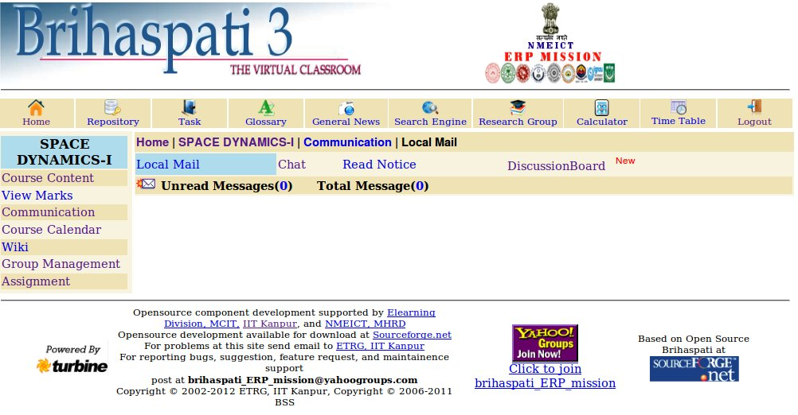

Chat
To save chat and white Board, you need to make some changes in java policy file. To help for it, please click here. Here Download Java SE Runtime Environment. If chat applet cannot connect, change the password once to create account for chat. Change Password to save chat and white Board, you need to make some changes in java policy file.

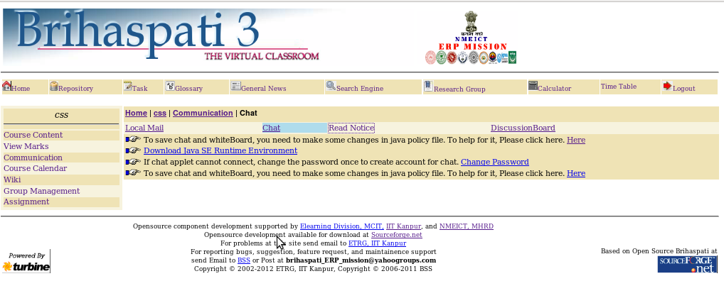

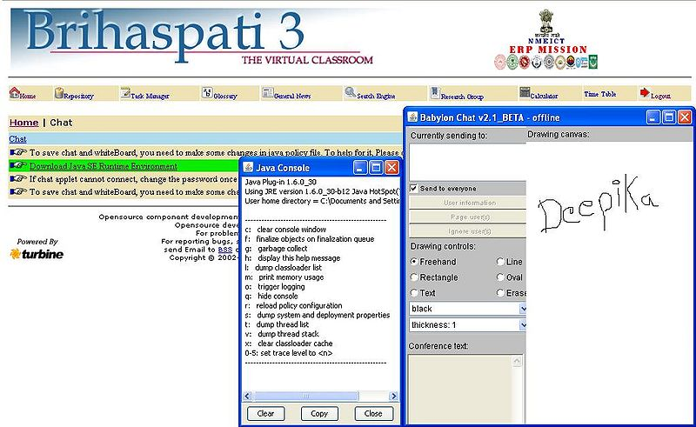

Discussion Board
The Discussion Board is another communication tool that can be used to enhance a course Web site. Topics are posted to the Discussion Board that course participants can reply to and converse about on-line. This feature is similar to the Lightweight Chat, but is designed for asynchronous use, meaning Students do not have to be online at the same time to have a conversation. An additional advantage of the Discussion Board is that Student conversations are logged and organized. Conversations are grouped into threads that contain a main posting and all related replies for easy retrieval

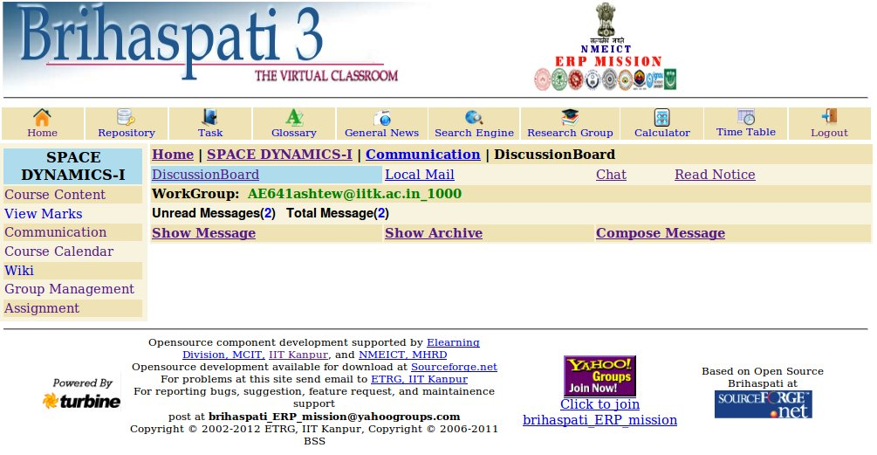

Find this Page

Follow the steps below to open the Message.

Step1- Unread Message.
Step2- Total Message.
Step3- Click the Show Message.
Step4- Click the Compose Message.

Fields:-
The table below details the fields on this page.

Field | Description
Unread Message | In this, Number of Unread Messages.
Total Message | In this, Number of Total Messages
Show Message | When we click on Show Messages the Mail Box. open & the Sender Name, Subject of mail, Date, Task & Status (Read or Unread) & Check boxes are shown.
Compose Message | When we click on Compose Messages, the new page will open. In this page, we have to fill all the entries like: - To, Subject & Message. We can attach the file through browsing. We can send this file or clear it.

Compose Messages

The Student can Compose & Send (Post) Messages from here. Topic Name have to be fill when we Select New Topic other wise we can Select from existing Topic also.We can write message & can also Attach Files with the Message and
Eetion Time for Expiry Status (In Days).

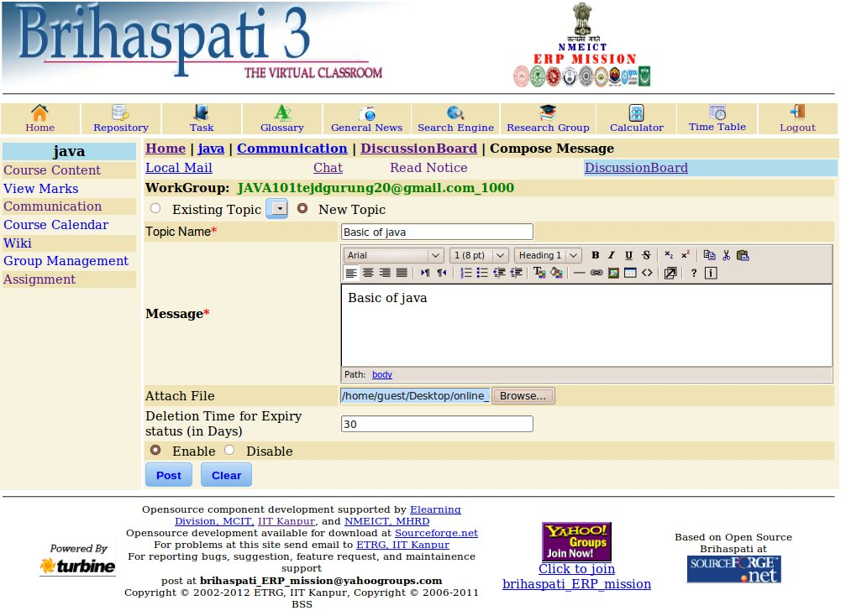

Note: Deletion time for expiry status (in days):- In this module, we can set it as Enable or Disable.
When the student selects “0” days, then the message are shown: - “Deletion Time should not be less than1 day & greater than 365 days”. That’s why it can't be posted. When the student select days less than 1 & greater than 365 days, then it will work as Disable & its Expiry time will be “Infinite”.

Find this page

Follow the steps below to open the Create New Message page.
Step 1 Enter the Subject.
Step 2 Write the Message.
Step 3 Click Enter the file path or click Browse to locate the file.

Fields

The table below details the fields on the Create New Message page.

Field | Description
To | All users enrolled in the course will appear.
Topic Name | Enter the topic name.
Message | Write the Message.
Attach Files | Click here to add attachments. Select Browse on the page that appears and navigate to the file that should be attached to the email. Enter the file path or click Browse to locate the file.

Show Message

From the list of show message, choose a topic that interests you and click on it. When the opens, you will see a list of messages. Choose a subject from the list and click on it to open the message. The replies to the messages are below, on the same page, so you can easily read all replies and follow the Local mail.

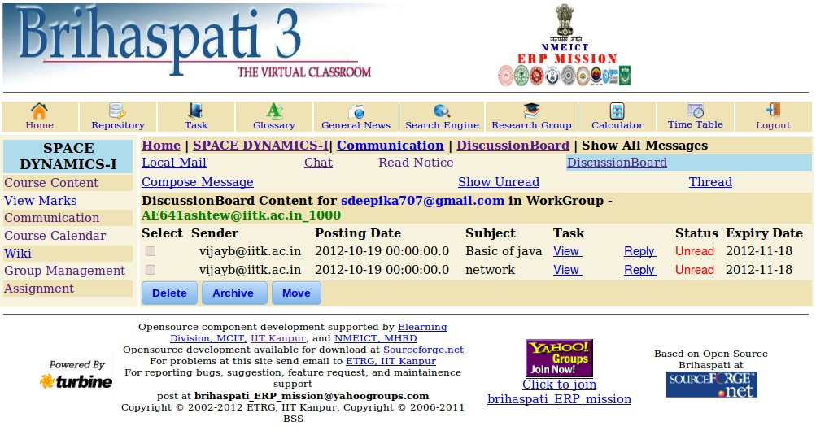

1. Task: - In Task, we can View, Edit or Reply for any mail.
2. Status: - The Read & Unread status is shown with different colors to differentiate between read & unread messages.
3. Reply: - The page opens, where we see the Receiver, Sender, Subject, Message & Attached file. And can also browse the attach file then send it.

Show Archive:-
We can view all the messages from here & can also Subject, Task.
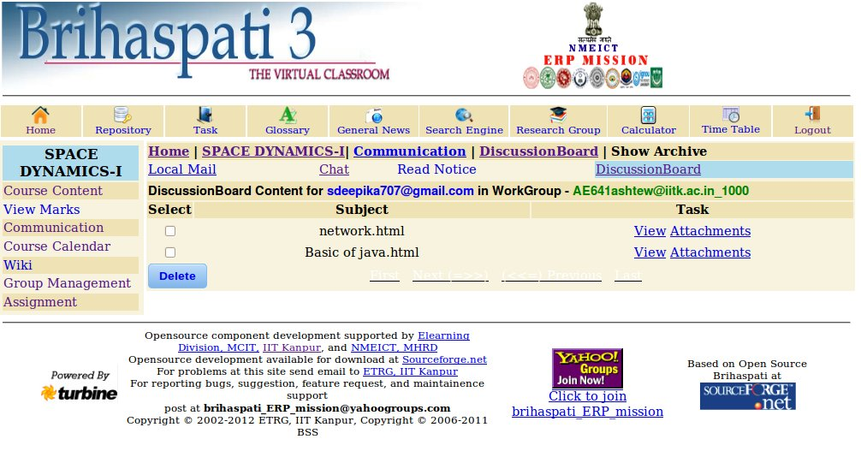

Thread

We can view all the messages from here & can also Subject,Task.

Read Notices

Read Notices: - The students can read the notice if available. If there is notice for the students then the following message is shown.

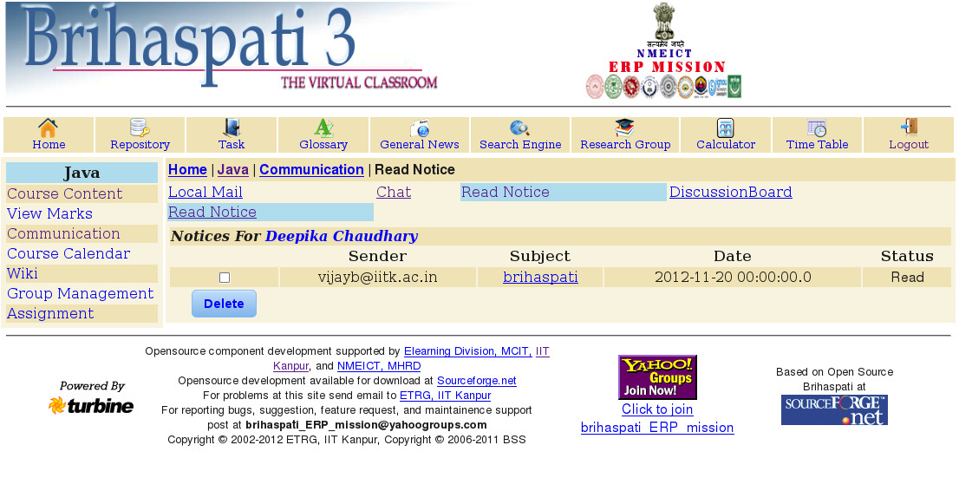

Group Management

To Join a Group the user must click on the button. This is the main page for Group Management. Currently there are 2 links i.e.

1. Join Group
2. View activity

Find This Page:-

Follow the steps below to open the Group Management page.
Modules:-
- Join Group
- View activity
Fields The table below details the fields on the Group Management Page.

Field | Description
Join Group | If you selected Users self-nominate to a group the Join button will be displayed next to the Group Heading. See below:
View activity | Click the View activity.

Join Group :-

The join group link provide facility to students to join available groups. (Allow students to select the groups they want to join by using sign-up forms)

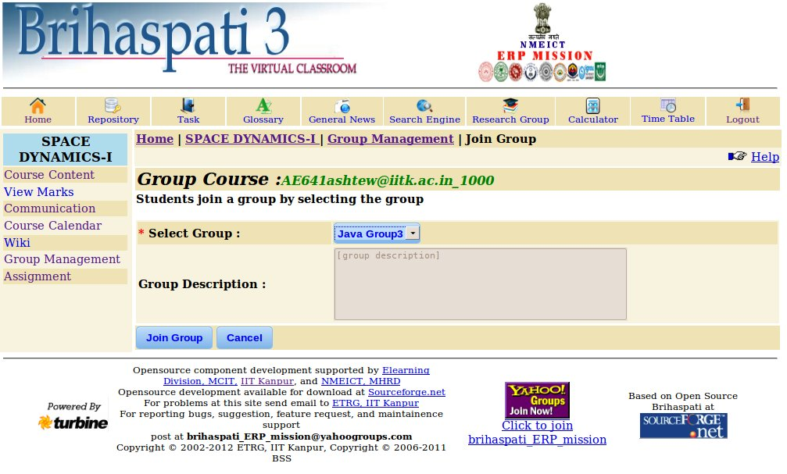

View Activity:-
This link provide facility to group members to access the available activity which is given by the Instructor and also give the information about the group members and types of groups.

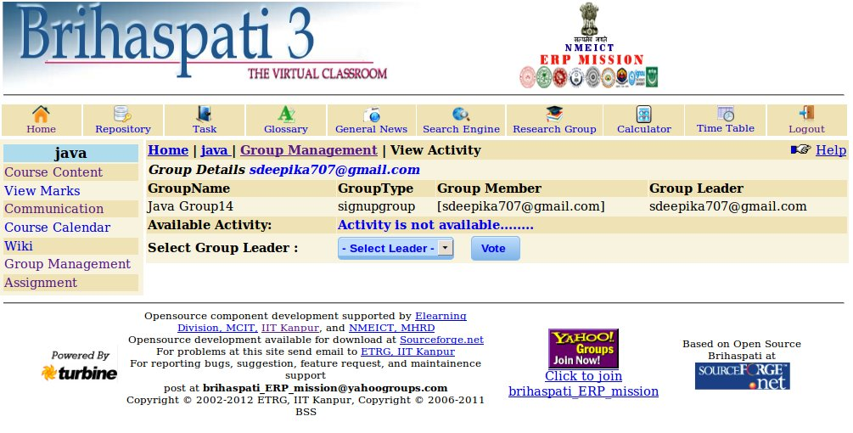

Exam

This page provides an interface by which A Student can Attempt any Quiz or Practice Quiz and can see Score Card and Grade Card.
This page contain Following links.
1.Attempt Quiz
2.Practice Quiz
3.Score Card
4.Grade Card
Attempt Quiz
If the time of quiz is running then you will find the link "START QUIZ" And if the time is left to Start the Quiz a message "Quiz is scheduled but it will start at time"is shown if Quiz is not scheduled message "There is no Quiz to Attempt"is shown.Once you have attempted any Quiz that Quiz will not be displayed again in the List Box. To Attempt Quiz select the Quiz from List Box that you have to attempt and click to "START QUIZ" Button. And you will get a message "Are you sure to start Quiz." and Quiz will be start with a view which has following Information.
- Quiz Name:It shows the Name of Quiz.
- Running Timer:It shows the Remaining time.If You have Five Minutes Remain then a message "You have only Five Minutes remaining. " is shown.
- Total Time:It shows the time Alloted to Attempt the Quiz.
- Total Marks:It shows the Total Marks of your Quiz.
- Total Question:It shows how many Questions are in Quiz.
- Questions:At the Left side Question's List is shown.
At the time of attempting Quiz go with the Following Instructions.
1. To Attempt the Question clicks to Question in the Question List.
2. When you will click on Question that Question will be shown at the Right side and corresponding Answers will be shown bellow it.
3. To save the Answer select the proper Answer from Answers shown bellow Question at the Right Side and then click to "SAVE ANSWER" Button.
4. Don't forget to save the answers otherwise you may be Failed.
5. To submit the Quiz click to "SUBMIT QUIZ" Button.
6. If you don't submit the Quiz and alloted time is over then a Message "Your Alloted time is over.” is shown and Quiz is submitted automatically.

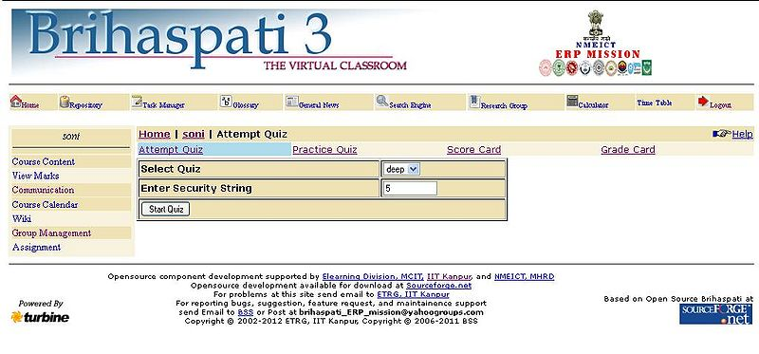

Practice Quiz
If there is No Practice Quiz is scheduled then message "No Practice Quiz to Attempt" is Shown.Otherwise you will find the link "START QUIZ"with a List Box of scheduled Quizes. To Attempt the Practice Quiz select a Quiz from List Box and click to "START QUIZ" Button.And you will get a message "Are you sure to start Quiz." and Quiz will be start with a view which has following Informations.
- Quiz Name:It shows the Name of Quiz.
- Running Timer:It shows the Remaining time.If You have Five Minutes Remain then a message "You have only Five Minutes remaining. " is shown.
- Total Time:It shows the time Alloted to Attempt the Quiz.
- Total Marks:It shows the Total Marks of your Quiz.
- Total Question:It shows how many Questions are in Quiz.
- Questions:At the Left side Question's List is shown.
When you are attempting Quiz go with the following instructions. 1. To Attempt the Question click to Question in the Question List.And you will get that Question at the Right side with the corresponding Answers. 2. To save the answer choose a proper answer and click to "SAVE ANSWER"Button.Don't forget to save the answer otherwise you may be Failed. 3. To submit the Quiz click to "SUBMIT QUIZ"Button. If you don't submit the Quiz and alloted time is over then message "Your Alloted time is over" is shown and Quiz is submitted automatically. When you will Submit the Quiz,Score Card will be shown with Total Marks ,Score ,Minimum Passing Marks and Percentage. To get the Answer Sheet click to "ANSWER SHEET" Button in score card.Answer Sheet shows the Questions that were in the Quiz, Options Answers with the corresponding Question, Your Answer, Correct Answer and marks Obtained
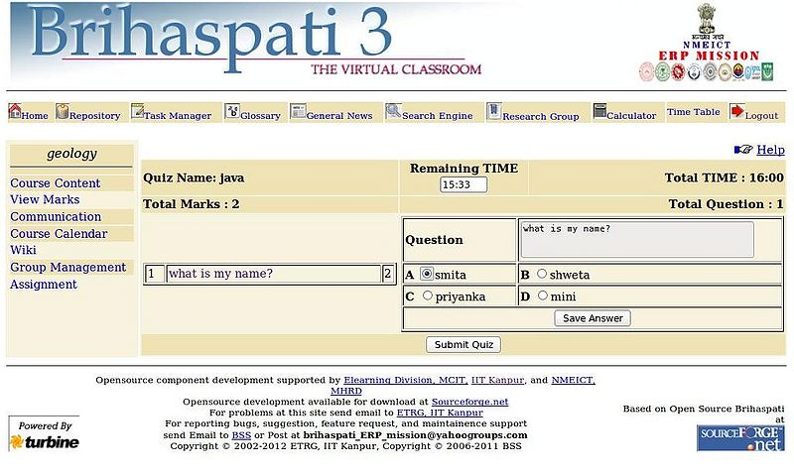

Score Card
In score card student can see own score and if quiz type is Short type student can see the right answer of the Question.If any Quiz is attempted then you will find a link "SHOW SCORE CARD" with a List Box of Quizes that you have attempted. To see your score card click to "SHOW SCORE CARD" Button.And you will get your score card with the Following Information.
- Total Marks:It shows the Total Marks of Quiz.
- Score:It shows the Total score that you have secured.
- Min Passing Marks:It shows the Minimum Marks that is required or Passing.
- Percentage (%):It shows the percentage of your total secured marks.
- Result:It shows Whether you have passed or Failed.
To click on "ANSWER SHEET" Button you can get your Answer Sheet with the Followinf Information. Question:It shows the Attempted or not attempted Questions. Options : Corresponding Answers. Your Answer: your Selected Answer. Correct Answer:Correct Answer selected by the Instructor. Marks Obtained: Marks that you have secured.

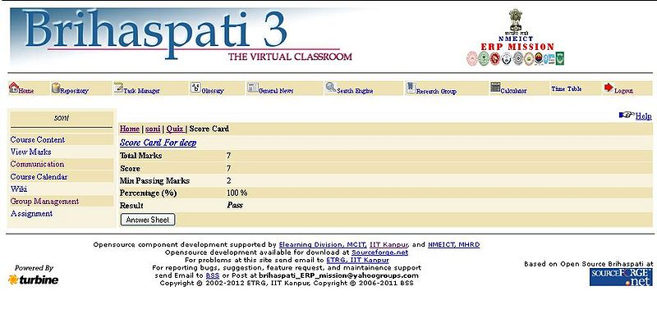
Grade Card
If any Quiz is attempted then you will find a link "SHOW GRADE CARD" with a List Box of Quizes that you have attempted. To see your grade card click to "SHOW GRADE CARD" Button.And you will get your grade card with the Following Information.
- Name: It shows name of the student.
- Roll No.:It shows Roll Number of student.
- Marks:It shows the Total Marks of Quiz.
- Grade:It shows you have Passed or Failed.
- Average:It shows Percentage of your total secured marks.
- No. of correct Answer:It shows number of correct Answers.
- Total No. of Question:It shows number of Questions are in the Quiz.
- Total Time Allowed for Quiz:It shows total time alloted to you.
- Time taken by student:It shows Total time taken by you to solve the Quiz.
To Print your Grade Card click to "PRINT" Button.
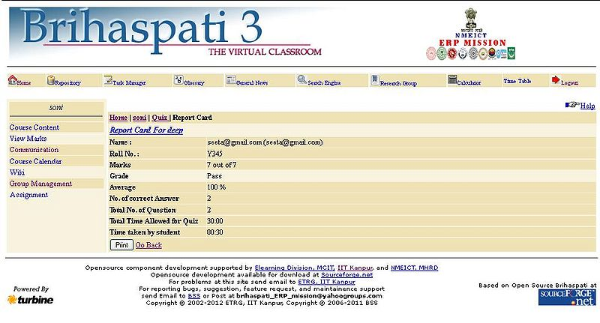

Course Calendar

The Calendar allows users to view Calendar items by Date, Time& Day, Week, Month, or Year. Users can also manage the following events through the Calendar:
Upcoming and past events can be viewed daily, weekly, or monthly and organized into categories.When we click on “Personal Calendar” in Instructor’s Interface, the Calendar page is open with the chart of Holidays, Academic Events, Calendar; Current Date etc. are shown on this page.

Pink colour:- Pink colour is showing “Academic Events”. Green colour:- Green colour is showing “Holidays (Restricted)”. Red colour:- Red colour is showing “All Sundays” in the Month. Blue colour:- Blue colour is showing “Normal Dates”.

--> Current Day, Date & Time is shown on this page. We can also search the calendar for any month of the year.
--> When we click on the Academic Event: - The Start Time, End Time, Details, Available Actions are shown.
--> When we click on the required Academic Event, then the specific Event's information is opened. We can delete any event from here & can add a new event also. And after filling these, we can reset &insert it. And when we add event the date with any event or holiday is shown with then “*“sign.And when we click on that date, we can access whole the information about that.

Find this page
Follow the steps below to open the Calendar page.

Step 1 Select Calendar

Functions:-
To use the functions available on the Calendar page, follow the table below.

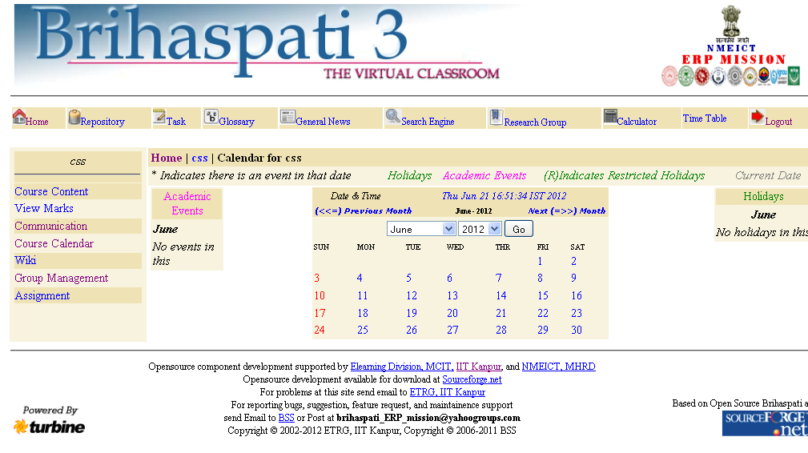

Find this page:-

Follow the steps below to open the Calendar page.

Step 1 - Select Calendar.

Functions

To use the functions available on the Calendar page, follow the table below.

To . . . | Click …
View events for a specific date  and time | Select a Date and Time and the  Calendar will immediately display events for  that Time.
Create an event and add it to  the Calendar | Add Event to access the Add Event page.
View events by Day, Week, or  Month | View events for the Current Day,  Current week or Current Month.
View event details | On a Calendar event to view details.
Add Event
Overview:-
When the Calendar is accessed through the Calendar users have the options to add and modify personal calendar items. Events may be added through the Add Calendar Event page and modified through the Modify Calendar Event page. These pages are the same, the difference being, the Add Calendar Event page opens with empty fields and the Modify Calendar Event page opens with populated fields.
Note: Only events created by the user can be modified. Events created by an Instructor, organization Manager or System Administrator cannot be changed by the user.

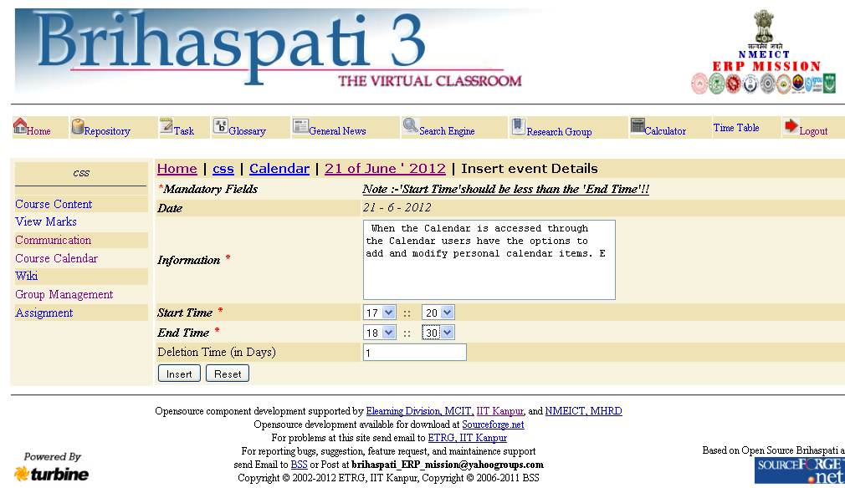

View Event:-
Click on an event to View event details. The Calendar: View Event page will appear as shown below.
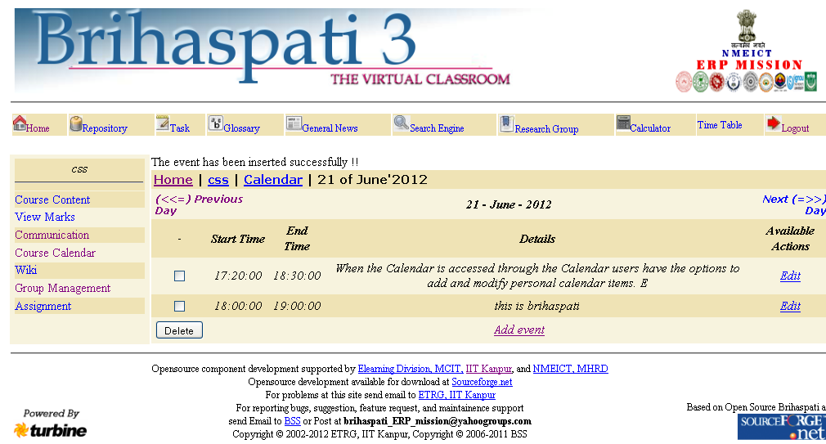

View Marks

View the marks of Student.

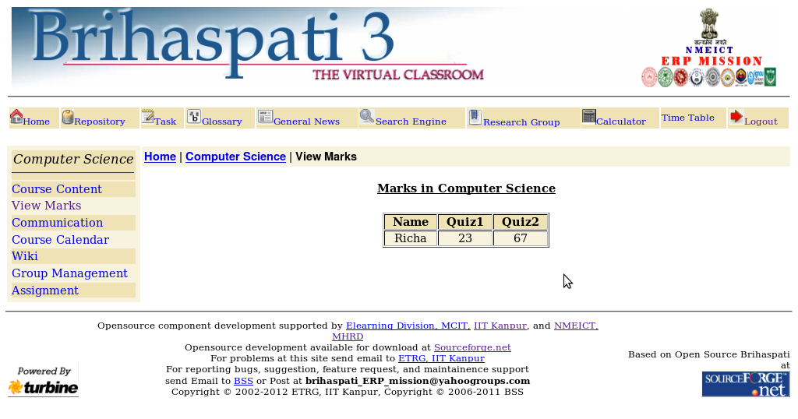

Wiki

When we click on wiki, we can “Create Page”, & can search the page / pattern. Wiki is website which has RCS as database and allows its users to become its page authors. Wiki is course specific that is you can see only pages of that course in which you are registered.

Note: - “The page name must be without spaces, such as Nuclear System”.

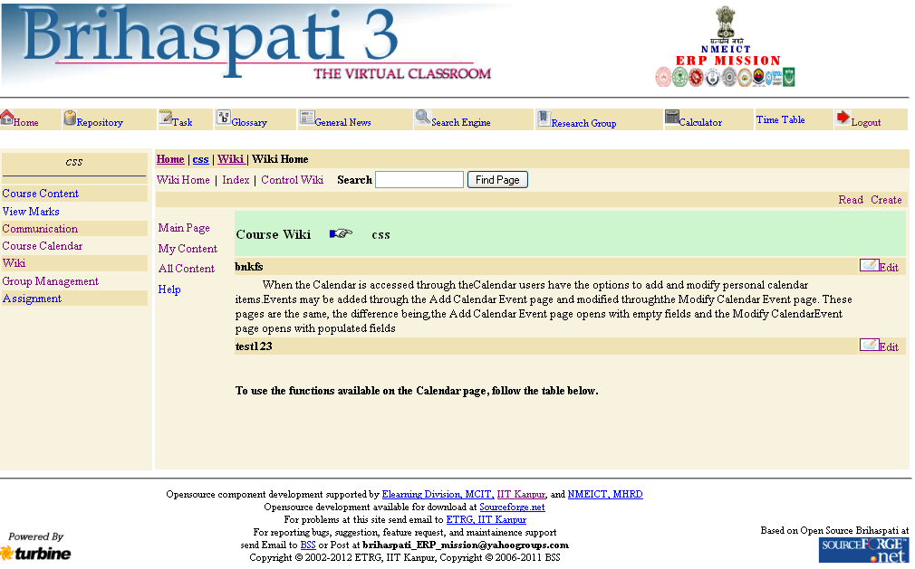

Find this page

Follow the steps below to open the Wiki page.

Step1 Click the Create Page.
Step2 Click the Search for Pattern/Page.
Step3 List of My Pages in Wiki.
Step4 List of All Pages in Wiki.

Fields
The table below details the fields on the Wiki Page.

Fields | Description
Wiki Page
Create Page | This creates new page for writing. As soon as page is created it is visible to all.
Search for Pattern/Page | Next there are two search options  1)Find Pattern  This searches for particular word in all visible pages in Wiki.  This displays list of all pages containing that word.  2)Find Pages  This displays list of pages whose page names contains the given word.
List of My Pages | There will be "List of My Pages".  This displays user specific pages
List of All Pages | Next there will be "List of All pages".  This displays list of all visible wiki pages.

This creates new page for writing. As soon as page is created it is visible to all.

Create Page

We can create page with entering the “Page Name” & can give description. About that page. After it we can save & clear (cancel) it. This creates new page for writing. As soon as page is created it is visible to all.

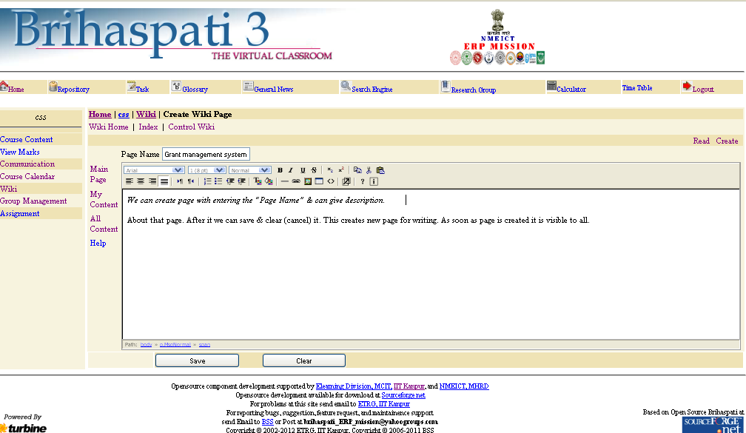

Control Wiki

This allows Primary Instructor (only not secondary instructors) to allow changed done by
Students on already created pages to be visible.

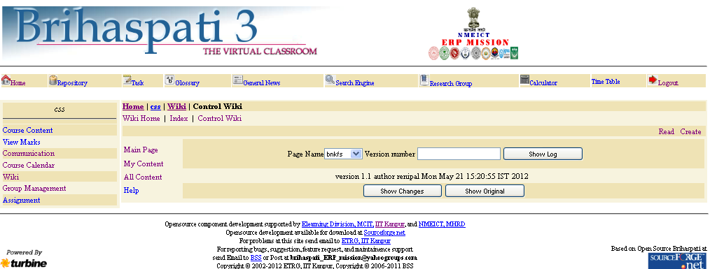

Find this page

Follow the steps below to open the Control Wiki page.

Step1 Click the Show Page.
Step2 Click the Show Merge Page.
Step3 Click the Show Changes.
Step4 Click the Show Merge Changes.
Step5 Click the Show Original.
Step6 Click the Save Original Page.
Step7 Click the Remove Page.
Step8 Click the Disable Edit.
Step9 Click the Enable Edit.

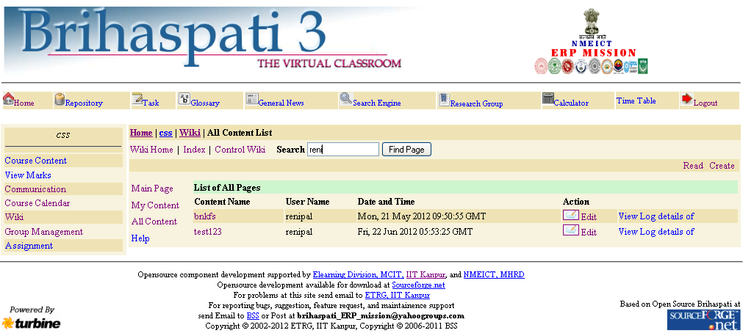

Field

The table below details the entry fields on the Control Wiki page.

Field | Description
Control Wiki page
Show Page | In this page, we can view the description of any particular page by click On “Show Page”.
Show Merge Page | This shows page according to version number .When one edits a page Wiki actually saves the page by a version number.  To retrieve that page one just has to give Page name and version number.  When no version number is given, last version is displayed.
Show Changes | This button shows the changes which has been done on existing page.
Show Merge Changes | This shows page that was approved by instructor. Actually there is separate folder which keeps last 20 approved changes. This button picks up page from that folder. Note as only last 20 changes are saved so after 20 versions are over you will see from version 2 to 21 not from 1 to 21 likewise version 80 to 100 .To retrieve that page one just has to give page name and version number. When no version number is given, last version is displayed.
Show Original | This button will show changes in the page versions with respect to last changed page. It will change all pages.
Save Original Page. | This option saves original page. Note there will be no new version that will store the original page. Original Page is kept in separate folder.  This button is used when you want to overwrite original page by given page version .Also useful to set back original to last nth approved page.
Remove Page | This option completely removes any page. This option has to be used to remove useless pages.
Disable Edit | This will disable edit option on page, though page will be viewable. This has to press before starting to merge changes in original page. After you press this button following things will happen:  1) Just above buttons you will see the page name in red font.  2) Two more buttons will be visible Merge now Merge Done.  3) No student will be able to edit the page.
Enable Edit | This will remove restriction of Edit on that page.
Remove Changes | - We can remove all the changes which are mode on that page.
Merge Now  - Page Name  - Version Number  - Show Log | In this box, we can select all the pages which are made.  Version number should be an Integer Value & should be Positive  By this button, we can show the version of the page, Author Name, Date, Day & Time when it is created.

Scorm Player

This is the main page for scorm player. Currently there are 1 links i.e.
- Play Content
From here student can view and show all scorm content.

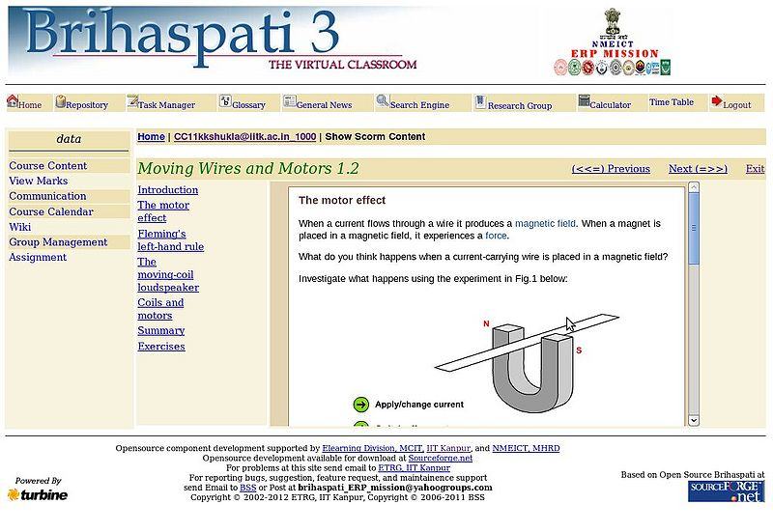

Log Out

After clicking on “Log out”, we again reach on the “Login Page”.

