Steps to Install and run LibMS
Step1:
- Install MySQL Server 5.1.
- Set port no-3307.
- Set Username-“root”.
- Set Password-blank (no password).
- Open command prompt screen of MySQL.
- Run the content of database script file (Copy content of script file and run it on the SQL>command prompt in window or terminal in Linux).
- Now database along with tables are created.

Step2:
- Install Apache Tomcat 6.0.20 server, set port no 8084
- Copy LibMS-Struts folder and paste into webapps folder.
- Start the server.

Step3:
- Now open browser and type http://localhost:8084/LibMS-Struts/, Home page of LibMS appears on the screen.

The above username passwords should be as set
- New Institutes interested in using the LibMS may themselves get registered using Institute Registration link given in the home/login page of LibMS. Fill up the institute registration form and send/submit it for acceptance by superadmin.
- Now to View/Accept any request for registration by institutes, we shall login as SuperAdmin from Home/Login Page of LibMS and the superadmin will accept the pending request by assigning a unique Library_Id (like, iitk, iitr, amu, dei, etc).

For Super Admin Login username and Passwords are given below:
Enter User Name- ‘superadmin'
Enter Password- ‘superadmin’

After acceptance of request for registration by superadmin, institute admin can login from Home/Login Page of LibMS.

In this Section We have following options
View Pending View All View Approved Search Institute Logout

- Institute Admin Interface
For Admin Login
Enter User Name- ‘amu.dushyant@gmail.com’
Enter Password- ‘kumar’

- Application Menubar page: After successfully logging in through Login Page this page is displayed.

All the options in application menu bar are activated in case of Admin Login, That is to say that, Administrator has all the privileges. In case of Library Staff login menu bar options are activated or deactivated as per the assigned privileges to the specific library staff given by library administrator.
Administration:- From this Menu We can Manage Staff Registration, Account details and Privileges. Firstly, the staff is registered, user’s login account is created and then the user is assigned privileges. Administrator may enter necessary details of the Library Staff using Register Staff option, may create login account for the registered staff and then assign privileges to the staff whose login account has been created. These are performed by menu option Administrator and sub-options of it.

Administrator may enter necessary details of the Library Staff using Register Staff option, may create login account for the registered staff and then assign privileges to the staff whose login account has been created. These are performed by menu option Administrator and sub-options of it.

Sub options like Register Staff, Change Staff Detail, Delete Staff and View Staff Record displays the page for managing library staff information. The four action buttons Register, Update, View and Delete are given on this page to Manage Staff information. Sub option View All Staff Record shows a grid view of all the records of library staffs.

- Role Based Login:
After role based login the Application Menubar page is displayed where the menu bar options are activated or deactivated as per assigned. An example of such type of role based login is shown below:
For Library Staffs having limited privileges/Role Based Login
Enter User Name- ‘faraz.hasan@live.in
Enter Password- ‘hasan’

Enter User Name- ‘iqubal@gmail.com
Enter Password- ‘ahmad’

- OPAC Menu: This allows library users to search books/thesis/journals etc on various key words and by using various search conditions. The search can be narrowed down using Advance Search Option.

Superadmin Login
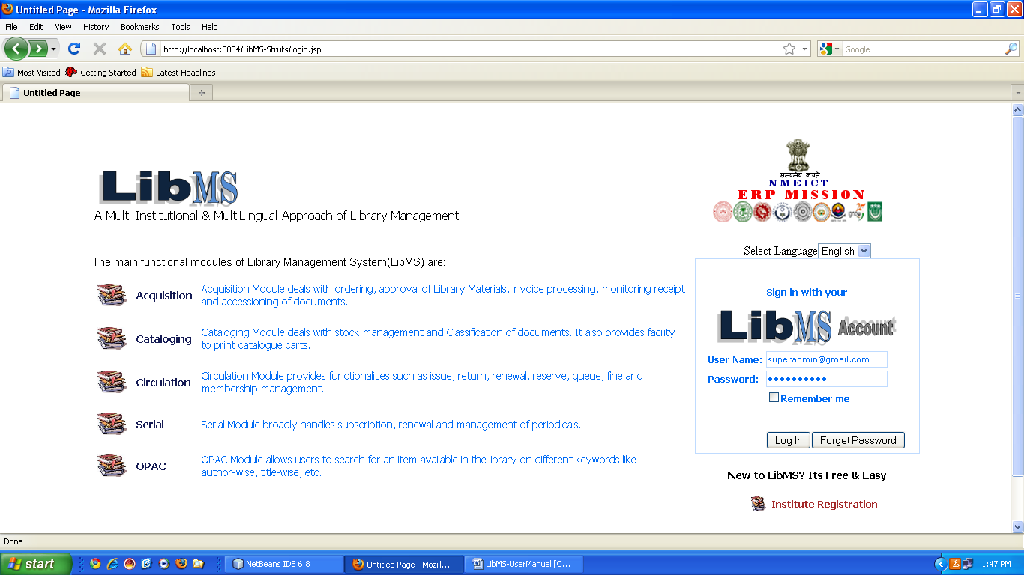
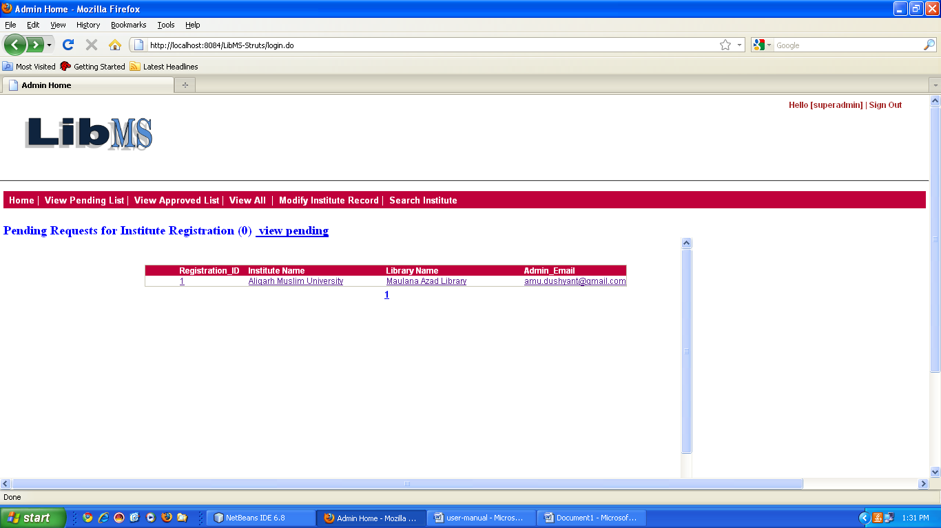

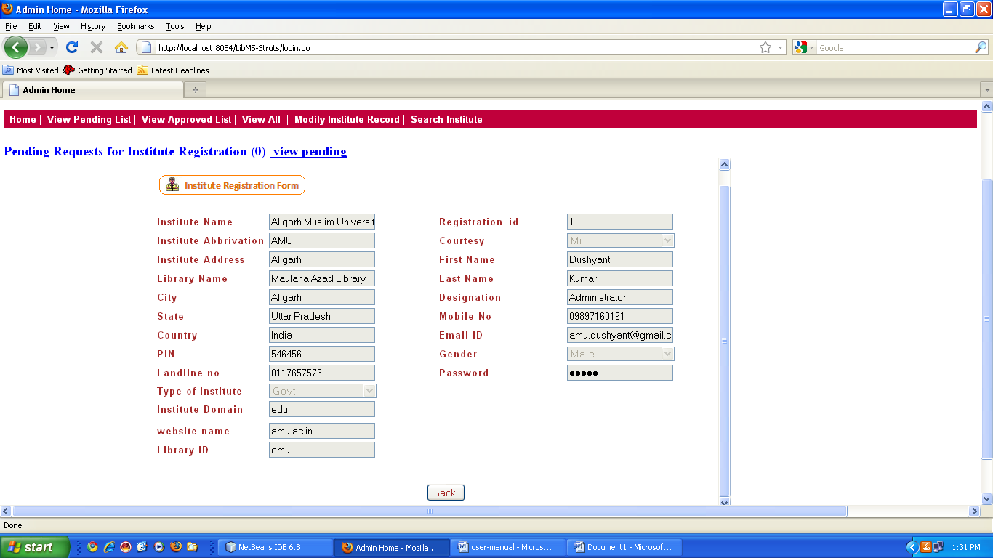

Institute admin Main Menu

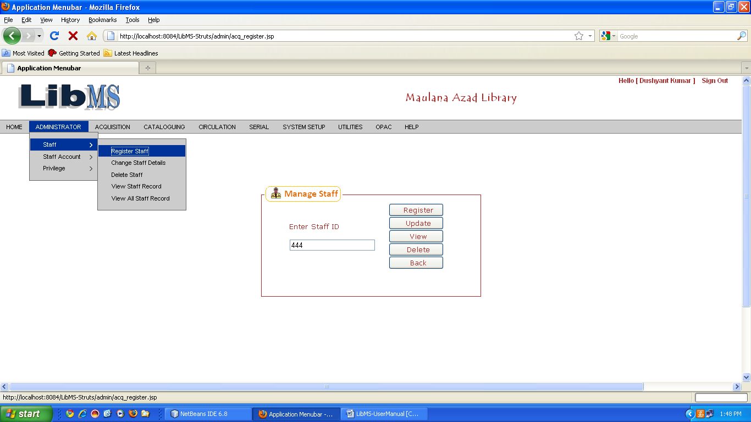
Assign Privilege
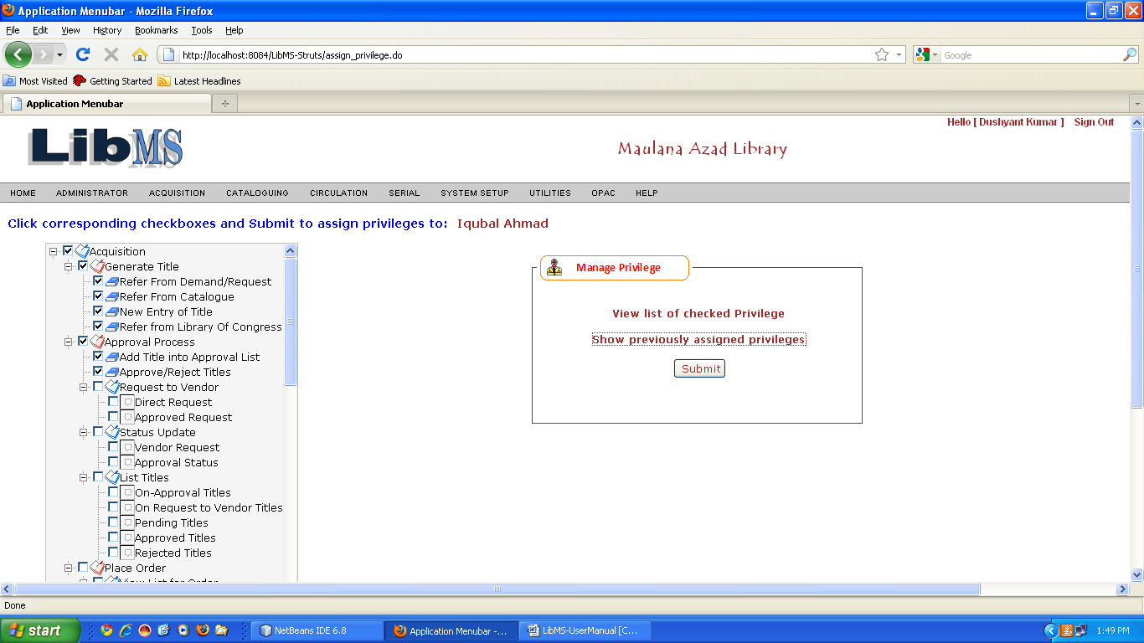

OPAC Interface
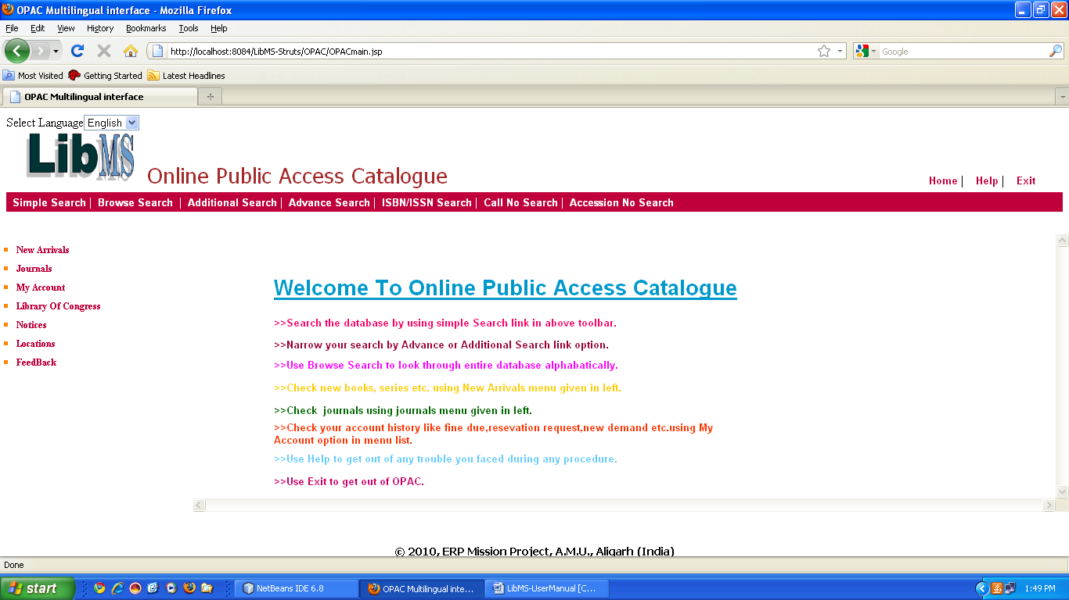
Advance Search
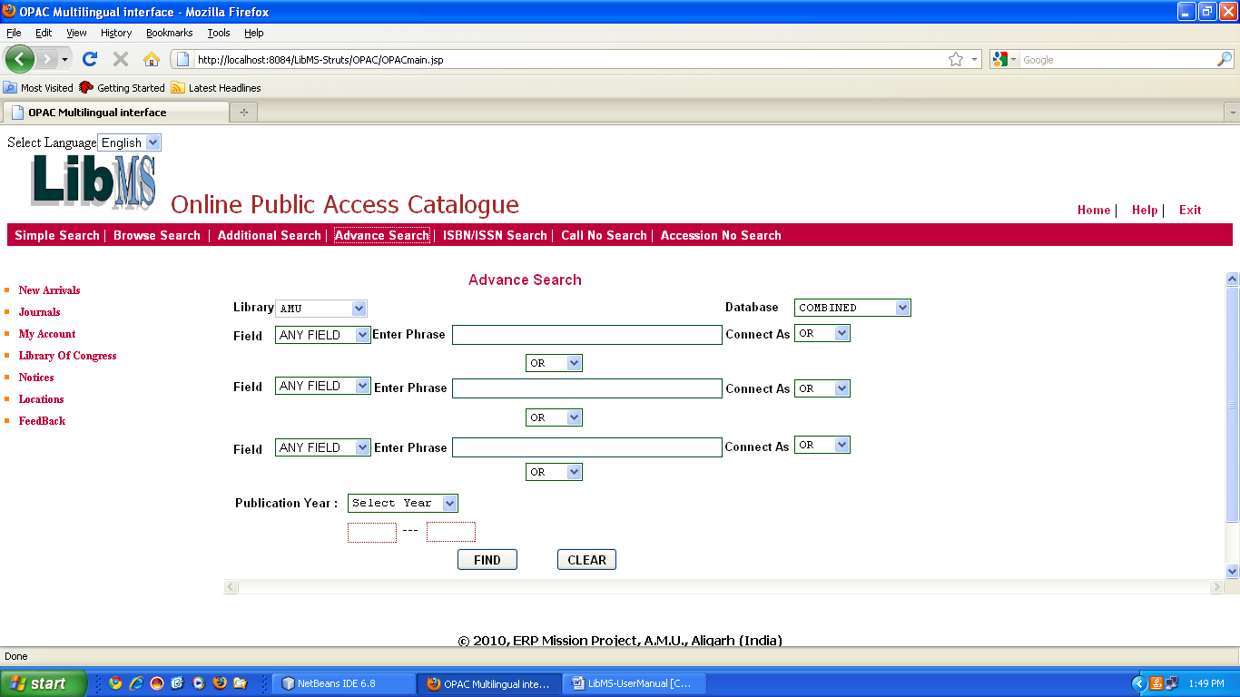

Advance Search Result

