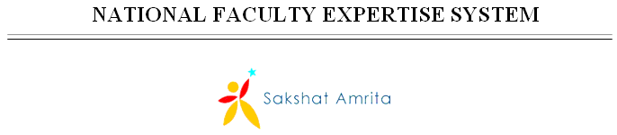

User Guide Document

Version History
Date | Description
12-Dec-2010 | First Draft
07-Feb-2011 | New screens, changed navigation flow, multiple records entry

Table of Contents

Version History 2
1 Introduction 4
1.1 Purpose 4
1.2 Staff Registration 4
1.3 Lost password? 5
1.4 Change password 6
2 Profile 6
3 Awards 7
4 Conference Papers 7
5 Books/chapters 8
6 Projects 9
7 Consultancy offered 10
8 Patents 11
9 Professional memberships 12
10 Journal Papers 13
11 Media publications 14
12 Seminars 15
13 Invited talks/guest lectures 16
14 Faculty exchange program 17
15 Governance 18
16 Review Committees 19
17 Community service 20

Introduction

Purpose

This document provides the detailed step by step guidance for using the National Faculty Expertise System project.

This is a ‘living document’ and the explanations will change, continuously, as the project proceeds. More details will be added and the existing information edited as the requirements, architecture and design evolve in the course of the project.

Log-in

Figure 1: Log In
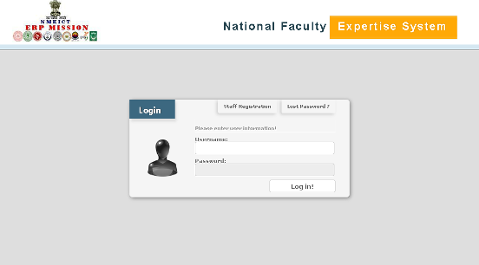

Email id of the user is the log in username for this application.
Clicking button Log in! the user can enter NFES system and view/modify own details.

Clicking button Staff Registration opens the screen as shown in Fig 2.

Clicking button Lost password? opens the screen as shown in Fig 3.

Staff Registration

Any professor/teaching faculty who wishes to upload the professional details in this expert database can register in the application with a valid e-mail id
Clicking on Back takes the user back to Log in page.

Figure 2: Staff registration
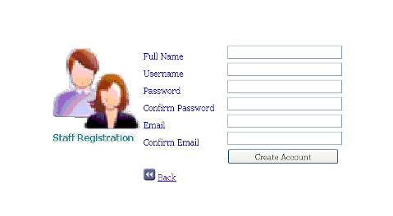



Lost password?

Clicking on Lost password? button opens the screen below:

Figure 3: Lost password?
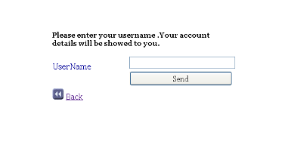

Change password
The change password icon is provided right next to the Log-out button. Here the user may change the password any number of times as necessary.

Figure 4: Change password
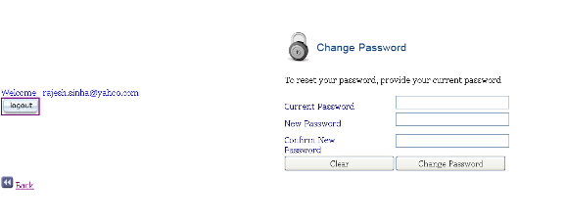

Profile

Here, basic details such educational, contact, and work experience details are captured.

Figure 5: Profile
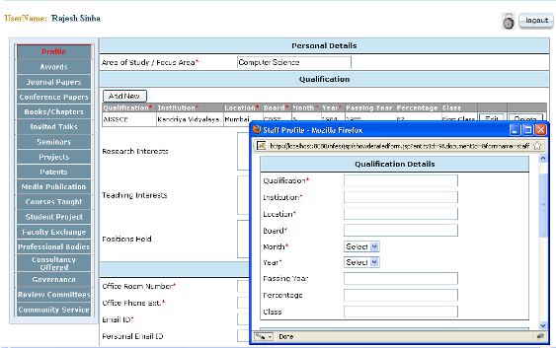

The above is the home page on logging into the application. Multiple records can be added by clicking Add new and opening a separate window as shown in Fig 4 above. Mandatory fields are indicated.

All the buttons on the left panel, on clicking, open the corresponding pages to save details of the user. As can be seen, the button corresponding to the open page at any time, is in a different font color

Please note that the user can log out from any of the screens, by clicking on the Log out button on the top right corner of every page in the application.
The following sections detail the pages opened for each of the buttons on the left panel.

Awards

In this screen, details of any awards received during the career can be captured. Multiple records can be added by clicking Add new and opening a separate window. Mandatory fields are indicated.

Figure 6: Awards
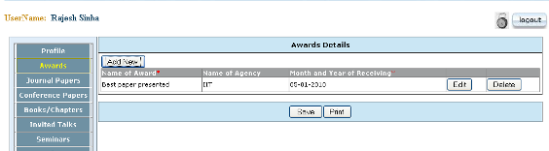

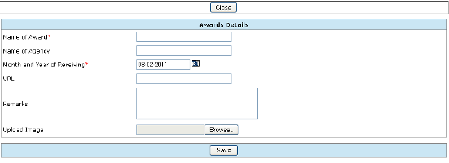

Conference Papers

In this screen, details of any papers presented at conferences, during the career can be captured. Multiple records can be added by clicking Add new and opening a separate window. Mandatory fields are indicated.

Figure 7: Conference Papers
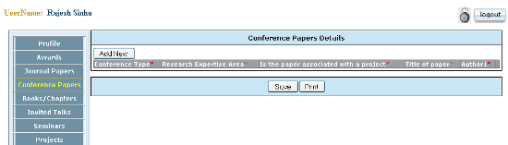

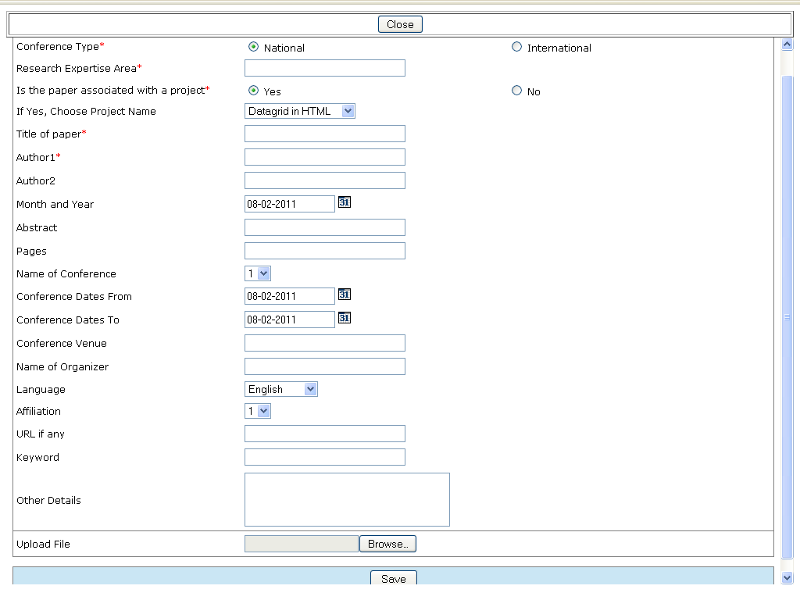

Books/chapters

In this screen, details of any books/chapters to which the user has contributed during the career can be captured. Multiple records can be added by clicking Add new and opening a separate window. Mandatory fields are indicated.

Figure 8: Books

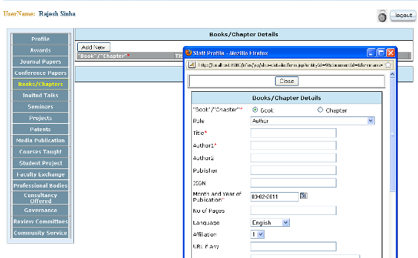

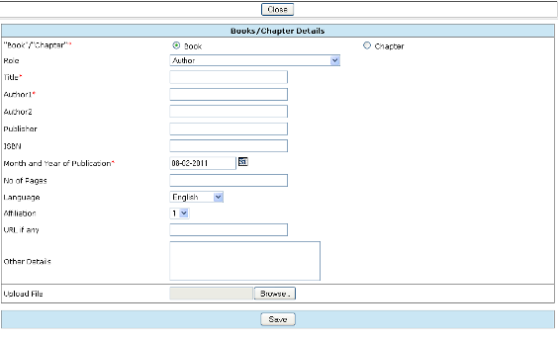

Projects

In this screen, details of projects executed during the career can be captured. Multiple records can be added by clicking Add new and opening a separate window. Mandatory fields are indicated.

Figure 9: Projects
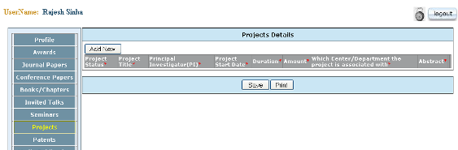

Consultancy offered

In this screen, details of any consultancy offered to corporates during the career can be captured. Multiple records can be added by clicking Add new and opening a separate window. Mandatory fields are indicated.

Figure 10: Consultancy offered
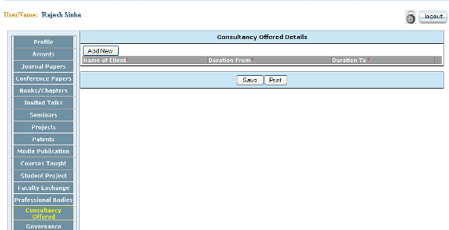

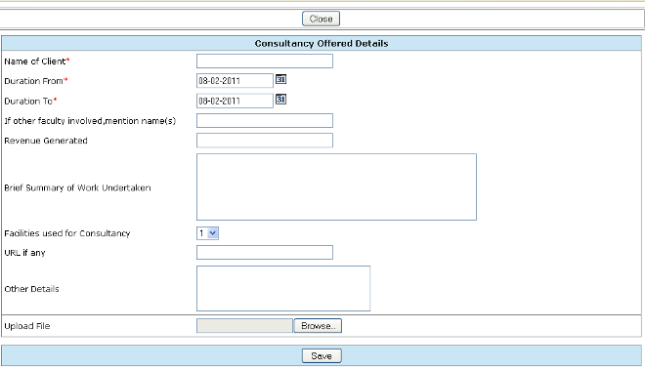

Patents

In this screen, details of any patents granted/pending during the career can be captured. Multiple records can be added by clicking Add new and opening a separate window. Mandatory fields are indicated.

Figure 11: Patents
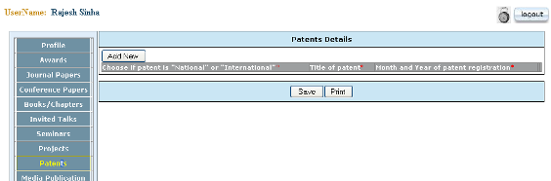

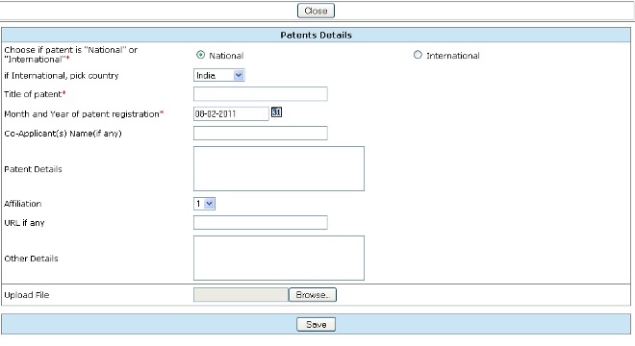

Professional memberships

In this screen, details of any professional memberships maintained by the user can be captured. Multiple records can be added by clicking Add new and opening a separate window. Mandatory fields are indicated.

Figure 12: Professional bodies/societies
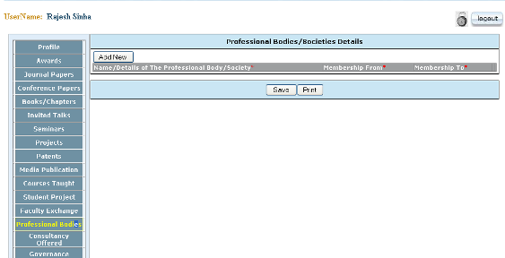

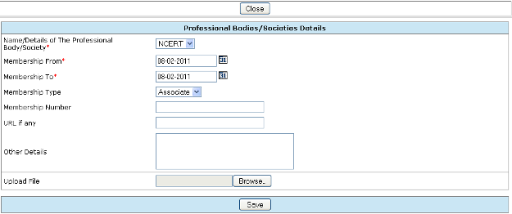

Journal Papers

In this screen, details of any papers published by the user can be captured. Multiple records can be added by clicking Add new and opening a separate window. Mandatory fields are indicated.

Figure 13: Journal Papers
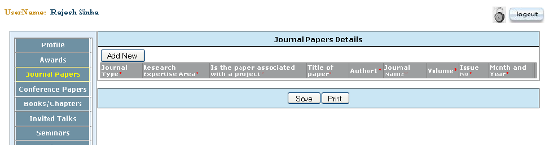

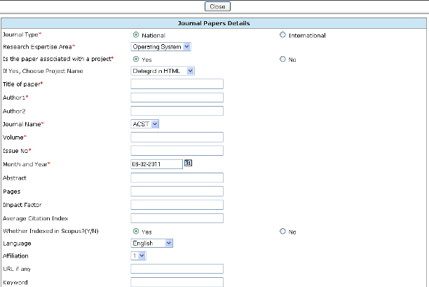
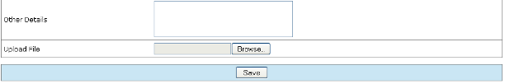

Media publications

In this screen, details of any publications made in the media during the career can be captured. Multiple records can be added by clicking Add new and opening a separate window. Mandatory fields are indicated.

Figure 14: Media publications
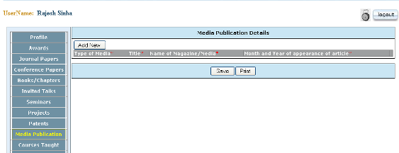

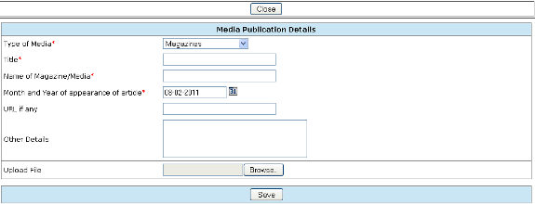

Seminars

In this screen, details of any seminars/conferences/workshops or trainings attended during the career can be captured. Multiple records can be added by clicking Add new and opening a separate window. Mandatory fields are indicated.

Figure 15: Seminars
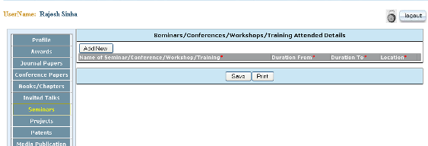

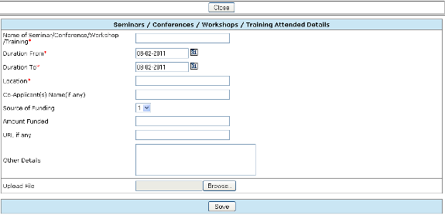

Invited talks/guest lectures

In this screen, details of any talks or lectures given by the user during the career can be captured. Multiple records can be added by clicking Add new and opening a separate window. Mandatory fields are indicated.

Figure 16: Invited talks/guest lectures details
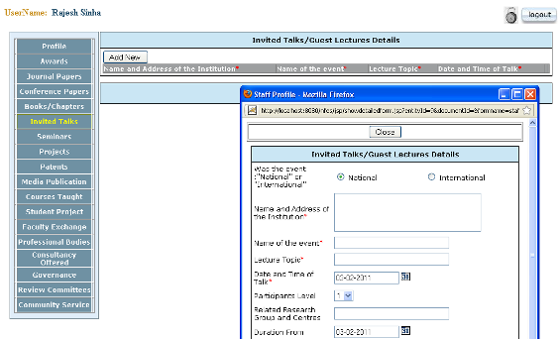

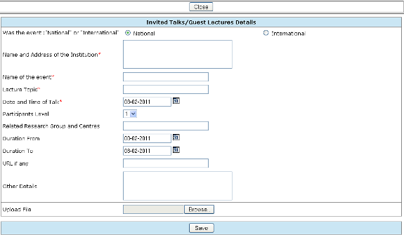

Faculty exchange program

In this screen, details of any faculty exchange programs that the user may have participated in, during the career can be captured. Multiple records can be added by clicking Add new and opening a separate window. Mandatory fields are indicated.

Figure 17: Faculty exchange program
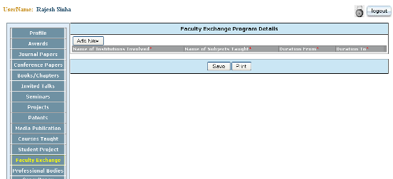

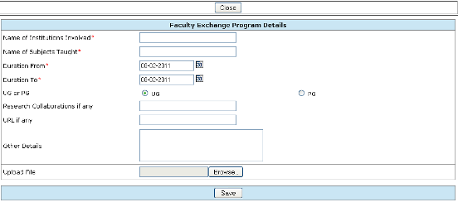

Governance

In this screen, details of any governing committees of which the user may have been a member, during the career can be captured. Multiple records can be added by clicking Add new and opening a separate window. Mandatory fields are indicated.

Figure 18: Governance Details
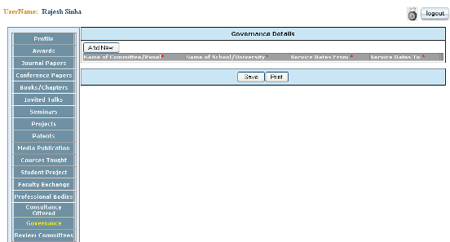

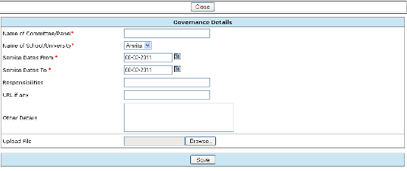

Review Committees
In this screen, details of any review committees of which the user may have been a member, can be captured. Multiple records can be added by clicking Add new and opening a separate window. Mandatory fields are indicated.

Figure 19: Review Committees Details
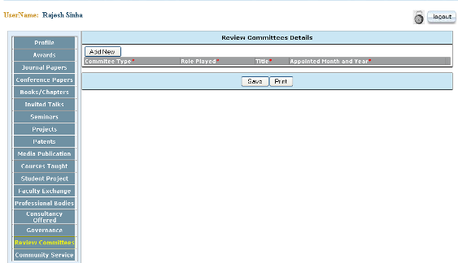

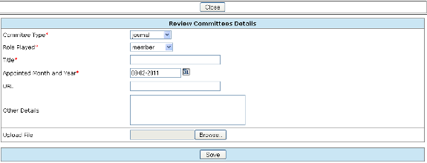

Community service

In this screen, details of any community service of which the user may have been a part of, can be captured. Multiple records can be added by clicking Add new and opening a separate window. Mandatory fields are indicated.

Figure 20: Community service
