



(Installation Manual)
By : User Documentation Team

Version 1.0

05 September 2011

Table of Contents
- Brief Product Introduction
  - Brief Introduction
- Introduction
  - Prerequisites Software Requirement
  - Software Installation guidelines
  - Checking the Installation
- Importing Data Base Script
  - Create DataBase
  - Import SQL Script File in MySQL
- Manual Setting
  - Edit the configuration file
- Deployment of Project
  - Clean and Build Using Ant
  - Deployment of Project
- Trouble-shooting
  - Data Base Connectivity problem
  - Mail Sending Error

Product Brief Introduction & License
LibMS is a multi-institutional, multi-layer, multi-lingual library management system.
Elaborating the term multi-institutional means that the system is running on one server namely on IITK server and any interested institute wishes to use it can send request to have an account to access the system, irrespective of its local requirements like database server, local server. The system is running as a service on IITK server and interested institution can use all the services provided by the system free of cost. System can also be installed locally if someone wants to install.
The term multi-layer means after successful access to the system the user can create multiple libraries inside its own vicinity. So the system becomes multilayered as dependent libraries can be created inside one independent library.
The term multi-lingual means the system provies the user with interfaces in different languages thus breaking the barrier of language boundation and having the essence of truely local.

Feedback

We would appreciate any constructive feedback on this document. Please let us have your Suggestions,Corrections, or Modifications by mail to amuedrp@gmail.com.

Introduction
2.1 Prerequisites Software Requirement
The Softwares that you need to be installed on your Local PC for running this Project are as follows:
- MySql Server 5.1
- Ant 1.7
- Tomcat 6.0.18
- Java 1.6
Apart from above softwares, You must have
a) Valid Gmail Account (For Sending Mail From WebAdmin to Register Libraries) &
b) Internet Connection

2.2 Software Installation guidelines
1) Installation Step of Java
For Linux OS
Click on Application->Accessories->Terminal
- Debian, Ubuntu, etc.
On the command line, type:
$ sudo apt-get install openjdk-6-jre
The openjdk-6-jre package contains just the Java Runtime Environment. If you want to develop Java programs then install the openjdk-6-jdk package.

b) Fedora, Oracle Linux, Red Hat Enterprise Linux, etc.
On the command line, type:
$ su -c "yum install java-1.6.0-openjdk"
The java-1.6.0-openjdk package contains just the Java Runtime Environment. If you want
to develop Java programs then install the java-1.6.0-openjdk-devel package.
For Further Ref Click here : http://openjdk.java.net/install/
For Window OS
You can download the latest version of jdk from http://java.sun.com/javase/downloads/index.jsp. Once you download the exe file you can now install it.
To install the jdk, double click on the downloaded exe file (jdk-6u1-windows-i586-p.exe)
For Futher Ref Click on :
http://www.roseindia.net/java/learn-java-in-a-day/download-and-install-java.shtml
2) Install Tomcat Server 6.0.18
For Linux OS
Step 1: Download Tomcat 6.0.18
http://tomcat.apache.org/download-60.cgi and download the Binary Distribution
We recommend to install Tomcat in the "/home/User" directory. Thus copy the downloaded file into "/home/User".
Step 2:Extract it with
$tar xzvf apache-tomcat-6.0.18.tar.gz
Step 3:Test Tomcat
Start Tomcat with:
/home/user/apache-tomcat-6.0.18/bin/startup.sh
Hit http://localhost:8080. If all is fine you should see the Tomcat homepage.
For Further ref Click here:
For Windows OS
Step 1: Download Tomcat 6.0.18 from the given link
http://tomcat.apache.org/download-60.cgi

Step 2:Install it by double click on it and specify the location where you want to Install it

Step 3:Test Tomcat
Start Tomcat by Double Click on
C:\ApacheSoftwareFoundation\Tomcat Server 6.0\bin\startup.exe
Open Browser and Hit http://localhost:8080. If all is fine you should see the Tomcat homepage.
For Further ref Click here: http://tomcat.apache.org/download-60.cgi

3) Install Ant 1.7
You need the Java build tool Apache Ant to install to Compile the project and Build war files.
To run Apache Ant, you will require a correctly installed Java Runtime Environment (JRE).

- Download and Extract
Download the Apache Ant binary release from http://ant.apache.org/bindownload.cgi.
Once it is downloaded, extract it in a preferred installation location, such as c:\Program Files\Apache\Ant\ for Windows or /opt/apache-ant-1.8/. for Linux.
- Add the ANT_HOME Environment Variable
Create an environmental variable called ANT_HOME. This variable has to contain the path created in the previous step.
  - To do this on Red Hat Enterprise Linux, add the following line to the ~/.bash_profile file, substituting the path below with that which you created in the previous step.
export ANT_HOME=/opt/apache-ant-1.7.1
  - On Microsoft Windows, do this by click on the Start Menu, opening the Control Panel and selecting System -> Advanced -> Environment Variables.
Create a new variable, call it ANT_HOME and configure it to point to the directory you created in the previous step.
- Include bin in the PATH
Append the Ant installation's bin directory to the PATH environmental variable.
  - On Unix/Linux systems, do this by adding the following line to the ~/.bash_profile file. (Put it after the one which sets the ANT_HOME variable):
export PATH=$PATH:$ANT_HOME/bin
  - On Microsoft Windows, do this task by opening the Control Panel and selecting System -> Advanced -> Environment Variables -> System Variables. Edit the PATH variable and append the text ;%ANT_HOME%\bin.
To test the Apache Ant installation, run ant -version from a terminal. The output should look similar to this:
$ ant -version
Apache Ant version 1.7 compiled on June 27 2008
For Futher Details Click here :
http://docs.redhat.com/docs/en-US/JBoss_Enterprise_SOA_Platform/5/html/SOA_Getting_Started_Guide/appe-install_ant.html

4)Install MySQL 5.1
For Red Hat and similar distributions, the MySQL distribution is divided into a number of separate packages, mysql for the client tools, mysql-server for the server and associated tools, and mysql-libs for the libraries. The libraries are required if you want to provide connectivity from different languages and environments such as Perl, Python and others.
To install, use the yum command to specify the packages that you want to install. For example:
root-shell> yum install mysql mysql-server mysql-libs mysql-server
MySQL and the MySQL server should now be installed. A sample configuration file is installed into /etc/my.cnf. An init script, to start and stop the server, will have been installed into /etc/init.d/mysqld. To start the MySQL server use service:
root-shell> service mysqld start
To enable the server to be started and stopped automatically during boot, use chkconfig:
root-shell> chkconfig --levels 235 mysqld on
Which enables the MySQL server to be started (and stopped) automatically at the specified the run levels.
The database tables will have been automatically created for you, if they do not already exist. You should, however, run mysql_secure_installation to set the root passwords on your server.

Default port of MySQL is 3306

For Futher Details Click here :
http://dev.mysql.com/doc/refman/5.1/en/linux-installation-native.html
For Window OS
Step 1: Download MySQL Server for Windows from the given link
http://dev.mysql.com/downloads/mysql/

Step 2:Install it by double click on it and Follow the Steps.

Step 3:Please Specify root password there

For Further ref Click here:
http://www.wikihow.com/Install-the-MySQL-Database-Server-on-Your-Windows-PC

2.3 Checking for Installation
1) For Linux OS
  - Install Java
Open terminal from application->accessories->Terminal and type the given command
$java -version
  - Install Tomcat Server 6.18
In the browser type Hit http://localhost:8080 . It has to display welcome page of apache Tomcat Server.
1.3) Install Ant 1.7
Open terminal from application->accessiories->Terminal and type the given command
$ant -version
1.4) Install MySQL 5.1
Open terminal from application->accessiories->Terminal and type the given command
$mysql –u root –p <Press Enter>
It will prompt for password and after successful login can move on mysql command prompt
2) For Windows OS
2.1) Install Java
Click on Start->Run, Type cmd and press enter, Now Type the given command
C:\>java -version
2.2) Install Tomcat Server 6.0
In the browser type Hit http://localhost:8080 . It has to display welcome page of apache Tomcat Server.
2.3) Install ANT 1.7
C:\>ant -version
2.4) Install MySQL 5.1
Click on Start->Run, Type mysql –u root –p <Press Enter>
It will prompt for password and after successful login can move on mysql command prompt
Importing DataBase Script
3.1Create databases
- For Windows PC
Click on Start->Run, Type mysql –u root –p <Press Enter>
It will prompt for password and after successful login can move on mysql command prompt
mysql>create database libms;
b) For Linux PC
Open terminal from application->accessories->Terminal and type the given command
$mysql –u root –p <Press Enter>
It will prompt for password and after successful login can move on mysql command prompt
mysql>create database libms;
3.2 Import SQL Script File in MySQL
a) For Windows PC
Step 1: Click on Start->Run, Type cmd
Step 2: type the following command
C:\>mysql –u root –p libms < LibMSScript.sql
It will prompt for password and after successful authentication It will import all table from script to LibMS Database.
Note : LibMSScript.sql file along with path is required in case if not in current working directory location
b) For Linux PC
Step 1: open terminal in Linux from Application->Accessories->Terminal
Step 2: type the following command
C:\>mysql –u root –p libms < LibMSScript.sql
It will prompt for password and after successful authentication It will import all table from script to LibMS Database.
Note : LibMSScript.sql file along with path is required in case if not in current working directory location

Manual Setting
  - Edit the Configuration Files
- Modify Conext.xml of Web/META-INF File and add DB Username & Password in it.
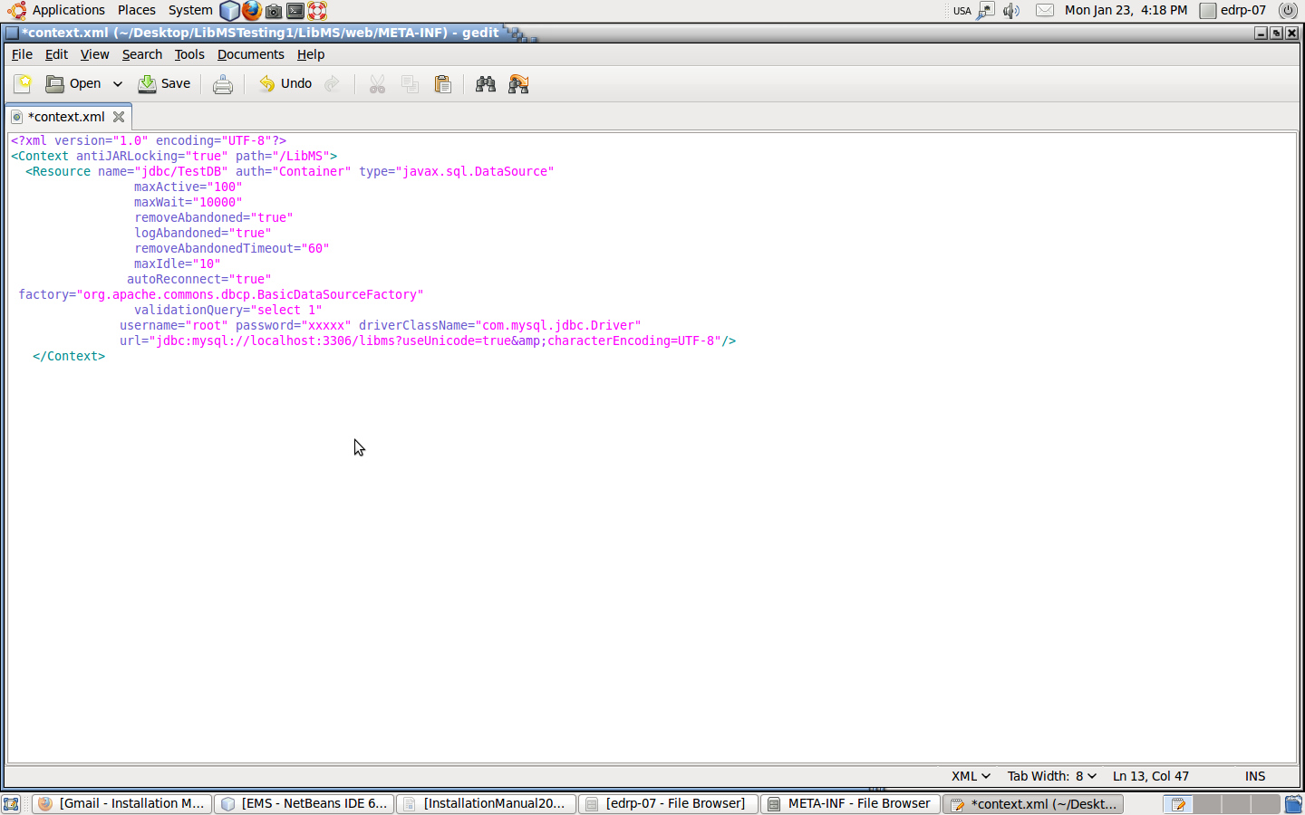

- store libms.properties file in Linux home directory having following keys
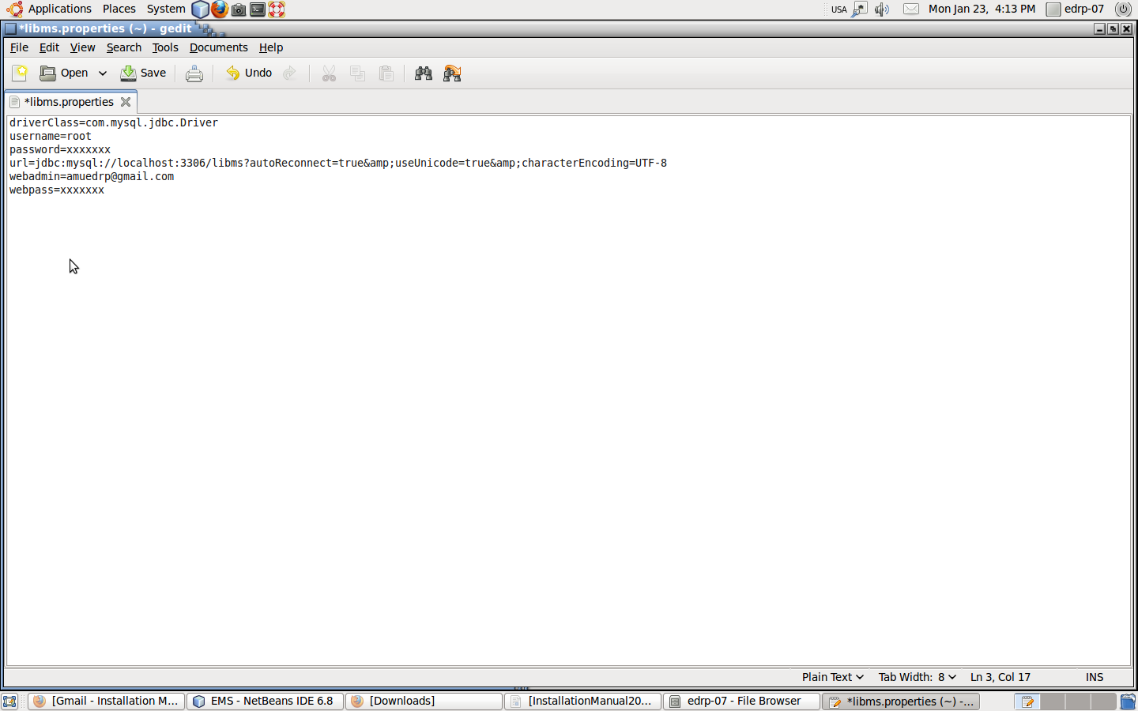
b) Add WebAdmin Email/Password
Step 1: Open libms.properties file and
replace amuedrp@gmail.com with your webadmin gmail Id and specify webadmin email password in it without any additional spaces.

Deployment of Project

Checkout the LibMS Folder and save in apache Tomcat Folder on your Local PC.
For Linux OS
Step 1: Click on Application->Accessoires->Terminal type the following command
/home/user$svn –co http://202.141.40.215/repos/amuedrp/trunk/LibMS
Step 2: Move LibMS Project to /home/user/apache-tomcat6.0.18/webapps folder.

5.1Clean and Build Using Ant
For Windows OS
Step 1: Click on Start->Run, Type cmd
Step 2: Move in LibMS Project and type ant
C:\ApacheSoftwareFoundation\Apache Tomcat 6.0\webapps\LibMS>ant <Press Enter>
It will display build successfull message.
For Linux OS
Step 1: Click on Application->Accessoires->Terminal
Step 2: Move in LibMS Project and type ant
\home\User\apache-tomcat 6.0.18\webapps\LibMS>ant <Press Enter>

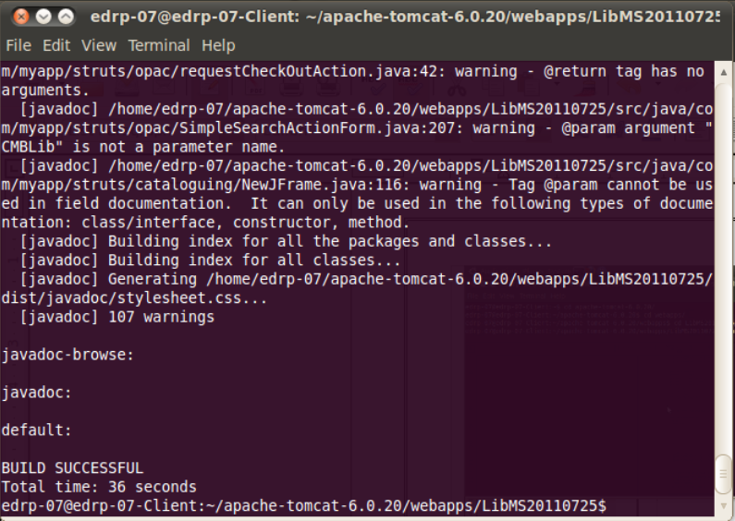
It will display build successfull message.
5.2 Deployment of Project
For Linux OS/Window OS
Step 1 : Start apache tomcat and open browser
Step 2: In the browser type Hit http://localhost:8080/LibMS . It has to display welcome page of LibMS.
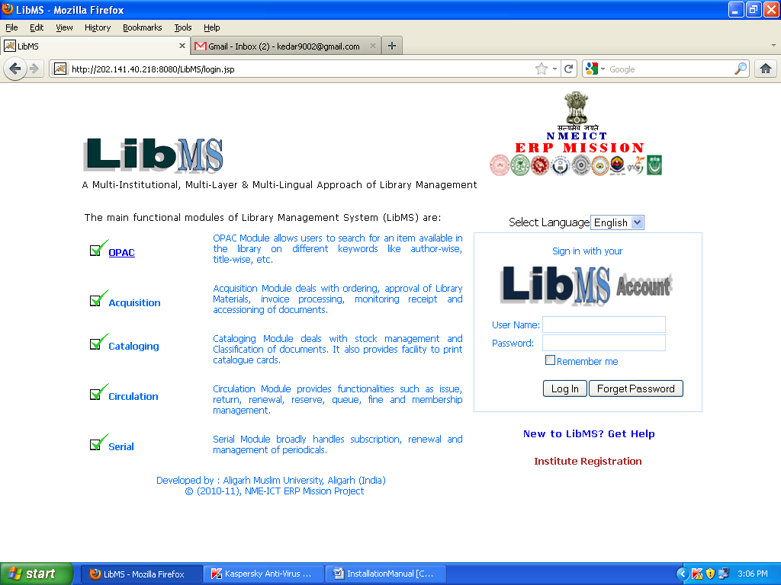

For Super Admin Login username and Passwords are given below:
Enter User Name- ‘superadmin'
Enter Password- ‘superadmin’
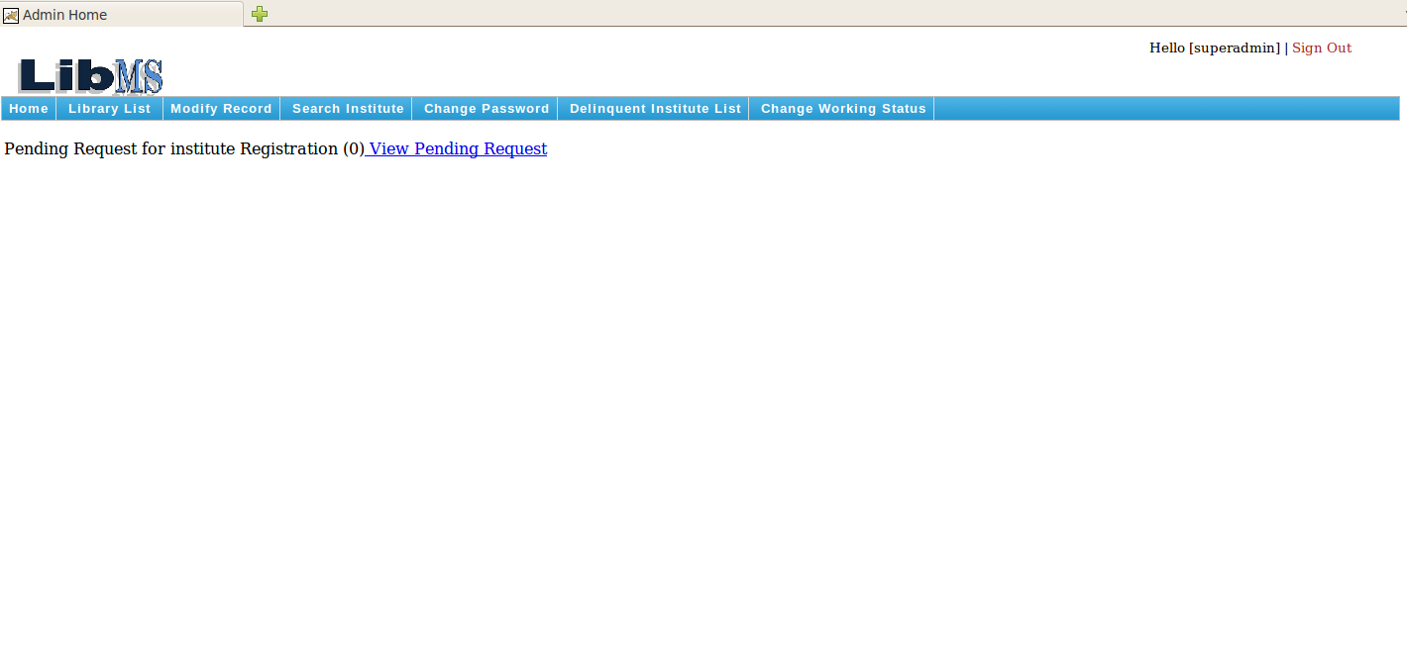

Trouble-shooting
6.1 Data Base Connectivity problem
At the Time of login from Login.jsp, You might face this situtation After Entering valid userid and password. To Resolve this problem please check Following details:
1.Check port no of MySQL is 3306 set in META-INF/Context.xml
2.Check database user name and password is correctly mention in META-INF/Context.xml
6.2Mail Sending Error
Email in not Sent Successfully to library Staff from WebAdmin. To Resolve this problem please check Following details:
1.Check correct password mention in n libms.properies file
2.Check correct webadmin email id mention in n libms.properies file

