Expense Approval Request

Detailed Design Document

Ver. 1.8

Version History
Date | Description
5-Feb-2011 | First Draft

Table of Contents

Version History 2
1 Introduction 5
2 Associated Tables 5
3 Expense Request Evaluation 6
3.1 Submission of Expense request by staff members 6
3.2 Expense Request approval 12
3.3 Payment 14
4 Data Dictionary 16

Table of Figures

Figure 1: Staff - Add new expense request 7
Figure 2: Staff - Edit expense entry 8
Figure 3: Staff - expense entry - non editable 9
Figure 4: Clerk– Expense Request List 9
Figure 5: Clerk - View Request Details 10
Figure 6: Clerk - Approval status history 11
Figure 7: Clerk - Payment Entry 11
Figure 8: Approval authority – Evaluate Expense Request - List 12
Figure 9: Approval authority – Request Evaluation 13
Figure 10: Approval authority – Send request for further approval 14
Figure 11: Approval authority - evaluation not completed 14
Figure 12: Approval authority – Request cannot be sent 14
Figure 13: Clerk - multiple payment entries 15

Introduction

This document provides the detailed design specifications for the various activities associated with expense request evaluation and any approved payment within an organization Multisite Grant Management System project.

This is not a project plan nor does it detail the source code. It is a guide for system architecture and development, not for phasing, timelines or deliverables.

Finally, this is a ‘living document’ and the specification will change, continuously, as the project proceeds. More details will be added and the existing information edited as the requirements, architecture and design evolve in the course of the project.

Associated Tables
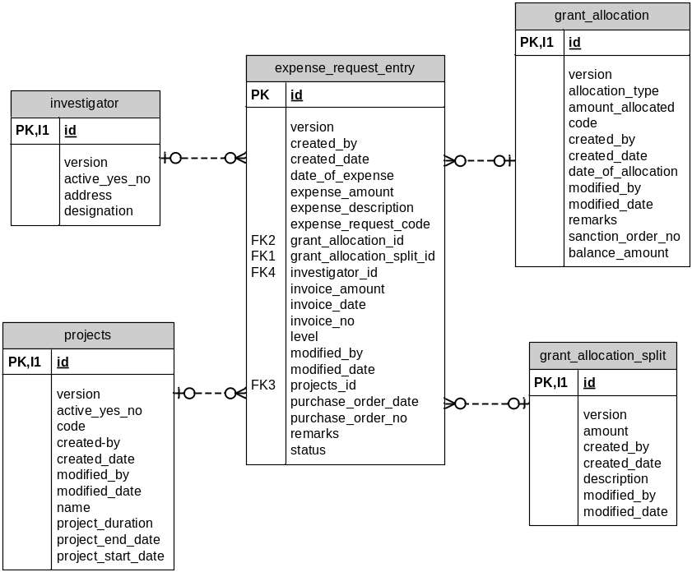

Currently MGMS supports 2 flows for expense recording. Either and both flows may be used by a user.

- In the first process, there is just recording of the item, amount and mode of payment details which can be edited till the utilization certificate is submitted. For this, the details are stored in grant_expense table.
- The new additional flow requires the expense amount and payment amount to be stored separately. Also there is an approval process before payment. So the approval request details are stored in expense_request_entry table. Payment details are then stored in the grant_expense table.
So incase of the second flow, expense_request_code saved (in expense_request_entry table) is captured in the expense_request_code field in the grant_expense table to link the 2.

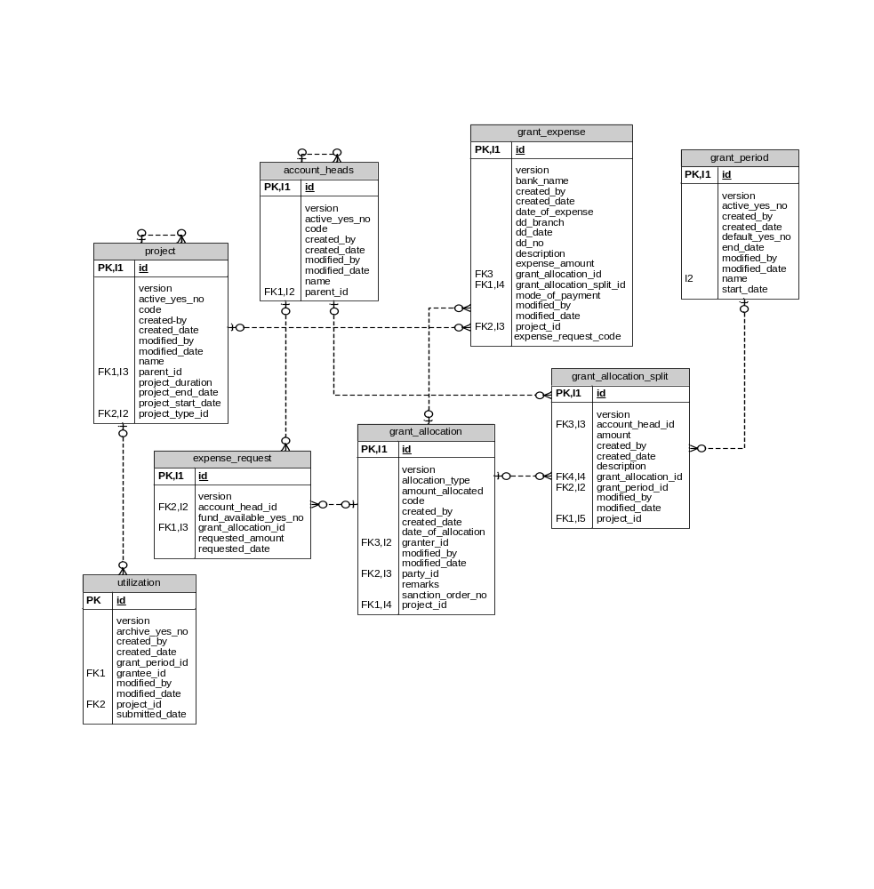

For the approval process, approval authority is created which is a group of users who have the privilege to approve of a specific request. In MGMS, approval authorities are used in many scenarios, for example, review of pre-proposals, full proposals, external proposals etc. In order to distinguish between the type of approval, the proposal_type field (in proposal_approval_authority_map table) value is used.

(Some current values of proposal_type are : PrePrposal, FullProposal, ExpenseRequest, Proposal etc)

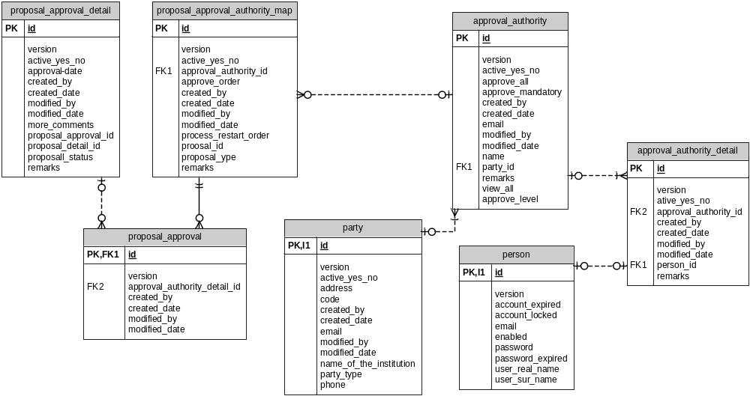

Expense Request Evaluation

Submission of Expense request by staff members
The staff includes those users who submit expense requests /proposals for evaluation. The Staff logs into the application to create and submit expense requests to own institution for review. After logging in, user clicks Enter Expense Request Menu on the left panel. The page below is opened.
Figure 1: Staff - Add new expense request
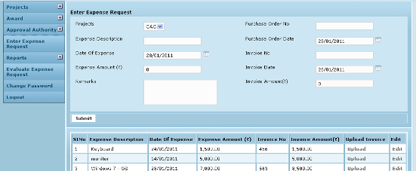

Field /Label | Input-Control | Data Type | Remarks
Project | List box | varchar(255) | projects>code; list of all projects for which the logged in user is the PI
Purchase Order # | Text box | varchar(255) | expense_request_entry>purchase_order_no
Date of expense | Calendar | datetime | expense_request_entry>date_of_expense
Expense Description | Text box | varchar(255) | expense_request_entry>expense_description
Purchase Order Date | Calendar | datetime | expense_request_entry>purchase_order_date
Invoice # | Text box | varchar(255) | expense_request_entry>invoice_no
Invoice Date | Calendar | datetime | expense_request_entry>invoice_date
Expense Amount | Text box | double | expense_request_entry>expense_amount
Invoice amount | Text box | double | expense_request_entry>invoice_amount
Remarks | Text area | varchar(255) | expense_request_entry>remarks
Submit | Button

Purchase Order Date is the date of order for the items made to the vendor. Date of Expense is the day of receipt of the ordered items and Invoice Date is the date as on the bill accompanying the items. For certain purchases, it is not necessary to have Purchase Orders and then date of expense and invoice date are sufficient. It is also possible for all 3 dates to be the same.
Documents can be uploaded (for e.g. PO, Quotations, invoices etc) to be reviewed by the approval authorities.
On clicking Submit, the institution’s expense request is displayed as a line item in the table below as well as in the finance clerk’s (who is privileged to receive all expense requests) Request List.
Later as the routing process progresses the status can be viewed in the Requests List table in (Fig 5).

Please note that the request can still be edited as long as the request is still with the clerk.
Figure 2: Staff - Edit expense entry
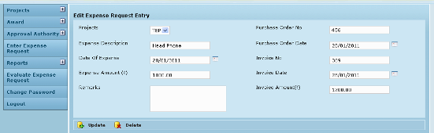

Field /Label | Input-Control | Data Type | Remarks
Project | List box | varchar(255) | projects>code; list of all projects for which the logged in user is the PI
Purchase Order # | Text box | varchar(255) | expense_request_entry>purchase_order_no
Date of expense | Calendar | datetime | expense_request_entry>date_of_expense
Expense Description | Text box | varchar(255) | expense_request_entry>expense_description
Purchase Order Date | Calendar | datetime | expense_request_entry>purchase_order_date
Invoice # | Text box | varchar(255) | expense_request_entry>invoice_no
Invoice Date | Calendar | datetime | expense_request_entry>invoice_date
Expense Amount | Text box | double | expense_request_entry>expense_amount
Invoice amount | Text box | double | expense_request_entry>invoice_amount
Remarks | Text area | varchar(255) | expense_request_entry>remarks
Update | Button
Delete | Button
Once the clerk sends it for approval, Edit option is no longer available for the particular line item. Message is displayed as shown below and the user can only view the details.
Figure 3: Staff - expense entry - non editable
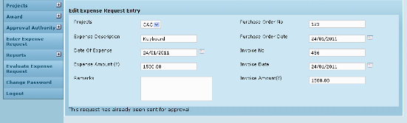

Finance Clerk:

The screen below shows the Clerk‘s list of expense requests which have been submitted so far from various projects and their status.

Figure 4: Clerk– Expense Request List
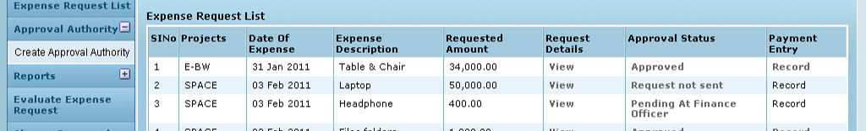

Field /Label | Input-Control | Data Type | Remarks
Expense Request List
Sl No | Auto increment auto populated
Project | Auto populated | varchar(255) | projects>code
Date of Expense | Auto populated | datetime | expense_request_entry>date_of_expense
Expense Description | Auto populated | varchar(255) | expense_request_entry>expense_description
Requested Amount | Auto populated | double | expense_request_entry>expense_amount
Request Details | “View” – link
Approval Status | <status> - Link
Payment Entry | “Record” – Link

Clicking View for a line item in the column Request Details, the following page is opened:
Figure 5: Clerk - View Request Details
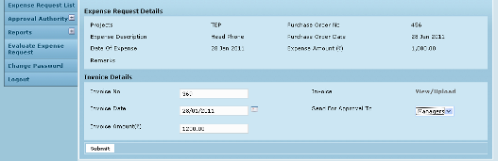

Field /Label | Input-Control | Data Type | Remarks
Project | < > | varchar(255) | projects>code; list of all projects for which the logged in user is the PI
Purchase Order # | < > | varchar(255) | expense_request_entry>purchase_order_no
Expense Description | < > | varchar(255) | expense_request_entry>date_of_expense
Purchase Order Date | < > | datetime | expense_request_entry>expense_description
Expense Amount | < > | double | expense_request_entry>purchase_order_date
Remarks | < > | varchar(255) | expense_request_entry>invoice_no
Invoice Details |  |  |  |  | datetime | expense_request_entry>invoice_date
Invoice Date | Calendar | double | expense_request_entry>expense_amount
Invoice # | Text box | double | expense_request_entry>invoice_amount
Invoice amount | Text box | varchar(255) | expense_request_entry>remarks
Invoice View/Upload | Link
Send for approval to | List box | varchar(255) | approval_authority>name; list all approval authorities created in the institution
Submit | Button |  | message – submitted successfully

The invoice details are populated here and editable. The reason for this provision is to cover a scenario where the invoice is sent to the institution directly. In that case, the clerk will be capturing the invoice details. It is assumed that the purchase order details are completed by the staff/PI always.
Documents may be uploaded as well as existing attachments viewed by clicking link – View/Upload
On every Expense Request form, the clerk selects the first level for approving the form from the list box – Send for approval to. Then on clicking Submit, the request details get populated in the Request List tables of those belonging to that approval level. For e.g. if Asst Manager is selected, the line item goes to all asst managers added as members of that approval level. Whereas, if “Vishal Sharma” is selected, then it goes to Vishal Sharma’s Request List only since he is the only member of that approval level.

By clicking Status link in Approval Status column (Fig 8), a new window is opened where the Approval Status history can be viewed. The status set by each individual at every evaluation level is seen here and the clerk can know who submitted what evaluation result.
Currently, in an evaluation level, even if 1 person rejects the request and sets the evaluation as complete, then the level’s status is displayed as “Rejected” for the finance clerk.
Currently an expense approval request rejected at a level can be send to another level for review. Only the review result of the last evaluation level (which sets evaluation completed status) is considered and displayed.
Figure 6: Clerk - Approval status history
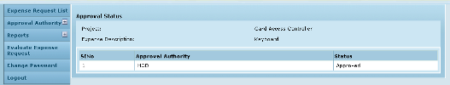

Field /Label | Input-Control | Data Type | Remarks
Approval Status
Project | < > | varchar(255) | projects>code
Expense Description | < > | varchar(255) | expense_request_entry>expense_description
Sl No | Auto increment
Approval Authority |  | varchar(255) | approval_authority>name
Status |  | varchar(255) | Displays “Approved” if evaluation completed and all members of the last level approved;  Displays “Rejected’ if evaluation completed and if at least 1 member of the last level rejected.  Displays “Pending” if evaluation is not completed

On clicking Record link in Payment Entry column, IF the request has been approved already, the following screen opens up – Fig 11. If not approved yet, then the link Record remains disabled.
Figure 7: Clerk - Payment Entry
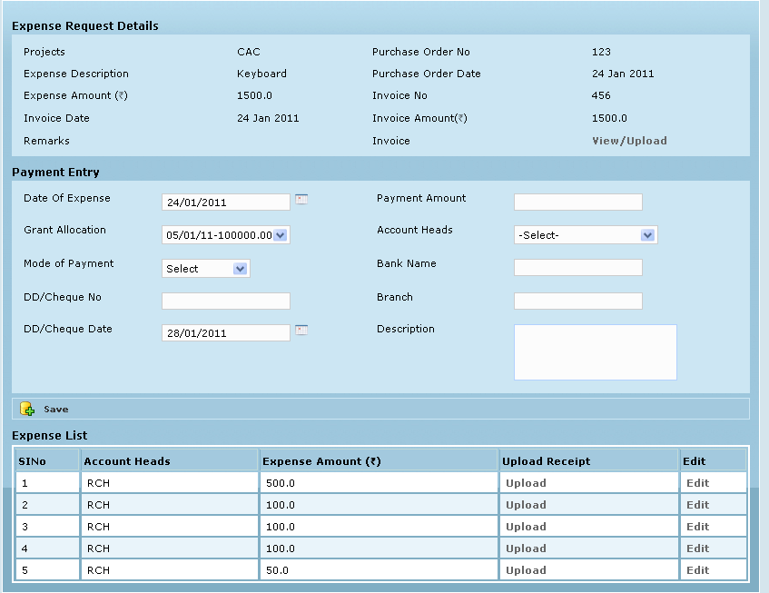

Field /Label | Input-Control | Data Type | Remarks
Project | < > | varchar(255) | projects>code; list of all projects for which the logged in user is the PI
Purchase Order # | < > | varchar(255) | expense_request_entry>purchase_order_no
Date of Payment |  | datetime | grant_expense >date_of_payment
Expense Description | < > | varchar(255) | expense_request_entry>expense_description
Purchase Order | < > | varchar(255) | expense_request_entry>purchase_order_date
Invoice # | < > | varchar(255) | expense_request_entry>invoice_no
Invoice Date | < > | datetime | expense_request_entry>invoice_date
Expense Amount | < > | double | expense_request_entry>expense_amount
Invoice amount | < > | double | expense_request_entry>invoice_amount
Remarks | < > | varchar(255) | expense_request_entry>remarks
Submit | Button

The evaluation process is described below:

Expense Request approval

The finance department approver logs in, clicks Evaluate Expense Request menu on the left. The list of expense requests expected to be reviewed by this employee at various evaluation levels is displayed here.
Figure 8: Approval authority – Evaluate Expense Request - List
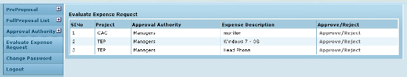
Field /Label | Input-Control | Data Type | Remarks
Evaluate Expense Request
Sl No | Auto increment
Project |  | varchar(255) | projects>code
Approval Authority |  | varchar(255) | approval_authority>name
Expense Description |  | varchar(255) | expense_request_entry>expense_description
Approve/Reject | Link

On clicking the “Approve/Reject” link in the Approve/Reject column, the specific expense request is opened and the approval authority is provided with 2 buttons – Accept & Reject, along with a field to enter comments.

Figure 9: Approval authority – Request Evaluation
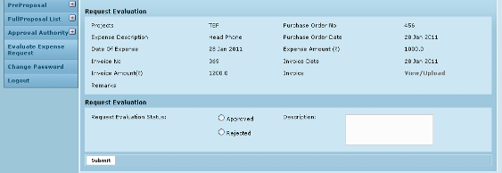
Field /Label | Input-Control | Data Type | Remarks
Project | < > | varchar(255) | projects>code; list of all projects for which the logged in user is the PI
Purchase Order # | < > | varchar(255) | expense_request_entry>purchase_order_no
Expense Description | < > | datetime | expense_request_entry>date_of_expense
Purchase Order | < > | varchar(255) | expense_request_entry>expense_description
Invoice # | < > | varchar(255) | expense_request_entry>purchase_order_date
Invoice Date | < > | datetime | expense_request_entry>invoice_no
Expense Amount | < > | double | expense_request_entry>invoice_date
Invoice amount | < > | double | expense_request_entry>expense_amount
Remarks | < > | varchar(255) | expense_request_entry>invoice_amount
Invoice View/Upload | Link |  | expense_request_entry>remarks
Request evaluation
Request evaluation status
Approved | Radio button
Rejected | Radio button
Description | Text area | varchar(255)
Submit | Button

Once a suitable status (for e.g. Approved) is selected, the screen refreshes to display additional fields along with the message confirming successful completion of evaluation

Here (Fig 14), if the user is the final approver for this request then he can directly click button “Evaluation Completed”. The process ends and in the clerk’s Request List, the Record link is activated for entering payment details (Fig 8).

Figure 10: Approval authority – Send request for further approval
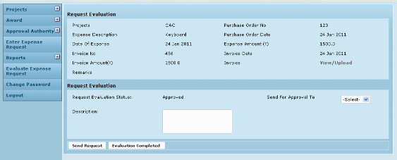

Field /Label | Input-Control | Data Type | Remarks
Request evaluation
Request evaluation Status | < >
Send for approval to | List box
Description | Text area
Send Request | Button
Evaluation completed | Button

If there are multiple members for an authority level, then “Evaluation Completed” can be set only by the last member in that level. Else, the following message is displayed:
Figure 11: Approval authority - evaluation not completed
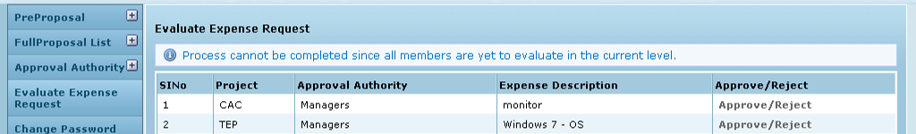

On the other hand, if the request needs to be sent to a different approval authority, the user selects the particular authority from the drop down list Send for approval to and then clicks “Send Request”. Here again, if the other members are yet to evaluate, only a message is shown.
Figure 12: Approval authority – Request cannot be sent
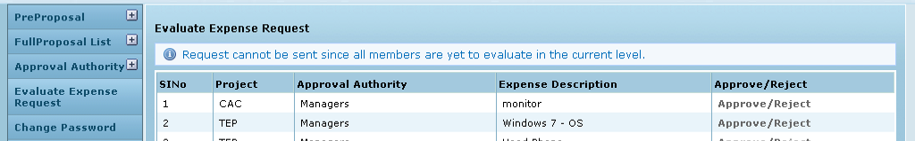

Once successfully evaluated by all members in a level and the request sent to the next level, the line item now populates the selected approval authorities’ lists. The process is repeated.

Please note that currently it is possible for an authority to “Reject” a request and still send it to a different authority. The final status of a request is the same as that set by the authority which clicked “Evaluation completed”.
Currently if the finance clerk tries to resend an item – message is displayed explaining that the evaluation process is already completed for the particular request.

Payment

Once a request gets approved, the Record link is enabled for the privileged user in the Payment entry column (Fig 8 – Expense Request List). By clicking this link, the user can open the Payment entry screen and record the transaction. It is possible to record multiple payments for the same expense – the only validation being that the total payment should not exceed the total expense. Currently it is expected that payment dates may be before, after on the day of expense.

Figure 13: Clerk - multiple payment entries
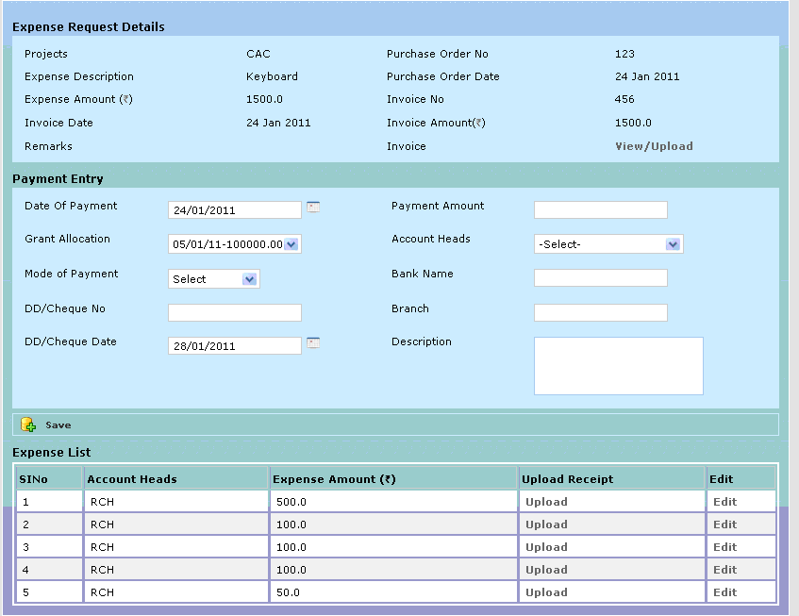

Field /Label | Input-Control | Data Type | Remarks
Project | < > | varchar(255) | projects>code; list of all projects for which the logged in user is the PI
Purchase Order # | < > | varchar(255) | expense_request_entry>purchase_order_no
Expense Description | < > | varchar(255) | expense_request_entry>date_of_expense
Purchase Order | < > | varchar(255) | expense_request_entry>expense_description
Invoice # | < > | varchar(255) | expense_request_entry>purchase_order_date
Invoice Date | < > | datetime | expense_request_entry>invoice_no
Expense Amount | < > | double | expense_request_entry>invoice_date
Invoice amount | < > | double | expense_request_entry>expense_amount
Invoice View/Upload | Link |  | expense_request_entry>invoice_amount
Remarks | < > | varchar(255) | expense_request_entry>remarks
Payment Entry
Date of payment | Calendar | datetime
Payment Amount | Text box |  | grant_expense>expense_amount
Grant allocation | List box | varchar(255) | (grant_allocation> amount_allocated) (grant_allocation_date_of_allocation)
Account head | List box | varchar(255) | account_heads>name
Mode of Payment | List box | varchar(255) | grant_expense>mode_of_payment
DD/Cheque # | Text box | varchar(255) | grant_expense>dd_no
DD/Cheque Date | Text box | datetime | grant_expense>dd_date
Bank | Text box | varchar(255) | grant_expense>bank_name
Branch | Calendar | varchar(255) | grant_expense>dd_branch
Description | Text area | varchar(255) | grant_expense>description
Save | Button
Payment List
Sl No | Auto increment
Account head |  | varchar(255) | account_heads>name
Payment amount |  | double | grant_expense>expense_amount
Upload receipt | Link
Edit | Button

There is an expense_request_code field in grant_expense table which connects a PI expense approval request with the payment.
For a single request, multiple payments can be assigned with the validation that total payment amount should not go beyond the expense amount.

Data Dictionary

account_heads

Fields

Field | Type | Collation | Null | Key | Default | Extra | Privileges
id | bigint(20) | (NULL) | NO | PRI | (NULL) | auto_increment | select,insert,update,references
version | bigint(20) | (NULL) | NO |  |  |  | select,insert,update,references
active_yes_no | char(1) | latin1_swedish_ci | NO |  |  |  | select,insert,update,references
code | varchar(255) | latin1_swedish_ci | NO |  |  |  | select,insert,update,references
created_by | varchar(255) | latin1_swedish_ci | NO |  |  |  | select,insert,update,references
created_date | datetime | (NULL) | YES |  | (NULL) |  | select,insert,update,references
modified_by | varchar(255) | latin1_swedish_ci | NO |  |  |  | select,insert,update,references
modified_date | datetime | (NULL) | YES |  | (NULL) |  | select,insert,update,references
name | varchar(255) | latin1_swedish_ci | NO |  |  |  | select,insert,update,references
parent_id | bigint(20) | (NULL) | YES | MUL | (NULL) |  | select,insert,update,references

Indexes

Table | Non  unique | Key  name | Seq  in  index | Column  name | Collation | Cardinality | Sub  part | Packed | Null | Index  type
account_heads | 0 | PRIMARY | 1 | id | A | 102 | (NULL) | (NULL) |  | BTREE
account_heads | 1 | FKE001C601C4F4CD56 | 1 | parent_id | A | 51 | (NULL) | (NULL) | YES | BTREE

Foreign Key Relationships

FK Id | Reference Table | Source Column | Target Column | Extra Info
FKE001C601C4F4CD56 | account_heads | `parent_id` | `id`
expense_request

Fields

Field | Type | Collation | Null | Key | Default | Extra | Privileges
id | bigint(20) | (NULL) | NO | PRI | (NULL) | auto_increment | select,insert,update,references
version | bigint(20) | (NULL) | NO |  |  |  | select,insert,update,references
account_head_id | bigint(20) | (NULL) | NO | MUL |  |  | select,insert,update,references
fund_available_yes_no | char(1) | latin1_swedish_ci | NO |  |  |  | select,insert,update,references
grant_allocation_id | bigint(20) | (NULL) | NO | MUL |  |  | select,insert,update,references
requested_amount | double | (NULL) | NO |  |  |  | select,insert,update,references
requested_date | datetime | (NULL) | NO |  |  |  | select,insert,update,references

Indexes

Table | Non  unique | Key  name | Seq  in  index | Column  name | Collation | Cardinality | Sub  part | Packed | Null | Index  type
expense_request | 0 | PRIMARY | 1 | id | A | 0 | (NULL) | (NULL) |  | BTREE
expense_request | 1 | FKBA1189A83036284E | 1 | account_head_id | A | 0 | (NULL) | (NULL) |  | BTREE
expense_request | 1 | FKBA1189A8B8D959F3 | 1 | grant_allocation_id | A | 0 | (NULL) | (NULL) |  | BTREE

Foreign Key Relationships

FK Id | Reference Table | Source Column | Target Column | Extra Info
FKBA1189A8B8D959F3 | grant_allocation | `grant_allocation_id` | `id` | ,
FKBA1189A83036284E | account_heads | `account_head_id` | `id`

expense_request_entry

Fields

Field | Type | Collation | Null | Key | Default | Extra | Privileges
id | bigint(20) | (NULL) | NO | PRI | (NULL) | auto_increment | select,insert,update,references
version | bigint(20) | (NULL) | NO |  |  |  | select,insert,update,references
created_by | varchar(255) | latin1_swedish_ci | NO |  |  |  | select,insert,update,references
created_date | datetime | (NULL) | NO |  |  |  | select,insert,update,references
date_of_expense | datetime | (NULL) | NO |  |  |  | select,insert,update,references
expense_amount | double | (NULL) | NO |  |  |  | select,insert,update,references
expense_description | varchar(255) | latin1_swedish_ci | NO |  |  |  | select,insert,update,references
expense_request_code | varchar(255) | latin1_swedish_ci | NO |  |  |  | select,insert,update,references
grant_allocation_id | bigint(20) | (NULL) | YES | MUL | (NULL) |  | select,insert,update,references
grant_allocation_split_id | bigint(20) | (NULL) | YES | MUL | (NULL) |  | select,insert,update,references
investigator_id | bigint(20) | (NULL) | NO | MUL |  |  | select,insert,update,references
invoice_amount | double | (NULL) | YES |  | (NULL) |  | select,insert,update,references
invoice_date | datetime | (NULL) | YES |  | (NULL) |  | select,insert,update,references
invoice_no | varchar(255) | latin1_swedish_ci | YES |  |  |  | select,insert,update,references
level | int(11) | (NULL) | NO |  |  |  | select,insert,update,references
modified_by | varchar(255) | latin1_swedish_ci | YES |  | (NULL) |  | select,insert,update,references
modified_date | datetime | (NULL) | YES |  | (NULL) |  | select,insert,update,references
projects_id | bigint(20) | (NULL) | NO | MUL |  |  | select,insert,update,references
purchase_order_date | datetime | (NULL) | NO |  |  |  | select,insert,update,references
purchase_order_no | varchar(255) | latin1_swedish_ci | NO |  |  |  | select,insert,update,references
remarks | varchar(255) | latin1_swedish_ci | NO |  |  |  | select,insert,update,references
status | varchar(255) | latin1_swedish_ci | NO |  |  |  | select,insert,update,references

Indexes

Table | Non  unique | Key  name | Seq  in  index | Column  name | Collation | Cardinality | Sub  part | Packed | Null | Index  type
expense_request  _entry | 0 | PRIMARY | 1 | id | A | 43 | (NULL) | (NULL) |  | BTREE
expense_request  _entry | 1 | FKBDFD171BB8D959F3 | 1 | grant_allocation_id | A | 2 | (NULL) | (NULL) | YES | BTREE
expense_request  _entry | 1 | FKBDFD171B905C4B9A | 1 | projects_id | A | 43 | (NULL) | (NULL) |  | BTREE
expense_request  _entry | 1 | FKBDFD171B893BB93A | 1 | investigator_id | A | 14 | (NULL) | (NULL) |  | BTREE
expense_request  _entry | 1 | FKBDFD171B33CE82BA | 1 | grant_allocation_  split_id | A | 2 | (NULL) | (NULL) | YES | BTREE

Foreign Key Relationships

FK Id | Reference Table | Source Column | Target Column | Extra Info
FKBDFD171B33CE82BA | grant_allocation_split | `grant_allocation_split_id` | `id` | ,
FKBDFD171B893BB93A | investigator | `investigator_id` | `id` | ,
FKBDFD171B905C4B9A | projects | `projects_id` | `id` | ,
FKBDFD171BB8D959F3 | grant_allocation | `grant_allocation_id` | `id`
grant_allocation

Fields

Field | Type | Collation | Null | Key | Default | Extra | Privileges
id | bigint(20) | (NULL) | NO | PRI | (NULL) | auto_increment | select,insert,update,references
version | bigint(20) | (NULL) | NO |  |  |  | select,insert,update,references
allocation_type | varchar(255) | latin1_swedish_ci | NO |  |  |  | select,insert,update,references
amount_allocated | double | (NULL) | NO |  |  |  | select,insert,update,references
code | varchar(255) | latin1_swedish_ci | NO |  |  |  | select,insert,update,references
created_by | varchar(255) | latin1_swedish_ci | NO |  |  |  | select,insert,update,references
created_date | datetime | (NULL) | YES |  | (NULL) |  | select,insert,update,references
date_of_allocation | datetime | (NULL) | NO |  |  |  | select,insert,update,references
granter_id | bigint(20) | (NULL) | YES | MUL | (NULL) |  | select,insert,update,references
modified_by | varchar(255) | latin1_swedish_ci | NO |  |  |  | select,insert,update,references
modified_date | datetime | (NULL) | YES |  | (NULL) |  | select,insert,update,references
party_id | bigint(20) | (NULL) | NO | MUL |  |  | select,insert,update,references
projects_id | bigint(20) | (NULL) | NO | MUL |  |  | select,insert,update,references
remarks | varchar(255) | latin1_swedish_ci | NO |  |  |  | select,insert,update,references
sanction_order_no | varchar(255) | latin1_swedish_ci | YES |  | (NULL) |  | select,insert,update,references

Indexes

Table | Non  unique | Key  name | Seq  in  index | Column  name | Collation | Cardinality | Sub  part | Packed | Null | Index  type
grant_allocation | 0 | PRIMARY | 1 | id | A | 457 | (NULL) | (NULL) |  | BTREE
grant_allocation | 1 | FK221B5BE337914517 | 1 | granter_id | A | 45 | (NULL) | (NULL) | YES | BTREE
grant_allocation | 1 | FK221B5BE34B78CFDA | 1 | party_id | A | 76 | (NULL) | (NULL) |  | BTREE
grant_allocation | 1 | FK221B5BE3905C4B9A | 1 | projects_id | A | 457 | (NULL) | (NULL) |  | BTREE

Foreign Key Relationships

FK Id | Reference Table | Source Column | Target Column | Extra Info
FK221B5BE3905C4B9A | projects | `projects_id` | `id` | ,
FK221B5BE337914517 | party | `granter_id` | `id` | ,
FK221B5BE34B78CFDA | party | `party_id` | `id`
grant_allocation_split

Fields

Field | Type | Collation | Null | Key | Default | Extra | Privileges
id | bigint(20) | (NULL) | NO | PRI | (NULL) | auto_increment | select,insert,update,references
version | bigint(20) | (NULL) | NO |  |  |  | select,insert,update,references
account_head_id | bigint(20) | (NULL) | NO | MUL |  |  | select,insert,update,references
amount | double | (NULL) | NO |  |  |  | select,insert,update,references
created_by | varchar(255) | latin1_swedish_ci | NO |  |  |  | select,insert,update,references
created_date | datetime | (NULL) | NO |  |  |  | select,insert,update,references
description | varchar(255) | latin1_swedish_ci | NO |  |  |  | select,insert,update,references
grant_allocation_id | bigint(20) | (NULL) | YES | MUL | (NULL) |  | select,insert,update,references
grant_period_id | bigint(20) | (NULL) | NO | MUL |  |  | select,insert,update,references
modified_by | varchar(255) | latin1_swedish_ci | YES |  | (NULL) |  | select,insert,update,references
modified_date | datetime | (NULL) | YES |  | (NULL) |  | select,insert,update,references
projects_id | bigint(20) | (NULL) | NO | MUL |  |  | select,insert,update,references

Indexes

Table | Non  unique | Key  name | Seq  in  index | Column  name | Collation | Cardinality | Sub  part | Packed | Null | Index  type
grant_allocation_split | 0 | PRIMARY | 1 | id | A | 147 | (NULL) | (NULL) |  | BTREE
grant_allocation_split | 1 | FK49B723BE161A26D3 | 1 | grant_period_id | A | 12 | (NULL) | (NULL) |  | BTREE
grant_allocation_split | 1 | FK49B723BE3036284E | 1 | account_head_id | A | 73 | (NULL) | (NULL) |  | BTREE
grant_allocation_split | 1 | FK49B723BEB8D959F3 | 1 | grant_allocation_id | A | 147 | (NULL) | (NULL) | YES | BTREE
grant_allocation_split | 1 | FK49B723BE905C4B9A | 1 | projects_id | A | 147 | (NULL) | (NULL) |  | BTREE

Foreign Key Relationships

FK Id | Reference Table | Source Column | Target Column | Extra Info
FK49B723BE905C4B9A | projects | `projects_id` | `id` | ,
FK49B723BE161A26D3 | grant_period | `grant_period_id` | `id` | ,
FK49B723BE3036284E | account_heads | `account_head_id` | `id` | ,
FK49B723BEB8D959F3 | grant_allocation | `grant_allocation_id` | `id`
grant_expense

Fields

Field | Type | Collation | Null | Key | Default | Extra | Privileges
id | bigint(20) | (NULL) | NO | PRI | (NULL) | auto_increment | select,insert,update,references
version | bigint(20) | (NULL) | NO |  |  |  | select,insert,update,references
bank_name | varchar(255) | latin1_swedish_ci | NO |  |  |  | select,insert,update,references
created_by | varchar(255) | latin1_swedish_ci | NO |  |  |  | select,insert,update,references
created_date | datetime | (NULL) | NO |  |  |  | select,insert,update,references
date_of_expense | datetime | (NULL) | NO |  |  |  | select,insert,update,references
dd_branch | varchar(255) | latin1_swedish_ci | NO |  |  |  | select,insert,update,references
dd_date | datetime | (NULL) | NO |  |  |  | select,insert,update,references
dd_no | varchar(255) | latin1_swedish_ci | NO |  |  |  | select,insert,update,references
description | varchar(255) | latin1_swedish_ci | NO |  |  |  | select,insert,update,references
expense_amount | double | (NULL) | NO |  |  |  | select,insert,update,references
grant_allocation_id | bigint(20) | (NULL) | YES | MUL | (NULL) |  | select,insert,update,references
grant_allocation_split_id | bigint(20) | (NULL) | YES | MUL | (NULL) |  | select,insert,update,references
mode_of_payment | varchar(255) | latin1_swedish_ci | NO |  |  |  | select,insert,update,references
modified_by | varchar(255) | latin1_swedish_ci | YES |  | (NULL) |  | select,insert,update,references
modified_date | datetime | (NULL) | YES |  | (NULL) |  | select,insert,update,references
projects_id | bigint(20) | (NULL) | NO | MUL |  |  | select,insert,update,references
expense_request_code | varchar(255) | latin1_swedish_ci | YES |  | (NULL) |  | select,insert,update,references

Indexes

Table | Non  unique | Key  name | Seq  in  index | Column  name | Collation | Cardinality | Sub  part | Packed | Null | Index  type
grant_expense | 0 | PRIMARY | 1 | id | A | 88 | (NULL) | (NULL) |  | BTREE
grant_expense | 1 | FK33905435B8D959F3 | 1 | grant_allocation_id | A | 88 | (NULL) | (NULL) | YES | BTREE
grant_expense | 1 | FK33905435905C4B9A | 1 | projects_id | A | 88 | (NULL) | (NULL) |  | BTREE
grant_expense | 1 | FK3390543533CE82BA | 1 | grant_allocation_split_id | A | 88 | (NULL) | (NULL) | YES | BTREE

Foreign Key Relationships

FK Id | Reference Table | Source Column | Target Column | Extra Info
FK3390543533CE82BA | grant_allocation_split | `grant_allocation_split_id` | `id` | ,
FK33905435905C4B9A | projects | `projects_id` | `id` | ,
FK33905435B8D959F3 | grant_allocation | `grant_allocation_id` | `id`

grant_period

Fields

Field | Type | Collation | Null | Key | Default | Extra | Privileges
id | bigint(20) | (NULL) | NO | PRI | (NULL) | auto_increment | select,insert,update,references
version | bigint(20) | (NULL) | NO |  |  |  | select,insert,update,references
active_yes_no | char(1) | latin1_swedish_ci | NO |  |  |  | select,insert,update,references
created_by | varchar(255) | latin1_swedish_ci | NO |  |  |  | select,insert,update,references
created_date | datetime | (NULL) | YES |  | (NULL) |  | select,insert,update,references
default_yes_no | char(1) | latin1_swedish_ci | NO |  |  |  | select,insert,update,references
end_date | datetime | (NULL) | NO |  |  |  | select,insert,update,references
modified_by | varchar(255) | latin1_swedish_ci | NO |  |  |  | select,insert,update,references
modified_date | datetime | (NULL) | YES |  | (NULL) |  | select,insert,update,references
name | varchar(255) | latin1_swedish_ci | NO | MUL |  |  | select,insert,update,references
start_date | datetime | (NULL) | NO |  |  |  | select,insert,update,references

Indexes

Table | Non  unique | Key  name | Seq  in  index | Column  name | Collation | Cardinality | Sub  part | Packed | Null | Index  type
grant_period | 0 | PRIMARY | 1 | id | A | 76 | (NULL) | (NULL) |  | BTREE
grant_period | 1 | name | 1 | name | A | 76 | (NULL) | (NULL) |  | BTREE
investigator

Fields

Field | Type | Collation | Null | Key | Default | Extra | Privileges
id | bigint(20) | (NULL) | NO | PRI | (NULL) | auto_increment | select,insert,update,references
version | bigint(20) | (NULL) | NO |  |  |  | select,insert,update,references
active_yes_no | char(1) | latin1_swedish_ci | NO |  |  |  | select,insert,update,references
address | varchar(255) | latin1_swedish_ci | NO |  |  |  | select,insert,update,references
department_id | bigint(20) | (NULL) | YES | MUL | (NULL) |  | select,insert,update,references
designation | varchar(255) | latin1_swedish_ci | NO |  |  |  | select,insert,update,references
email | varchar(255) | latin1_swedish_ci | NO | UNI |  |  | select,insert,update,references
name | varchar(255) | latin1_swedish_ci | NO | MUL |  |  | select,insert,update,references
party_id | bigint(20) | (NULL) | NO | MUL |  |  | select,insert,update,references

Indexes

Table | Non  unique | Key  name | Seq  in  index | Column  name | Collation | Cardinality | Sub  part | Packed | Null | Index  type
investigator | 0 | PRIMARY | 1 | id | A | 84 | (NULL) | (NULL) |  | BTREE
investigator | 0 | email | 1 | email | A | 84 | (NULL) | (NULL) |  | BTREE
investigator | 1 | FK967BBBA99F389FE0 | 1 | department_id | A | 84 | (NULL) | (NULL) | YES | BTREE
investigator | 1 | FK967BBBA94B78CFDA | 1 | party_id | A | 28 | (NULL) | (NULL) |  | BTREE
investigator | 1 | name | 1 | name | A | 84 | (NULL) | (NULL) |  | BTREE

Foreign Key Relationships

FK Id | Reference Table | Source Column | Target Column | Extra Info
FK967BBBA94B78CFDA | party | `party_id` | `id` | ,
FK967BBBA99F389FE0 | party_department | `department_id` | `id`
projects

Fields

Field | Type | Collation | Null | Key | Default | Extra | Privileges
id | bigint(20) | (NULL) | NO | PRI | (NULL) | auto_increment | select,insert,update,references
version | bigint(20) | (NULL) | NO |  |  |  | select,insert,update,references
active_yes_no | char(1) | latin1_swedish_ci | NO |  |  |  | select,insert,update,references
code | varchar(255) | latin1_swedish_ci | NO |  |  |  | select,insert,update,references
created_by | varchar(255) | latin1_swedish_ci | NO |  |  |  | select,insert,update,references
created_date | datetime | (NULL) | NO |  |  |  | select,insert,update,references
modified_by | varchar(255) | latin1_swedish_ci | NO |  |  |  | select,insert,update,references
modified_date | datetime | (NULL) | NO |  |  |  | select,insert,update,references
name | varchar(255) | latin1_swedish_ci | NO |  |  |  | select,insert,update,references
parent_id | bigint(20) | (NULL) | YES | MUL | (NULL) |  | select,insert,update,references
project_duration | varchar(255) | latin1_swedish_ci | YES |  | (NULL) |  | select,insert,update,references
project_end_date | datetime | (NULL) | YES |  | (NULL) |  | select,insert,update,references
project_start_date | datetime | (NULL) | YES |  | (NULL) |  | select,insert,update,references
project_type_id | int(11) | (NULL) | NO | MUL |  |  | select,insert,update,references

Indexes

Table | Non  unique | Key  name | Seq  in  index | Column  name | Collation | Cardinality | Sub  part | Packed | Null | Index  type
projects | 0 | PRIMARY | 1 | id | A | 229 | (NULL) | (NULL) |  | BTREE
projects | 1 | FKC479187A69DF6AED | 1 | project_type_id | A | 229 | (NULL) | (NULL) |  | BTREE
projects | 1 | FKC479187A43BA2D6A | 1 | parent_id | A | 229 | (NULL) | (NULL) | YES | BTREE

Foreign Key Relationships

FK Id | Reference Table | Source Column | Target Column | Extra Info
FKC479187A43BA2D6A | projects | `parent_id` | `id` | ,
FKC479187A69DF6AED | project_type | `project_type_id` | `id`
utilization

Fields

Field | Type | Collation | Null | Key | Default | Extra | Privileges
id | bigint(20) | (NULL) | NO | PRI | (NULL) | auto_increment | select,insert,update,references
version | bigint(20) | (NULL) | NO |  |  |  | select,insert,update,references
archive_yes_no | varchar(255) | latin1_swedish_ci | YES |  | (NULL) |  | select,insert,update,references
created_by | varchar(255) | latin1_swedish_ci | YES |  | (NULL) |  | select,insert,update,references
created_date | datetime | (NULL) | YES |  | (NULL) |  | select,insert,update,references
end_date | datetime | (NULL) | NO |  |  |  | select,insert,update,references
grantee_id | bigint(20) | (NULL) | NO | MUL |  |  | select,insert,update,references
modified_by | varchar(255) | latin1_swedish_ci | YES |  | (NULL) |  | select,insert,update,references
modified_date | datetime | (NULL) | YES |  | (NULL) |  | select,insert,update,references
projects_id | bigint(20) | (NULL) | NO | MUL |  |  | select,insert,update,references
start_date | datetime | (NULL) | NO |  |  |  | select,insert,update,references
submitted_date | datetime | (NULL) | NO |  |  |  | select,insert,update,references

Indexes

Table | Non  unique | Key  name | Seq  in  index | Column  name | Collation | Cardinality | Sub  part | Packed | Null | Index  type
utilization | 0 | PRIMARY | 1 | id | A | 51 | (NULL) | (NULL) |  | BTREE
utilization | 1 | FKE9082E22378B5C44 | 1 | grantee_id | A | 17 | (NULL) | (NULL) |  | BTREE
utilization | 1 | FKE9082E22905C4B9A | 1 | projects_id | A | 51 | (NULL) | (NULL) |  | BTREE

Foreign Key Relationships

FK Id | Reference Table | Source Column | Target Column | Extra Info
FKE9082E22905C4B9A | projects | `projects_id` | `id` | ,
FKE9082E22378B5C44 | party | `grantee_id` | `id`

