MGMS – Human Resource

Detailed Design Document

Ver. 1.4

Version History
Date | Description
25-Oct-2010 | First Draft
12-Dec-2010 | Label changes

Table of Contents

Version History 2
1 Introduction 3
2 HR Management 4
3 Associated tables 12
4 Data Dictionary 13

Introduction

This document provides the detailed design specifications for the Multisite Grant Management System project.

This is not a project plan nor does it detail the source code. It is a guide for system architecture and development, not for phasing, timelines or deliverables.

Finally, this is a ‘living document’ and the specification will change, continuously, as the project proceeds. More details will be added and the existing information edited as the requirements, architecture and design evolve in the course of the project.

HR Management

In HR module, there is provision to add personnel against each project.
The details saved are:
  - Details such employee name, employee no:, DOB, joining date, relieving date from the project) , designation etc.
  - Qualification details such as University, exam passed, % marks, passing out year etc.
  - Experience Details such previous employer’s name, joining/relieving dates and designation while there.
  - Salary Details such as salary component, corresponding amount , date with effect from etc

Clicking on the HR Management menu on the left panel will open the Current Projects list screen, as shown below:

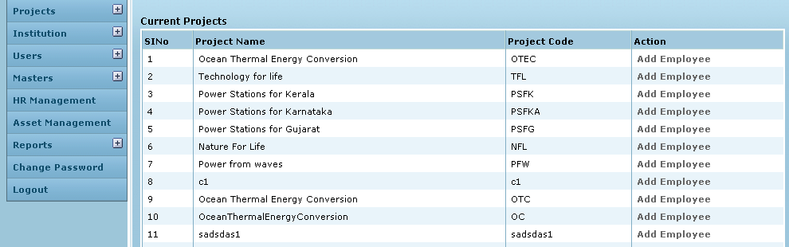

Control Description

Field /Label | Input-Control | Data Type | DB Table>Field
Sl No | Auto generated sequential numbering for each row
Project Name | Auto populated | varchar(255) | projects>name
Project Code | Auto populated | varchar(255) | projects>code
Action | “Add Employee” link | link

Clicking on Add Employee for a particular project will open the Project Employees screen as shown below:

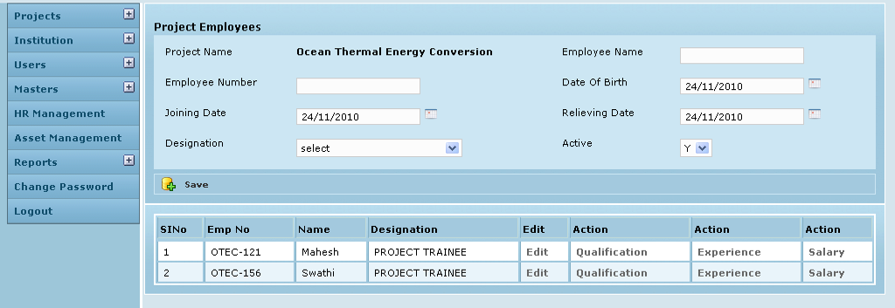

Control Description

Field /Label | Input-Control | Data Type | DB Table>Field
Project Name | Auto populated | varchar(255) | projects>name
Employee Name | Textbox | varchar(255) | project_employee>emp_name
Employee Number | Textbox | varchar(255) | project_employee>emp_no
Date of Birth | Calendar | datetime | project_employee>dob
Joining Date | Calendar | datetime | project_employee>joining_date
Relieving Date | Calendar | datetime | project_employee>relieving_date
Designation | Listbox | varchar(255) | employee_designation>designation corresponding to the project_employee>employee_designation_id
Active | Listbox | varchar(255) | project_employee>status
Save | Button
Sl.No | Auto incremented sequential | varchar(255)
Emp No | Auto populated | varchar(255) | project_employee>emp_no
Name | Auto populated | varchar(255) | project_employee>emp_name
Designation | Auto populated | varchar(255) | employee_designation>designation corresponding to the project_employee>employee_designation_id
Edit | “Edit” | Link | opens the Edit Project Employee screen
Action | “Qualification” | Link | opens the Project Employee Qualification screen
Action | “Experience” | Link | opens the Project Employee Experience screen
Action | “Salary” | Link | opens the Project Employee Salary screen

Clicking on Edit for a particular employee in the table will open the Edit Project Employee screen as shown below:

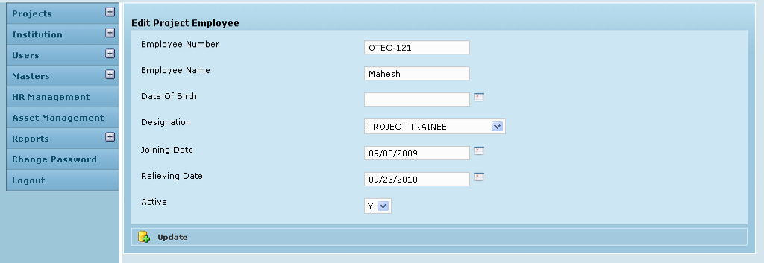

Control Description

Field /Label | Input-Control | Data Type | DB Table>Field
Employee Name | Textbox | varchar(255) | project_employee>emp_name
Employee Number | Textbox | varchar(255) | project_employee>emp_no
Date of Birth | Calendar | varchar(255) | employee_designation>designation corresponding to the project_employee>employee_designation_id
Joining Date | Calendar | datetime | project_employee>joining_date
Relieving Date | Calendar | datetime | project_employee>relieving_date
Designation | Listbox | varchar(255) | employee_designation>designation corresponding to the project_employee>employee_designation_id
Active | Listbox | varchar(255) | project_employee>status
Update | Button

Clicking on Qualification will open the Project Employee Qualification screen as shown below:

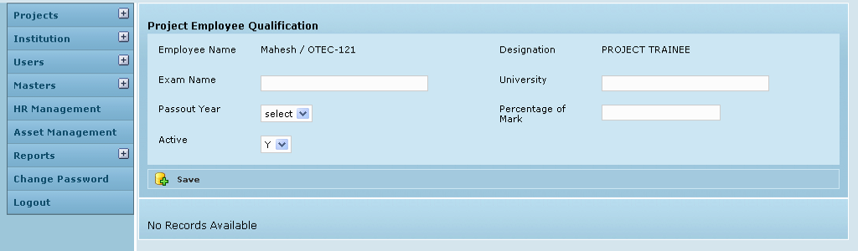

Control Description

Field /Label | Input-Control | Data Type | DB Table>Field
Employee Name | Auto populated | varchar(255) | project_employee>emp_name
Designation | Auto populated | varchar(255) | employee_designation>designation corresponding to the project_employee>employee_designation_id
Exam Name | Textbox | varchar(255) | project_employee_qualification>examname
University | Textbox | varchar(255) | project_employee_qualification>university
Pass out Year | Listbox | varchar(255) | project_employee_qualification>passout_year
Percentage of Marks | Textbox | double | project_employee_qualification>perc_mark
Active | Listbox | varchar(255) | project_employee_qualification>status
Save | Button

When there are no saved records, a message is displayed on the screen as shown above – “No records available”

Each time a record is saved, the screen is refreshed with a message – “Created Successfully” and the details y are displayed in table format as shown in the screen below:

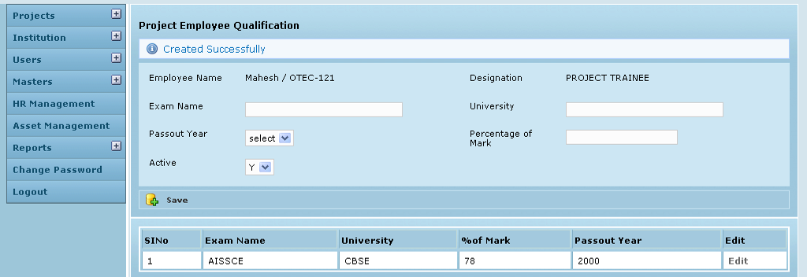

Control Description

Field /Label | Input-Control | Data Type | DB Table>Field
Sl. No | Auto generated, sequential increment for each row of record | varchar(255)
Exam Name | Auto populated | varchar(255) | project_employee_qualification>examname
University | Auto populated | varchar(255) | project_employee_qualification>university
Pass out Year | Auto populated | varchar(255) | project_employee_qualification>passout_year
Percentage of Marks | Auto populated | double | project_employee_qualification>perc_mark
Edit | Button

Clicking on Edit opens the following screen

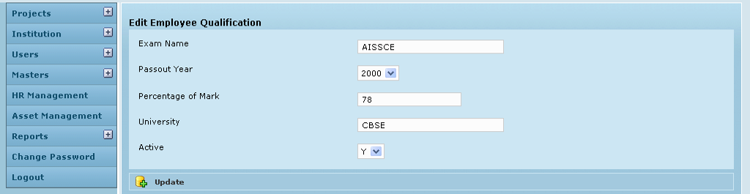

Control Description

Field /Label | Input-Control | Data Type | DB Table>Field
Sl. No | Auto generated, sequential increment for each row of record | varchar(255)
Exam Name | Auto populated editable textbox | varchar(255) | project_employee_qualification>examname
University | Auto populated editable textbox | varchar(255) | project_employee_qualification>university
Pass out Year | Auto populated editable textbox | varchar(255) | project_employee_qualification>passout_year
Percentage of Marks | Auto populated editable textbox | double | project_employee_qualification>perc_mark
Active | Auto populated editable listbox | varchar(255) | project_employee_qualification>status
Update | Button

Clicking on Experience will open the Project Employee Experience screen as shown below:

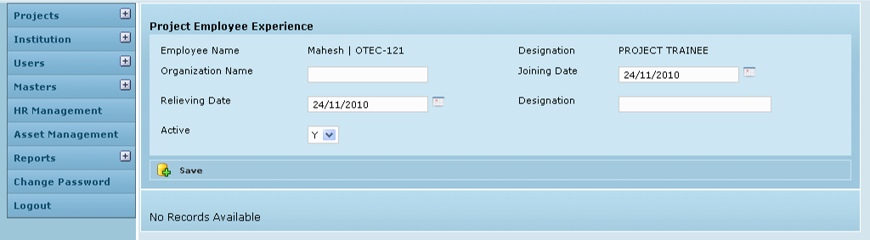

Control Description

Field /Label | Input-Control | Data Type | DB Table>Field
Employee Name | Auto populated | varchar(255) | project_employee>emp_name
Designation | Auto populated | varchar(255) | employee_designation>designation corresponding to the project_employee>employee_designation_id
Organization | Textbox | varchar(255) | project_employee_experience>organization_name
Joining Date | Calendar | datetime | project_employee_experience>joining_date
Relieving Date | Calendar | datetime | project_employee_experience>relieving_date
Designation | Listbox | varchar(255) | project_employee_experience>designation
Active | Textbox | varchar(255) | project_employee_experience>status
Save | Button

When there are no saved records, a message is displayed on the screen as shown above – “No records available”

Each time a record is saved, the screen is refreshed with a message – “Created Successfully” and the details y are displayed in table format as shown in the screen below:

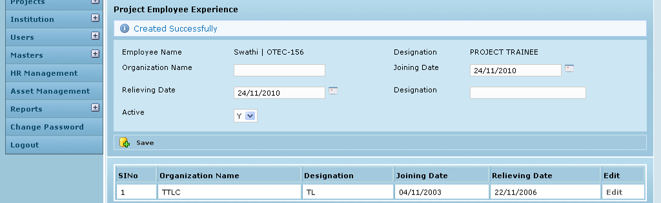

Control Description

Field /Label | Input-Control | Data Type | DB Table>Field
Sl No | Auto incremented sequential | varchar(255)
Designation | Auto populated | varchar(255) | project_employee_experience>designation
Organization | Auto populated | varchar(255) | project_employee_experience>organization_name
Joining Date | Auto populated | datetime | project_employee_experience>joining_date
Relieving Date | Auto populated | datetime | project_employee_experience>relieving_date
Edit | Button

Clicking on Edit opens the following screen
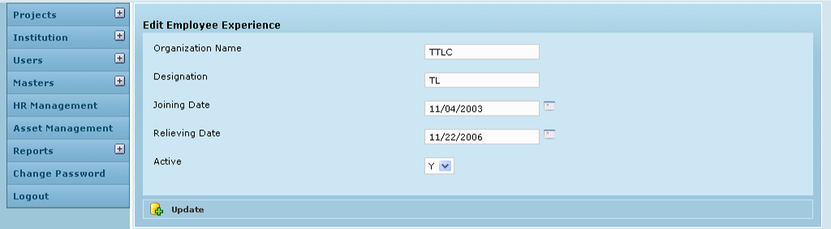

Control Description

Field /Label | Input-Control | Data Type | DB Table>Field
Sl No | Auto incremented sequential | varchar(255)
Designation | Auto populated editable textbox | varchar(255) | project_employee_experience>designation
Organization | Auto populated editable textbox | varchar(255) | project_employee_experience>organization_name
Joining Date | Auto populated editable calendar | datetime | project_employee_experience>joining_date
Relieving Date | Auto populated editable calendar | datetime | project_employee_experience>relieving_date
Active | Auto populated editable listbox | varchar(255) | project_employee_experience>status
Update | Button

Clicking on Salary will open the Project Employee Salary screen as shown below:

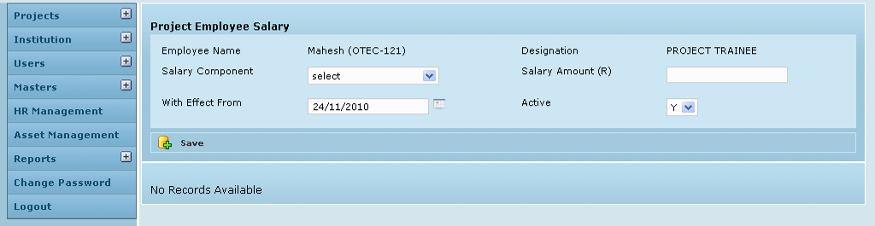

Control Description

Field /Label | Input-Control | Data Type | DB Table>Field
Employee Name | Auto populated | varchar(255) | project_employee>emp_name
Designation | Auto populated | varchar(255) | employee_designation>designation corresponding to the project_employee>employee_designation_id
Salary Component | Listbox | varchar(255) | salary_component>name corresponding to the project_employee_salary_details>salary_component_id
Salary Amount | Textbox | double | project_employee_salary_details>salary_amount
With effect from | Calendar | datetime | project_employee_salary_details>with_effect_from
Active | Listbox | varchar(255) | project_employee_salary_details>status
Save | Button

When there are no saved records, a message is displayed on the screen as shown above – “No records available”

Each time a record is saved, the screen is refreshed with a message – “Created Successfully” and the details y are displayed in table format as shown in the screen below:

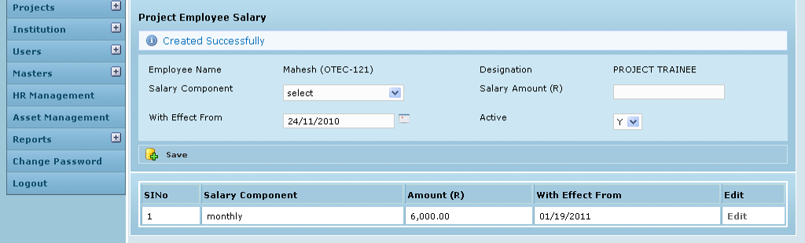

Control Description

Field /Label | Input-Control | Data Type | DB Table>Field
Sl No | Auto populated | varchar(255)
Salary Component | Listbox | varchar(255) | salary_component>name corresponding to the project_employee_salary_details>salary_component_id
Salary Amount | Textbox | double | project_employee_salary_details>salary_amount
With effect from | Calendar | datetime | project_employee_salary_details>with_effect_from
Edit | Button

Clicking on Edit opens the following screen

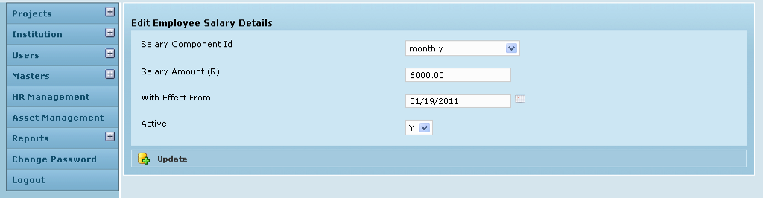

Control Description

Field /Label | Input-Control | Data Type | DB Table>Field
Salary Component | Auto populated editable Listbox | varchar(255) | salary_component>name corresponding to the project_employee_salary_details>salary_component_id
Salary Amount | Auto populated editable textbox | double | project_employee_salary_details>salary_amount
With effect from | Auto populated editable Calendar | datetime | project_employee_salary_details>with_effect_from
Active | Auto populated editable Listbox | varchar(255) | project_employee_salary_details>status
Update | Button

Associated tables

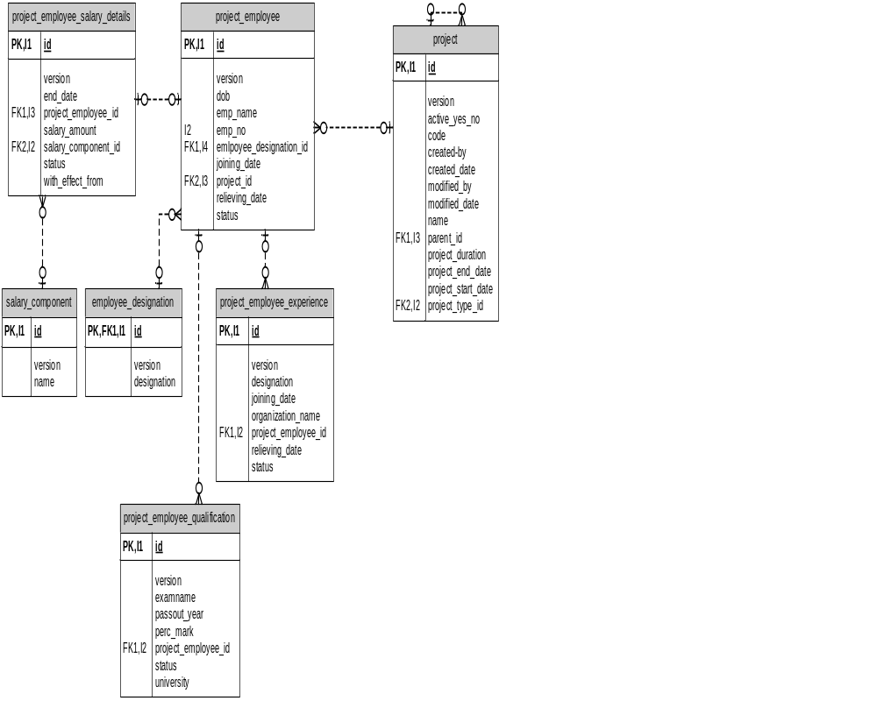

Data Dictionary

project_employee

Fields

Field | Type | Collation | Null | Key | Default | Extra | Privileges
id | bigint(20) | (NULL) | NO | PRI | (NULL) | auto_  increment | select,insert,update,references
version | bigint(20) | (NULL) | NO |  |  |  | select,insert,update,references
dob | datetime | (NULL) | YES |  | (NULL) |  | select,insert,update,references
emp_name | varchar(255) | latin1_swedish_ci | NO |  |  |  | select,insert,update,references
emp_no | varchar(255) | latin1_swedish_ci | NO | UNI |  |  | select,insert,update,references
employee_designation_id | bigint(20) | (NULL) | NO | MUL |  |  | select,insert,update,references
joining_date | datetime | (NULL) | NO |  |  |  | select,insert,update,references
projects_id | bigint(20) | (NULL) | NO | MUL |  |  | select,insert,update,references
relieving_date | datetime | (NULL) | YES |  | (NULL) |  | select,insert,update,references
status | varchar(255) | latin1_swedish_ci | NO |  |  |  | select,insert,update,references

Indexes

Table | Non  unique | Key  name | Seq  in  index | Column  name | Collation | Cardinality | Sub  part | Packed | Null | Index  type
project_employee | 0 | PRIMARY | 1 | id | A | 6 | (NULL) | (NULL) |  | BTREE
project_employee | 0 | emp_no | 1 | emp_no | A | 6 | (NULL) | (NULL) |  | BTREE
project_employee | 1 | FK483914905C4B9A | 1 | projects_id | A | 6 | (NULL) | (NULL) |  | BTREE
project_employee | 1 | FK4839148CE4205D | 1 | employee_  designation_id | A | 6 | (NULL) | (NULL) |  | BTREE

Foreign Key Relationships

FK Id | Reference Table | Source Column | Target Column | Extra Info
FK4839148CE4205D | employee_designation | `employee_designation_id` | `id` | ,
FK483914905C4B9A | projects | `projects_id` | `id`

project_employee_experience

Fields

Field | Type | Collation | Null | Key | Default | Extra | Privileges
id | bigint(20) | (NULL) | NO | PRI | (NULL) | auto_increment | select,insert,update,references
version | bigint(20) | (NULL) | NO |  |  |  | select,insert,update,references
designation | varchar(255) | latin1_swedish_ci | NO |  |  |  | select,insert,update,references
joining_date | datetime | (NULL) | NO |  |  |  | select,insert,update,references
organization_name | varchar(255) | latin1_swedish_ci | NO |  |  |  | select,insert,update,references
project_employee_id | bigint(20) | (NULL) | NO | MUL |  |  | select,insert,update,references
relieving_date | datetime | (NULL) | NO |  |  |  | select,insert,update,references
status | varchar(255) | latin1_swedish_ci | NO |  |  |  | select,insert,update,references

Indexes

Table | Non  unique | Key  name | Seq  in  index | Column  name | Collation | Cardinality | Sub  part | Packed | Null | Index  type
project_  employee_experience | 0 | PRIMARY | 1 | id | A | 0 | (NULL) | (NULL) |  | BTREE
project_  employee_experience | 1 | FKE62FC175C8FFD4ED | 1 | project_  employee_id | A | 0 | (NULL) | (NULL) |  | BTREE

Foreign Key Relationships

FK Id | Reference Table | Source Column | Target Column | Extra Info
FKE62FC175C8FFD4ED | project_employee | `project_employee_id` | `id`

project_employee_qualification

Fields

Field | Type | Collation | Null | Key | Default | Extra | Privileges
id | bigint(20) | (NULL) | NO | PRI | (NULL) | auto_increment | select,insert,update,references
version | bigint(20) | (NULL) | NO |  |  |  | select,insert,update,references
examname | varchar(255) | latin1_swedish_ci | NO |  |  |  | select,insert,update,references
passout_year | varchar(255) | latin1_swedish_ci | NO |  |  |  | select,insert,update,references
perc_mark | double | (NULL) | NO |  |  |  | select,insert,update,references
project_employee_id | bigint(20) | (NULL) | NO | MUL |  |  | select,insert,update,references
status | varchar(255) | latin1_swedish_ci | NO |  |  |  | select,insert,update,references
university | varchar(255) | latin1_swedish_ci | NO |  |  |  | select,insert,update,references

Indexes

Table | Non  unique | Key  name | Seq  in  index | Column  name | Collation | Cardinality | Sub  part | Packed | Null | Index  type
project_employee_  qualification | 0 | PRIMARY | 1 | id | A | 0 | (NULL) | (NULL) |  | BTREE
project_employee_  qualification | 1 | FK6DC13604C8FFD4ED | 1 | project_  employee_id | A | 0 | (NULL) | (NULL) |  | BTREE

Foreign Key Relationships

FK Id | Reference Table | Source Column | Target Column | Extra Info
FK6DC13604C8FFD4ED | project_employee | `project_employee_id` | `id`

project_employee_salary_details

Fields

Field | Type | Collation | Null | Key | Default | Extra | Privileges
id | bigint(20) | (NULL) | NO | PRI | (NULL) | auto_increment | select,insert,update,references
version | bigint(20) | (NULL) | NO |  |  |  | select,insert,update,references
end_date | datetime | (NULL) | YES |  | (NULL) |  | select,insert,update,references
project_employee_id | bigint(20) | (NULL) | NO | MUL |  |  | select,insert,update,references
salary_amount | double | (NULL) | NO |  |  |  | select,insert,update,references
salary_component_id | bigint(20) | (NULL) | NO | MUL |  |  | select,insert,update,references
status | varchar(255) | latin1_swedish_ci | NO |  |  |  | select,insert,update,references
with_effect_from | datetime | (NULL) | NO |  |  |  | select,insert,update,references

Indexes

Table | Non  unique | Key  name | Seq  in  index | Column  name | Collation | Cardinality | Sub  part | Packed | Null | Index  type
project_employee_  salary_details | 0 | PRIMARY | 1 | id | A | 3 | (NULL) | (NULL) |  | BTREE
project_employee_  salary_details | 1 | FK1F466358B27ABE25 | 1 | salary_  component_id | A | 3 | (NULL) | (NULL) |  | BTREE
project_employee_  salary_details | 1 | FK1F466358C8FFD4ED | 1 | project_  employee_id | A | 3 | (NULL) | (NULL) |  | BTREE

Foreign Key Relationships

FK Id | Reference Table | Source Column | Target Column | Extra Info
FK1F466358C8FFD4ED | project_employee | `project_employee_id` | `id` | ,
FK1F466358B27ABE25 | salary_component | `salary_component_id` | `id`
projects

Fields

Field | Type | Collation | Null | Key | Default | Extra | Privileges
id | bigint(20) | (NULL) | NO | PRI | (NULL) | auto_increment | select,insert,update,references
version | bigint(20) | (NULL) | NO |  |  |  | select,insert,update,references
active_yes_no | char(1) | latin1_swedish_ci | NO |  |  |  | select,insert,update,references
code | varchar(255) | latin1_swedish_ci | NO |  |  |  | select,insert,update,references
created_by | varchar(255) | latin1_swedish_ci | NO |  |  |  | select,insert,update,references
created_date | datetime | (NULL) | NO |  |  |  | select,insert,update,references
modified_by | varchar(255) | latin1_swedish_ci | NO |  |  |  | select,insert,update,references
modified_date | datetime | (NULL) | NO |  |  |  | select,insert,update,references
name | varchar(255) | latin1_swedish_ci | NO |  |  |  | select,insert,update,references
parent_id | bigint(20) | (NULL) | YES | MUL | (NULL) |  | select,insert,update,references
project_duration | varchar(255) | latin1_swedish_ci | YES |  | (NULL) |  | select,insert,update,references
project_end_date | datetime | (NULL) | YES |  | (NULL) |  | select,insert,update,references
project_start_date | datetime | (NULL) | YES |  | (NULL) |  | select,insert,update,references
project_type_id | int(11) | (NULL) | NO | MUL |  |  | select,insert,update,references

Indexes

Table | Non  unique | Key  name | Seq  in  index | Column  name | Collation | Cardinality | Sub  part | Packed | Null | Index  type | Comment
projects | 0 | PRIMARY | 1 | id | A | 137 | (NULL) | (NULL) |  | BTREE
projects | 1 | FKC479187A69DF6AED | 1 | project_type_id | A | 8 | (NULL) | (NULL) |  | BTREE
projects | 1 | FKC479187A43BA2D6A | 1 | parent_id | A | 137 | (NULL) | (NULL) | YES | BTREE

Foreign Key Relationships

FK Id | Reference Table | Source Column | Target Column | Extra Info
FKC479187A43BA2D6A | projects | `parent_id` | `id` | ,
FKC479187A69DF6AED | project_type | `project_type_id` | `id`

