MGMS – Institution

Detailed Design Document

Ver. 1.4

Version History
Date | Description
21-Oct-2010 | First draft

Table of Contents

Version History 2
1 Introduction 4
1.1 Purpose 4
1.2 Scope 4
1.3 Assumptions 4
1.4 Constraints 4
1. Main Menu – Institution 5
1.1. Sub menu – Add Department 5
1.2. Sub menu – Institutions List 7
2 Data Dictionary 8

Introduction

Purpose

This document provides the detailed design specifications for the Multisite Grant Management System project.

This is not a project plan nor does it detail the source code. It is a guide for system architecture and development, not for phasing, timelines or deliverables.

Finally, this is a ‘living document’ and the specification will change, continuously, as the project proceeds. More details will be added and the existing information edited as the requirements, architecture and design evolve in the course of the project.

Scope

Assumptions

Constraints

Main Menu – Institution

Institution is the organization which undertakes own projects on self funding, assigns projects to other similar institutions along with grants, and also takes up projects from other organizations to be receiving a grant allocation from it.
An institution will have several departments in it involved in different functions.
Provision is made for updating institution and department details.

Sub menu – Add Department

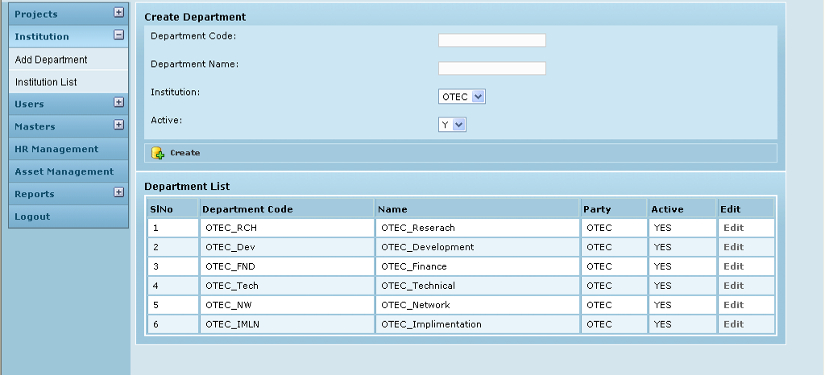

Field /Label | Input-Control | Data Type | Remarks /db table>field
Create Department
Department Code: | Textbox | varchar(255) | party_department>department_code
Department Name: | Textbox | varchar(255) | party_department>name
Institution: | Listbox | varchar(255) | party>code
Active: | Listbox | char(1) | party_department>active_yes_no
Create | Button |  | The details are saved and added as a new row to the table below
Department List
(Table fields)
SlNo | Auto populated
Department Code | Auto populated | varchar(255) | party_department>department_code
Name | Auto populated | varchar(255) | party_department>name
Party | Auto populated | varchar(255) | party>code
Active | Auto populated | char(1) | party_department>active_yes_no
Edit | “Edit” - link

Edit Department

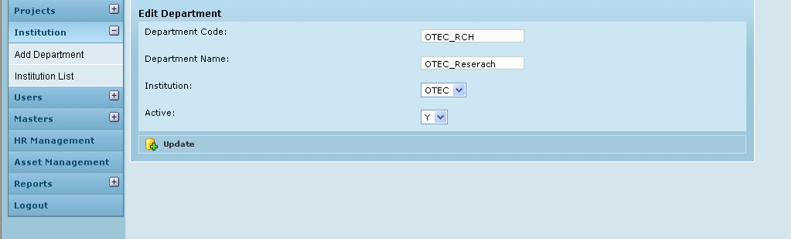

Field /Label | Input-Control | Data Type | Remarks /db table>field
Edit Department
Department Code: | Auto populated & editable Textbox | varchar(255) | party_department>department_code
Department Name: | Auto populated & editable Textbox | varchar(255) | party_department>name
Institution: | Listbox; Auto populated & editable | varchar(255) | party>code
Active: | Listbox; Auto populated & editable | char(1) | party_department>active_yes_no
Update | Button |  | Message: “Department details updated successfully”

Sub menu – Institutions List

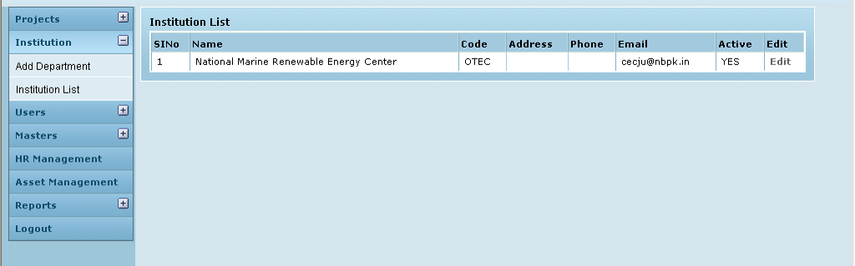

Field /Label | Input-Control | Data Type | Remarks / db table>field
Institution List
(table fields)
SlNo | Auto increment populated
Name | Auto populated |  | party>name_of_the_institution
Code | Auto populated |  | party>code
Address | Auto populated |  | party>address
Phone | Auto populated |  | party>phone
Email | Auto populated |  | party>email
Active | Auto populated |  | party>active_yes_no
Edit | “Edit” button

Edit Institution

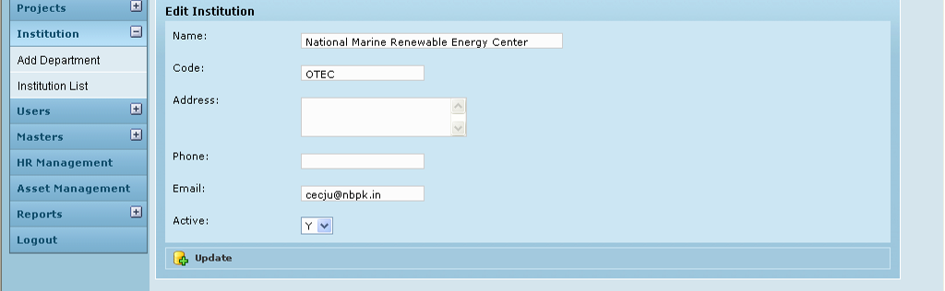

Field /Label | Input-Control | Data Type | Remarks/db table>field
Edit Institution
Name | Textbox | varchar(255) | party>name_of_the_institution
Code | Textbox | varchar(255) | party>code
Address | Textarea | varchar(255) | party>address
Phone | Textbox | varchar(255) | party>phone
Email | Textbox | varchar(255) | party>email
Active | Listbox | char(1) | party>active_yes_no
Update | Button |  | Message: “Institution details updated successfully”

Associated tables

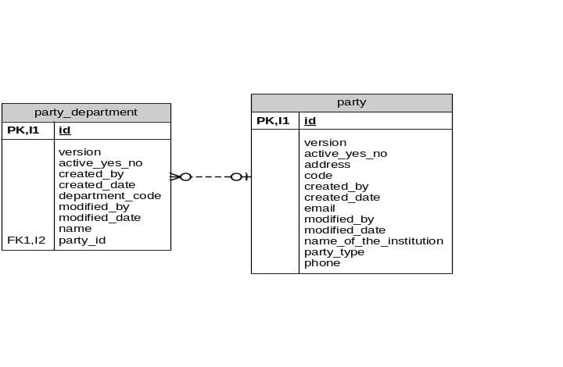

Data Dictionary

