MGMS – Log In

Detailed Design Document

Ver. 1.4

Version History
Date | Description
12-Oct-2010

Table of Contents

Version History 2
1 Introduction 4
2 Log-In 4
2.1 Forgot your password ? 6

Introduction

This document provides the detailed design specifications for the Multisite Grant Management System project.

This is not a project plan nor does it detail the source code. It is a guide for system architecture and development, not for phasing, timelines or deliverables.

Finally, this is a ‘living document’ and the specification will change, continuously, as the project proceeds. More details will be added and the existing information edited as the requirements, architecture and design evolve in the course of the project.

Log-In

Screen & Control Description

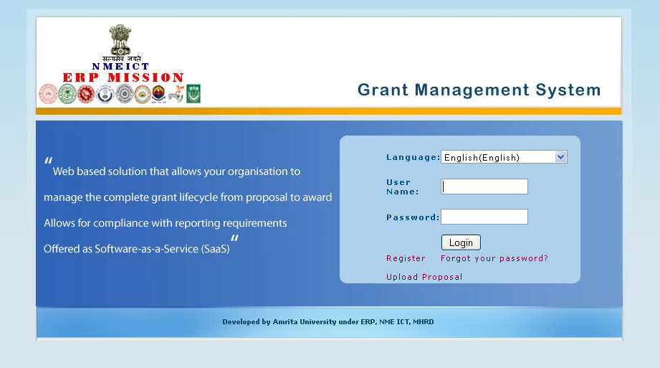

Field /Label | Input-Control | Data Type | DB Table>Field
User Name | Textbox | varchar(255) | person>username
Password | Textbox | varchar(255) | person>password
Login | Button
Register | Link | Opens page – “Create site admin” where the user should register on behalf of his institution.
Forgot Password? | Link | Opens page for creating new password and send to user’s email id (activation link)

Associated tables

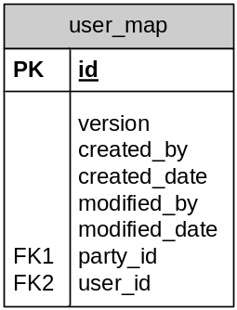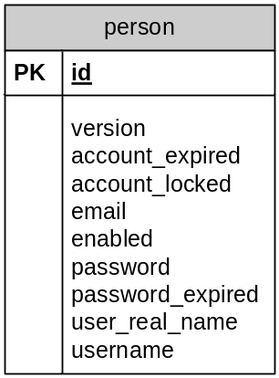

Forgot your password ?

Screen & Control Description

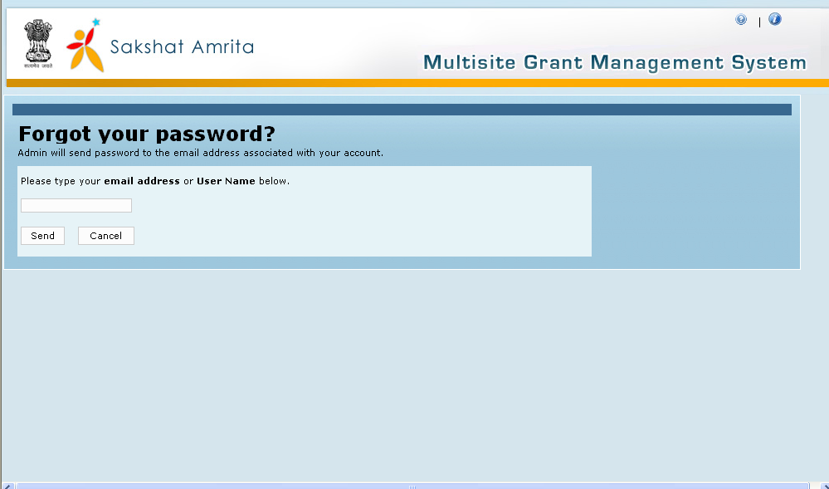

Field /Label | Input-Control | Data Type | Remarks
Forgot your password ?
Admin will send password to the email address associated with your account.
Please type your email address or User Name below. | Textbox | varchar(255)
Send | Button
Cancel | Button

Click on the button which will send password and account activation link to the email id entered. Through the activation link provided in mail user can re-activate the account.

Associated tables

