MGMS – Settings

Detailed Design Document

Ver. 1.8

Version History
Date | Description
28-Nov-2010 | First Draft
12-Dec-2010 | Added Eligibility criteria - related sections
15-Feb-2011 | Renamed Masters to Settings

Table of Contents

Version History 2
1 Introduction 4
2 Menu – Settings 4
2.1 Sub menu- Grant Agency 4
2.2 Sub menu – Account Head 6
2.3 Sub menu – Grant Period 7
2.4 Sub menu – Project type 9
2.5 Sub menu – Attachment Type 11
2.6 Sub menu – PI 13
2.7 Sub menu – Add Role 15
2.8 Sub Menu – Employee Designation 17
2.9 Sub Menu – Salary Component 18
2.10 Sub menu – Proposal Category 20
2.11 Sub menu – Upload proposal form 21

Introduction

This document provides the detailed design specifications for the Multisite Grant Management System project.

This is not a project plan nor does it detail the source code. It is a guide for system architecture and development, not for phasing, timelines or deliverables.

Finally, this is a ‘living document’ and the specification will change, continuously, as the project proceeds. More details will be added and the existing information edited as the requirements, architecture and design evolve in the course of the project.

Menu – Settings

Sub menu- Grant Agency

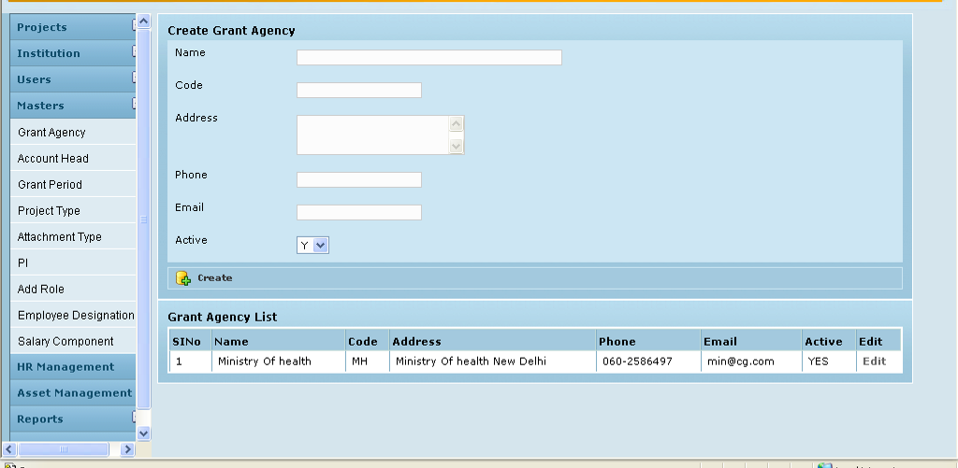

Field /Label | Input-Control | Data Type | Remarks/db table>field
Create Grant Agency
Name | Textbox | varchar(255) | party>name_of_the_institution
Code | Textbox | varchar(255) | party>code
Address | Textarea | varchar(255) | party>address
Phone | Textbox | varchar(255) | party>phone
Email | Textbox | varchar(255) | party>email
Active | Listbox | char(1) | party>active_yes_no
Create | Button
Grant Agency List
(table fields)
SlNo | Auto populated
Name | Auto populated |  | party>name_of_the_institution
Code | Auto populated |  | party>code
Address | Auto populated |  | party>address
Phone | Auto populated |  | party>phone
Email | Auto populated |  | party>email
Active | Auto populated |  | party>active_yes_no
Edit | Link

Edit Grant Agency
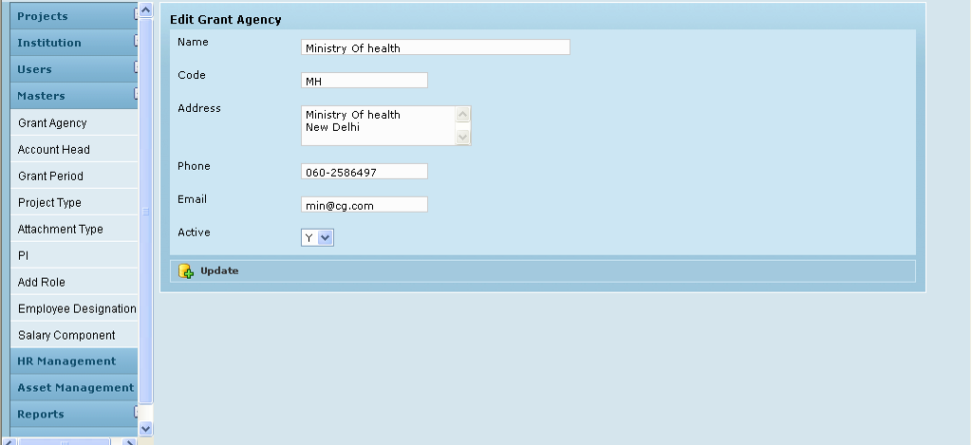

Field /Label | Input-Control | Data Type | Remarks/db table>field
Edit Grant Agency
Name | Textbox; Auto populated & editable | varchar(255) | party>name_of_the_institution
Code | Textbox; Auto populated & editable | varchar(255) | party>code
Address | Textarea; Auto populated & editable | varchar(255) | party>address
Phone | Textbox; Auto populated & editable | varchar(255) | party>phone
Email | Textbox; Auto populated & editable | varchar(255) | party>email
Active | Listbox; Pre-selected & editable | char(1) | party>active_yes_no
Update | Button

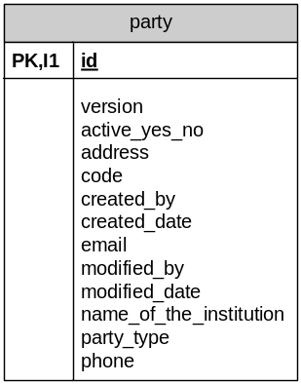

Sub menu – Account Head

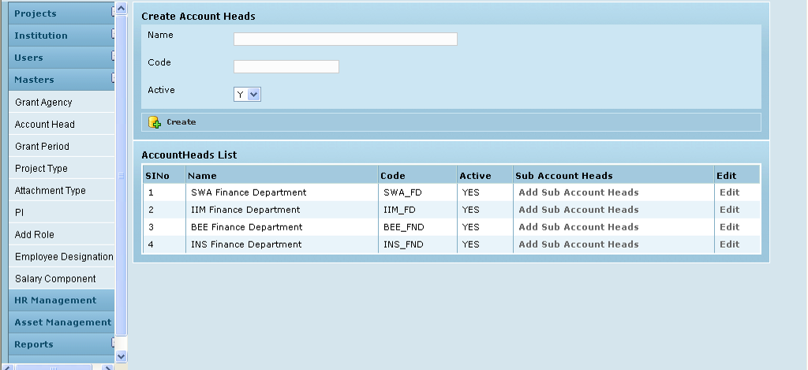

Field /Label | Input-Control | Data Type | Remarks/db table>field
Create Account Heads:
Name | Textbox | varchar(255) | account_heads>name
Code | Textbox | varchar(255) | account_heads>code
Active | Listbox | char(1) | account_heads>active_yes_no
Create | Button
AccountHeads List
SlNo | Auto populated
Name | Auto populated | varchar(255) | account_heads>name
Code | Auto populated | varchar(255) | account_heads>code
Active | Auto populated | char(1) | account_heads>active_yes_no
Sub Account Heads | Auto populated | varchar(255) | account_heads>code
Edit | “Edit” link

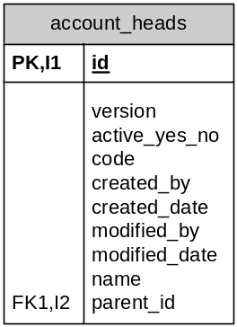

Edit Account Heads

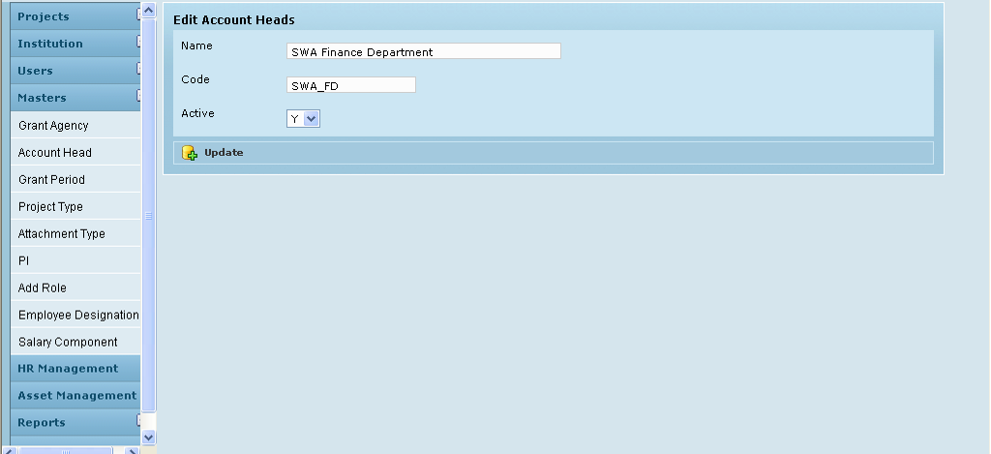

Field /Label | Input-Control | Data Type | Remarks/db table>field
Create Account Heads:
Name | Textbox; Auto populated & editable | varchar(255) | account_heads>name
Code | Textbox; Auto populated & editable | varchar(255) | account_heads>code
Active | Listbox; Pre-selected & editable | char(1) | account_heads>active_yes_no
Update | Button

Sub menu – Grant Period

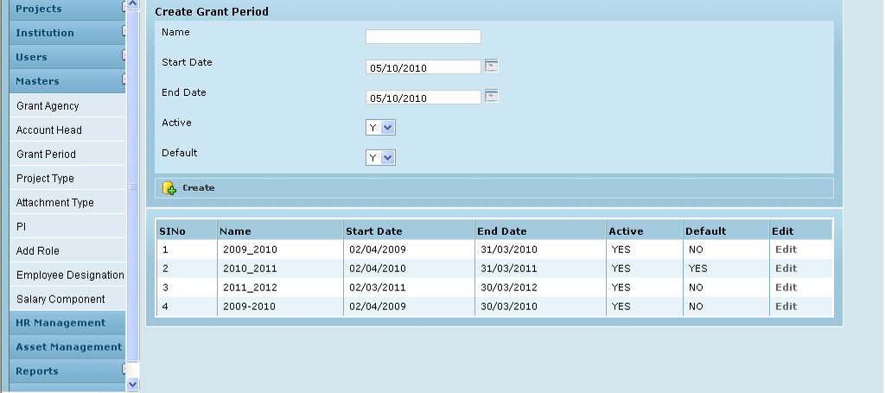

Field /Label | Input-Control | Data Type | Remarks/db table>field
Create Grant Period
Name | Textbox | varchar(255) | grant_period>name
Start Date | Calendar | datetime | grant_period>start_date
End Date | Calendar | datetime | grant_period>end_date
Active | Listbox | char(1) | grant_period>active_yes_no
Default | Listbox | char(1) | grant_period>default_yes_no
Create | Button
SlNo | Auto populated
Name | Auto populated | varchar(255) | grant_period>name
Start Date | Auto populated | datetime | grant_period>start_date
End Date | Auto populated | datetime | grant_period>end_date
Active | Auto populated | char(1) | grant_period>active_yes_no
Default | Auto populated | char(1) | grant_period>default_yes_no
Edit | “Edit” link

Edit

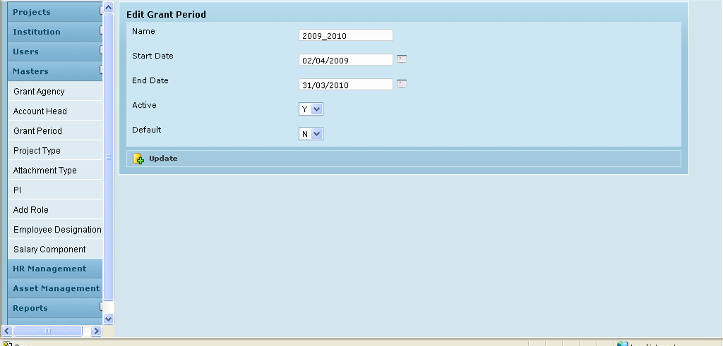

Field /Label | Input-Control | Data Type | Remarks/db table>field
Edit Grant Period
Name | Textbox; Auto populated & editable | varchar(255) | grant_period>name
Start Date | Calendar; Auto populated & editable | datetime | grant_period>start_date
End Date | Calendar; Auto populated & editable | datetime | grant_period>end_date
Active | Listbox; Pre-selected & editable | char(1) | grant_period>active_yes_no
Default | Listbox; Pre-selected & editable | char(1) | grant_period>default_yes_no
Update | Button
Associated Tables

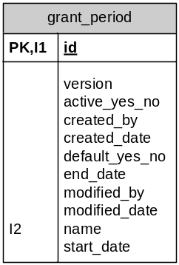

Sub menu – Project type

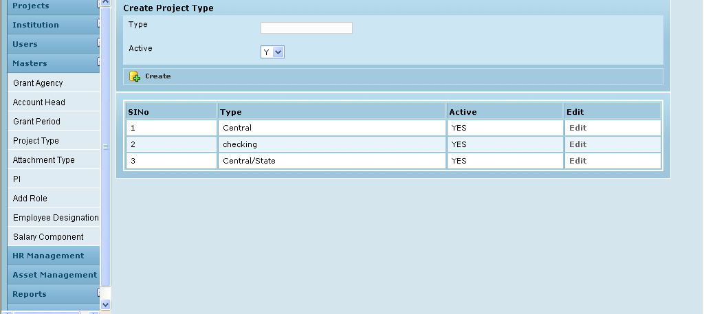

Field /Label | Input-Control | Data Type | Remarks/db table>field
Create Project Type
Type | Textbox | varchar(255) | project_type>type
Active | Listbox | char(1) | project_type>active_yes_no
Create | Button
SlNo | Auto populated
Type | Auto populated | varchar(255) | project_type>type
Active | Auto populated | char(1) | project_type>active_yes_no
Edit | “Edit” Link

Edit

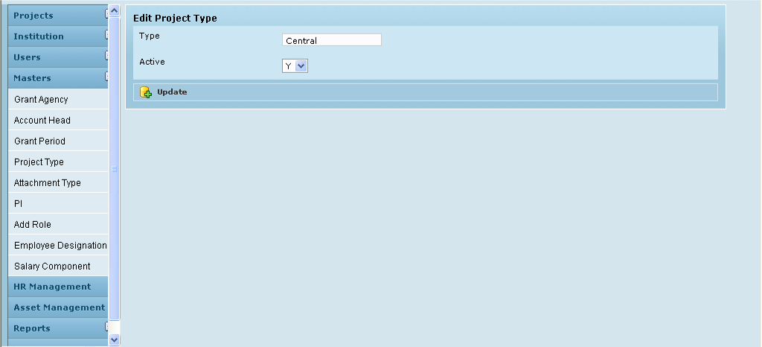

Field /Label | Input-Control | Data Type | Remarks/db table>field
Edit Project Type
Type | Textbox; Auto populated & editable | varchar(255) | project_type>type
Active | Listbox; Preselected & editable | char(1) | project_type>active_yes_no
Update | Button

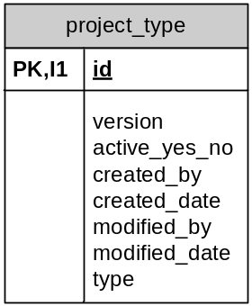

Sub menu – Attachment Type

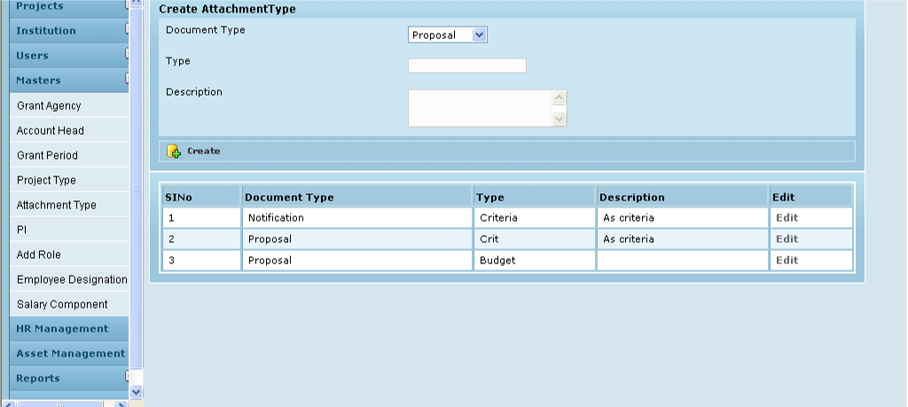

Field /Label | Input-Control | Data Type | Remarks/db table>field
Create Attachment Type
Document Type | Listbox | varchar(255) | attachment_type>document_type
Type | Textbox | varchar(255) | attachment_type>type
Description | Textarea | varchar(255) | attachment_type>description
Create | Button
SlNo | Auto populated
Document Type | Auto populated | varchar(255) | attachment_type>document_type
Type | Auto populated | varchar(255) | attachment_type>type
Description | Auto populated | varchar(255) | attachment_type>description
Edit | “Edit” link

Edit

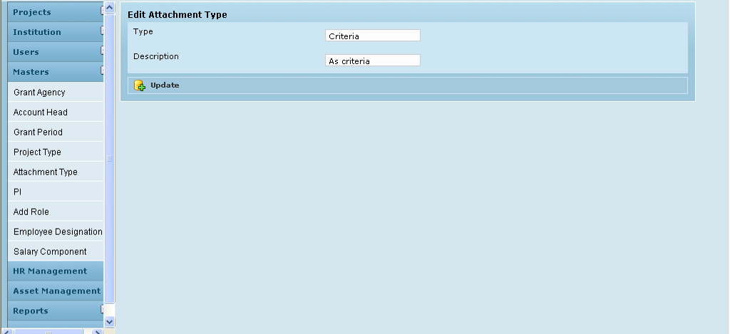

Field /Label | Input-Control | Data Type | Remarks/db table>field
Edit Attachment Type
Type | Textbox; Auto populated & editable | varchar(255) | attachment_type>document_type
Description | Textarea | varchar(255) | attachment_type>description
Update | Button

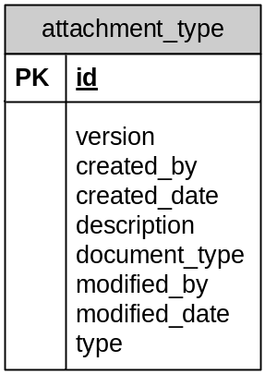

Sub menu – PI

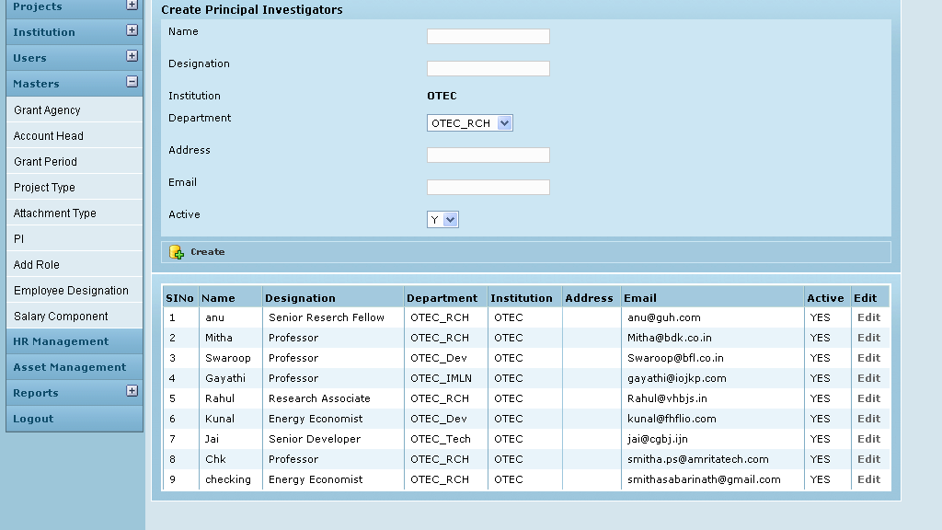

Field /Label | Input-Control | Data Type | Remarks/db table>field
Create Principal Investigators
Name | Textbox | varchar(255) | investigator>name
Designation | Textbox | varchar(255) | investigator>designation
Institution | Auto populated | varchar(255) | party>name_of_the_institution
Department | Listbox; preselected & editable | varchar(255) | party_department>name
Address | Textbox | varchar(255) | investigator>address
Email | Textbox | varchar(255) | investigator>email
Active | Listbox | char(1) | investigator>active_yes_no
Create | Button
(table fields)
Name | Auto populated | varchar(255) | investigator>name
Designation | Auto populated | varchar(255) | investigator>designation
Institution | Auto populated | varchar(255) | party>name_of_the_institution
Department | Auto populated | varchar(255) | party_department>name
Address | Auto populated | varchar(255) | investigator>address
Email | Auto populated | varchar(255) | investigator>email
Active | Auto populated | char(1) | investigator>active_yes_no
Edit | “Edit” link

Edit Principal Investigators

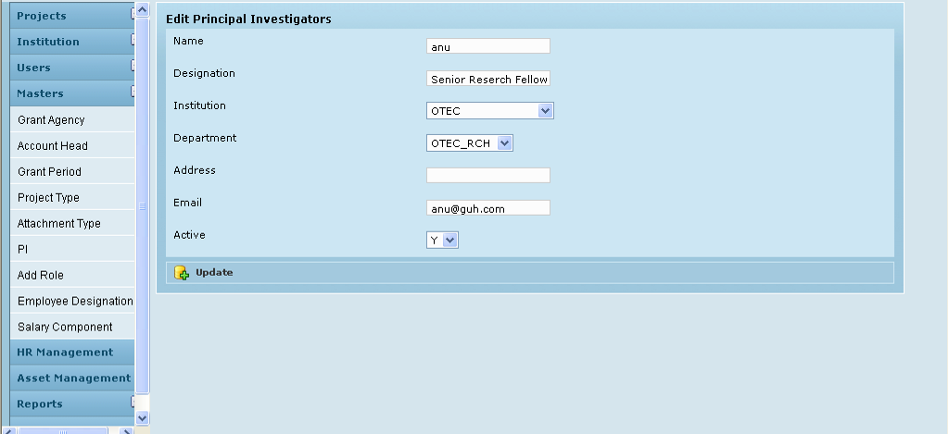

Field /Label | Input-Control | Data Type | Remarks/db table>field
Edit Principal Investigators
Name | Textbox; Auto populated & editable | varchar(255) | investigator>name
Designation | Textbox; Auto populated & editable | varchar(255) | investigator>designation
Institution | Listbox; preselected & editable | varchar(255) | party>name_of_the_institution
Department | Listbox; preselected & editable | varchar(255) | party_department>name
Address | Textbox; Auto populated & editable | varchar(255) | investigator>address
Email | Textbox; Auto populated & editable | varchar(255) | investigator>email
Active | Listbox; preselected & editable | char(1) | investigator>active_yes_no
Update | Button

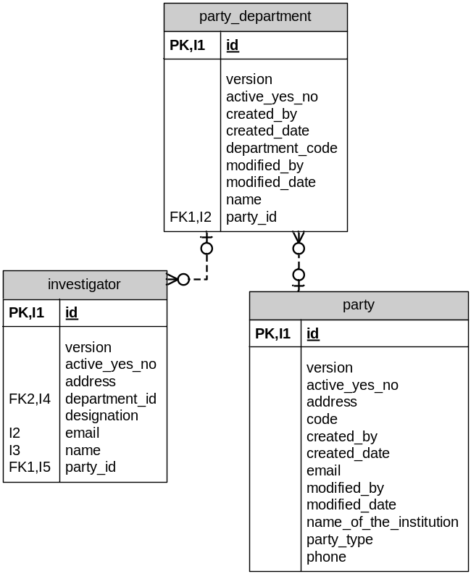

Sub menu – Add Role

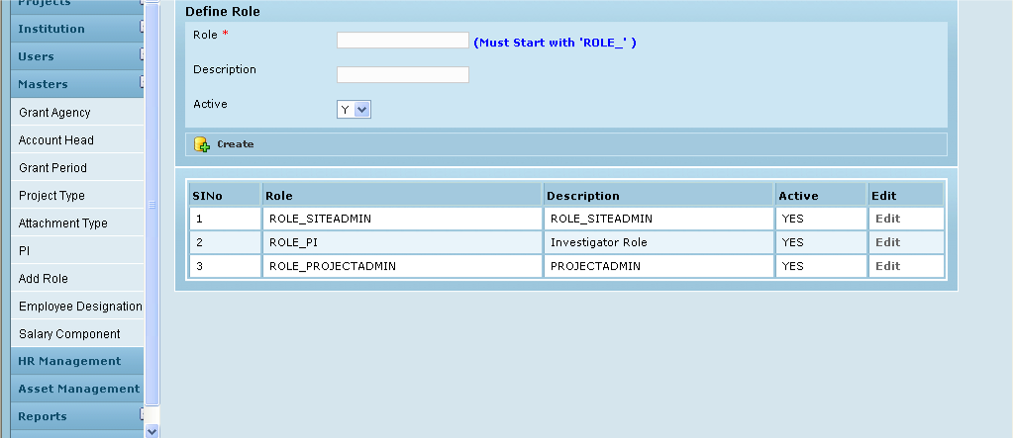

Field /Label | Input-Control | Data Type | Remarks/db table>field
Define Role
Role * | Textbox | varchar(255) | authority>authorityyes
Description | Textbox | varchar(255) | authority>description
Active | Listbox | char(1) | authority>active_yes_no
Create | Button
(table fields)
SlNo | Auto populated
Role | Auto populated | varchar(255) | authority>authority
Description | Auto populated | varchar(255) | authority>description
Active | Auto populated | char(1) | authority>active_yes_no
Edit | “Edit” link

Edit Role

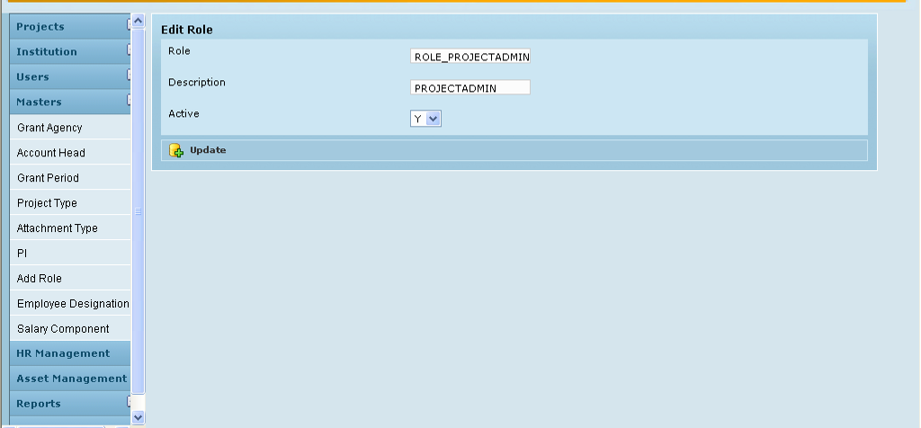

Field /Label | Input-Control | Data Type | Remarks/db table>field
Edit Role
Role * | Textbox; Auto populated & editable | varchar(255) | authority>authority
Description | Textbox; Auto populated & editable | varchar(255) | authority>description
Active | Listbox; preselected & editable | char(1) | authority>active_yes_no
Update | Button

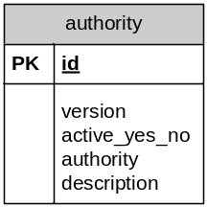

Sub Menu – Employee Designation

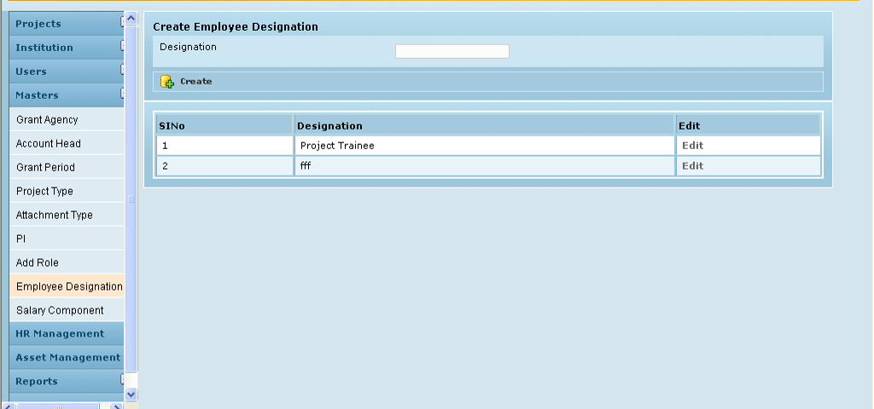

Field /Label | Input-Control | Data Type | Remarks/db table>field
Create Employee Designation
Designation | Textbox | varchar(255) | employee_designation>designation
Create | Button
SlNo | Auto populated
Designation | Auto populated | varchar(255) | employee_designation>designation
Edit | “Edit” Link

Edit

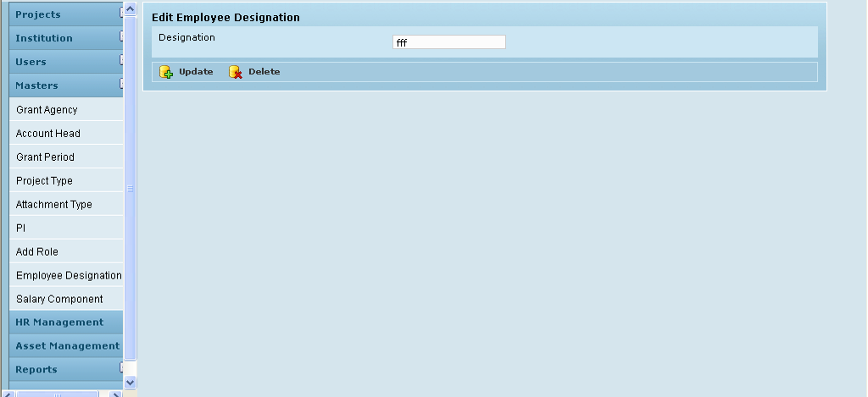

Field /Label | Input-Control | Data Type | Remarks/db table>field
Edit Employee Designation
Designation | Textbox | varchar(255) | employee_designation>designation
Update | Button
Delete | Button

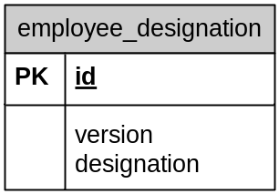

Sub Menu – Salary Component

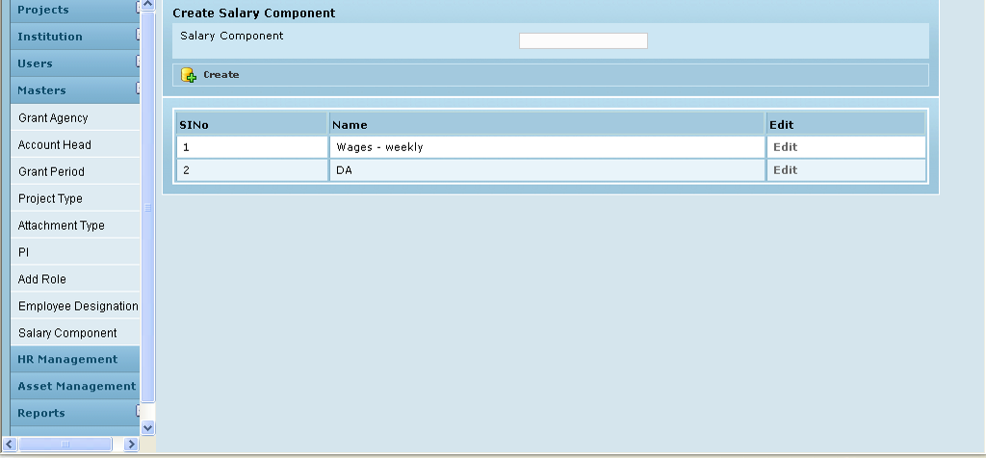

Field /Label | Input-Control | Data Type | Remarks/db table>field
Create Salary Component
Salary Component | Textbox | varchar(255) | salary_component>name
Create | Button
(table fields)
SlNo | Auto populated
Name | Auto populated | varchar(255) | salary_component>name
Edit | “Edit” Link

Edit Salary Component

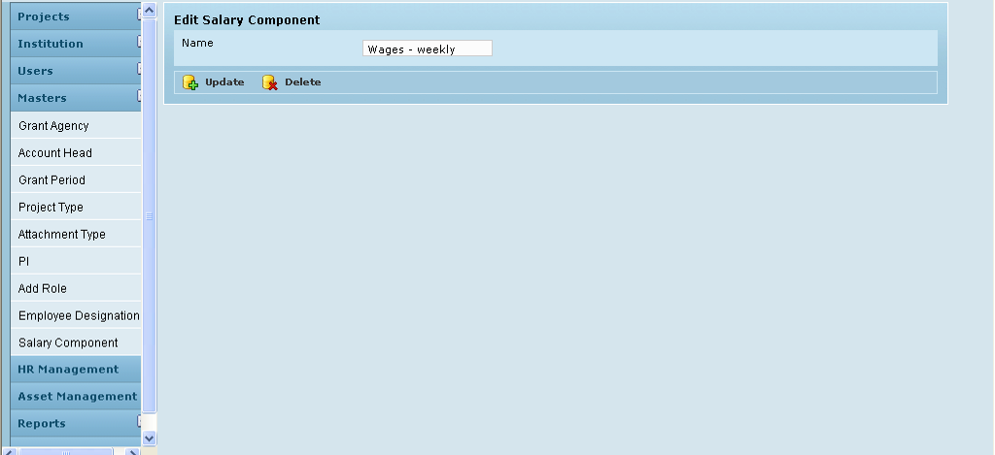

Field /Label | Input-Control | Data Type | Remarks/db table>field
Edit Salary Component
Name | Textbox; Auto populated & editable | varchar(255) | salary_component>name
Update | Button
Delete | Button

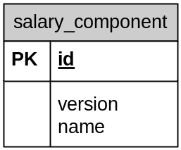

Sub menu – Proposal Category

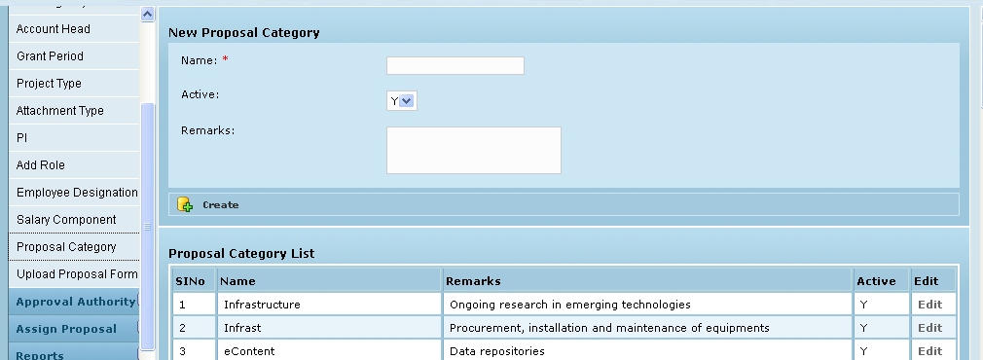

Field /Label | Input-Control | Data Type | Remarks/Edit Check
New Proposal Category
Name | Textbox | varchar(255) | Required
Active | List box | char(1) | Required
Remarks | Text area | varchar(255)
Create | Button

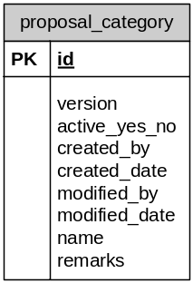

Sub menu – Upload proposal form

