MULTISITE GRANT MANAGEMENT SYSTEM

User Guide Document

Ver. 1.4

Version History
Date | Description
21-Oct-2010 | First draft
10-Feb-2011 | New sections – eligibility criteria, proposal category

Table of Contents

Version History 2
1 Introduction 4
1.1 Purpose 4
2 Settings module 4
2.1 Creating a Grant Agency 4
2.2 Creation of Accounts Head 5
2.3 Adding Sub Account Heads 5
2.4 Creation of Grant Period 6
2.5 Creating a New Project Type 6
2.6 Creation of Attachment Type 7
2.7 Creation of Project Investigator-Click on PI 7
2.8 Create Employee Designation 8
2.9 Create Salary Component 8
2.10 Add a new Role 9
2.11 Eligibility Criteria 9
2.12 Proposal Category 10

Introduction

Purpose

This document provides the step-by-step instructions for the site administrator for creating and maintaining entities and options to be used by users in the Multisite Grant Management System, in day-to-day operations

Please note that this is a ‘living document’ and the specification will change, continuously, as the project proceeds. More details will be added and the existing information edited as the requirements, scenarios and use cases evolve in the course of the project.

Settings module

Creating a Grant Agency

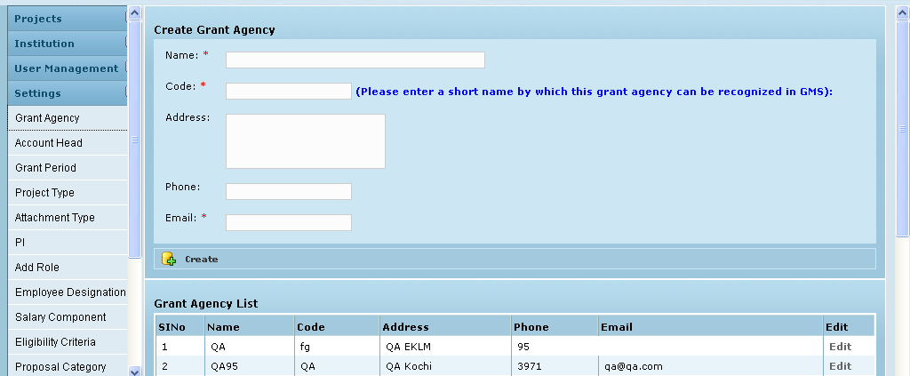
Click on Settings

Click on Grant Agency to add a New Grant Agency

Fill in the fields and Click Create button-The agency will be listed below

Creation of Accounts Head

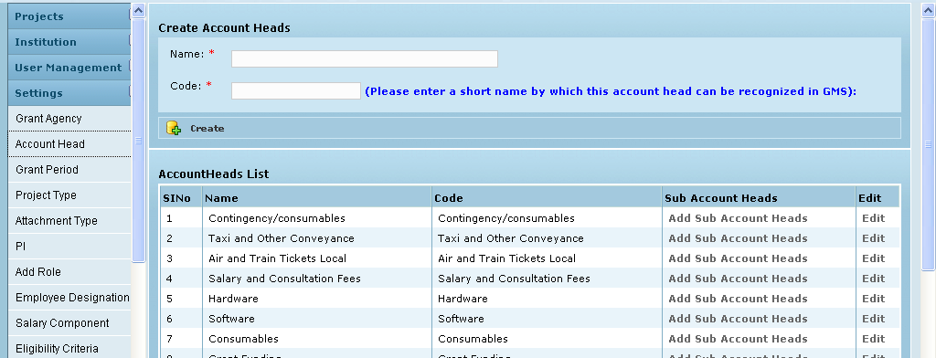
Click on Account Head

Fill in the fields and Click on Create the new Account Head will be created and listed below

Adding Sub Account Heads
Click on Add Sub Account Head Link in Account Heads List

Select Add Sub Account Heads

Enter the Sub Head Name and Code and Click on Create to Add New Sub Head of Accounts and is listed below

Creation of Grant Period
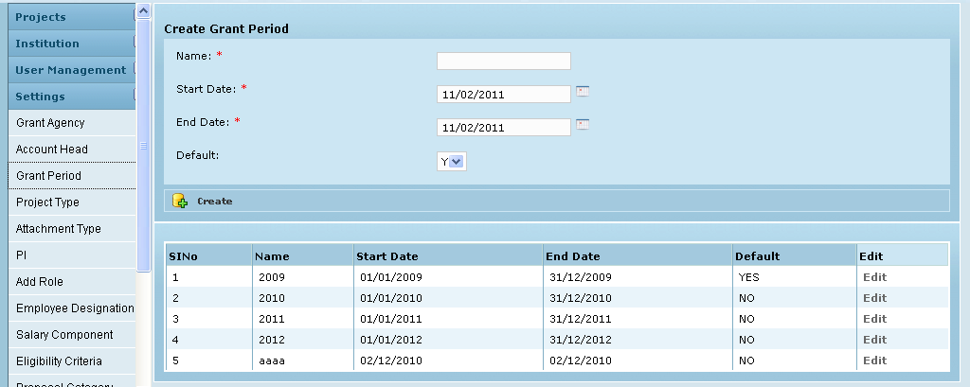
Click on Grant Period

Fill in the fields and Click Create button-The Grant Period will be created and listed below.
- Only one Grant Period can be ‘default – YES’. This helps in head wise allocation where you don’t have to enter the Grant Period again and again.
- You have the option to change the default settings.
- If a period is ‘Active –YES’ then only grant period is listed in any grant period list.

Creating a New Project Type
Enter the Project Type and Click Create to add a New Project Type. Newly Created Project Type is displayed below in the List

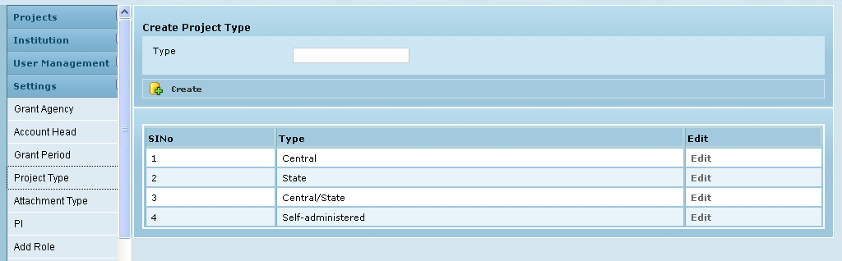
Click on Project Type

Creation of Attachment Type
- Select document Type
- Enter the type of the document and description then click on create
- Attachment type will be created and listed below

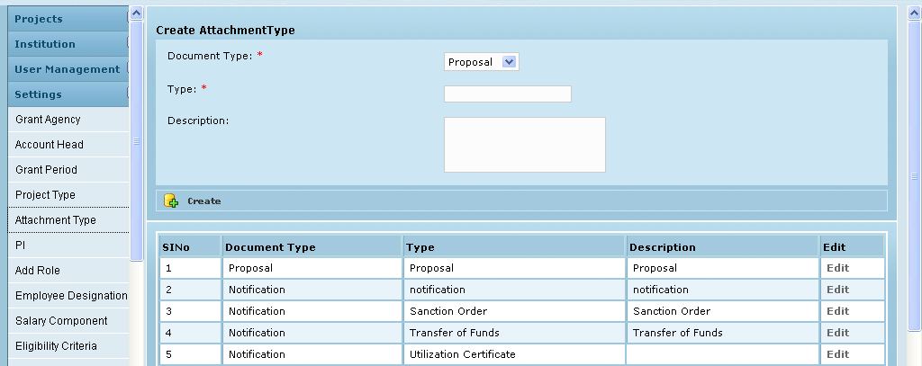
Click on Attachment Type

Creation of Project Investigator-Click on PI

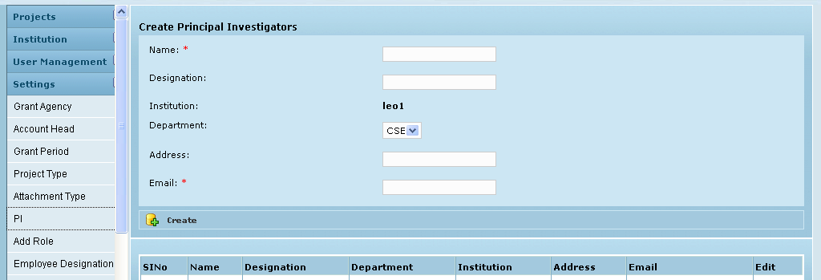
Click on PI

Fill in the fields and Click on Create the new Project Investigator will create and listed below

Click on Create
Please give a valid E-mail ID. The E-mail id will be the Username for the PI to login to MGMS. His password will be the name till ‘@’ in the mail id. E.g. if, PI’s User Id is arun.m@gmail.com Password will be arun.m.

Create Employee Designation
Settings → Employee Designation
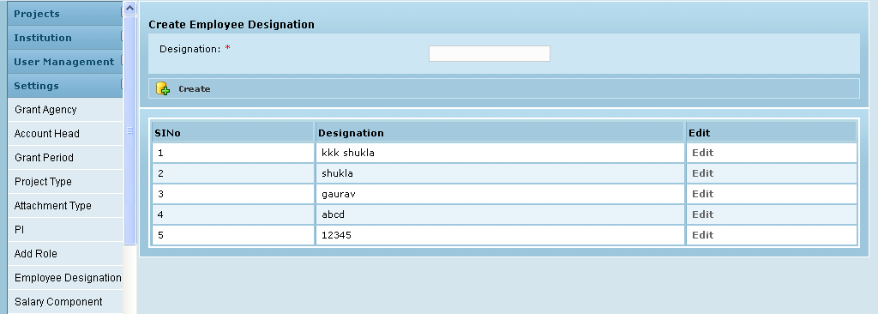
Enter the designation name and clicks create, new designation will be created and listed below.

Create Salary Component
Settings → Salary Component
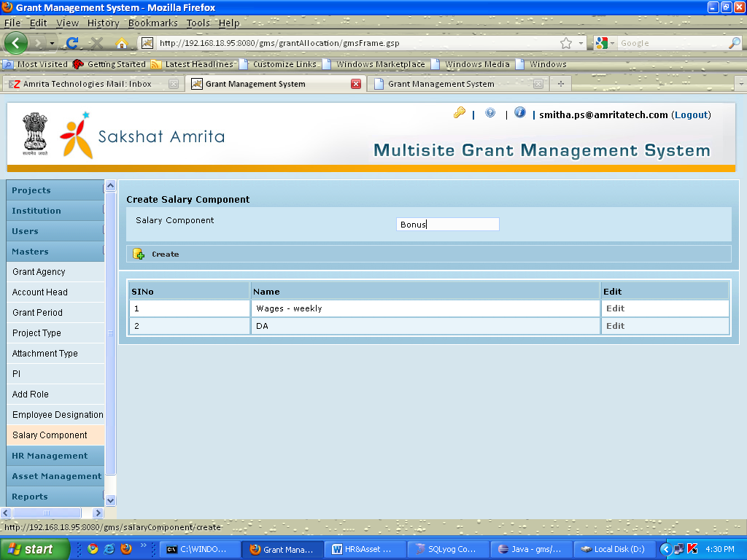
Enter the Salary component and clicks create, new component will be created and listed below.

Add a new Role
By default we have some roles with the privilages., But can create new roles with new privilages.

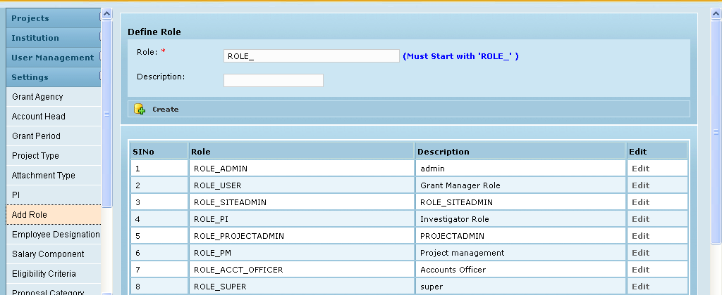
Click on Add Role

Enter the Role Name (Must start with ROLE_) and Description Click on Create to Add New Role and is listed below

Eligibility Criteria

Settings module – Eligibility Criteria

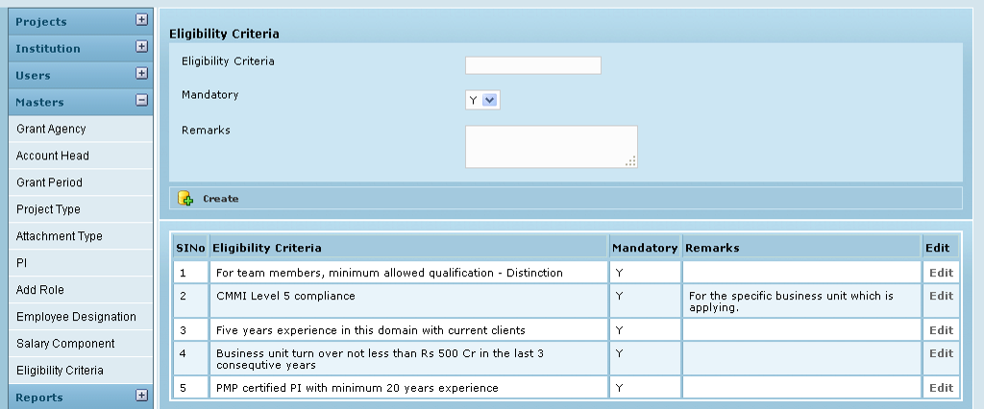

Currently, the same set of criteria will be displayed for every project’s proposal evaluation.

Proposal Category

The Admin has to save the various proposal categories in the GMS application for users (staff) to select from while creating their proposals. Examples for category are Research, e-content, infrastructure, network etc. This is done in the Settings module, sub menu – Proposal Category

