Basic DFD of Preferential Voting
Preferential Voting (also known as instant runoff voting) is a type of election where voters rank the candidates in order of preference, with "1" being the highest (most preferred) ranking. The first preference on each ballot counts as a vote for that particular candidate, and the votes are tallied. If no candidate receives a majority (greater than 50% of the total valid ballots), the candidate with the fewest number of votes is eliminated and the ballots for that candidate are redistributed to each ballot's second preference. The process continues until a majority is reached by one of the candidates. The Wikipedia article on Instant Runoff Voting is a good reference.

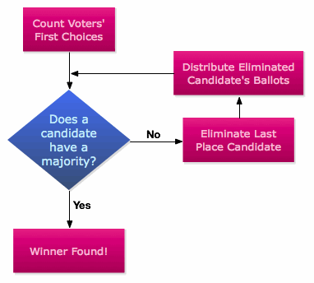

To be considered a valid ballot, the submitted ballot must satisfy the following conditions:
- At least one candidate must be ranked (i.e. a selection other than "no preference" made) for each position. If the voter has selected "no preference" for all candidates for a position, the ballot may still count as valid for any other positions in the election.
- No two candidates can have the same ranking, or the ballot is invalid (for that particular position only).
- Any candidate can be given any ranking, as it is the relative ranking that is counted. For example, in an election for a position with five (5) candidates, a valid ballot may be ranked "no preference/no preference/4th/5th/3rd". In this case, the last candidate will be first choice for this voter (since "3rd" is the highest ranking marked on the ballot), followed by the third candidate and then the 4th candidate.

