Table of Index

1. | Acquisition Module | 3
 | 1.1 Generate Title | 3
 | 1.1.1 New Entry of Title | 3
 | 1.1.2 Initiate Acquisition | 8
 | 1.2 Approval Process | 11
 | 1.2.1 Add Title into Approval List | 11
 | 1.2.2 | 13
 | 1.2.3 | 14
 | 1.2.3 | 15
 | 1.2.5 View All Account | 16
 | 1.3 Order Process | 17
 | 1.3.1 View List For Order | 17
 | 1.3.1.1 Direct Request | 18
 | 1.3.1.2 Approved Request | 20
 | 1.3.2 Generate Order
 | Circulation Module
 | Cataloging Module
 | System Setup

Acquisition Module

From this Module we can deal with
- Acquiring the library materials.
- Approval of library materials.
- Ordering of library materials.
- Receiving of library materials.
- Invoicing of library materials.
Activity Name : Acquisition - > Generate Title - > New Entry of Title

In this module Acquisition Staff enter the new title of book which are not exists in the library for that acquisition staff Click on New Entry of Title. Generate Title → New Entry of Title as mention in given screen shot.

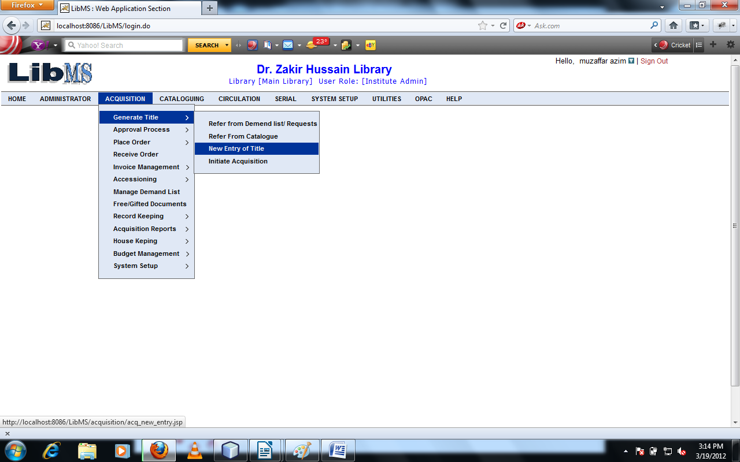

On Clicking New Entry of title Link. We have following interface.

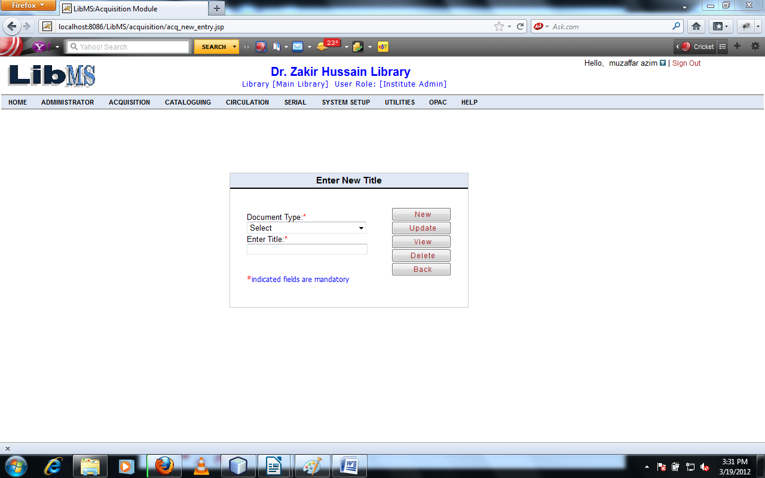

After filling the mandatory field by the staff and Click on New Button.
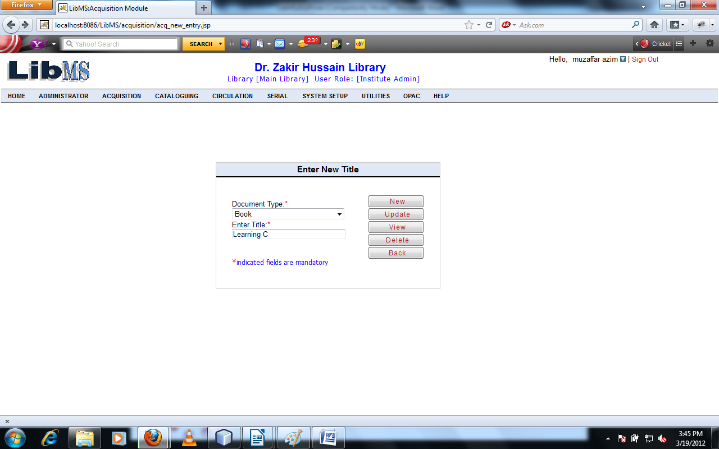

We have got following interface.

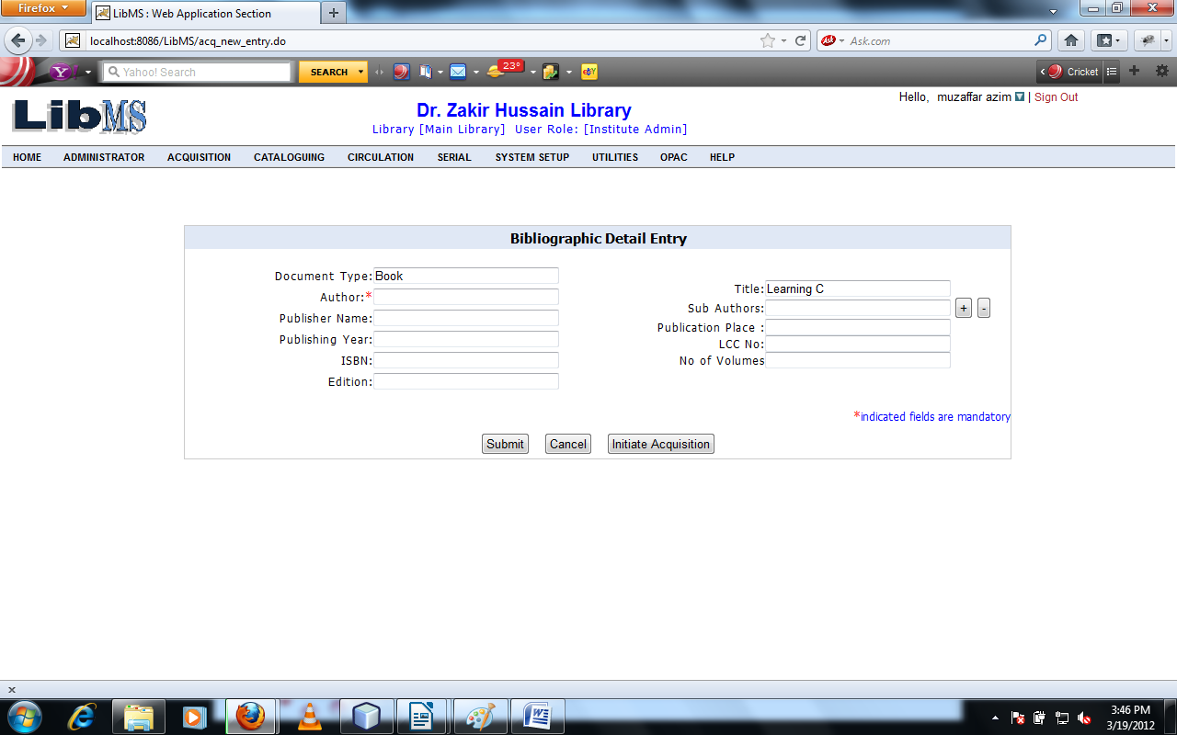

After entering the mandatory field in this interface. We have got following interface.

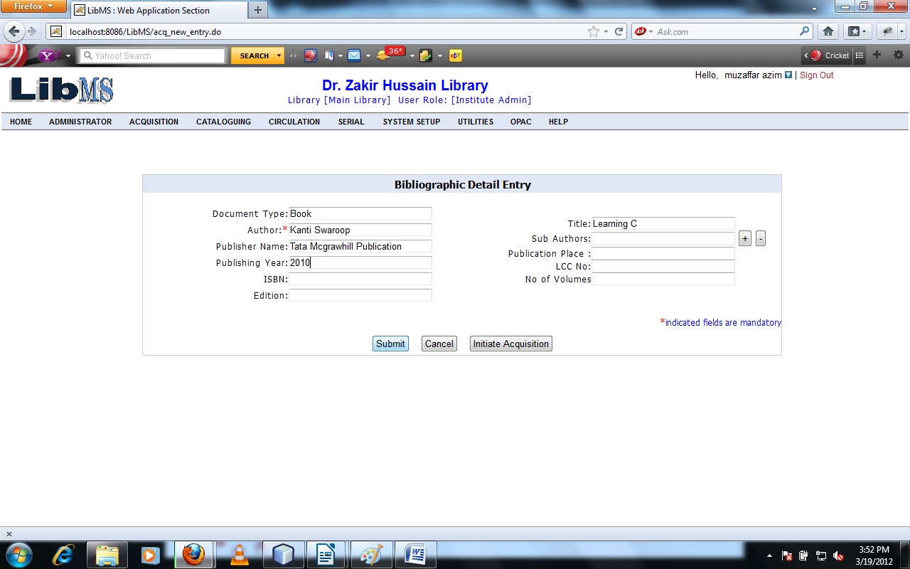
On clicking Submit button we have successfully entered the new title entry and move to the first screen with successfully message with title id.

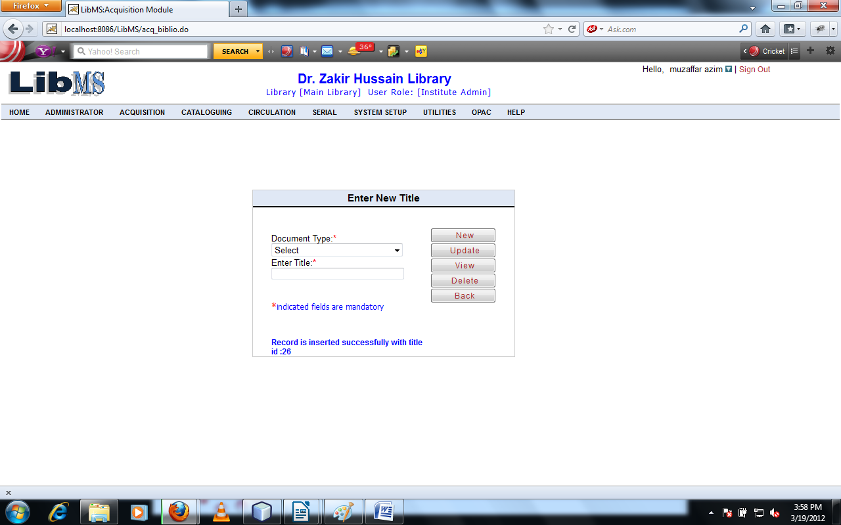
OR
Otherwise on clicking InitiateAcquisition button we have got following interface.
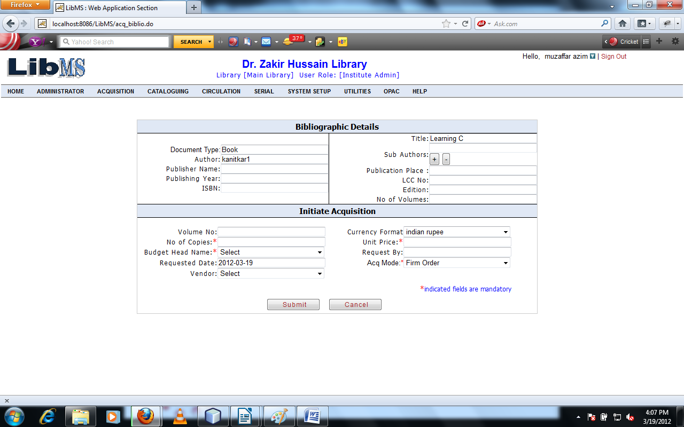
On Clicking Submit button we can start the acquisition processing after filling all mandatory fields.

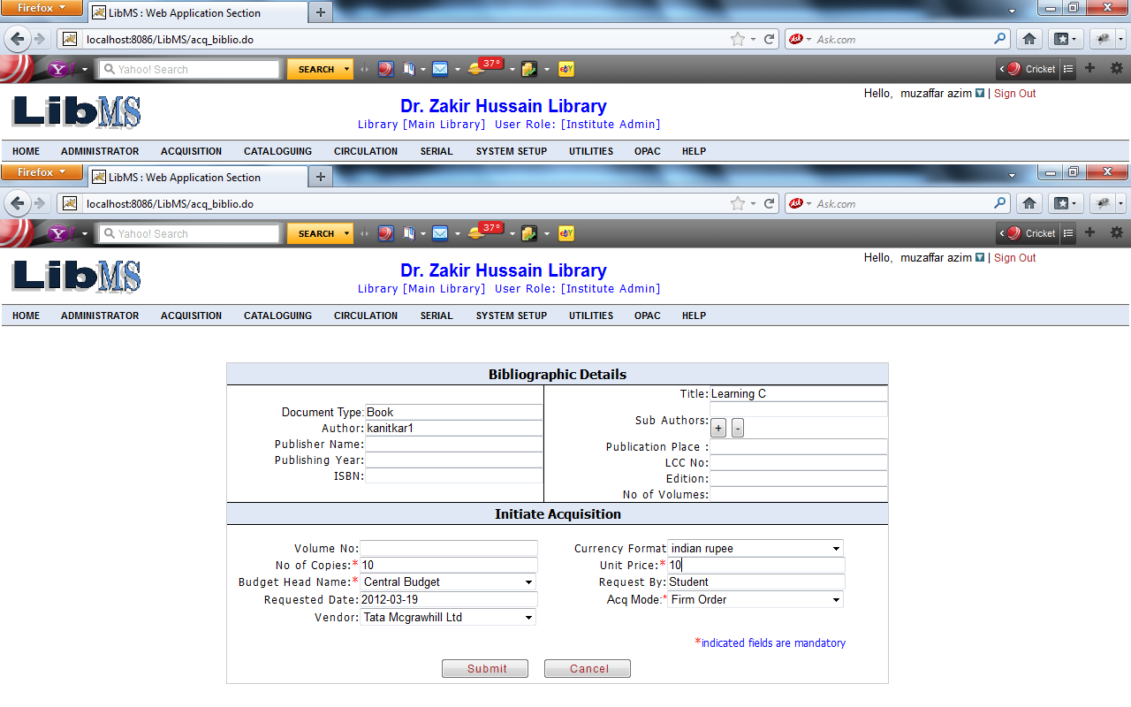
On Clicking Submit button we successfully start the acquisition processing and move to the first with successful entry message with control no.

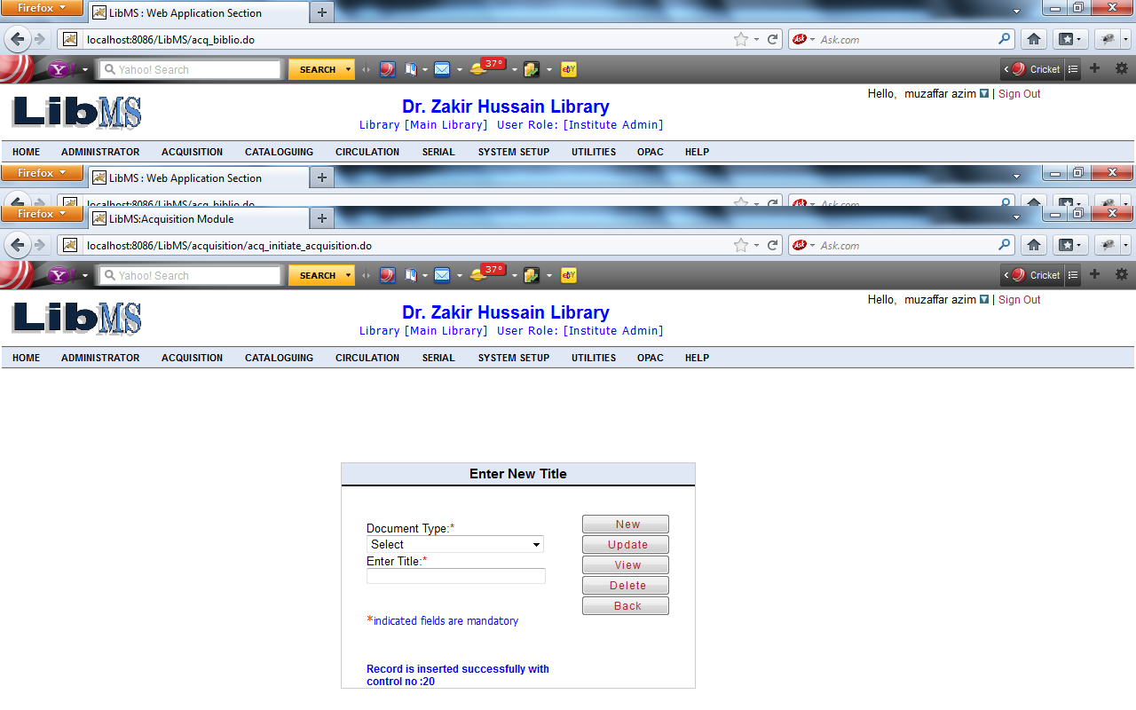

Now we have to move to first screen if we want to update the record of the New entered title.

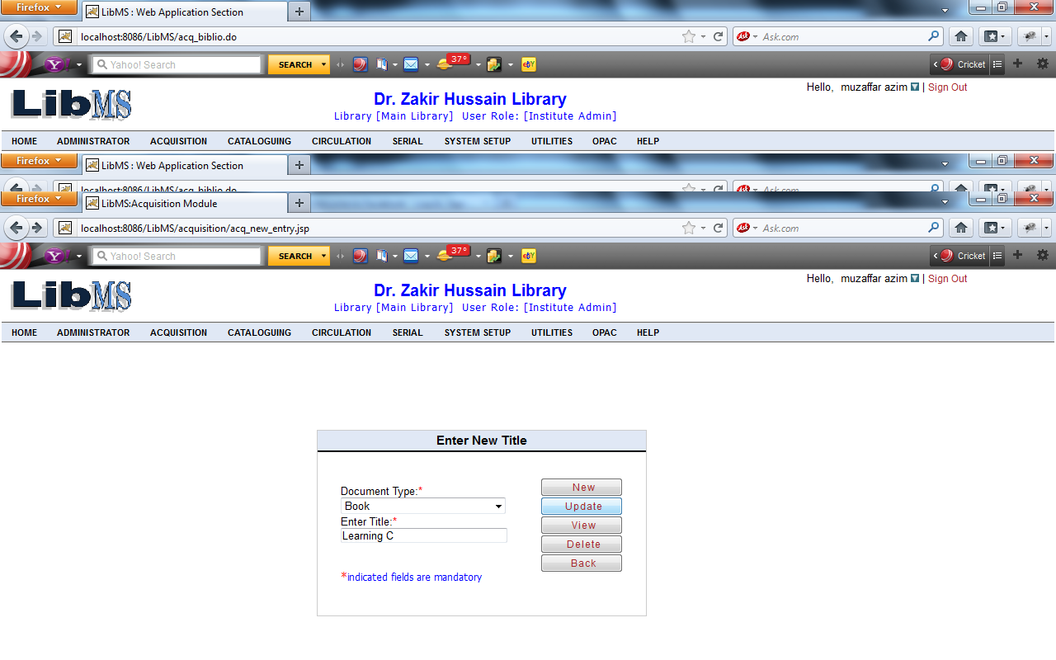
Clicking on update if title is duplicate but author is not same we have got following screen shot.

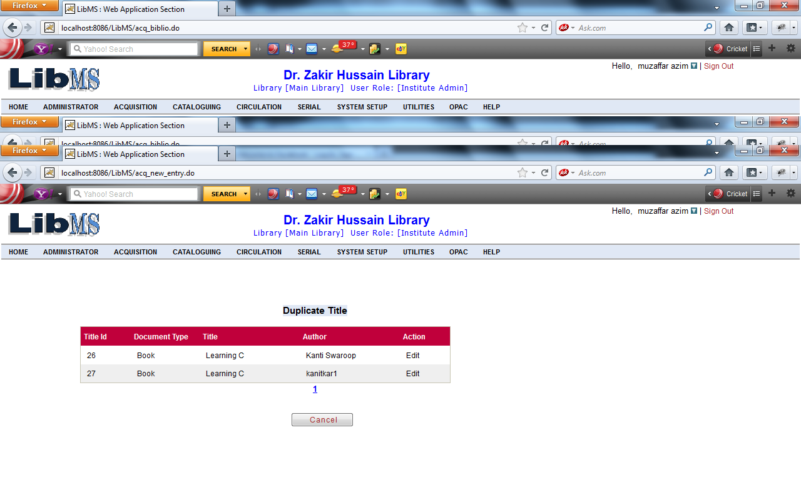
Now Click on Edit button. We have got following screen shot.

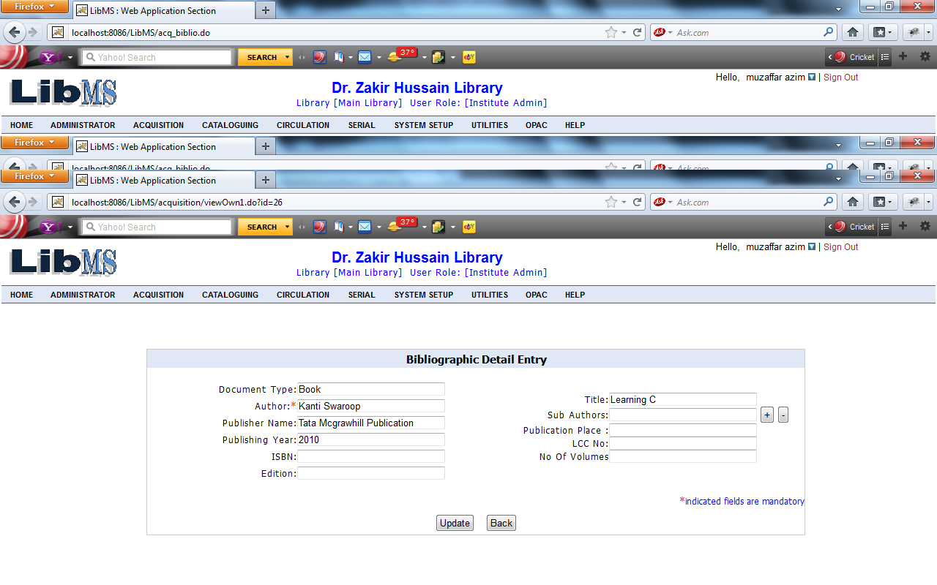
Modify the record Click on Update button.
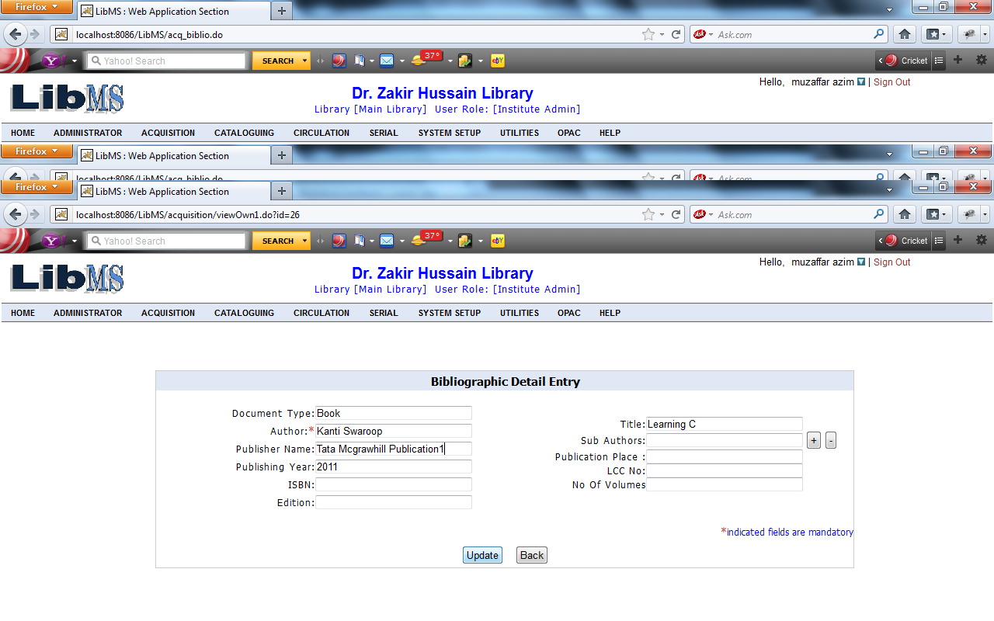

After clicking on Update button we are move on first screen with successfully updated messege.
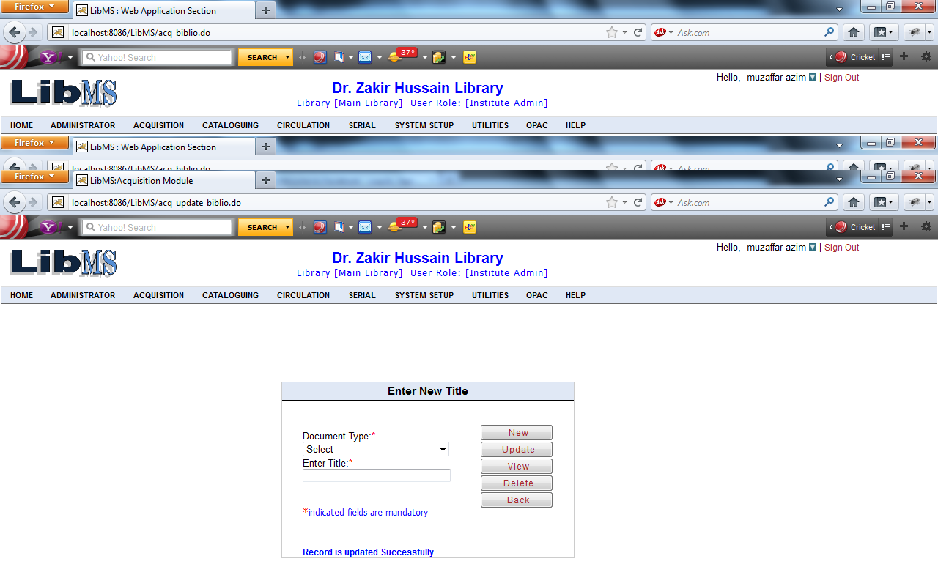
Now If user want to view the entered record then come to first screen. Then we have to move to first screen. After entering all the mandatory fields Click on View button.
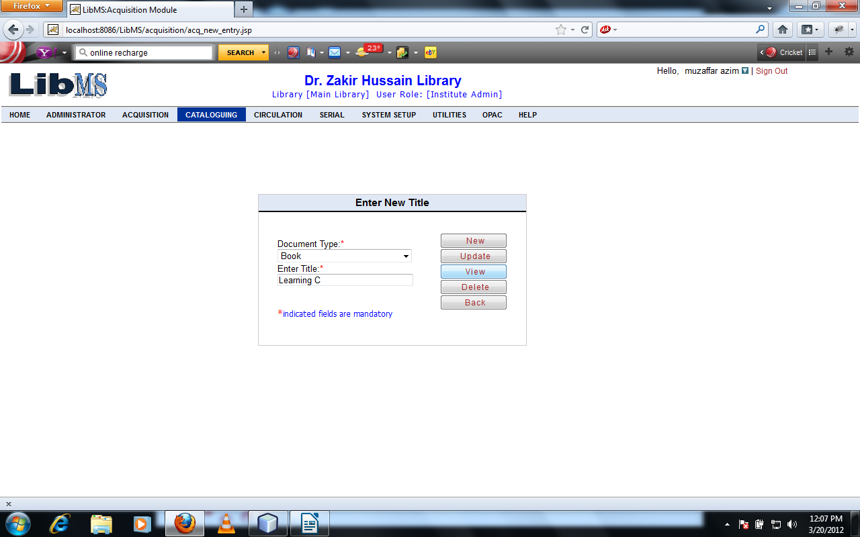
Click on View Button we have got the following interface. If title is same the duplicate grid shown otherwise view the record directly.
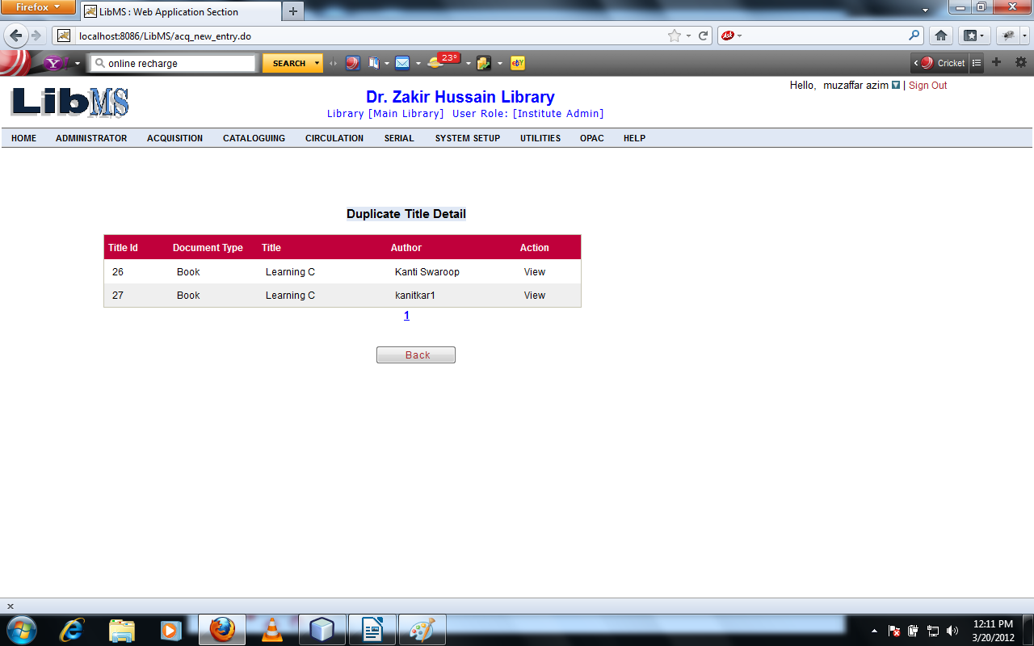
Click on View button we have got following interface.
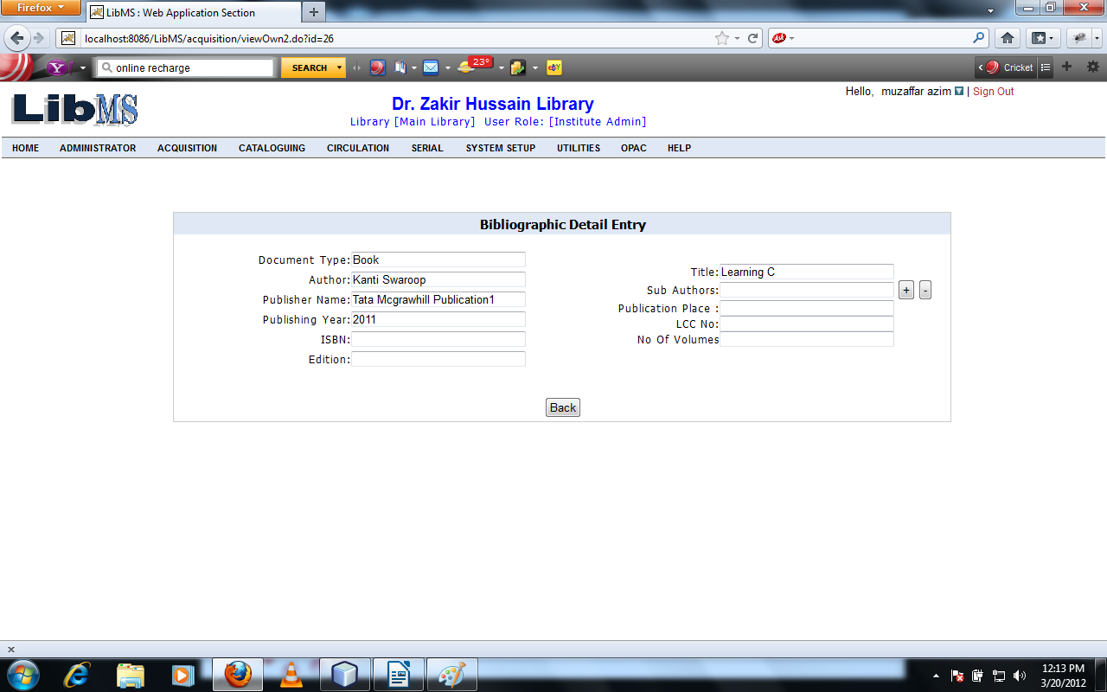

Click on Back button we have to move first screen.
If user want to delete the record of entered title. Then We have to move on first screen.

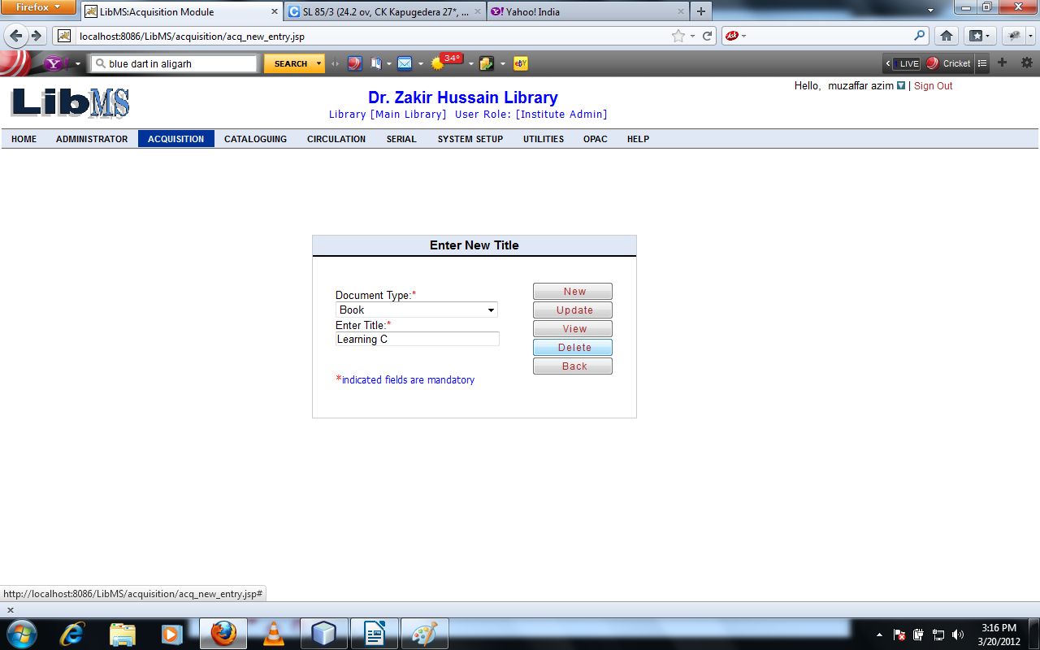

On clicking Delete button if duplicate title occurred then duplicate title grid is shown as following interface.
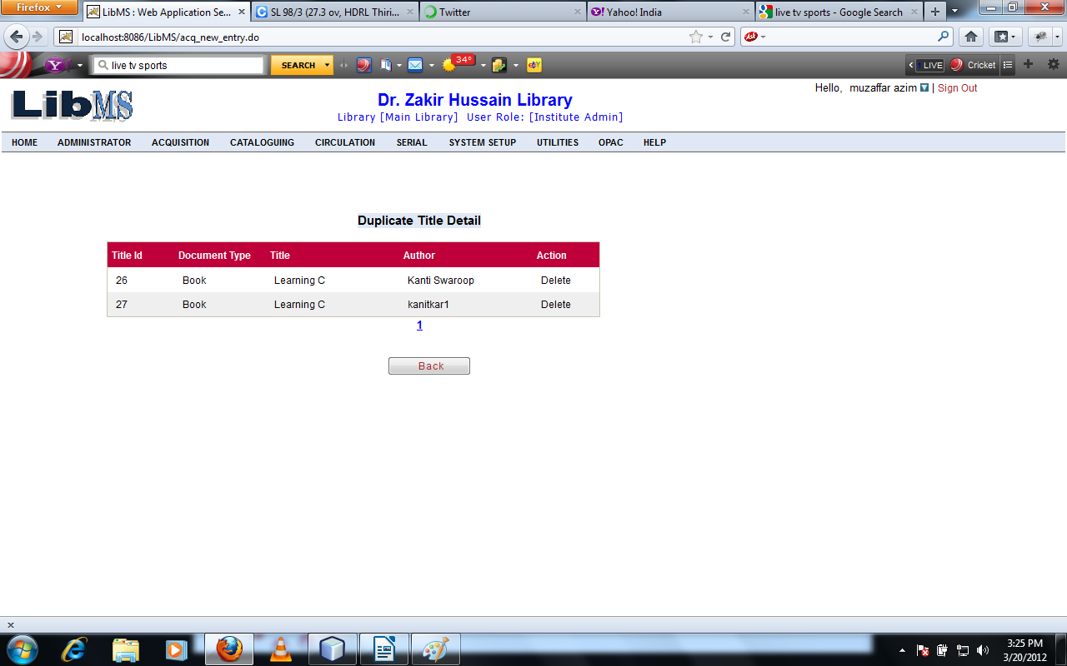
Click on Delete button on Grid.
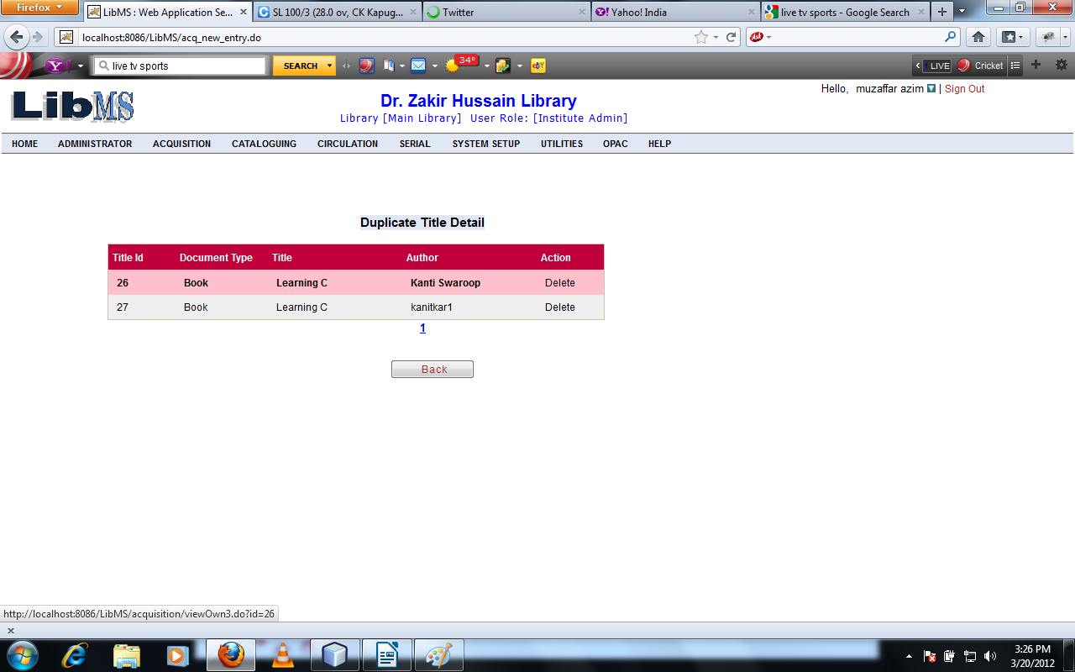
Clicking on Delete Button We have got following interface and we got the following interface.
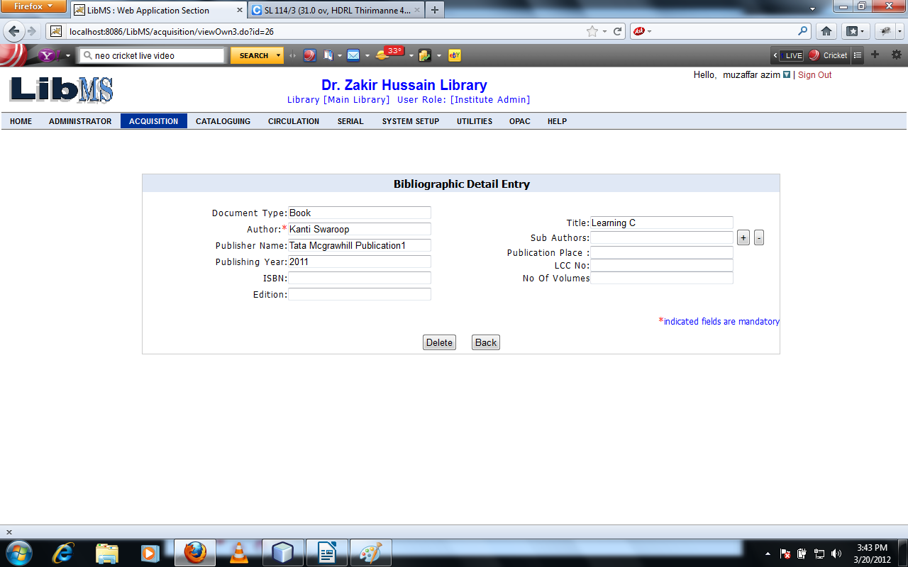

On Clicking on Delete button record is deleted successfully and page redirect to the first page
With Record deleteed successfully message.
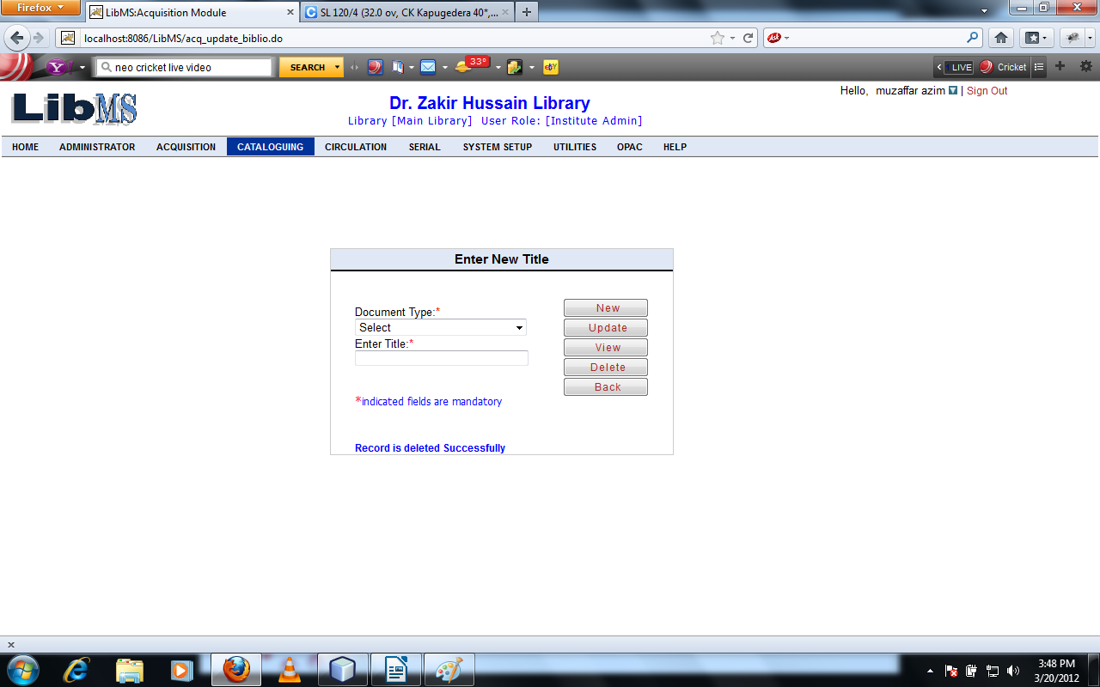
Activity Name : Acquisition - > Generate Title - > Initiate Acquisition

Acquisition Staff can start the Acquisition process directly from the main menu shown as the following interface.
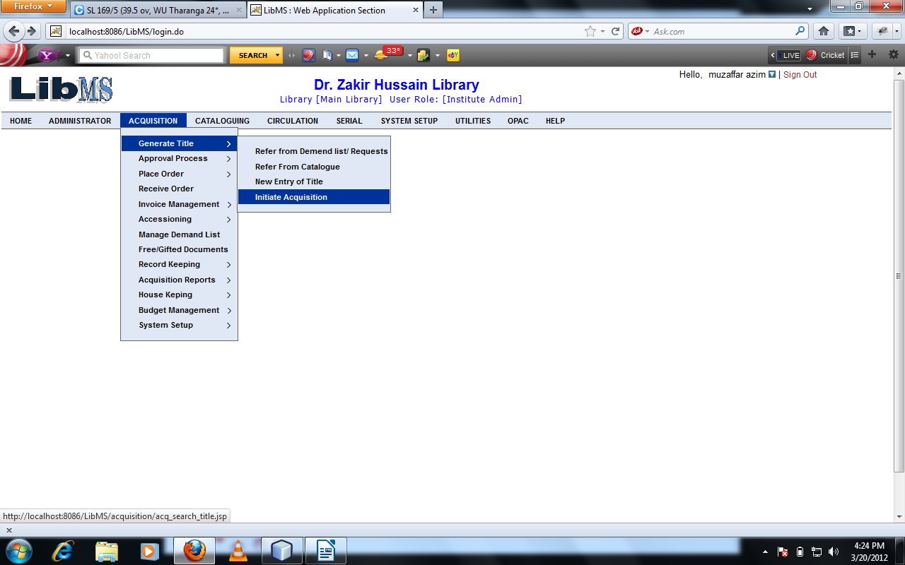
Clicking on Initiate Acquisition Link we have got the following interface.
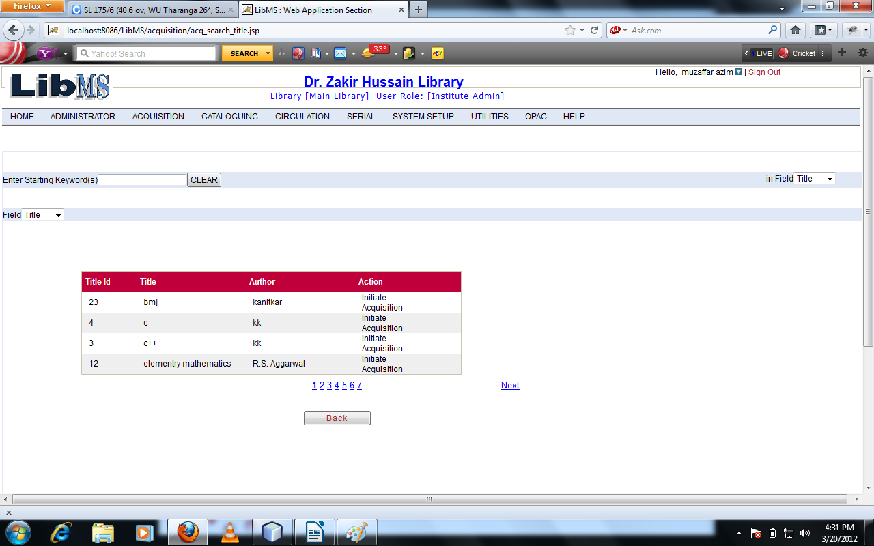

Grid Shows the title of book which are came in the library for acquisition process. Select the book for acquisition process.

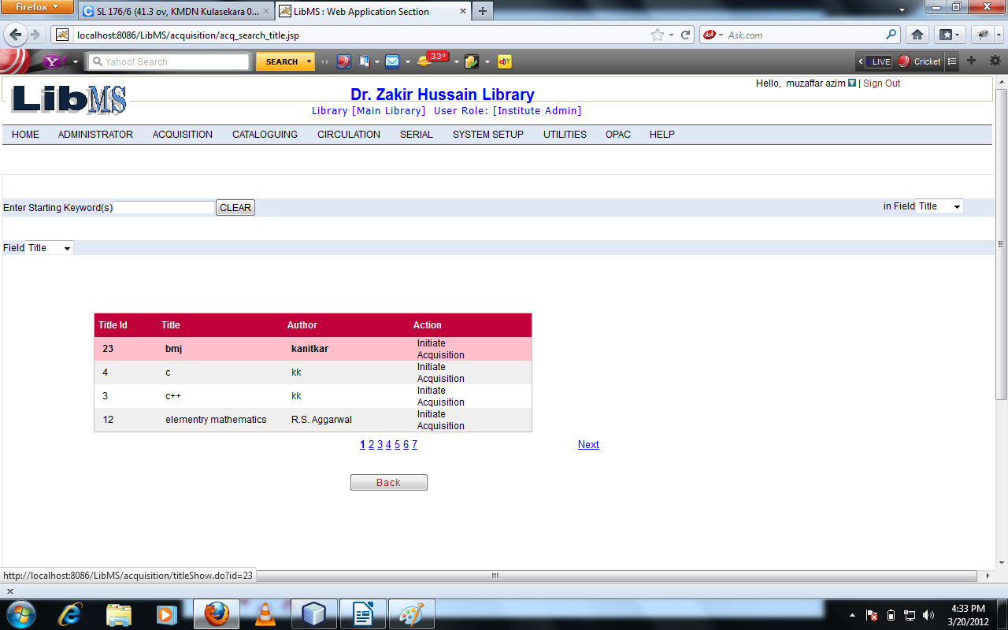
Click on Initiate Acquisition Link we have got the following interface.

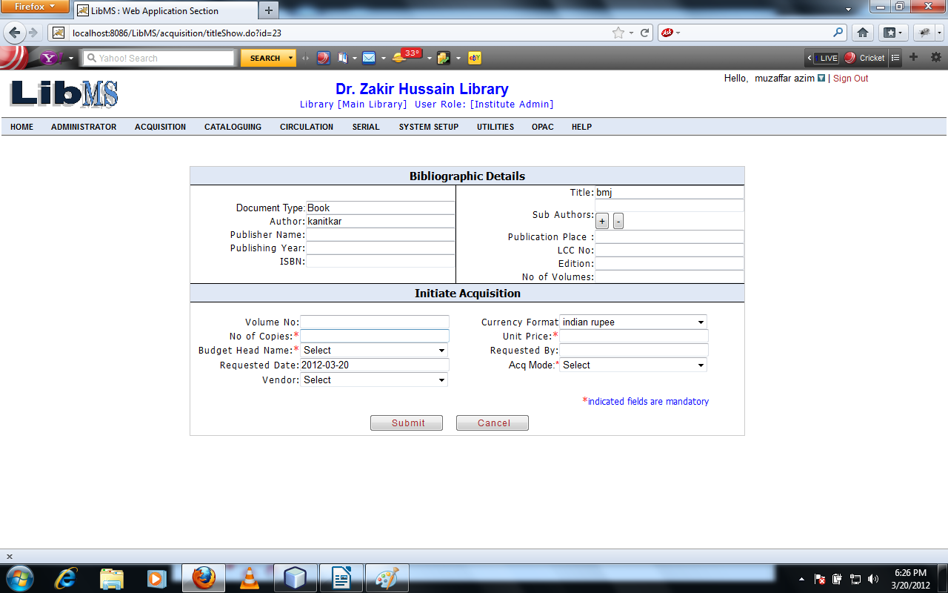
Enter the all mandatory field.
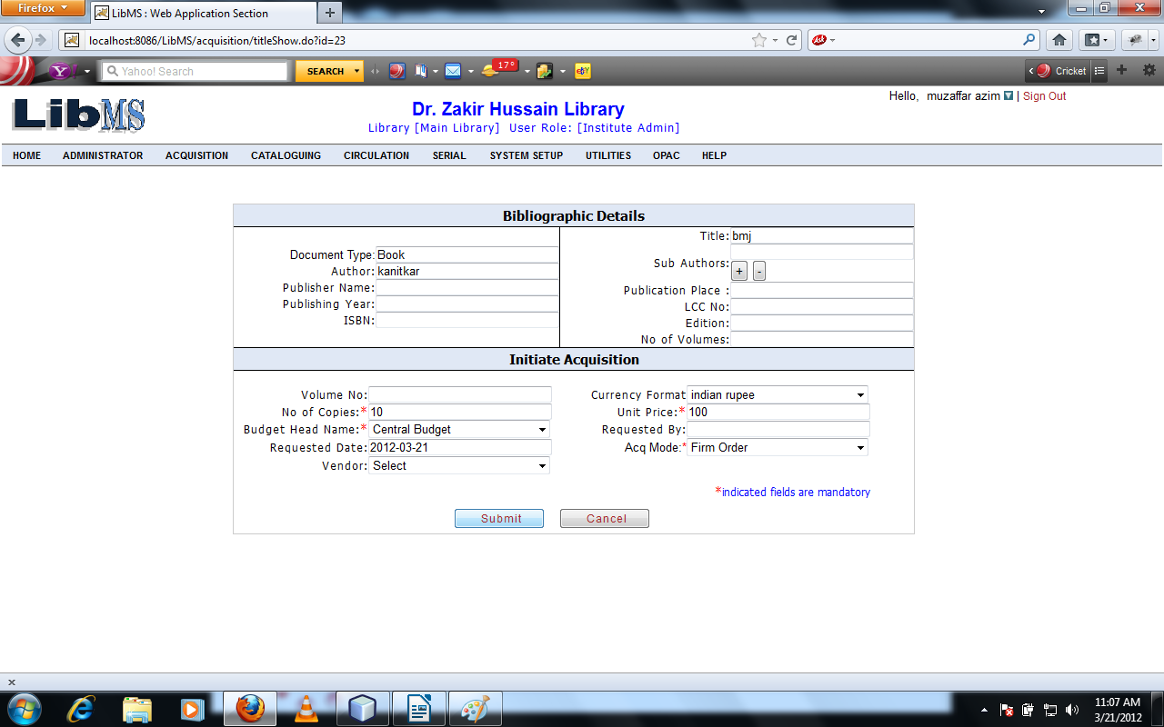

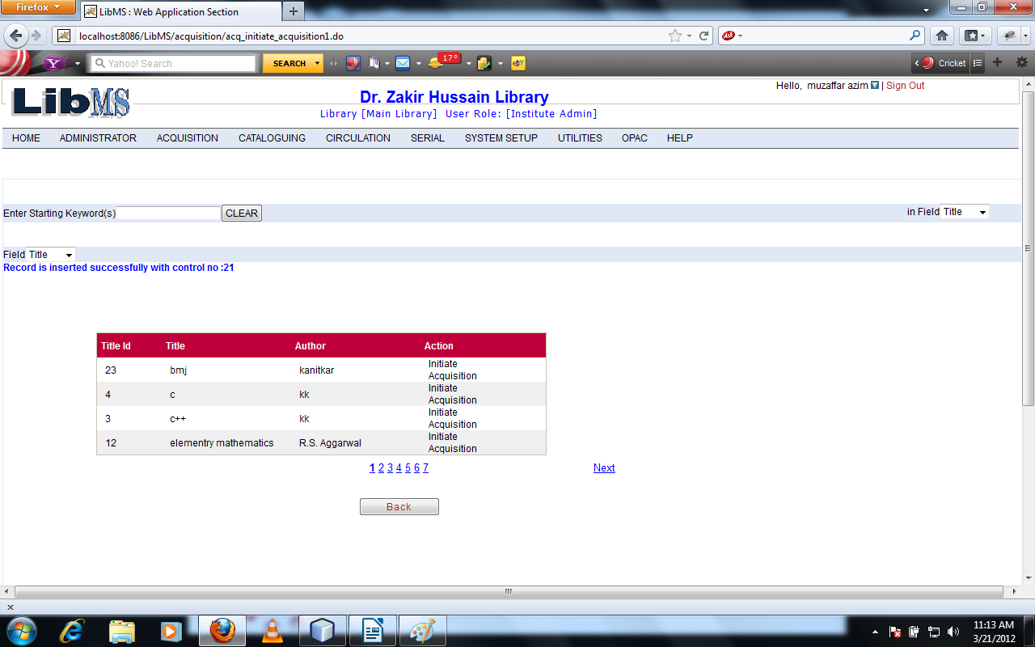
Click on Submit button Acquisition process start successfully and page is forwarded to following interface with the message Record inserted successfully with control no.

Now we are in the Activity Approval Process in which Library management approve the library
materials which have approval required.
Activity Name : Acquisition - >Approval Process - > Add Title into Approval List

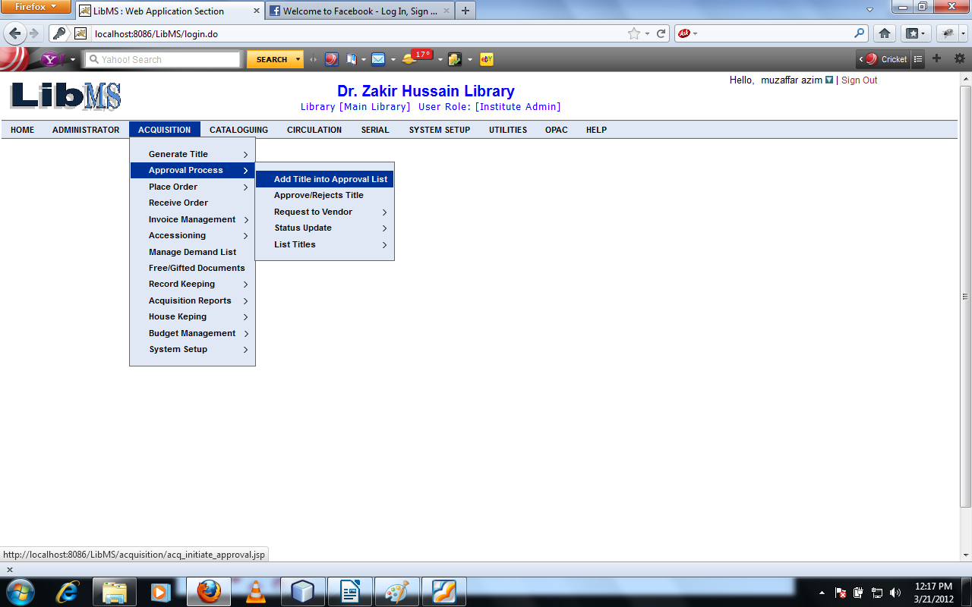

Click On Add Title into Approval List we have got the following interface.
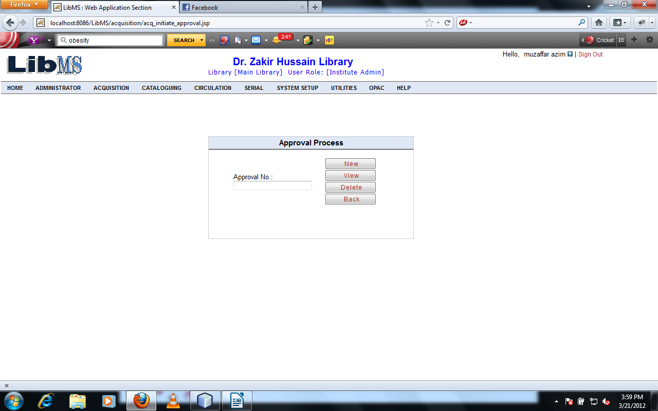
After entering approval no Click on New Button we have got the following interface.
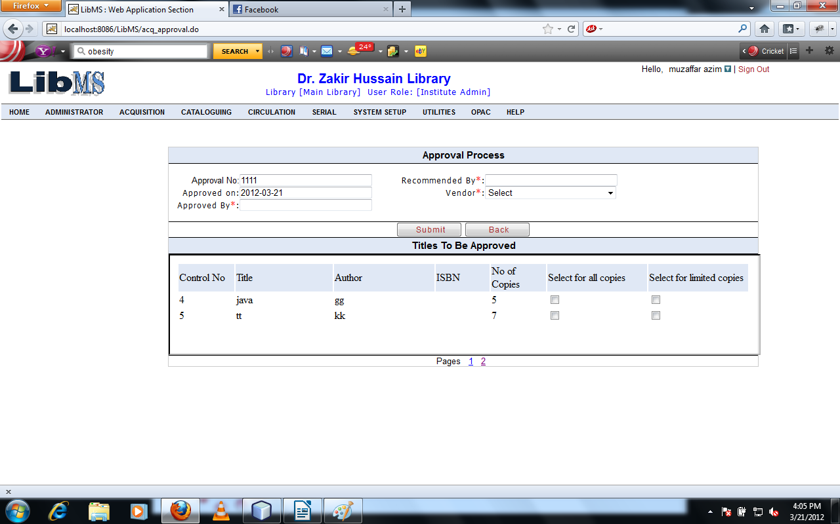

Enter the all mandatory field by user and select the no of copies. We have got following interface.

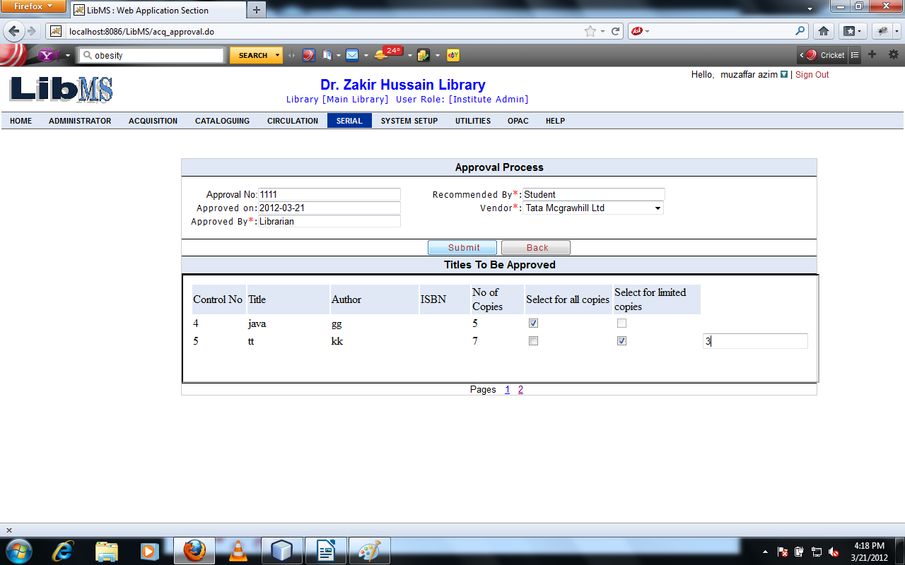
Click on Submit button the library material is approved by Librarian and move to the first screen with successful approval message.
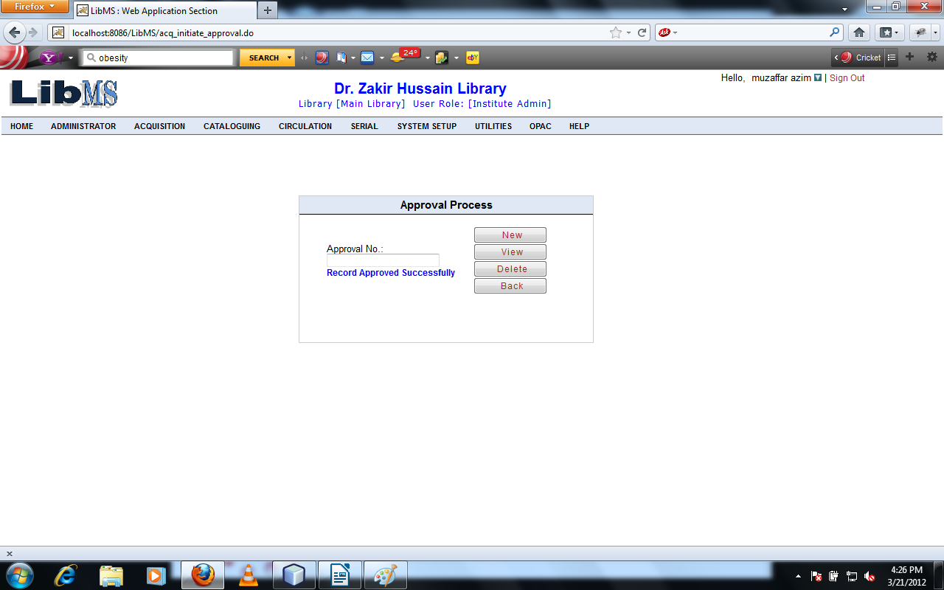
If we want to view the record of approved item then we have to enter the approved approval no on the first screen and click on view button.
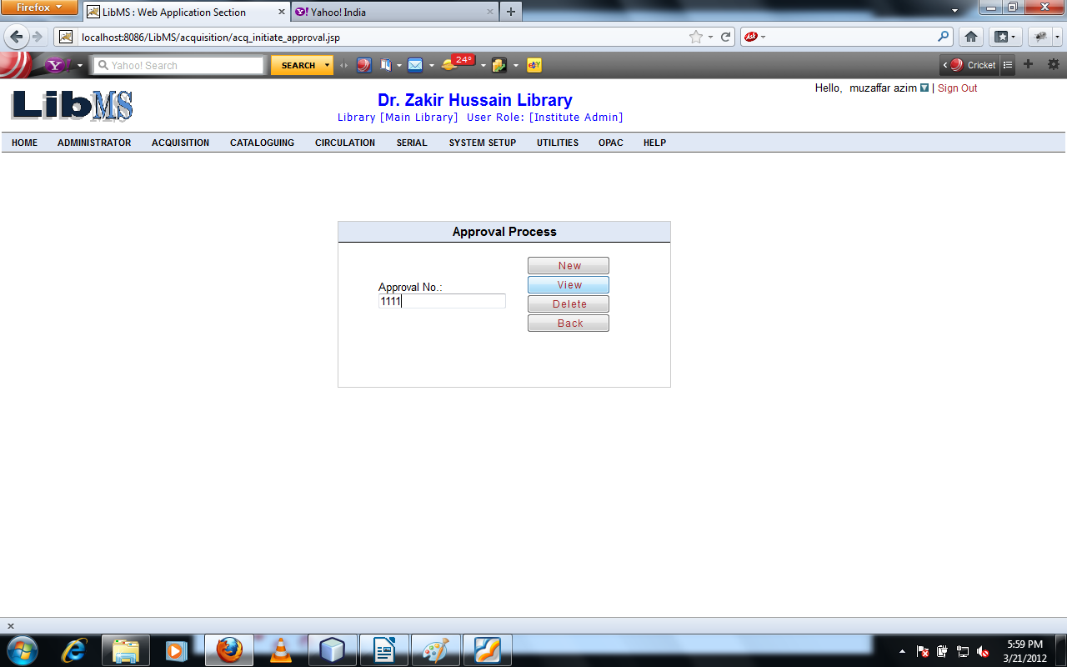
Click on View button we have got following interface. We can view the approved list of books.
Click on Back button refer to the first screen.

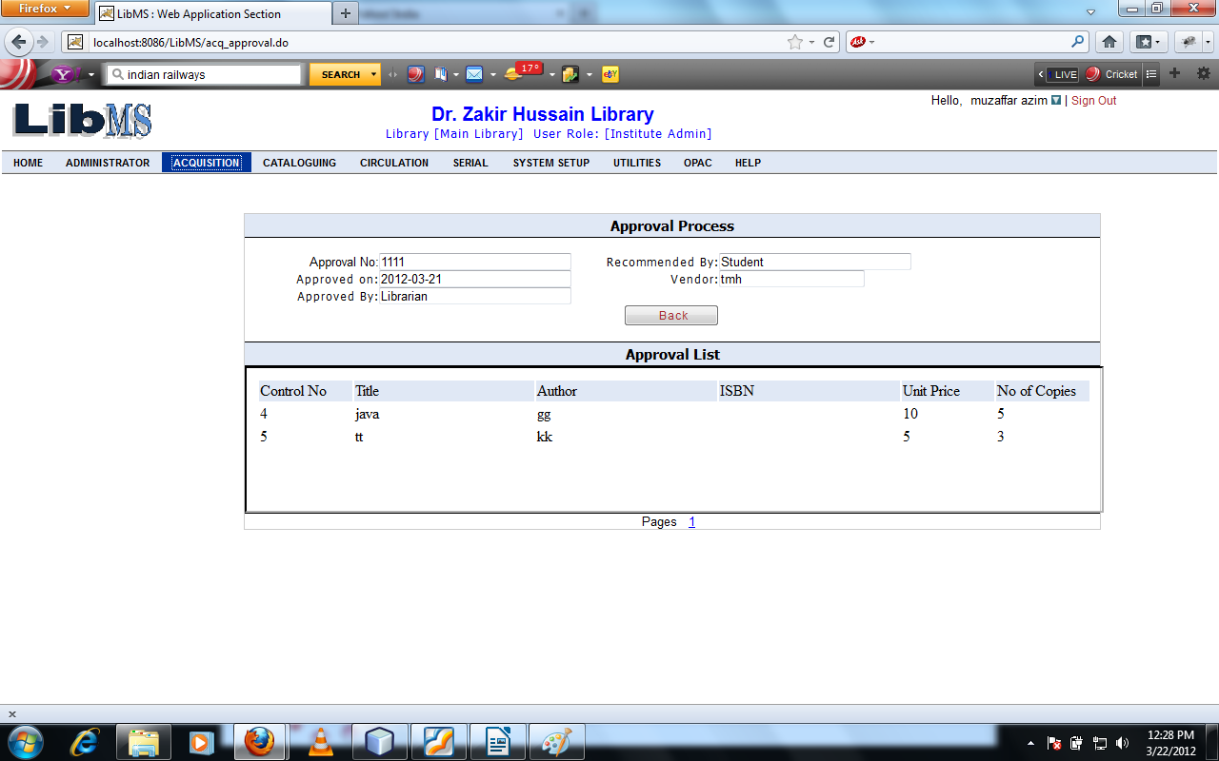

Now if we want to delete the record of approved item then we have to come on the first screen and enter the approval no according to following interface.
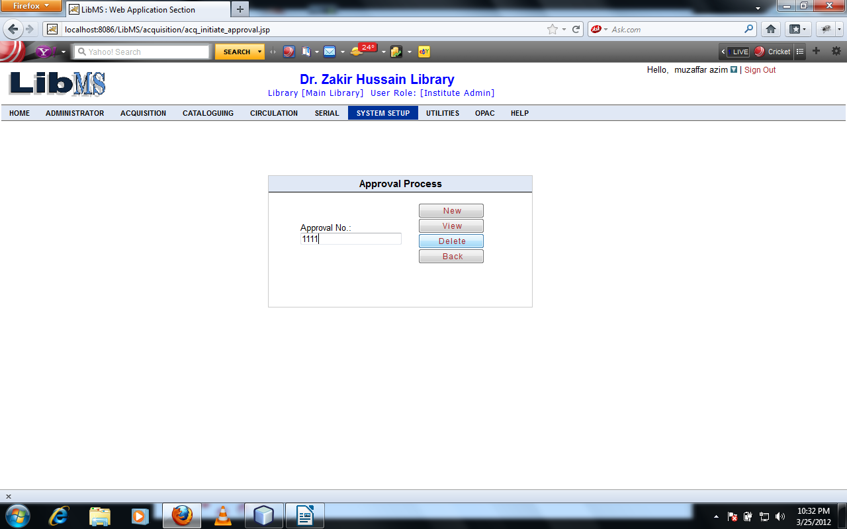
Click on Delete button we have got following interface.
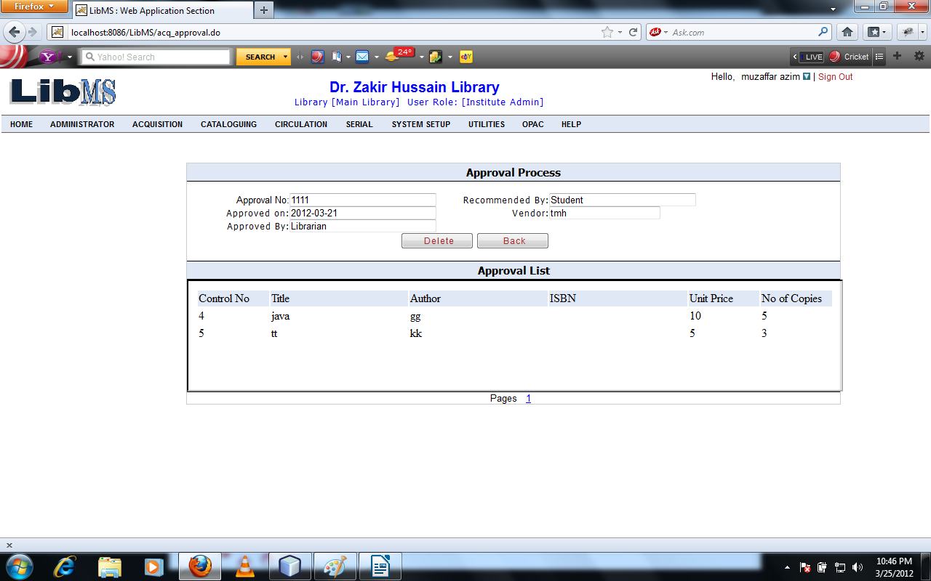
Click on delete button warning message shown like following interface.
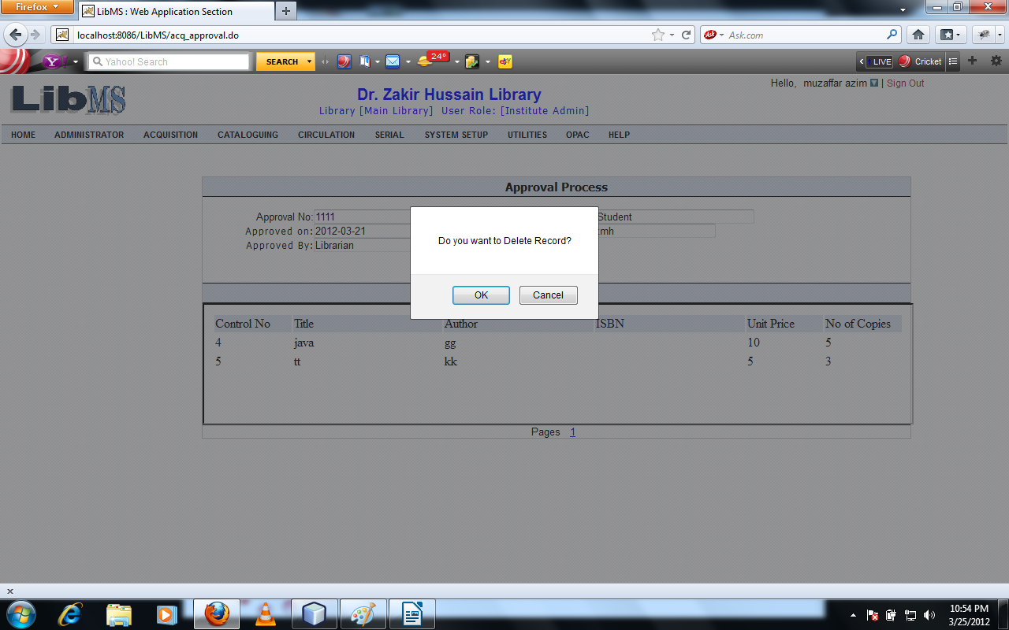

Click on Delete button the record is deleted successfully and redirect to the first page of approval process with record deleted successfully message.

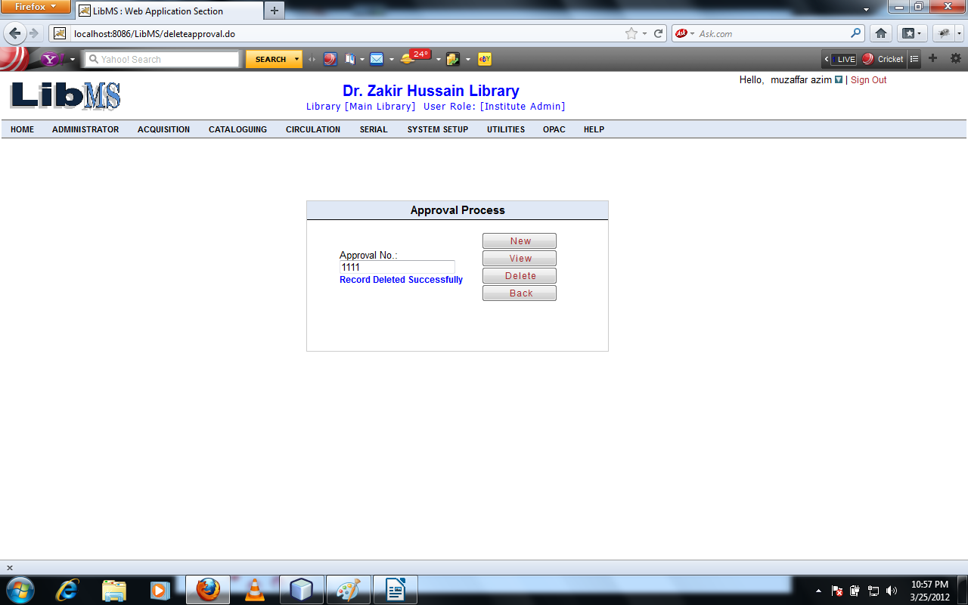

Activity Name : Acquisition -> Approval Process - > List Titles - >On-Approval Titles

Now we are on main menu of approval process.
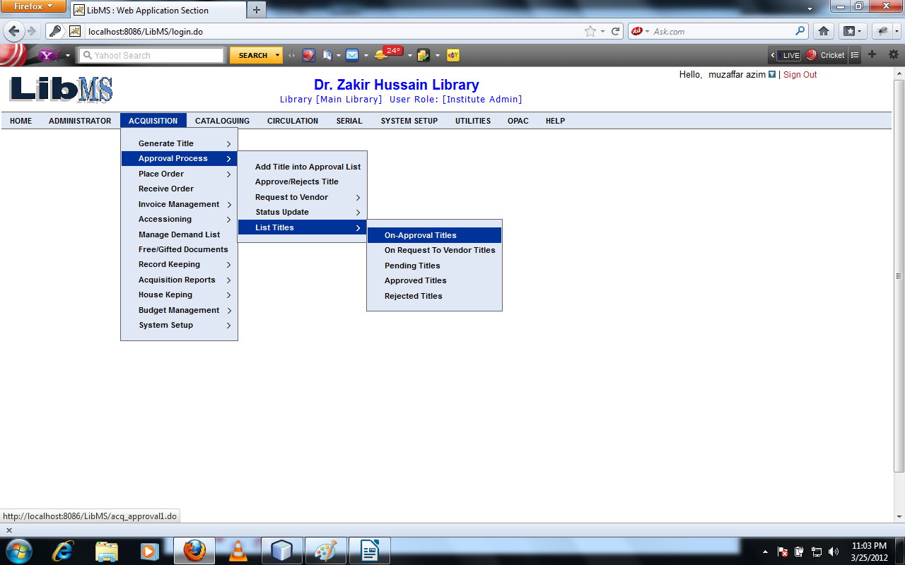

Click on On-Approval Titles Link we can see the title which are come to the library for Approval process that are shown as following interface.
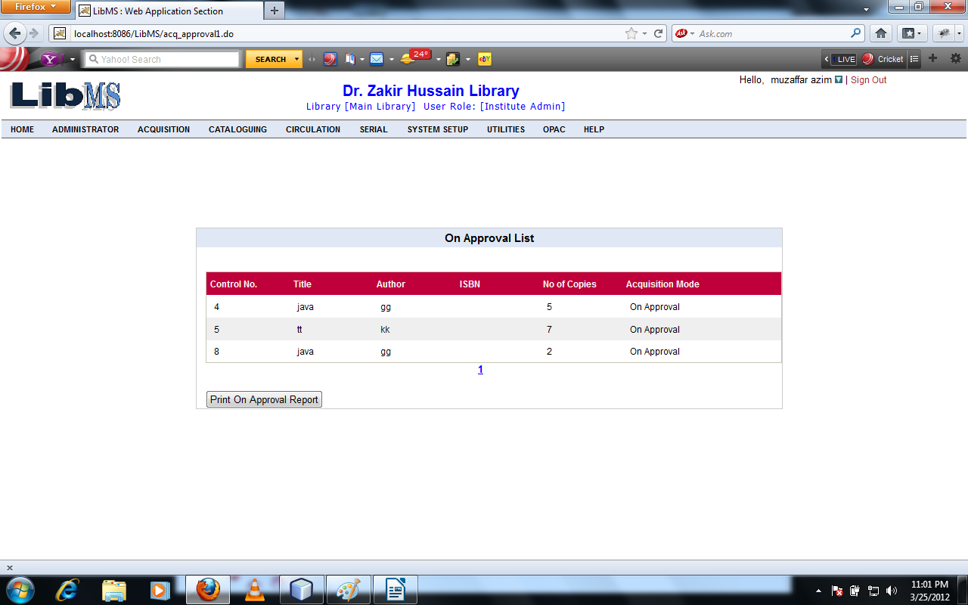
Clicking on Print On Approval Report button then report on Approval list is generated as pdf format with the following interface.
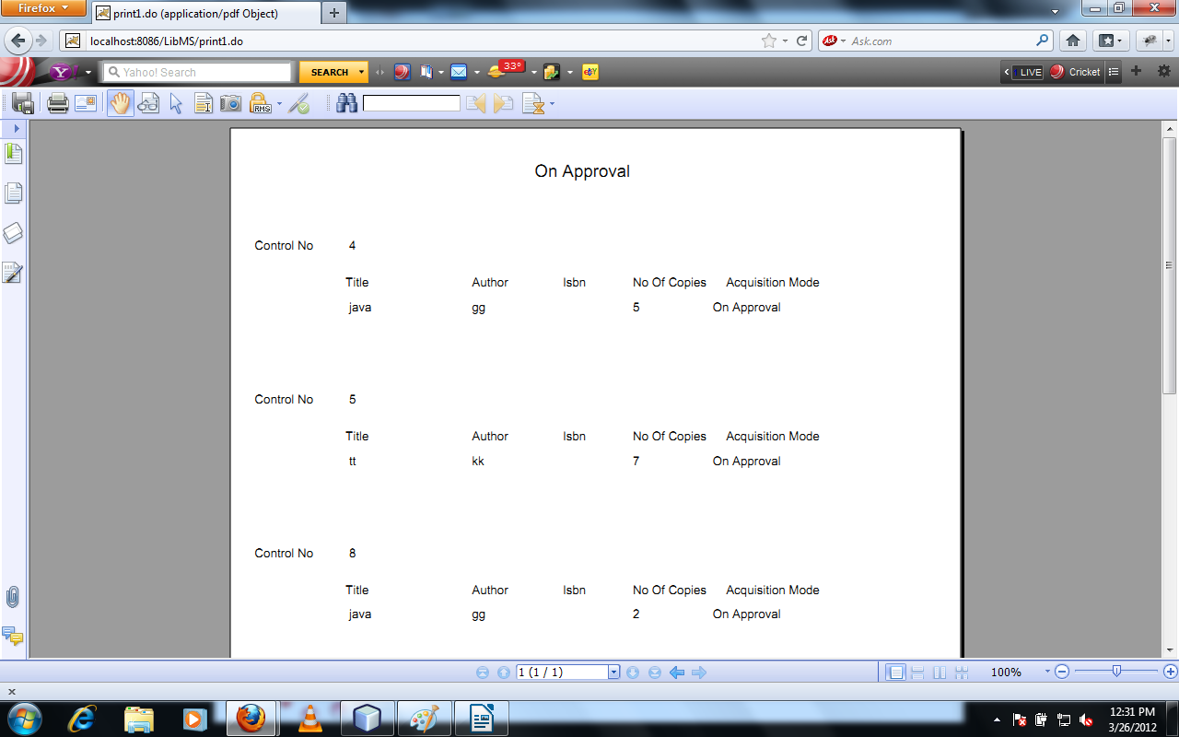
Now We are on the Main Menu
Activity Name : Acquisition - >Approval Process - > List Titles - >Approved Titles

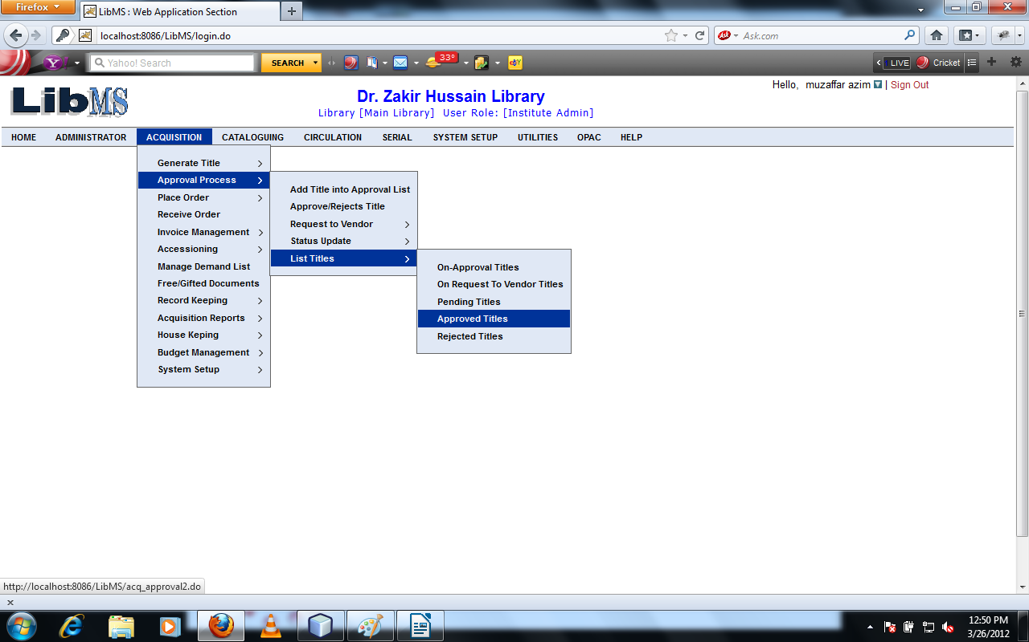
Clicking On Approved Titles Link we have got following interface.
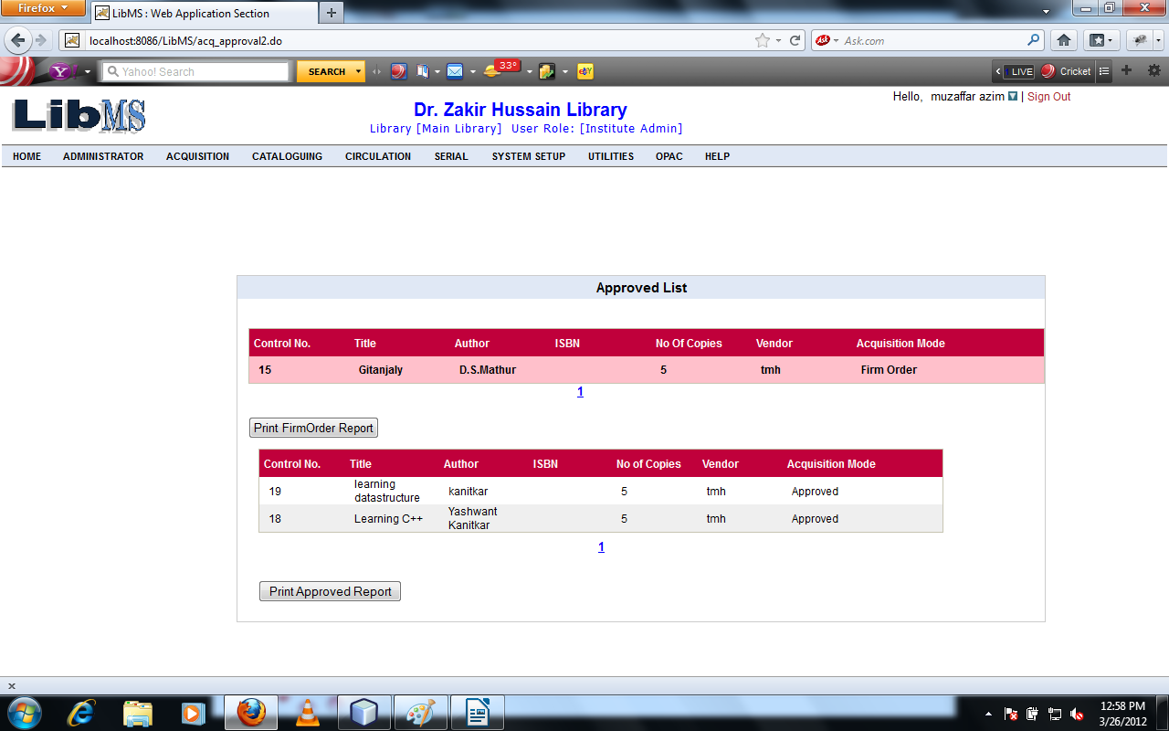

Now We are in the Order Processing activity of Acquisition Module in which section library authority manage the ordering the library materials.
Activity Name : Acquisition - >Place Order - > View List For Order - >Direct Request

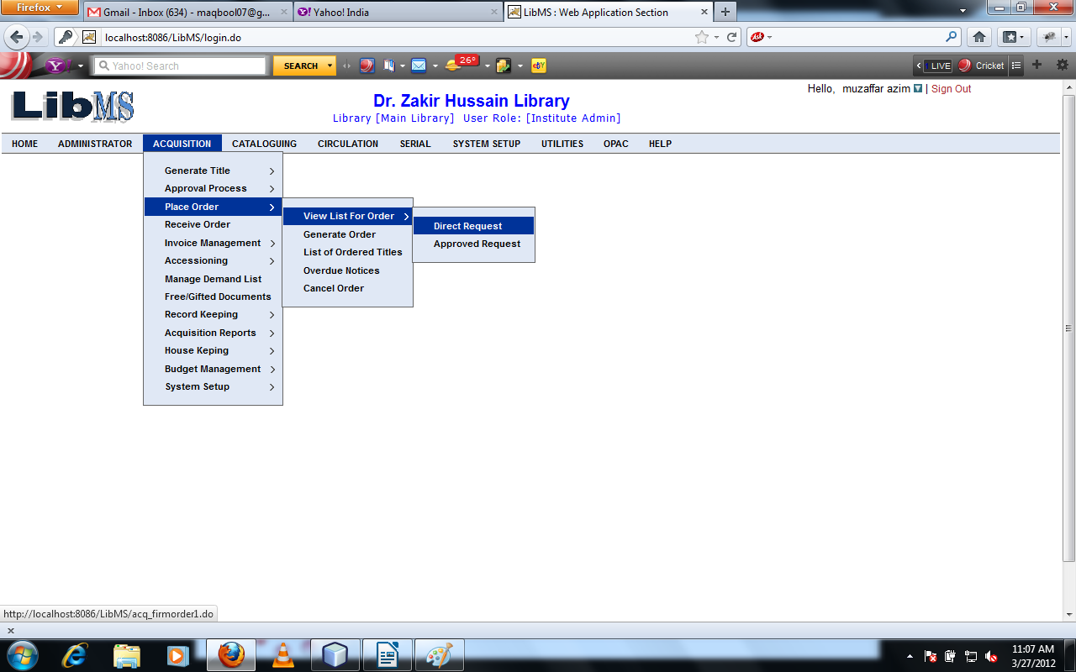
Click on Direct Request link we can seen the list of title which are came from Firm Order. That interface is shown below.

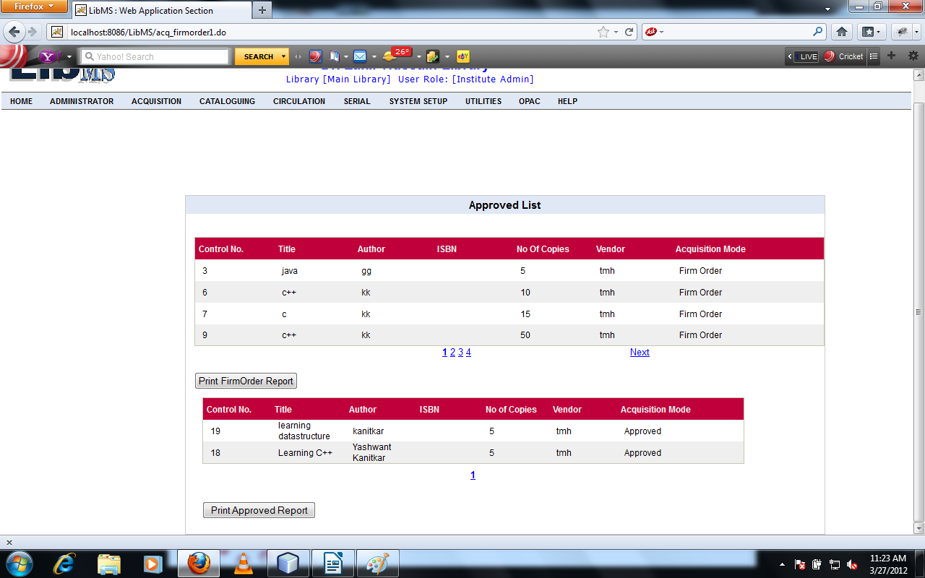
Now we are in the activity of generating order of the library materials.
Activity Name : Acquisition - > Place Order - > Generate Order

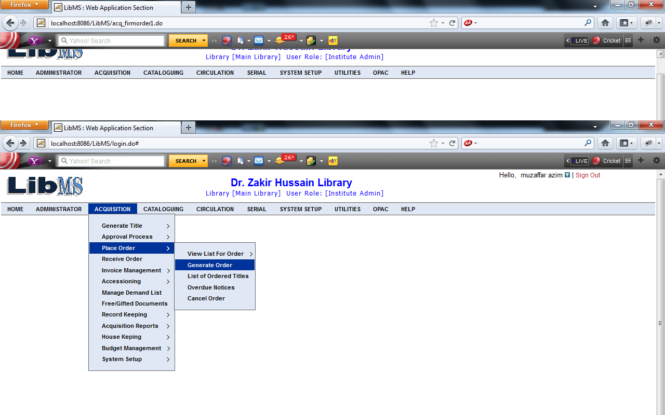

Click on Generate Order link we have got following interface.

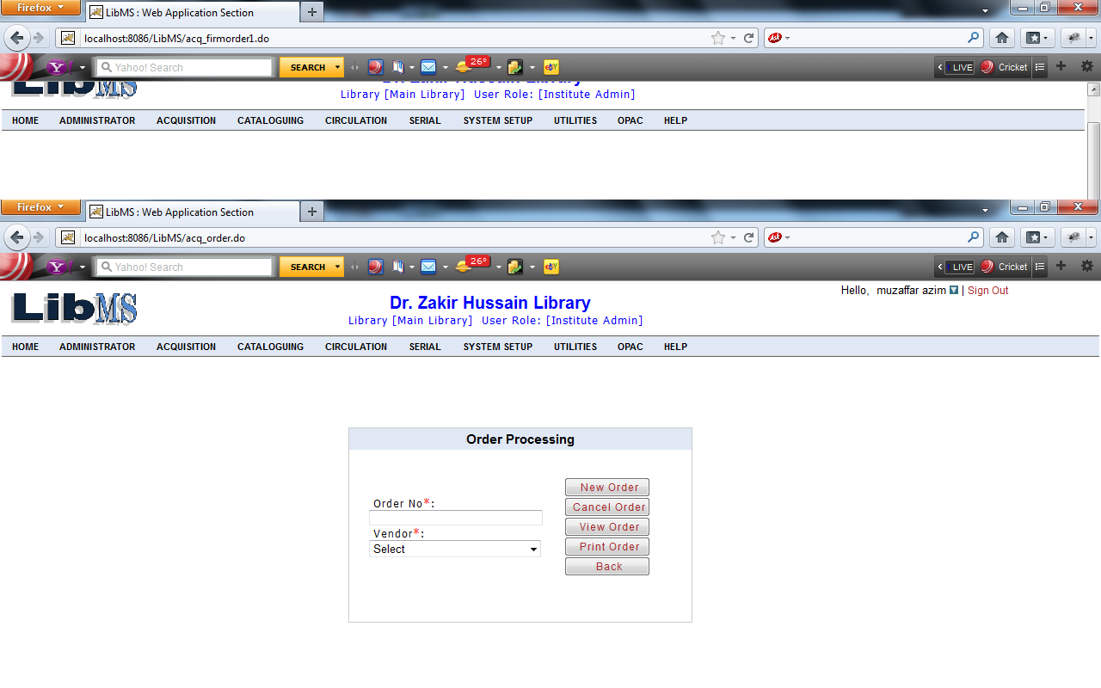

After entering the all mandatory field we have to got the following interface.

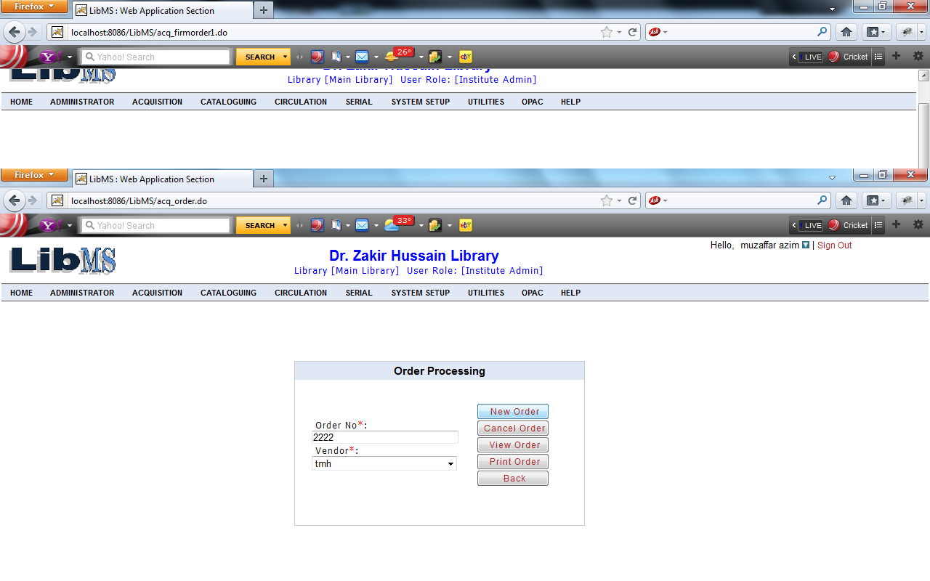

Now when we click on New Order Button we have got the following interface. We have got the list of titles which are came to library for ordering.

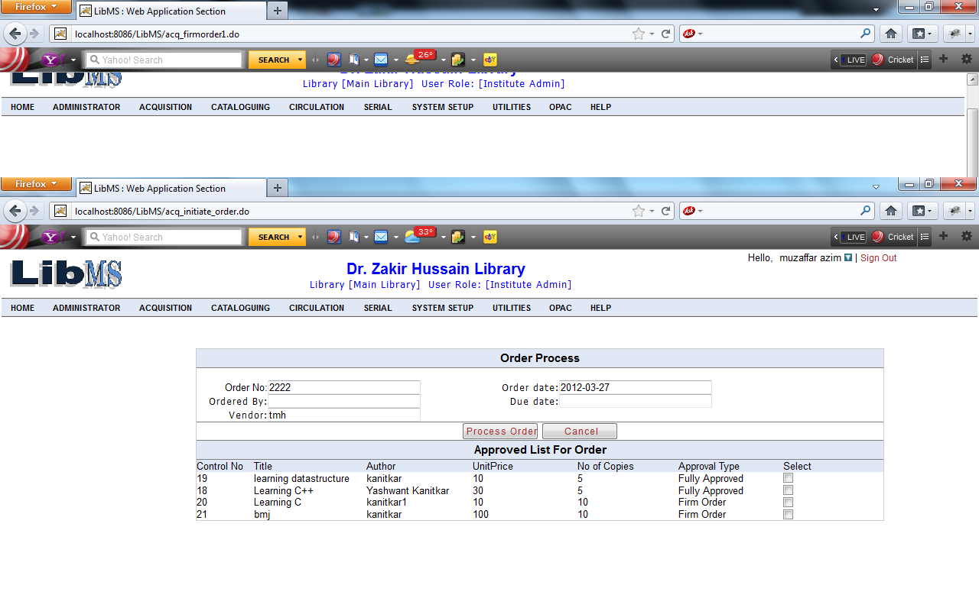

Enter all the details which are required and select the list of titles.
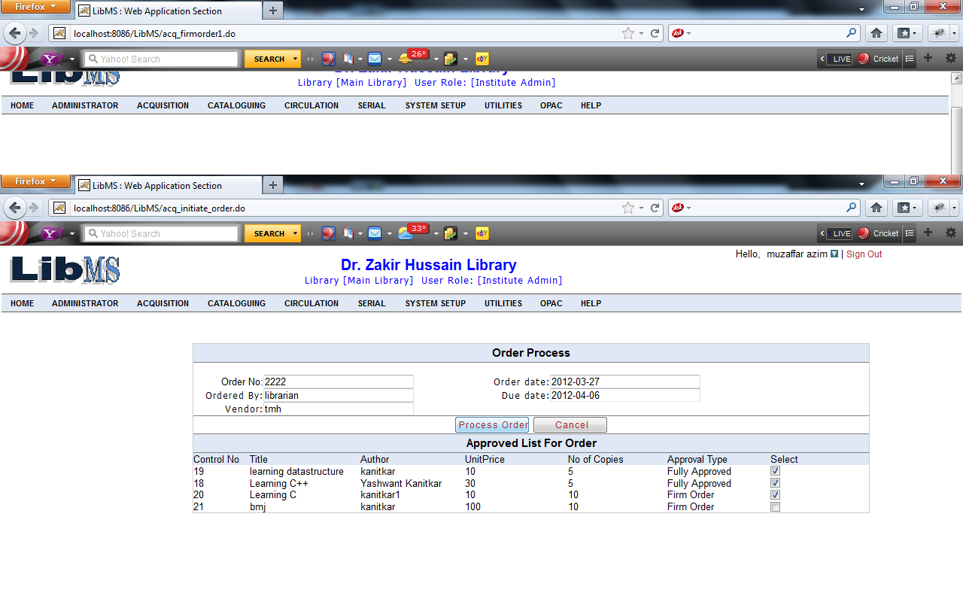
Clicking on Process Order button we have got the following interface.
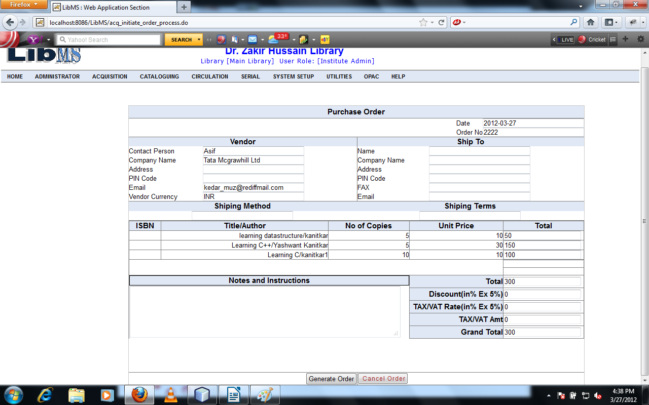
Enter the details which are required and click on Generate Order button.
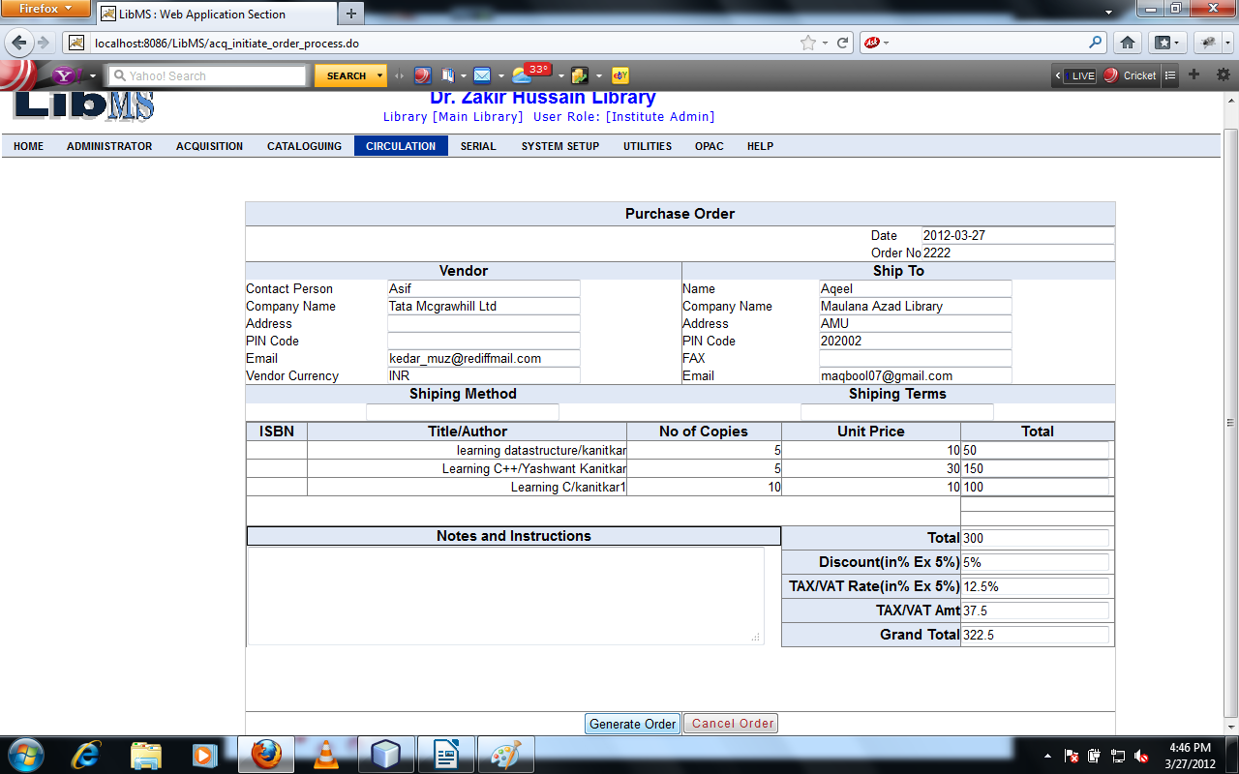

Clicking on Generate Order button we can process the order successfully and forward to the first screen of order process with ordered successful message.

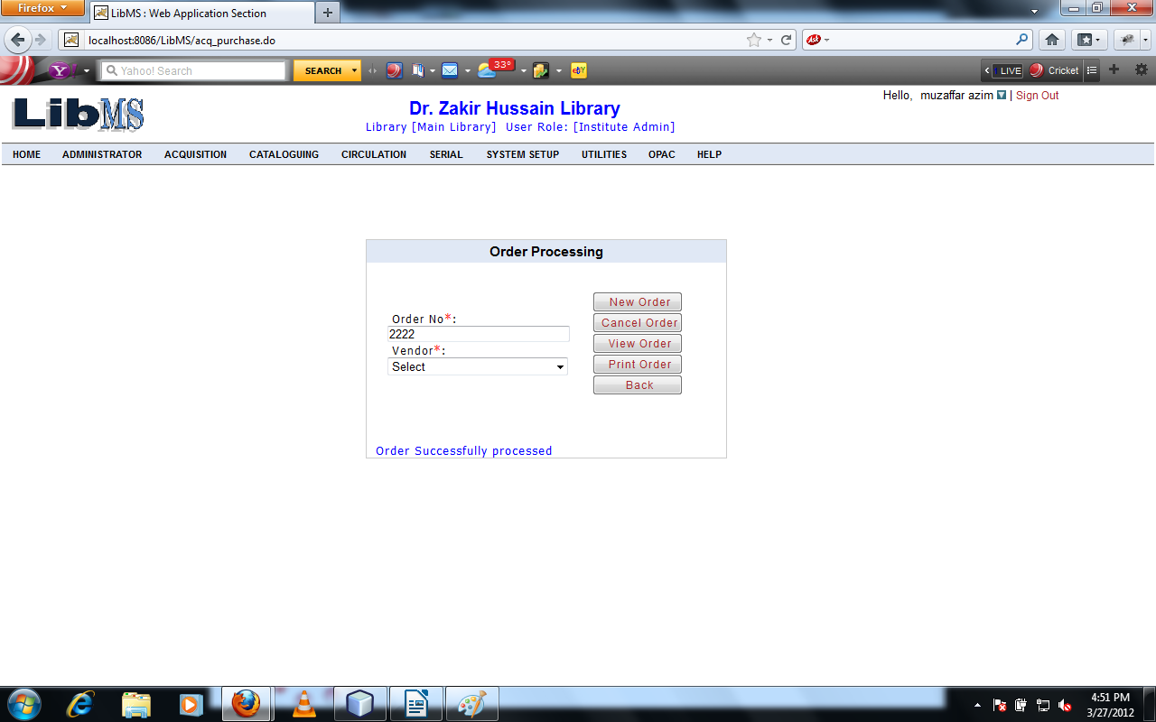
If we want to cancel the order which are placed click on Cancel order button after entering the order no and vendor id.

When we click on Cancel Order button we have got following interface.

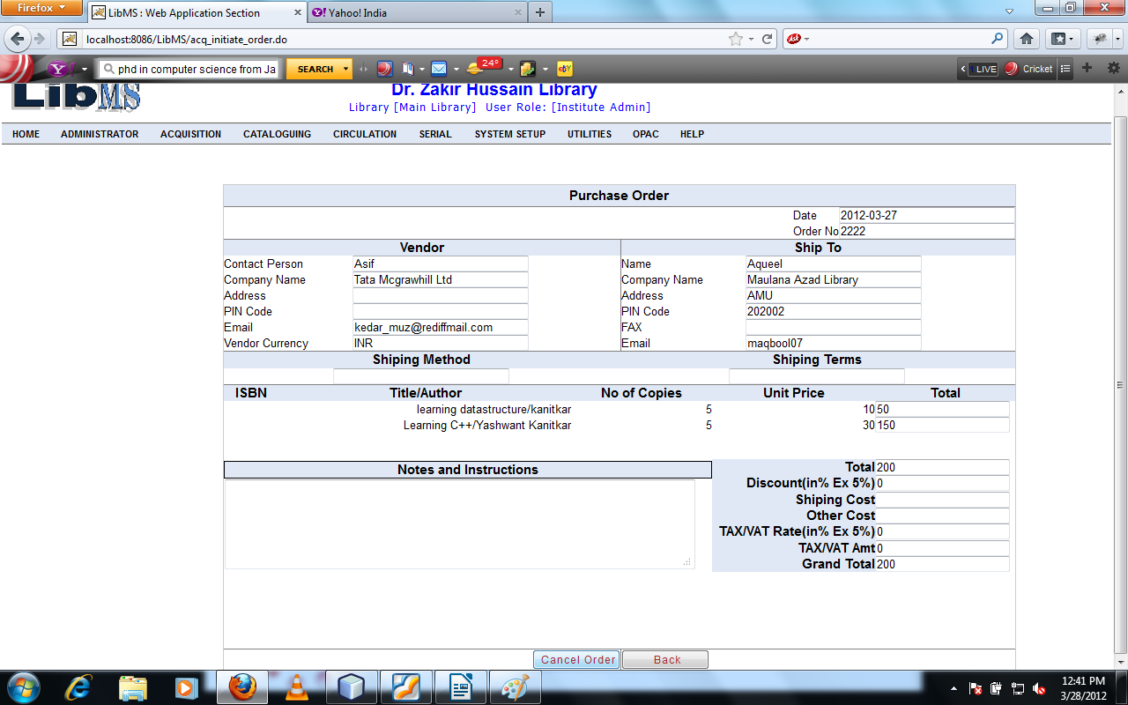

Click on Cancel Order button. We cancel the order successfully with successfully message.and forwarded to the first screen of Order Process screen.

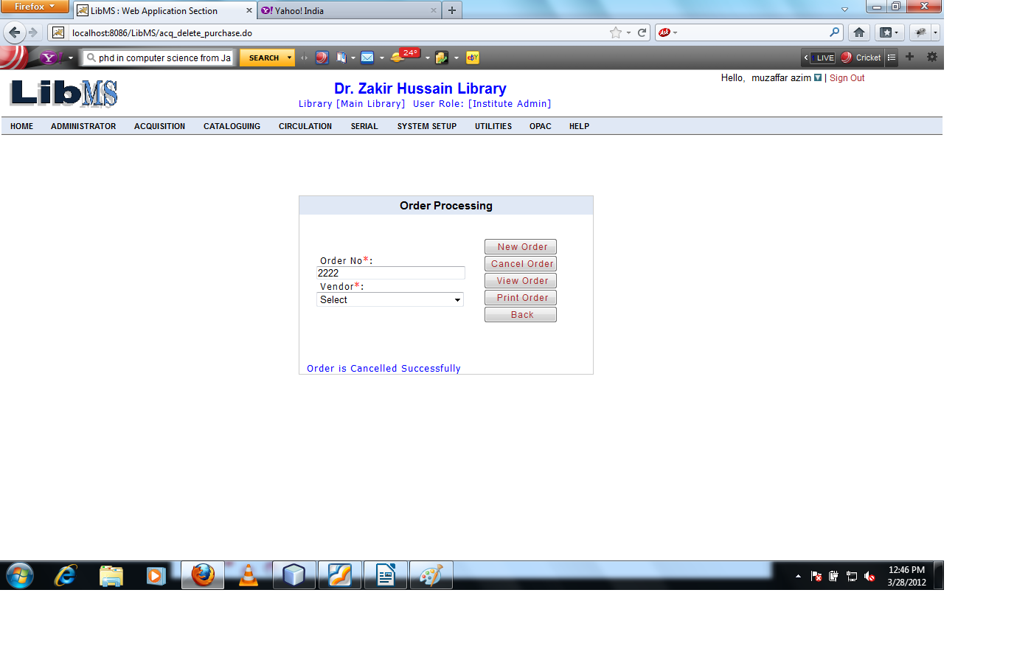

If we want to view the detail of order which are placed. Enter the mandatory fields like order no and and vendor details and click the View Order button.
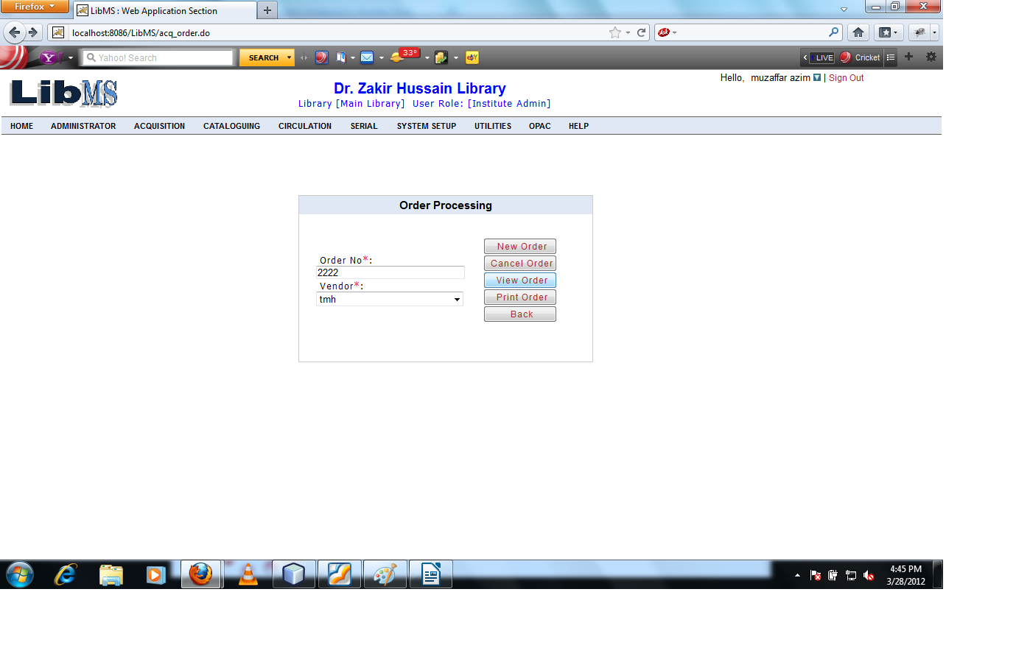
When we click on View Order button we have got the following interface.

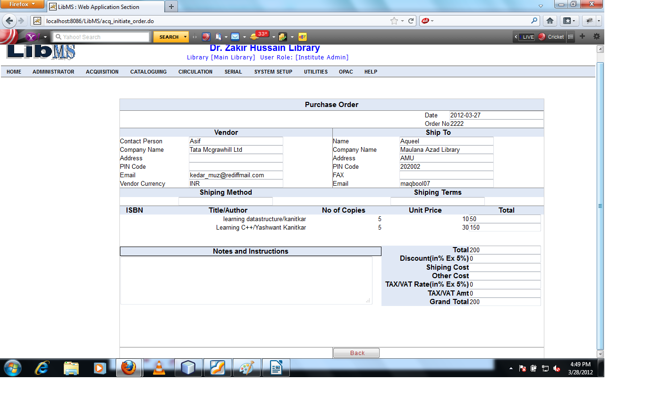
Click on Back button refers to the first screen of order process.
Now we have to take print of processed order.
After entering the order no and vendor id click on Print order button.
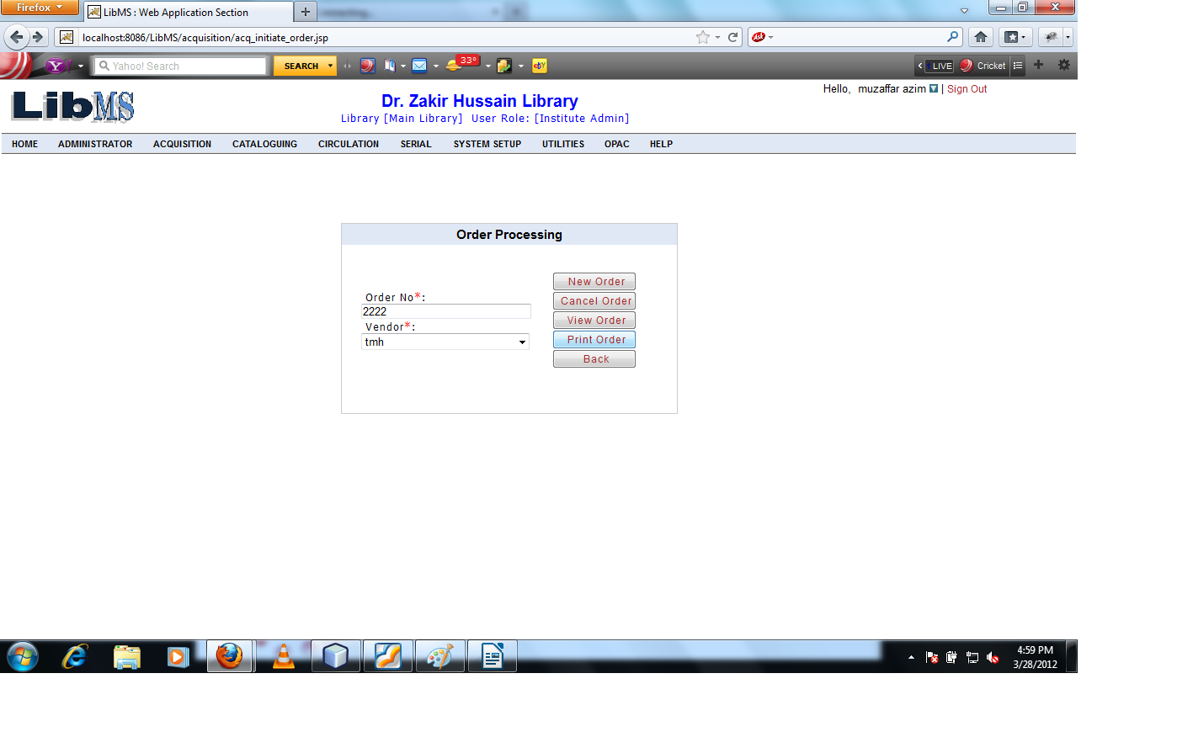
After clicking Print Order button.

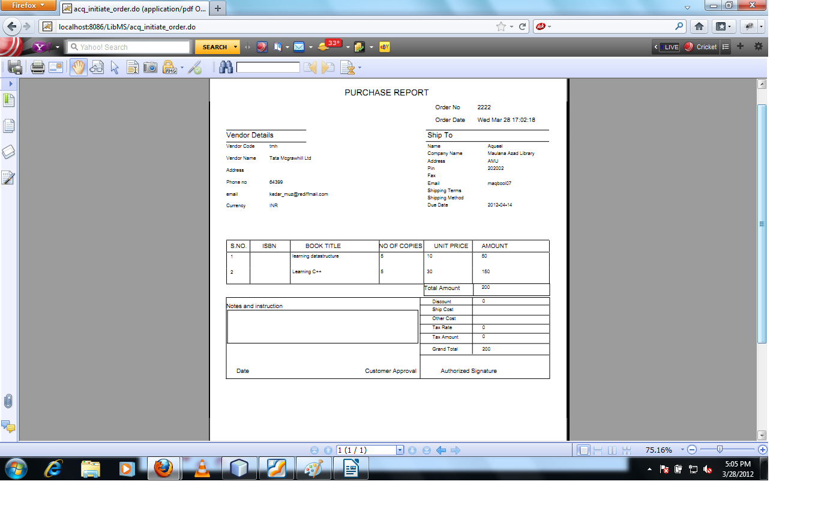
In this Activity Library Authority Receive the library materials.
Activity Name : Acquisition - > Receive Order

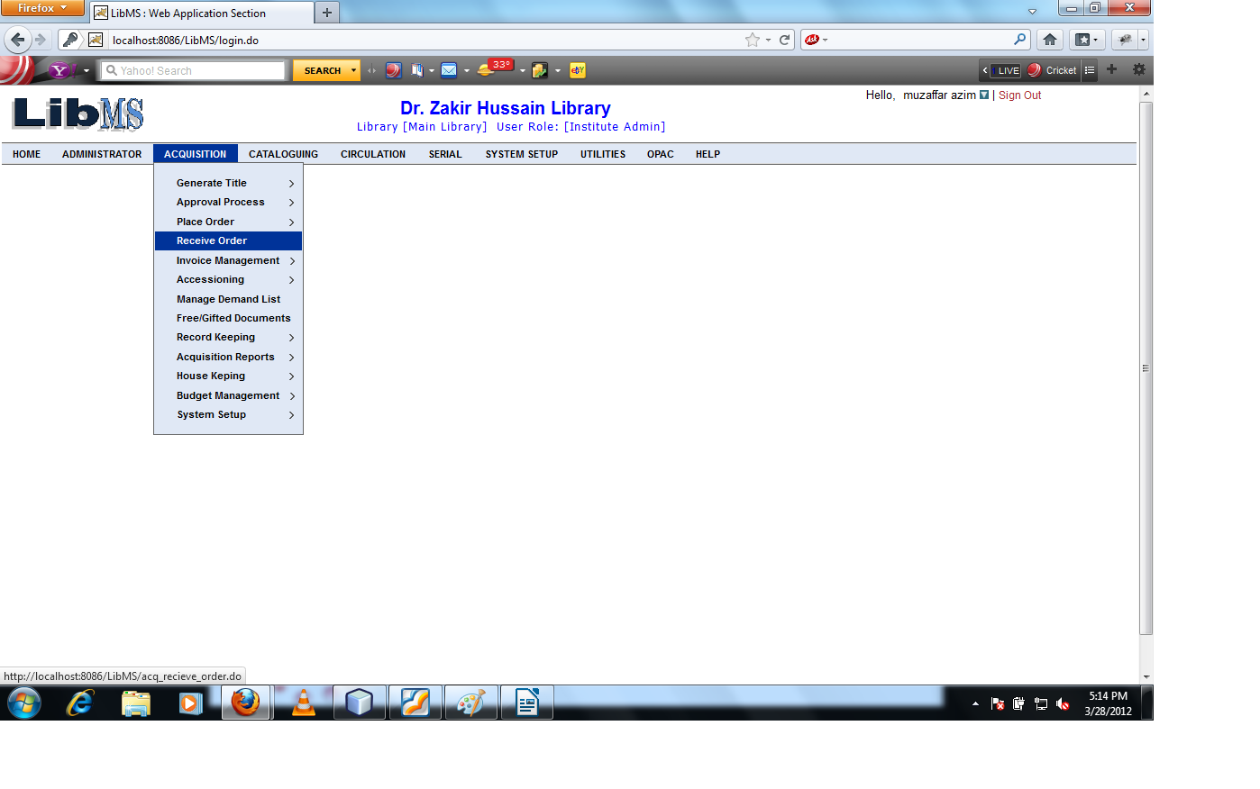
When we click on the Receive Order Link we have got following interface.

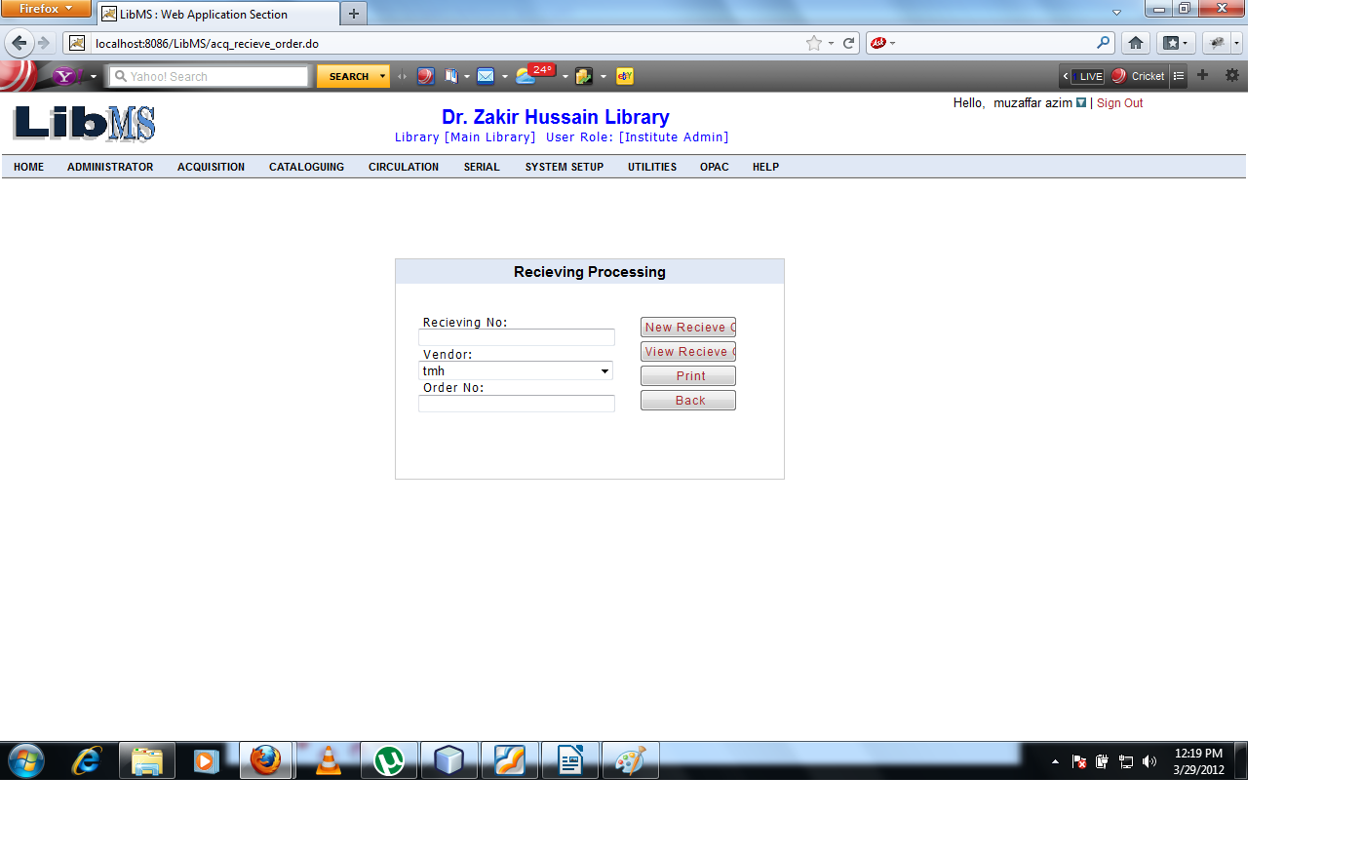
Enter the new receiving no,order no which are exist and, vendor id.
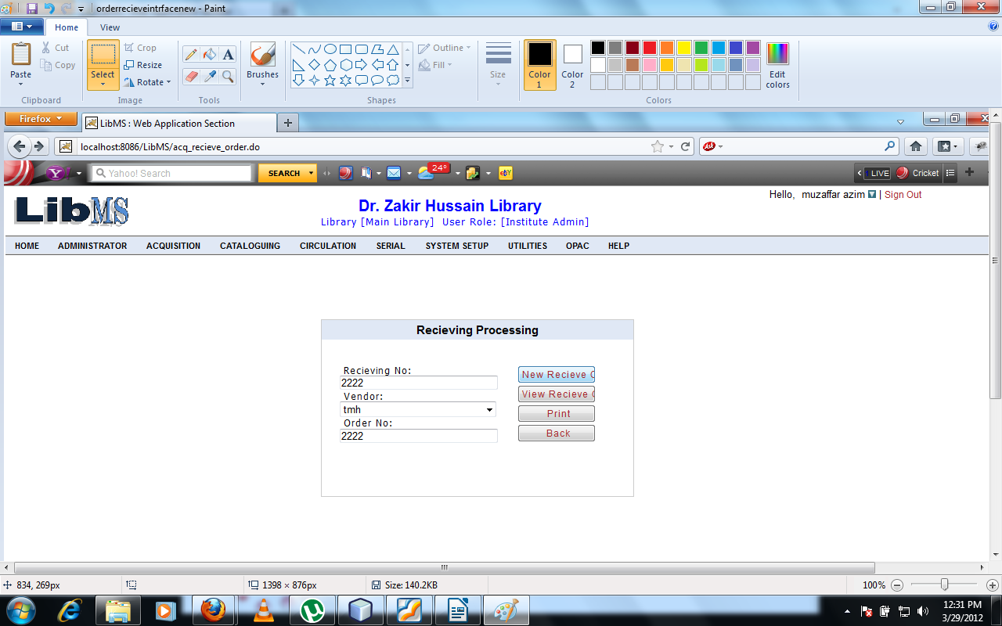
Click on New Receive Order button we have got the following interface. List of ordered list for receiving.
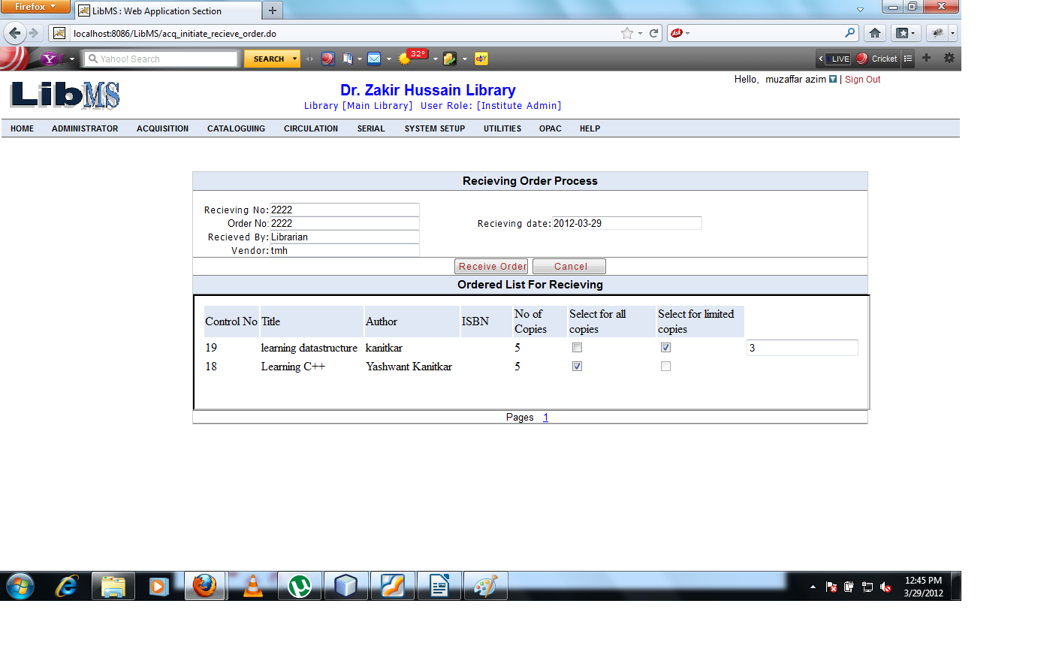
Click on Receive Order button we can receive the library materials successfully and forwarded to the first screen of receive order process with successfully Receive message.
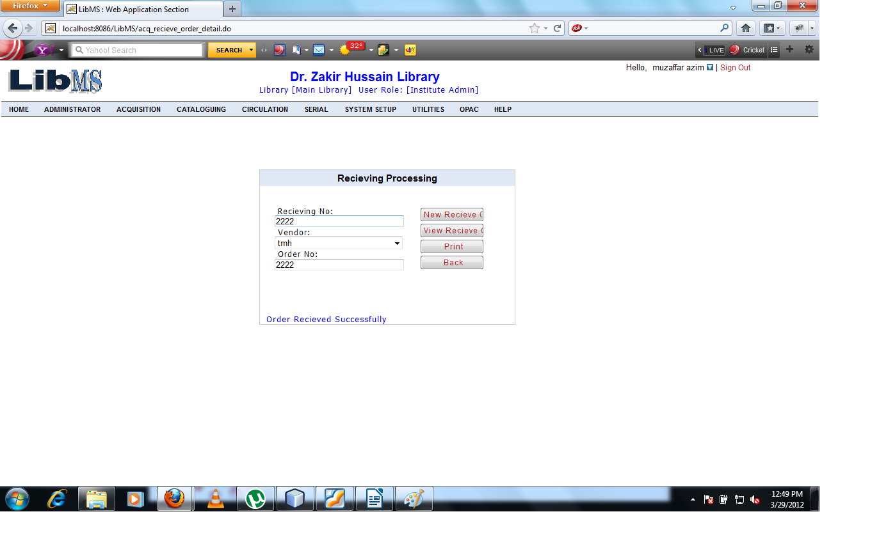
If we want to view the list of titles which are received enter the receiving no corresponding to their order no and vendor id.
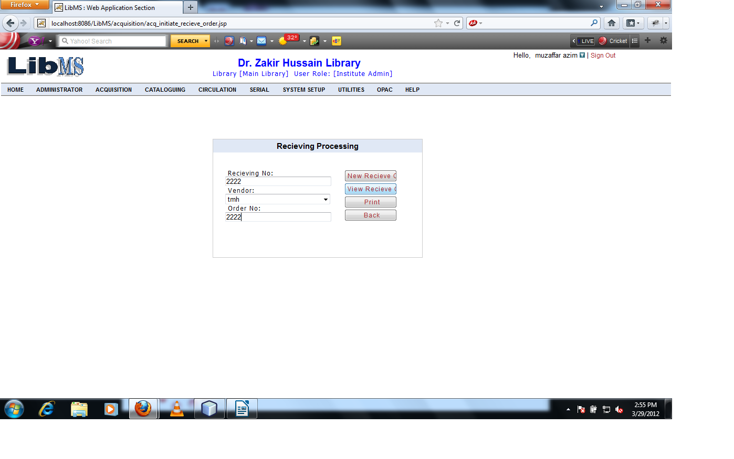
Click on View Receive button we can see the lists of titles which are received.
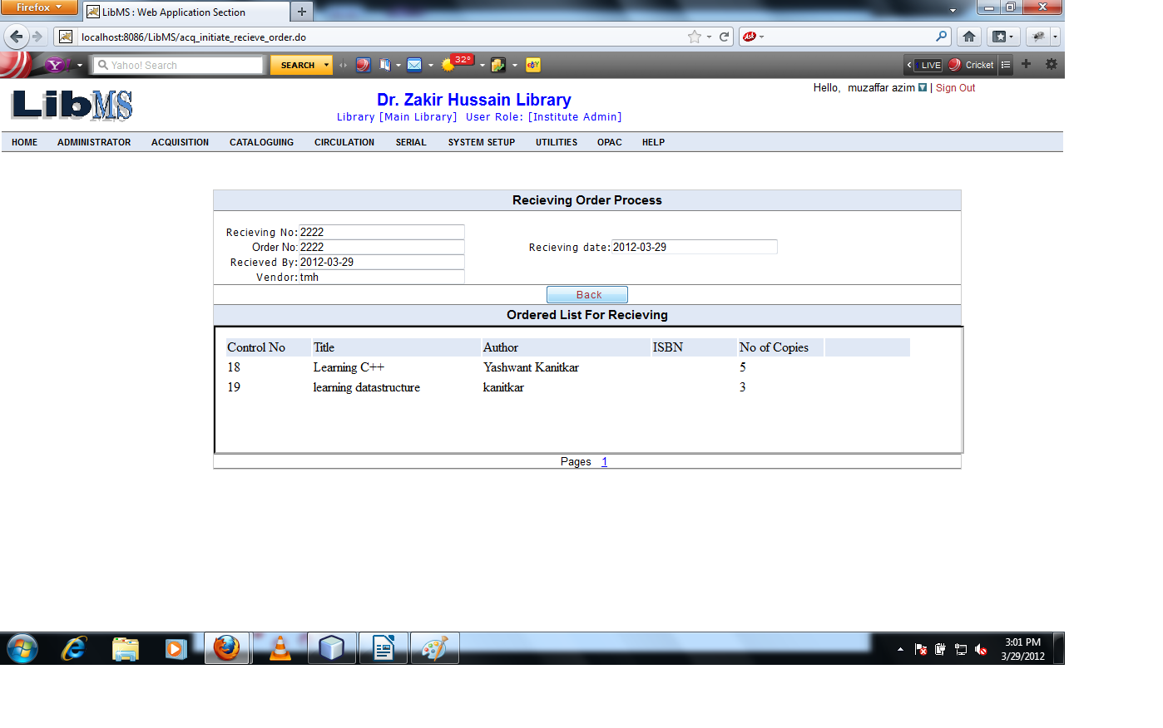

Clicking on back button forwarded to the first screen of receiving process.
Now if we want to take print of received list of titles enter the receiving no corresponding to their order no and vendor id.

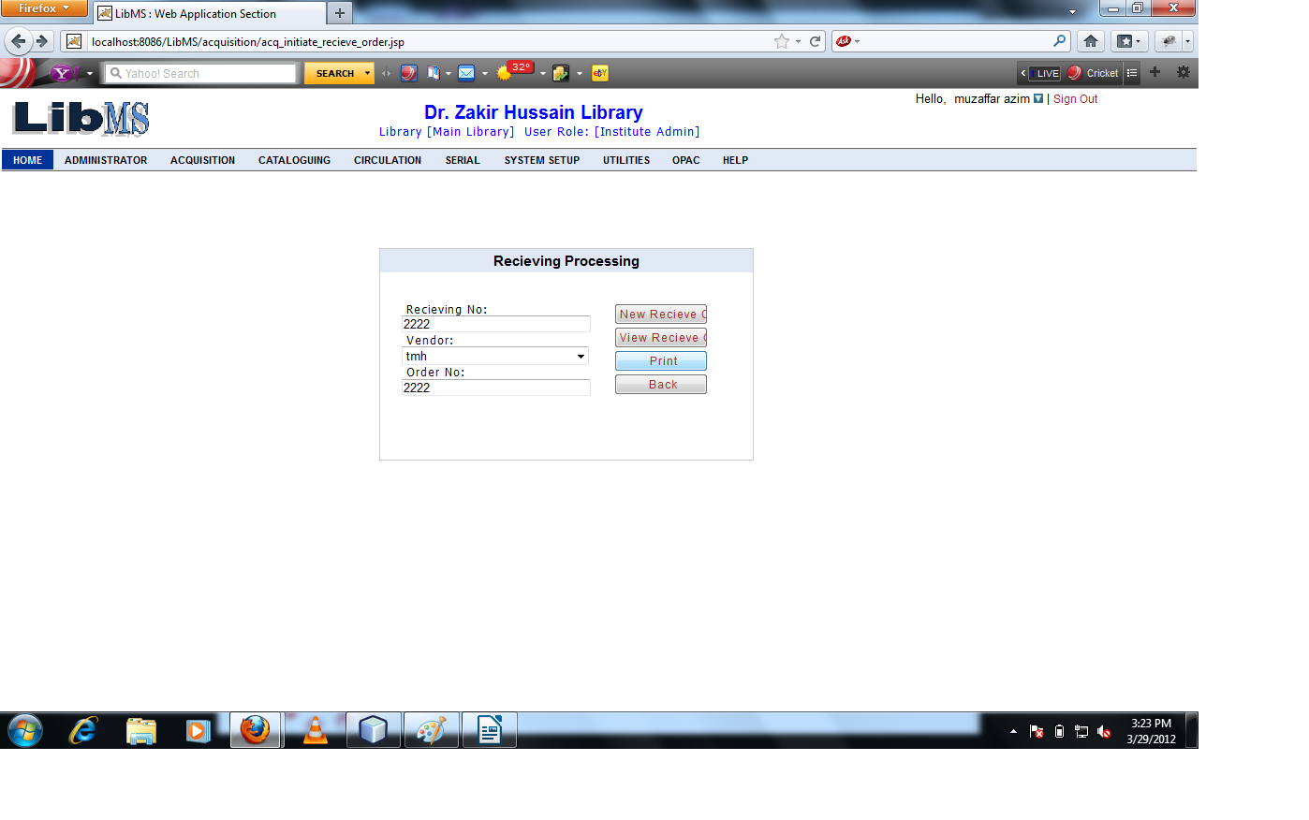
Clicking on Print button we have got the pdf of received order.

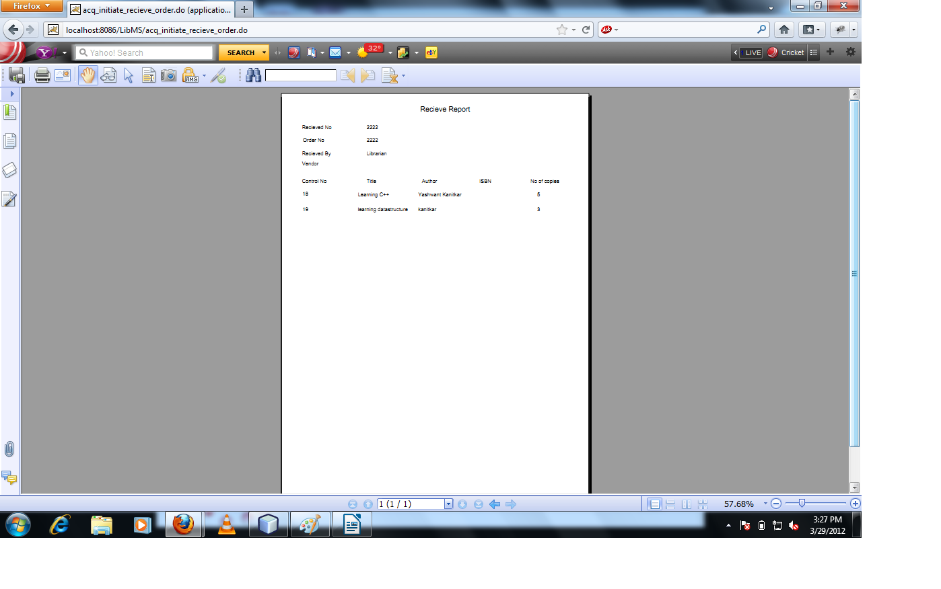

Budget Management of Acquisition Module.
In this Activity process we deal with the Budget Head,Budget allocation etc.
Come to the menu screen
Activity Name : Acquisition - >Budget Management - >Budget Head

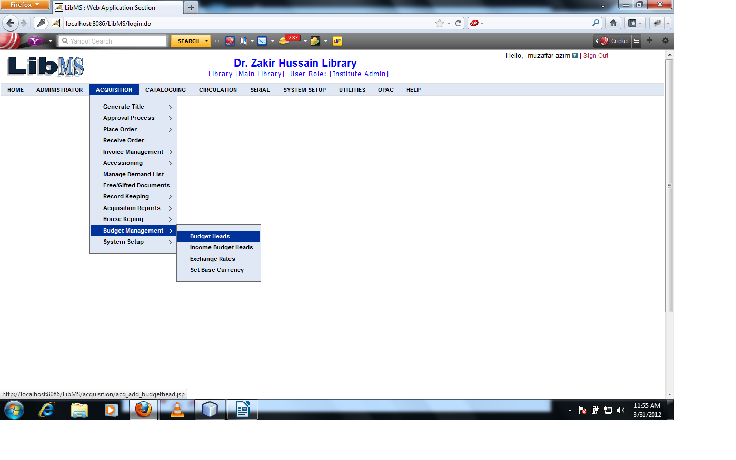

Clicking On Budget Head Link we have got following interface.
Creating Budget Head.
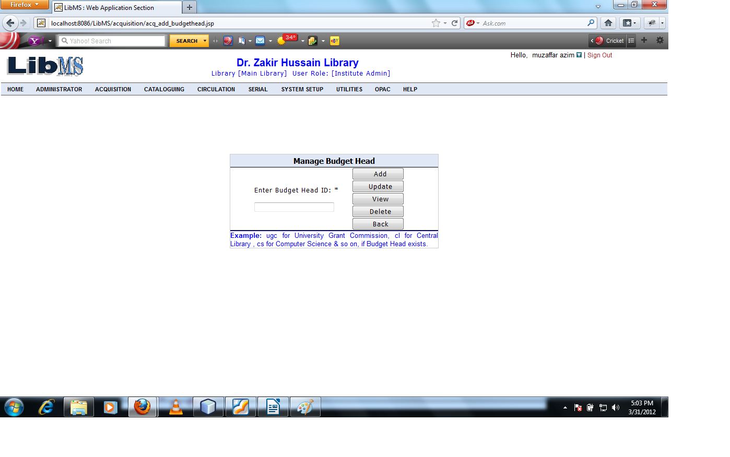

Entering the id of Budget Head like UGC for university grant Commission,CL for central library etc.
Clicking on Add button we have got following interface.

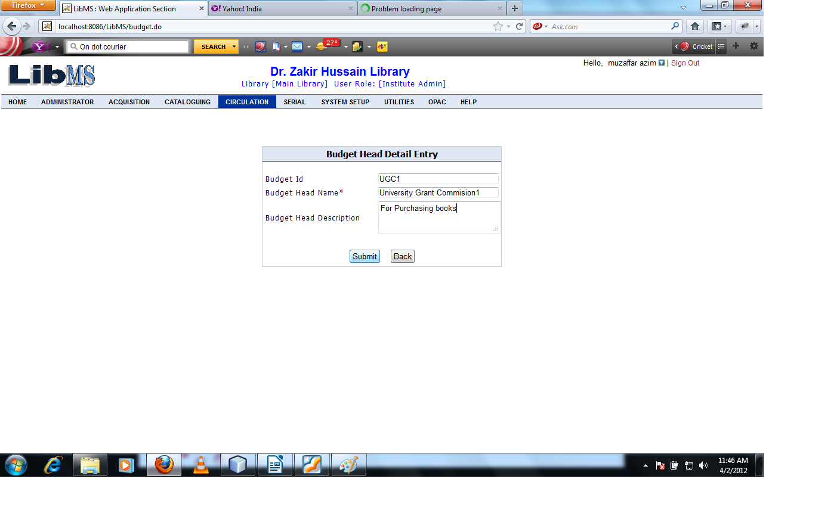

When we click on submit button we create budget head successfully and forwarded to the first screen with successfully budget head created message.
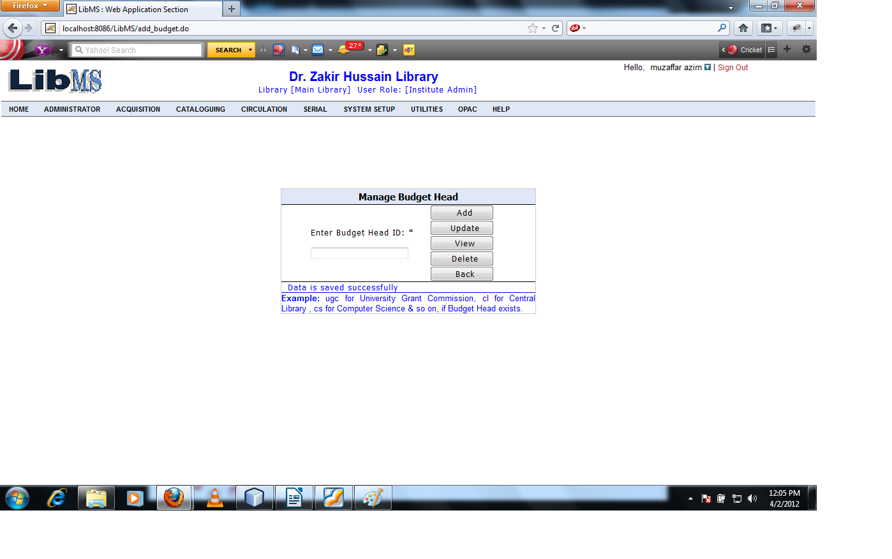

Now if we want to modify the existing budget head enter the budget head id and Clicking on Update button.
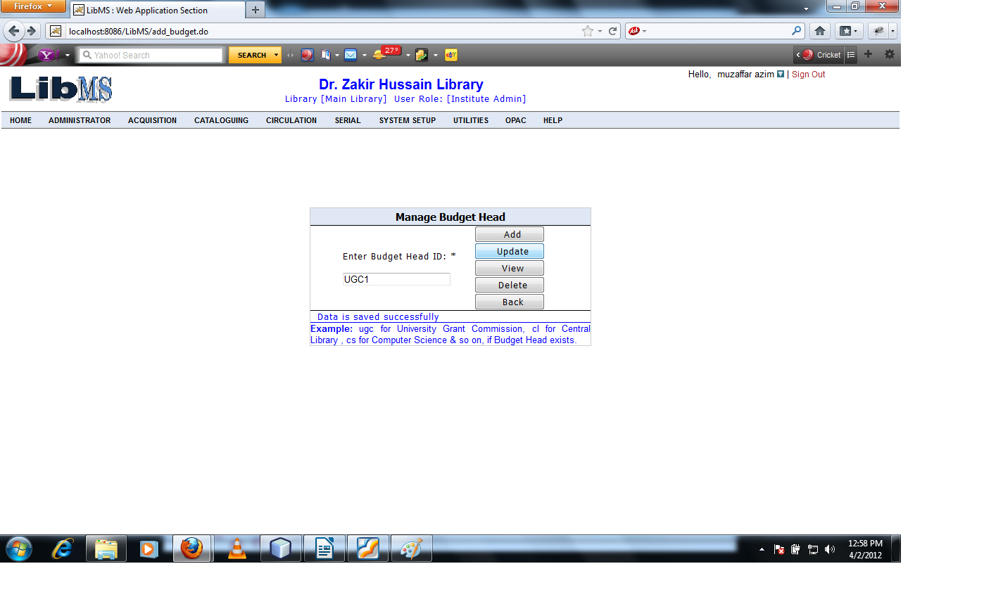
Click on Update button we have get the following interface.

Click on Update button we have got following interface.

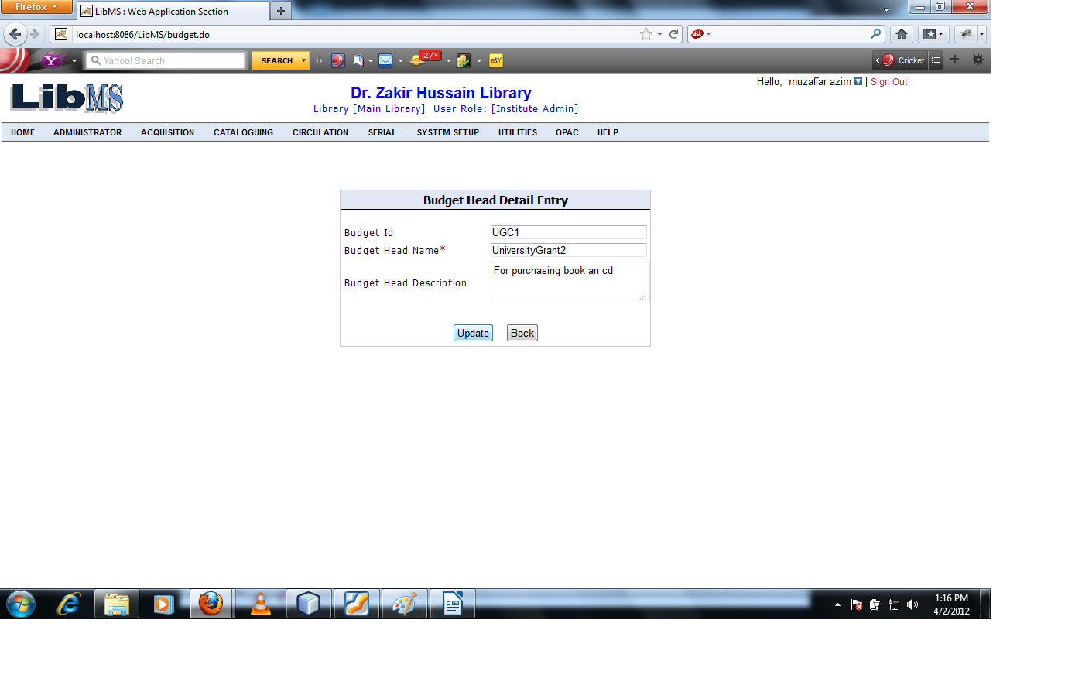

Clicking on Update button record is updated successfully and forwarded to the first page.
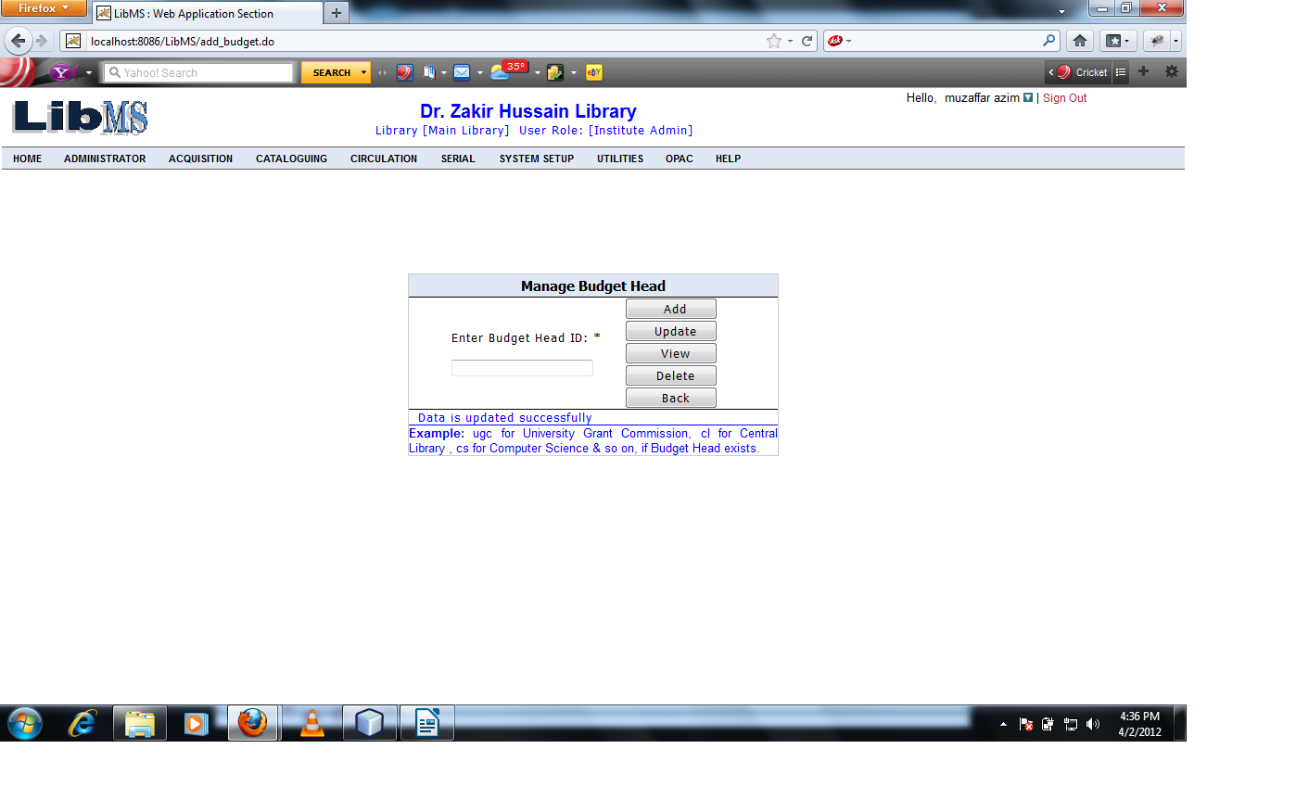

If we want to view the details of existing budget head then enter the budget head id and click on View button.
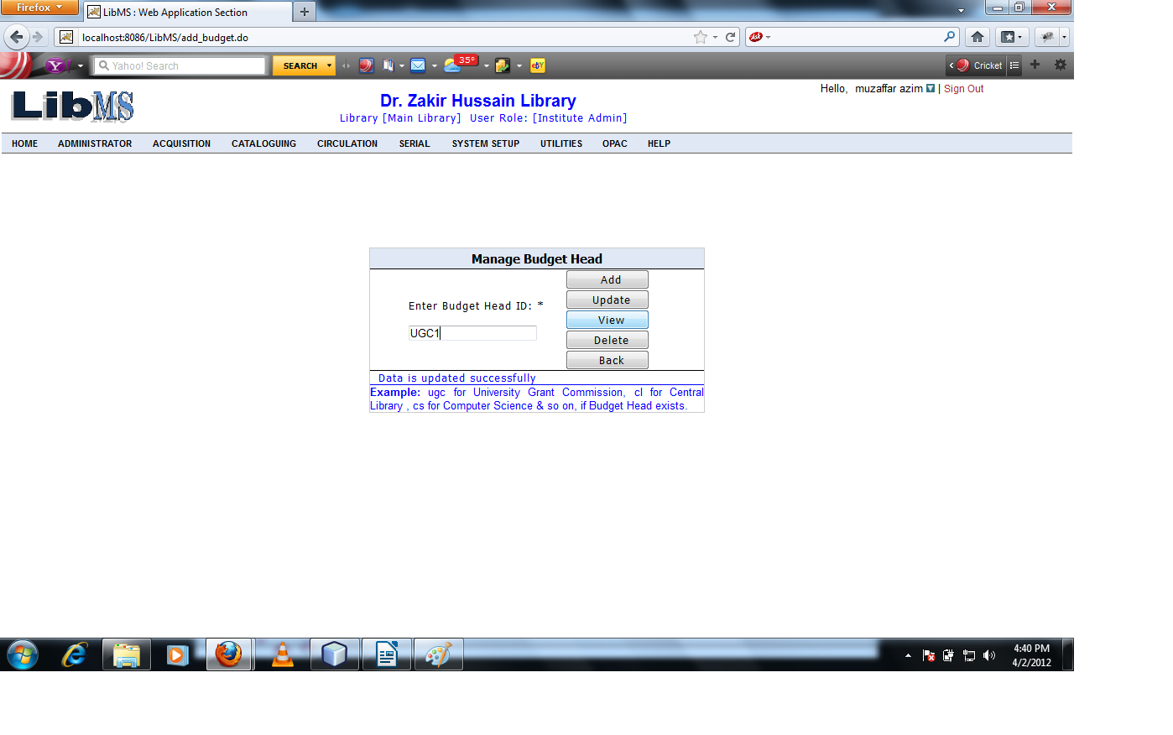

After clicking on View button we can see the details of the existing budget head .
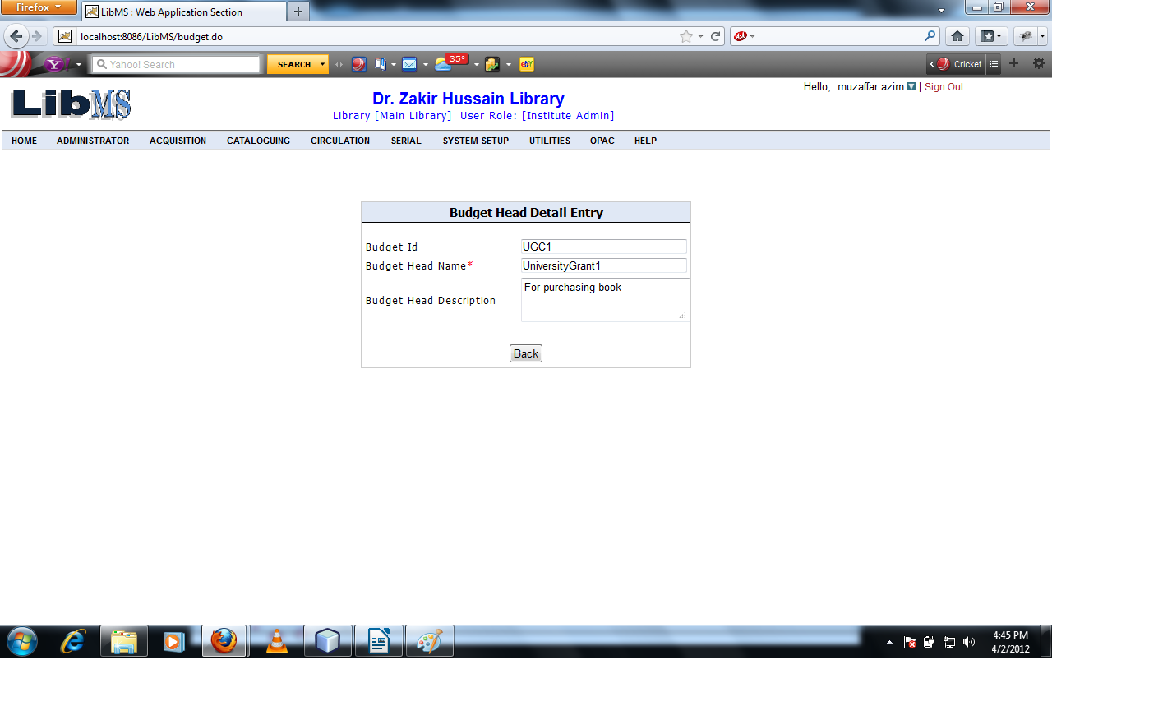
Clicking on Back button redirect to the previous screen.

If we want to delete the record of the existing budget head .Then enter the budget head id and Click on Delete button.
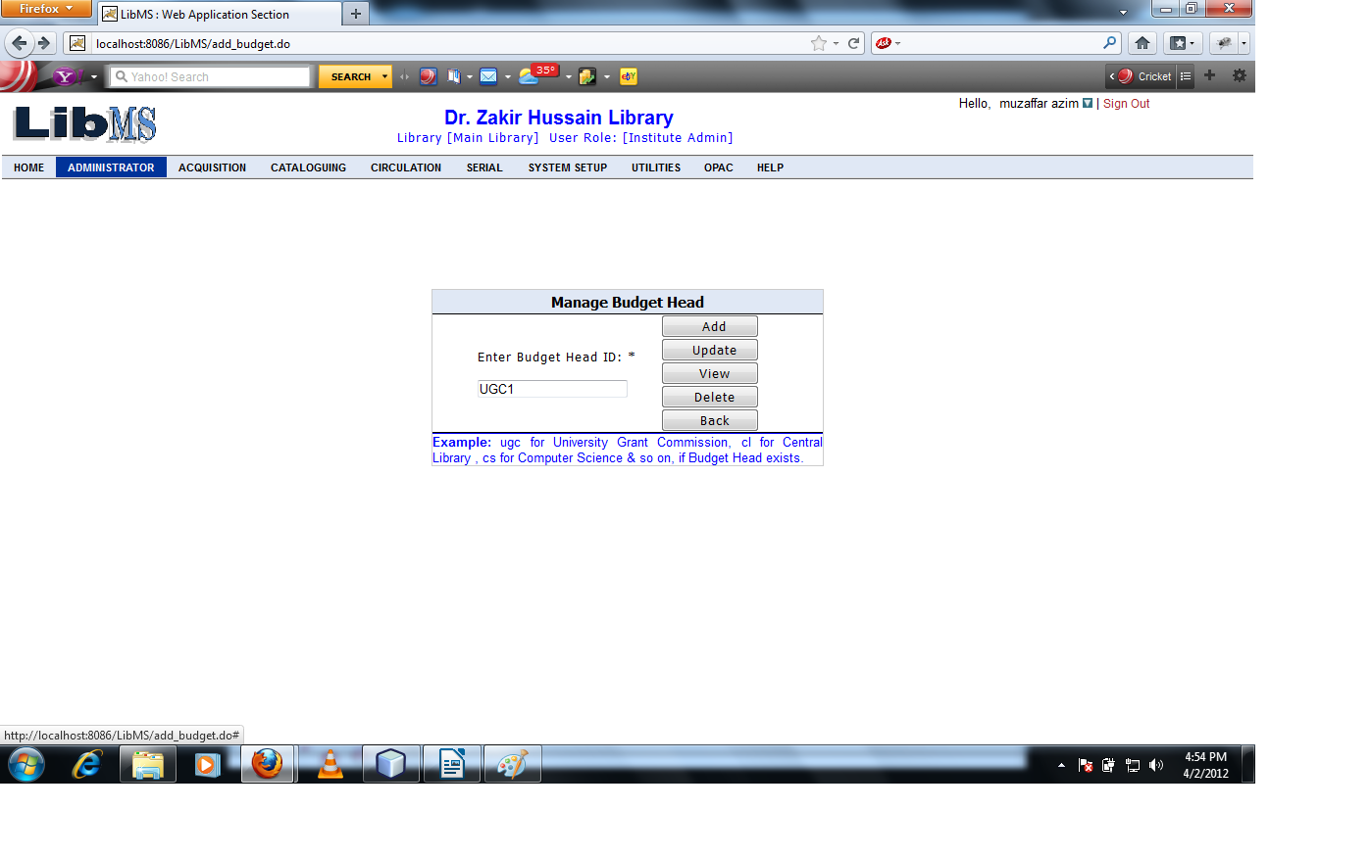

After Clicking on Delete button we have got the following interface.
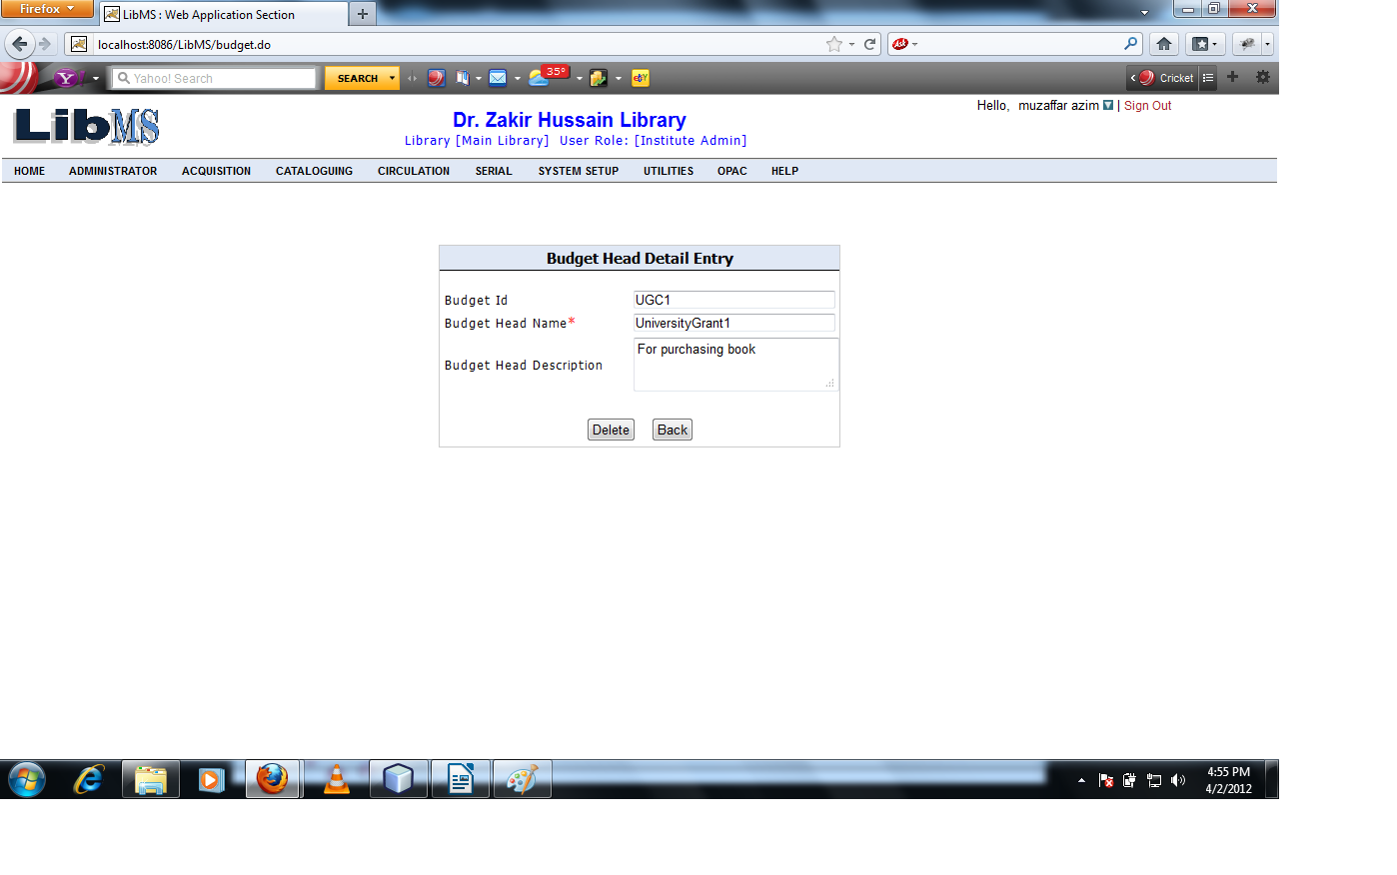
Clicking on Delete button warning message display.
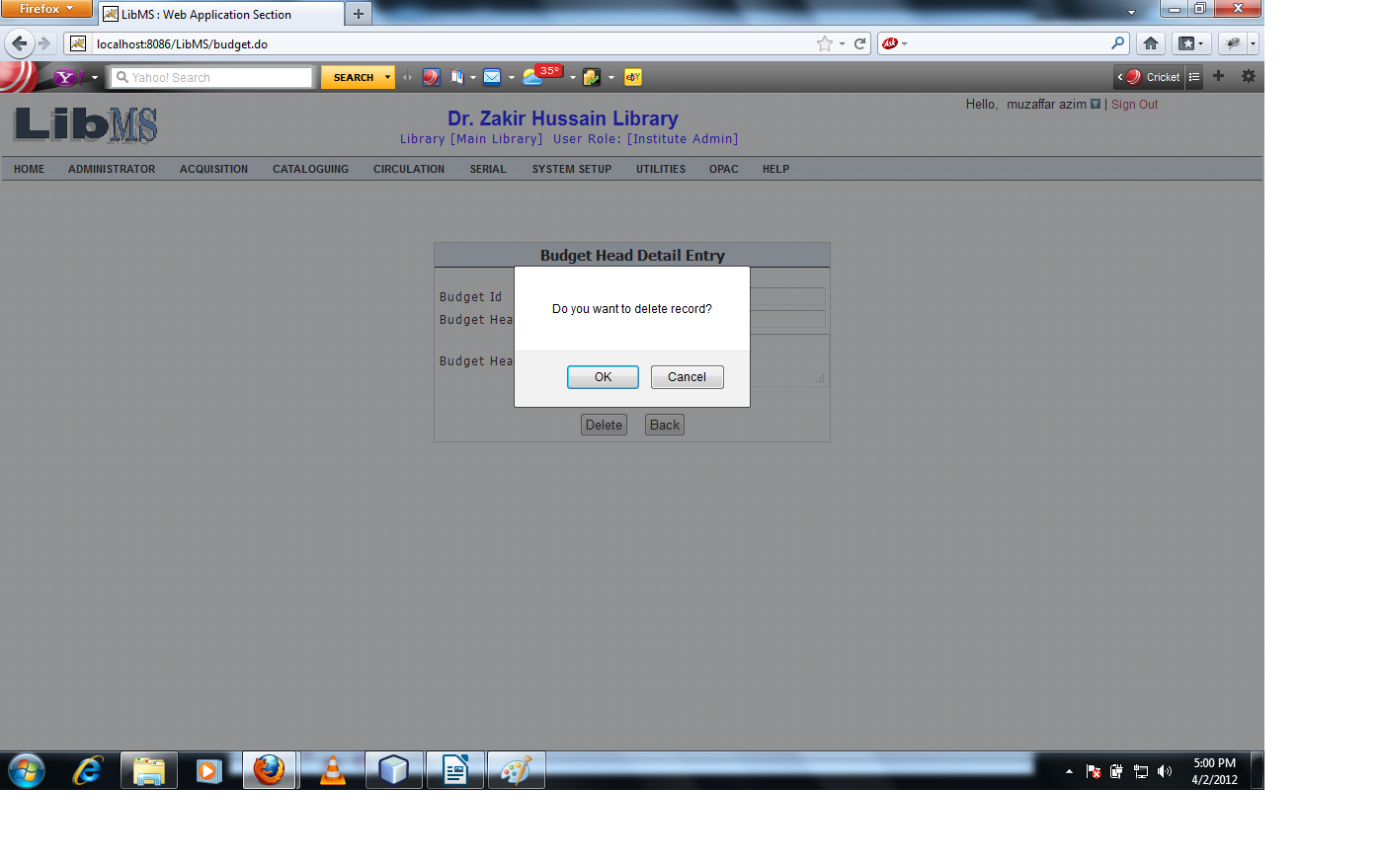
Click on Ok button record is deleted successfully and forwarded to the previous screen.
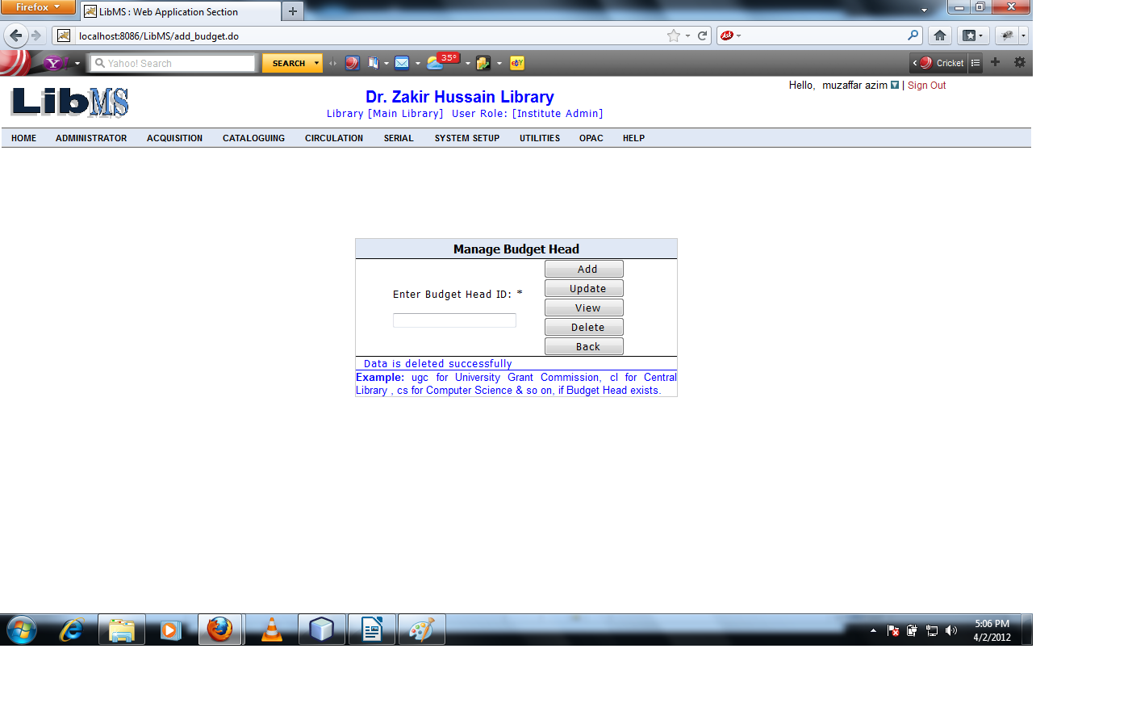

Income Budget head means the amount of money is granted to particular budget head for purchasing books for that financial year.
Activity Name : Acquisition - > Budget Management - > Income Budget Head

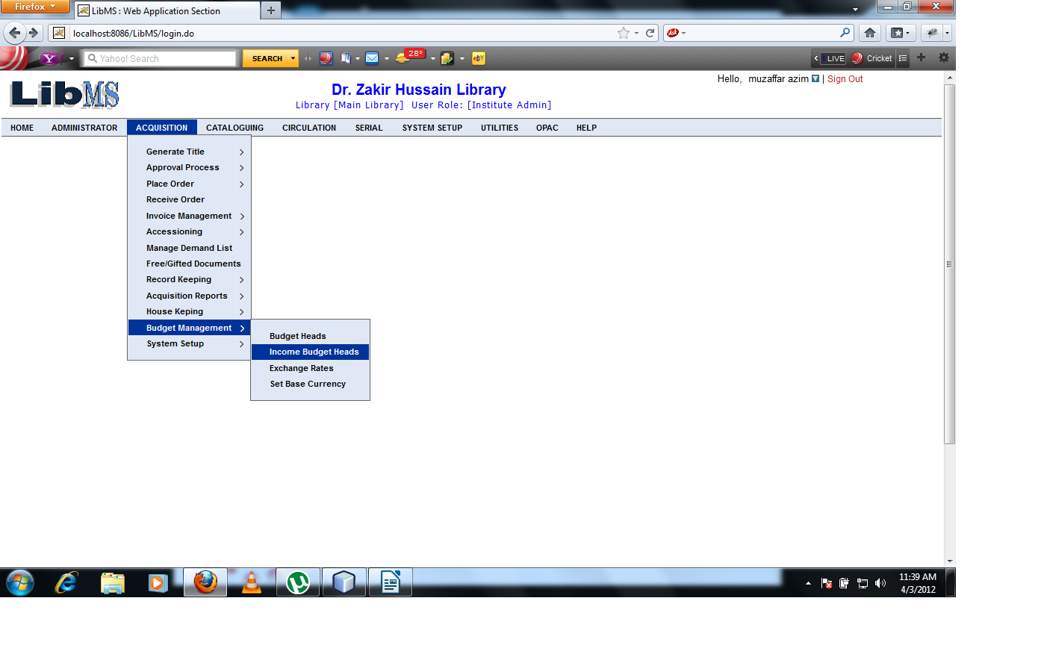

When we Click on Income Budget Head Link we have got following interface.
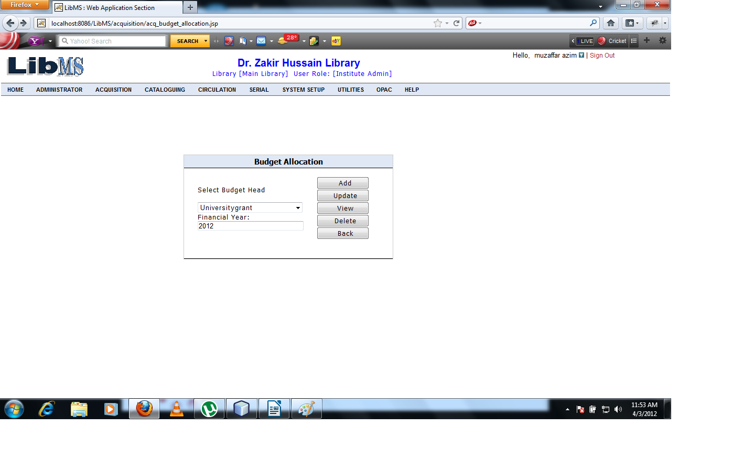

After entering the Budget Head name and financial year and Click on Add button we have got the following interface.
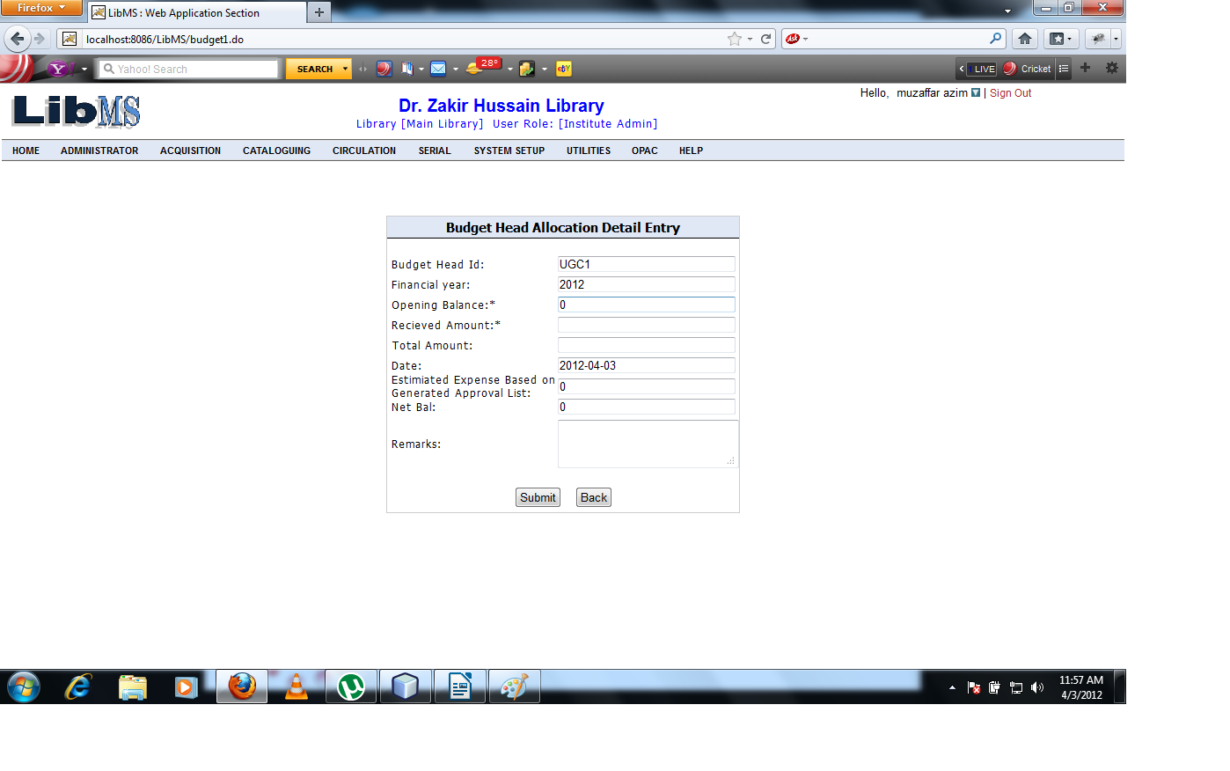

Opening balance means the amount of funds remains in the previous year. Enter the Received Amount.
We have got the following interface.
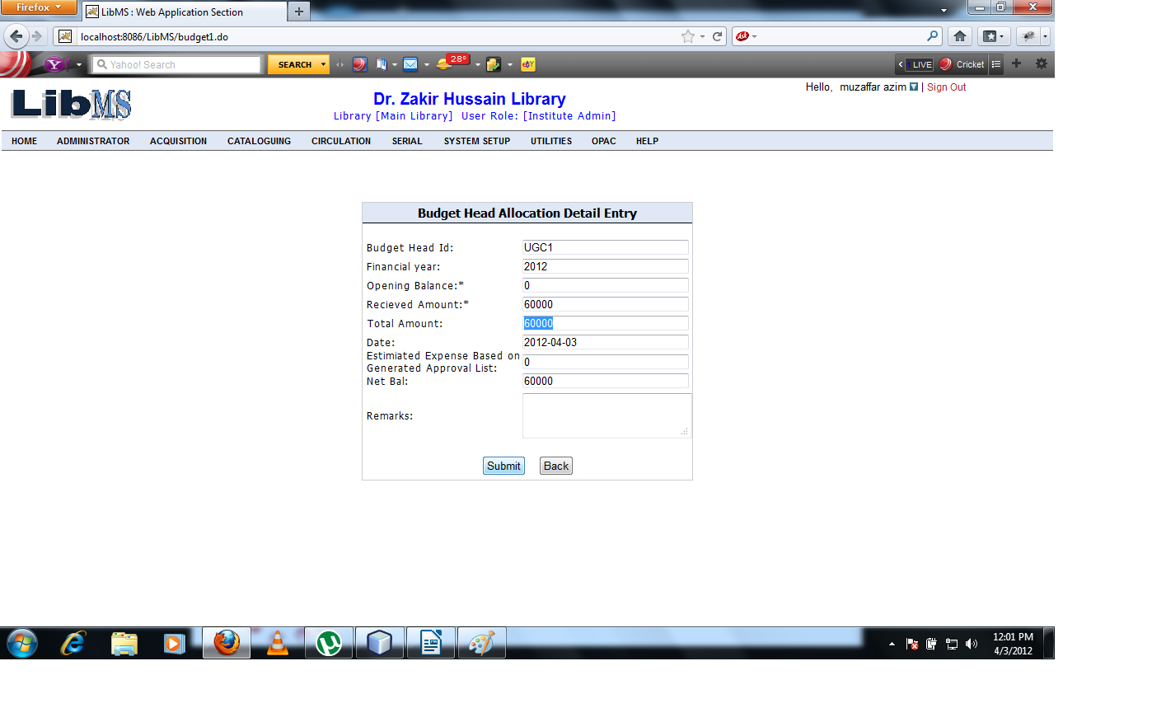
Modify the record and click on Update button.
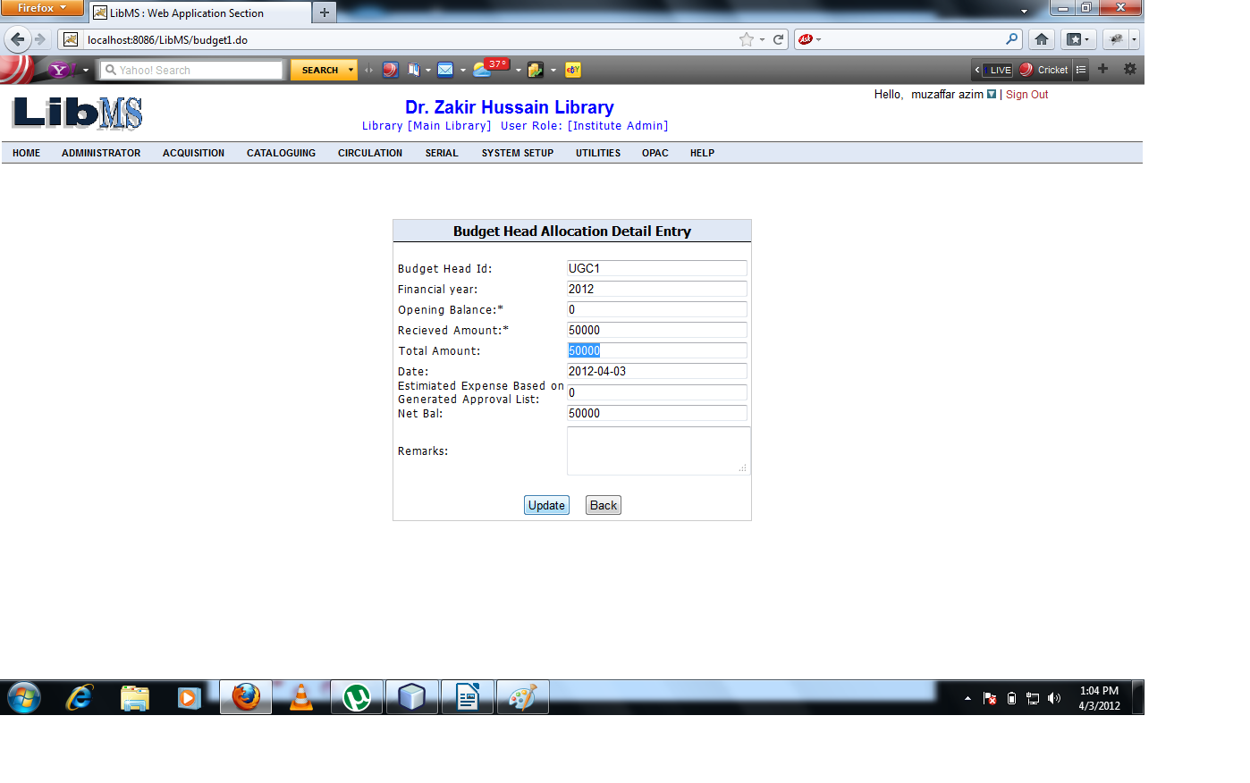

Click on Submit button budget allocated to this financial year successfully and forwarded to the first screen.
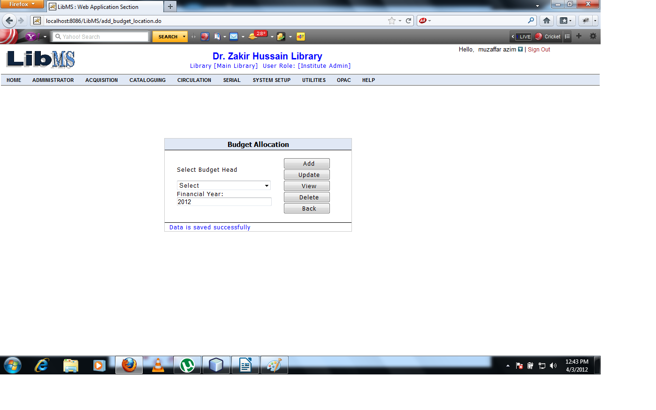
Now if we want to modify the record of the existing budget allocated to the particular Budget Head.

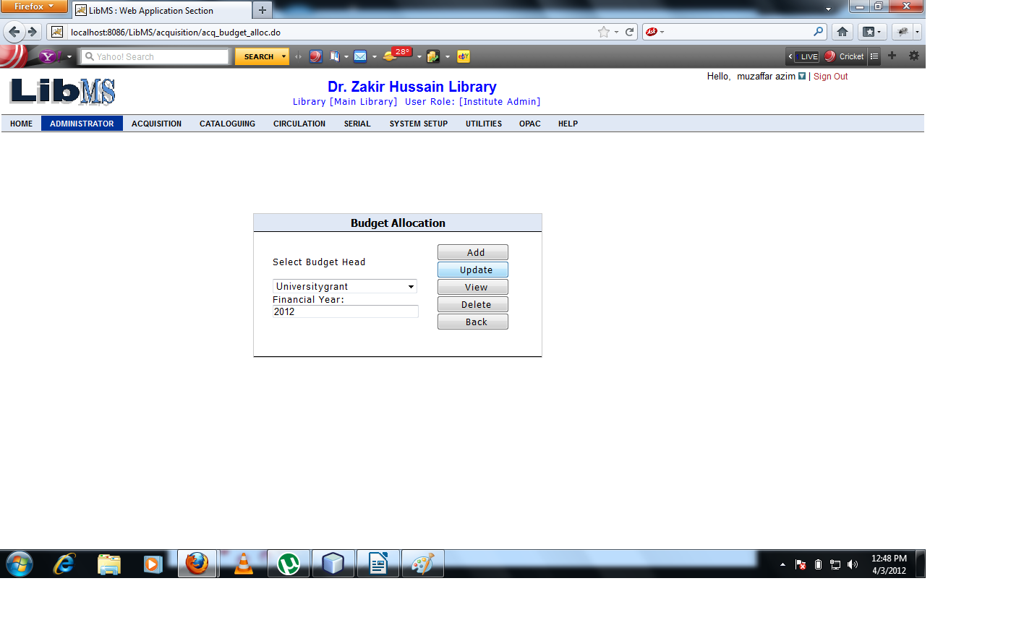

Enter the budget head name and Financial year Click on Update button we have got the following interface.
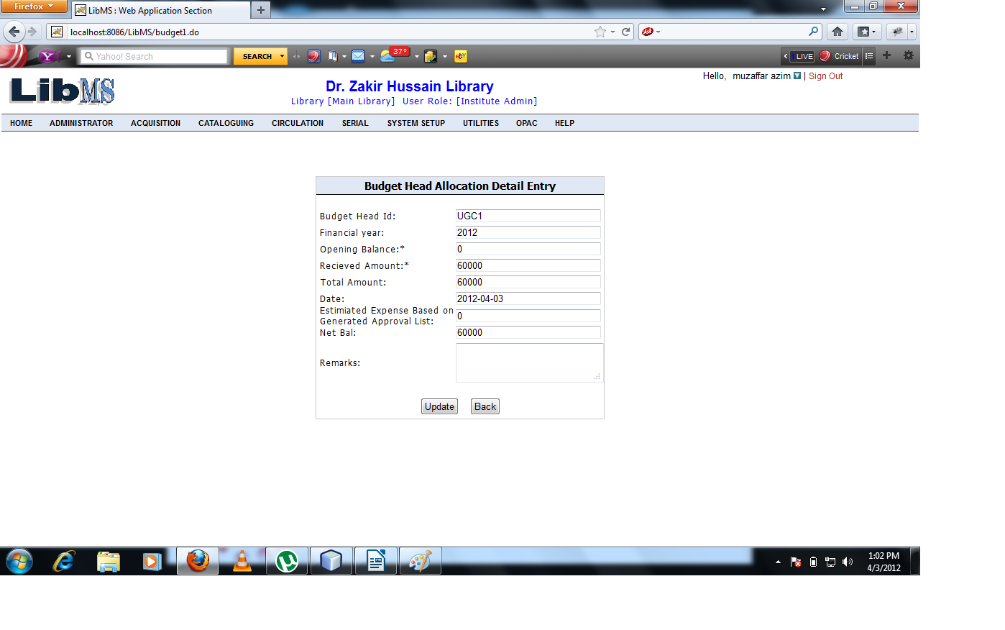
Modify the record as shown below.

On clicking Update button record is modify successfully and forwarded to the first screen.
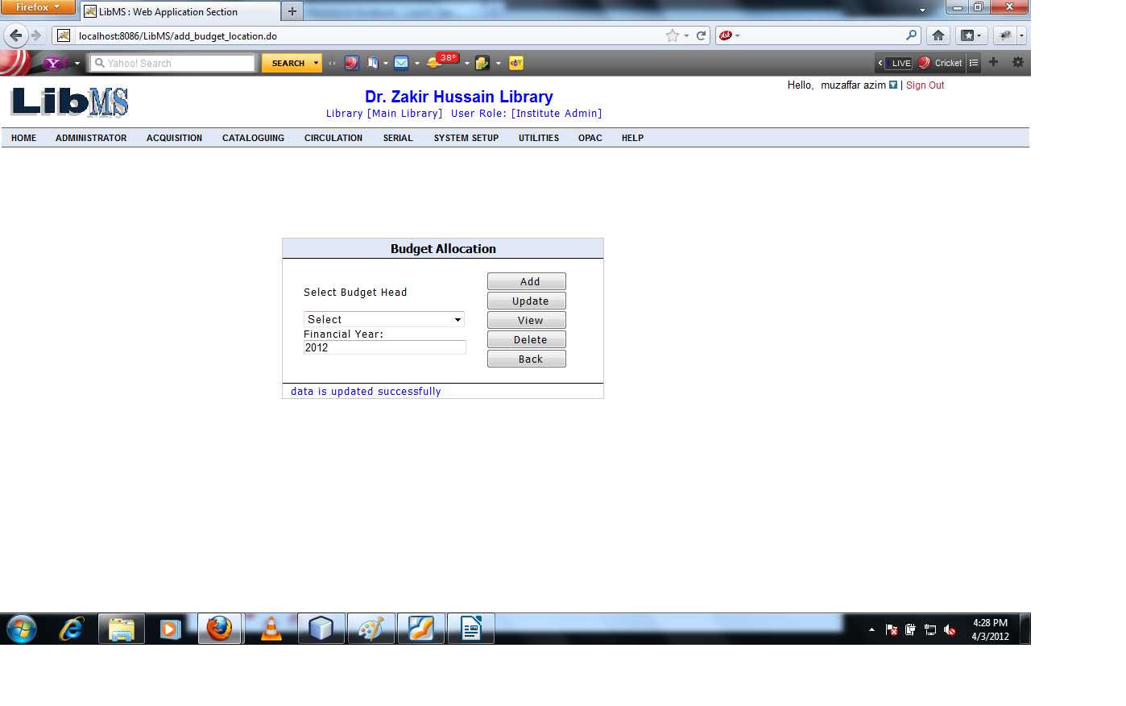

If we want to see the record of existing budget allocation. Enter the budget head and select financial year click on View button.
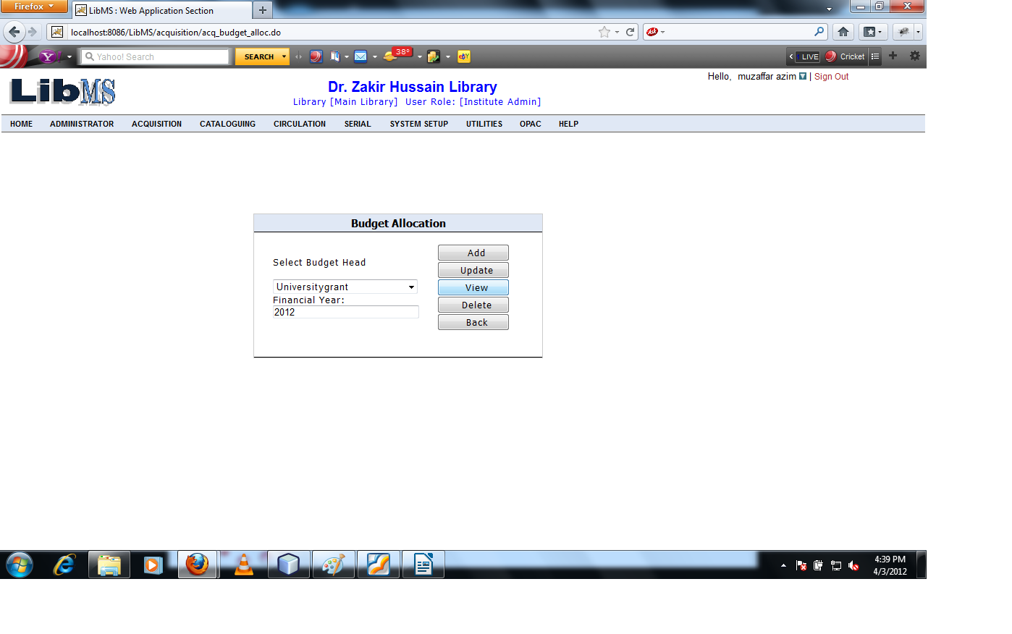

Clicking on View button we can see the record of existing budget allocation.

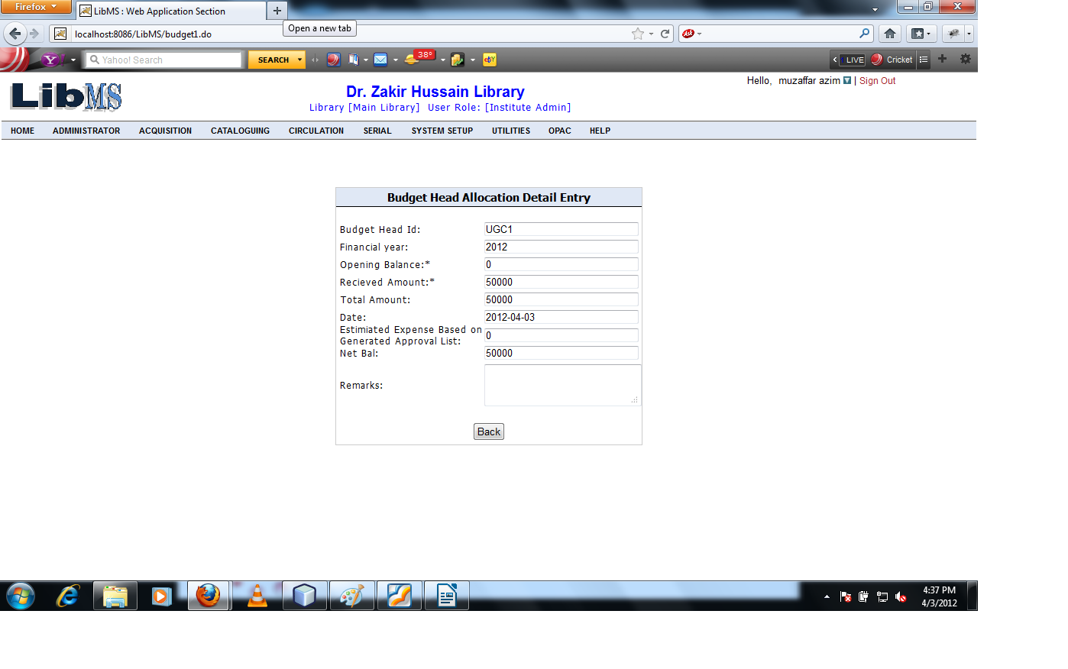
Clicking on Back button refer to previous page.

Now if we want to delete the record of existing budget allocation. Enter the budget head name and financial year click on Delete button.
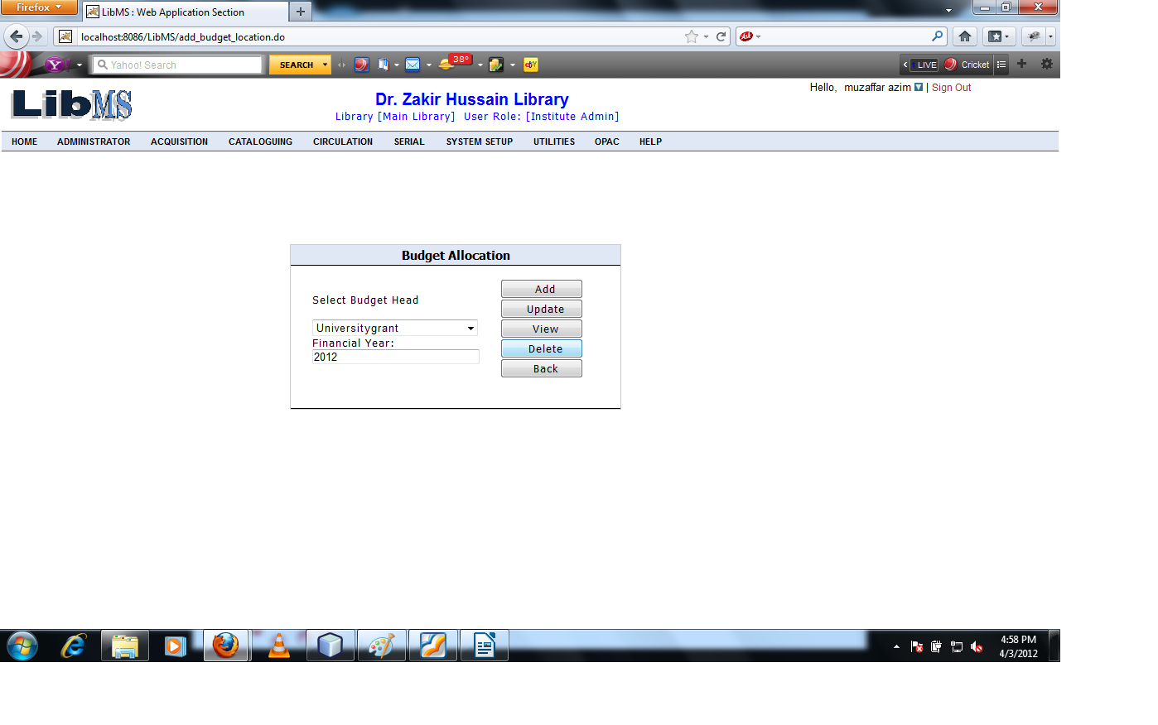

We have got the following interface.
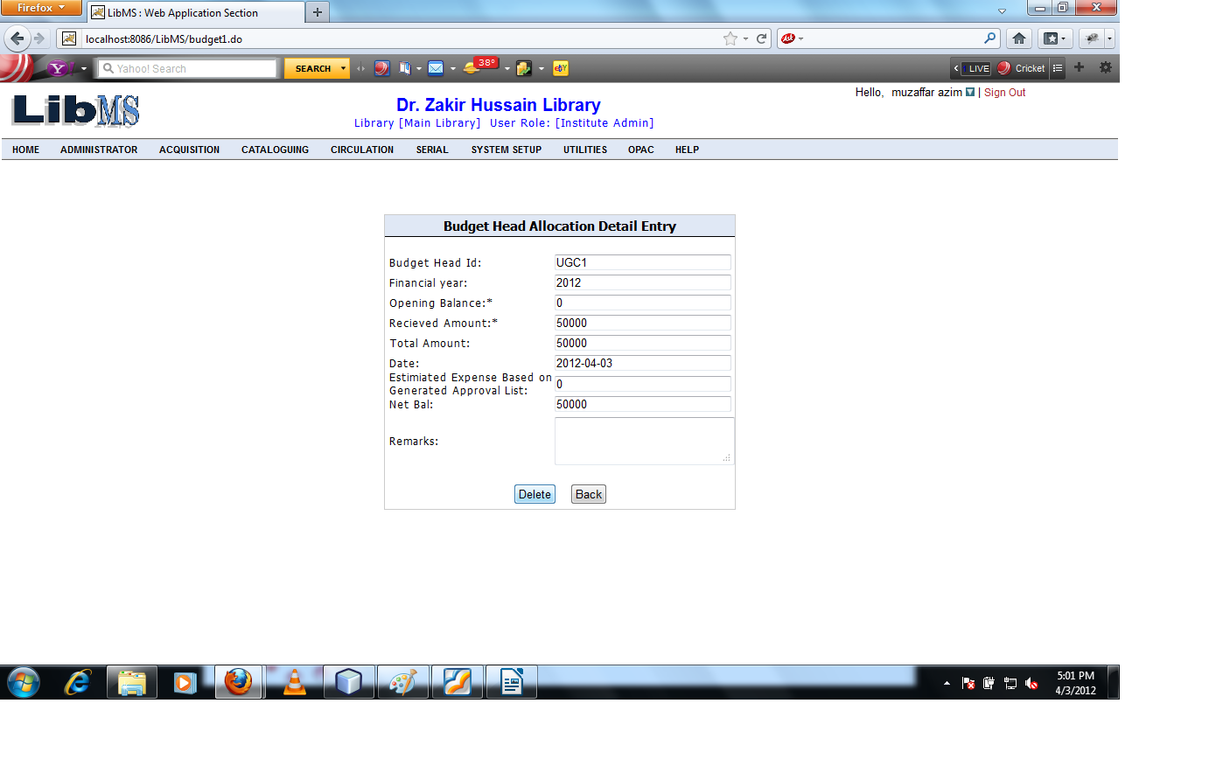

Click on Delete button warning message shown.

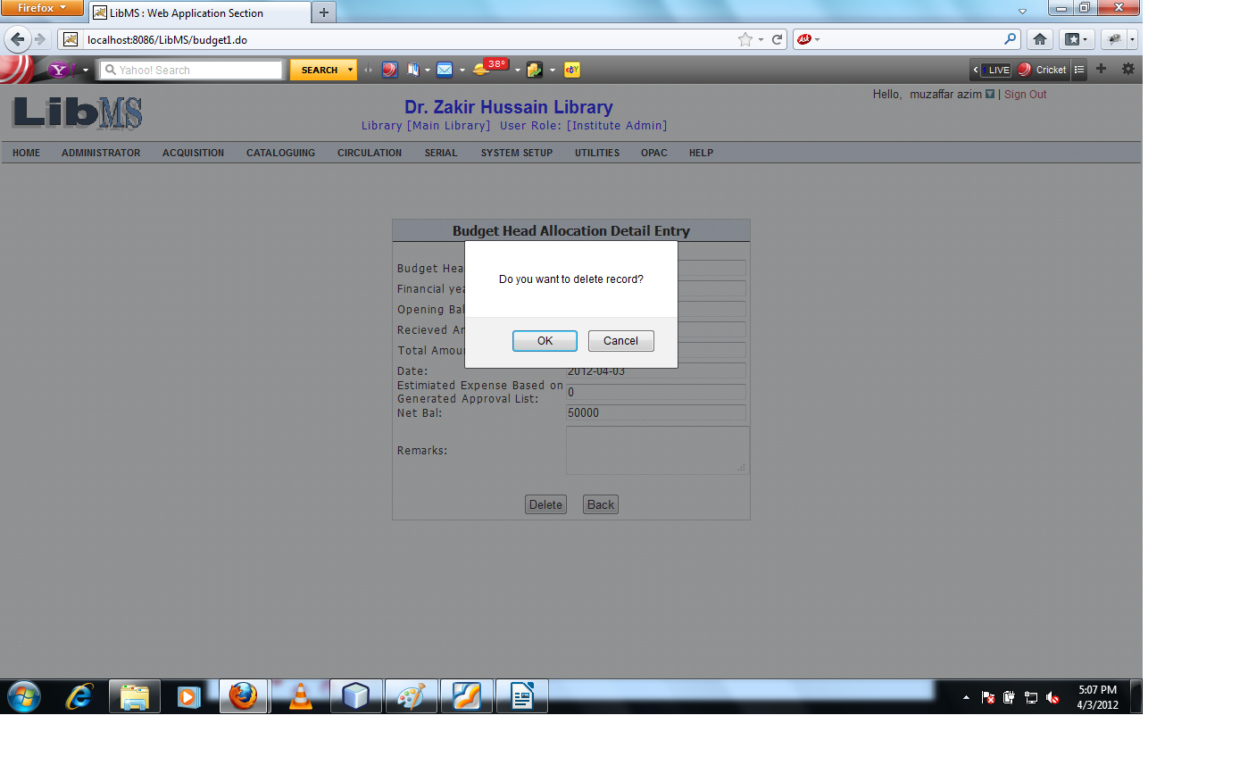

Click on Ok button record is deleted successfully and forwarded previous screen.

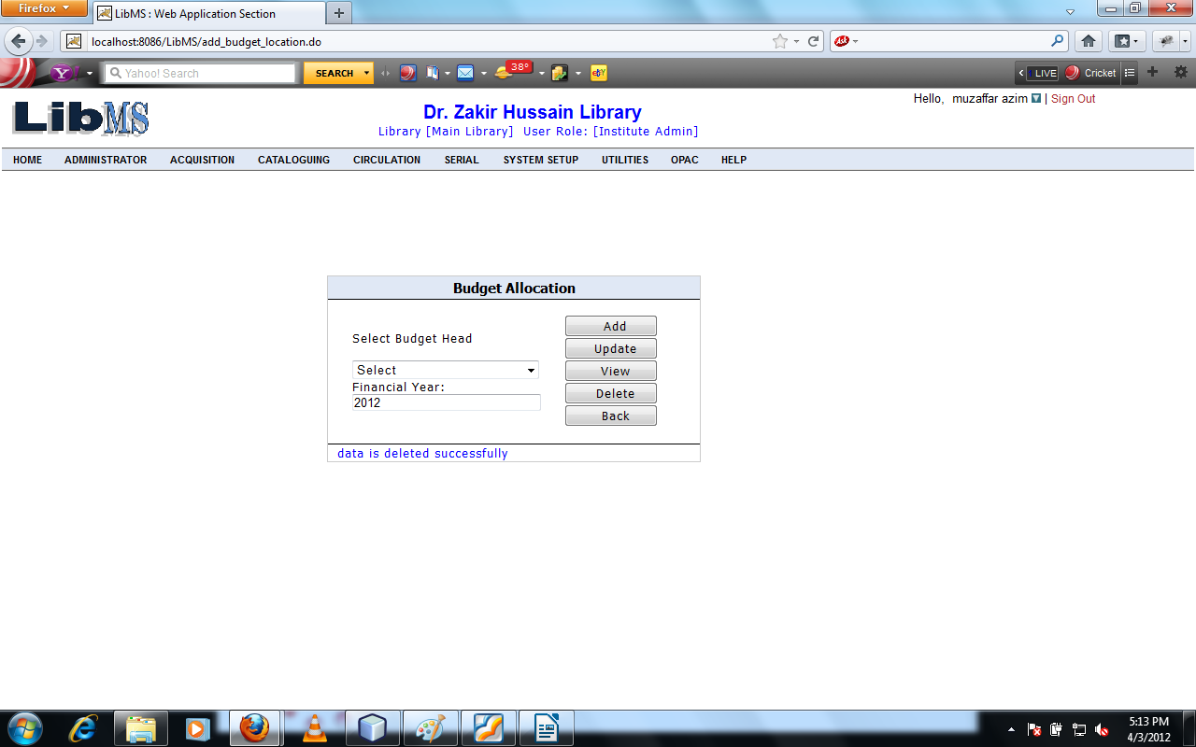

Exchange Rates in this activity user can convert the currency value with the library base currency.
Activity Name : Acquisition - > Budget Management - > Exchange Rates

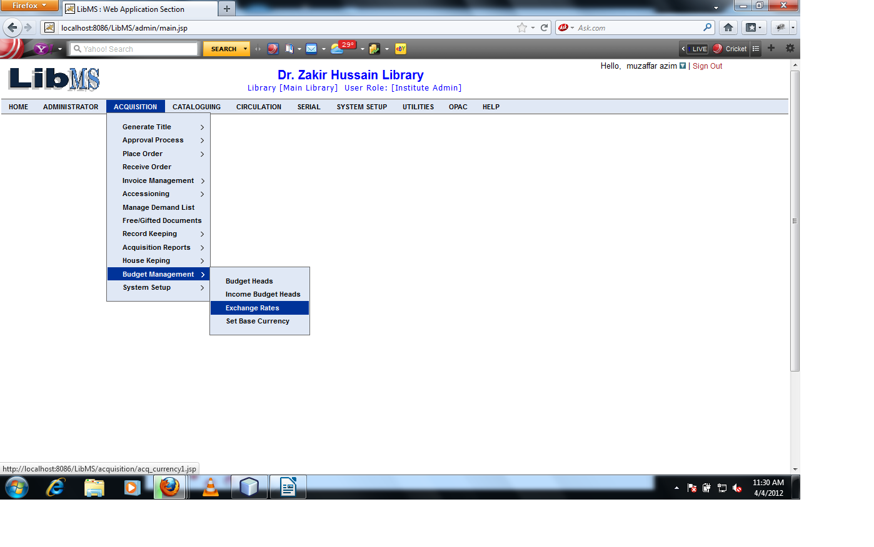

Clicking on Exchange Rates link we have got the following interface.

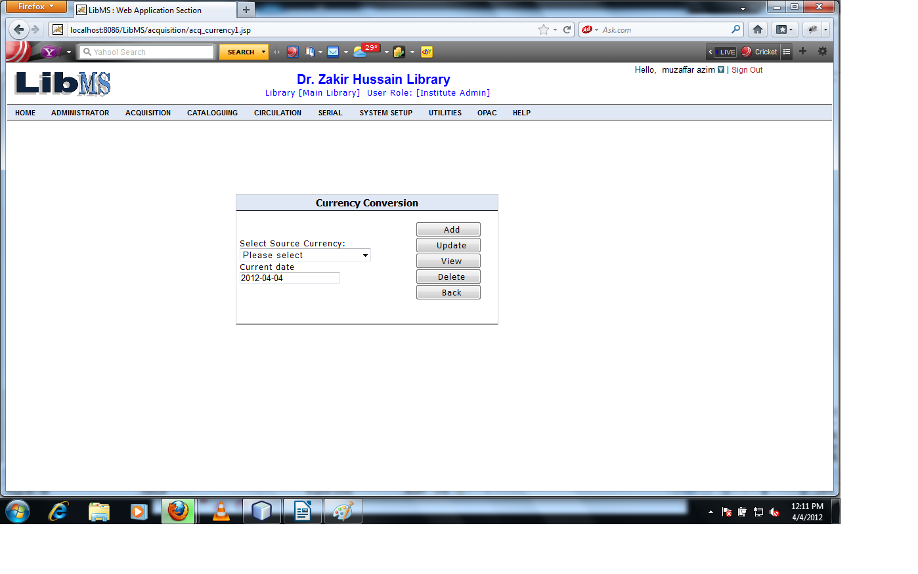

Select the Source Currency and select the currency date.
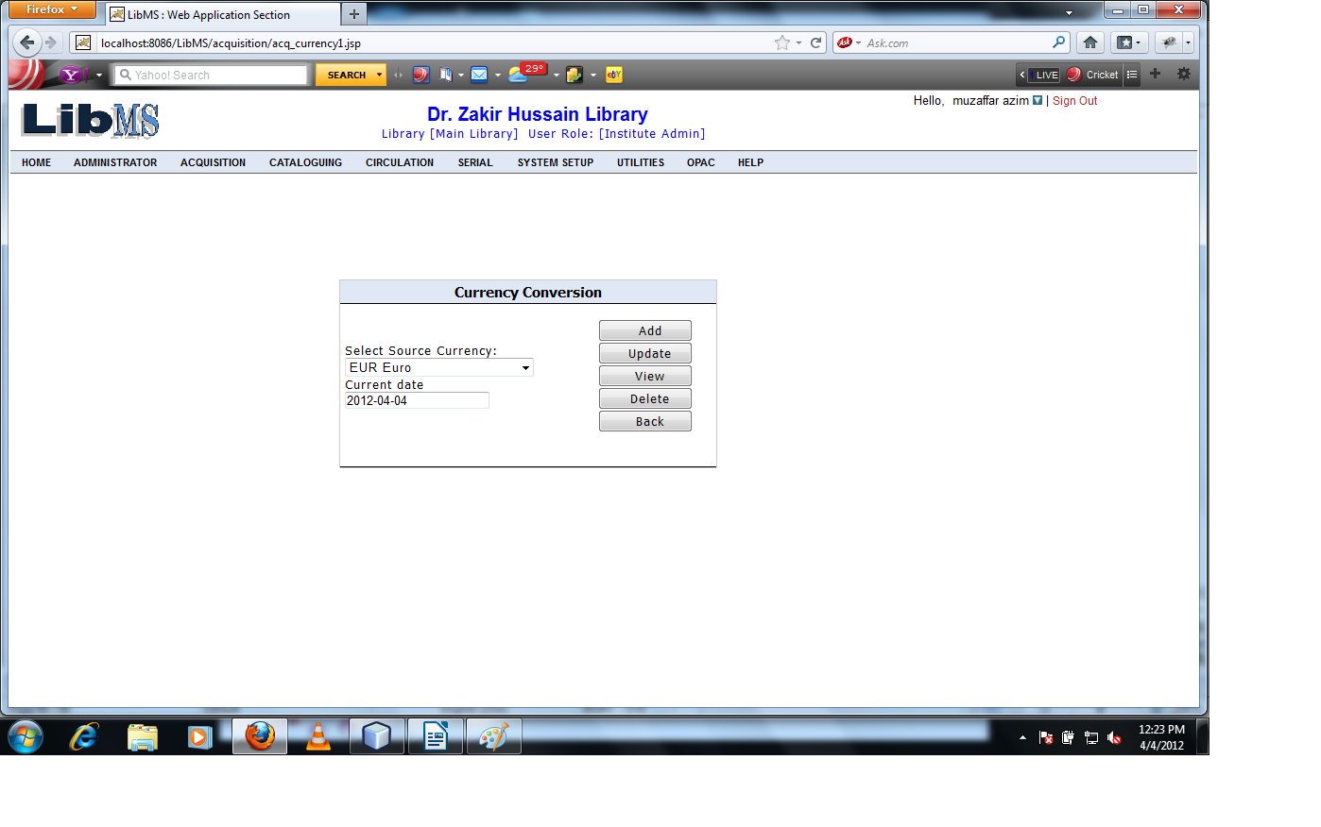
Click on Add button we have got the following interface.
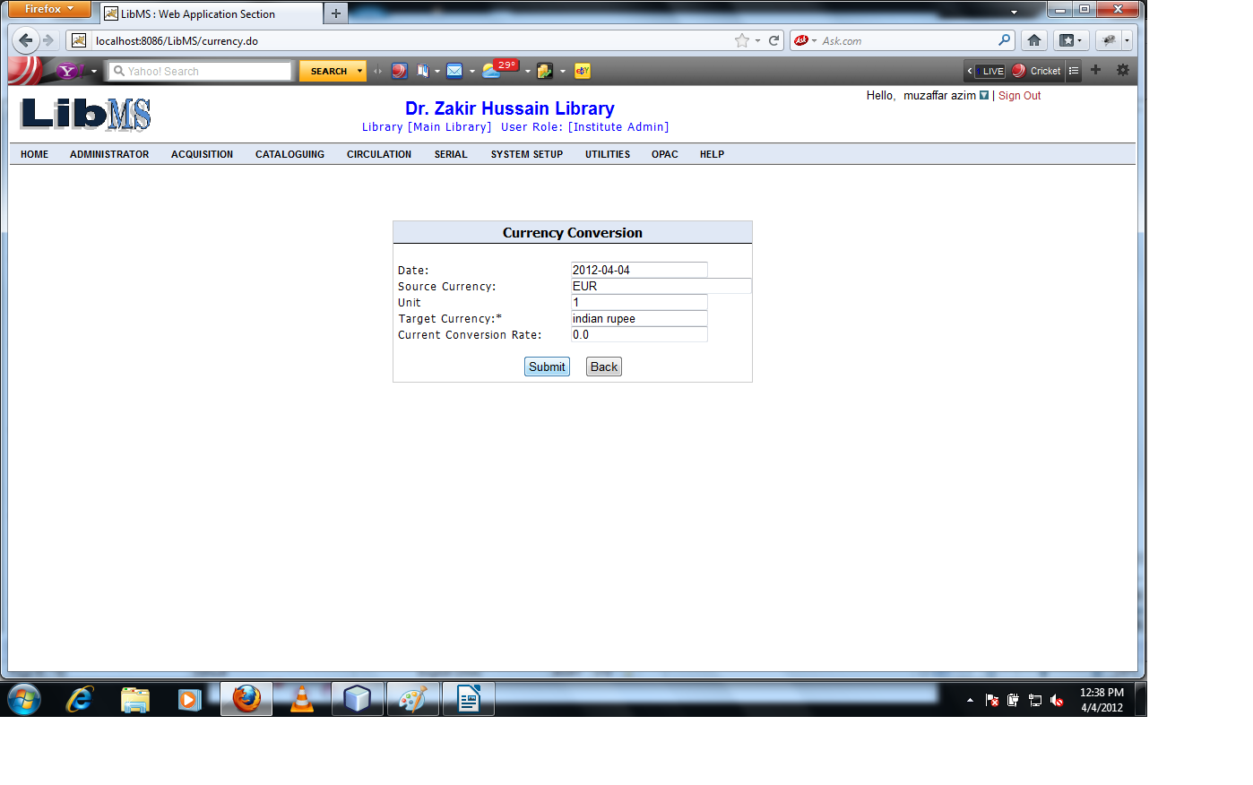

The base currency is Indian rupee at present. Enter the conversion rate of 1 euro to Indian rupee.
1euro=70rs(Approx)
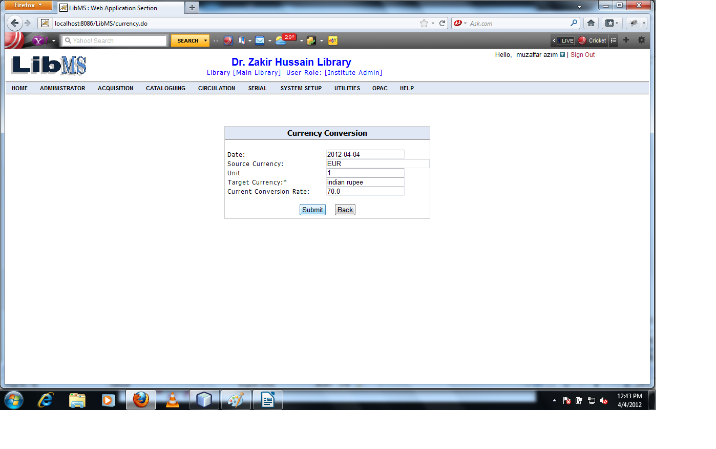

Click on submit button the conversion rate of 1 euro is set with respect to Indian rupee and forwarded
to the first screen of currency conversion activity.
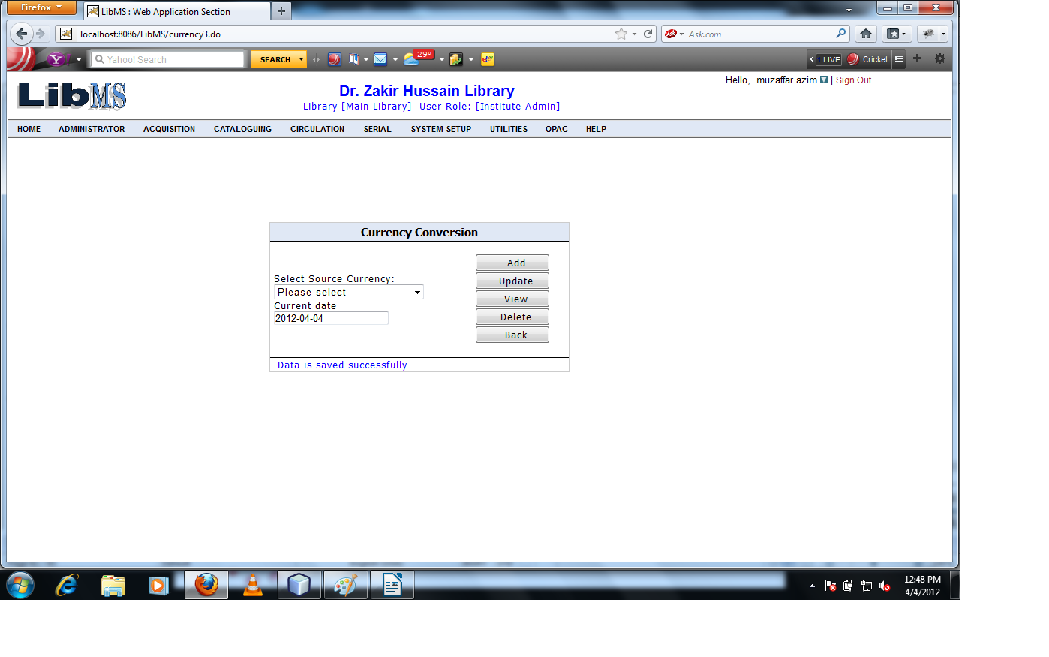

If we want to modify the rate of existing currency with respect to Indian rupee. Then Select the currency which are exist and click on Update button.
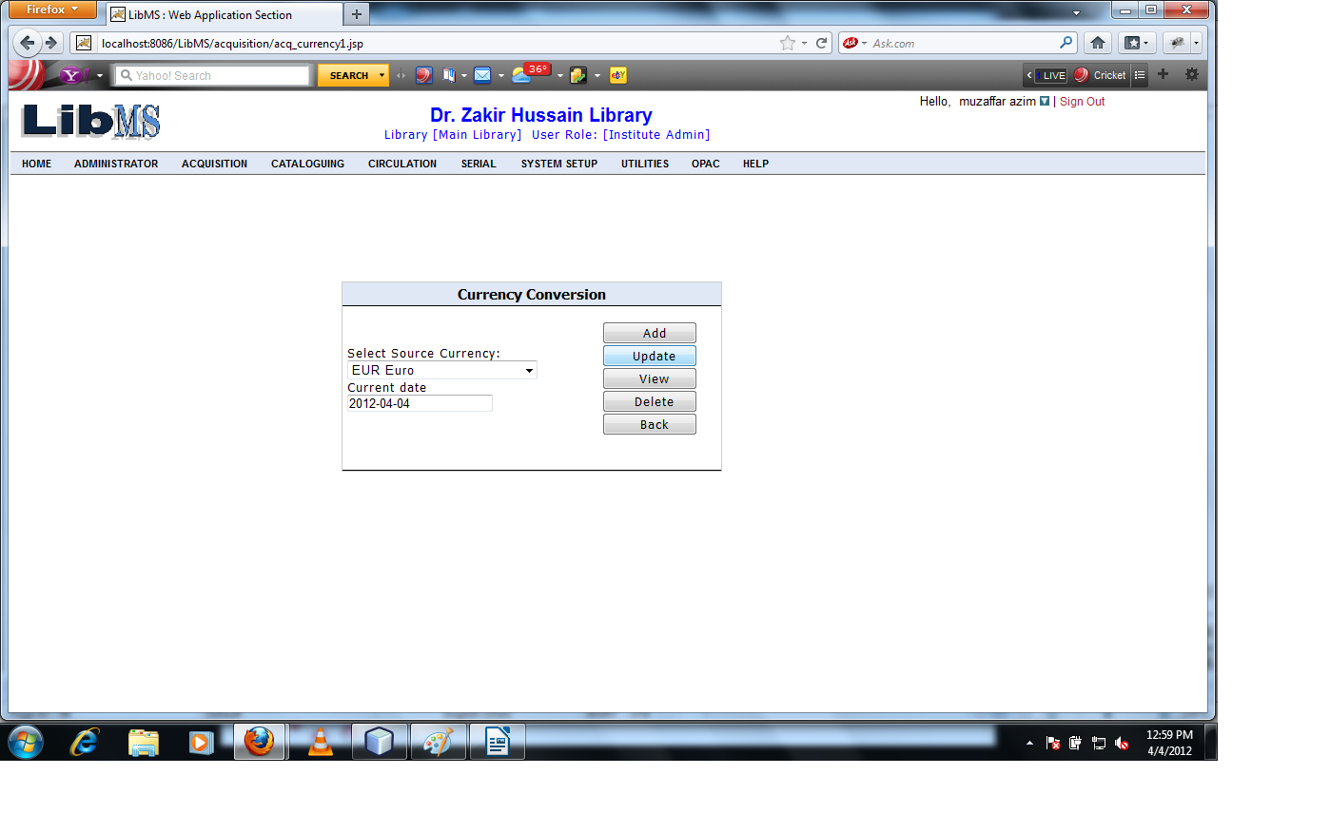

On Clicking Update button we have got the following interface.
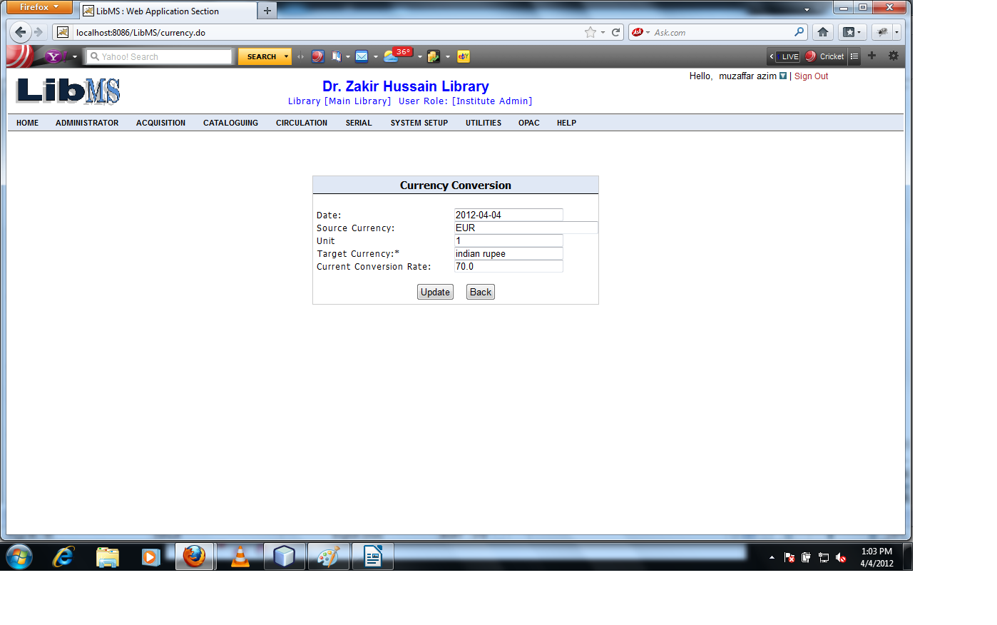

Modify the rate of currency and click on Update button.
Now 1 Euro=75.0 Rs
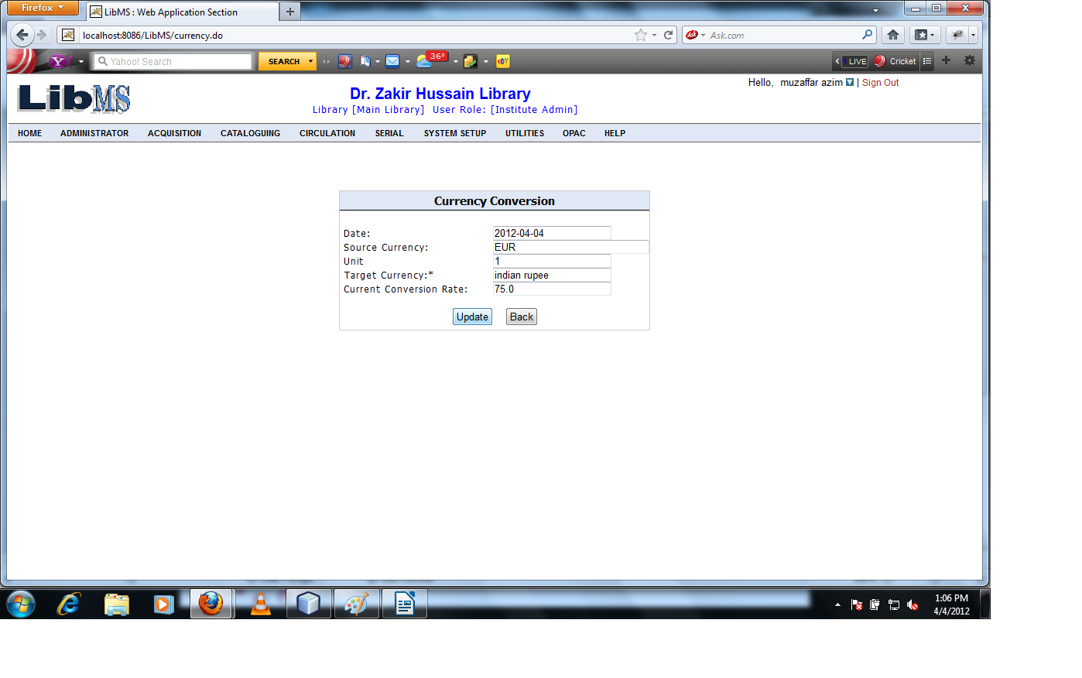

On Clicking Update button the rate of currency modify successfully and forwarded to the first screen of
the Currency conversion Activity.
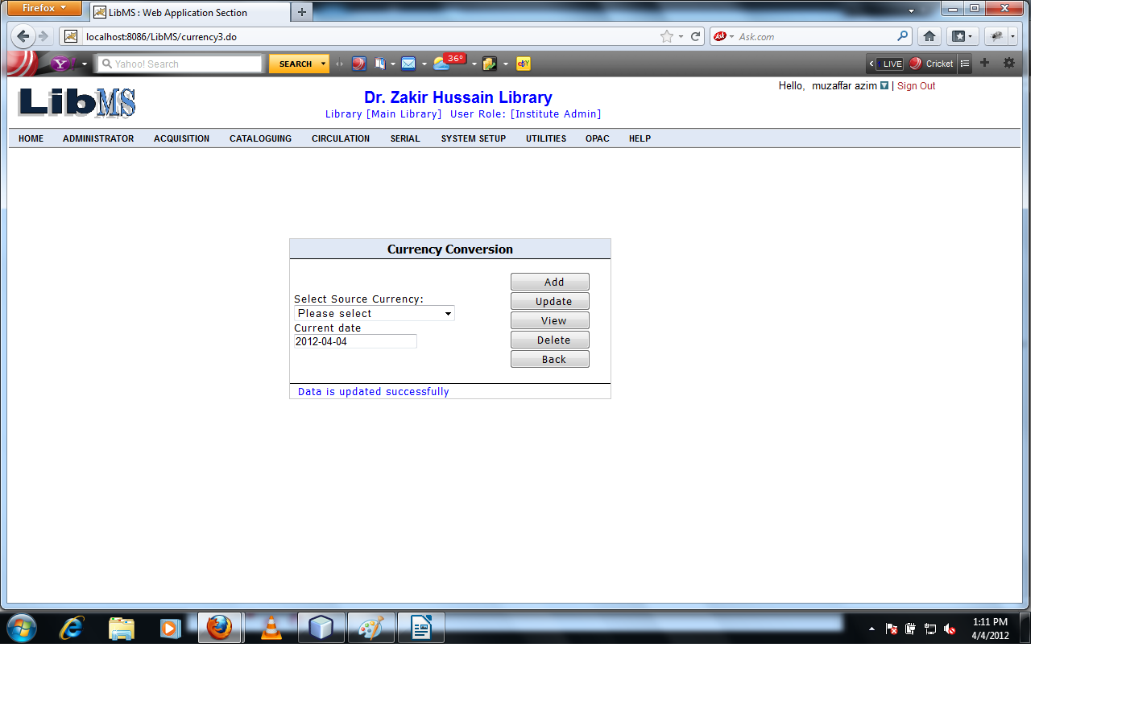
Now if we want to View the converted rate of existing currency rate with respect to Indian rupee.
Enter the Currency code and click on View button.
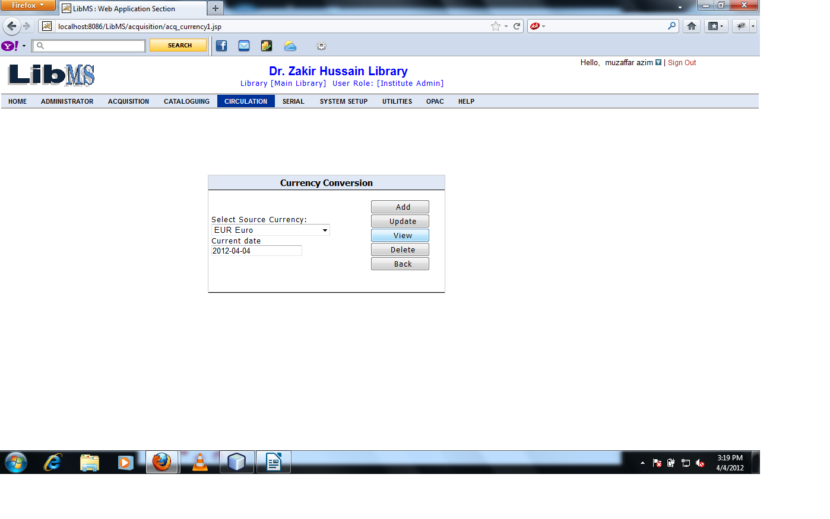
Clicking on View button we have got the following interface.
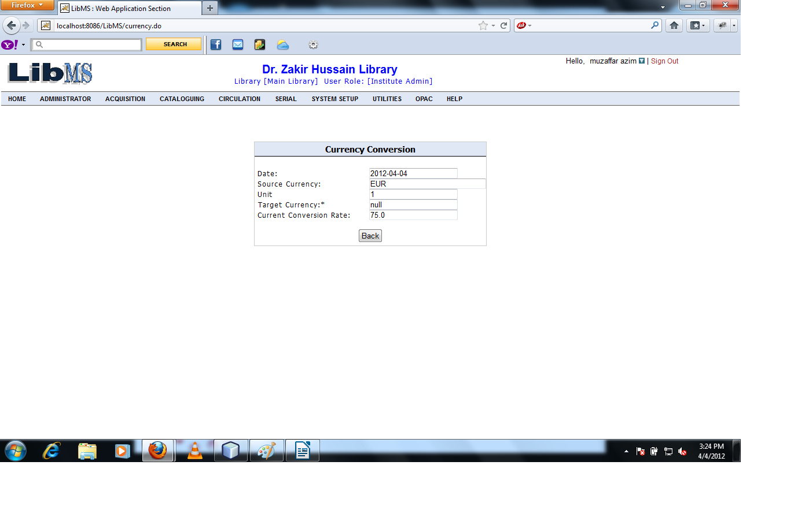

Clicking on Back button forwarded to the previous screen.
Now if we want to delete the record of the existing conversion rate of currency. Enter the currency code and click on delete button.
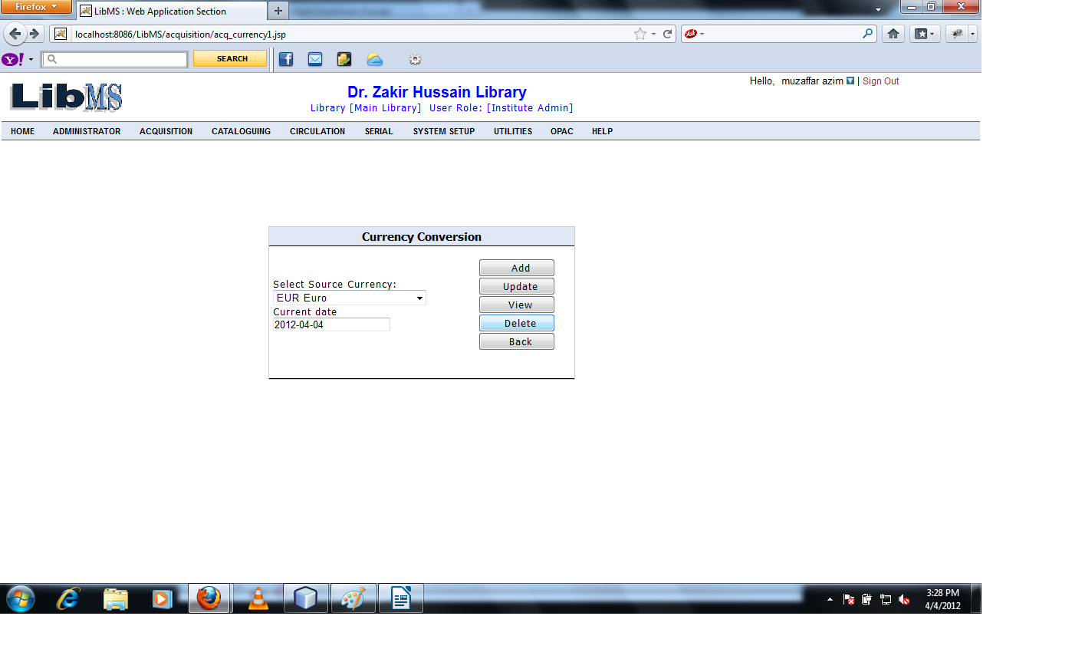

Clicking on Delete button we have got the following interface.

Clicking on Delete button we have got the following interface.
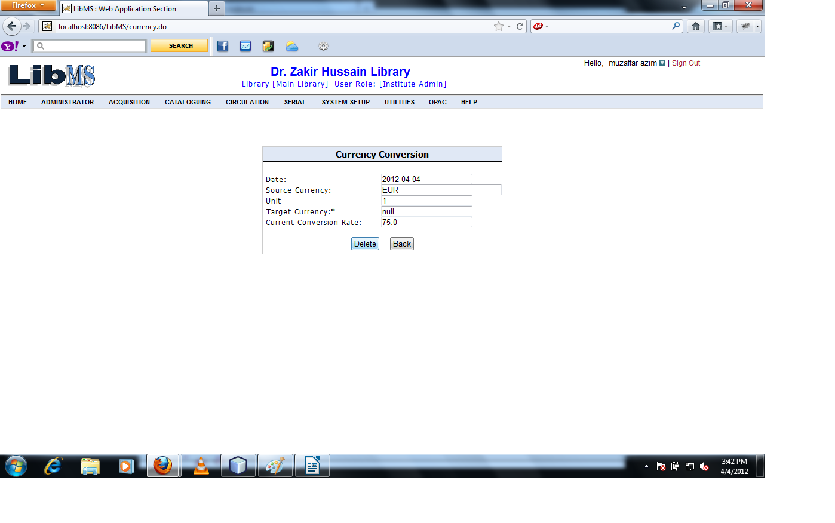

Clicking on Delete button warning message shows.

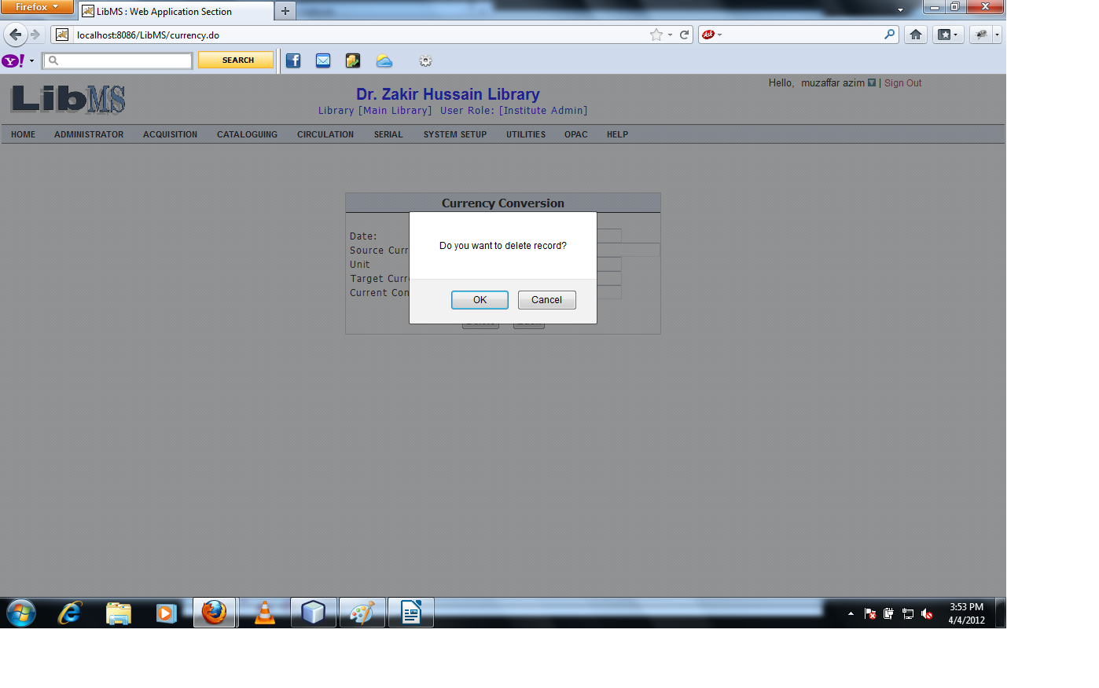

Click on Ok button the existing currency conversion rate is deleted successfully and forwarded to the first screen with the successfully deleted message.
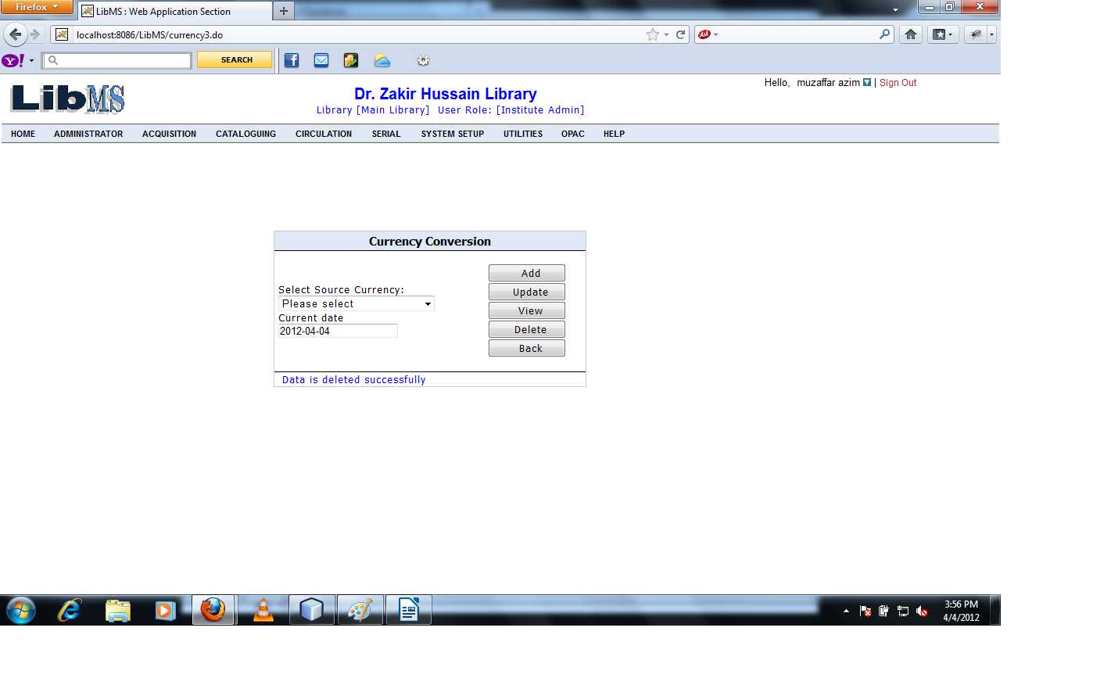

Set Base Currency

Activity Name : Acquisition - > Budget Management - > Set Base Currency

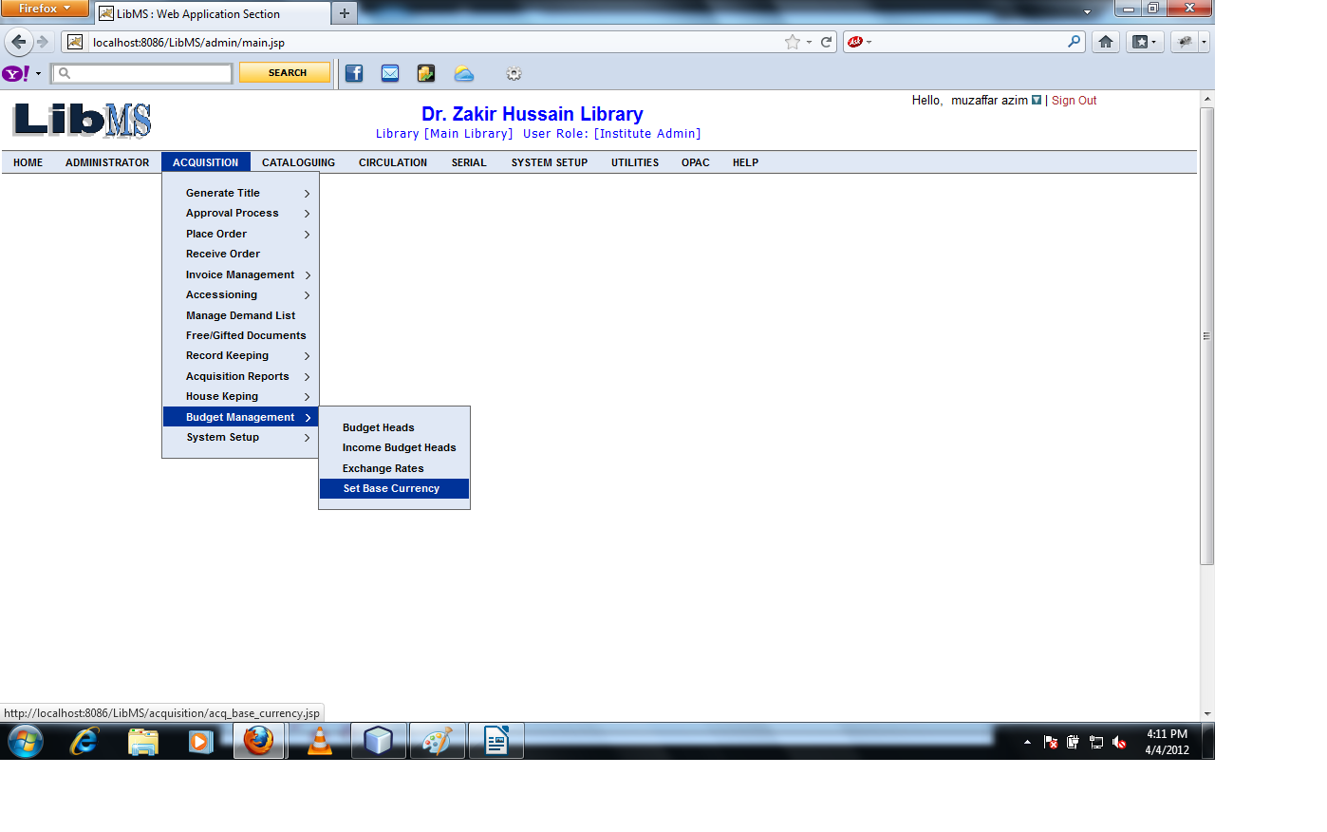

Clicking on Set Base Currency Link we have got the following interface.

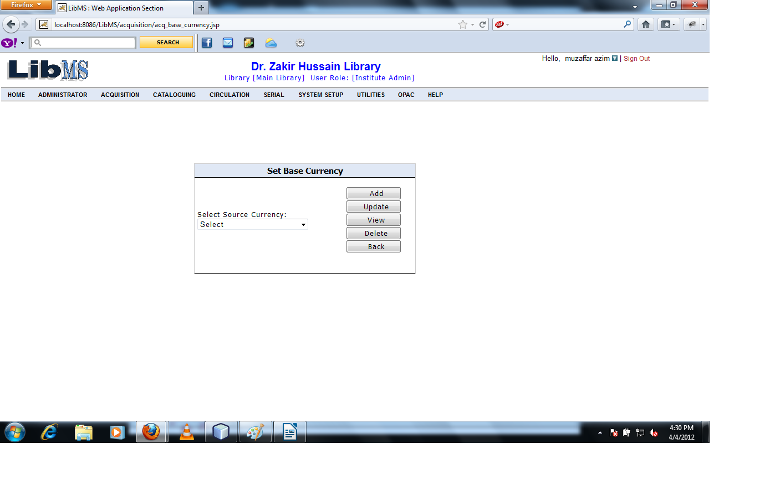

Select Source Currency code from the given List and Click on Add button.

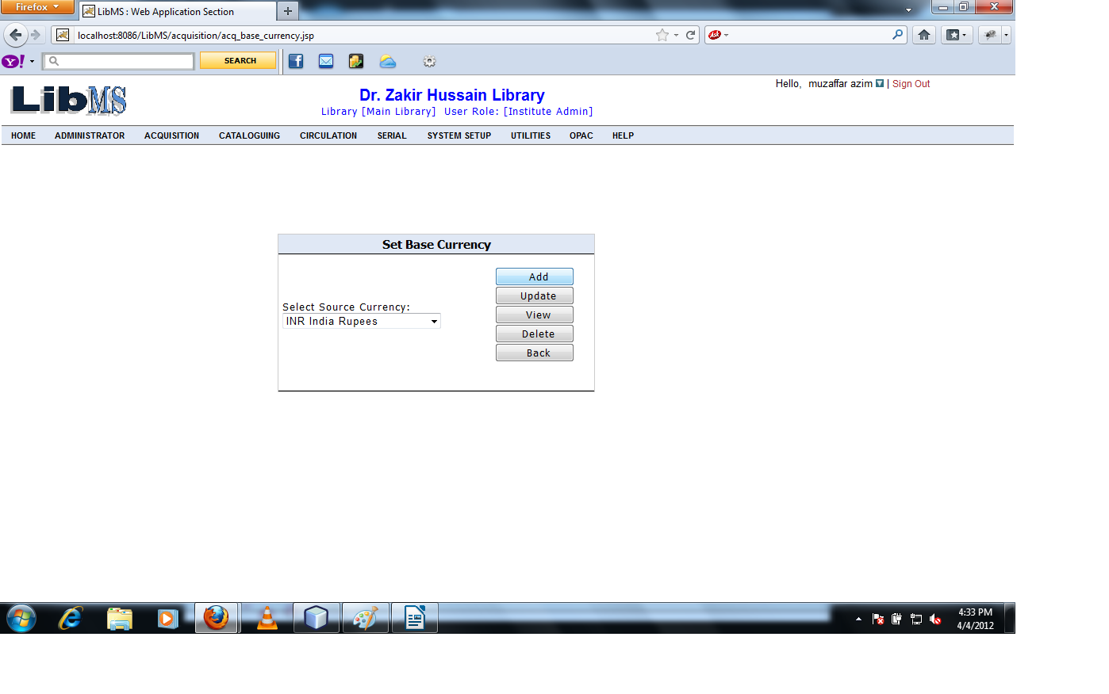

Clicking on Add button we have got the following interface.

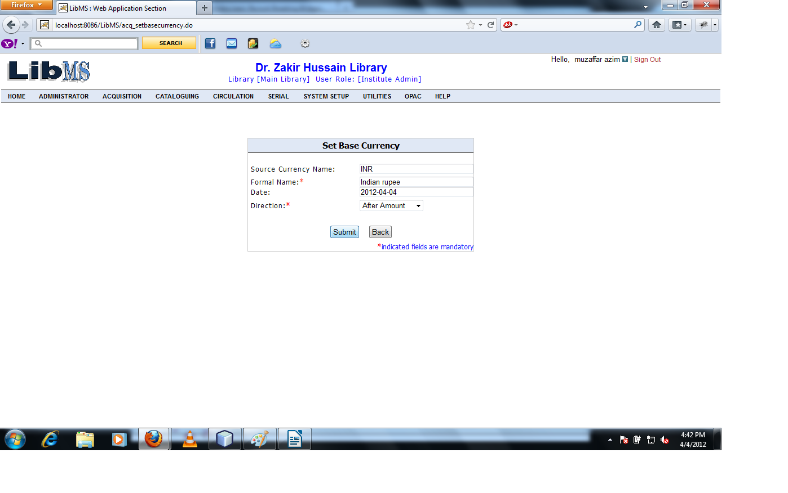

Click on Submit button the base currency is set and forwarded to the first screen with successful
message.

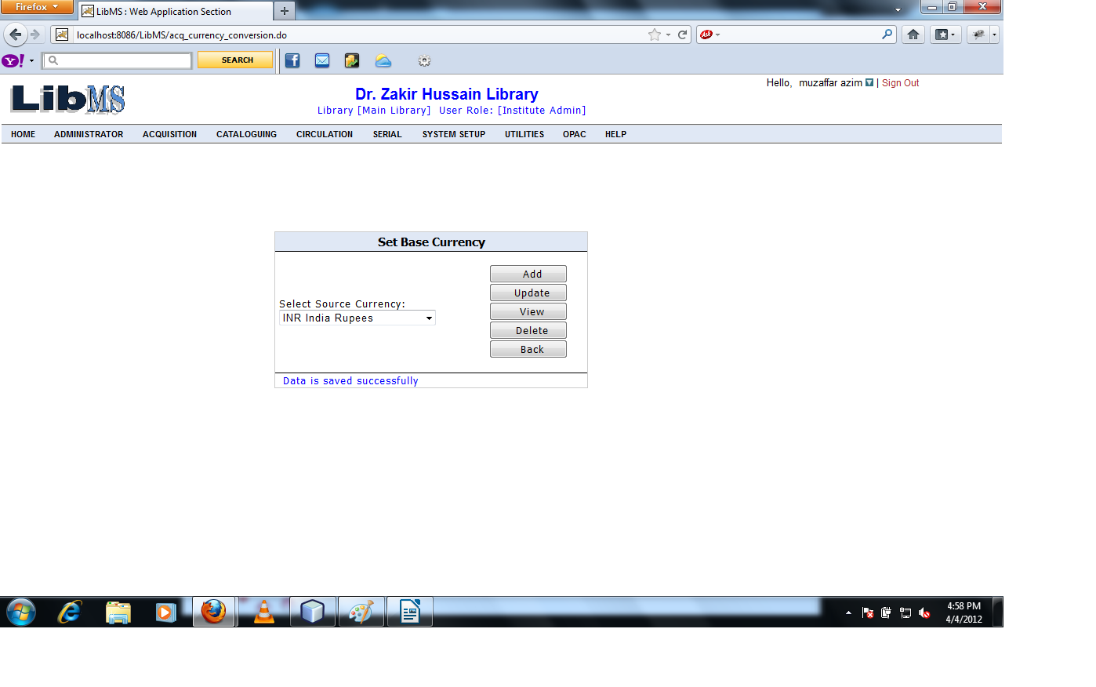

If we want to modification in the base currency then enter the code of Source Currency and Click on Update button.

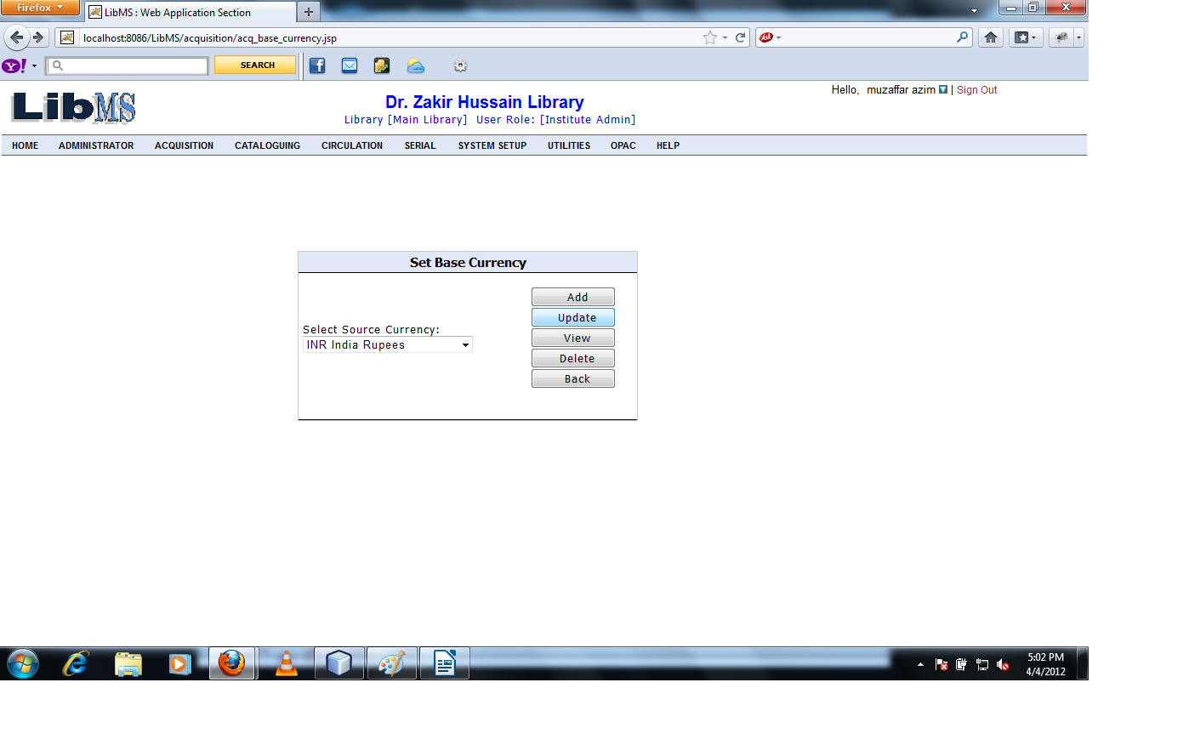

Clicking on Update button we have got the following interface.

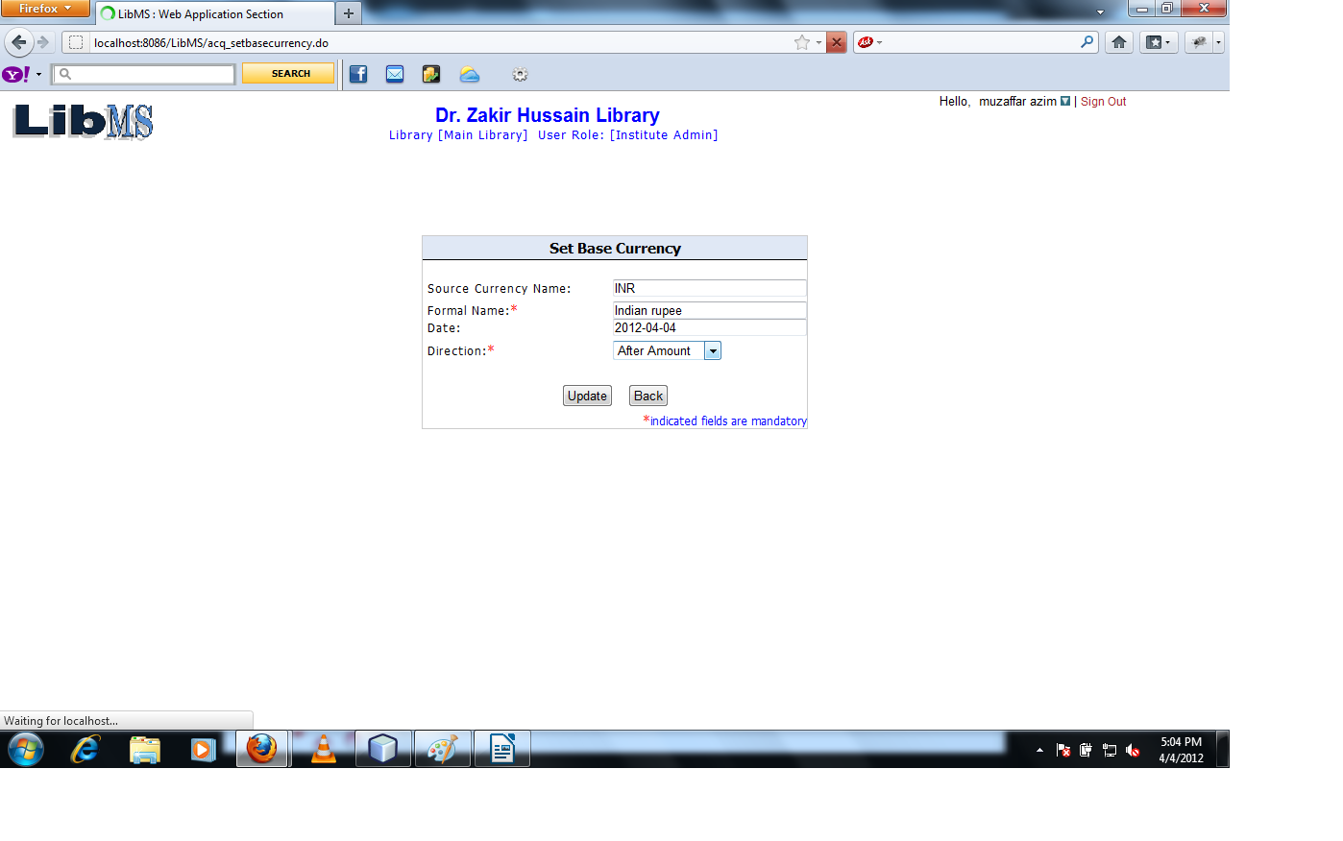

Modify the record

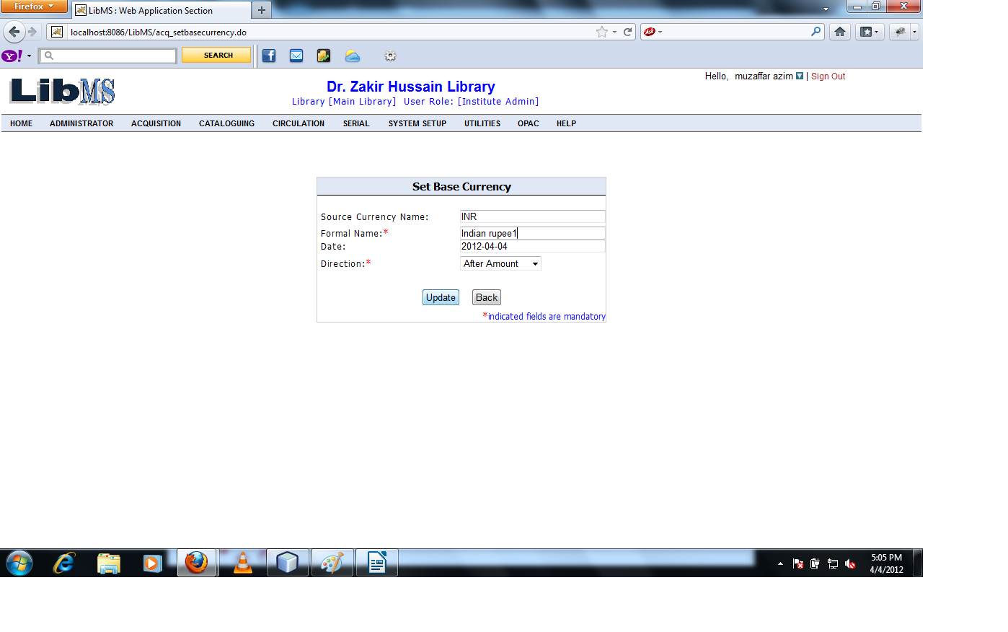

Clicking on Update button the record is modified successfully and forwarded to the previous page.

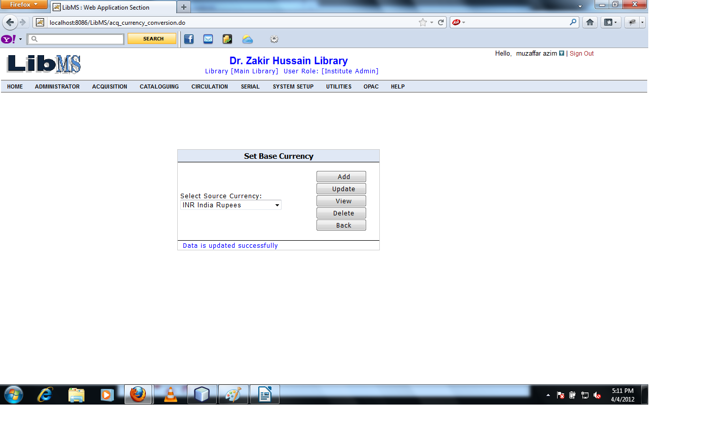

If we want to view the base currency.
Select the base currency and Click View.
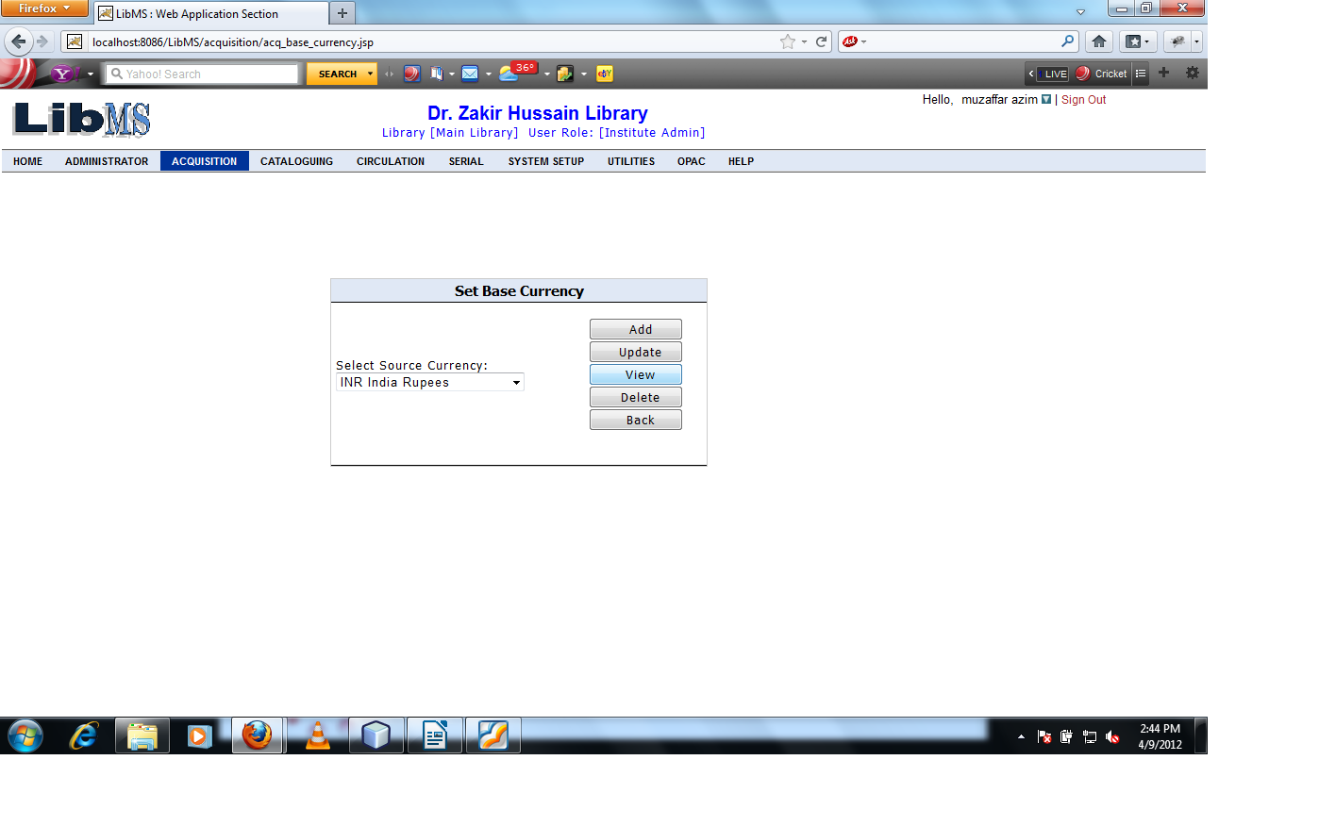

After Clicking on View Button. We have got the following interface.

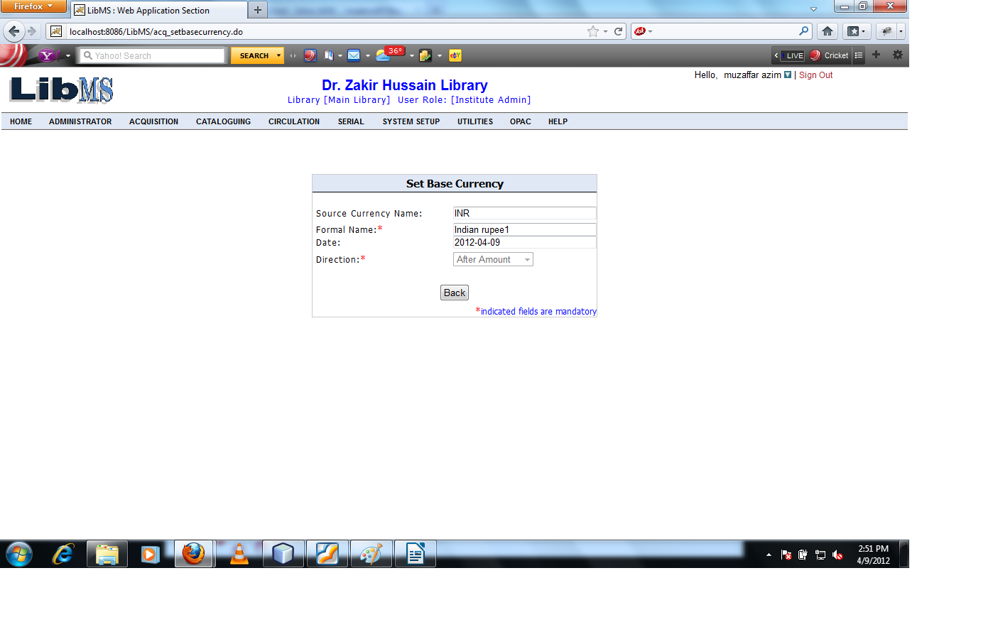
Click on Back button come to the previous page.

Now if we want to delete the record of base currency. Then select the existing currency code and click on Delete button.
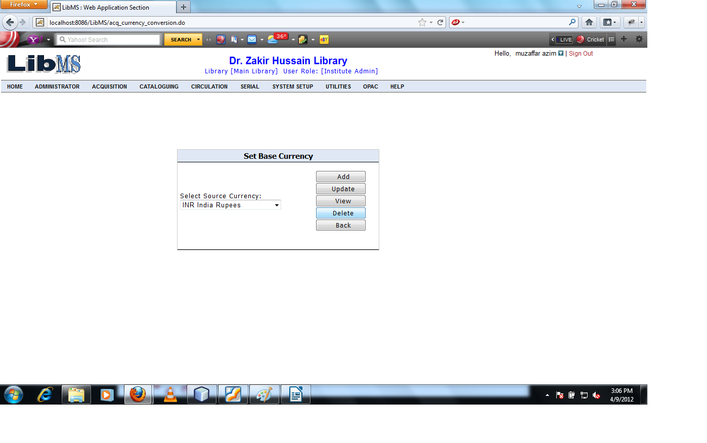

Clicking on Delete button we have got the following interface.
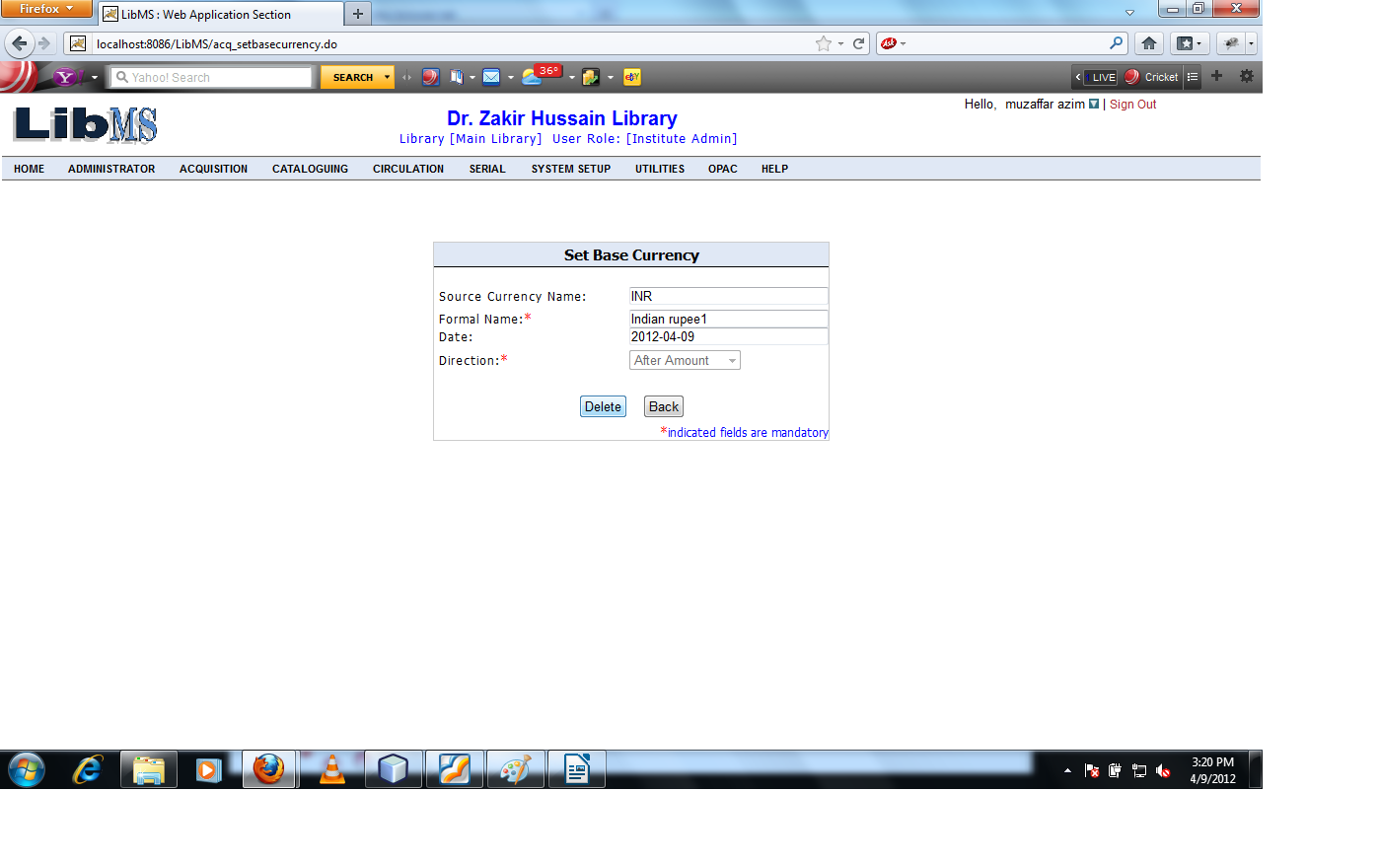

Clicking on Delete button warning message shown.

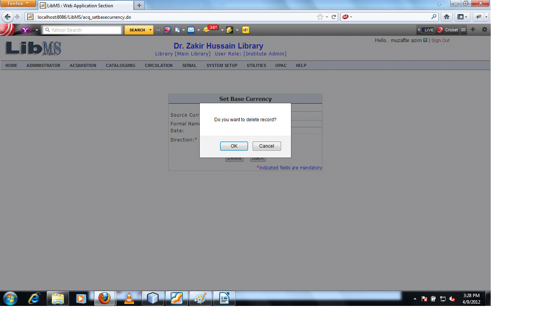

The set Base currency can not be delete because the acquisition is in process and the price is calculated on base currency if we want to delete the base currency the before starting acquisition processing.


