

Operation Manual
(LibMS)

Developed by : Aligarh Muslim University, Aligarh (India)
© (2010-11), NME-ICT ERP Mission Project

Table of Index

Pages
1 | Administrator Module | 6
 | 1.1 Manage Staff Registration | 6
 | 1.1.1 Register Staff | 6
 | 1.1.2 Update Staff | 11
 | 1.1.3 View Staff | 12
 | 1.1.4 Delete Staff | 13
 | 1.1.5 View All Staff Details | 13
 | 1.2 Manage Staff Account | 14
 | 1.2.1 Create Account | 14
 | 1.2.2 Update Account | 16
 | 1.2.3 View Account | 17
 | 1.2.4 Delete Account | 18
 | 1.2.5 View All Account | 19
 | 1.3 Assign Privileges | 20
 | 1.3.1 Assign Privileges | 20
 | 1.3.2 Change Privileges | 21
 | 1.3.3 View Privileges | 23
2 | Circulation Module | 25
 | 2.1 Member Management | 26
 | 2.1.1 Member Detail Registration | 27
 | 2.1.1.1 Member Detail Update | 28
 | 2.1.1.2 Member Detail Delete | 30
 | 2.1.1.3 Member Detail View | 32
 | 2.1.1.4 Member Detail View All | 34
 | 2.1.2 Member Account | 36
 | 2.1.2.1 Create Member Account | 37
 | 2.1.2.2 Update Member Account | 39
 | 2.1.2.3 Delete Member Account | 41
 | 2.1.2.4 View Member Account | 41
 | 2.1.2.4 View All Member Account | 43
 | 2.2 Check Out | 44
 | 2.3 Check In | 48
 | 2.4 Delinquent Member | 49
 | 2.5 Check Out Report | 52
 | 2.6 Check In Report | 53
3 | Cataloging Module | 54
 | 3.1 Initiate cataloging | 54
 | 3.1.1 Old Title Entry | 54
 | 3.1.1.1 Manage Bibliographic->New | 55
 | 3.1.1.2 Manage Bibliographic->Update | 57
 | 3.1.1.3 Manage Bibliographic->View | 58
 | 3.1.1.4 Manage Bibliographic->Delete | 60
 | 3.1.1.5 Manage Bibliographic-> View All | 62
 | 3.1.2 Accession Management | 64
 | 3.1.2.1 Change Accession Number | 65
 | 3.1.2.2 Assign Accession Number->New | 66
 | 3.1.2.3 Assign Accession Number->Update | 69
 | 3.1.2.4 Assign Accession Number->View | 72
 | 3.1.2.5 Assign Accession Number->Delete | 74
 | 3.1.3 Cataloging Of New Titles | 78
 | 3.1.3.1 Entry Using Simple Template->New | 79
 | 3.1.3.2 Entry Using Simple Template->Update | 83
 | 3.1.3.3 Entry Using Simple Template->View | 86
 | 3.1.3.4 Entry Using Simple Template->Delete | 89
4 | System Setup | 89
 | 4.1 Manage Notice | 91
 | 4.1.1 Add Notice | 91
 | 4.1.2 Update Notice | 96
 | 4.1.3 Delete Notice | 99
 | 4.1.4 View Notice | 102
 | 4.1.5 View All Notice | 105
 | 4.2 Manage Location | 108
 | 4.2.1 Add Location | 108
 | 4.2.2 Update Location | 112
 | 4.2.3 Delete Location | 116
 | 4.2.4 View Location | 120
 | 4.2.5 View All Location | 123
 | 4.3 Manage Member Type | 126
 | 4.3.1 Add Member | 127
 | 4.3.2 Update Member | 131
 | 4.3.3 Delete Member | 135
 | 4.3.4 View Member | 138
 | 4.3.5 View All Member | 141
 | 4.4 Manage Sub Member Type | 143
 | 4.4.1 Add Sub Member | 144
 | 4.4.2 Update Sub Member | 147
 | 4.4.3 Delete Sub Member | 151
 | 4.4.4 View Sub Member | 154
 | 4.4.5 View All Sub Member | 158
 | 4.5 Manage Document Category | 159
 | 4.5.1 Add Document Category | 160
 | 4.5.2 Update Document Category | 162
 | 4.5.3 Delete Document Category | 167
 | 4.5.4 View Document Category | 171
 | 4.5.5 View All Document Category | 174
 | 4.6 Configure Fine Detail | 175
 | 4.6.1 Set Fine Detail | 176
 | 4.6.2 Update Fine Detail | 179
 | 4.6.3 Delete Fine Detail | 184
 | 4.6.4 View Fine Detail | 188
 | 4.6.5 View All Fine Detail | 191
 | 4.7 Manage Faculty | 193
 | 4.7.1 Add Faculty | 193
 | 4.7.2 Update Faculty | 197
 | 4.7.3 Delete Faculty | 201
 | 4.7.4 View Faculty | 205
 | 4.7.5 View All Faculty | 208
 | 4.8 Manage Department | 210
 | 4.8.1 Add Department | 211
 | 4.8.2 Update Department | 215
 | 4.8.3 Delete Department | 219
 | 4.8.4 View Department | 223
 | 4.8.5 View All Department | 226
 | 4.9 Manage Courses | 227
 | 4.9.1 Add Courses | 228
 | 4.9.2 Update Courses | 231
 | 4.9.3 Delete Courses | 234
 | 4.9.4 View Courses | 240
 | 4.9.5 View All Courses | 243
 | 4.10 Manage SubLibrary | 244
 | 4.10.1 Add SubLibrary | 245
 | 4.10.2 Update SubLibrary | 247
 | 4.10.3 Delete SubLibrary | 253
 | 4.10.4 View SubLibrary | 256
 | 4.10.5 View All SubLibrary | 258

Administrator Module

From this Module We can Manage Staff Registration, Account details and Privileges of Staff's. Administrator may enter necessary details of the Library Staff using Register Staff option, may create login account for the registered staff and then assign privileges to the staff whose login account has been created.

Activity Name : Administrator->Staff Registration

In Staff Registration we can add Library Staff in LibMS, by Which They can login in LibMS and can perform different activities based on privileges assigned to them for that, Click on Staff Registration->Register Staff as mention in given screen shot of Register Staff Page
Administrator->Staff Registration->Register Staff->Register

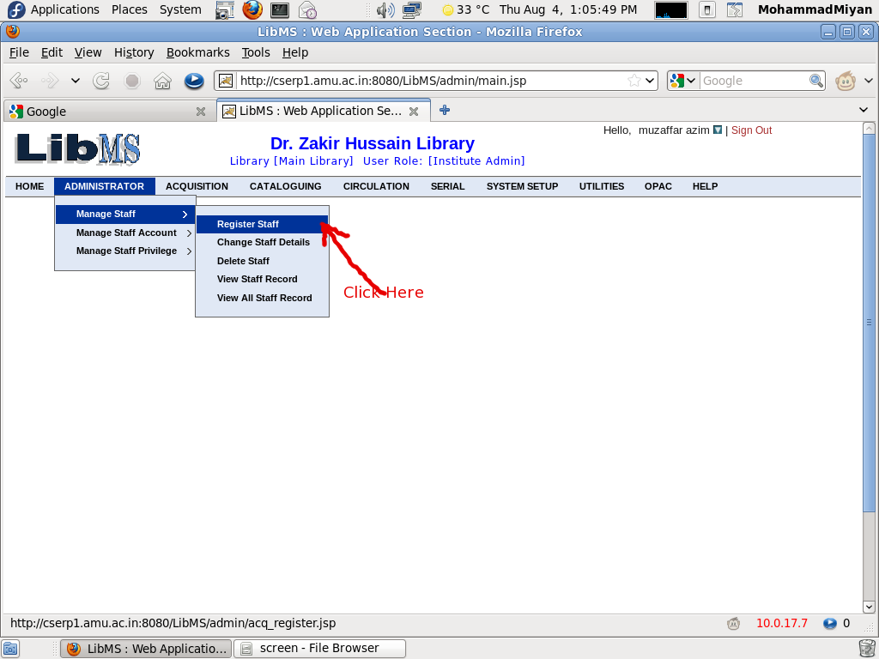

You need to enter staff id/Emp ID (Ex - ABC90934). For Registration ,We need to Press Register button,
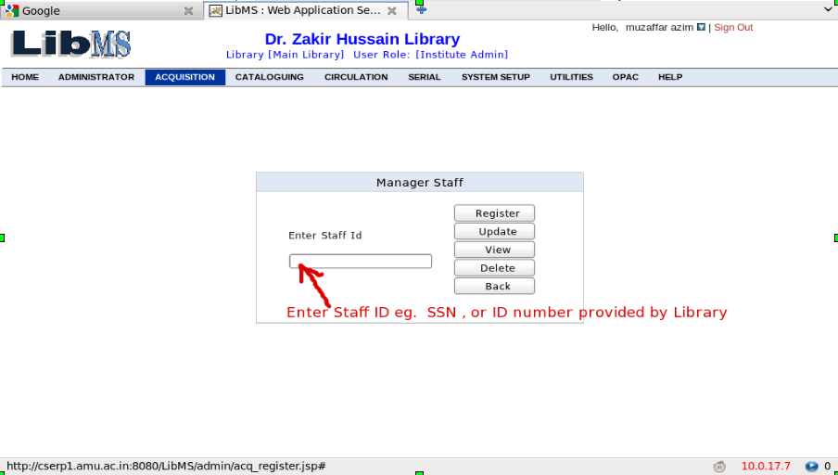

Now We are redirected to following page
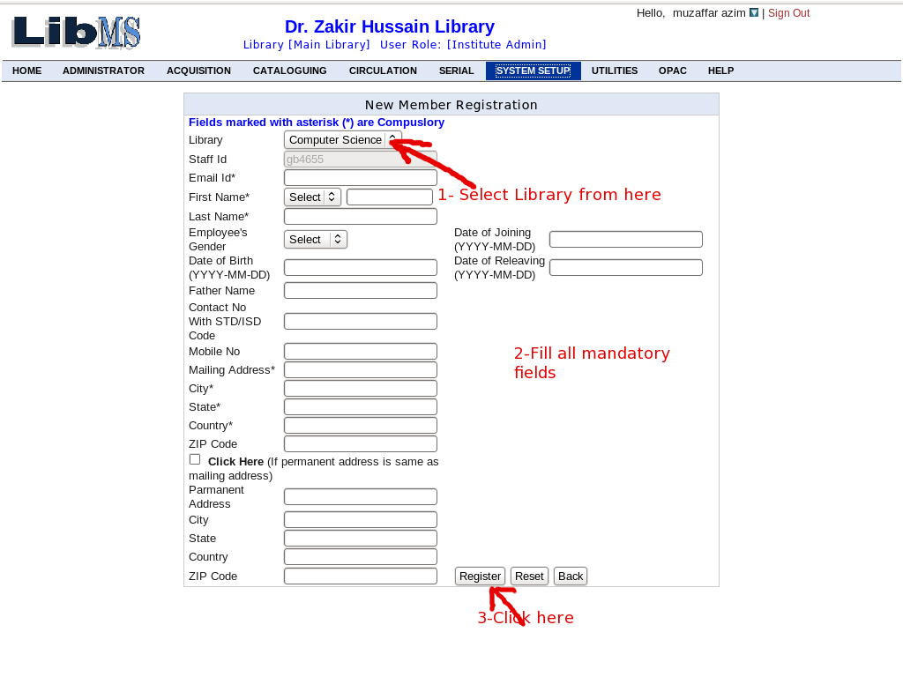

When staff detail is registered successfully you(Institute Admin) can create account for the registered member. You can also skip this step, but if you skip here you have to create account later from Manage staff Account menu.(path: Administrator->Manage Staff Account->Create Account)
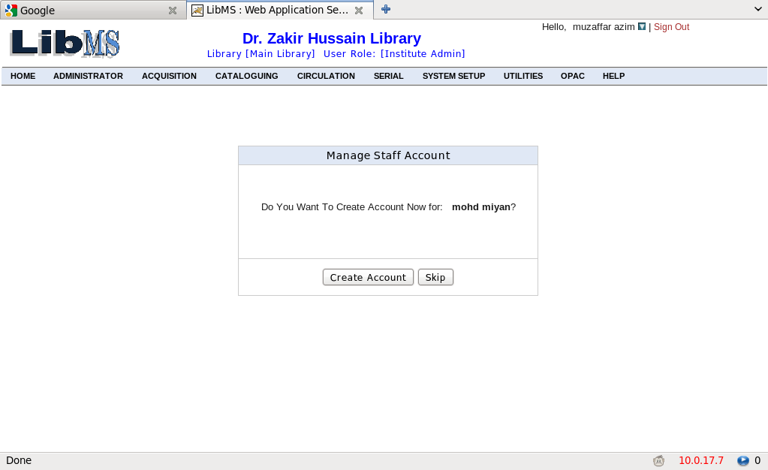

type the desired login Id for member , select role and click Create Account.
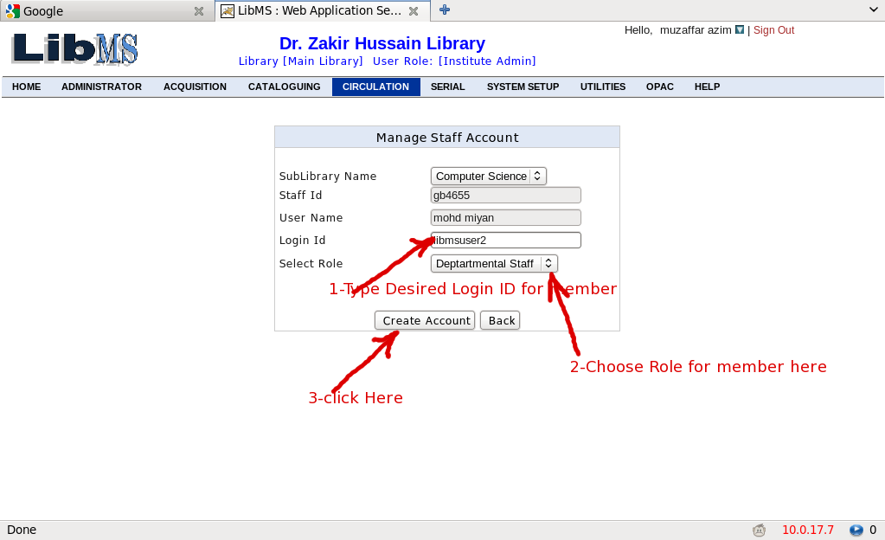

When you click Create Account an email regarding user-name and password is sent to the staff member. Now he can access your Library with his user name and password.

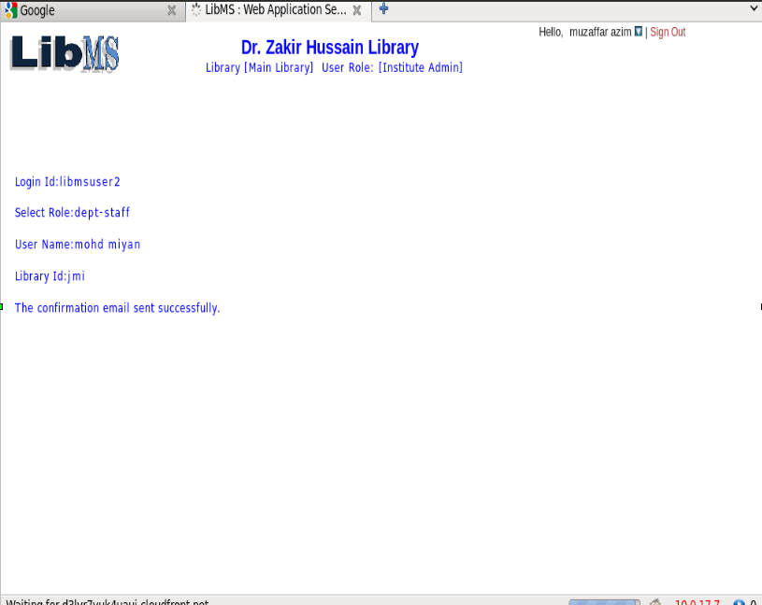

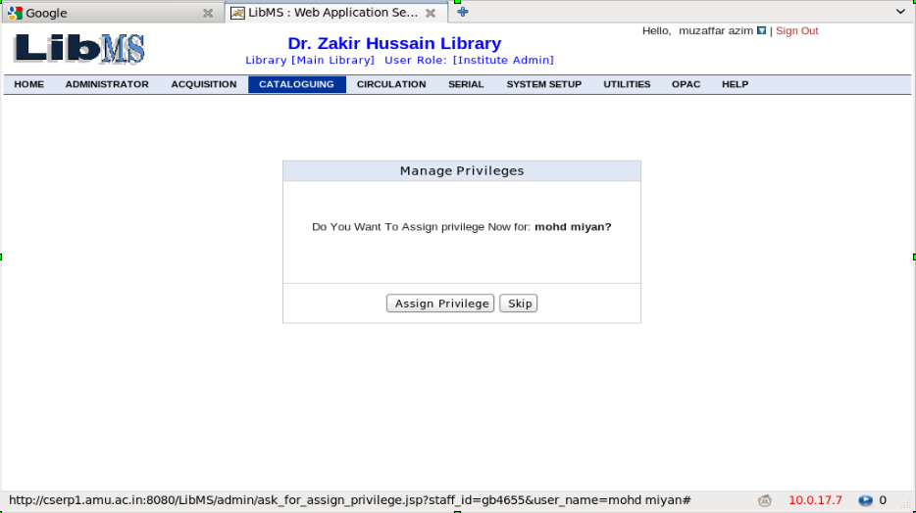

Assign the privileges for the member or you can skip this step here. If you skip here later you have to set privileges(by entering Staff ID ) from Manage Staff Privilege menu(Path: Administrator->Manage Staff Privilege->Assign Privilege).
select check boxes to assign the privilege to the member and click submit.
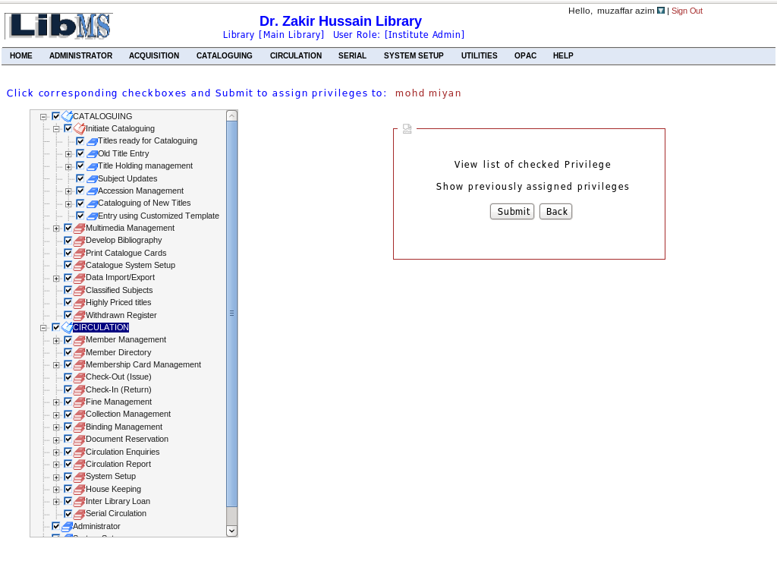

when you click submit the staff member screen will appear with the assigned privilege menu in bold letters. member can access only those menu which are dark(bold letters).
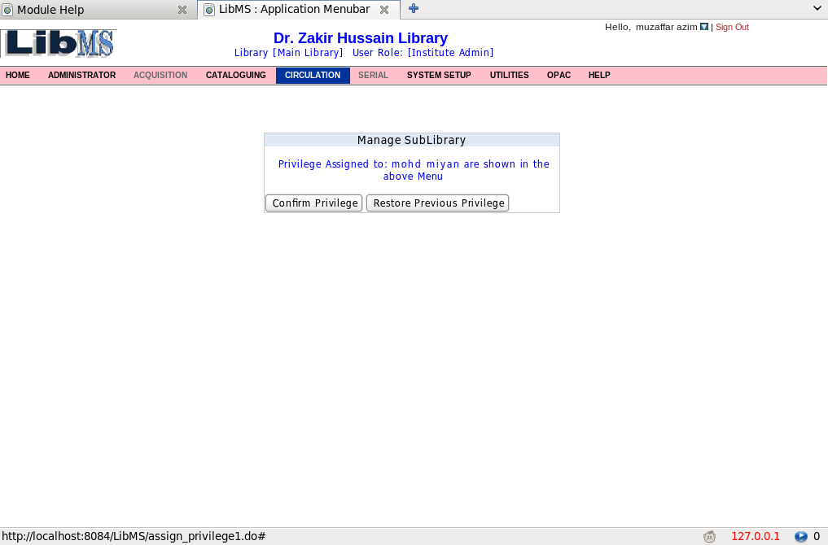

On Click on Confirm Privileges the privileges are successfully set to the staff and mail is send to him regrading it.
Administrator->Staff Registration->Register Staff->Update Staff
Institute admin can update and change member detail by using staff Id.
if you want to change detail of the staff member click change staff detail. Enter Staff id of the member and click update button.

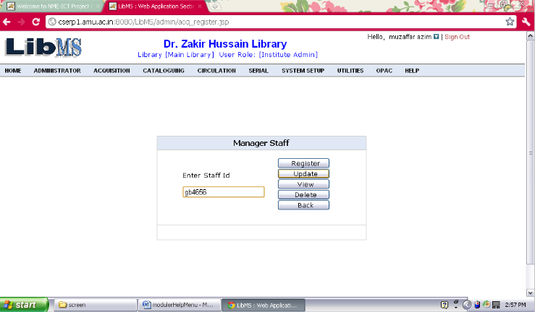

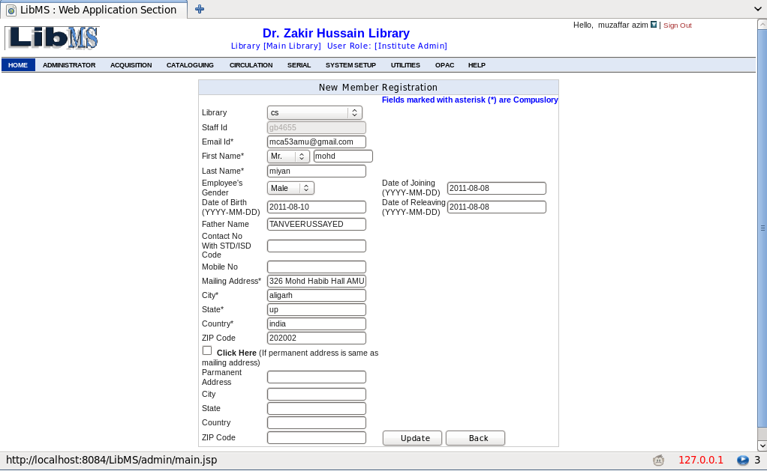

make changes in the field values and click Update

Record Successfully Updated message will appear.
Administrator->Staff Registration->Register Staff->View Staff Details

Enter Staff id of the member and click view button.
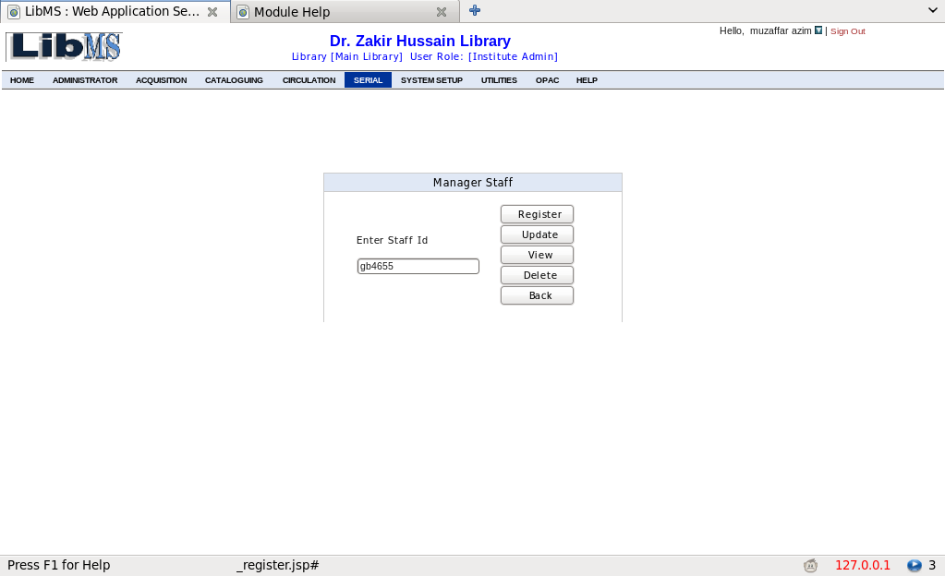

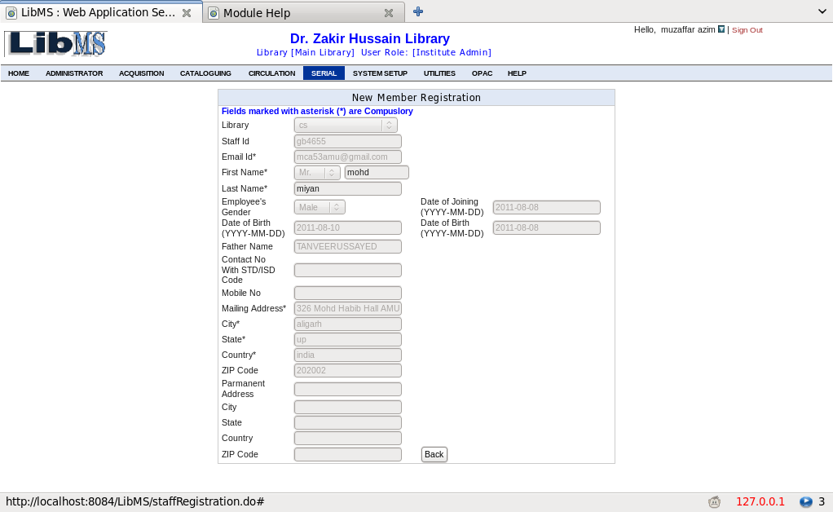

Administrator->Staff Registration->Register Staff->Delete Staff Details

Step 1: Enter Staff id of the Member.
Step 2: Click Confirm Button to delete. You Can Also go back if you don’t want to delete.
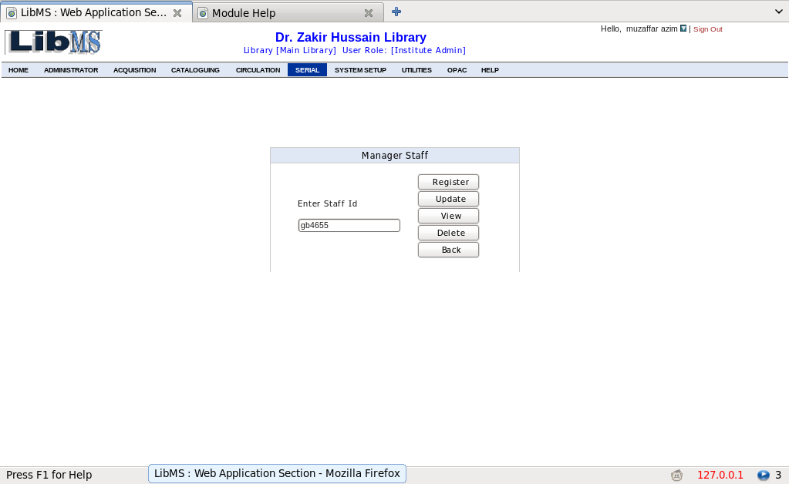

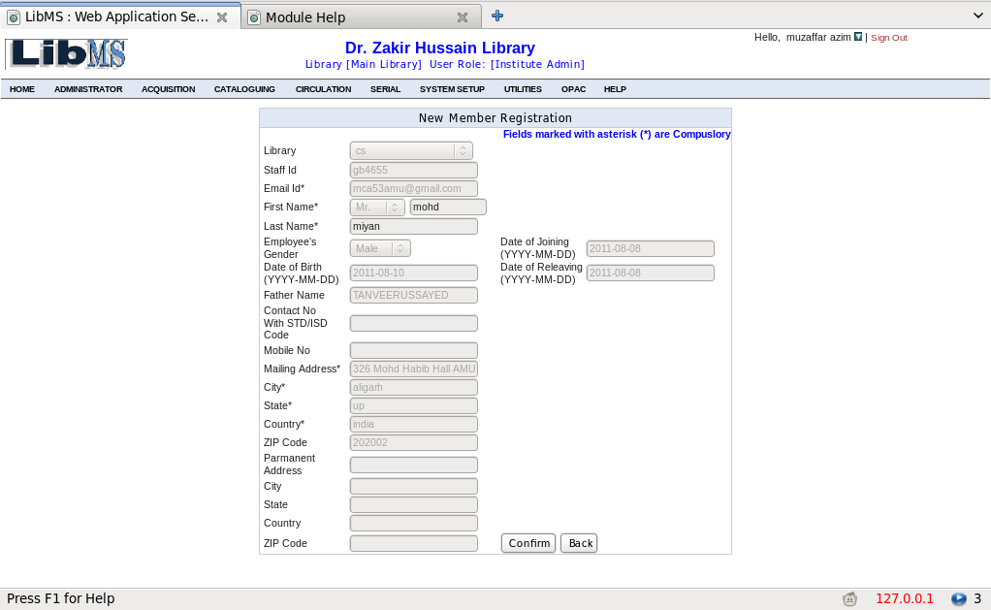

Administrator->Staff Registration->Register Staff->View All
Click View All Staff Record to view all registered members
All the records of the members are shown in the grid. click any record to find the detail of the record
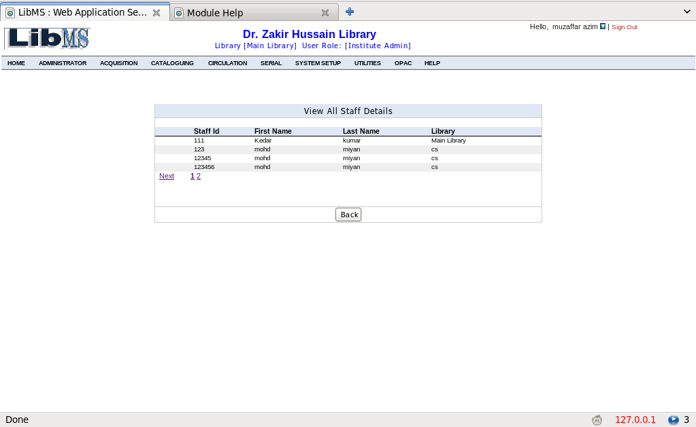

Administrator->Manage Staff->Create Account

From this Module We can create account for member who have previously been registered.
Step 1: Enter Staff id of the member who you want to create account for and click create account button. See picture below
Step 2: Assign appropriate login id of the user and select role. See picture below.
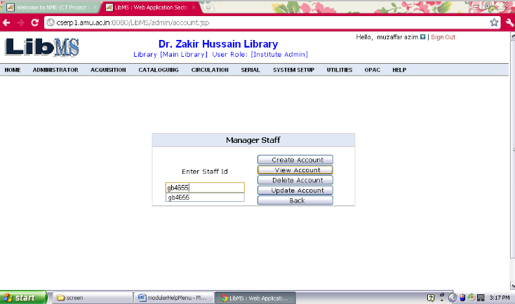

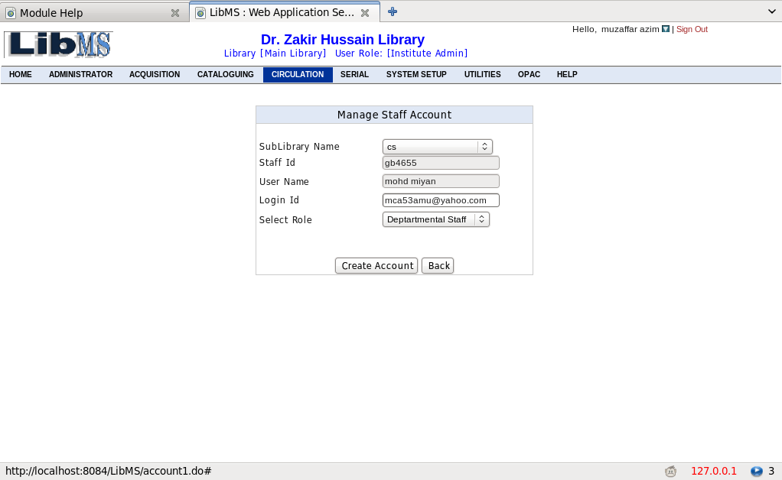

Step 3: It Will Display Following Message in a Pop Up Window.
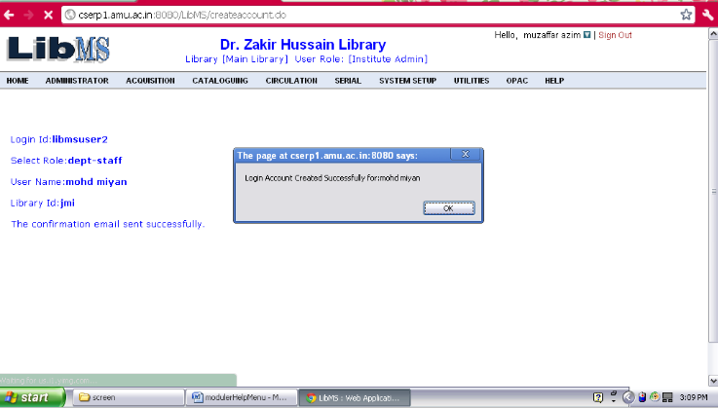

Step 4: In The Same Chaining It will again prompt to Assign Privileges to Staff (Same as Register Staff Activity).
You can update account for those members who are registered and whose account has been created.
Administrator->Manage Staff->Update Account
Step 1: Enter Staff Id of the member who you want to update account for and click on update Button.
Here, You can change Sub library Name and his role in the library.

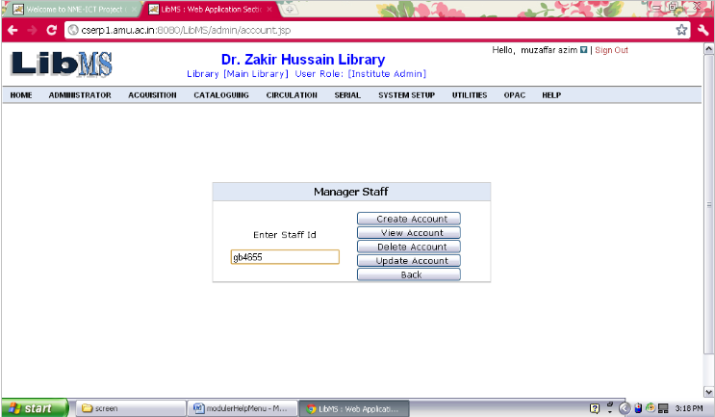

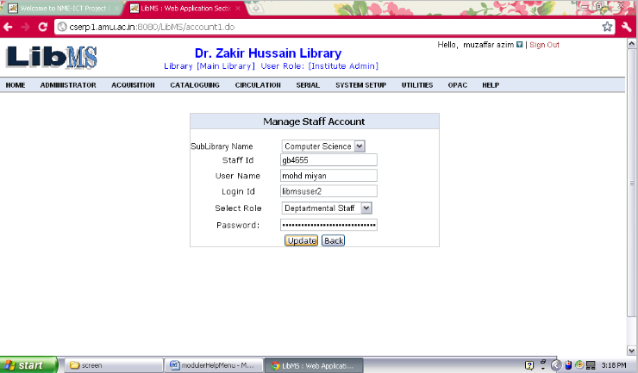

This Activity will display the Account Details of Registered Member
Step 1: Enter Staff Id of the member and click view button.
Administrator->Manage Staff->View Account

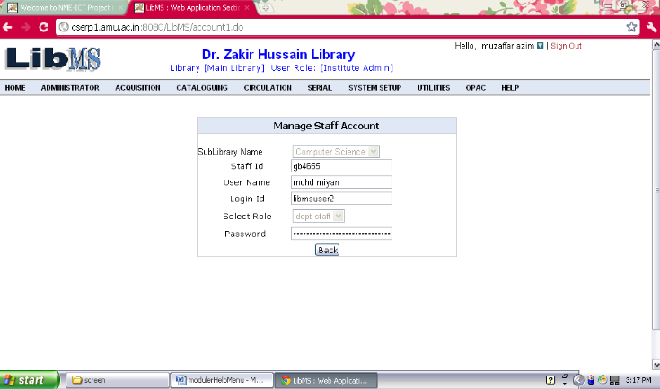

Administrator->Manage Staff->Delete Account
This Activity is use to delete account for a member. In future you can again create for the deleted member, you don’t need to re Register staff detail.
Step 1: Enter Staff Id of the member and click Delete button.
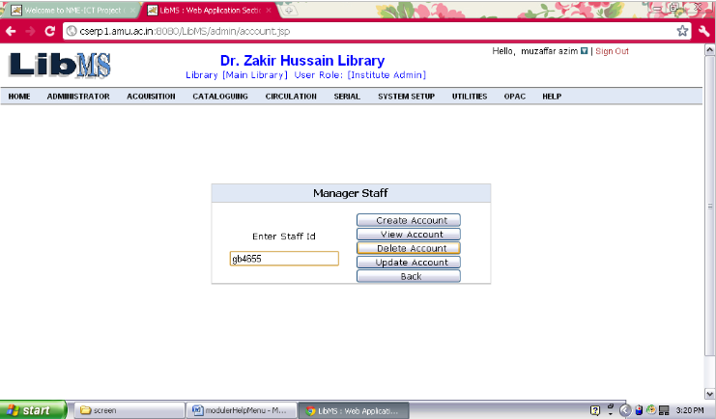
Step 2: Finally Click on Confirm Button.

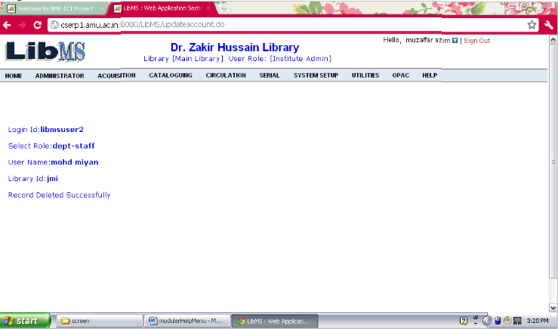

This Activity is use to view all registered member details whose account has been created.
Administrator->Manage Staff->View All Staff Account
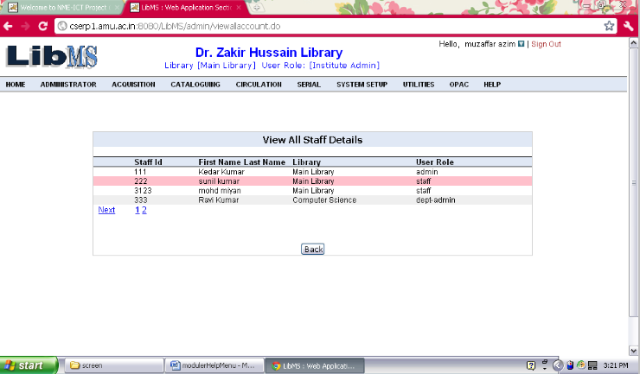

From this Module We can Assign/View/Change privilege to members who are registered as well as their account has been created.
Administrator->Manage Staff Privileges->Assign Privileges

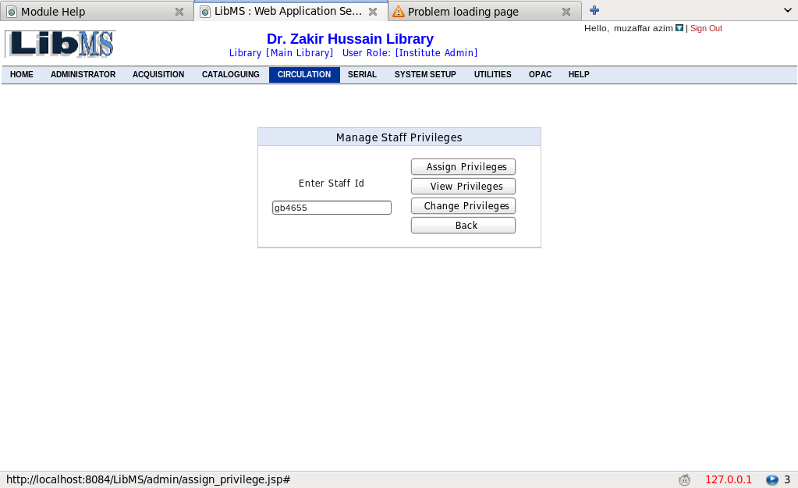

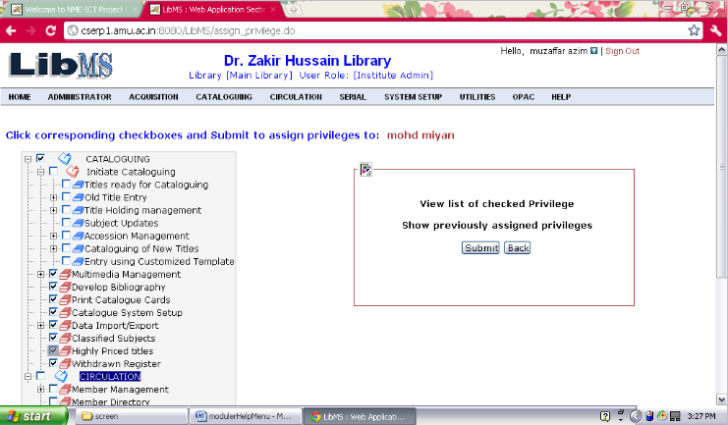

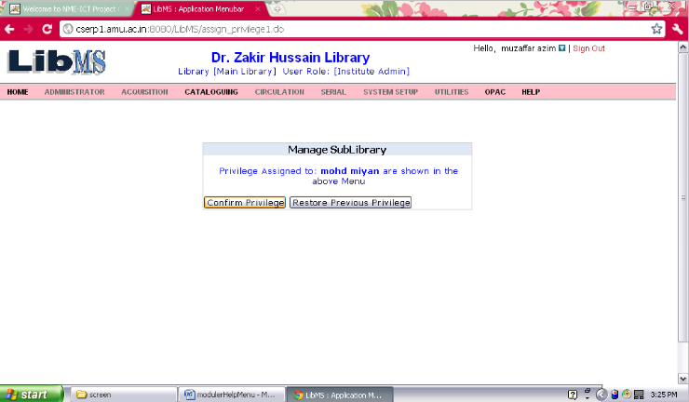

Finally Either Click on Confirm Privileges to Activate the Changes made by you or Restore Privileges to its previous Status by Clicking on Restore Previous Privileges

Administrator->Manage Staff Privileges->Change Privileges

You can Change privilege of the member from here, by giving staff id of the member. You can also see assigned privilege for the member by giving staff id. The assigned privileges will be highlighted.

Finally Either Click on Confirm Privileges to Activate the Changes made by you or Restore Privileges to its previous Status by Clicking on Restore Previous Privileges

Administrator->Manage Staff Privileges->View Privileges
This Activity is use to view assigned privileges of Registered Member.
You need to give Staff id of the member and Click on View Privileges.

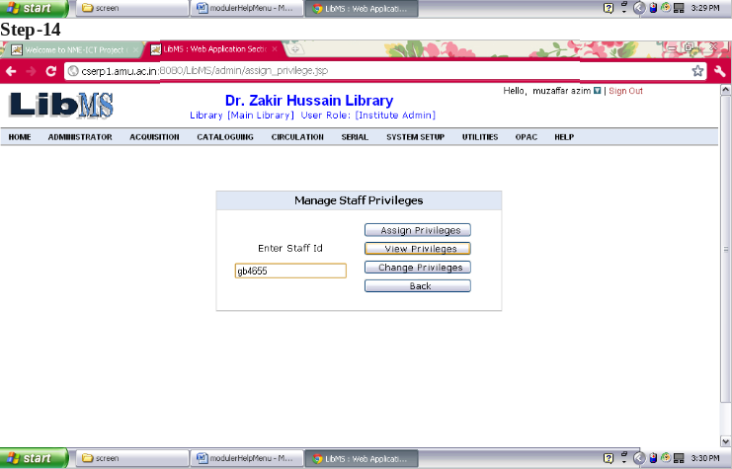
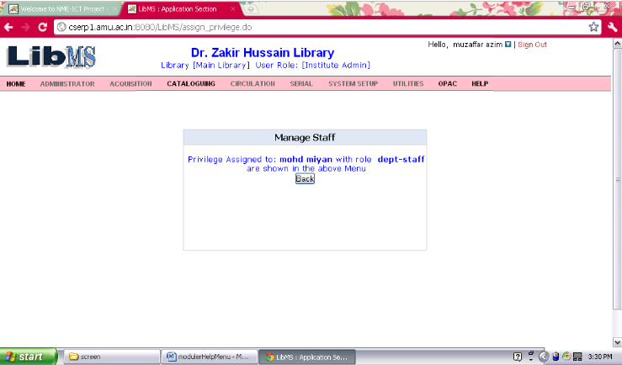

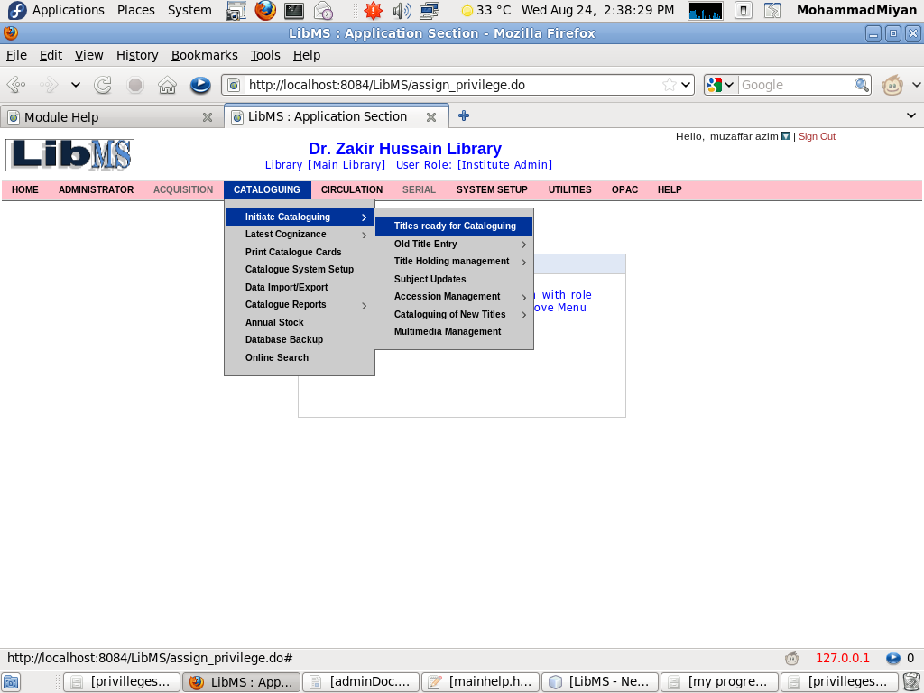
Circulation Module

In Circulation Module, We can perform Activities like Member Registration Activity, Member Account creation activity. Circulation transactions viz. issue, return, renewal, reserve, queue can be successfully done also.
Circulation->Member Management->Member Detail->Register

The librarian/Administrator of the library can Register Member of the user by clicking Register Link.
Enter Member ID of the user to register. The Member Id can be enrollment number or any other Id number belonging to the member.

Fill all the fields and click Submit button
After Clicking on Submit Button, If registration is done Record Inserted Successfully message will appear.
You can also Create account here or you can Skip this step to create account later.

Enter Card Id and Click Submit button

if account is created successfully a confirmation mail regarding username and password is sent to the user
Circulation->Member Management->Member Detail->Update

Enter Member ID to update
Make Changes you want to make and click update button
Record Updated successfully message will appear.

Circulation->Member Management->Member Detail->Delete

Enter Member Id of the user to delete record
If there Is Check Out (or the user is issued a book) you can not delete him
Circulation->Member Management->Member Detail->View

Enter Member Id and Click View button

Circulation->Member Management->Member Detail->View All

Circulation->Member Management->Member Account->Create Account
You can Create account for already registered user(If a user is not registered you have to register him then you can create account for him)
Fill all the mandatory fields and click Submit button to create account

If account is created a email regarding username and password is sent to the member

Circulation->Member Management->Member Account->Update Account
This Activity is use to Update Member account Details.

This Activity is use to display the Account Details of Circulation. Enter Member Id and click view button to View Detail for him
Circulation->Member Management->Member Account->View Account

Circulation->Member Management->Member Account->Delete Account

Enter Member Id and Clcik Delete button to delete

Circulation->Member Management->Member Account->View All Account

Here is the list of all accounts

Circulation->Check Out (Issue)
Member can get books/documents issued with this module. Click Check Out to Issue book to the member

Enter Member Id to check Out

Enter call Number of the book and click Submit button and click check out button to check out

You can check check out detail of the member by clicking detail link

Here is the check out detail of the member

Circulation->Check In (Return)
Click Check In to receive a book from the member.

Enter Accession Number of the book to Check In

Click check In Button to check in

Finally Check In successful message will appear

Circulation->Delinquent Member

This Activities is use to block/unblock a member.
Enter Member Id and Click Block button to blocked the member.

Enter Reason of blocking account and click Submit button

Member Record Successfully Blocked message will appear

Circulation->Check Out Report
You can check all the Check out made by user for a particular period of time by this module

Circulation->Check In Report
You can check all the Check In made by user for a particular period of time by this module

Cataloguing Module

The various activities in this module are- Initiate cataloguing process where the user can manage bibliographic record of a title.
The facility of entering data in multi-language is given in LibMS. For eg. if a title is in Hindi the user can insert bibliographic records in Hindi with or without changing the system keyboard.
Accessioning of items corresponding to a title.
Catalog card and bar-code printing of items.
Updating holding of a title.
MARC21 standard bibliogarphic data entry facility.
Import and export facility from and to various file formats such as excel, marc file, and text file.
Multilingual data entry in cataloguing module.
Multilingual search in OPAC module.
Catalog card printing, bar-code generation, MARC21 standard data entry facility are yet to be integrated with LibMS.

Activity Name : Cataloguing->Initiate Cataloguing->Old Title Entry->Manage Bibliographic

Select Document type(BOOK,Journal,CD,DVD),Enter title and ISBN of the book and Click New Button.

Select Document Category from the drop down box(Make sure the document you are feeding here is issuable or non issuable. If the document you are feeding here is issuable select document type from the issuable document type if it is non issuable then select it from non issuable document type. If you dont find category of your document you can add it from system Setup
(System Setup->Manage Document Category->Add Document).
Fill all the mandatory fields and click Save button. You can also assign accession number to the document from here by clicking 'Save and go for accession'.
Note : Every Book/document in the library must has different accession number. We do accessioning to assign number of copies of the same title name.

You will see this screen only when you click 'save and go for accession'. This screen is for assigning accession number to the book. You can not assign same accession number for two book/document.
Fill in all the relevant fields and click 'add item'.
You will see a message "Item is saved successfully with record no * ".If you want to add more books click add item otherwise click 'Cancel'.
Activity Name : Cataloguing->Initiate Cataloguing->Old Title Entry->Manage Bibliographic->Update
Select Document type,Enter Title and ISBN and Click update button to update.
Make changes in the relevant fields and click update button.
"Record updated Successful" message will appear.
Activity Name : Cataloguing->Initiate Cataloguing->Old Title Entry->Manage Bibliographic->View

View Select Document type, Enter Title and ISBN and Click view button to view
Activity Name : Cataloguing->Initiate Cataloguing->Old Title Entry->Manage Bibliographic->Delete
Select Document type Enter Title of the Book and/or ISBN of book and click Delete Button
You will see information regarding book/document if you want to delete click delete button.

You can not delete a book if multiple copies of it are accessioned,So delete detail of the book from here delete all its accessioned copies.
If no book is accessioned you can delete recotrd and you will see following message "Record Deleted successfully".

Activity Name : Cataloguing->Initiate Cataloguing->Old Title Entry->View All

You will see a list of various document titles. Click view if you want to see bibliographic details of it.
On Clicking View you will see this screen.

Activity Name : Cataloguing->Initiate Cataloguing->Accession Management->Change Accession Number
Accession number is the unique identity of a particular copy of a particular book.We can assign accession number to a book only if its title is registered/fed through "Entry Using Simple Template" (cataloguing->Initiate cataloguing->cataloguing of New Title->Entry Using Simple Template). Every Book/document in the library must has different accession number.We do accessioning to assign number of copies of the same title name.

Click on cataloguing->Initiate cataloguing->Accession Management->Change Accession Number

Select Document Type and enter title of the book/document of which you want to assign accession number and click new button.
You will see book /document detail. if click add new item.
Fill in all relevant fields and click add item.
You will see a message "Record is saved successful with Record no * ".If you want to add more books click add item otherwise click 'Cancel'.
UPDATE You can update accession number of a book/document from here.
Select Document Type, enter book/document title and click update button.
You will see Bibliographic detail of the book. Click Edit to Update.
You will see a list of books/documents regarding the entered title.Click Edit which book you want to update.
You will see message "Item Detail is Updated successfully".
ViewSelect Document type,Enter Title and Click view button to view.
You will see Bibliographic detail of the book.Click View to View.
You will a see list of different accessioned book of the same title. click view to view a particular accessioned book.
Delete Select Document type Enter Title of the Book and click Delete Button
You will see bibliographic detail of the book. To delete Click delete.
you will see a list of different accessioned book of the same title.Click delete to delete a particular accessioned book.
Note you can not delete a book if it is issued.
Click Delete.
You will see a message "Item detail is deleted successfully"
Activity Name : Cataloging->Initiate Catalouging->Cataloging of New Titles->Entry Using Simple Template

If you add a record here, the user can see this record in OPAC module's New Arrival.
Select Document type(BOOK,Journal,CD,DVD),Enter title and ISBN of the book and Click New Button.
Select Document Category from the drop down box(Make sure the document you are feeding here is issuable or non issuable. If the document you are feeding here is issuable select document type from the issuable document type if it is non issuable then select it from non issuable document type. If you dont find category of your document you can add it from system Setup(System Setup->Manage Document Category->Add Document).
Fill all the mandatory fields and click Save button. You can also assign accession number to the document from here by clicking 'Save and go for accession'.
NOteEvery Book/document in the library must has different accession number.We do accessioning to assign number of copies of the same title name.
You will see this screen only when you click 'save and go for accession'. This screen is for assigning accession number to the book. You can not assign same accession number for two book/document.
Fill in all the relevant fields and click 'add item'.
Cateloguing->Initiate Cateloguing->Cateloguing of New Titles->Entry Using Simple Template->Update
Select Document type,Enter Title and ISBN and Click update button to update.
Make changes in the relevant fields and click update button.
"Record updated Successful" message will appear.
Cateloguing->Initiate Cateloguing->Cateloguing of New Titles->Entry Using Simple Template->View Button
Select Document type,Enter Title and ISBN and Click view button to view.
Delete Select Document type Enter Title of the Book and/or ISBN of book and click Delete Button

System Setup
From this Module you can customize LibMS according to your library, you can set how much fine should be charged to the member and the period of relax of fine,you can set label/hierarchy of the library, sub library, departmental library,seminar library, book banks etc,you can add and publish notices for the members of the library,you can add faculty and manage them, you can add departments and courses run by various departments,you can define member types such as students, employee,staff etc of the library.

System Setup->Manage Notices->Add Notice
in this module you can write notice and publish them. All the notices published in this module are displayed in OPAC module.
Click on System Setup->Manage Notices->Add Notice

To write notice you have to give a proper notice id, all the notices are distinguised by this notice id.It is better to have some criteria while making this notice id so that notice id can be remembered easily.

Type the subject of the notice and write notice in the Enter detail section,Click Submit button.Now your notice is published in the library, you can check it in OPAC->Notices

Your notice is displayed in OPAC, see picture below

System Setup->Manage Notice->Update Notice
Click on System Setup->Manage Notice->Update Notice
Enter Notice Id to update Notice and click update button.

Make changes in the notice and click update button. to go back click Back button.

Record updated successfully message will appear. see picture below.

System Setup->Manage Notice->Delete Notice
Click on System Setup->Manage Notice->Delete Notice
Enter notice Id and click delete button to delete notice.

click confirm button to delete or go back
Record deleted successfully message will appear. see picture below

System Setup->Manage Notice->View NOtice
Click on System Setup->Manage Notice->View Notice
Enter Notice id to view the notice. You can view all notices in (System Setup->Manage Notice->View All Notice).

System Setup->Manage Notice->View All Notices
Click view All Notices and you will be displayed a list of all notices.
here is the list of notices

Manage Location
In this module you can define various location of your library. You can give proper Names to various section of the library(eg. Research Division, Professional Division, Graduation Studies etc). Every location name is uniquely identified by its unique location Id so it is recommended to use some criteria while making location id(eg. use RD for Research Division)

System Setup->Manage Location->Add Location
Click on System Setup->Manage Location->Add Location
Enter appropriate Location Id and click add button. It is recommended to make certain criteria to generate location Id so that you can easily remember location Id( Ex. PSD for professional studies division).

type location name and its description in the fields and click submit button.

record inserted successfully message will appear. See picture below.

record Inserted successfully message will appear..

System Setup->Manage Location->Update Location
Click on System Setup->Manage Location->Update Location
type location id and click update button

Make changes in the fields and click update button.

record Updated successfully message will appear..

System Setup->Manage Location->Delete location
Click on System Setup->Manage Location->Delete location.
Enter location id to delete location.

System Setup->Manage Location->View location
Click on Manage Location->View location
Type location Id and click View button

System Setup->Manage Location->View All Location

Click view all location to view all locations.

Here is the list of all the locations, see picture below.

Manage Member Types
In manage member types module you can define Member types Ex. Student, Staff, Teaching, Non Teaching etc. So that you can define various type of services(Number of books permitted to issue, max number of day a member of the group allowed to keep the book) to them. You can further categorize each member type to its sub member type Ex. Student is further categorize to gradate and postgraduate.

System Setup->Manage Member Types->Add Member

Click on System Setup->Manage Member Types->Add Member.

Enter Member type Id and click add button. It is recommended to make some criteria to generate member type id so that it is easy to remember.

Enter member Name and click Submit button.

record Inserted successfully message will appear..

System Setup->Manage Member Types->update Member
Click on Manage Member Types->update Member.
Enter location id you want to Update.

Make changes you want to reflect and click update.

record Updated successfully message will appear..

System Setup->Manage Member Types->Delete Member
Click on Manage Member Types->Delete Member
Enter location id you want to delete.

click delete or go back.

record deleted successfully message will appear..

System Setup->Manage Member Types->view Member
Click on System Setup->Manage Member Types->view Member.

System Setup->Manage Member Types->View All Member
Click on System Setup->Manage Member Types->View All Member

Manage Sub Member Types
In this module you can make one level hierarchy of member types(ie. you can make sub member of the members you have priviously defined in "Manage Member Types module"). This hierarchy of members and sub members will be used in defining fine details.

System Setup->Manage Sub Member Types->Add Sub Member
Click on System Setup->Manage Sub Member Types->Add Sub Member
Enter appropriate Sub Member Id add Sub Member. Use some criteria while making new sub member id so it is remembered easily.

System Setup->Manage Sub Member Types->Update Sub Member
Click on System Setup->Manage Sub Member Types->Update Sub Member
Enter Sub Member Id to Update Sub member.

System Setup->Manage Sub Member Types->Delete Sub Member
Click on System Setup->Manage Sub Member Types->Delete Sub Member.
Enter Sub Member ID to Delete Sub Member.

System Setup->Manage Sub Member Types->View Sub Member
Click on System Setup->Manage Sub Member Types->View Sub Member.
Enter Sub Member ID to view Sub Member.

System Setup->Manage Sub Member Types->View All Sub Member
Click on System Setup->Manage Sub Member Types->View All Sub Member.
Here is the list of all the sub members.

Manange Document Category
In this module you can define document types (Text Books,Journals,Reference Books,Periodicals,News Papers,CD etc) available in your library. you can also define documents which can not be issued to the members .

System Setup->Manage Document Category->Add Document Category
Click on System Setup->Manage Document Category->Add Document Category.
Enter appropriate document ID to add document. Use some criteria while making document ID so that it is easy to remember.

System Setup->Manage Document Category->Update Document Category
Click on System Setup->Manage Document Category->Update Document Category.
Enter document id to update document.
Make changes in the fields and click update.

System Setup->Manage Document Category->delete Document Category
Click on System Setup->Manage Document Category->delete Document Category
Enter Document ID to delete document.

System Setup->Manage Document Category->View Document Category
Click on System Setup->Manage Document Category->View Document Category
Enter document id to view document.

System Setup->Manage Document Category->View All Document Category
Click on System Setup->Manage Document Category->View All Document Category
Here is the list of documents.

Configure Fine Parameters
In this module you can define fine and max number of permissible days a member can have any document of the library. The fine is calculated on the basis of sub member(eg. Student->Post Graduate) of the library.

System Setup->Configure Fine Detail->Set Fine detail
Click on System Setup->Configure Fine Detail->Set Fine detail
Select Member Type, Sub Member Type,Document Category and click add button. If the member type is not in the drop down list Add it in Add Member Type(System Setup->Manage Member Type->Add Member).If the sub member is not in the drop down list add it in Add Sub Member(System Setup->Manage Member Type->Add Sub Member)
set fine detail and click submit button.
Record inserted successfully message will appear.

System Setup->Configure Fine Detail->Update Fine detail
Cl;ick on System Setup->Configure Fine Detail->Update Fine detail.
Select Member type, Sub Member type,Document Type and click Update button
Make changes in the fields and click update button to update.
If record is updated "Record Updated Successfully" message will appear.

System Setup->Configure Fine Detail->Delete Fine detail
Click on Configure Fine Detail->Delete Fine detail
Select Member Type,Sub Member type,Document Category and Click Delete button.
Click Confirm button if you want to delete.

System Setup->Configure Fine Detail->View Fine detail
Click on System Setup->Configure Fine Detail->View Fine detail
Select Member Type,Sub Member type,Document Category and Click view button.

System Setup->Configure Fine Detail->View All Fine detail
Click on System Setup->Configure Fine Detail->View All Fine detail
Here is the list of all the fines.

Manage Faculty
In this module admin/librarian can define university/college structure. A college can have many faculties(A faculty consists of many departments such as faculty name "Science" can be made of various departments like botany,Zoology,Comp Sc,Mathematics,Chemistry,Physics etc).

System Setup->Manage faculty->Add Faculty
Click Add Faculty to add a faculty in your college/university .
Enter appropriate faculty Id to add a faculty name. Use some criteria while making this Id so that it is remembered easily. Some examples are use sc for science and engg for Engineering faculty.
Enter Faculty Name and click Submit button.
Record Inserted successfully message will appear.

System Setup->Manage faculty->Update Faculty
Click Update Faculty to update faculty name.
Enter Faculty Id to update faculty name.
make changes in the name and click update
Record update successfully message will appear.

System Setup->Manage faculty->delete Faculty
click delete to faculty from the library record.
Enter Faculty Id to delete faculty.
Click Delete button to delete faculty.
Record deleted successfully message will appear.

System Setup->Manage faculty->View Faculty
Click View faculty to view faculty name.
Enter Faculty Id to view Faculty.

System Setup->Manage faculty->View All Faculty
Click View All Faculty to see all faculty names in the library.
Here is the list of all faculties ............

Manage Department
This module is used to Make the structure of the Faculty. Admin/librarian can add departments in a particular faculty.

System Setup->Manage Departments->Add Department
Click Add department to add department in the faculty.
Chose faculty and enter appropriate department Id to add department.
Enter department name and click submit button.
Record inserted Successfully message will appear.

System Setup->Manage Departments->Update Department
Click update Department to update.
Enter department Id.
Make changes in the name and click update button.
Record updated successfully message will appear.

System Setup->Manage Departments->delete Department
Click Delete Department to delete department.
Select faculty and Enter department id to delete department from faculty.
Click delete button to delete department from the faculty.
record Deleted successfully message will appear.

System Setup->Manage Departments->View Department
Click View Department to view name of the department.
Enter department Id to view department.

System Setup->Manage Departments->View All Department
Click view all department to view list of all department.
Here is the list of all the departments.

Manage Course
This module you can add various courses run by departments. This is the last level of library hierarchy can make departmental library of various courses here by adding course in the department.

System Setup->Manage Courses->Add Course
Click Add Course to add a course in the department.
Select Faculty and then Department and enter appropriate course Id. every course is recognized by its id in the library.
Enter Course name and click submit button.
Record inserted successfully message will appear.

System Setup->Manage Departments->Update Course
Click update Course to update course name.
Select Faculty and Department and enter course id to update course.
change course name and click update button to update .
Record updated successfully message will appear.

System Setup->Manage Departments->Delete Course
Click Delete Course to to delete.
Select Faculty and Department and enter course id to delete Course.
Click confirm button to delete.
Record delted successfully message will appear.

System Setup->Manage Departments->View Course
click View Course to view course.
Select Faculty and Department and Enter Course Id to view course detail.

System Setup->Manage Departments->View All Course
Click View All Course to view all courses of a particular department.
Here is the list of all course of the selected department.

Manage Sub Library
In this module admin/librarian can make one level hierarchy of sublibraries/Departmental libraries.

System Setup->Manage Sub Library->add Sub Library
Click add SubLibrary to add SubLibrary.
Enter appropriate Sub library Id to make Sub Library.
Select Faculty and Department and enter Department address and click Submit button to add Sub Library.
Record Inserted successfully message will appear.

System Setup->Manage Sub Library->Update Sub Library
Click Update Sub Library to update Sub Library.
Enter Sub Library Id and Click Update button.
Select Faculty and Department then make changes in the Sub library address and click update button.
Record updated successfully message will appear.

System Setup->Manage Sub Library->Delete Sub Library
Click Delete Sub Library to delete Sub library.
enter Sub Library Id and click delete button.
Record Deleted Successfully message will appear.

System Setup->Manage Sub Library->View Sub Library
Click View Sub Library to view a sub library.
Enter Sub Library Id to see detail of the Sub library and click view button.
Here is the detail of the sub library(see picture).

System Setup->Manage Sub Library->View All Sub Library
Click View All Sub Library to see all Sub libraries.
Here is the list of all the Sub Libraries.

