Activity Name : Barcode Generation of Accession No.

Here we enter list of accession number in the given box ,the list must be separated by comma otherwise there are some errors while barcodes to be generated of the list .if the list does have an accession number which is not available in library, it reports for non availability of the number.
In the following, we are providing list of accession number separated by commas.
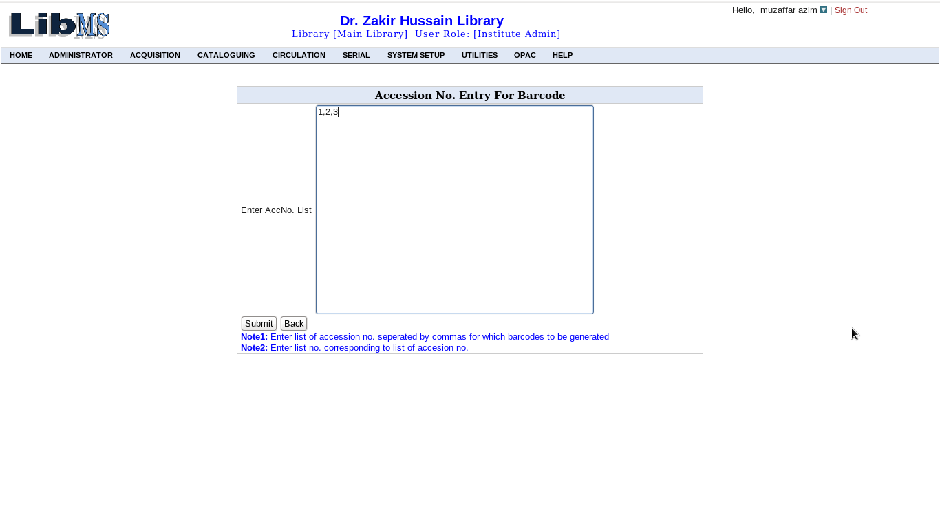
After clicking the submit button,we have the following screen
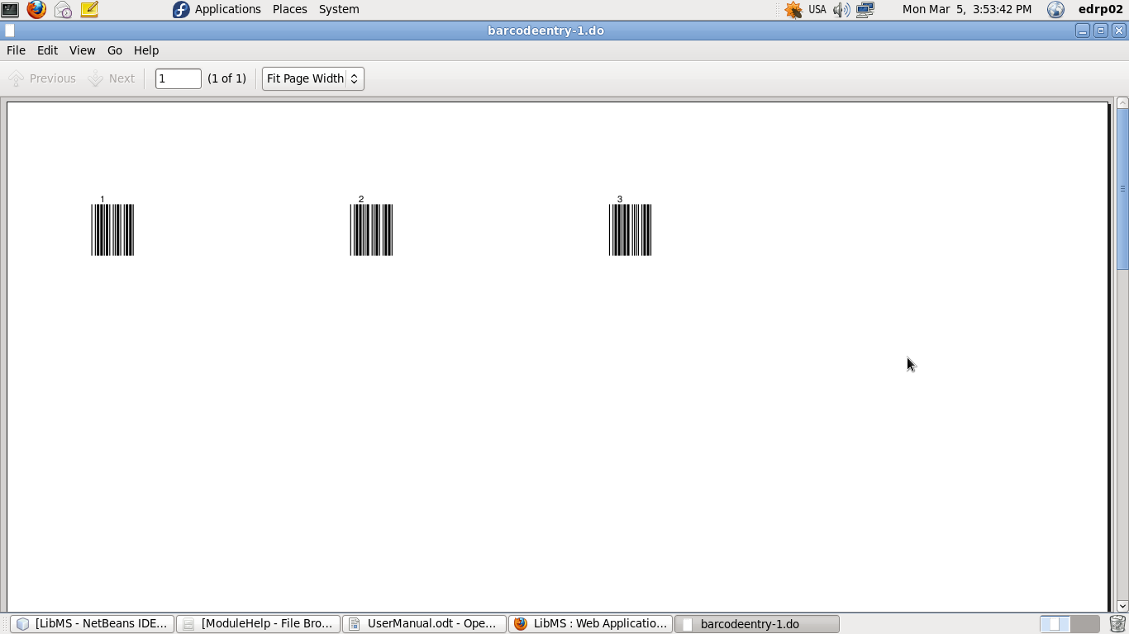
If we have list of accession numbers in which some accession number are not exist then we have the following screen.
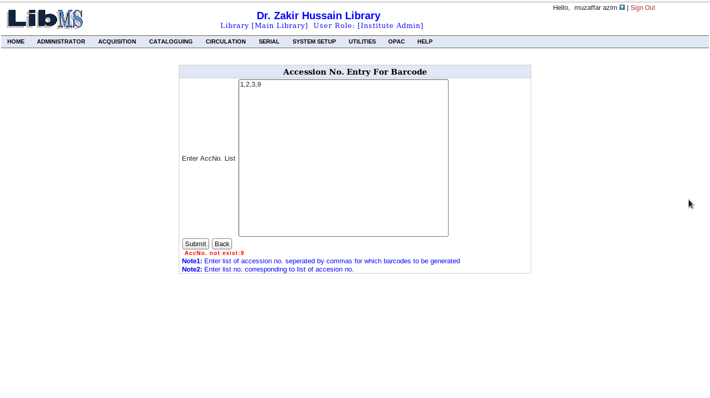
Accession number 9 is not exist in the library so it reports AccNo not exist.
Activity Name : Barcode Scanner
In this activity we deal with barcode and barcode scanner, here we
scan barcode on book and the scanned thing picks in the corresponding text
box of the following interface that results information of the book corresponding to the barcode on the book. the following interface depicts the
activity.

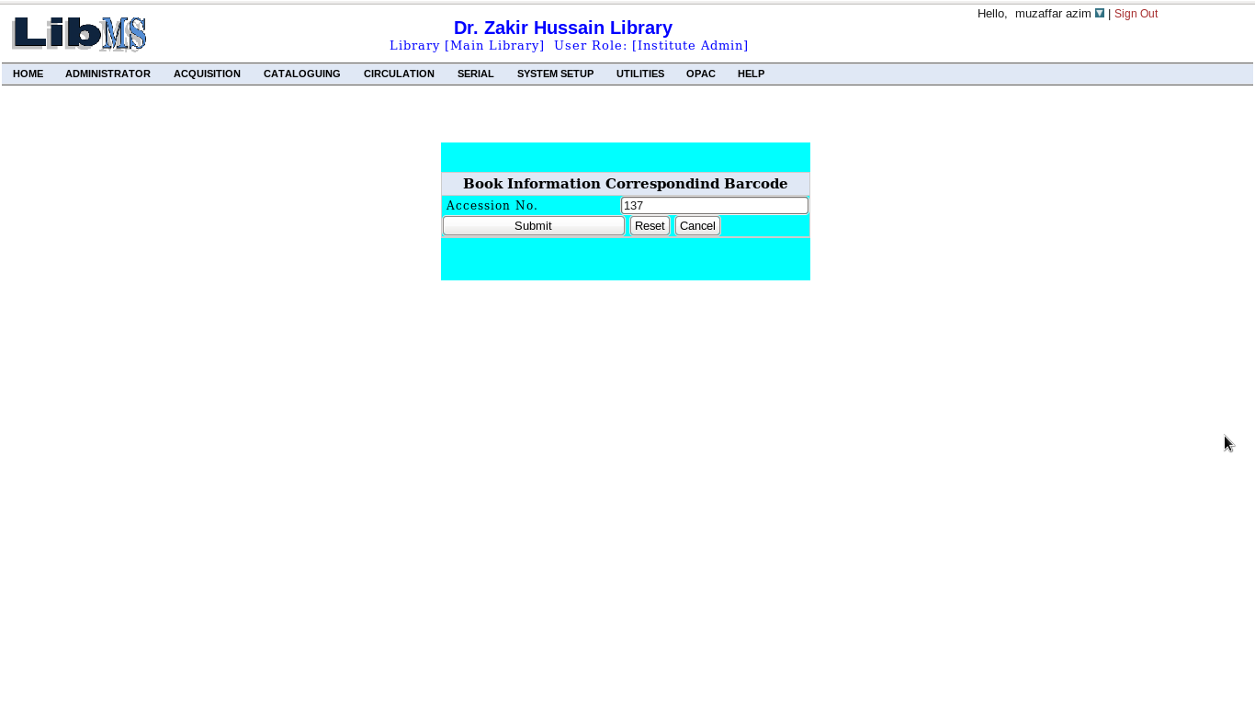
After scanning barcode on the book and click on the submit button
we have the following interface.
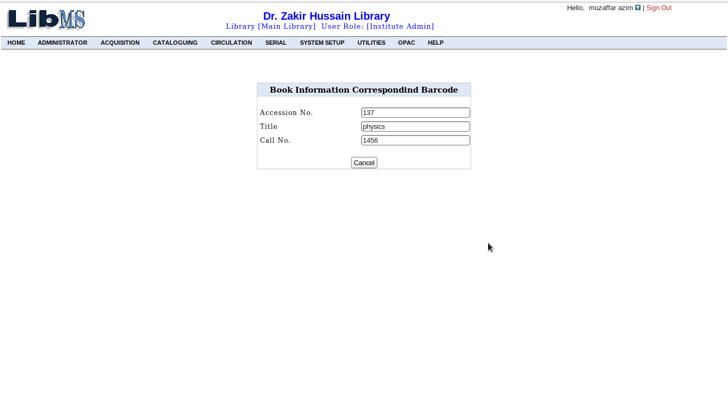
Activity Name :Record Keeping-> Serial Language

To perform this activity we have the following interface.
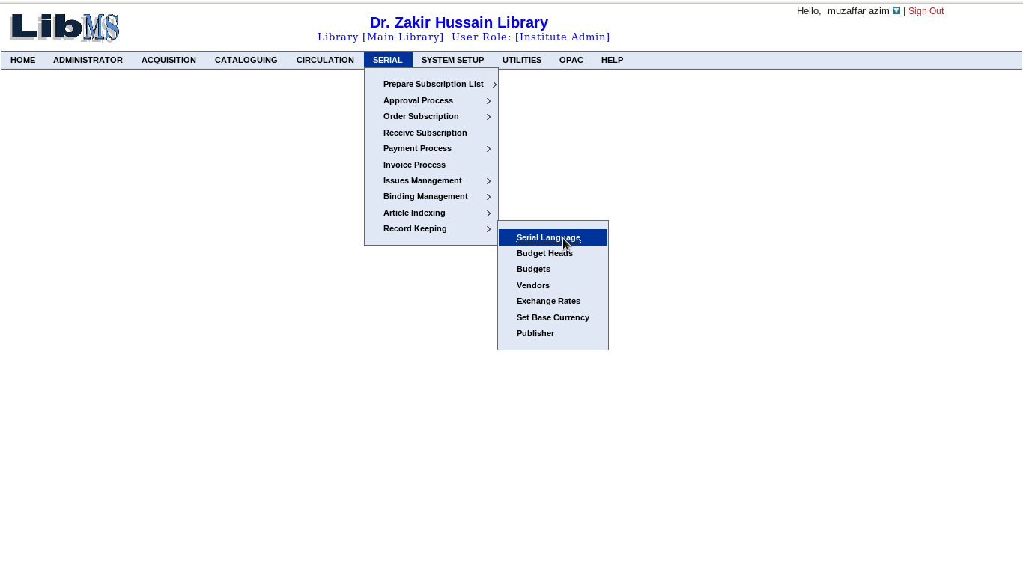

This activity deals with serial languages in which we enter types of
languages of the given serial. first we enter language id to enter new language or to update, delete, and view language corresponding to the language. the interface use to do this is given below.
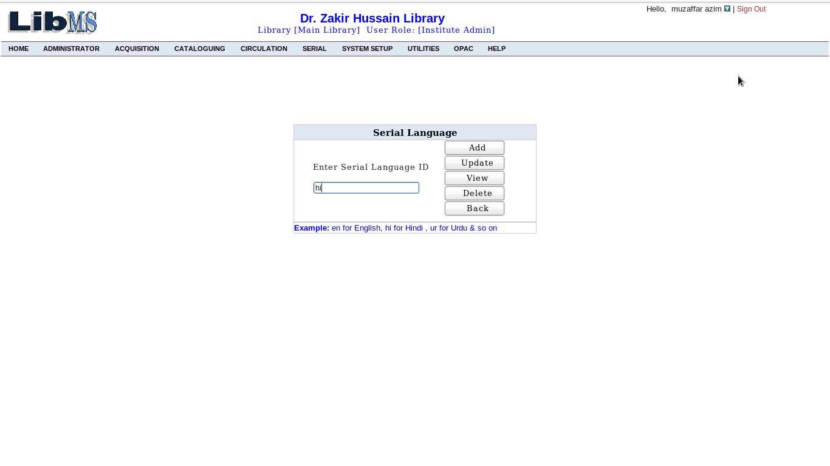
After clicking on the button Add, we have the following interface
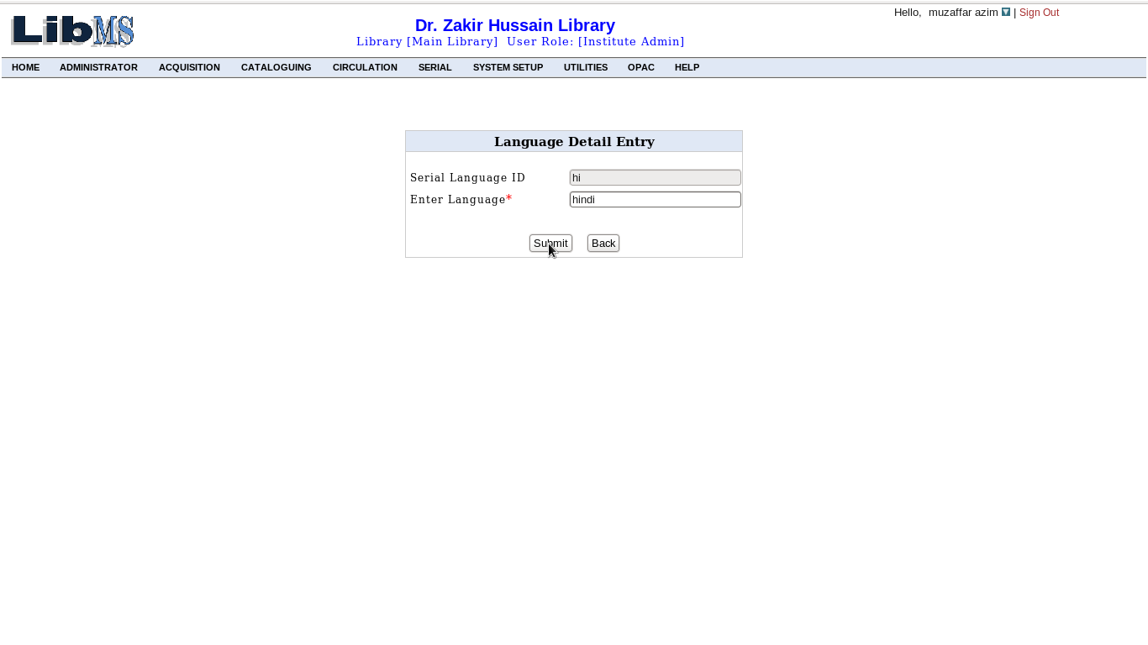

click on the submit button , Hindi language has been entered into the system
and the same procedure, we can follow for updating, deleting and view. After performing any of the such activity, we have the following interface with successful message corresponding activity.

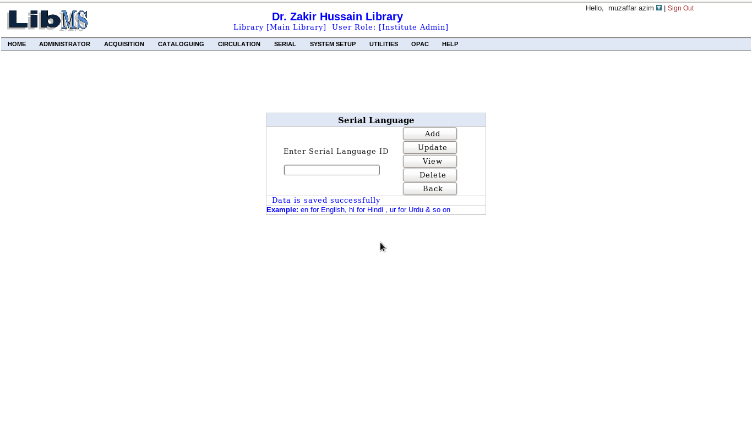

Activity Name :Record Keeping-> Publisher

To perform this activity we have the link in the following interface.

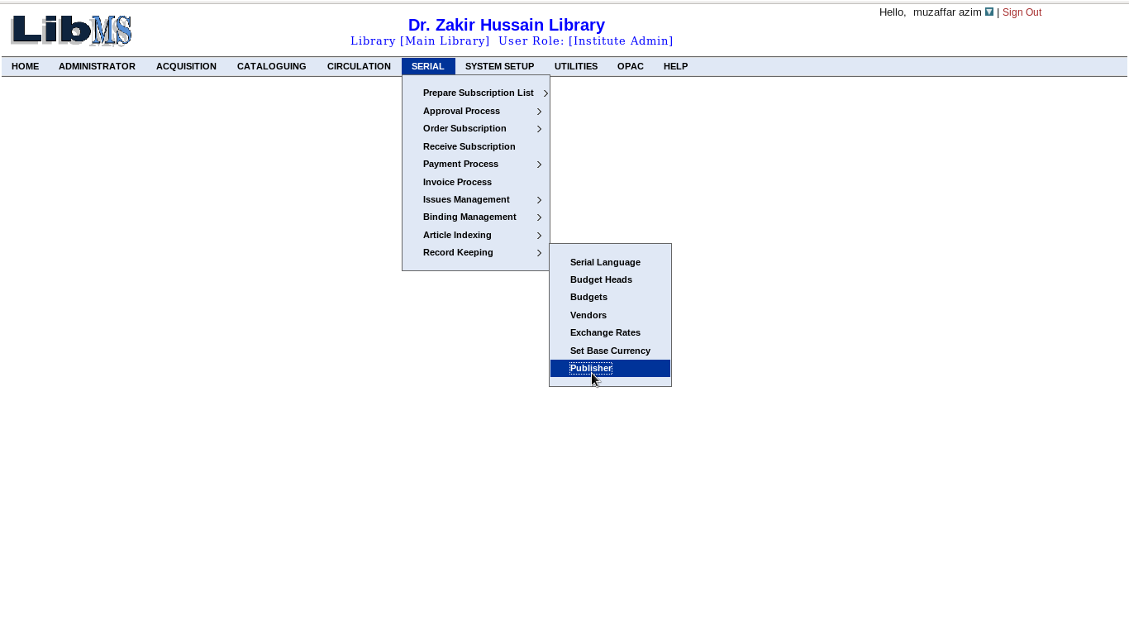
This activity deals with serial Publisher in which we enter Publisher of serials. first we enter serial id for adding new publisher or to update, delete, and view Publisher corresponding to the serial id. the interface use to do this is given below.
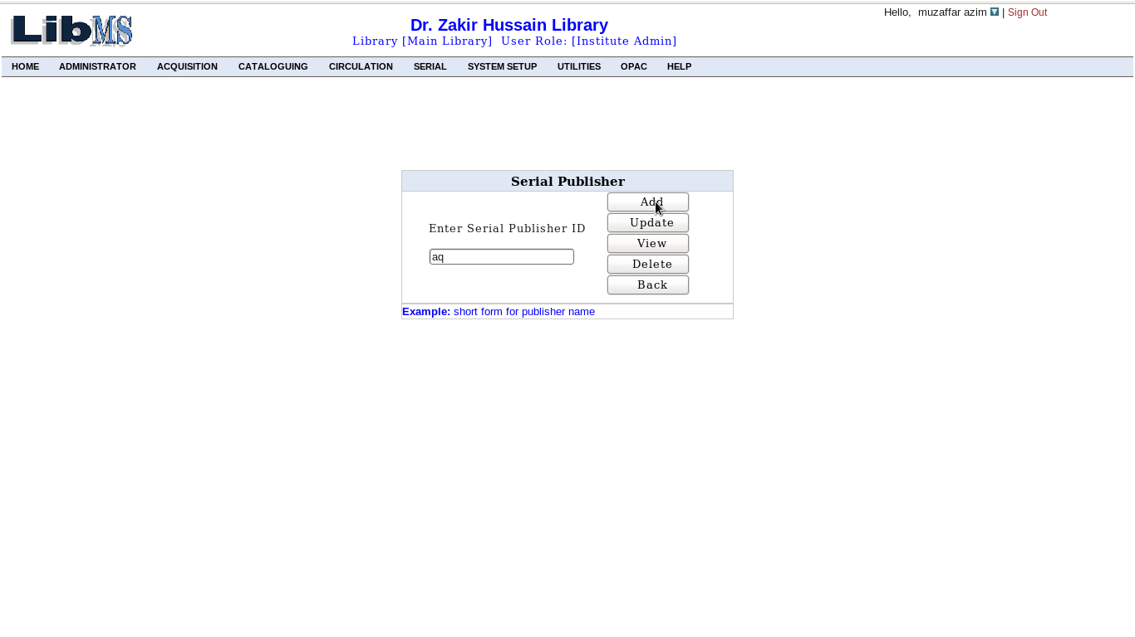
After clicking on the button Add, we have the following interface
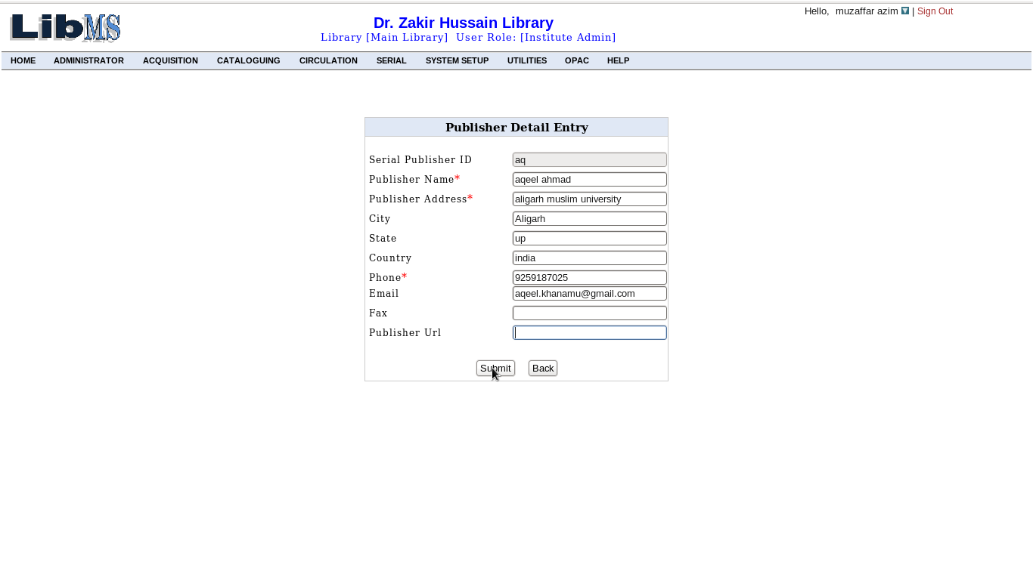
click on the submit button , Publisher Aqeel Ahmad has been entered into the system and the same procedure, we can follow for updating, deleting and view. After performing any of the such activity, we have the following interface with successful message corresponding activity.

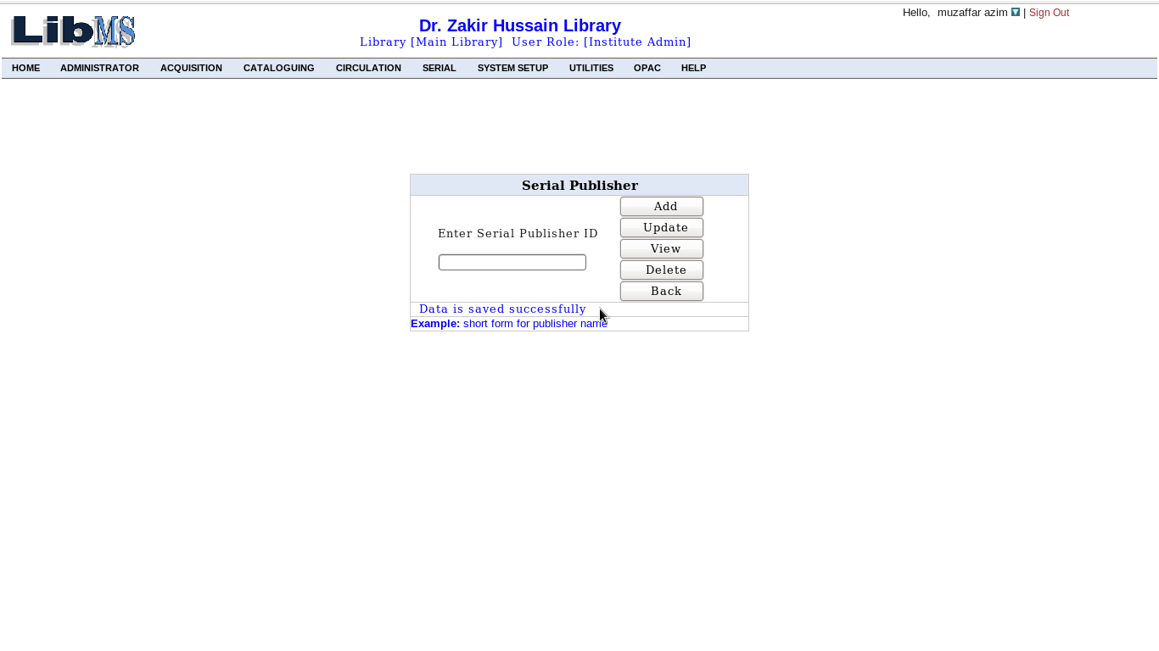
Activity Name :Record Keeping-> Budget Head

To perform this activity we have the link in the following interface.
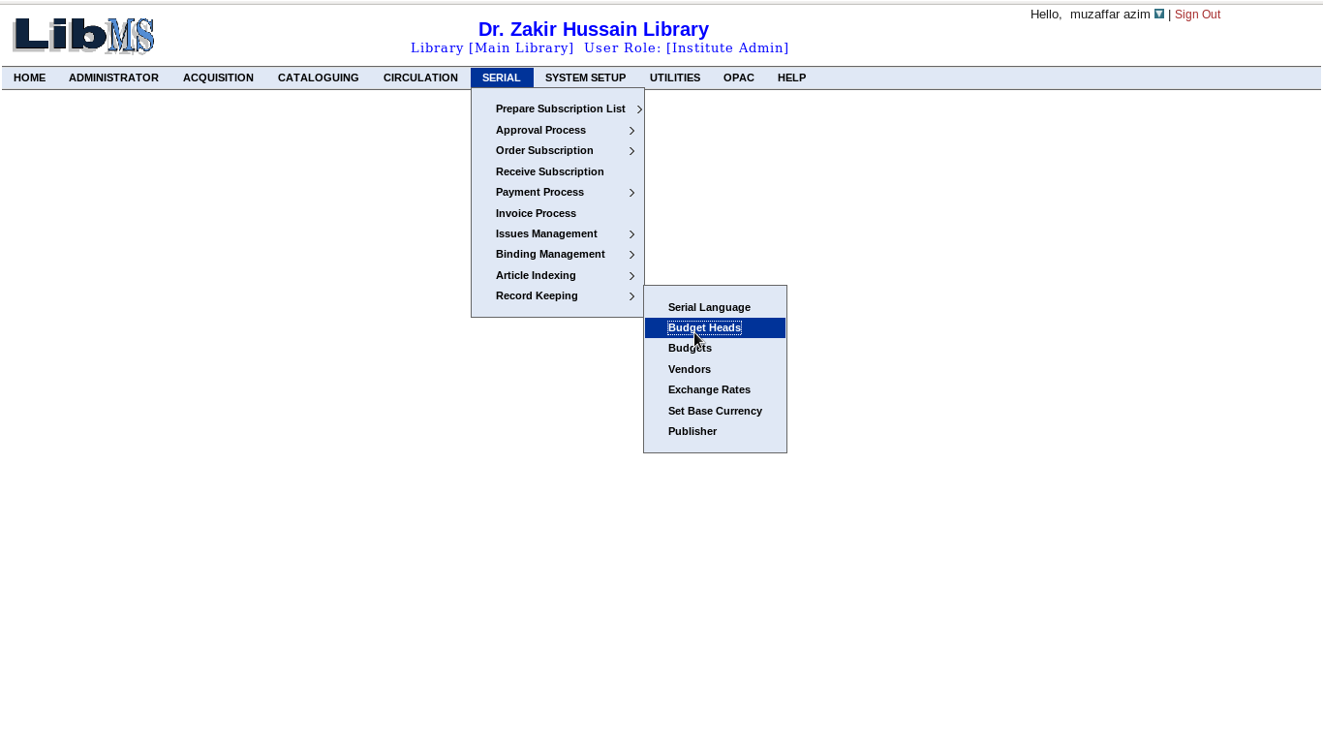
This activity deals with creating budget heads for the department, library and etc. to create new budget head or update, delete, view old budget head first to enter budget head id corresponding to budget head and to do this we have the following interface. The following interface may also be used to view all budget heads that had been entered by clicking the viewAll button.

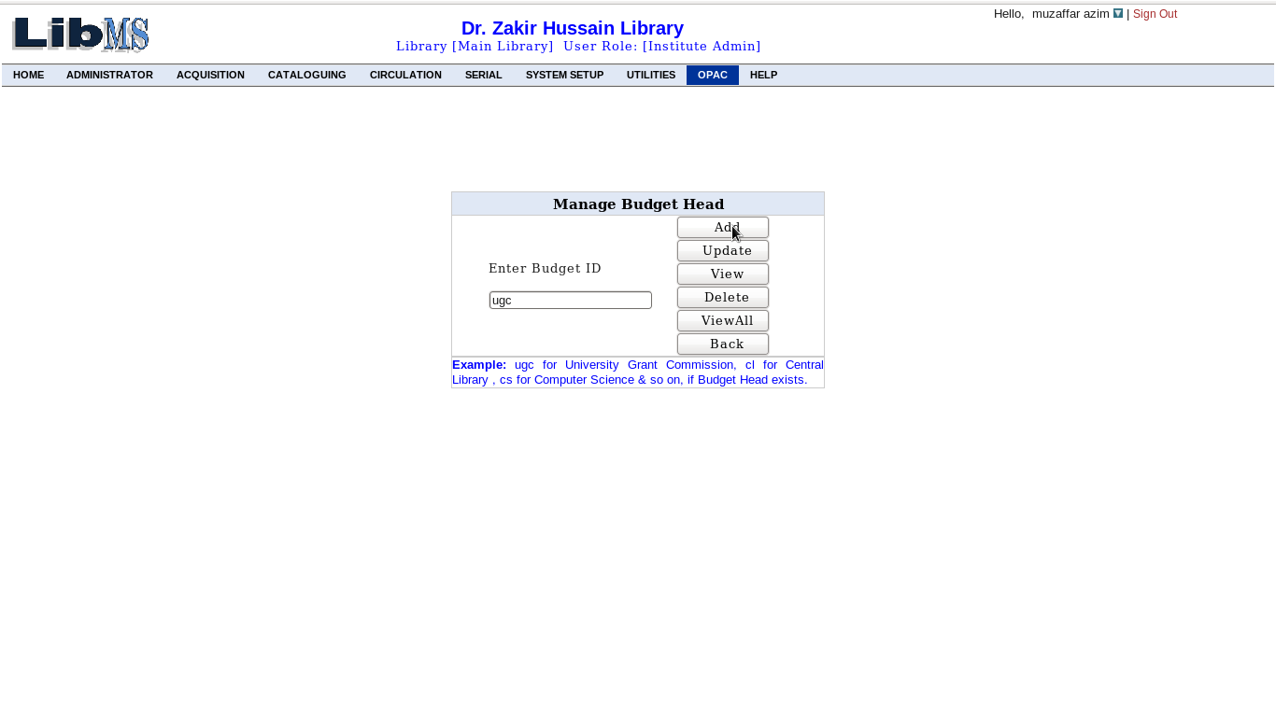
After clicking on the Add button, we have the following interface
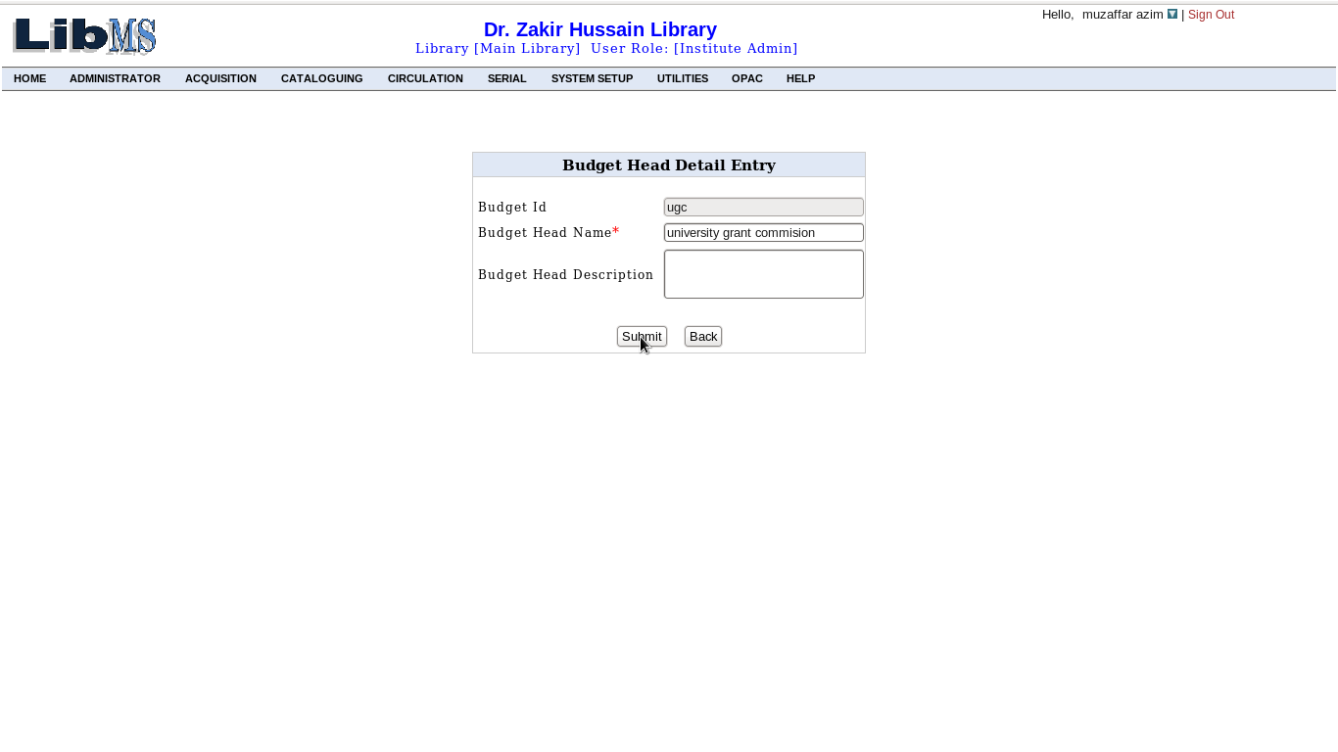
here we must provide the budget head name corresponding to the budget head id and budget head description may or may not be provide,it depends on you. After filling the necessary details click on the Submit button, Budget Head University Grant Commision has been entered into the system and the same procedure, we can follow for updating, deleting and view. After performing any of the such activity, we have the following interface with successful message corresponding activity.
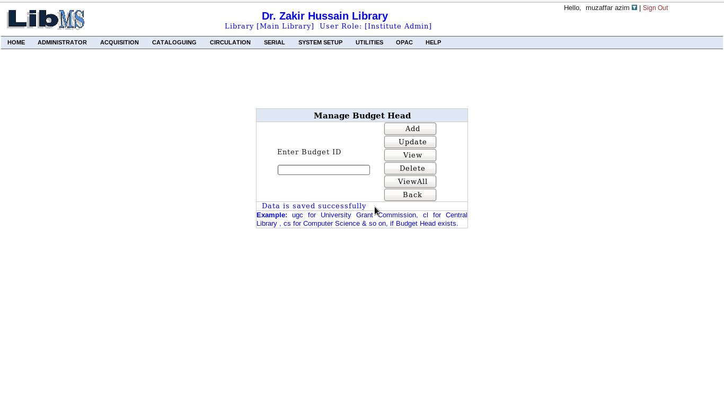
To view all budget head that has been registered with the system by clicking the ViewAll Button in the following interface.
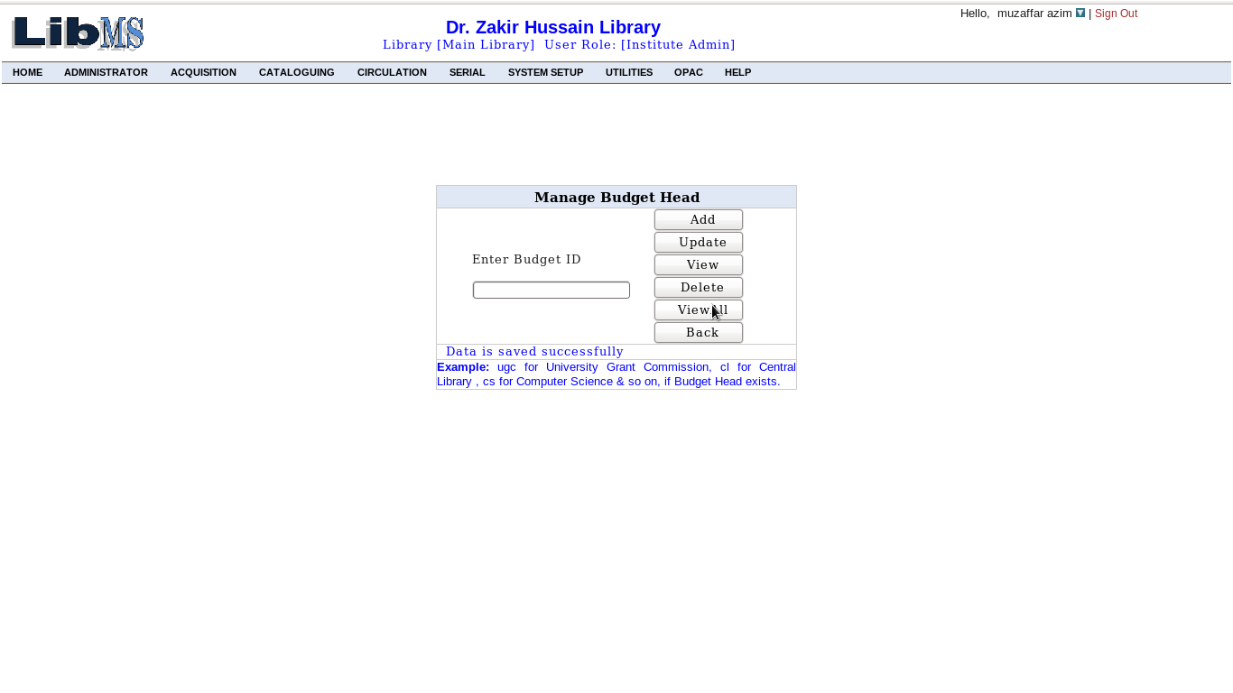

After clicking we have details of all registered budget heads of the system.
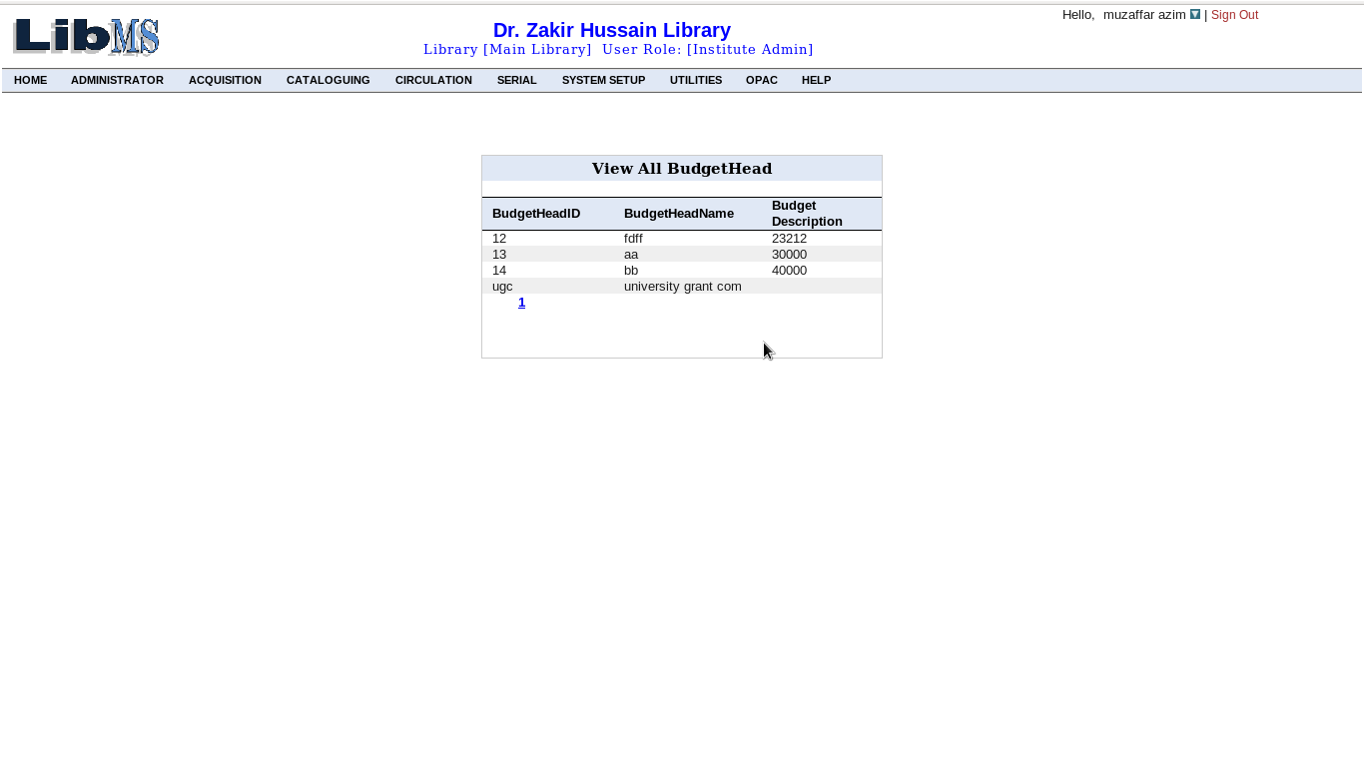
Activity Name :Record Keeping-> Budget Head

To perform this activity we have the link in the following interface.
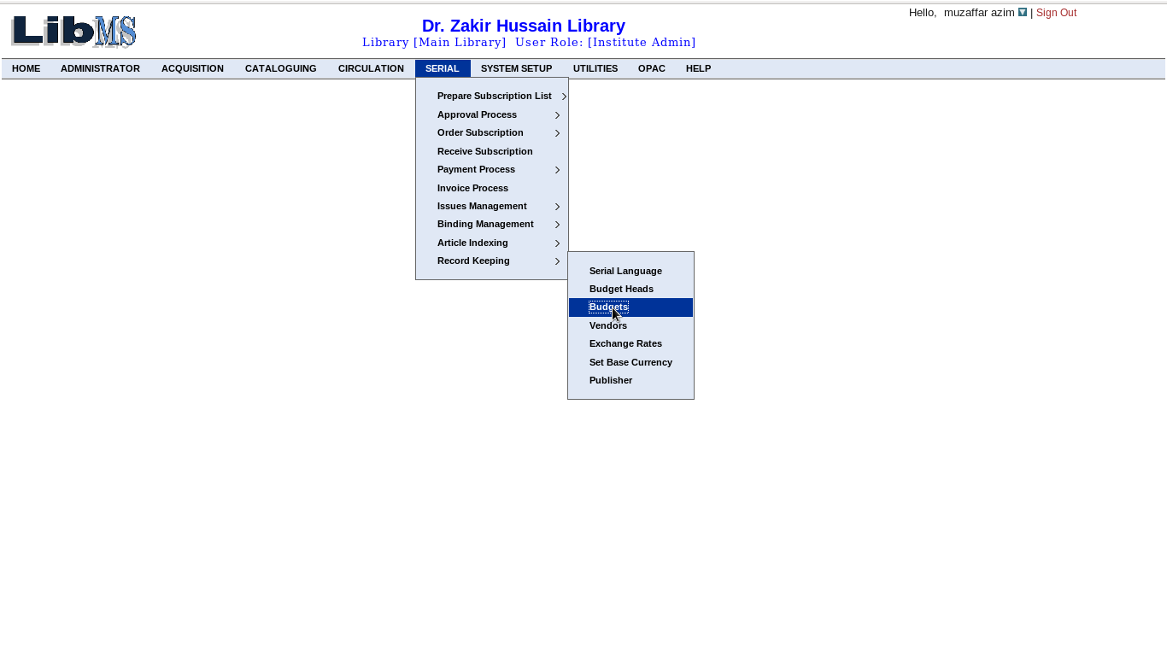
This activity deals with to allocate budget corresponding to the already created budget head. To do this we have the following interface in which we must select the budget head to which budget to be allocated and financial year.

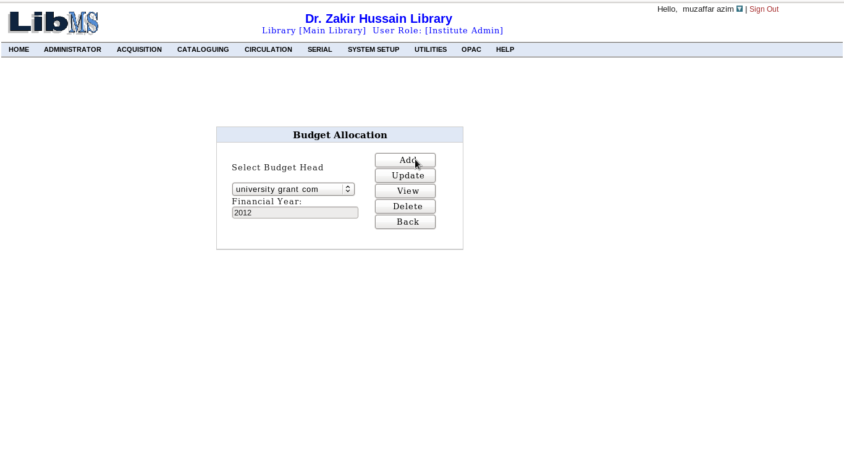
After clicking Add button we have the following interface.
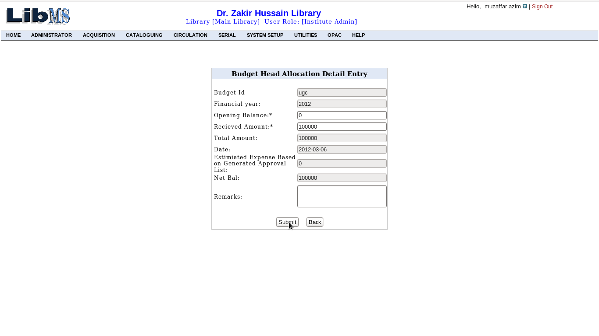
Here we must provide received amount that shows how much amount is being allocated. Opening balance and total amount depends on system.After filling the necessary details click on the Submit button, Budget for University Grant Commission has been allocated into the system and the same procedure, we can follow for updating, deleting and view. After performing any of the such activity, we have the following interface with successful message corresponding activity.

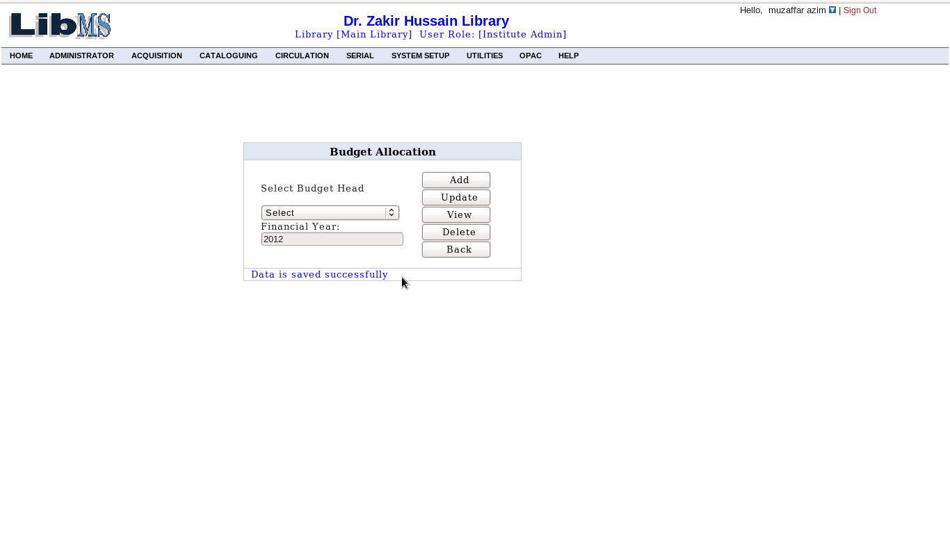
Activity Name :Record Keeping-> Vendors

To perform this activity we have the link in the following interface.
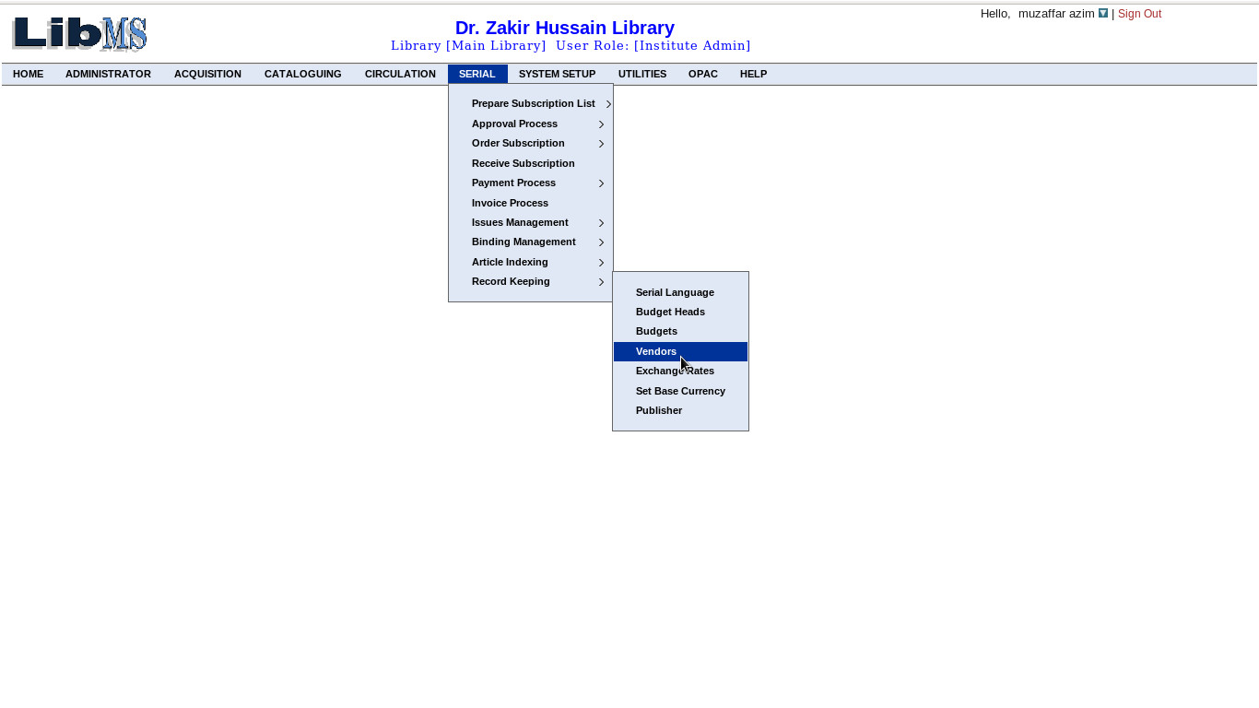
This activity deals with to create serial vendors. To do this we have the following interface in which we must provide vendor id to enter new vendor or update, delete and view corresponding to vendor id. If vendor already registered with the system, it reports vendor already exist. It also provides the facility to view all registered vendors of the system by clicking the ViewAll button.
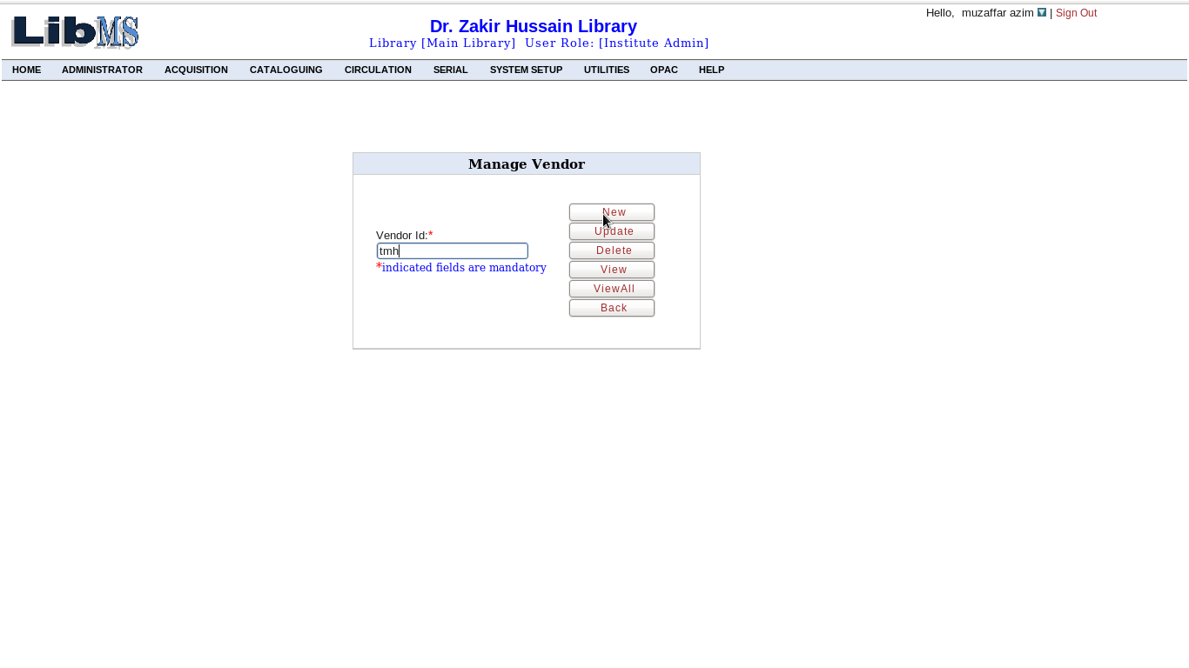
After clicking New button, we have the following interface.
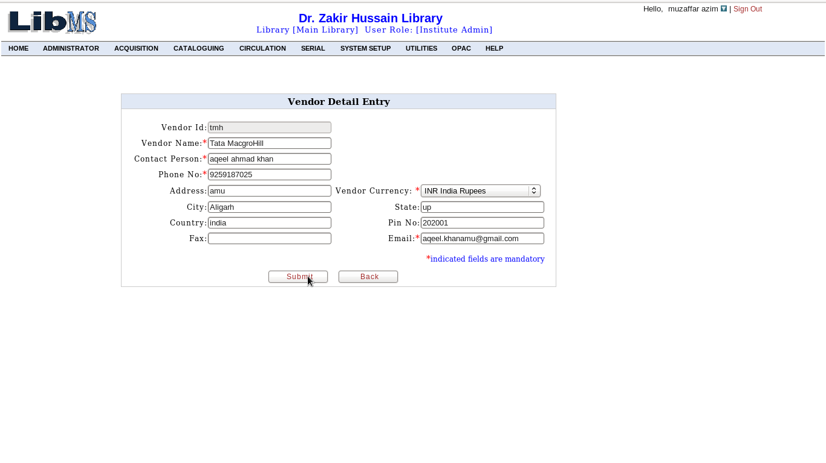
Here we must provide the necessary details of the vendor to registered with system. After providing the necessary details click on the Submit button, Vendor tmh has been registered into the system and the same procedure, we can follow for updating, deleting and view. After performing any of the such activity, we have the following interface with successful message corresponding activity.
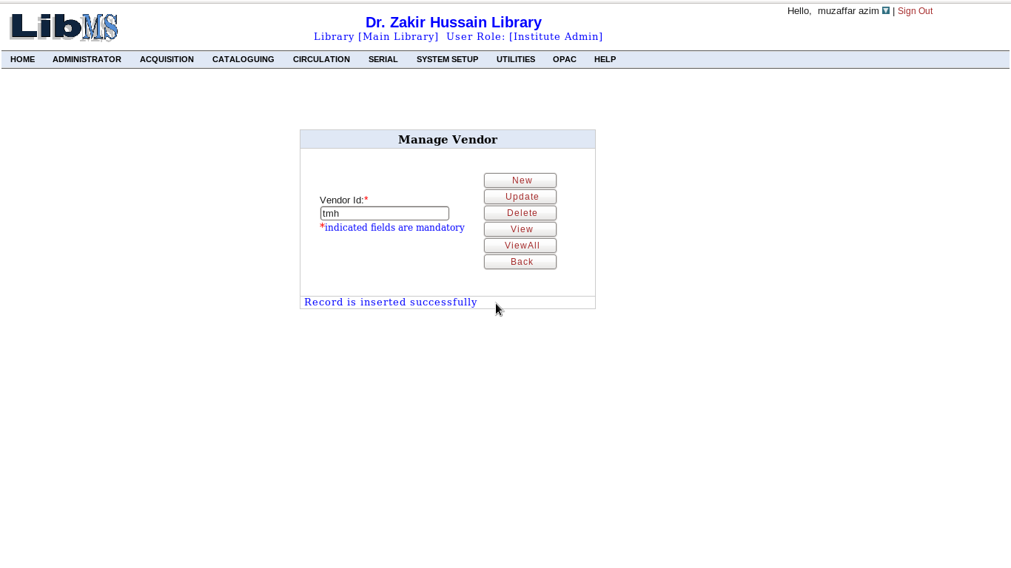
To view all registered vendors of the system click on the ViewAll button that shows all registered vendors.
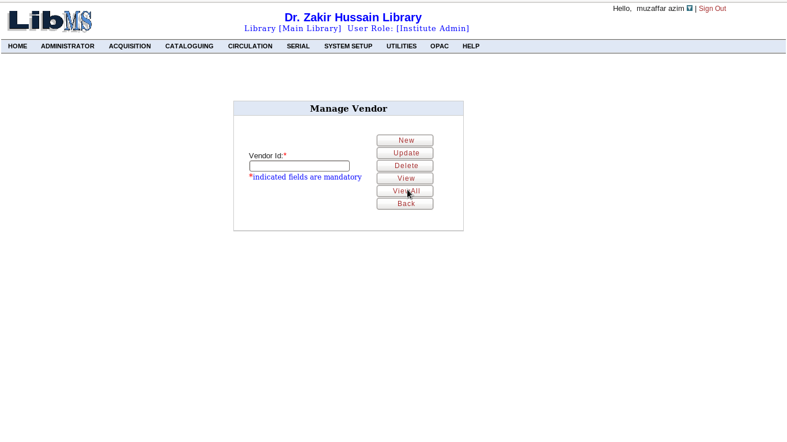

After clicking ,we have the following interface.

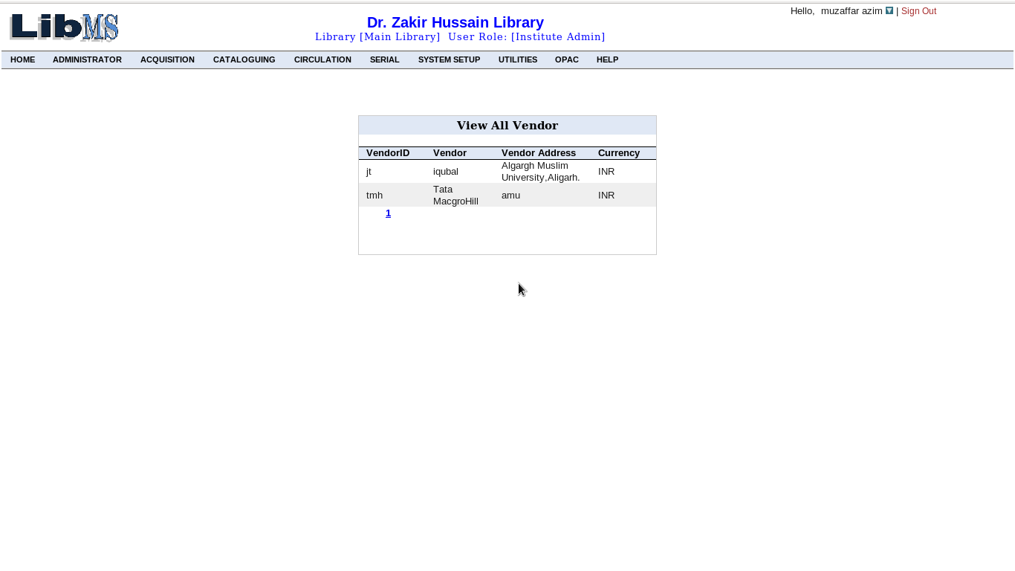
Activity Name :Record Keeping-> Exchange Rate

To perform this activity we have the link in the following interface.
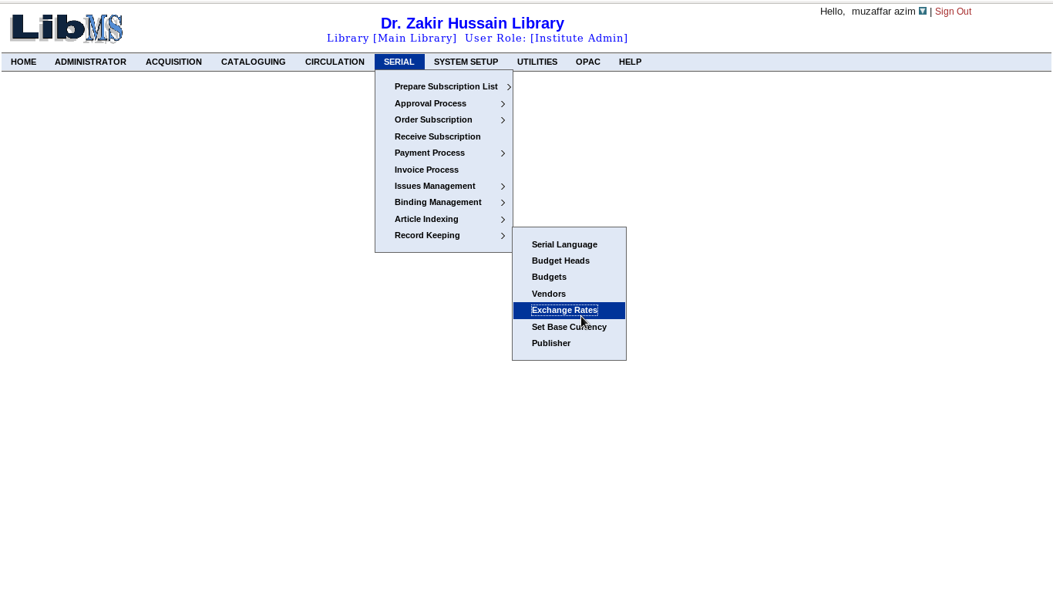
This activity deals with how to convert a given currency of the vendor into base currency of the library. It is done by manually with the help of the given interface, by adding conversion rate between two currency with help of the following. To add currency conversion first to select source currency on the given system date and click Add button.

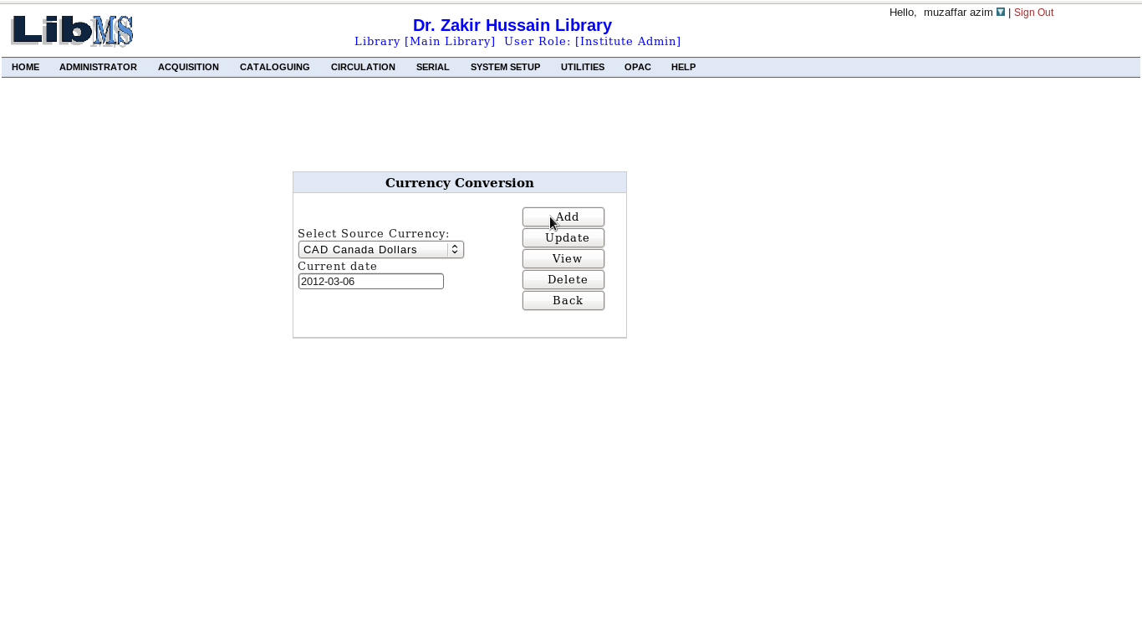
Here we have selected Canada Dollars and after this we have the following interface.
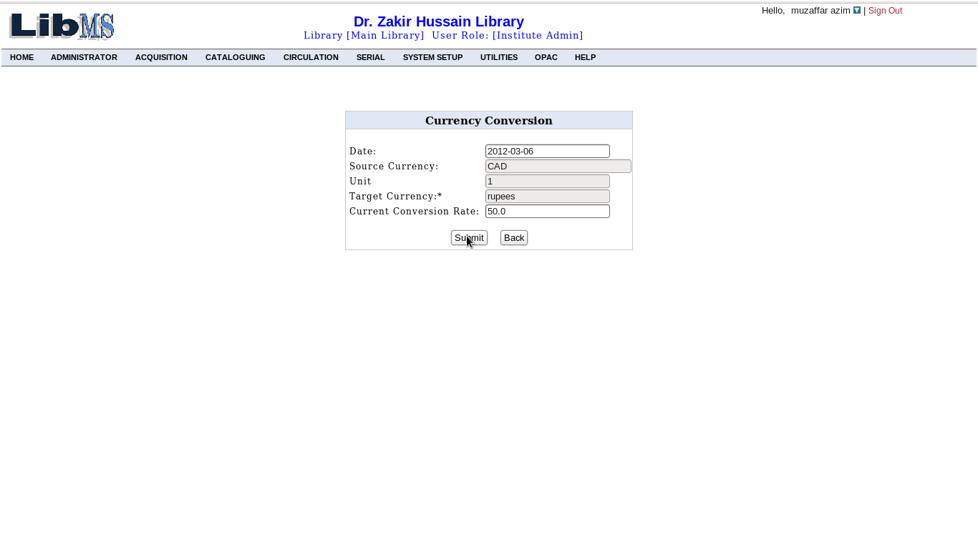
Now we have to provide necessary information corresponding to the base currency as rupees. We provide Currency Conversion Rate between rupees and Canada Dollar on the current date. Click on Submit button, Currency Conversion Rate between rupees and Canada Dollar has been added into the system and the same procedure, we can follow for updating, deleting and view. After performing any of the such activity, we have the following interface with successful message corresponding activity.
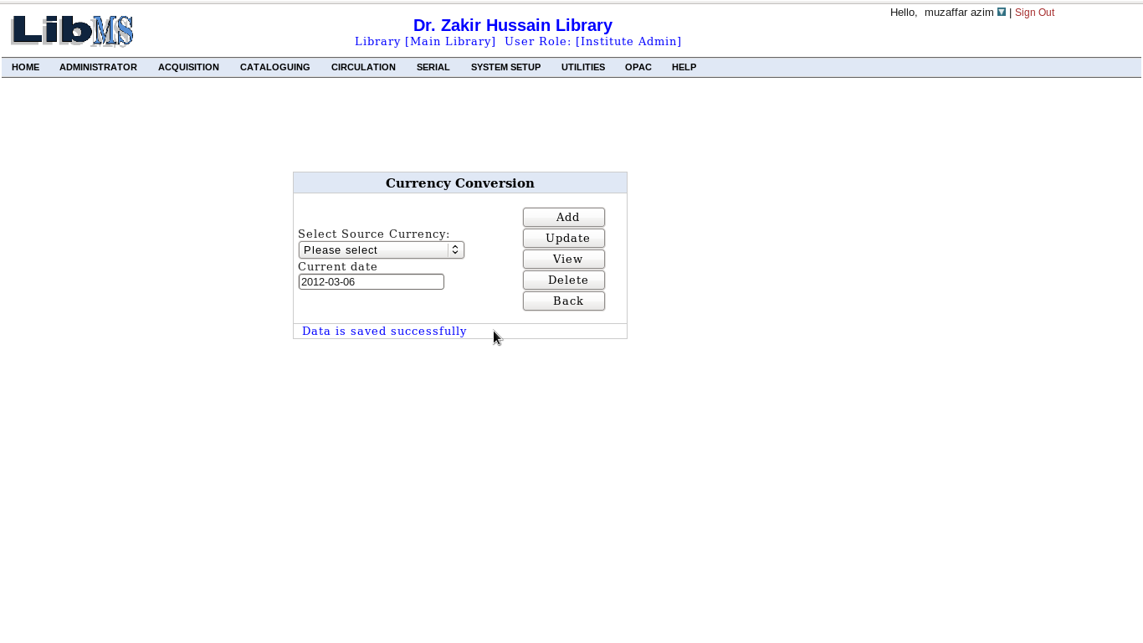
Activity Name :Record Keeping-> Exchange Rate

To perform this activity we have the link in the following interface.
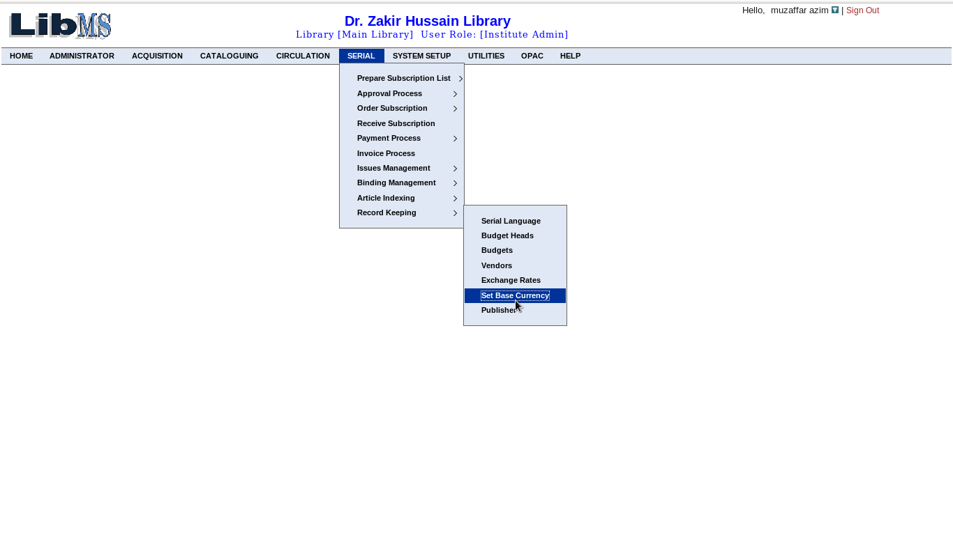
This activity deals with how to set base currency of the library on which, it is working. To set base currency we have the following interface. Here we have to select the base currency of the library first.
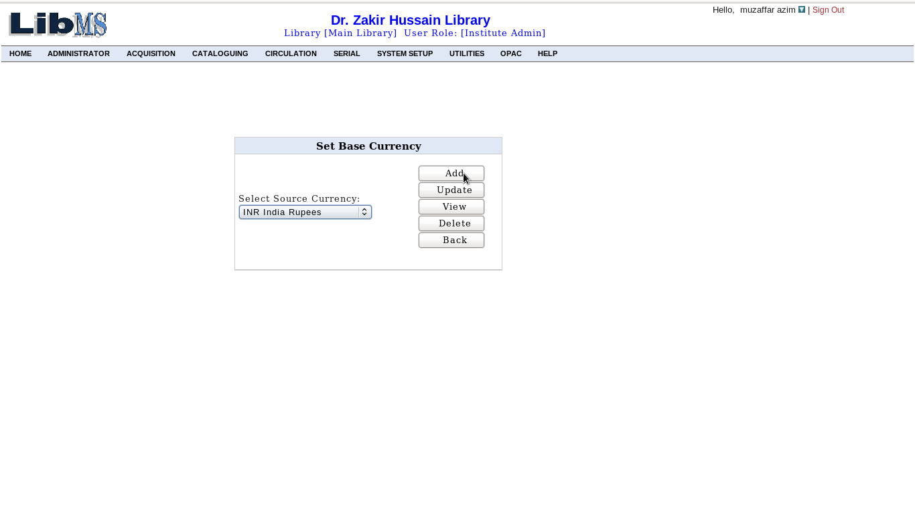
After selecting base currency then click on the Add button, we have the following interface.
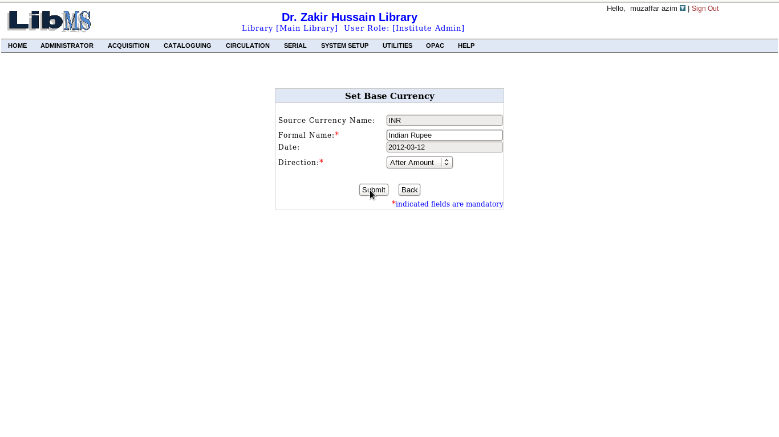
Here we must provide the necessary information eg Formal Name and Direction. And click on the Submit button, base Currency of the library has been added into the system and the same procedure we can follow for updating, deleting and view. After performing any of the such activity, we have the following interface with successful message corresponding activity.
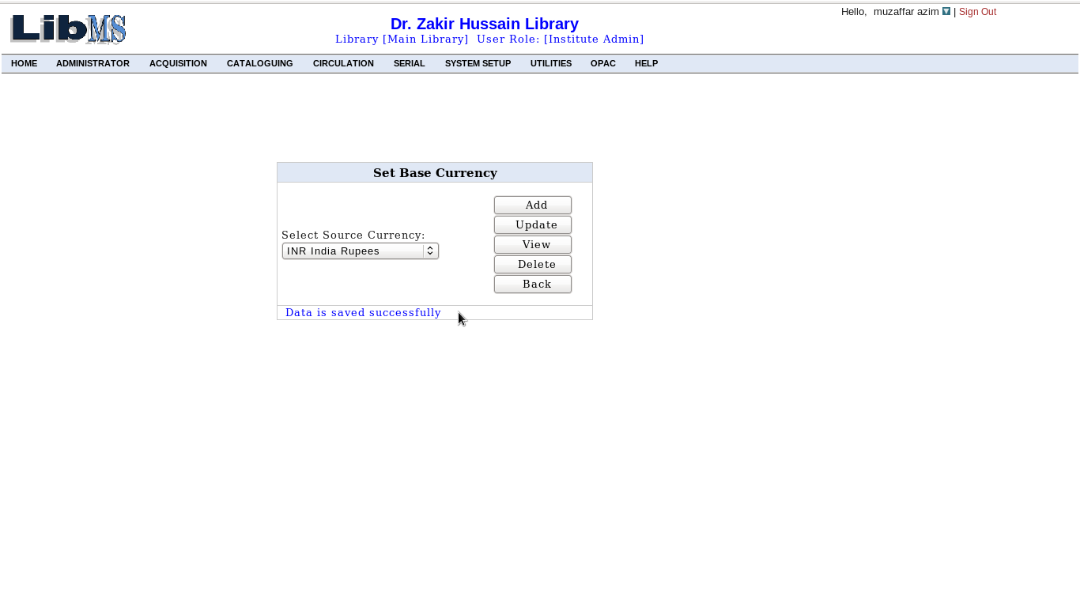
If base currency already exist in the library then report that base currency already defined.
