Chapter 1: Installation Manual
Index
1.1 Prerequisite software/Installation Manual
1.2 Hardware and software prerequisites
1.3 Software Requirements & Installation Guidelines
1.4 EMS Deployment/Installation under the Window-32/Linux family of operating systems
1.5 Overview of Election Management System

1.1 Prerequisite software/Installation Manual
Election Management System is a n-tier, client-server application. The figure below shows how the application is tiered or segmented into different layers. We Follow MVC Architecture for Web Application Development as follows.
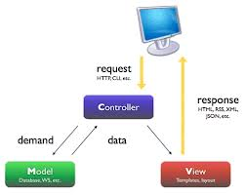

Fig 1.1: Basic Architecture of web application

Fig 1.2: Struts Framework Architecture of EMS Project

1.2 Hardware and software prerequisites
The installation of the database server, application server,and the EMS application programs is done on one or more server machines.
The servers could be any of the following:
A server at a public domain web site, LAN/Intranet server, or a standalone machine.
The standalone or LAN/Intranet version uses the MySQL as the database server and this can run under Windows 2000 Professional, Windows XP Professional or RedHat Linux 9.0/Fedora 14/CentOS 5/Ubunto 10 and above.
Client PCs or workstations for Institute staff to use the functional modules of EMS will require to install a Jdk 1.7. This is done by installing it from the Java web site client machines are defined: 1. Institute clients and 2. End-user clients.Institute clients must be at least PIII machines with at least 700 MHz clock speed, with 128 MB RAM. End-user clients could be even 486 machines with at least 64 MB RAM.
Web servers for the Networking/Consortium version or the LAN/Intranet versions of EMS should be at least P4 servers with a minimum of 1024 MB RAM. The higher the
configuration the better the performance for Institute functionality

1.3 Software Requirements & Installation GuideLines
- Java 1.6
- Tomcat 6.0
- Ant 1.7
- Mozilla Firefox

JAVA INSTALLATION
For Linux OS
a) Debian, Ubuntu
Click on Application->Accessories->Terminal
On the command line, type:
$ sudo apt-get install openjdk-6-jre
b) Fedora, Oracle Linux, Red Hat Enterprise Linux, etc.
On the command line, type:
$ su -c "yum install java-1.6.0-openjdk"
For Further Ref Click here : http://openjdk.java.net/install/
c) For Window OS
You can download the latest version of jdk from http://java.sun.com/javase/downloads/index.jsp.
Once you download the exe file you can now install it.
To install the jdk, double click on the downloaded exe file
(jdk-6u1-windows-i586-p.exe)
INSTALLATION
APACHE TOMCAT INSTALLATION
a) For Linux OS
Step 1: Download Tomcat 6.0.18 from http://tomcat.apache.org/download-60.cgi and download the Binary Distribution.
Step 2:Extract it with
$tar xzvf apache-tomcat-6.0.18.tar.gz
Step 3:Test Tomcat
Start Tomcat with:
/home/user/apache-tomcat-6.0.18/bin/startup.sh
Hit http://localhost:8080.
If all is fine you should see the Tomcat homepage.
b) For Windows OS
Step 1: Download Tomcat 6.0.18 from the given link
http://tomcat.apache.org/download-60.cgi
Step 2:Install it by double click on it and specify the location where you want to Install it
Step 3:Test Tomcat
Start Tomcat by Double Click on
C:\ApacheSoftwareFoundation\Tomcat Server 6.0\bin\startup.exe
Open Browser and Hit http://localhost:8080.
If all is fine you should see the Tomcat homepage.
For Further ref Click here: http://tomcat.apache.org/download-60.cgi

ANT INSTALLATION
- Download the Apache Ant binary release from http://ant.apache.org/bindownload.cgi.
- Once it is downloaded, extract it in a preferred installation location,
such as C:\Program Files\Apache\Ant\ for Windows or
/opt/apache-ant-1.8/. for Linux.
- Add the ANT_HOME Environment Variable
- Create an environmental variable called ANT_HOME. This variable has to contain the path created in the previous step.
- To do this on Red Hat Enterprise Linux, add the following line to the ~/.bash_profile file, substituting the path below with that which you created in the previous step.
export ANT_HOME=/opt/apache-ant-1.7.1
- On Microsoft Windows, do this by click on the Start Menu, opening the Control Panel and selecting System -> Advanced -> Environment Variables.
- Create a new variable, call it ANT_HOME and configure it to point to the directory you created in the previous step.
- Include bin in the PATH
- Append the Ant installation's bin directory to the PATH environmental variable.
- On Unix/Linux systems, do this by adding the following line to the ~/.bash_profile file. (Put it after the one which sets the ANT_HOME variable):
export PATH=$PATH:$ANT_HOME/bin
- On Microsoft Windows, do this task by opening the Control Panel and selecting System -> Advanced -> Environment Variables -> System Variables. Edit the PATH variable and append the text ;%ANT_HOME%\bin.
- To test the Apache Ant installation, run ant -version from a terminal. The output should look similar to this:
$ ant -version
Apache Ant version 1.7 compiled on June 27 2008

MYSQL INSTALLATION
FOR LINUX OS
To install, use the yum command to specify the packages that you want to install. For example:
root-shell> yum install mysql mysql-server mysql-libs mysql-server
MySQL and the MySQL server should now be installed. A sample configuration file is installed into /etc/my.cnf. An init script, to start and stop the server, will have been installed into /etc/init.d/mysqld. To start the MySQL server use service:
root-shell> service mysqld start
To enable the server to be started and stopped automatically during boot, use chkconfig:
root-shell> chkconfig --levels 235 mysqld on
Which enables the MySQL server to be started (and stopped) automatically at the specified the run levels.
The database tables will have been automatically created for you, if they do not already exist. You should, however, run mysql_secure_installation to set the root passwords on your server.
Default port of MySQL is 3306
For Futher Details Click here :
http://dev.mysql.com/doc/refman/5.1/en/linux-installation-native.html

For Window OS

Step 1: Download MySQL Server for Windows from the given link
http://dev.mysql.com/downloads/mysql/
Step 2: Install it by double click on it and Follow the Steps.
Step 3: Please Specify root password there

1.4 EMS Deployment/Installation under the Window-32/Linux operating systems
This document describes procedure to install EMS on any Linux machine.
Step for Installation of Election Management System
1. You must install tomcat application server version 6.0 onwards,
download from http://tomcat.apache.org/
2. You must install ant 1.6 onwards,
download from http://ant.apache.org/
3. You must install mysql 5 or onwards,
download from http://dev.mysql.com/downloads/
4. Download source code from sourceforge.net or our svn repository,
download from http://sourceforge.net/projects/brihaspati
or svn co http://brihsvn.iitk.ernet.in/repos/amuedrp/trunk/EMS
5. Set the context for project in context.xml at your application server
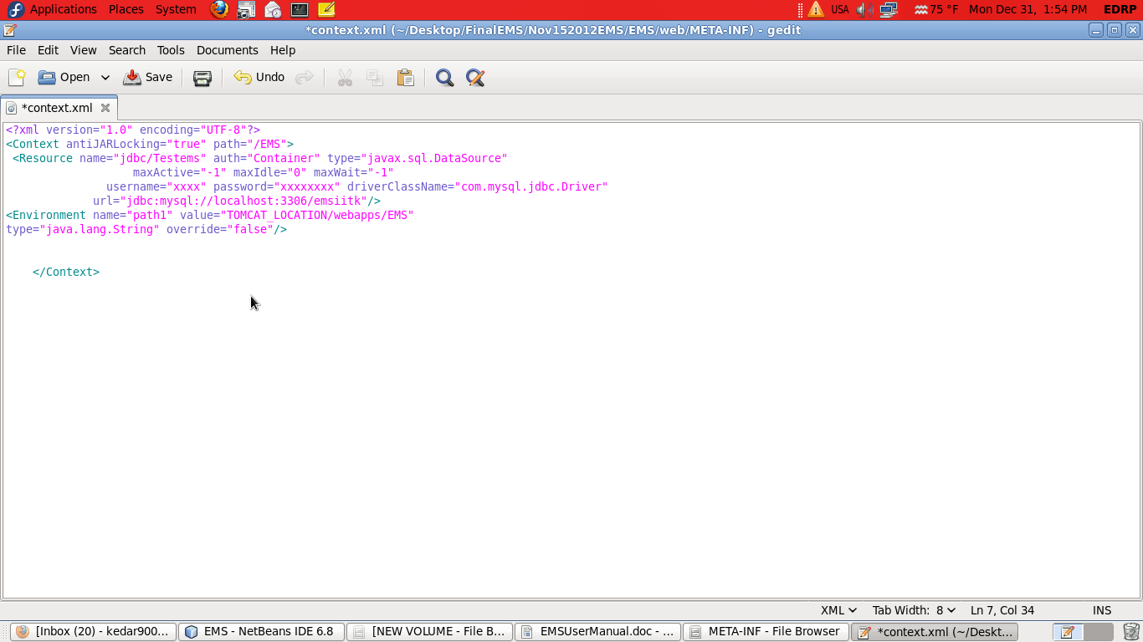

Fig 1.3 : context.xml configuration

6. create database emsiitk & Run sql script in mysql database for creating tables
7. run ant command in side EMS dir. this will generate war file
8. Start application server and deploy this war file on server
9. Access application via this URL
http://servername:portname/EMS

1.5 Overview of Election Management System

- EMS is a multi-institutional and multi-lingual election management system. It is a role-based access system. In future system will support both the Bio-metric Authentication mode as well as Unique id (UID) authentication mode and provide the mailing notice facility to its users.
- Elaborating the term multi-institutional means that the system is running on one server namely IITK server and any interested institute wishes to use it can send request to have an account to access the system, irrespective of its local requirements like database server, local server. The system is running as a service on IITK server and interested institution can use all the services provided by the system free of cost. System can also be installed locally if someone wants to install.
- The term multi-lingual means the system provies the user with interfaces in different languages thus breaking the barrier of language boundation and having the essence of truely local.
- EMS is a Web-based application. Databases created with EMS reside on web servers and can therefore be accessed by any client machine connected to the Internet. However, there Can local installations which do not need to run as applications requiring access to the web. In such case, the databases reside on local area network (LAN) or Intranet severs
- EMS uses Relational Database technology to manage databases created with it. EMS used under open source RDBMS such as MySQL. The current version of EMS that this tutorial addresses is targeted to Institute of all kinds. Currently the System support general voting process. In future System facilitate Preferential Voting Process.
- Voter Authentication for Voting Process is currently addressed in a way that One time key is sent to All Eligible voter . Only One Time Holder can vote in the running elections. In future System target Biometric Authentication Process also.
- EMS allows configured with SSL https protocol for Implementing Security
Functional modules in Election Management System.
- Web admin
- Chief Election officer
- Election Manager
- Voter
- Candidate
- Web-admin is the person who manages the EMS on server side. He receives registration requests from different institutes who wish to use the services of EMS. web-admin has the privileges to accept or reject requests for registration from any institute after verification. web-admin can reset the password of users on their request.
- Chief Election Officer is the authority of any institute who will manage the whole election process. Institute admin works as a chief election officer and can create Election Manager i.e. Election Officer for the managing particular election process. This module helps in managing Election Manager Registration, Block Election Managers Account.
- Election Officer can create, open and close elections. Election Manager will be able to manage requests of voters and candidates for registration. It will be the responsibility of Election Manager to authenticate voters, candidates and publish the result on time. This modules facilitate to upload Bulk data of voters as well as candidates. Election Manager is responsible to send user-id and password, which is system generated, to its voters and candidates.
- Voters/Candidate may register themselves online and cast their votes. Voters can register themselves as a candidate and able to manage their account in a restricted manner. Voters will be able to interact with candidates online using services like Blog, Chat, bulletin boards, etc. Voters gets a one time password for each election which is system generated and valid for a particular election.being a Candidates voter can file nomination for a particular post in a election declared by the Election Manager online. Candidates will be able to campaign online and cast their vote in secure manner.

