Step for using Brihaspati security lib

- Create remote_auth dir at home and create brihaspati3-remote-access.properties file in side remote_auth dir.

- The content of properties file are given below
ignou_eportfolio;ABCD4746280092FCDGEQWERT; http://202.141.40.215:8080/brihaspati/servlet/brihaspati/action/remoteAuthenticate
dei_admission;ABCD4746280092FCDGEQWERT; http://202.141.40.215:8080/brihaspati/servlet/brihaspati/action/remoteAuthenticate

##server_url=http://202.141.40.215:8080/brihaspati/servlet/brihaspati/action/remoteAuthenticate ##security_key=ABCD4746280092FCDGEQWERT
##source_id=ignou_eportfolio

- Create login page as
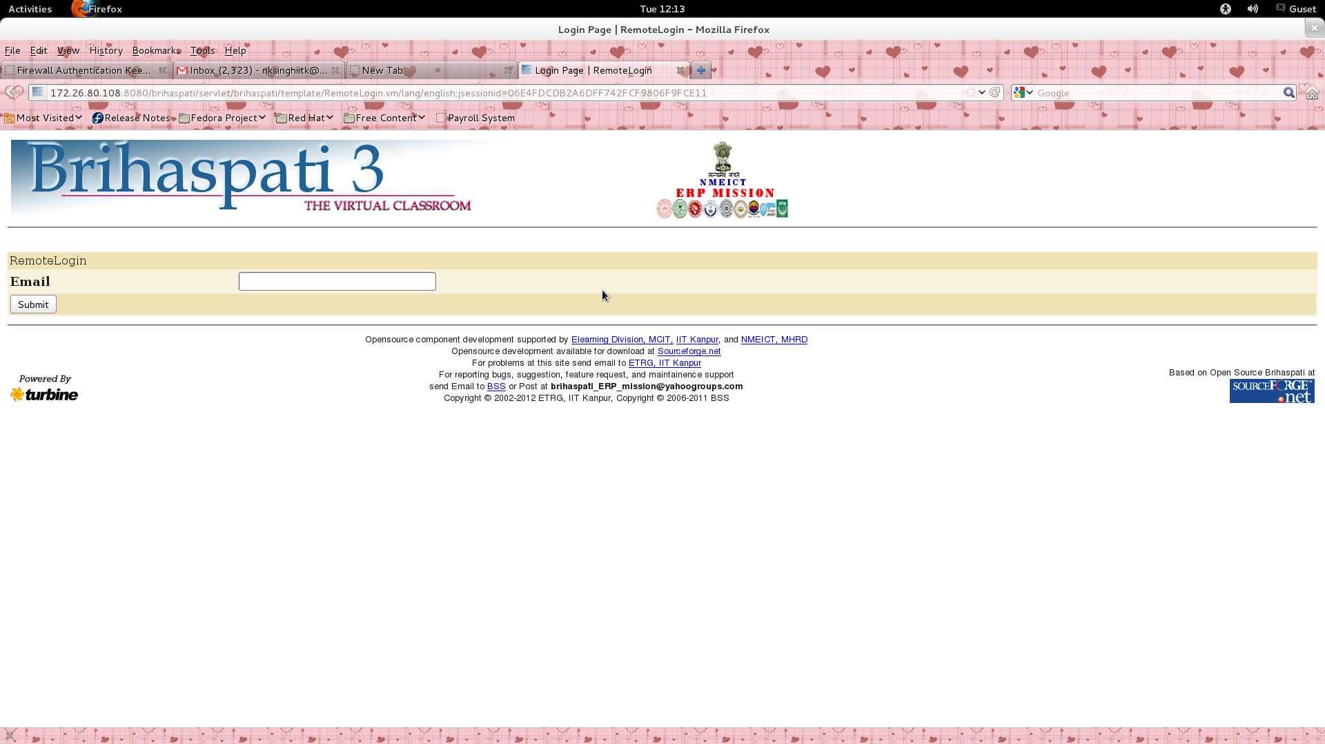

- On submit call the action. In the action

get the value of email
ParameterParser pp=data.getParameters();
String email = pp.getString("email","");
set the return url
String returnurl="http://172.26.80.108:8080/brihaspati/servlet/brihaspati/template/Success.vm/lang/english";

call the method
String resp=RemoteAuth.AuthR(email,returnurl,sourceid);
redirect to the server
data.getResponse().sendRedirect(resp);

5. You have to do verification on Success page. On the success page you get three parameter
encripted data, Random String, keyed hash

get security key
String hdir=System.getProperty("user.home");
String path=hdir+"/remote_auth/brihaspati3-remote-access.properties";

String line=ReadNWriteInTxt.readLin(path,sourceid);
skey=StringUtils.substringBetween(line,";",";");
serverurl=StringUtils.substringAfterLast(line,";");
decript received data
String enUrl=EncrptDecrpt.decrypt(encriptData, sourceid);
get email and session from enUrl

String hashcode=EncrptDecrpt.keyedHash(email,randomstr,skey);
match hashcode and keyedhash
if (matched)
verify the email and session from remote_user.txt file
boolean verified=ReadNWriteInTxt.readF(filepath, “email;session”);
if(verified)
set the authorization as per your application
else
redirected to login page

else
redirected to login page

For Accessing content from Brihaspati Server st IIT kanpur

Get the value
Decrypt it from your secret keyStorePassword

Get the different parameter ( value, random number and hash)

For creating keyed hash -
String hashcode=EncrptDecrpt.keyedHash(sourceid, randomstr, skey);

match hash with hashcode
if matched then process as per your requirements otherwise return null.
The methods are written below-

Method to check user exist in the system or not If user exist it return false and if user does not exit it return true
checkUserExist(java.lang.String email, java.lang.String srcid)
Returns: String "false" for user exist and "true" for user not exist

Method to get course list on the basis of email and institute id
getCourseList(java.lang.String email, java.lang.String instituteId, java.lang.String srcid)
Returns: String combination of (Groupname-coursename-role)

Method To get the institute id on behalf of institute name If institute exist then return indtitute code else it return null
getInstituteId(java.lang.String Iname, java.lang.String srcid)
Returns: String institute identification code

Method to be used for getting the institute list on behalf of user
getInstituteList(java.lang.String email, java.lang.String srcid)
Returns: List combination (InstituteId-InstituteName-RoleName)

Method to be used for getting registration information before use this method pls call userexist() method
getInternalMarks(java.lang.String email, java.lang.String InstituteId, java.lang.String ProgramId, java.lang.String srcid)
Returns: String combination of String (CourseId-AssignmentName-DateofAssignment-MaxMark-ObtainMark-Grade)

Method to be used for gettting personal information before use this method pls call userexist() method
getPersonalInfo(java.lang.String email, java.lang.String srcid)
Returns: String

Method to be used for getting registration information before use this method pls call userexist() method
getRegistartionInfo(java.lang.String email, java.lang.String srcid)
Returns: String combination of String (Rollno-InstituteName-InstituteId-ProgramName-ProgramId-date)

Method To get the roles on behalf of email(user name)
getRole(java.lang.String email, java.lang.String srcid)
Method To get the roles on behalf of email(user name)
Returns: String semicolon separated list of roles

