

User Guide Document

Version History
Date | Description
03/19/12 | This release Includes user level ELL framework access with content editing functional features. Build 1.0

Introduction

Purpose

This document provides the features specifications for the ELL framework.

This is not a project plan nor does it detail the source code. It is a guide for system architecture and development, not for phasing, timelines or deliverables.

Finally, this is a ‘living document’ and the specification will change, continuously, as the project proceeds. More details will be added and the existing information edited as the requirements, architecture and design evolve in the course of the project.

ELL Framework

Current application provides the ELL home page to users where they can perform with different types of learning aids.

In the current version, application provides user role based access restriction including the admin part access. User needs to create an account and login using the valid credentials to access the system.

Login Page:

User needs to login using the valid credentials or by using the open id. The interfaces are as shown below.
ELL Admin User [Username,Password for Access the admin area]
Username/Password : elladmin@ell.edu / ell

ELL User
Username/ Password : iitadmin@iit.co.in / ell

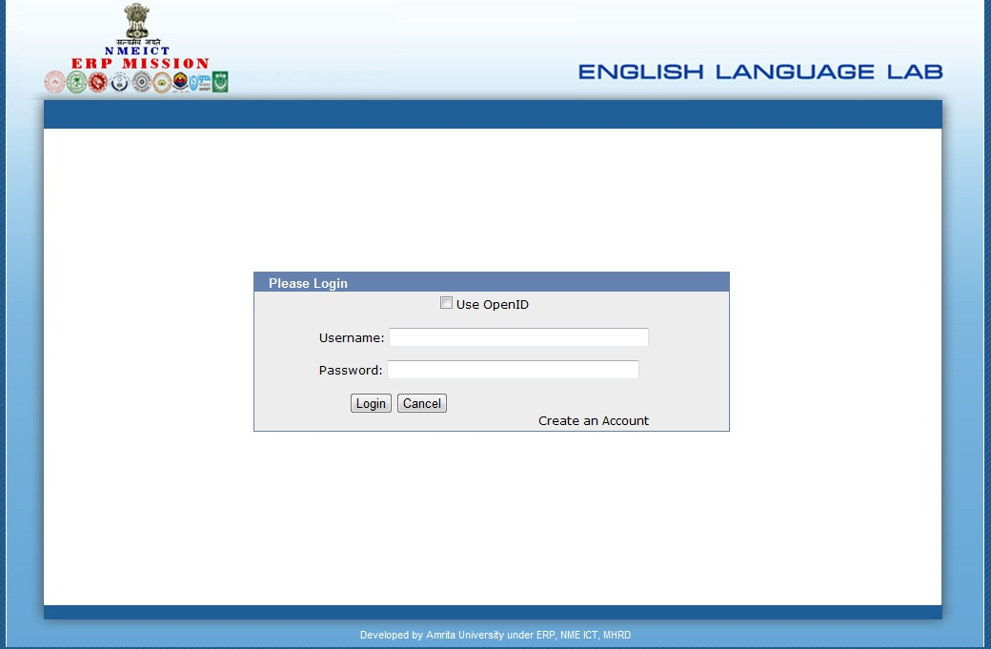

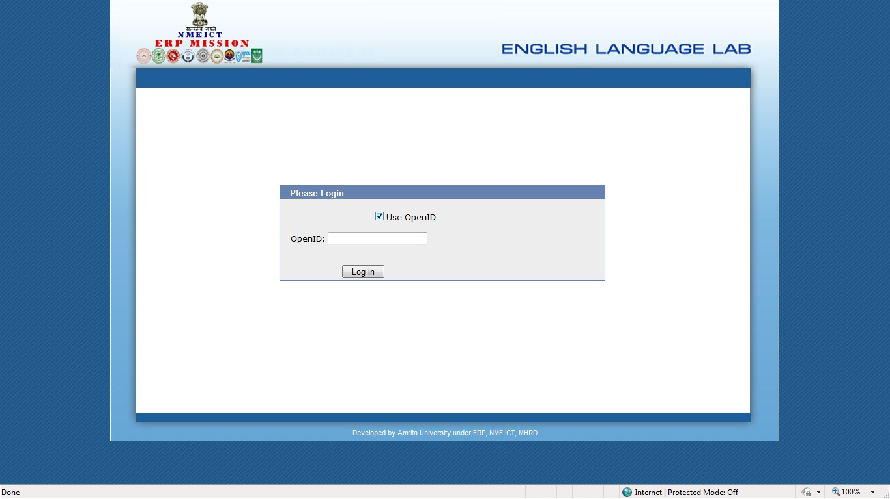

User Home page:

Once the user logs in, he is redirected to the home page where the user can select the assigned modules/subject. The module/subject details are described as below;

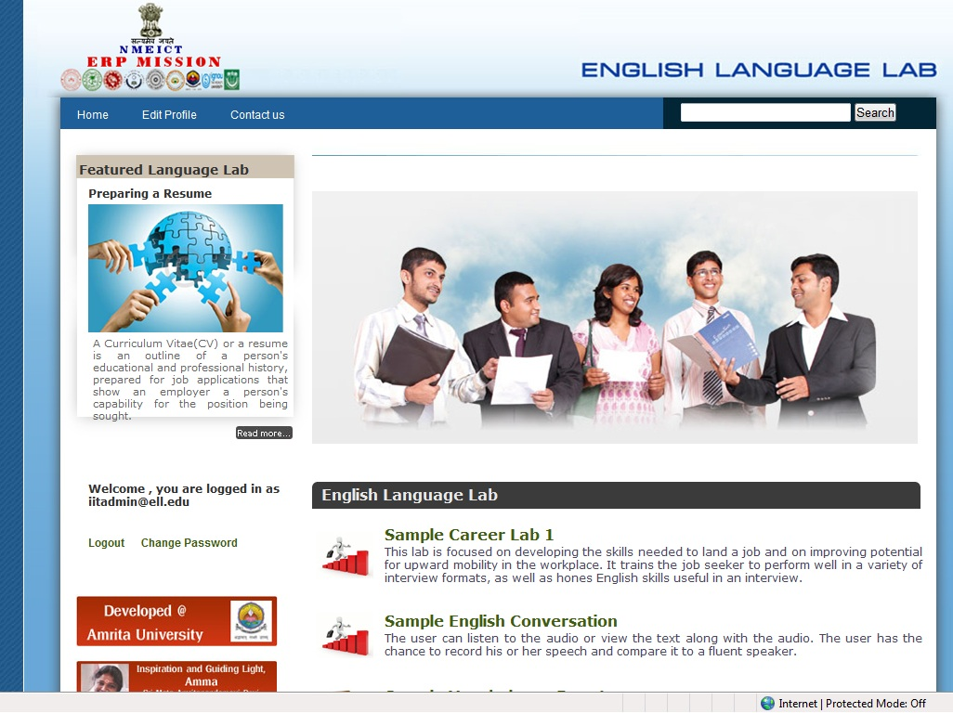

Module Selection:
The user can select any of the module or subject from the home page where he/she wants to work.

Learning content display page:
The selection of a module from the home page redirects to main content display page where the user gets the language lab information. The information hierarchy as explained as follows;

- Module1
- Topic1 .1
- Sub Topic1.1.1
- Sub Topic1.1.2
- Topic1.2
- Sub Topic1.2.1
- Sub Topic1.2.2

- Module2
- Topic2.1
- Sub Topic2.1.1
- Sub Topic2.1.2
- Topic2.2
- Sub Topic2.2.1
- Sub Topic2.2.1

- Module3
………..
…………
Topics and corresponding sub topic provide low level information about the learning aids. So sub topics are covered in different possible areas where the user can retrieve maximum information. The topic – subtopic hierarchy menu representation is displayed as shown in the below screen.
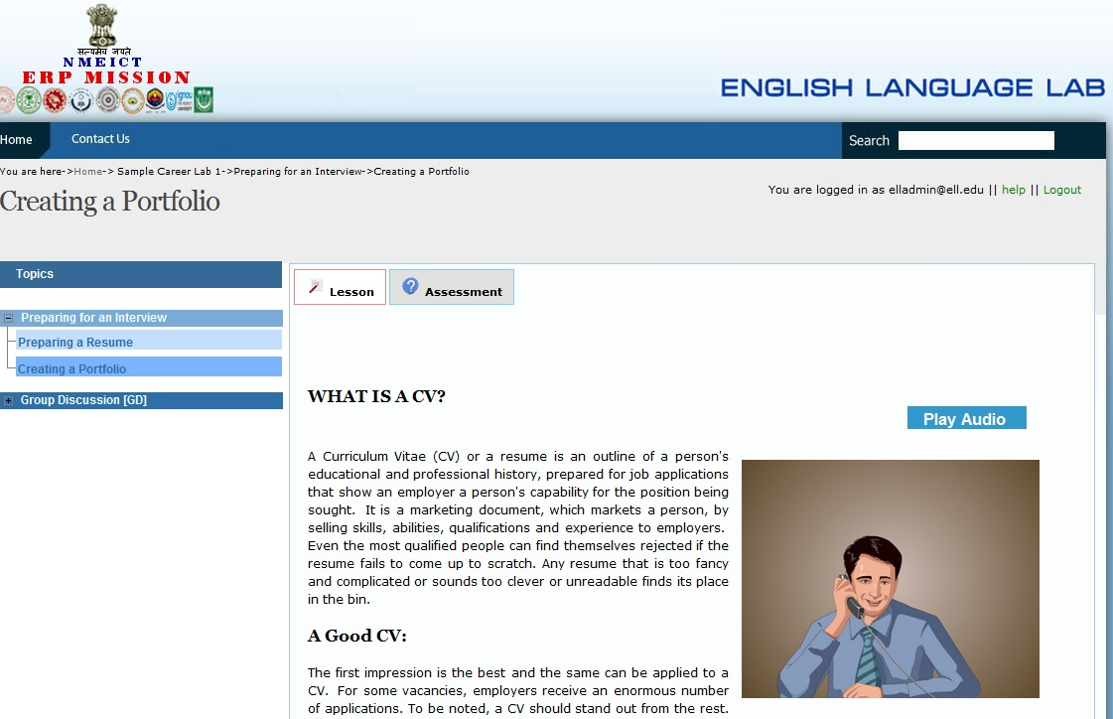

The different types of learning methods included in this framework are categorized into the following levels;
- Text based learning content:
- Video tutorials: We can upload the videos on YouTube and ELL framework can use it wherever necessary. The sample source code for attaching this with the content are as follows; “
<p style="text-align: justify"><a toptions="width = 660, height = 440, type = flash, title = How to write a resume" href="http://www.youtube.com/v/8-mNZ3kzQso&amp;hl=en&amp;fs=1&amp;rel=0&amp;hd=1&amp;autoplay=1"><img alt="" align="right" width="320" height="227" src="images/video-torsion.jpg" /></a>
“

- Audio tutorial:
Firstly, audio files can be placed/uploaded in the server path, aell/web-app/uploads/Media folder.
Play Audio button can be embedded in the source code (sample) as follows;
<div id="playButton" class="lessonAudio"><a href="/aell/uploads/Professional_Interview .mp3">Play Audio&nbsp;</a></div>

[Please note that, embedding the video & audio files are managed by admin using the admin interfaces.]

The below mentioned screen includes the information about the learning aid.

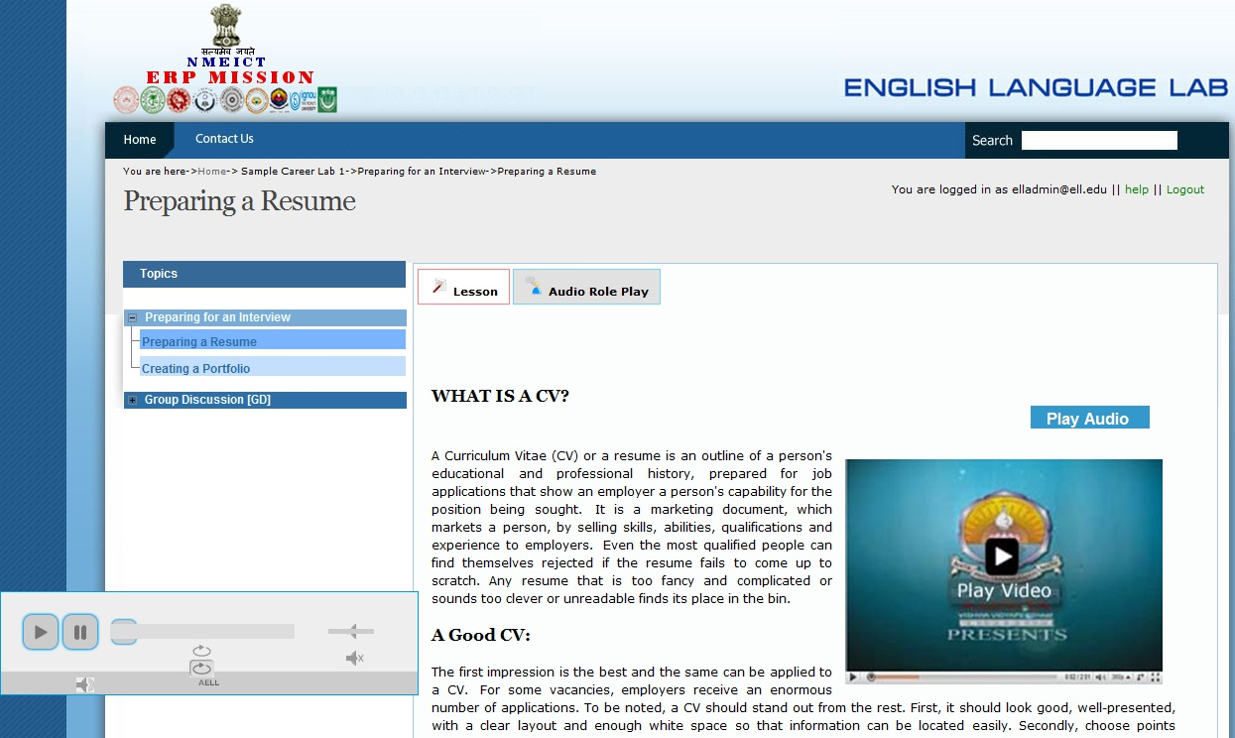

- Data base driven dictionary for contents: Students can select the word to find the exact meaning of it. On double clicking on a word, a pop up box is displayed with the meaning along with an audio pronunciation and image of the corresponding word if such exists. By clicking on the audio icon placed at the right side of the popup box, students can hear the pronunciation of each word and also clicking on the image icon they can view the image of the corresponding word.

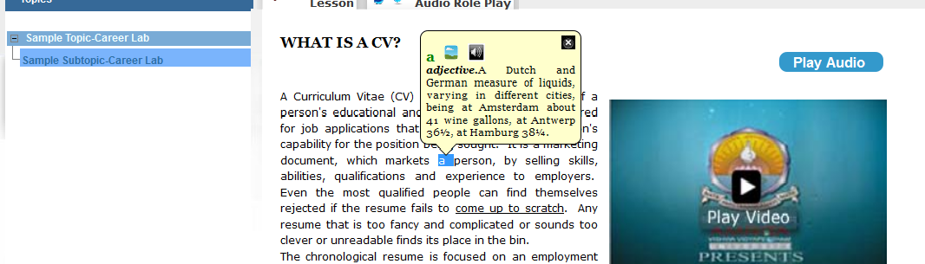

- Audio Role play based learning: Students can listen the audio carefully and after that they can record their own voice in the place of the original audio, using a record button. Once the recording is over, they can play back and listen their recorded voice. This helps a user identify the difference of pronunciation between their voice and the original voice. Play all button will play all the audios/recorded audios, one by one. Recording will be done a sentence at a time.

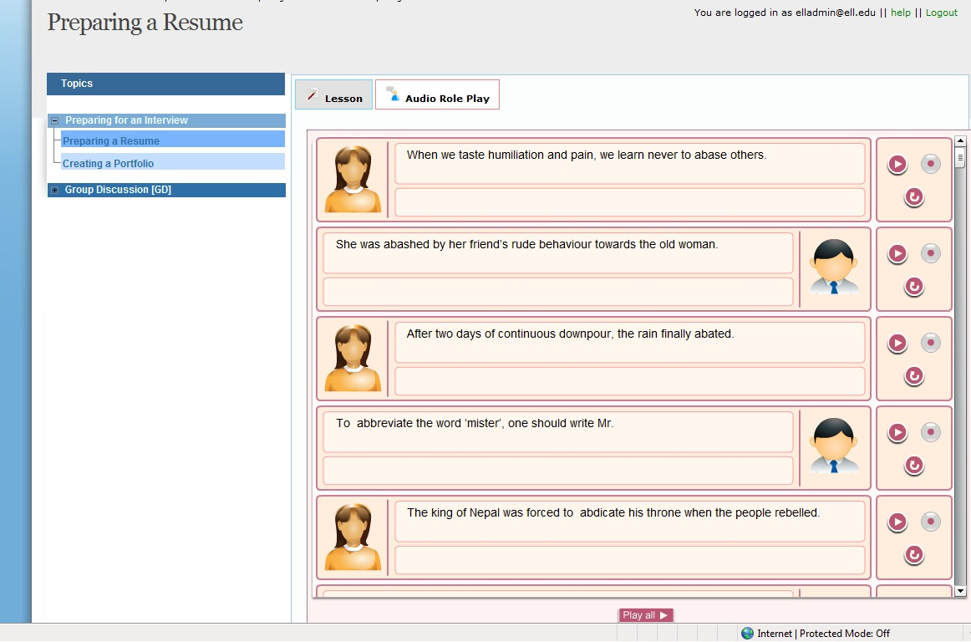

- Adding ‘External links’ feature is also included in this version. This is mainly used for a reference purpose.

- Quiz/Assessment: User can do the assessments by navigating through the tabs. Currently the framework supports multiple choices, fill in the blanks type and match the followings with section head feature. Section head separates the questions as groups. Please have a walk through the below mentioned screens. Users can submit and check their performance as to how many questions were answered correctly and how many went wrong. They can try this ‘n’ number of times and all the sessions are stored in the database. Below screens shows the different types of quiz formats that appear at the user end to perform.

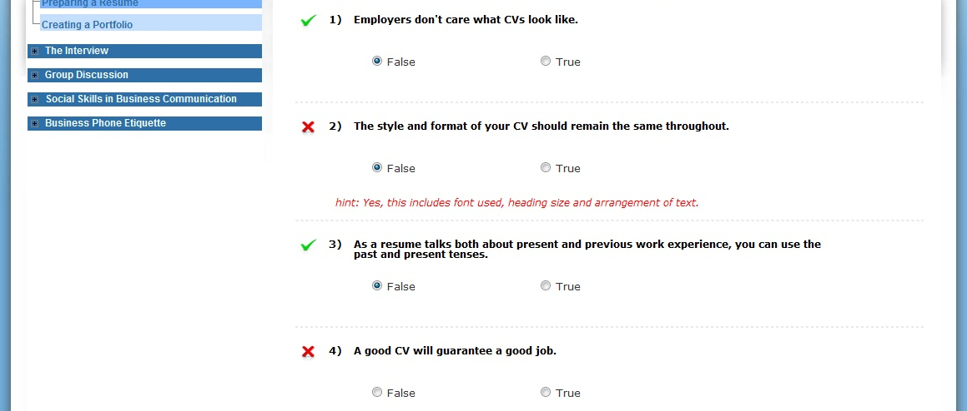

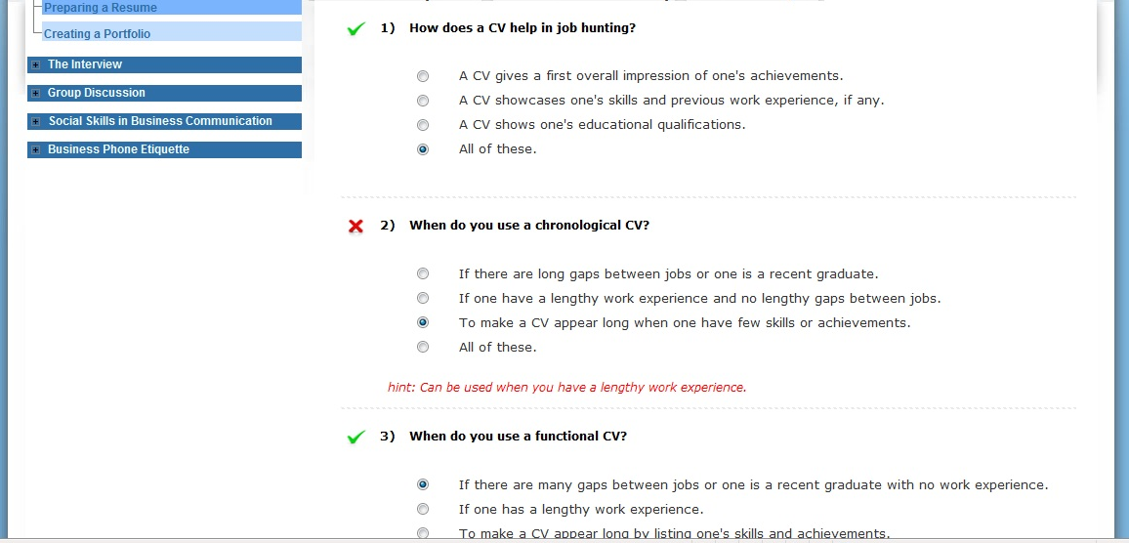

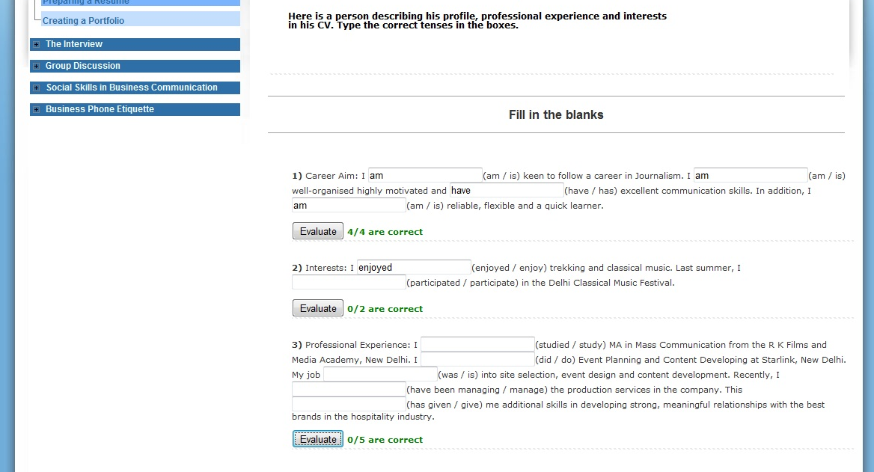

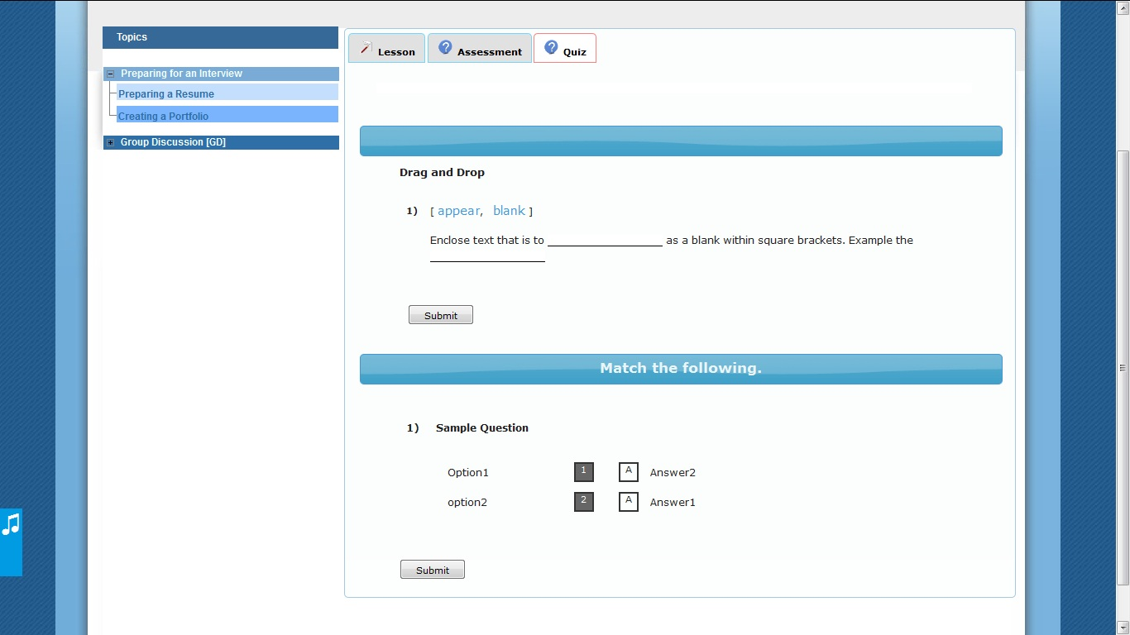

ELL framework – Edit Content:

- Login: If the logged in user is an admin, he will be redirected to the ELL home page with the ‘Visit Admin Dashboard’ option where the user can navigate through the admin interfaces as shown below.

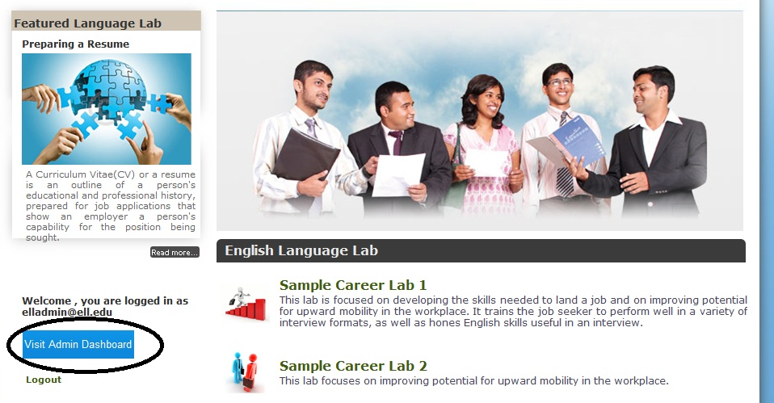

- Admin Home Page: Valid admin user will be redirected (Click on Visit Dash board) to the admin home page where the user can manage all the ELL framework contents. Currently admin area can be divided into two; a) Edit Content area and b) Portal Admin. The Edit Content area is categorized as follows;
here, admin belongs to any university. So university name will be populated/selected first.
- Module Management:
  - Add Module
  - Edit Module
  - Delete Module
- Topic Management:
  - Add Topic
  - Edit Topic
  - Delete Topic

- Sub Topic Management:
  - Add Sub Topic
  - Edit Sub Topic
  - Delete Sub Topic

All hierarchy depends only on the parent selection. For eg: topics displayed will depend on the selection of the module.
The interface provided for managing the module/topic/sub topics are as follows;

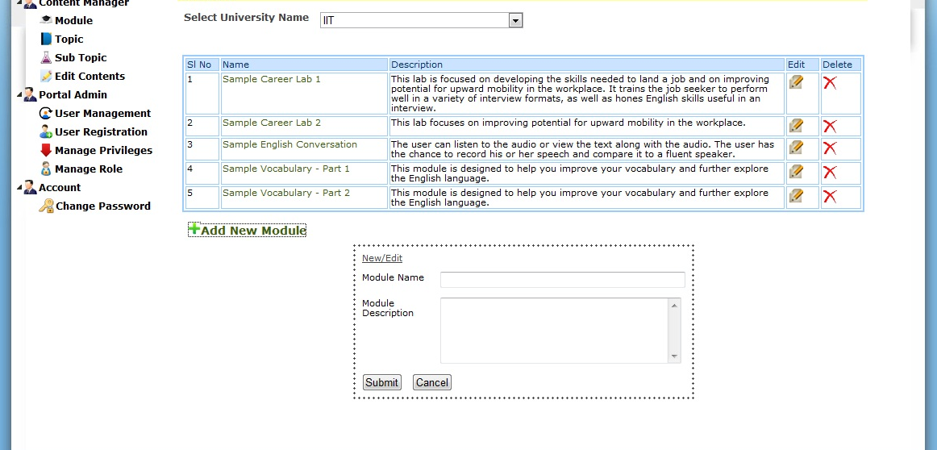

- Edit Content: This is the main part of the content admin, which takes care of the following functionalities;
  - Tab Management: Tab represents, learning aid type or type of material to present to the user. While creating a sub topic, by default, system automatically creates a tab called “Lesson”. Admin can delete this tab if not needed. The main functions included in tab management are as follows;
    - Add tab with icon.
    - Edit tab/Edit Icon
    - Delete tab
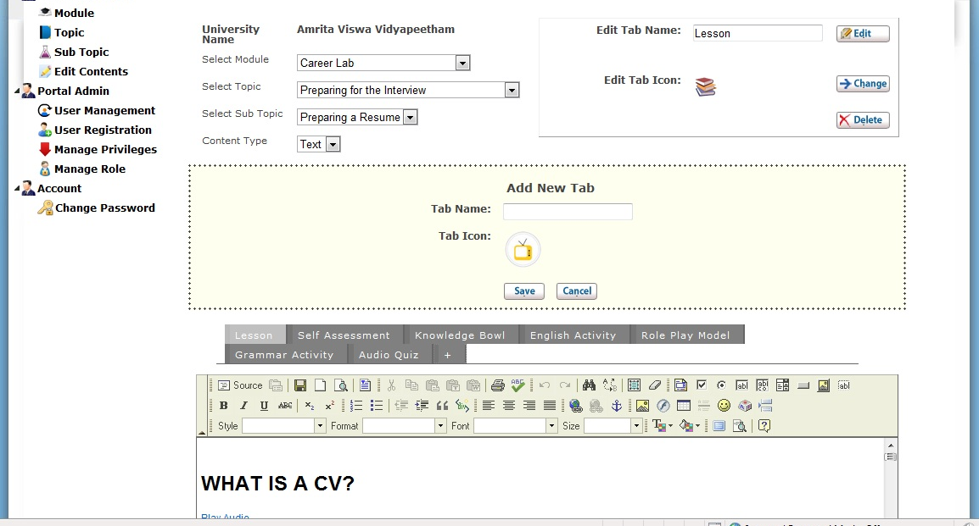

- Selection of Content Type: Currently there are three types of content types support.

- Text: Selection of this type will show the content editor where the text based contents can edit. Please refer the screen shot as below;
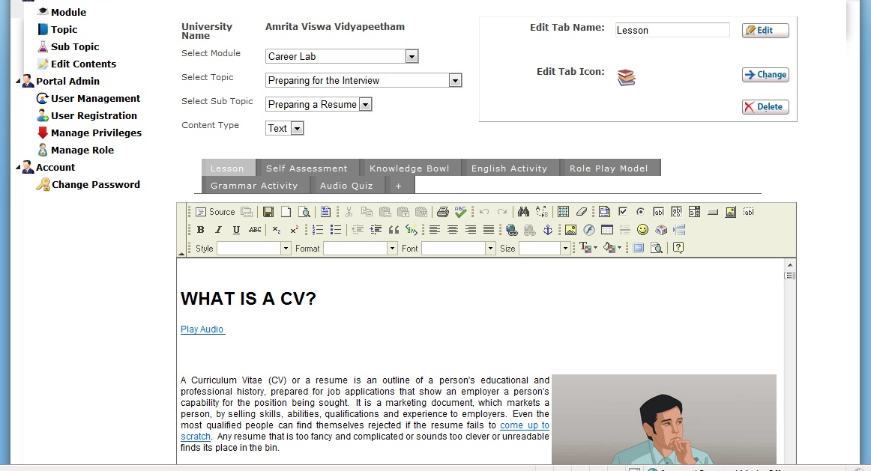

Video tutorials: We can upload the videos on YouTube and the ELL framework can use it wherever necessary. The sample source code for attaching this with the content are as follows; “
<p style="text-align: justify"><a toptions="width = 660, height = 440, type = flash, title = How to write a resume" href="http://www.youtube.com/v/8-mNZ3kzQso&amp;hl=en&amp;fs=1&amp;rel=0&amp;hd=1&amp;autoplay=1"><img alt="" align="right" width="320" height="227" src="images/video-torsion.jpg" /></a>”
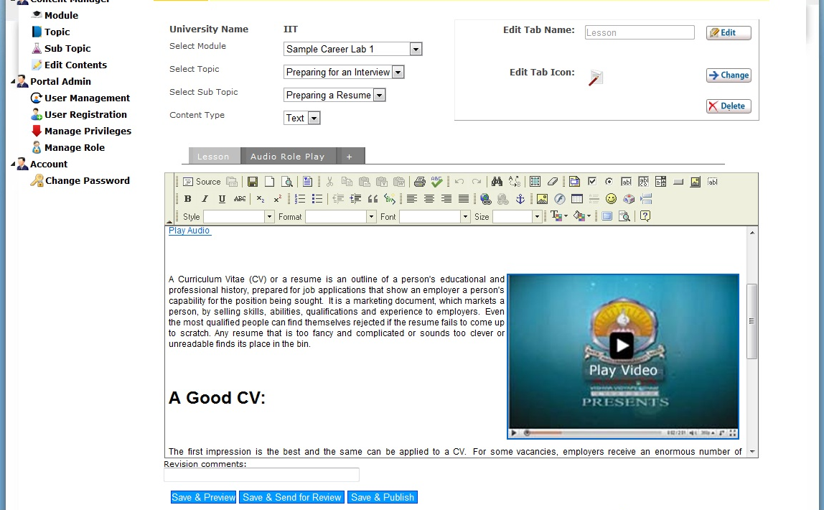
Audio tutorial:
Firstly, audio files can be placed/uploaded in the server path, aell/web-app/uploads/audio folder.
Play Audio button can be embedded in the source code (sample) as follows;

<div id="playButton" class="lessonAudio"><a href="/aell/uploads/Professional_Interview .mp3">Play Audio&nbsp;</a></div>
Image can be directly uploaded using the editor interface.

- Link: Redirects to the text area where the user can provide the external link for the learning aid. Please refer the screen shot as shown below;

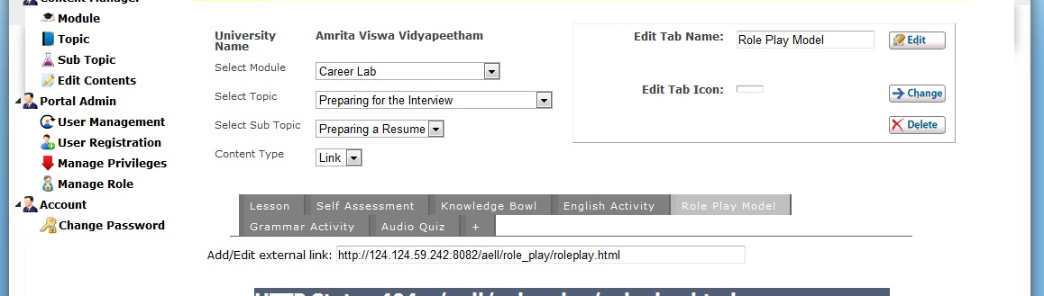

Quiz [Multiple choice with Text type contents] : Assessment questions, answers and choices can be added using the interface as shown below. Here the text based contents are to be used for questions and answers.

Quiz [Multiple choices with Image type contents]: Facilitates the entry of adding image based questions and answers.

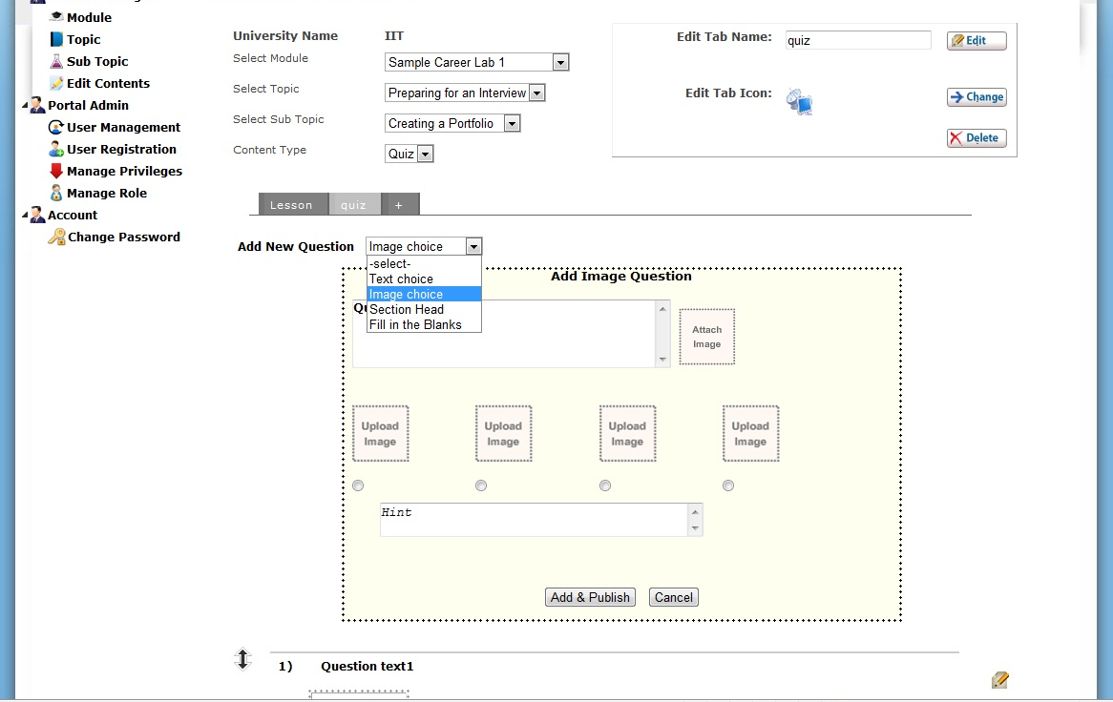

Quiz [Multiple choices with section head feature]: This feature helps the user to group the questions into a single unit.

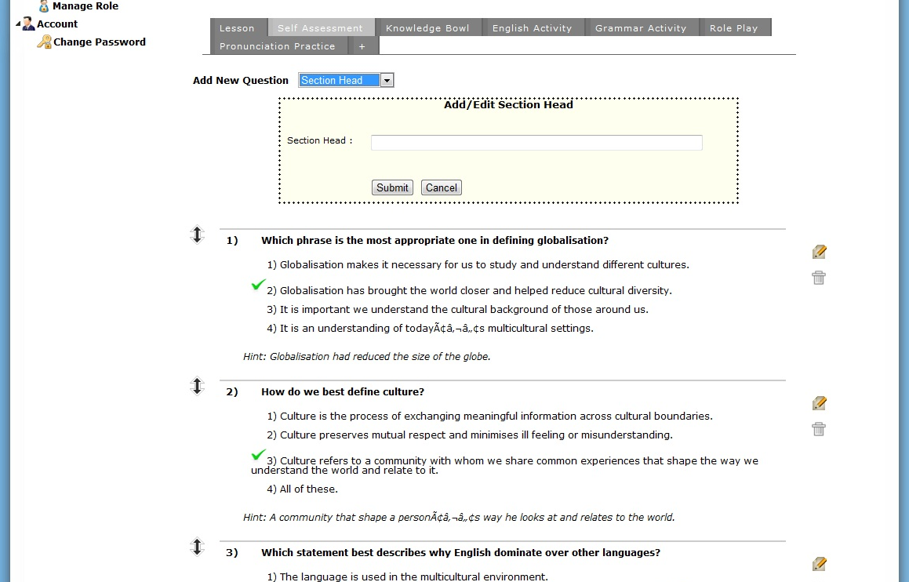

Quiz [Fill in the blanks feature]:
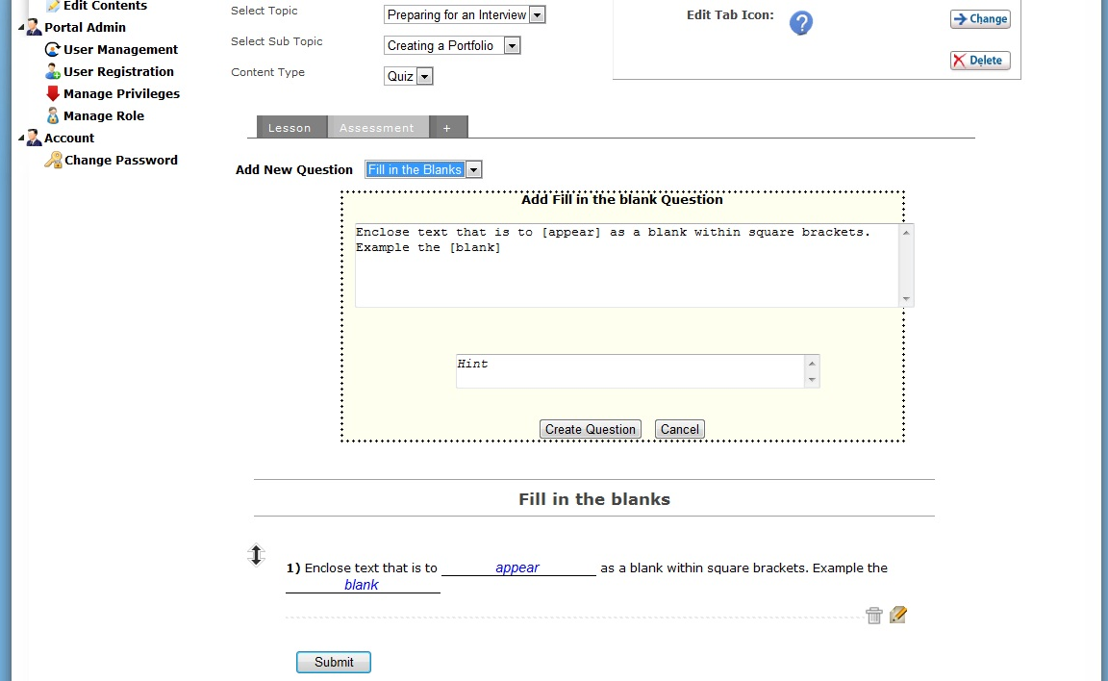

Quiz [Match the following]:

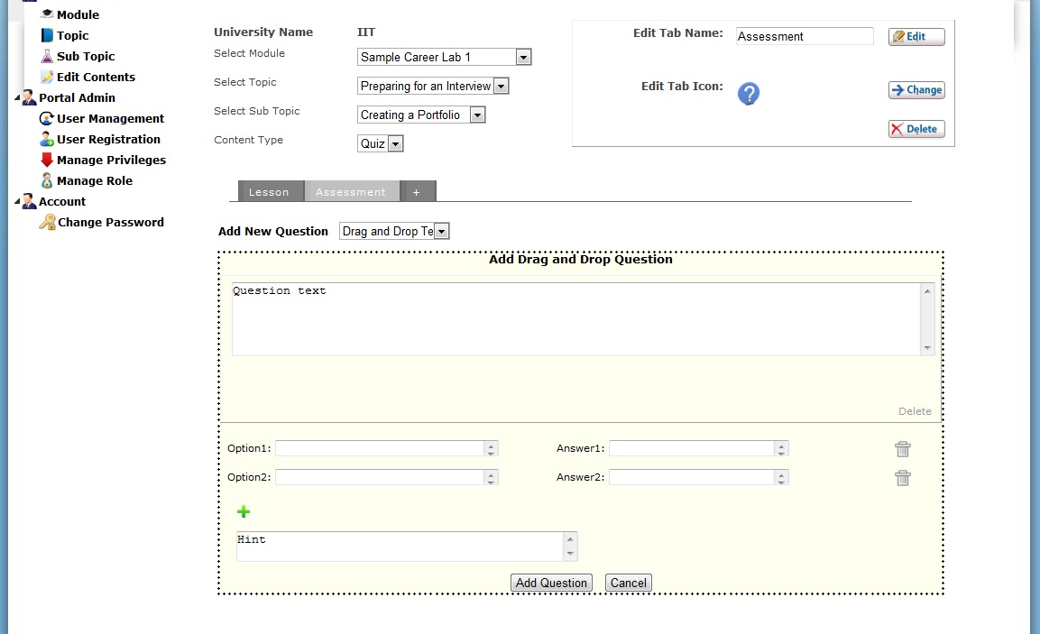

Quiz [Drag and Drop type]:
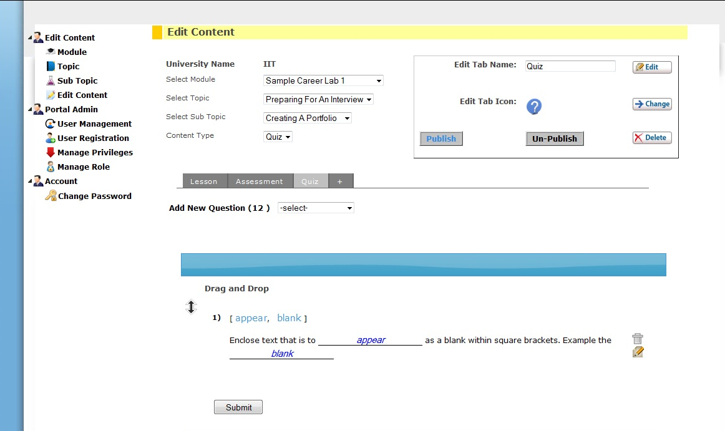

  - Add/ Edit content: This includes text/audio/video based contents. Using an editor, content can be placed and stored/uploaded to server as per the submit action. There are 3 types of submission takes place in the admin end.
    - Save & Preview
    - Save & Send for Review
    - Save & Publish: Only once the content is published can a user access the content at user page.

  - Manage Revisions: There are two types of tasks involved for content manage tasks.
    - Add revision comments: Admin user can place the revision comments for each edit made in the content.
    - Add revision summary: Same way, revision summary automatically updated in the database like the edited time stamp with user name.

- Manage Tools:

Audio Role Play activities:

Role play activity can be placed in tools folder in the same application/or outside application and can be given the server access link in “Link” content type. But make sure that the ‘tools’ folder can be accessed by web [In short, in the admin area, where we can place the link as http://IPAddress/aell/tools/ rolePlay/rolPlay.html]. The applied tab can be accessed from the user end.

Portal Admin:

- User management:
Admin user can view all the registered users can edit their profile or can make the user status as active or de-active.

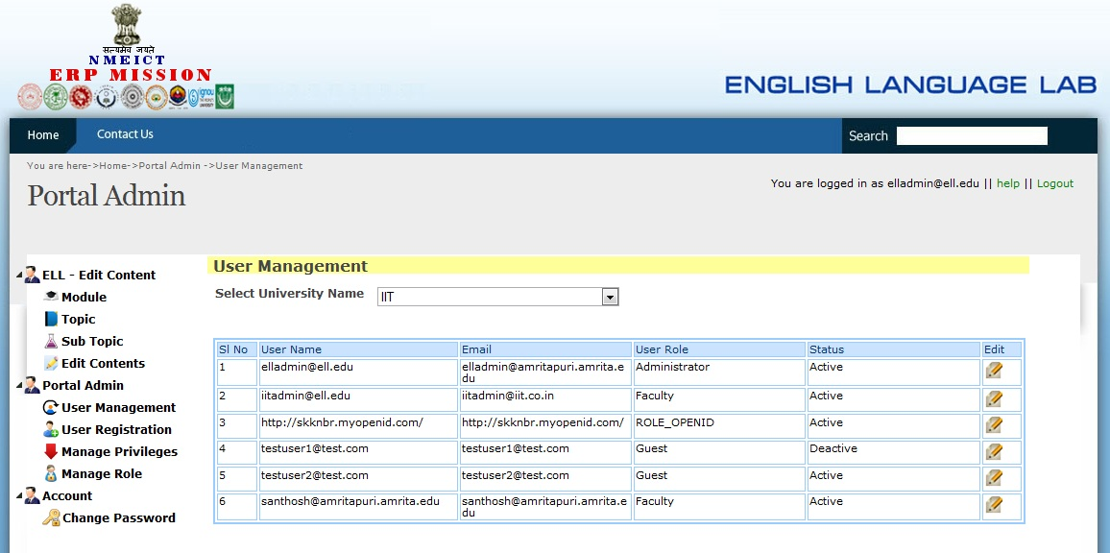

- User registration:
Admin can create a new user with any roles using this option.

- Manage role and privileges:
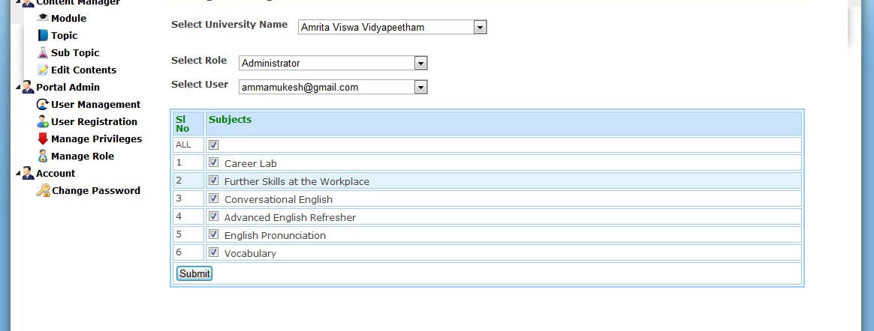
Admin can assign the user privileges to access the modules. Selection of roles, the user list will be populated and admin can assign the corresponding modules to each user.

- Change password:
Provision for changing the password. Admin can get this option from admin area and normal users can do this using the ‘change password’ option which is available in the home page.

