CSAD Project: Flutter with back4App integrated application – To Do App

# Introduction:

Using Flutter and back4app as back end an application has been created to manage to do items for a person.

Using this app we can maintain a list of To do Items.

We can add a to do Item, mark it as done and even delete the same .Also once the to do item is added it gets displayed as a list on the UI

While adding a new to do Item a new record gets created at the back end table in back4app.

When the to do item is marked as done the back end record gets updated.

And when the to do item is deleted from the list the back end record gets deleted.

# Soft wares Used for creating this app:

Flutter

Bak4app – Application is integrated to use version 7.0.0

VS code

Android Studio

# Application code is available in GitHub url as per below:

Https: <https://github.com/GarimaDalal88/CSAD_Project_2022MT13169.git>

Ssh: [git@github.com:GarimaDalal88/CSAD_Project_2022MT13169.git](mailto:git@github.com:GarimaDalal88/CSAD_Project_2022MT13169.git)

Github CLI: gh repo clone GarimaDalal88/CSAD_Project_2022MT13169

# Snapshots of the Application are as below:

## Snapshots from simulator:

1. Adding a new to do ‘Reading’ item:

Database before adding the new to do item:

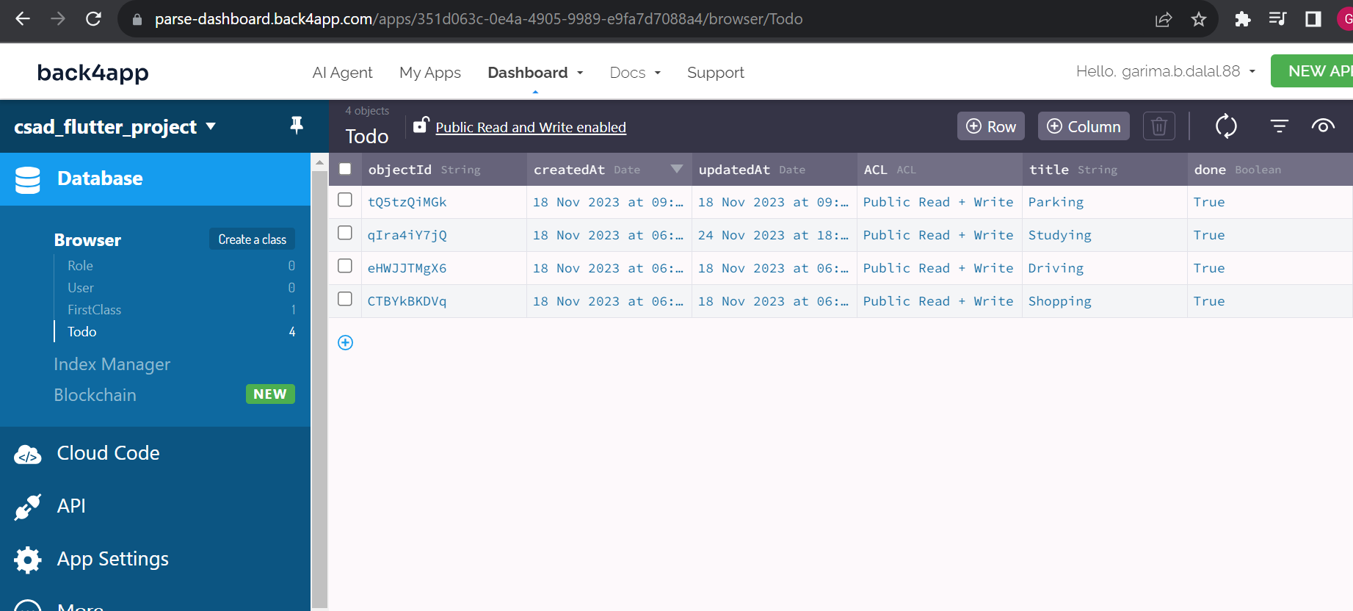

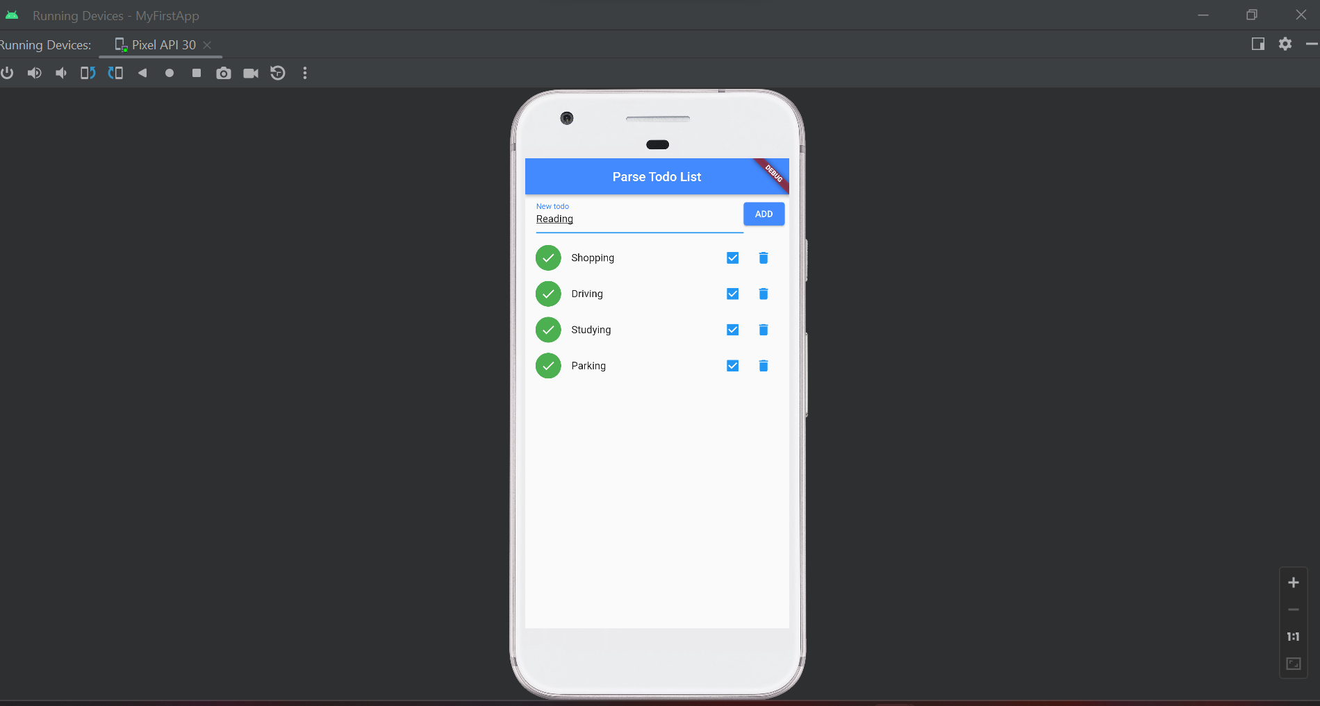

On adding the new item:

In back end:

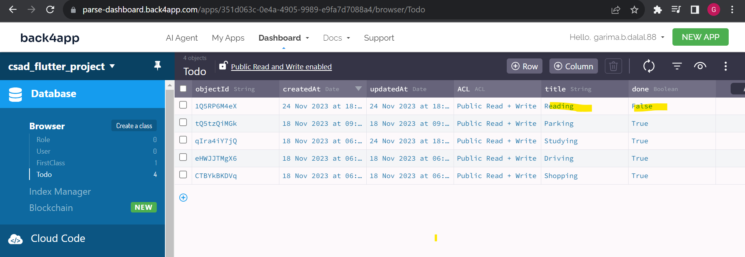

In simulator

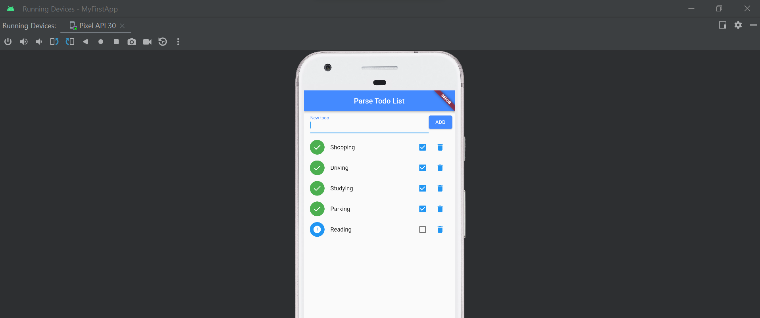

1. Marking it as done

In simulator:

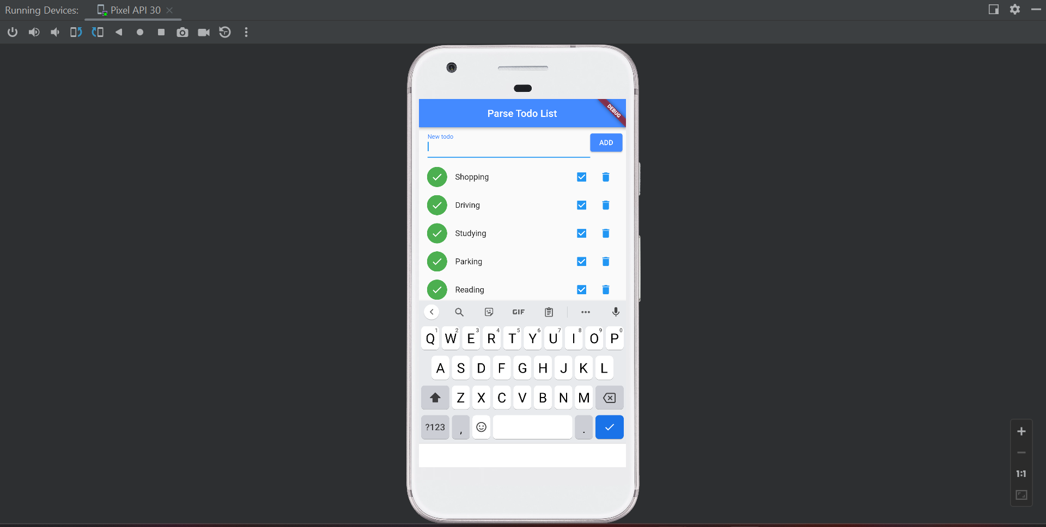

In back end:

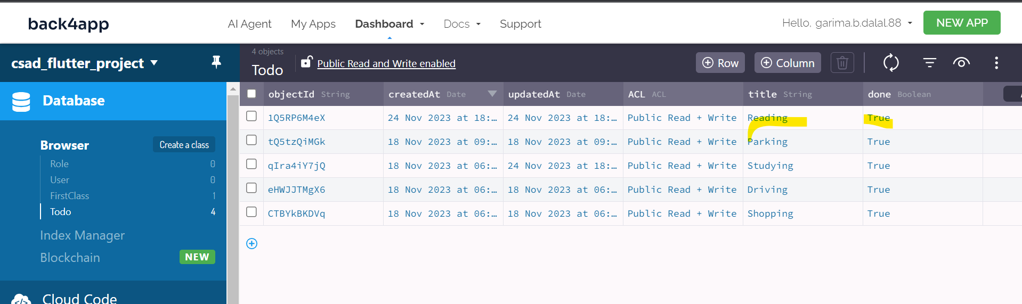

1. Deleting it

In simulator

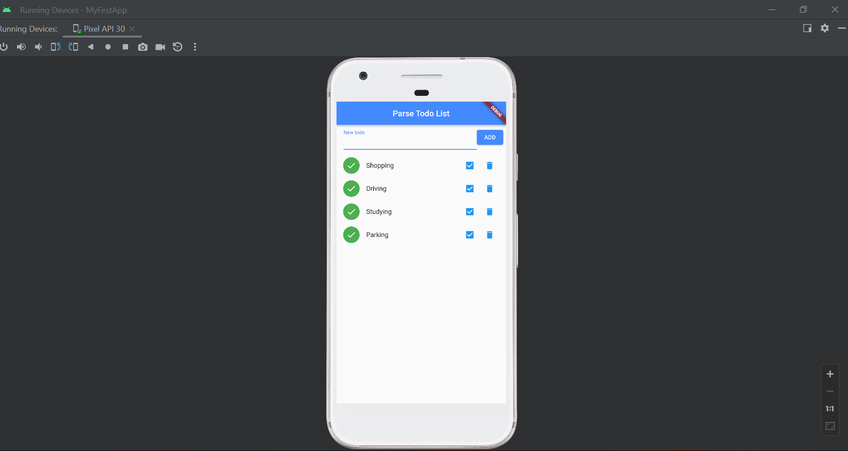

In back end: Since record is deleted we can see only 4 records as in step 1

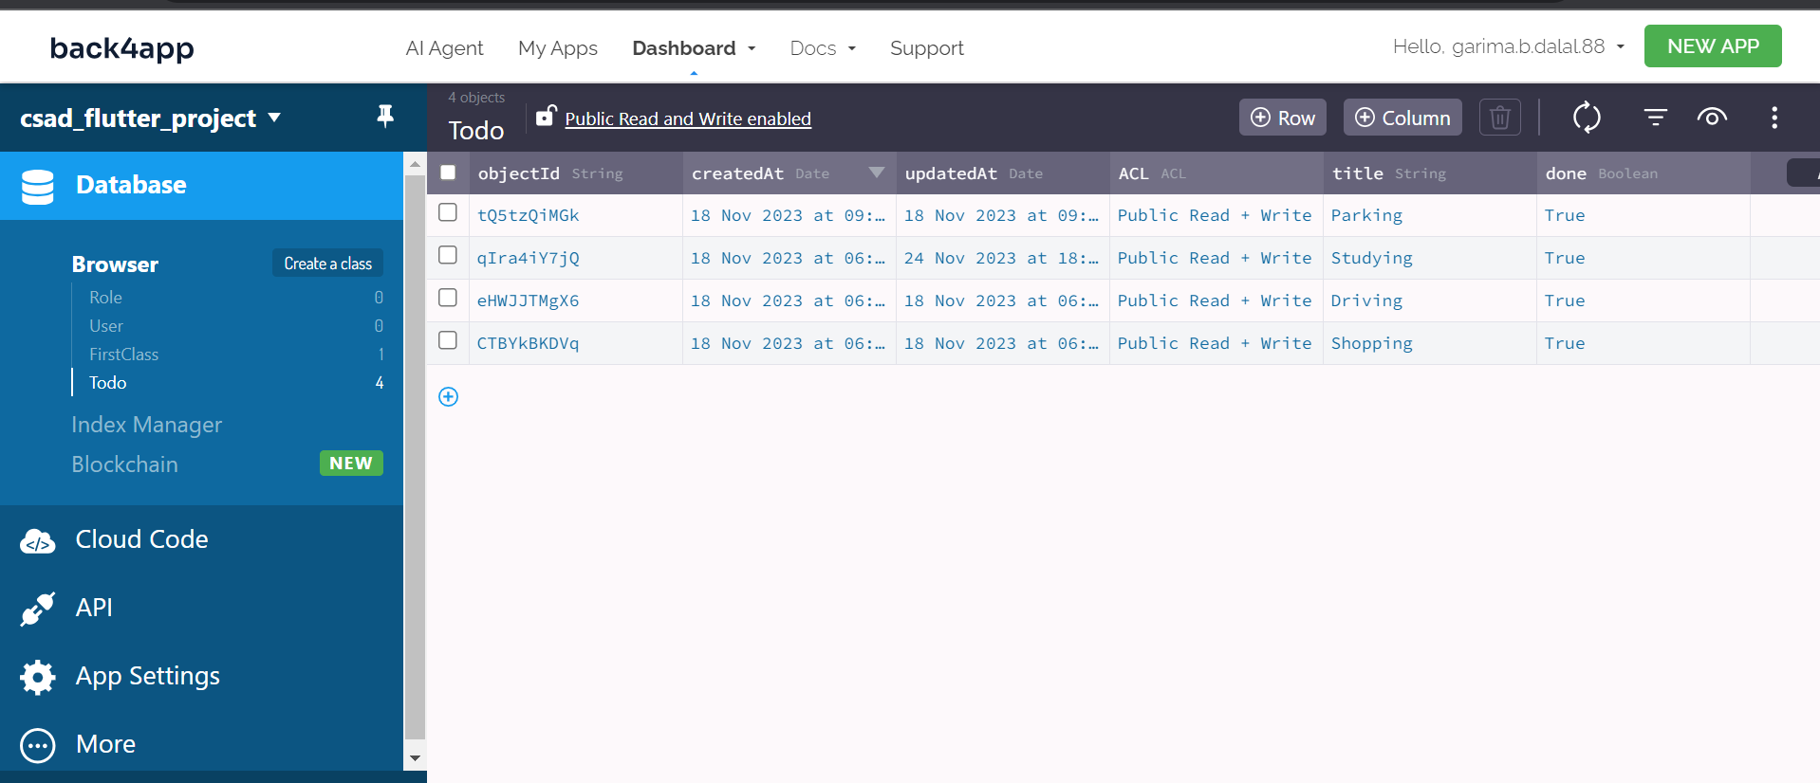

## Snapshots from android phone:

1. Adding a new to do item:

Back end before adding a new to Do Item:



in Phone

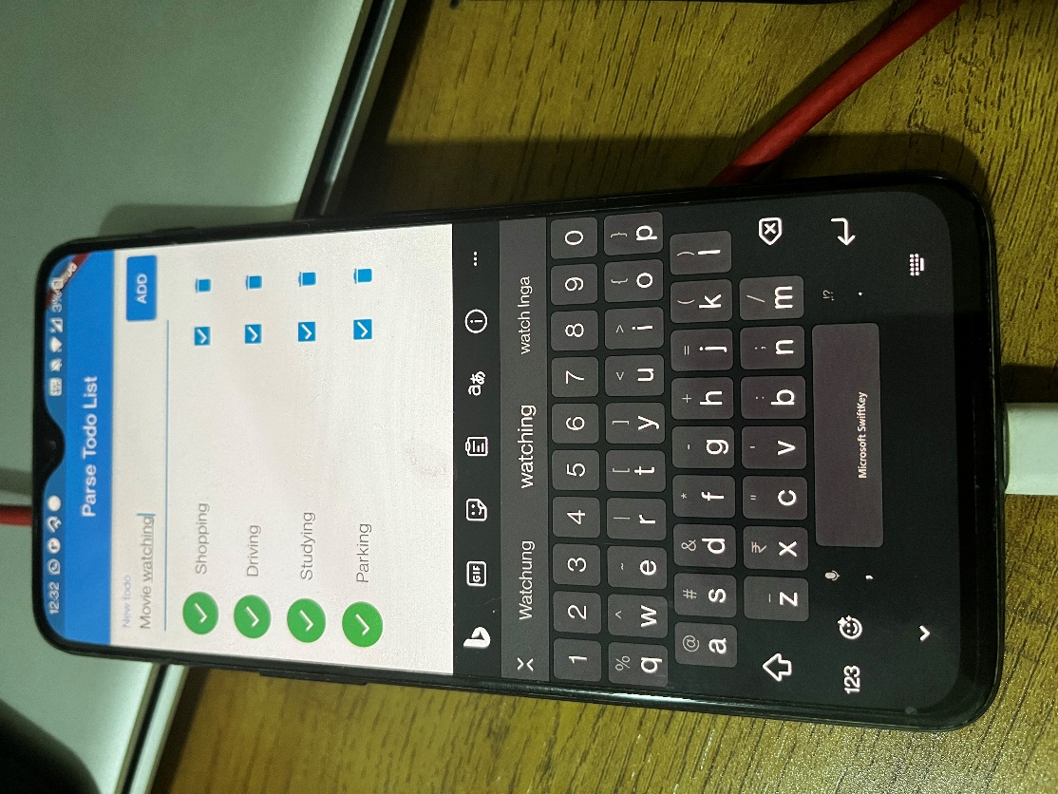

back end after adding:

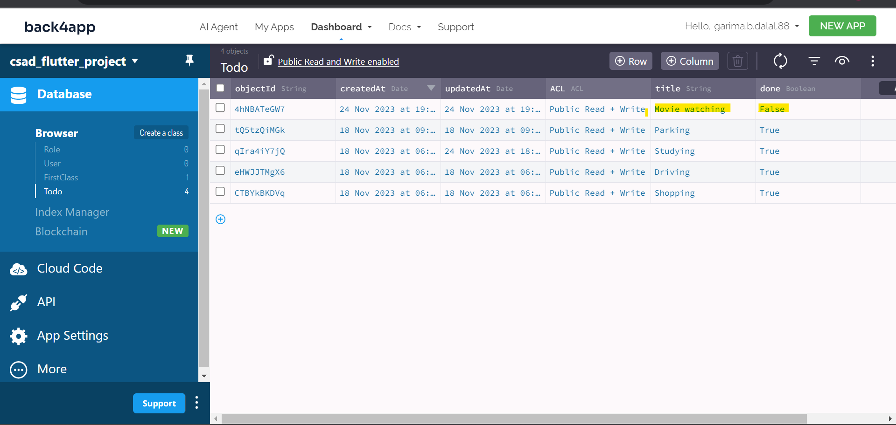

Phone screen after adding new to do Item:

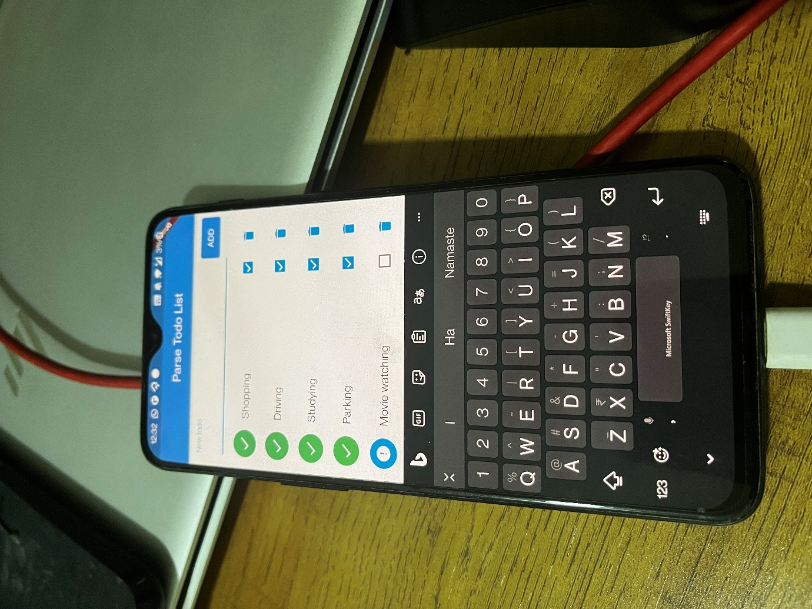

1. Marking it as done

On phone:

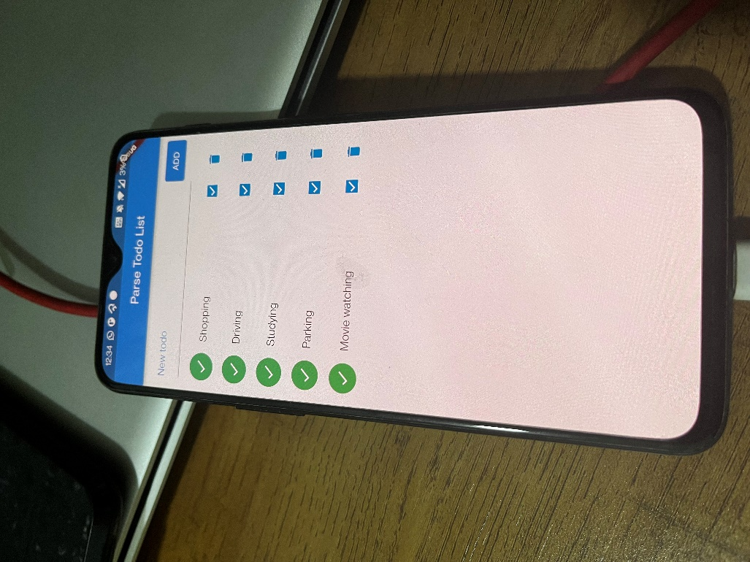

In back end:

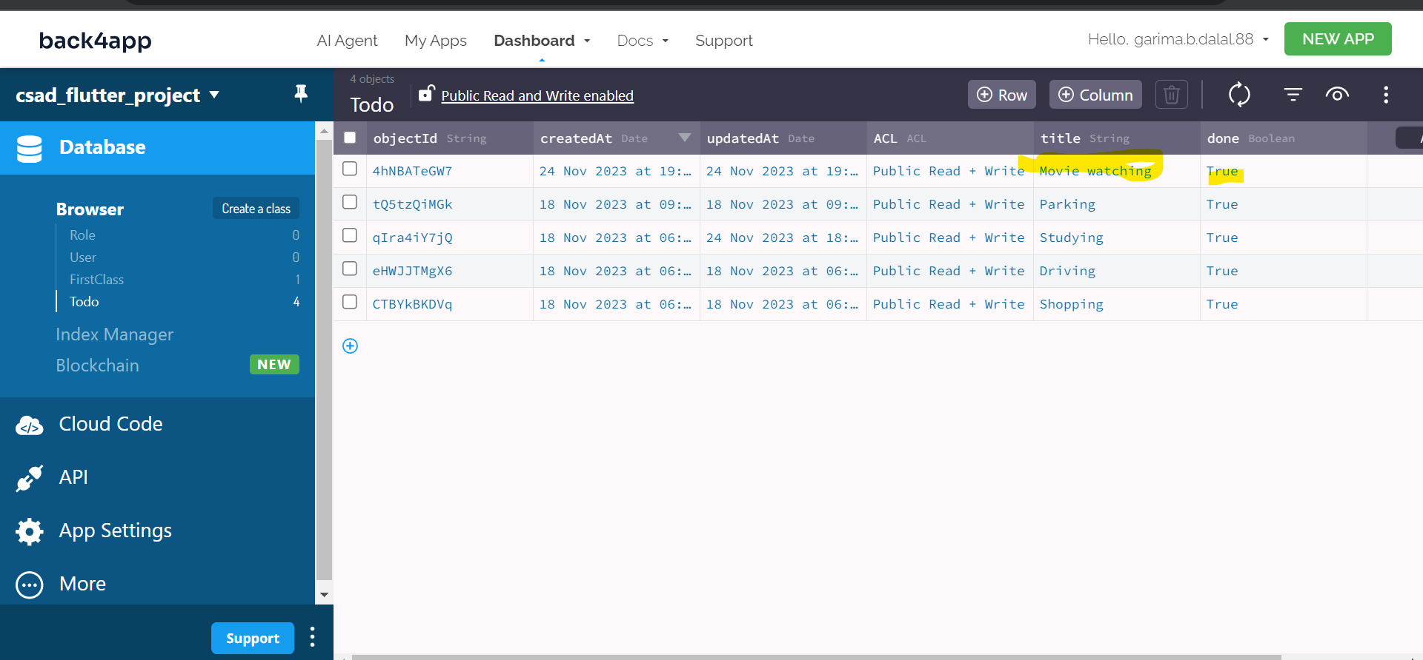

1. Deleting it

On Phone:

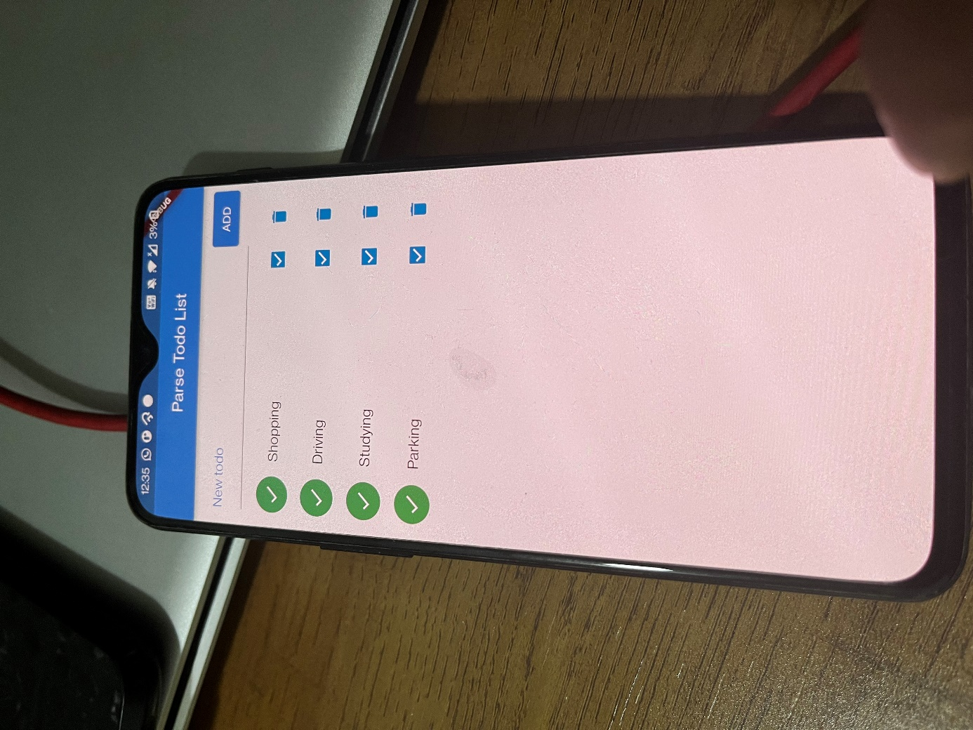

In back end: Since record is deleted we can see only 4 records as in step 1

