1. Bit Stuffing

The bit stuffing scheme shown in the slides is to stuff a 0 when it sees 5 consecutive 1’s. After stuffing, we add the flag to both side of the data. For de-stuffing, we first remove its flags and then recover the original data.

(a) Raw data: 10011111100101111100011

Processed data: 01111110 1001 1111 0 1001 0111 11 0 00 011 01111110

(b) Processed data: 01111110 001111101100111110011 01111110

De-stuffed data: 0011 1111 1001 1111 011

1. Link Layer Protocols

~~If we don’t need to wait for ACK and just send through the channel, it’s simply to see how many bits we can send in a 20ms window. 4000 * 0.02 / 1 = 80 bits.~~

Edit - after talking with TA and refer to the slides, I found the answer above is not correct.

If we do need to wait for ACK, then the propagation time will be doubled. In this case the window size becomes 4000 * 2 * 0.02 / 1 = 160 bits.

The window should be larger than or equal to the given lower bounds.

1. Distance Vector Routing

**After discussing with TAs, we found that there should be an error in the statement. Therefore, I use 9, 6, 3 rather than 6, 6, 3 for the costs between C and B, D, E.**

First we have some table like this one. It represents all the costs of pathways from B, D and E to other nodes.

|  |  |  |  |  |  |
| --- | --- | --- | --- | --- | --- |
| B | | D | | E | |
| A | 5 | A | 16 | A | 7 |
| B | 0 | B | 12 | B | 6 |
| C | 9 | C | 6 | C | 3 |
| D | 12 | D | 0 | D | 9 |
| E | 6 | E | 9 | E | 0 |
| F | 2 | F | 10 | F | 4 |

Then we can create the routing table for node C.

Routing table below.

|  |  |  |
| --- | --- | --- |
| Destination | Minimum Cost | Next Hop |
| A | 10 | E |
| B | 9 | B |
| C | 0 | NA |
| D | 6 | D |
| E | 3 | E |
| F | 7 | E |

1. TCP Sequence Numbers

If the sequence numbers have looped through all possible combinations of the 64 bits, then it heads back and start over. Therefore, it will be . So in order to make sure it won’t wrap around, we need to set the lifetime smaller than that amount. TCP header related discussion can be found on piazza @171.

1. DNS

With whois command on Ubuntu, I got the following information.

tc233@vcm-615:~$ whois duke.edu

This Registry database contains ONLY .EDU domains.

The data in the EDUCAUSE Whois database is provided

by EDUCAUSE for information purposes in order to

assist in the process of obtaining information about

or related to .edu domain registration records.

The EDUCAUSE Whois database is authoritative for the

.EDU domain.

A Web interface for the .EDU EDUCAUSE Whois Server is

available at: http://whois.educause.edu

By submitting a Whois query, you agree that this information

will not be used to allow, enable, or otherwise support

the transmission of unsolicited commercial advertising or

solicitations via e-mail. The use of electronic processes to

harvest information from this server is generally prohibited

except as reasonably necessary to register or modify .edu

domain names.

-------------------------------------------------------------

Domain Name: DUKE.EDU

Registrant:

Duke University

905 W. Main Street, Suite 18B

Suite 2106

Durham, NC 27701

United States of America

Administrative Contact:

Domain Administrator

Duke University

334 Blackwell St.

Suite 2106

Durham, NC 27701

United States of America

+1.9196845300

datacom-hostmaster@duke.edu

Technical Contact:

Domain Administrator

Duke University

334 Blackwell St.

Suite 2106

Durham, NC 27701

United States of America

+1.9196842200

datacom-hostmaster@duke.edu

Name Servers:

DNS-AUTH-02.OIT.DUKE.EDU

DNS-AUTH-01.OIT.DUKE.EDU

DNS-NC1-01.OIT.DUKE.EDU

Domain record activated: 02-Jun-1986

Domain record last updated: 11-Sep-2018

Domain expires: 31-Jul-2021

As we can see from this information, the domain is registered on 19860602, and it expires on 20210731. The DNS servers for duke.edu are the 3 listed above Name Servers. Below is a screenshot.

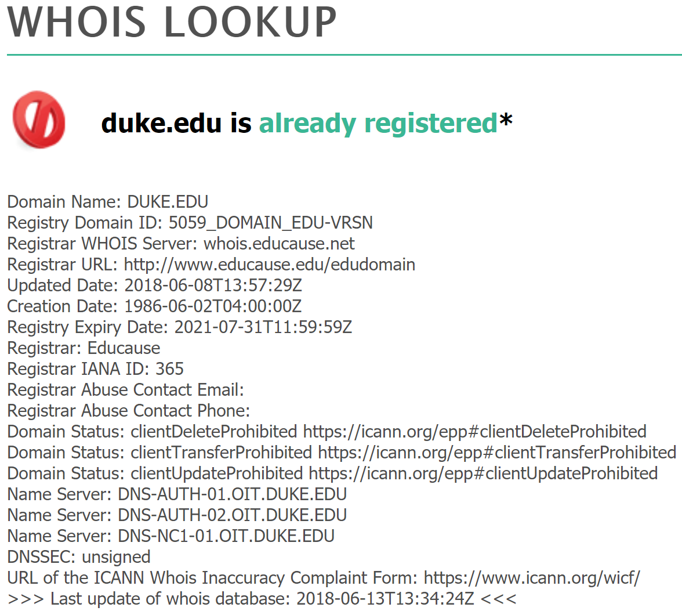

1. Internet Services

First, I use nc -h to see the basic usage of netcat. Then I wrote this command with pipe to post a GET request to the server of instructor.

echo -en "GET /awesome.txt HTTP/1.1\r\nHost: rabihyounes.com\r\nUser-Agent: nc/0.0.1\r\nAccept: */*\r\n\r\n" | netcat rabihyounes.com 80

This command works fine under my macOS system, but when I tried with vcm@Duke machine, it just returns a 400 Bad Request. I’ll consult TA later.

During dealing with this problem, I met some strange situation.

<https://piazza.com/class/jqo85inavzer4?cid=135>

Edit -

After consulting the TA, we found that there might be several reason causing this issue. First is the EOF and end-of-line characters. Some server only establish a connection or respond when receiving strictly valid requests. Second might be server settings, as I tested on public server such as Google and my own vm@Duke and they both worked, while the server of instructor behaved inconsistently. Therefore, we could create a file and use *cat file -* to disable sending the final end-of-line character to keep the session open.

And of course, the cat -

