CHRIST (DEEMED TO BE UNIVERSITY)
School of Engineering and Technology
Department of AI and Data Science Engineering
A PROJECT REPORT ON
MAZE RUNNER
Submitted in partial fulfillment of the requirements for the degree of
BACHELOR OF TECHNOLOGY
COMPUTER SCIENCE AND ENGINEERING
(ARTIFICIAL INTELLIGENCE AND MACHINE LEARNING)
Submitted By: [STUDENT NAME(S)] | [REGISTER NUMBER(S)]
Under the Guidance of: [FACULTY IN-CHARGE]
Department of AI and Data Science Engineering
School of Engineering and Technology
CHRIST (Deemed to be University)
Kumbalgodu, Bangalore – 560 074
Academic Year: 2026–27

CERTIFICATE
DEPARTMENT OF AI AND DATA SCIENCE ENGINEERING
School of Engineering and Technology | CHRIST (Deemed to be University)
This is to certify that [STUDENT NAME(S)], bearing Register Number(s) [REGISTER NUMBER(S)], have satisfactorily completed the project report titled “Maze Runner” in the course/project [COURSE TITLE AND CODE], prescribed by the Department of AI and Data Science Engineering, CHRIST (Deemed to be University), for the B.Tech. programme during the academic year 2026–27.
The project work is submitted in partial fulfilment of the requirements for the degree of Bachelor of Technology in Computer Science and Engineering (Artificial Intelligence and Machine Learning).

Certificate approval
Faculty In-charge | Head of the Department
[FACULTY NAME] | [HEAD OF DEPARTMENT NAME]
Signature: __________________ | Signature: __________________
Date: ______________________ | Date: ______________________
Place: Bangalore

UNIVERSITY AND DEPARTMENT PROFILE
University Vision
“Excellence and Service”
University Mission
“CHRIST (Deemed to be University) is a nurturing ground for an individual’s holistic development to make effective contribution to the society in a dynamic environment.”
Core Values
• Faith in God
• Moral Uprightness
• Love of Fellow Beings
• Social Responsibility
• Pursuit of Excellence

DEPARTMENT VISION, MISSION AND PROGRAMME EDUCATIONAL OBJECTIVES
Department Vision
“To excel in human-centred AI and data-driven innovation through ethical research, societal well-being, and transformative collaborations.”
Department Mission
• M1: Empowering individuals to ethically harness data and AI through accessible and value-driven curriculum.
• M2: Foster a dynamic research environment that advances innovative and impactful solutions for the betterment of global well-being.
• M3: Innovate scientific knowledge and Entrepreneurship through academia and Industry collaborations.
• M4: Sensitizes the students to serve for environmental, social & ethical needs of society through lifelong learning.
Programme Educational Objectives
PEO1: Professional Acumen: Understand, analyze and design solutions with professional competency for the real-world problems.
PEO2: Critical Analysis: Develop software/embedded solutions for the requirements, based on critical analysis and research.
PEO3: Team work: Function effectively in a team and as an individual in a multidisciplinary/multicultural environment.
PEO4: Life Long Learning: Accomplish holistic development comprehending professional responsibilities.

PROGRAMME OUTCOMES
PO1: Engineering Knowledge: Apply knowledge of mathematics, natural science, computing, engineering fundamentals and an engineering specialization to develop the solution of complex engineering problems.
PO2: Problem Analysis: Identify, formulate, review research literature and analyze complex engineering problems reaching substantiated conclusions with consideration for sustainable development.
PO3: Design/Development of Solutions: Design creative solutions for complex engineering problems and design/develop systems/components/processes to meet identified needs with consideration for the public health and safety, whole-life cost, net zero carbon, culture, society and environment as required.
PO4: Conduct Investigations of Complex Problems: Conduct investigations of complex engineering problems using research-based knowledge including design of experiments, modelling, analysis & interpretation of data to provide valid conclusions.
PO5: Engineering Tool Usage: Create, select and apply appropriate techniques, resources and modern engineering & IT tools, including prediction and modelling recognizing their limitations to solve complex engineering problems.
PO6: The Engineer and The World: Analyze and evaluate societal and environmental aspects while solving complex engineering problems for its impact on sustainability with reference to economy, health, safety, legal framework, culture and environment.
PO7: Ethics: Apply ethical principles and commit to professional ethics, human values, diversity and inclusion; adhere to national & international laws.
PO8: Individual and Collaborative Team work: Function effectively as an individual, and as a member or leader in diverse/multi-disciplinary teams.
PO9: Communication: Communicate effectively and inclusively within the engineering community and society at large, such as being able to comprehend and write effective reports and design documentation, make effective presentations considering cultural, language, and learning differences.
PO10: Project Management and Finance: Apply knowledge and understanding of engineering management principles and economic decision-making and apply these to one’s own work, as a member and leader in a team, and to manage projects and in multidisciplinary environments.
PO11: Life-Long Learning: Recognize the need for, and have the preparation and ability for i) independent and life-long learning ii) adaptability to new and emerging technologies and iii) critical thinking in the broadest context of technological change.

PROGRAMME SPECIFIC OUTCOMES AND CIA3 RUBRIC
PSO1: Artificial Intelligence: Drive artificial intelligence principles to solve real-world problems.
PSO2: Machine Learning: Select suitable machine-learning algorithms for a given problem.
PSO3: Service Learning: Analyse socially relevant problems and design solutions through service learning.
CIA 3 Mini Project (20 marks): Implementation and demonstration (10 marks) + viva and report (10 marks). The reference assessment sheet groups the criteria as follows: project formulation, literature survey, project design or methodology, implementation and result analysis (10); presentation skill and teamwork (5); project report (5). The component-level allocation is not further divided in the supplied rubric.
Table 1.1 CIA3 evaluation rubric (20 marks)
No. | Component | Date | Marks | Signature
1 | Problem formulation; literature survey; project design/methodology
2 | Implementation; result analysis; presentation skill
3 | Team work; project report
 | Total (20)

TABLE OF CONTENTS

CERTIFICATE .................................. 2
UNIVERSITY AND DEPARTMENT PROFILE ............ 3
DEPARTMENT VISION, MISSION AND PROGRAMME EDUCATIONAL OBJECTIVES ... 4
PROGRAMME OUTCOMES ........................... 5
PROGRAMME SPECIFIC OUTCOMES AND CIA3 RUBRIC ... 6
CHAPTER 1 INTRODUCTION ...................... 9
1.1 Purpose / Overview ....................... 9
1.2 Background ............................... 9
1.3 Problem Identification ................... 9
1.4 Problem Statement ........................ 9
1.5 Project Objectives ....................... 9
1.6 Scope of the Project ..................... 9
1.7 Significance of the Project .............. 10
CHAPTER 2 LITERATURE SURVEY AND CRITICAL REVIEW ... 11
2.1 Literature Collection and Segregation .... 11
2.2 Existing 2D Platformer Games ............. 11
2.3 Game Physics and Player Movement ......... 11
2.4 Character Controllers in 2D Games ........ 11
2.5 Enemy AI / Enemy Behaviour ............... 11
2.6 Character Customization Systems .......... 11
2.7 Game UI and Player Feedback .............. 11
2.8 Critical Review .......................... 12
2.9 Identified Gap ........................... 12
CHAPTER 3 SYSTEM REQUIREMENTS ............... 13
3.1 Hardware Requirements .................... 13
3.2 Software Requirements .................... 13
3.3 Development Environment .................. 13
3.4 Functional Requirements .................. 13
3.5 Non-Functional Requirements .............. 13
CHAPTER 4 SYSTEM DESIGN AND ARCHITECTURE .... 15
4.1 Overall System Architecture .............. 15
4.2 Game Flow ................................ 15
4.3 Scene Architecture ....................... 15
4.4 Player Architecture ...................... 16
4.5 Enemy Architecture ....................... 16
4.6 Combat Architecture ...................... 16
4.7 Health and Respawn Architecture .......... 17
4.8 Checkpoint Architecture .................. 17
4.9 Character Customization Architecture ..... 17
4.10 UI Architecture ......................... 18
4.11 Audio Architecture ...................... 18
4.12 Data Flow ............................... 18
4.13 System Workflow ......................... 18
CHAPTER 5 IMPLEMENTATION .................... 20
5.1 Player Controller and Movement ........... 20
5.2 Jump System and Ground Detection ......... 20
5.3 Player Animation ......................... 20
5.4 Combat System ............................ 20
5.5 Health System ............................ 20
5.6 Enemy System ............................. 20
5.7 Wraith Behaviour and Projectile System ... 20
5.8 Collectibles and Hazards ................. 21
5.9 Checkpoints and Level Goals .............. 21
5.10 Enemy Tracking and Level Progression .... 21
5.11 Main Menu and Level Selection ........... 21
5.12 Character Customization and Data ........ 21
5.13 HUD, Pause, Game Over and Completion UI ... 21
5.14 Audio ................................... 21
5.15 Camera System ........................... 21
CHAPTER 6 GAMEPLAY SYSTEMS AND LEVEL DESIGN ... 23
6.1 Gameplay Loop ............................ 23
6.2 Level 1 .................................. 23
6.3 Level 2 .................................. 23
6.4 Level 3 .................................. 23
6.5 Enemy Placement, Hazards and Collectibles ... 23
6.6 Checkpoints and Level Goals .............. 23
6.7 Character Progression .................... 23
6.8 Difficulty and Player Feedback ........... 24
CHAPTER 7 RESULTS AND ANALYSIS .............. 25
7.1 Implementation Results ................... 25
7.2 Gameplay and UI Results .................. 25
7.3 Customization Results .................... 25
7.4 Enemy, Combat, Health and Progression Results ... 25
7.5 Performance and Technical Observations ... 25
7.6 Limitations .............................. 25
7.7 Future Improvements ...................... 25
7.8 Gameplay Screenshots ..................... 26
CHAPTER 8 CONCLUSION ........................ 31
8.1 Conclusion ............................... 31
8.2 Achievement of Objectives ................ 31
8.3 Limitations .............................. 31
8.4 Future Scope ............................. 31
REFERENCES ................................... 32

CHAPTER 1 INTRODUCTION
1.1 Purpose / Overview
Maze Runner is a Unity 2D side-scrolling platform game organised around traversal, jumping, enemy encounters and level completion. The repository contains three gameplay scenes, a main menu, a level-selection scene and a character-customisation scene. It combines a physics-based player controller with health, checkpoint, combat, UI and progression components. This report explains the current implementation as represented by the Unity scenes, C# scripts, prefabs, ScriptableObjects, project settings and supplied editor screenshots.
1.2 Background
A platform game asks a player to move an avatar across traversable surfaces while managing jumps, hazards and opponents. In a small project, movement responsiveness and clear feedback matter because the same controller is repeatedly used to cross gaps, approach enemies and reach a goal. Maze Runner uses Rigidbody2D-based horizontal motion and jumping, a dedicated input-actions asset, sprite animation, three-heart health presentation, and event-driven UI updates. A manager handles level unlock and scene transitions; a separate configurator changes the visible character parts.
1.3 Problem Identification
A prototype with separate scenes and systems needs reliable connections between player input, physics, damage, respawn, enemy defeat and level completion. Without a clear composition model, a failure in one reference or trigger can interrupt progression. The project addresses this integration problem through focused MonoBehaviours, reusable prefabs, serialized Inspector fields, event callbacks and scene-based composition. Source availability alone does not prove every system is wired or verified at runtime; the report distinguishes implementation from confirmed scene presence.
1.4 Problem Statement
The project problem is to implement a playable 2D platforming prototype in Unity that supports responsive movement, bounded combat interactions, health and recovery, multiple authored levels, basic progression and player appearance configuration, while keeping these behaviours separable and configurable in the Editor.
1.5 Project Objectives
• Implement left/right movement and jumping using Unity’s Input System and Rigidbody2D.
• Provide responsive jumping through ground detection, coyote time, jump buffering, jump cutting and stronger falling gravity.
• Connect player combat with the available enemy types and communicate health changes through a HUD.
• Provide checkpoint-based recovery, one automatic respawn per level run, and a subsequent game-over flow.
• Compose three gameplay levels and menu/customisation scenes, with a configurable progression manager.
• Provide selectable character appearance options backed by ScriptableObject data and PlayerPrefs serialization.
• Use audio helpers and a camera-follow component to support gameplay feedback and presentation.
1.6 Scope of the Project
The assessed scope is a single-player 2D Unity project for desktop-style input. The repository specifies Unity 6000.5.1f1 and URP 2D. All three gameplay scenes contain player, gameplay UI, checkpoint and goal objects. Level1 contains ten named goblin enemies and one boss goblin; Levels 2 and 3 each contain an Enemy_01 object configured with the basic Enemy script. MainMenu, LevelSelect and Customization are included in Build Settings. Wraith/projectile and collectible behaviours exist in source, but their placement in the gameplay scenes is not established. The repository has no checked-in standalone build, named target-platform declaration or runtime test record.
1.7 Significance of the Project
As an academic software project, Maze Runner demonstrates how a game can be decomposed into stateful components and scene assets. The movement controller exposes tunable parameters; the health system publishes events; checkpoints store an in-memory recovery position; ScriptableObjects separate customisation data from the selection logic; and Unity scenes compose UI and world objects. These are concrete foundations for future iteration. The report makes no claim about commercial readiness, user-study outcomes or performance benchmarks.

CHAPTER 2 LITERATURE SURVEY AND CRITICAL REVIEW
2.1 Literature Collection and Segregation
The survey draws on peer-reviewed work about platform-game movement and game feel, together with Unity’s primary technical documentation for the engine mechanisms used by this project. These sources inform design interpretation; they do not serve as evidence that Maze Runner has passed player testing. The review is grouped into control feel, jump modelling, 2D physics, data configuration and player feedback.
2.2 Existing 2D Platformer Games
Commercial platformers such as the Super Mario series and Celeste provide familiar reference points for readable traversal, discrete challenge sequences and movement feedback. This report treats these titles as genre examples rather than making unsupported feature-by-feature comparisons. The academic sources below focus on measurable movement properties and player perceptions rather than proposing a single ideal controller.
2.3 Game Physics and Player Movement
Dahl and Kraus studied how varied avatar acceleration and deceleration affected players’ descriptions of control feel in a 2D platforming game. Participants used terms including responsive, slow and heavy, while sensitivity to parameter changes varied. This supports exposing and tuning motion parameters, but also cautions that parameter changes need player evaluation. Maze Runner serializes move speed, acceleration, deceleration and velocity power in PlayerController.
2.4 Character Controllers in 2D Games
Fasterholdt, Pichlmair and Holmgård propose a model for measuring and analysing jumps across platform games. In the project, jump force, early-release jump cutting, coyote time and buffering shape the jump arc and input tolerance. The controller uses an OverlapBox ground test and applies forces to a Rigidbody2D. These mechanics align with a measurable, parameterised approach; the repository does not contain telemetry or a controlled comparison of settings.
2.5 Enemy AI / Enemy Behaviour
The implemented goblin uses deterministic patrol limits, direction changes, vision and rear-detection conditions, attack range and cooldown, with an optional boss chase mode. Level1 serializes ten regular GoblinEnemy instances and one boss-mode GoblinEnemy; Levels 2 and 3 each serialize an Enemy_01 with the basic Enemy patrol script. Wraith patrol/projectile behaviour is available in source but is not established in the current gameplay scenes. These are bounded rule-based behaviours, not learning agents. Unity’s 2D physics triggers and overlap queries provide interaction mechanisms; runtime defeat and goal completion still require play validation.
2.6 Character Customization Systems
The project keeps categories and options in ScriptableObject assets, updates character layers through CharacterRenderer and stores selected option identifiers in PlayerPrefs as JSON. This design separates option data from the UI. It implements visual selection and persistence for appearance; it does not establish unlockable cosmetics, player progression rewards or server-side storage.
2.7 Game UI and Player Feedback
The supplied institutional reference and source code show a health display, pause/game-over/completion panels, level navigation, menu actions and button-audio support. Unity describes a 2D trigger as a collider that reports overlap events rather than blocking motion; Maze Runner uses triggers for checkpoints and goals. The three-heart display and health events make current health legible. No usability study is available to measure whether the interface is understood by players.
Table 2.1 Literature and technical review
Sl. No. | Paper / source | Method / technique | Key finding | Identified gap | Relevance to Maze Runner
1 | Dahl & Kraus (2015), ACM MindTrek | 2D platformer with varied avatar acceleration/deceleration and participant descriptions | Players describe control through perceptual terms; sensitivity differs among players | Parameter perception requires evaluation with the intended audience | Supports tuning exposed movement parameters; no player study is included here
2 | Fasterholdt et al. (2016), DiGRA/FDG | Measurement and comparison model for jumps in platform games | Jump design can be operationalised and analysed with movement measures | A model does not set universally best values | Relevant to force, variable jump, buffer and coyote-time settings
3 | Pichlmair & Johansen (2020), “Designing Game Feel” | Survey of academic and practitioner sources | Groups design intent into physicality, amplification and support | Survey framework does not validate a particular implementation | Frames movement, audiovisual feedback and input support
4 | Unity Manual, 2D game creation workflow | Engine documentation for Rigidbody2D, Collider2D and triggers | 2D physics components define motion, collision and overlap callbacks | Technical reference does not assess level or game quality | Documents mechanisms used by movement, goals and checkpoints
5 | Unity Manual, ScriptableObject | Engine data-container documentation | ScriptableObject assets hold reusable data independent of GameObjects | Data asset structure alone does not guarantee UI wiring | Relevant to customisation categories/options
6 | Unity Input System documentation | Action-based input abstraction | Input actions map device input to gameplay actions | Input API does not determine whether controls feel responsive | Relevant to Move and Jump actions read by PlayerController
2.8 Critical Review
The literature supports treating control as an interaction between motion parameters, jump behaviour and player perception. It does not justify claims that this project is “responsive” in a measured user-experience sense. The implementation contains common assistance mechanics, but their perceived effect remains an empirical question. Likewise, a rule-based enemy can be predictable and inexpensive, yet encounter quality depends on timing, level geometry and feedback, none of which has a recorded playtest dataset here.
2.9 Identified Gap
The current repository establishes a useful prototype foundation but lacks documented controlled playtesting, level difficulty measurements, accessibility evaluation, automated gameplay tests and a verified release build. A next iteration can measure jump completion and damage/respawn scenarios, collect player feedback, and check that each goal’s EnemyTracker state and each UI/audio reference are configured as intended.

CHAPTER 3 SYSTEM REQUIREMENTS
3.1 Hardware Requirements
The repository specifies no minimum processor, memory, graphics card, storage capacity or supported runtime device. The development requirement is a computer capable of running Unity Editor 6000.5.1f1 and importing this project. A keyboard and pointing device are suitable for the configured desktop input workflow. A numeric hardware baseline should be established only after profiling on the intended target.
3.2 Software Requirements
Table 3.1 Software requirements recorded in the repository
Software / dependency | Repository evidence / role
Unity Editor 6000.5.1f1 | Recorded in ProjectSettings/ProjectVersion.txt
Universal Render Pipeline 17.5.0 | Direct package; URP assets include a 2D renderer
Input System 1.19.0 | Direct package; active Input Actions configuration references the project asset
Unity UI 2.5.0 | Direct package for menu and HUD controls
2D Animation 15.1.0 | Direct package for 2D animation support
TextMesh Pro resources | Assets and UI scripts are present; current manifest has no direct TMP dependency entry
Git | Recent project history is available; remote URL not inferred
Windows desktop development | Current repository environment and Editor screenshots indicate Windows authoring; no exclusive target platform is declared
3.3 Development Environment
Unity scenes, prefabs, ScriptableObjects and project settings form the content environment. The active actions asset is Assets/InputSystem_Actions.inputactions. Rigidbody2D and Collider2D implement physical movement and triggers. Unity UI and TextMesh Pro assets support interface content. Git history documents incremental development, but no CI workflow or automated gameplay test suite is checked in.
3.4 Functional Requirements
• The player can move horizontally and jump using actions from the New Input System.
• The controller detects ground using Physics2D.OverlapBox and applies coyote time, buffering, variable jump release and modified falling gravity.
• The player can take damage, become temporarily invulnerable, lose health, respawn once at the last checkpoint, and enter game over after a later death.
• The player can interact with enemy scripts through stomping or goblin sword attacks.
• A checkpoint updates the runtime respawn position. A level goal requests completion when no tracked enemies remain and the progression manager is available.
• The main menu, level select, pause, game-over, level-completion and customization interfaces provide scene and state actions.
• Customization selections can be rendered, changed, reset, saved and loaded via PlayerPrefs.
3.5 Non-Functional Requirements
• Maintainability: gameplay, UI, level, audio and customization behaviours are separated into focused scripts.
• Configurability: movement and enemy tuning fields are serialized for Inspector changes.
• Reproducibility: scenes and project settings are stored as Unity assets under version control.
• Usability: input tolerance and clear health/progression feedback are intended design goals, not user-study results.
• Performance: no measured frame-time, memory or build-size target is documented.
• Reliability: trigger references, tags, layers, animation events and build-scene configuration require runtime validation before release.

CHAPTER 4 SYSTEM DESIGN AND ARCHITECTURE
4.1 Overall System Architecture
Unity scenes provide composition; MonoBehaviours implement runtime behaviour; prefabs package reusable characters and environment pieces; ScriptableObjects hold appearance data; PlayerPrefs stores local configuration and level unlock flags. The player controller reads actions and drives Rigidbody2D motion. Combat and enemy scripts affect enemy or player health. PlayerHealth publishes events for health and game-over UI. Checkpoints set a position on PlayerHealth. LevelGoal consults EnemyTracker and calls LevelProgressionManager. The diagrams describe source-level relationships and scene-level structure; they do not assert that every optional feature is active in each level.
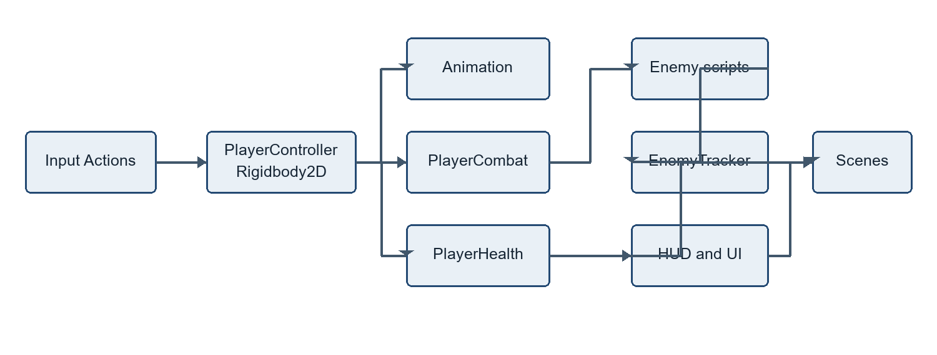
Figure 4.1 Overall game architecture
4.2 Game Flow
At a high level, the player enters through the main menu, starts or selects a level, traverses platforms, uses the available combat interaction, reaches a checkpoint and attempts the goal. Damage and falls route through the health system. A level-completion event opens its panel and supports replay, next level or return to the main menu.
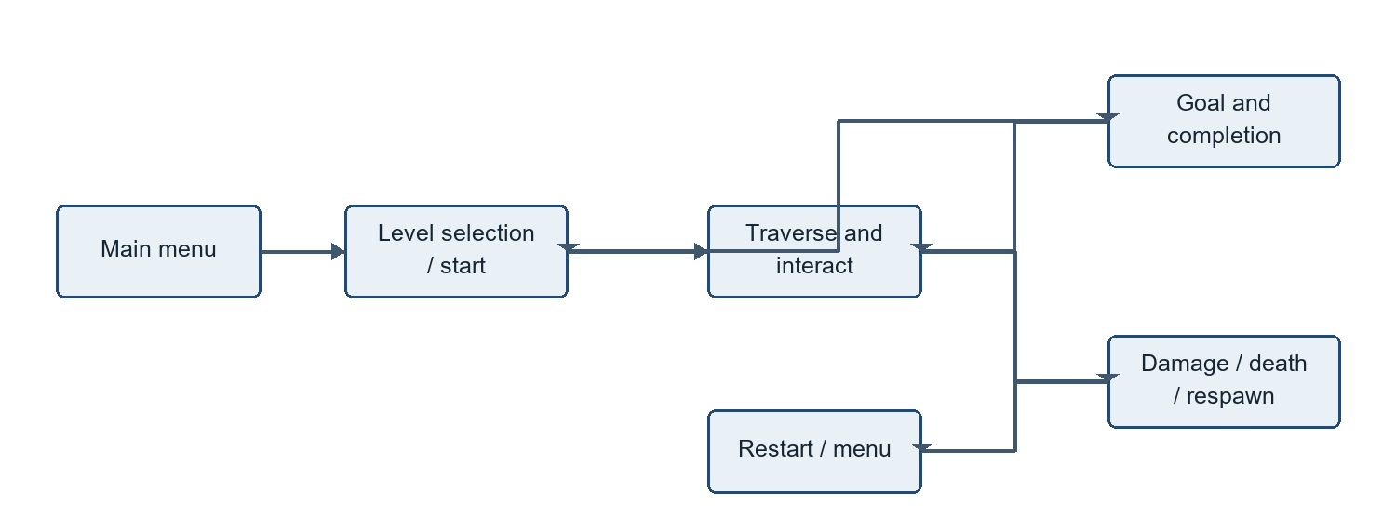
Figure 4.2 Player gameplay flow
4.3 Scene Architecture
The enabled build scenes are Level1, Level2, Level3, LevelSelect, MainMenu and Customization. SampleScene and the URP 2D template are auxiliary scenes. LevelProgressionManager uses scene names Level1, Level2 and Level3, persists across loads, and stores unlock state in PlayerPrefs. MainMenuController routes to the first level or to level selection/customization. The scenes are authored Unity YAML; there is no procedural scene builder.
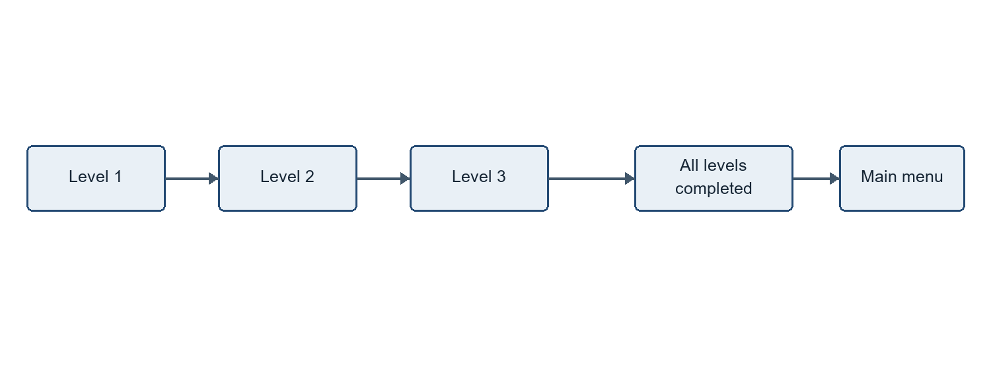
Figure 4.3 Level progression flow
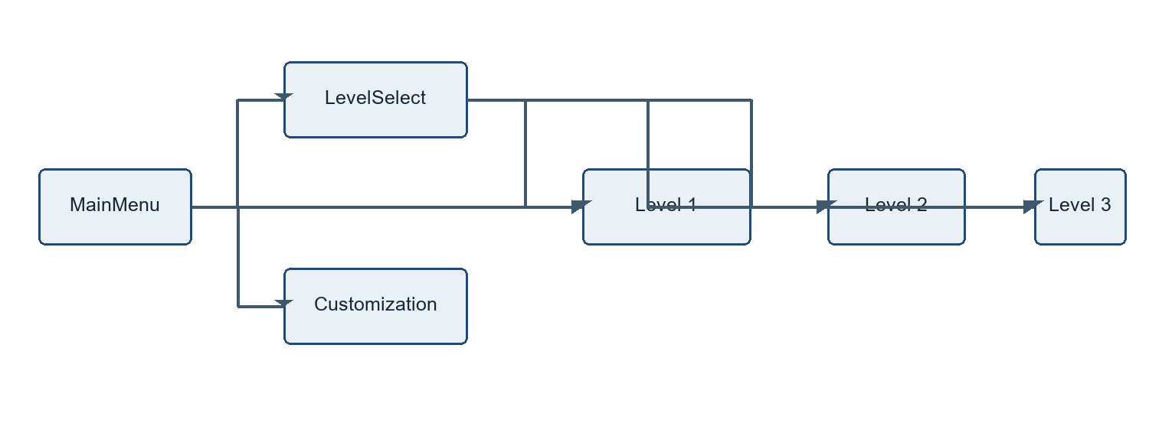
Figure 4.4 Scene and navigation flow
4.4 Player Architecture
Player.prefab combines Rigidbody2D, Collider2D, PlayerInput, PlayerController, PlayerHealth, PlayerCombat, CharacterRenderer, CharacterCustomizationManager and PlayerAnimationController. PlayerController translates the Move action into horizontal acceleration and the Jump action into a buffered impulse. The CharacterRenderer and animation system provide visual response. The scene-level camera component, where assigned, follows a target with smoothing and optional constraints.
4.5 Enemy Architecture
Enemy is a basic Rigidbody2D patrol/defeat implementation. GoblinEnemy adds patrol, player detection, attacks, health and an optional boss chase mode. WraithEnemy patrols with zero gravity and can spawn Projectile objects within range. EnemyTracker counts basic enemies, goblins and wraiths at scene load. Current scene serialization shows ten regular goblins plus one boss-mode goblin in Level1, and one basic Enemy component on Enemy_01 in each of Levels 2 and 3. The wraith implementation is not placed in those scenes.
4.6 Combat Architecture
PlayerCombat filters collisions using an enemy layer mask. A downward contact whose normal indicates a top surface is treated as a stomp: a basic Enemy is defeated or a goblin receives one damage, and the player is bounced upward. Ordinary body contact does not damage the player. Goblin sword damage is provided through DealDamage(), which checks a circular attack region and is intended for an animation event. A wraith projectile applies damage on player trigger contact.
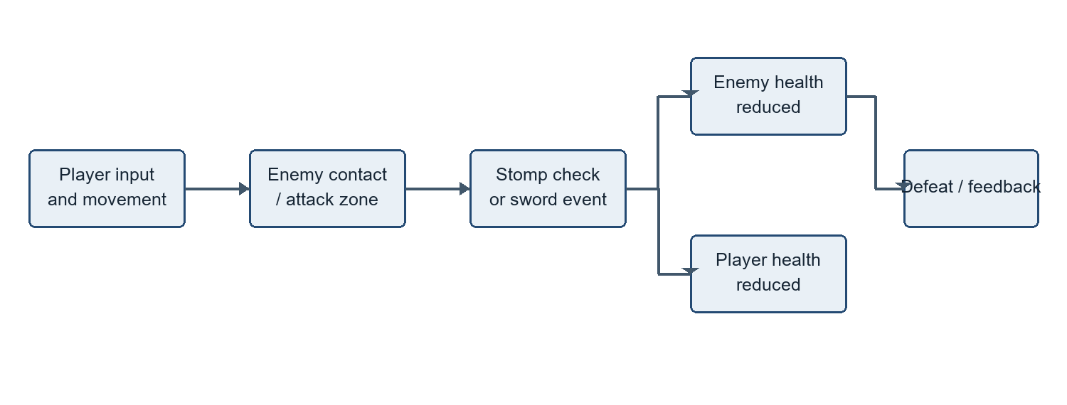
Figure 4.5 Combat flow
4.7 Health and Respawn Architecture
PlayerHealth begins at three health by default, ignores incoming damage during its invulnerability interval, and reports health changes to listeners. Falling below the configured Y threshold also invokes death. One death per scene run returns the player to the last checkpoint and restores full health; a subsequent death raises game over and disables PlayerController. Restart reloads the active scene.
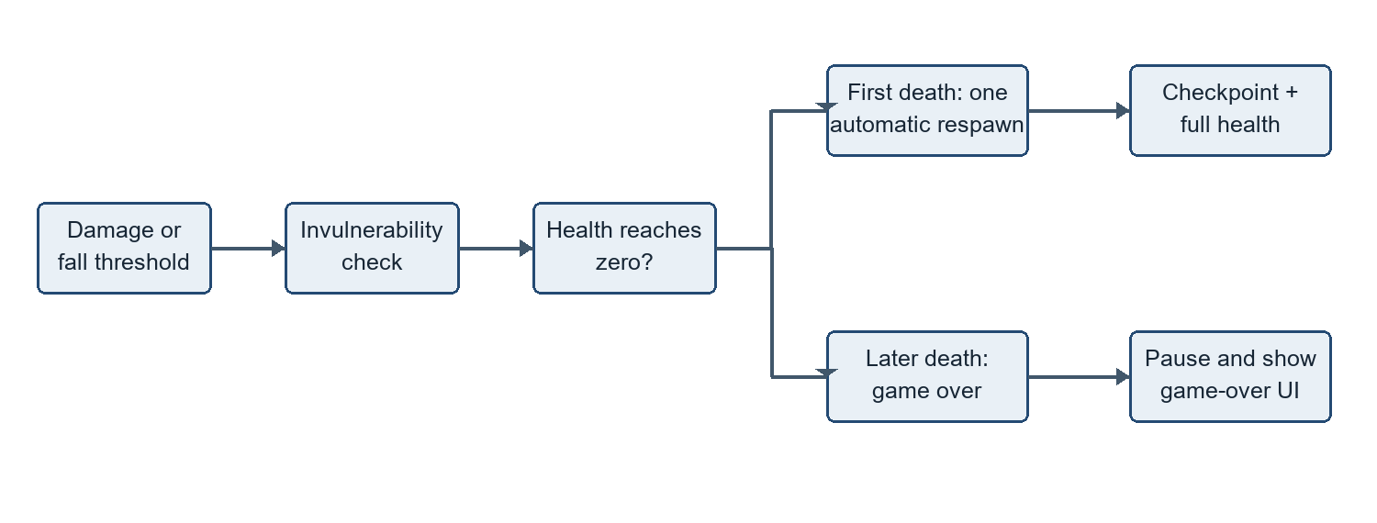
Figure 4.6 Health, death and respawn flow
4.8 Checkpoint Architecture
Checkpoint is a trigger that activates once when the Player tag enters. It stores its transform position through PlayerHealth.SetCheckpoint, updates its visual colour and requests checkpoint audio. The checkpoint is runtime state only; no persistence across level reload is implemented by this component.
4.9 Character Customization Architecture
CustomizationCategory and CustomizationOption are data assets. CharacterCustomizationManager indexes categories, applies the selected option and asks CharacterRenderer to update a visual layer. CustomizationUIController cycles categories and options and supports reset, apply/save and back navigation. CustomizationData serializes category option IDs as JSON in PlayerPrefs. The system changes appearance; it is not an unlock or progression economy.
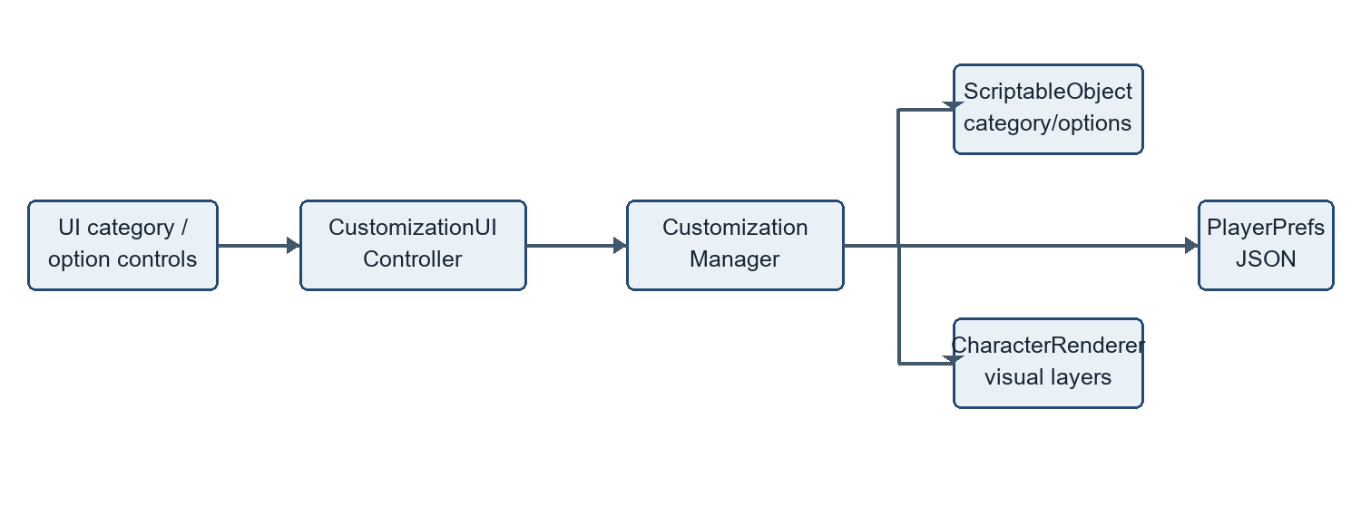
Figure 4.7 Character customization flow
4.10 UI Architecture
The UI scripts bind buttons and panels to actions such as scene loads, pause/resume, restart and level advancement. HealthDisplay presents hearts; HUDController presents text health, coin/gem count and level name. LevelCompleteController and GameOverController subscribe to manager/health events. The presence of a settings button is confirmed, but MainMenuController logs that settings are not implemented.
4.11 Audio Architecture
AudioManager is a persistent singleton with separate serialized music and SFX AudioSources. Its helper methods cover jump, collection, damage, enemy defeat, checkpoint, completion, button click, sword hit and respawn. It subscribes to collectible and level-completion events. Playback requires valid AudioSource and clip assignments; file presence alone does not prove every scene reference is active.
4.12 Data Flow
Input actions enter PlayerController, which applies Rigidbody2D forces. Collisions and trigger events call combat, hazard, checkpoint, collectible and goal behaviours. PlayerHealth events drive the health display and game-over flow. Enemy defeat feeds EnemyTracker; the goal queries remaining enemies before requesting progression. Customization UI writes selection into the manager, which updates renderer layers and saves IDs through PlayerPrefs.
4.13 System Workflow
The runtime is event- and scene-oriented: Unity initialises persistent managers, loads the selected scene, scene objects register or subscribe, then player actions produce physics events and UI/audio feedback. Completion and restart actions restore timeScale before changing scenes. Inspector references, build-scene names, tags and layer masks form important configuration contracts.
Table 4.1 Principal design components
Component | Responsibility | Key collaborators
PlayerController | Input, horizontal movement and jumping | PlayerInput; Rigidbody2D; animation/audio
PlayerHealth | Damage, health, death and single respawn | Checkpoint; HUD; game-over UI
GoblinEnemy / Enemy | Patrol and enemy interaction | PlayerCombat; Animator; EnemyTracker
LevelGoal | Gate on tracked enemy count then request completion | EnemyTracker; LevelProgressionManager
CharacterCustomizationManager | Apply, cycle and save selections | ScriptableObjects; CharacterRenderer; UI
LevelProgressionManager | Scene sequence and unlock persistence | SceneManager; level-select and completion UI

CHAPTER 5 IMPLEMENTATION
5.1 Player Controller and Movement
PlayerController requires Rigidbody2D and Collider2D and reads Move and Jump actions from PlayerInput. Each frame it reads a Vector2 movement value and updates timing and grounded state; each physics step it computes target horizontal velocity and applies force using exposed move-speed, acceleration, deceleration and velocity-power values. Rigidbody2D remains the authority for physical movement. The code targets the Unity 6 Rigidbody2D.linearVelocity property.
5.2 Jump System and Ground Detection
Ground detection uses Physics2D.OverlapBox at an assigned ground-check Transform and configured layer mask. When grounded, the coyote timer is refreshed; a short jump-press buffer permits a press just before landing to be consumed on landing. Jumping resets vertical velocity and applies an upward impulse. Releasing Jump early scales down positive vertical velocity. A higher gravity scale is used while falling. These controls add tolerance to the base physics response; exact Inspector values may vary by prefab/scene.
5.3 Player Animation
PlayerAnimationController reads movement, grounded, jumping and health state to update the Animator, flips the sprite according to horizontal direction, and exposes hurt, death and reset methods. The recent Git history records integration of Fallen Angels character animations and subsequent restoration of goblin animations. This report does not assert animation-event correctness beyond the script intent; event wiring should be checked on the relevant Animator clips in Unity.
5.4 Combat System
PlayerCombat checks an enemy layer mask before handling a collision. It identifies Enemy or GoblinEnemy components and uses the collision contact normal and player vertical velocity to recognise a downward stomp. It then defeats or damages the enemy and applies a bounce force. Body collisions are intentionally not a damage source in this code. Goblin attacks are separately performed through an overlap-circle query at an assigned attack point, with damage expected to be called by an animation event.
5.5 Health System
PlayerHealth keeps max/current health, invulnerability time, checkpoint position and a one-use respawn flag. TakeDamage clamps health to zero, starts invulnerability, emits OnHealthChanged, requests damage audio and triggers hurt animation. Heal clamps to maximum and emits the same event. Death either respawns or raises game over. Falling below fallDeathY invokes the same death method.
5.6 Enemy System
Enemy provides a simple patrol/defeat path. GoblinEnemy patrols over a configured distance, turns and flips its scale, checks player proximity and direction, and triggers an attack after cooldown when within attack range. A temporary noticed state can increase patrol speed. Boss mode instead chases inside a configured range and stops within attack range. Health depletion triggers a death animation and delayed destruction; goblin defeat notifies EnemyTracker. These are authored rules and do not use machine learning.
5.7 Wraith Behaviour and Projectile System
WraithEnemy removes gravity from its Rigidbody2D, patrols horizontally, and attempts a cast when the player is within attack range and cooldown permits. If a spell prefab and spawn point are assigned, it instantiates Projectile and passes direction, speed and damage. Projectile sets its velocity, rotates toward its travel vector, expires after a timeout and damages a tagged player on trigger contact. Current scene placement of a wraith is not established.
5.8 Collectibles and Hazards
Collectible supports Coin, Gem and Health types. Its collider is set as a trigger. When the player enters, a Health pickup calls PlayerHealth.Heal; all types emit OnCollected and destroy the pickup. HUDController counts coin and gem values; AudioManager listens for collection events. Hazard implements a player hazard interaction in source. The gameplay scenes inspected do not establish collectible placements, so these are described as implemented code capabilities rather than confirmed level content.
5.9 Checkpoints and Level Goals
Checkpoint activates on a Player-tag trigger, stores its position in PlayerHealth and updates feedback. LevelGoal also uses a trigger and checks EnemyTracker presence and remaining count. If no tracked enemies remain, it changes its configured visual state and calls LevelProgressionManager.CompleteCurrentLevel. The gate depends on the persistent tracker’s scene-load registration and enemy defeat notifications.
5.10 Enemy Tracking and Level Progression
EnemyTracker registers GoblinEnemy, WraithEnemy and basic Enemy instances when scenes load, resets the count for each level, and increments defeated count when notified. LevelProgressionManager is created before scene load if absent, persists, maps scene names to a configurable three-level sequence, and stores unlock flags using PlayerPrefs. Completing a level emits an event and unlocks the next level; the completion UI separately offers a next-level action.
5.11 Main Menu and Level Selection
MainMenuController can start the first level, open LevelSelect, open Customization, or quit. Its settings action currently logs that settings are not implemented. LevelSelectController updates buttons from the progression manager’s unlock flags and requests a selected level. Scene names and Build Settings entries must match for scene loading to succeed.
5.12 Character Customization and Data
CustomizationUIController defines an eight-category order: body, eyes, hair, shirt, pants, shoes, hat and accessory. Previous/next controls move among categories and options; reset applies defaults and clears saved data; apply serializes current IDs. CharacterCustomizationManager loads saved selections on start when configured, otherwise applies default first options. CharacterRenderer applies or clears category layers. The repository contains category assets for the listed appearance areas, though not every category has a separate default-option asset.
5.13 HUD, Pause, Game Over and Completion UI
HealthDisplay constructs heart images based on MaxHealth and responds to OnHealthChanged. HUDController subscribes to health and Collectible.OnCollected and displays health, coin/gem totals and current level. PauseMenuController creates an Escape action, pauses by setting timeScale to zero and can resume, restart or return to the menu. GameOverController displays its panel on OnGameOver and can restart or return. LevelCompleteController displays completion, pauses time and handles replay, next level or menu navigation.
5.14 Audio
AudioManager wraps PlayOneShot for configured clips, handles music pause/resume and clamps volume setters. PlayerController requests jump sound, checkpoints request checkpoint audio, PlayerHealth requests damage/respawn sounds, and UI buttons can request click sound. The implementation is conditional on non-null singleton, source and clip references.
5.15 Camera System
CameraFollow runs in LateUpdate, computes a target-plus-offset location, interpolates with a smoothing value and optionally constrains axes or clamps position to bounds. An optional look-ahead derives horizontal direction from target Rigidbody2D velocity. SetTarget and SnapToTarget support runtime retargeting. Cinemachine is absent from the current direct package manifest; this is a project-owned camera component.
Table 5.1 Key implementation scripts
Script group | Important scripts | Implementation role
Player | PlayerController; PlayerHealth; PlayerCombat; PlayerAnimationController | Movement, state, interactions and animation
Enemies | Enemy; GoblinEnemy; WraithEnemy; Projectile | Patrol, attack and damage handling
Levels | Checkpoint; Hazard; LevelGoal; EnemyTracker; LevelProgressionManager | Triggers, enemy count and scene progression
UI | MainMenuController; LevelSelectController; HUDController; HealthDisplay; PauseMenuController; GameOverController; LevelCompleteController | Menus, HUD and state panels
Customization | CustomizationCategory; CustomizationOption; CharacterCustomizationManager; CharacterRenderer; CustomizationUIController; CustomizationData | Appearance options, presentation and local saving
Services | AudioManager; CameraFollow; Collectible | Shared audio, camera motion and pickup events

CHAPTER 6 GAMEPLAY SYSTEMS AND LEVEL DESIGN
6.1 Gameplay Loop
The implemented loop is start or select a level, move and jump through the side-scrolling environment, encounter available enemies, use movement/combat to clear obstacles, activate a checkpoint and touch the level goal. Health recovery and one automatic respawn mitigate failure; further death opens game over. Completion UI can replay, advance or return to the main menu. No narrative campaign or score economy is established in the repository.
6.2 Level 1
Level1 is an enabled gameplay scene with a Player, platform environment, goal, checkpoint and gameplay interface. Its serialized prefab instances include ten regular GoblinEnemy objects and one boss-mode GoblinEnemy. The supplied screenshot shows the Unity Editor hierarchy/scene view rather than a runtime capture. The level goal depends on EnemyTracker reporting no remaining enemies; a successful clear was not demonstrated by the supplied evidence.
6.3 Level 2
Level2 is a separate enabled gameplay scene with the common player, goal, checkpoint and UI structure. Its Enemy_01 GameObject has Rigidbody2D, BoxCollider2D, SpriteRenderer and the basic Enemy patrol script. The scene data documents the configured object, not a tested encounter or successful completion path.
6.4 Level 3
Level3 is the third enabled gameplay scene and similarly contains an Enemy_01 with the basic Enemy script, alongside the goal, checkpoint and gameplay UI. The progression manager’s default scene sequence is Level1, Level2, Level3. Scene-specific difficulty values and measured completion times are not documented as tested results.
6.5 Enemy Placement, Hazards and Collectibles
The serialized scenes establish eleven goblin behaviours in Level1 and one basic Enemy in each of Levels 2 and 3. A hazard script and collectible types exist in source, but placements of those optional systems are not confirmed in these scenes. Future level-design documentation should record transforms, collision layers, enemy defeat notifications and goal dependencies.
6.6 Checkpoints and Level Goals
Each of the three gameplay scenes contains a Checkpoint and LevelGoal object. The checkpoint supplies a one-time in-run respawn position. The goal is gated by EnemyTracker.RemainingEnemyCount, so a tracked-enemy level requires defeat notifications to match enemy registration. The screenshots document the checkpoint and goal Inspector setup; they do not demonstrate a successful playthrough.
6.7 Character Progression
LevelProgressionManager stores unlock flags locally. It unlocks the first level on start and unlocks the next level when the current level is completed. Customization selections persist separately as option IDs. Health, checkpoints and collectible totals are not shown as cross-session progression systems. The project therefore has level access and appearance persistence, but no established experience, inventory or equipment progression.
6.8 Difficulty and Player Feedback
Difficulty is presently represented by authored platforms and enemy behaviour, not by a documented adaptive system. The player receives health and heart feedback, damage/hurt response, enemy attack/death animation requests, checkpoint visual/audio feedback, pause and completion panels, and sound helpers. There is no recorded balancing study, player survey or runtime performance benchmark.

CHAPTER 7 RESULTS AND ANALYSIS
7.1 Implementation Results
Repository inspection confirms a Unity 6000.5.1f1 project configured with URP 2D and the New Input System. It contains six enabled application scenes, gameplay scripts, a player prefab, environment prefabs, customization ScriptableObjects and UI/audio components. Current project documentation explicitly notes that repository presence is not equivalent to runtime validation.
7.2 Gameplay and UI Results
The authored scenes provide a menu path, level selection, three gameplay scenes and a customization scene. Gameplay scripts implement movement, jumping, combat, health, checkpoints, goals, progression and pause/game-over/completion UI. Available evidence is source and Inspector/scene screenshots. The report does not claim that a complete playthrough or all menu transitions were tested.
7.3 Customization Results
The option/category UI and data flow support selecting visual appearance options and saving selections locally. ScriptableObject assets exist for multiple categories. The screenshot evidence shows editor configuration of the customization Canvas and UI controller; there is no supplied runtime screenshot proving all options render correctly in a build.
7.4 Enemy, Combat, Health and Progression Results
PlayerCombat implements downward stomp handling and bounce. Goblin attacks can apply player damage through a configured overlap area; PlayerHealth includes invulnerability, checkpoint recovery and a single automatic respawn. EnemyTracker and LevelProgressionManager implement count and unlock flows. Scene contents configure ten goblins and a boss-mode goblin in Level1 plus a basic Enemy in each other level; these assets do not constitute test evidence for successful defeat-to-goal progression.
7.5 Performance and Technical Observations
No profiler capture, device specification, frame-rate sample, memory measurement or benchmark result is present. Performance is therefore unquantified. The component design exposes many tunable values, while the number of Unity objects and scenes is modest in the supplied scene assets. These source-level observations should not be interpreted as measured performance.
7.6 Limitations
• No checked-in standalone build or documented target platform.
• No checked-in automated gameplay test suite or runtime test results.
• Gameplay screenshot set documents Unity Editor configuration and scene layout, not captured play sessions.
• Enemy tracker registration, animation events, tags/layers and audio assignments require runtime validation.
• Wraith and collectible source systems are not confirmed as placed in the three levels.
• Main-menu settings action is a placeholder log message.
• No recorded playtest feedback, accessibility review, balance data or performance benchmark.
7.7 Future Improvements
• Capture verified runtime evidence for menu navigation, each level, combat, damage/respawn and goal completion.
• Add repeatable playtest scenarios or automated tests for jump windows, health changes, checkpoint activation, enemy tracking and scene transitions.
• Document per-level composition, exact enemy components, goal/tracker wiring, difficulty and intended controls.
• Complete or remove the settings affordance; add accessibility options and clearer input instructions.
• Profile an agreed target device and define a release build and support matrix.
• Integrate or explicitly defer wraiths, projectiles and collectible placements based on intended design.
7.8 Gameplay Screenshots
The supplied pics folder contains Unity Editor screenshots, not gameplay captures. The selected figures below are presented as configuration and scene evidence. Inspector screenshots are useful for documenting component setup but cannot prove the runtime appearance or success of the corresponding flow.

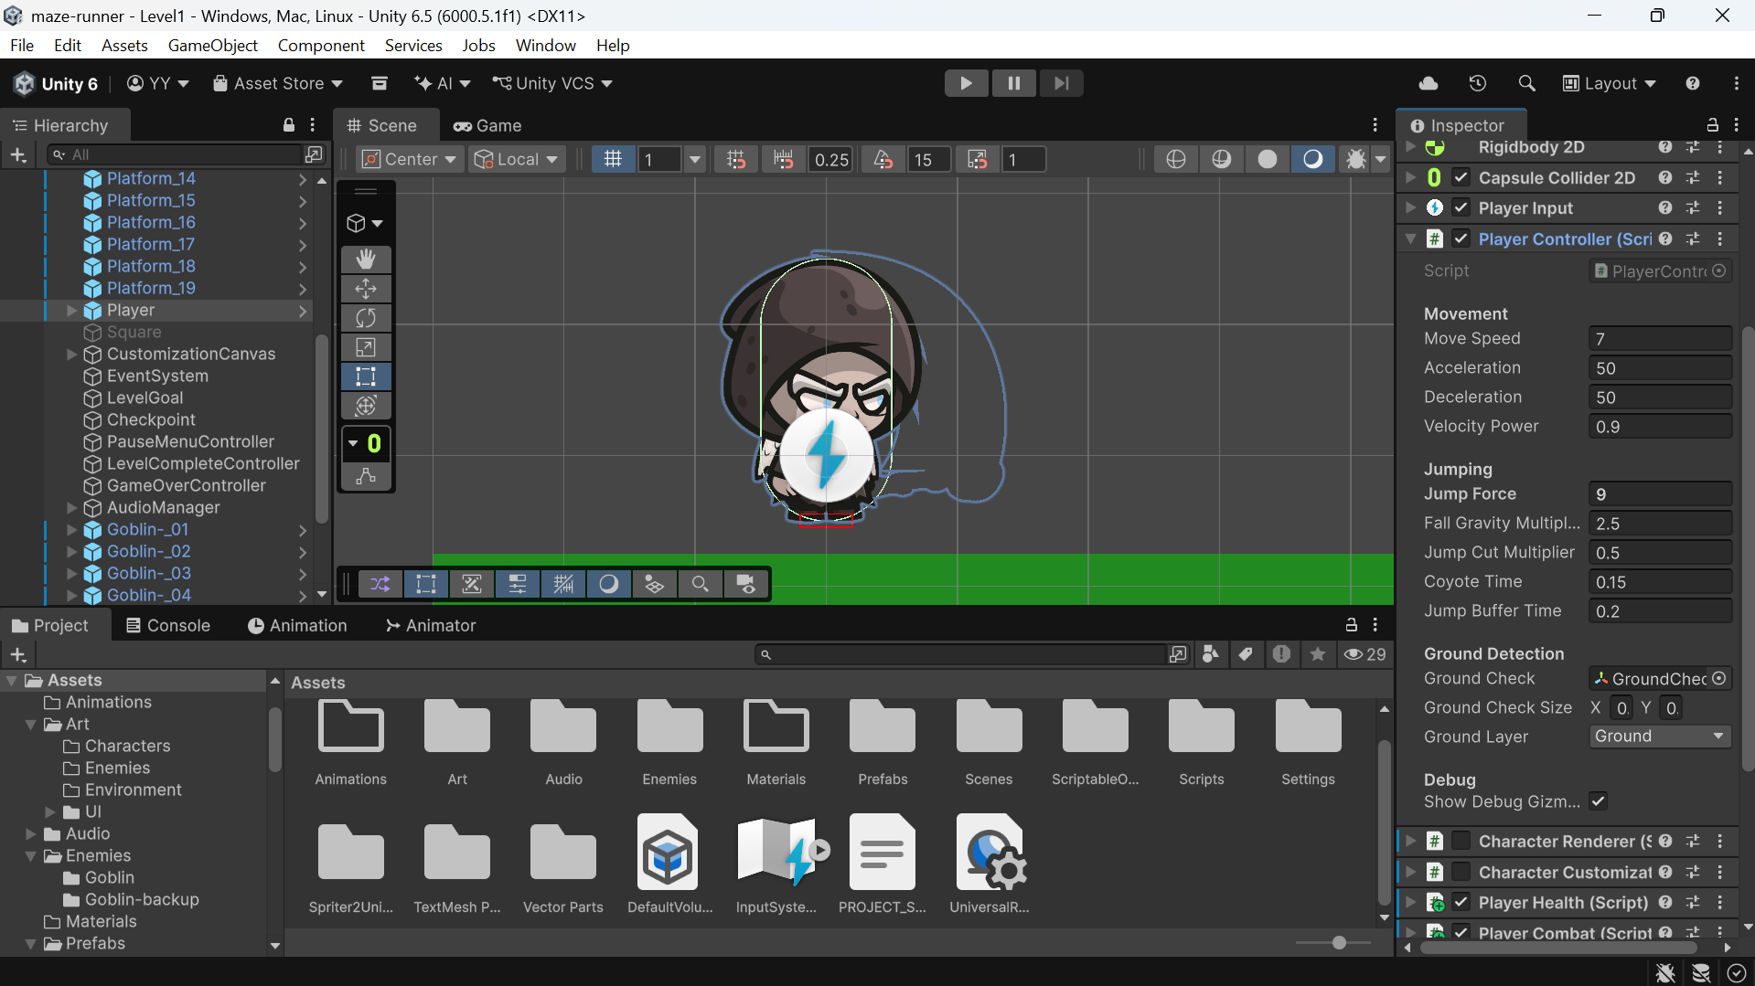
Figure 7.1 Player prefab and movement-controller Inspector values
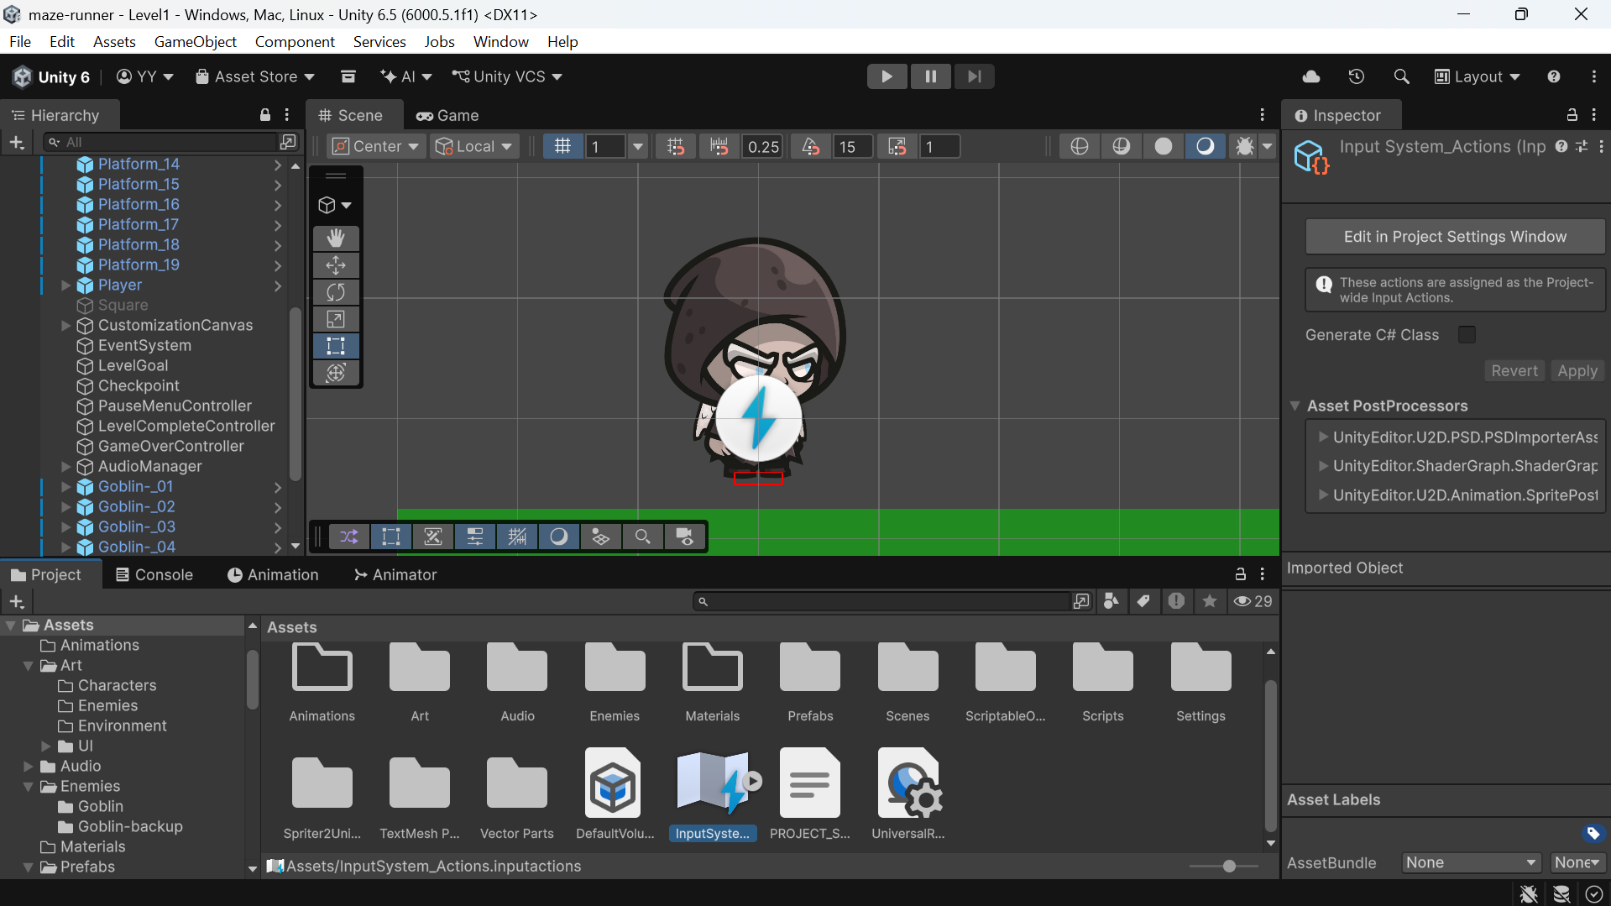
Figure 7.2 Input Actions asset configuration

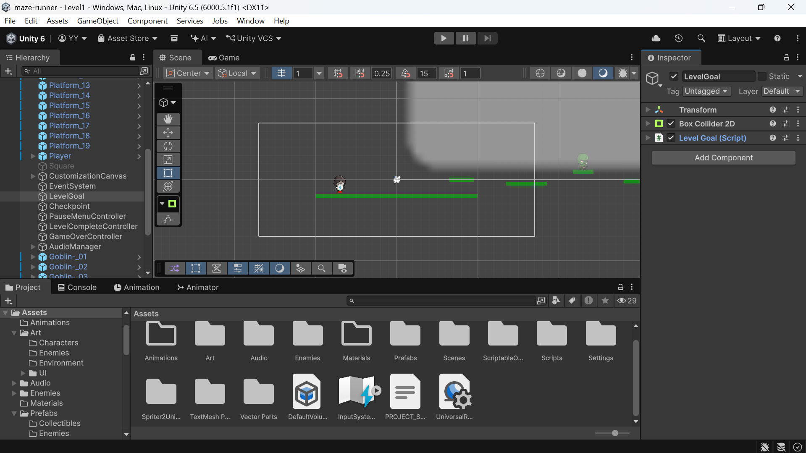
Figure 7.3 Camera-follow component configuration
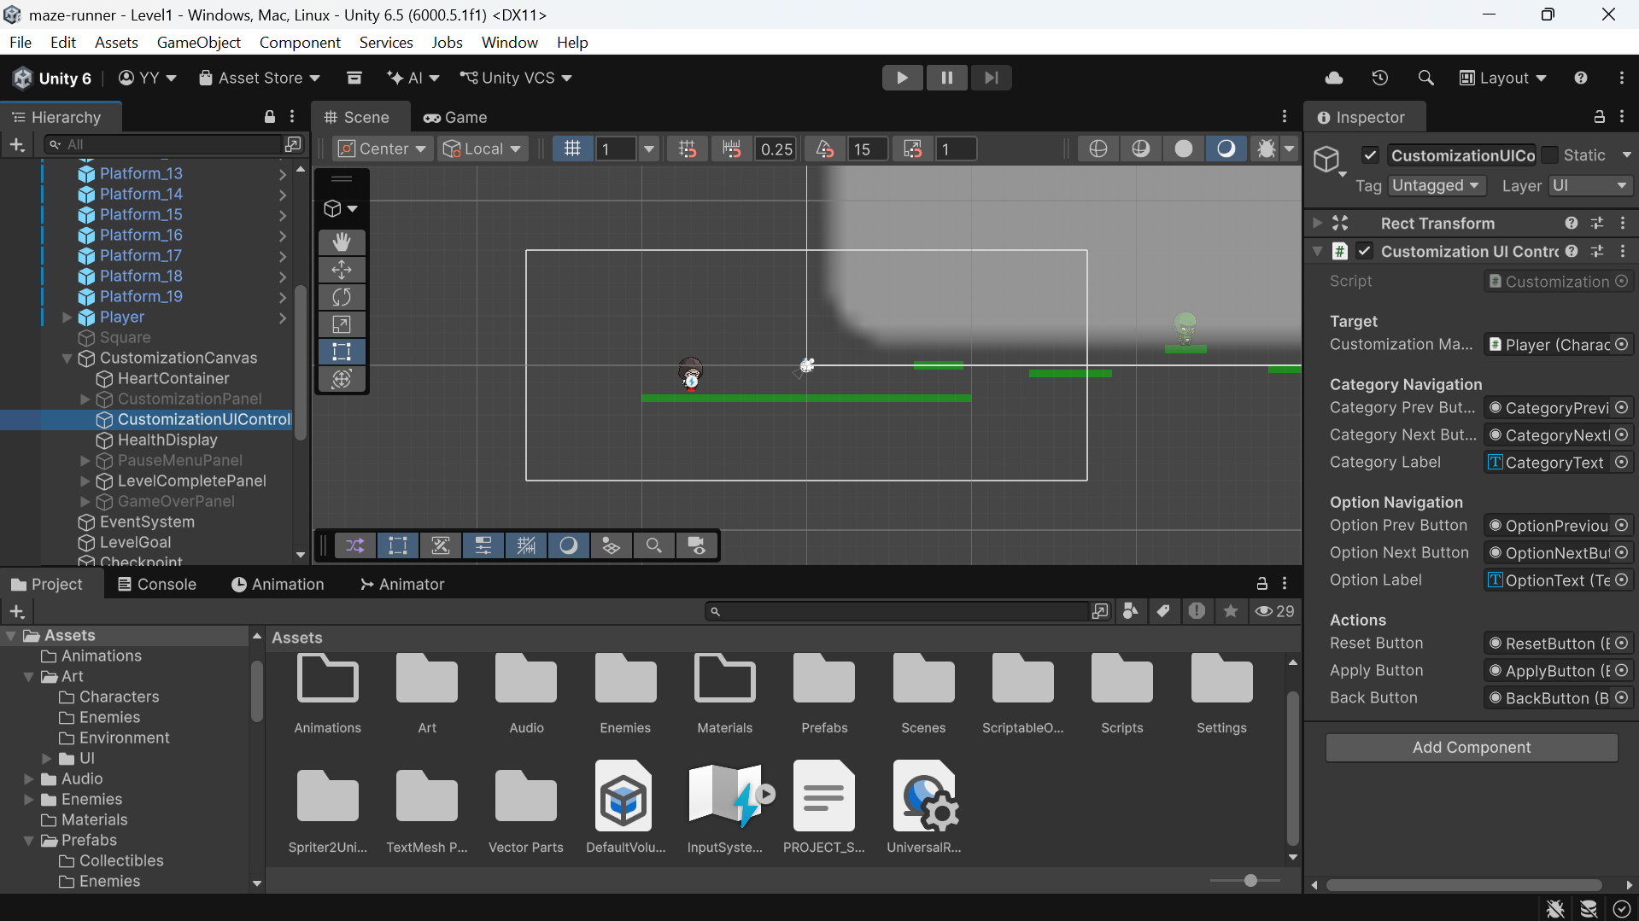
Figure 7.4 Character-customization UI controller references

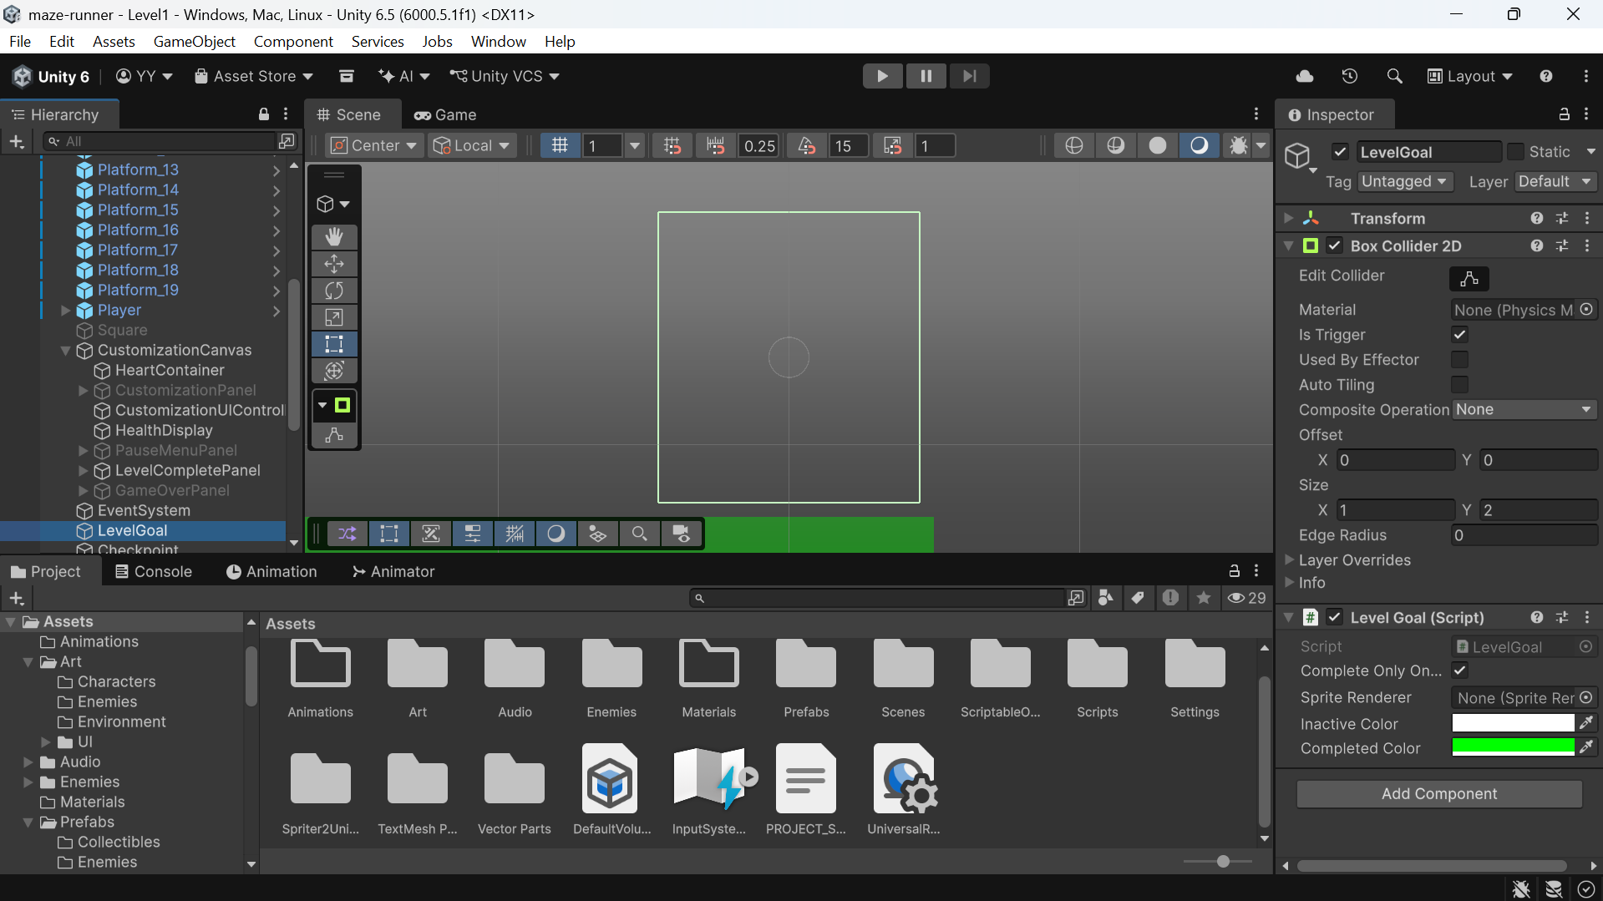
Figure 7.5 Level-goal trigger and visual configuration
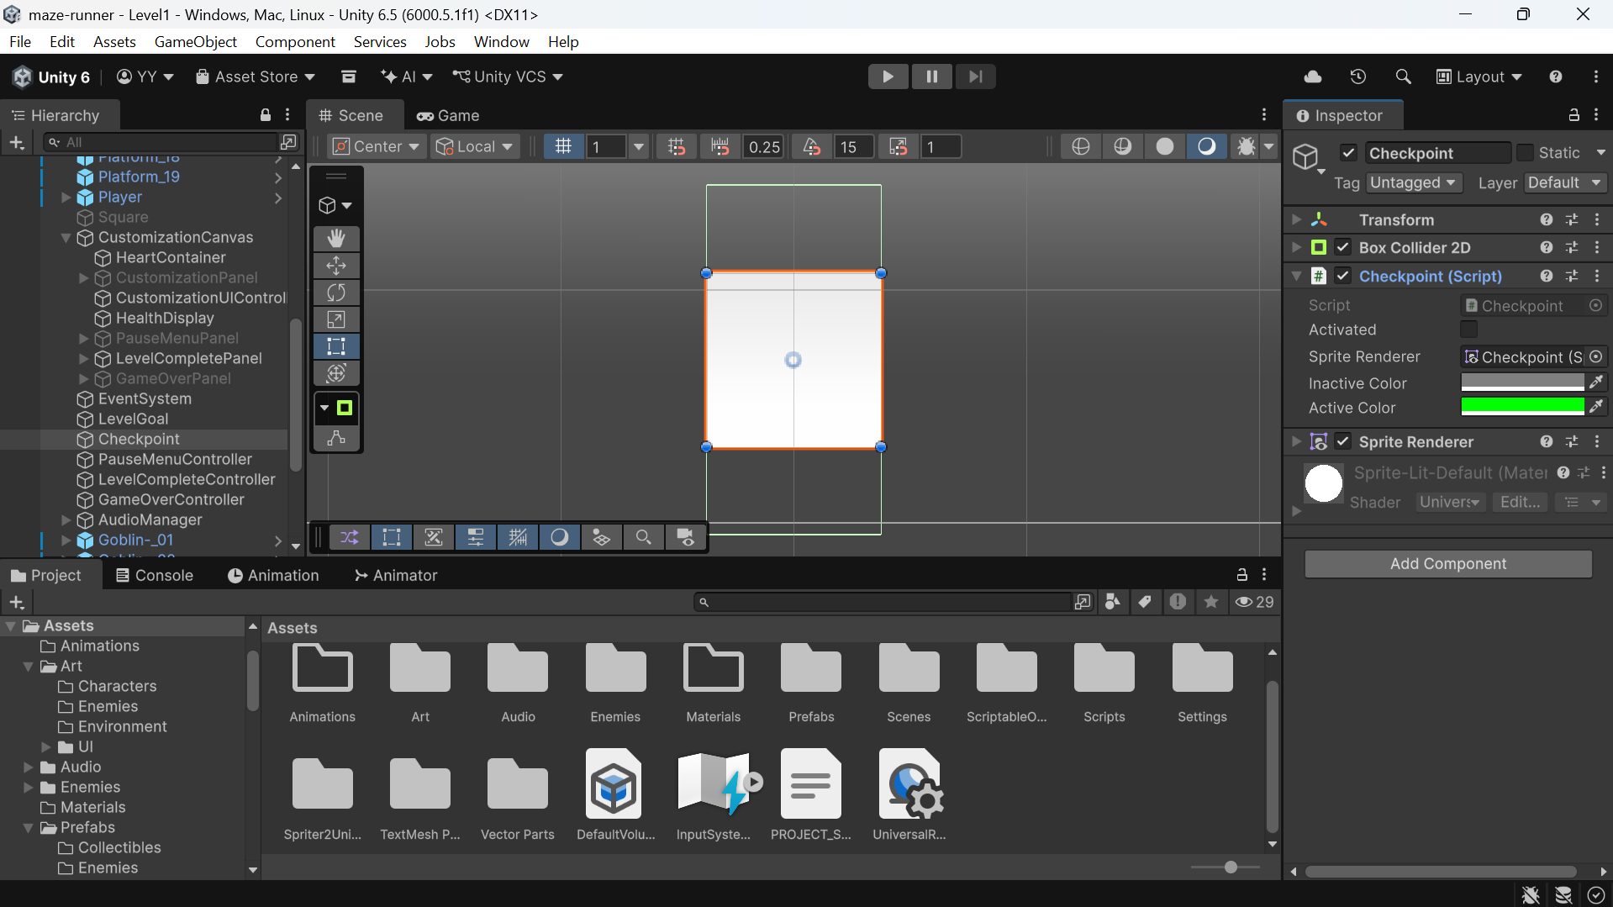
Figure 7.6 Checkpoint trigger and active/inactive visual setup

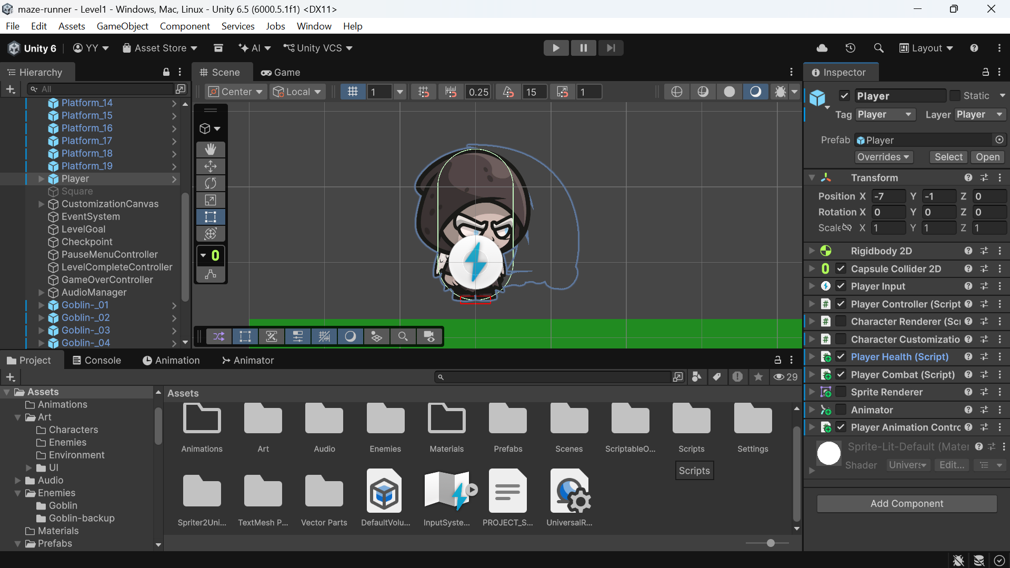
Figure 7.7 Player and goblin objects in the Level1 Editor scene
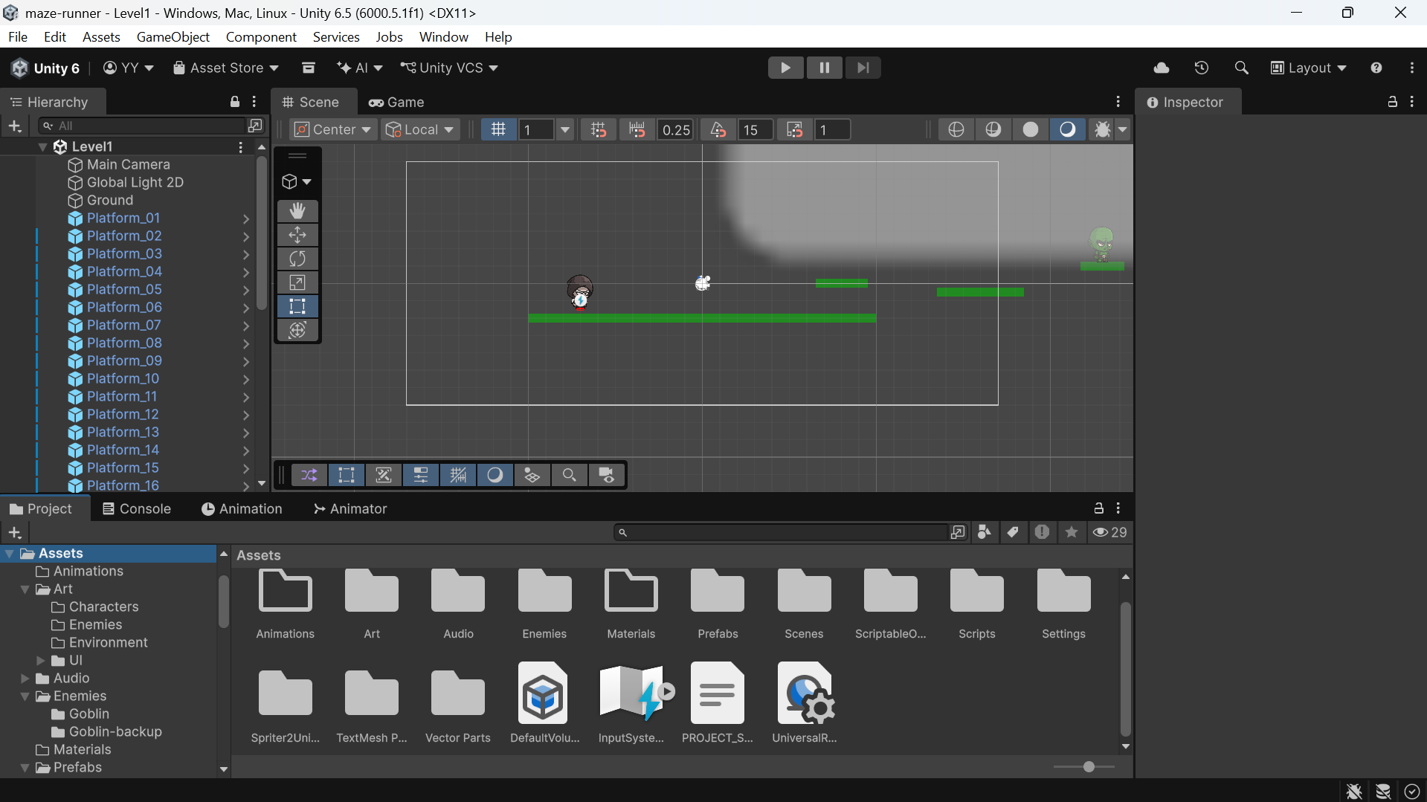
Figure 7.8 Level environment layout in the Unity Editor scene view

CHAPTER 8 CONCLUSION
8.1 Conclusion
Maze Runner is a Unity 2D platformer prototype with three authored gameplay levels and supporting menu/customization scenes. Its current codebase integrates a physics-driven player controller, jump assistance mechanics, combat interactions, three-point health, damage invulnerability, one automatic checkpoint-based respawn, goal and progression code, enemy behaviours, HUD and state panels, customization data and audio/camera helpers. The project is a functional implementation foundation documented through source, Unity assets and editor screenshots; the available repository does not supply runtime verification evidence or a release build.
8.2 Achievement of Objectives
Table 8.1 Objective coverage
Objective | Repository evidence | Assessment
Movement and jumping | PlayerController; Input Actions; Rigidbody2D setup | Implemented in source and prefab
Combat and enemies | PlayerCombat; Level1 goblins/boss; Enemy_01 in Levels 2 and 3 | Implemented in code; runtime combat needs validation
Health, checkpoint, respawn | PlayerHealth; Checkpoint; game-over and health UI | Implemented in source; not claimed play-tested
Multiple levels and progression | Three gameplay scenes and LevelProgressionManager | Authored and enabled in Build Settings
Customization | Category/option assets, renderer, manager, save data and UI scene | Implemented as local appearance selection
Feedback and presentation | HUD, panels, audio helpers and CameraFollow | Source/components present; assignments and runtime output need validation
8.3 Limitations
The strongest limitation in the available evidence is the absence of documented execution-based validation. The project’s implementation state is assessed from current source and serialized Unity content. Actual gameplay quality, frame performance, correct serialized references and scene-to-scene player experience remain outside what can be concluded from these materials.
8.4 Future Scope
Future work can validate the core loop in the Editor and on a named target device, record results for all three levels, refine encounter and jump parameters from player feedback, complete menu settings and accessibility support, and decide whether to integrate collectible and wraith content. A small test plan for scene loading, damage, checkpoint return, enemy-clear gating and local customization persistence would make later changes easier to review.

REFERENCES
[1] G. Dahl and M. Kraus, “Measuring how game feel is influenced by the player avatar’s acceleration and deceleration: using a 2D platformer to describe players’ perception of controls in videogames,” Proceedings of the 19th International Academic MindTrek Conference (Academic MindTrek ’15), pp. 41–46, 2015. doi: 10.1145/2818187.2818275.
[2] M. Fasterholdt, M. Pichlmair and C. Holmgård, “You Say Jump, I Say How High? Operationalising the Game Feel of Jumping,” Proceedings of DiGRA/FDG 2016, 2016. doi: 10.26503/dl.v2016i1.771.
[3] M. Pichlmair and M. Johansen, “Designing Game Feel. A Survey,” arXiv:2011.09201, 2020. https://arxiv.org/abs/2011.09201.
[4] Unity Technologies, “2D game creation workflow: Physics 2D,” Unity Manual, Unity 6.1. https://docs.unity3d.com/6000.1/Documentation/Manual/2d-game-creation-wokflow.html.
[5] Unity Technologies, “ScriptableObject,” Unity Manual, Unity 6.1. https://docs.unity3d.com/6000.1/Documentation/Manual/class-ScriptableObject.html.
[6] Unity Technologies, “Input System package,” Unity Documentation, package version 1.19.0 as recorded in Packages/manifest.json. https://docs.unity3d.com/Packages/com.unity.inputsystem@1.19/manual/index.html.
[7] Unity Technologies, “PlayerPrefs,” Unity Scripting API, Unity 6. https://docs.unity3d.com/6000.0/Documentation/ScriptReference/PlayerPrefs.html.
[8] Maze Runner repository, README.md, docs/ARCHITECTURE.md, docs/GAMEPLAY_SYSTEMS.md, docs/SETUP.md, Assets/Scripts/, Assets/Scenes/, ProjectSettings/ and Packages/manifest.json. Accessed 23 September 2026.
[9] CHRIST (Deemed to be University), School of Engineering and Technology, Department of AI and Data Science Engineering, CIA3 report format and Sports Arena CIA3 report supplied as formatting references. Institutional wording and rubric adapted from these user-provided documents.

