VISÃO POR COMPUTADOR - Trabalho Prático No 2 – Aurélien Bernier Levalois & Yoann Fleytoux

Part 1

1. Read any existing image on disk. (Ex: RGB image
"Cameraman.tif").
To convert an image s colors to an image in gray levels use the function
Rgb2gray.
I = imread('cameraman.tif');
imshow(I)
%I_G=rgb2gray(I);
%figure;
%imshow(I_G)
2. Add different types of noise to the picture (separately, ie you should not apply noise sequentially to the same image-noise is always applied to the original image).
A) Gaussian noise with: - zero mean and 2 values of variance; --Media 10, and 2 values of variance;
B) salt & pepper noise with density 0.1 and 0.5.
C) speckle noise with variance 0.8. Using the imnoise function available in MATLAB

J1 = imnoise(I,'gaussian',0,0.1)
Figure
imshow(J1)
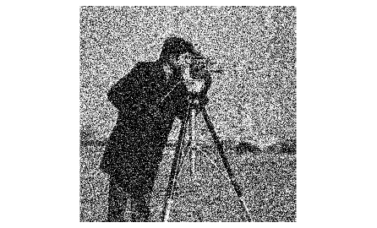
Figure 1 : Gaussian noise with variance 0.1

J2 = imnoise(I,'gaussian',0,0.3)
figure
imshow(J2)

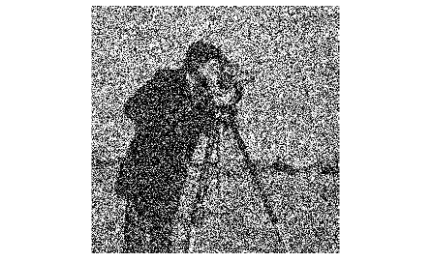
Figure 2 : Gaussian noise with variance 0.3

J3 = imnoise(I,'gaussian',10,0.1)
figure
imshow(J3)

J4 = imnoise(I,'gaussian',10,0.3)
figure
imshow(J4)


Figure 3 : Gaussian noise with mean 10 (possible mistake)

J5 = imnoise(I,'salt & pepper',0.1)
figure
imshow(J5)

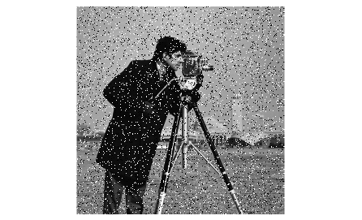
Figure 4 : Salt & Pepper with density 0.1

J6 = imnoise(I,'salt & pepper',0.5)
figure
imshow(J6)

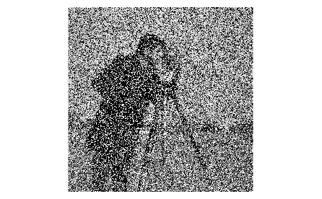
Figure 5 : Salt & Pepper with density 0.5

J7 = imnoise(I,'speckle',0.8)
figure
imshow(J7)

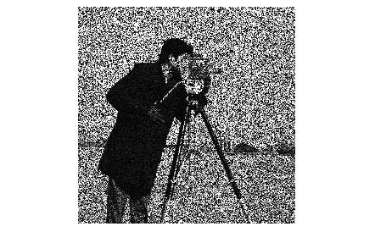
Figure 6 : Speckle with variance 0.8
From now on, you can see the MATLAB code in the file attached.

3. Carry out the filtering of each image using the average filter, the
Gaussian filter and the median filter. Apply the filters separately.
Use the imfilter function available in MATLAB.
Convolution masks can be obtained through the special function.
The medfilt2 function performs median filtering

A) Compare the performance of the various filters in the presence of different types of noise. What is the difference between the application of the linear filter of mean and Gaussian?

We will only put all the pictures for the filters on the Gaussian noise with variance 0.1 and explain for all of them.

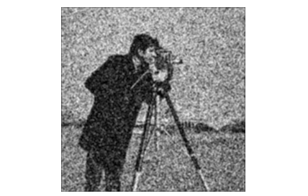
Figure 1 : Average filter on picture with Gaussian noise of variance 0.1
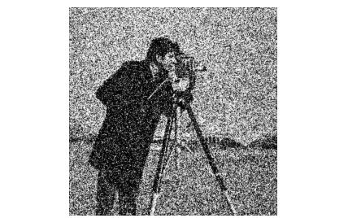
Figure 2 : Gaussian filter on picture with Gaussian noise of variance 0.1
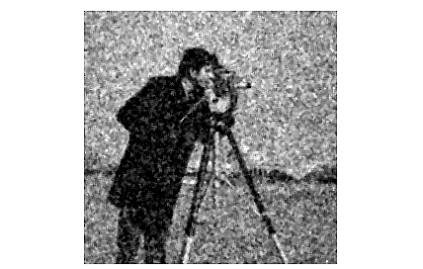
Figure 3 : Median filter on picture with Gaussian noise of variance 0.1
As we can see, the filter with the most satisfying result seems to be the Gaussian filter for a picture with a Gaussian noise of variance 0.1.
For the salt & pepper noise, we can see that the best result is with the median filter:
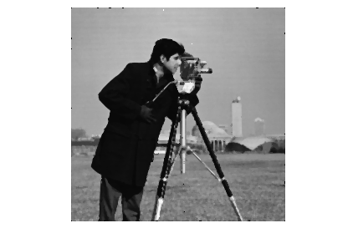
Figure 4 : Median filter on picture with Salt & Pepper noise, density 0.5
The image is more blurry, but nearly all of the salt and pepper dots disappeared.

As for the speckle noise, we can see the best result is using the average filter, however the result is less satisfying than with the other types of noise:
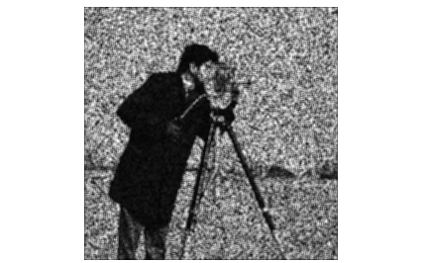
Figure 5 : Average filter on picture with Speckle noise of variance 0.8

Use the improfile function to display gray level values ​​over
A horizontal line in the image. Compare the values ​​before and after filtering.
Add the graphics.

Here are the graphs comparing the values before and after filtering for each type of noise.
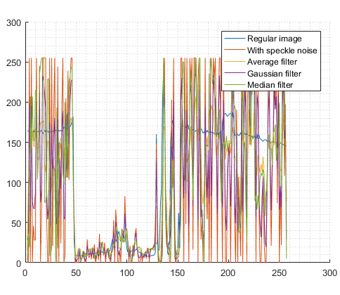
Figure 6 : Comparison of pixel values with and without filtering (speckle noise)
We can confirm the result we saw before analyzing the values: We’re closer to the main image with the average filter.
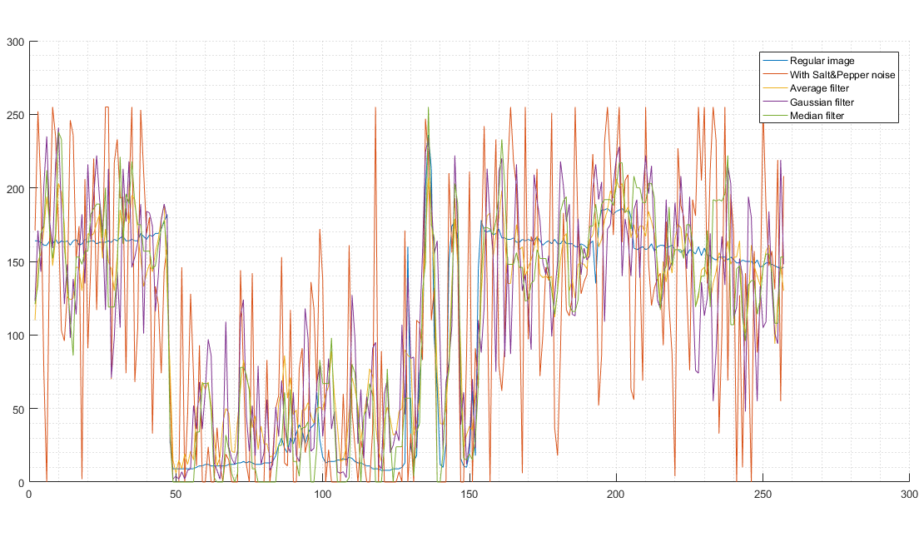
Figure 7: Comparison of pixel values with and without filtering (salt & pepper noise)
Here we can see that compared to what we saw with the naked eye, the best filter might be the average filter in some places, but the median filter is still good.

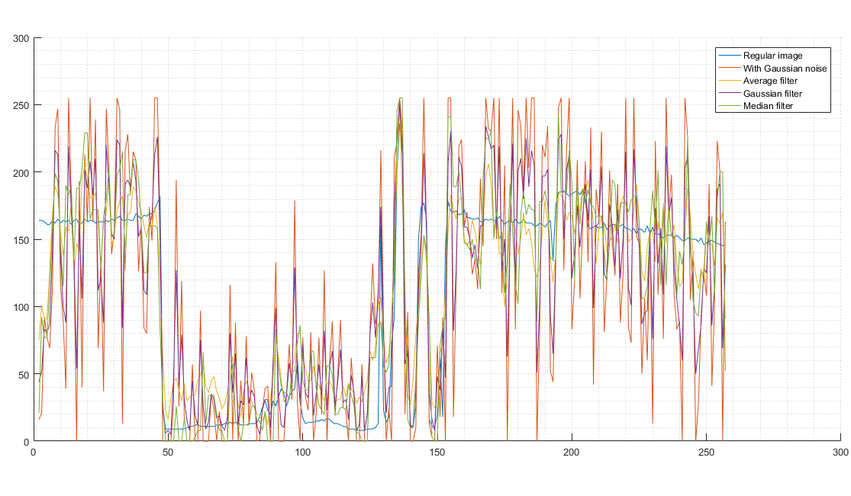
Figure 8 : Comparison of pixel values with and without filtering (Gaussian noise)
Here we can see that the filters are roughly as efficient as each other.

B) What is the influence of the standard deviation on the convolution mask definition of the Gaussian filter? Justify.
Use the special function to obtain the filter mask associated with a
Determined standard deviation.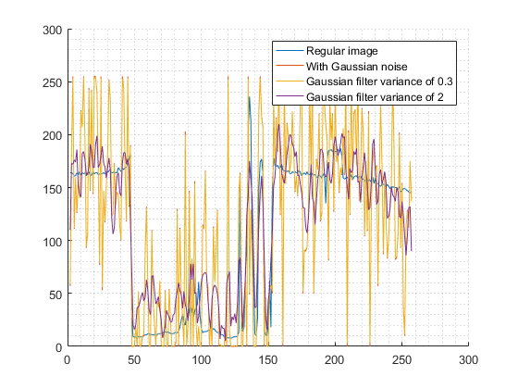
Figure 9 : Comparison of pixel values depending on the Variance of the Gaussian filter

Here, we can see that the higher variance of 2 gives a way more accurate result, with the variance of 0.3 we barely see the difference with the original noisy image.

4) Implement the median filter and compare its performance with the Matlab filter.
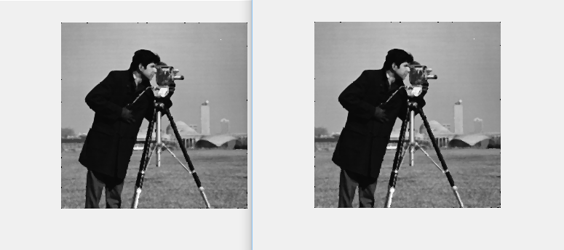
Figure 10 : Comparison of the two median filters : MATLAB (left) & Homemade (right)
They’re very similar. They both work well on a salt & pepper image.

PART 2

5.

Edge detection:

Sobel mask result:
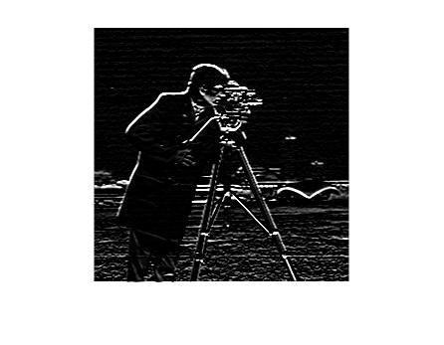
Sobel gradient vector display:
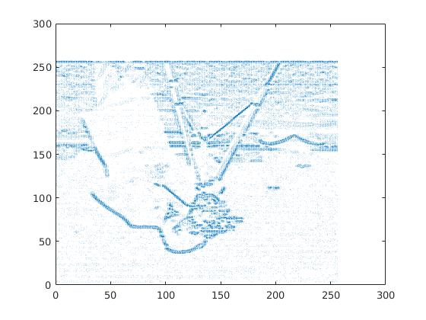
Laplacian mask result:
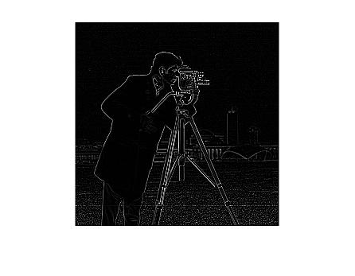
Laplacian gradient vector display:
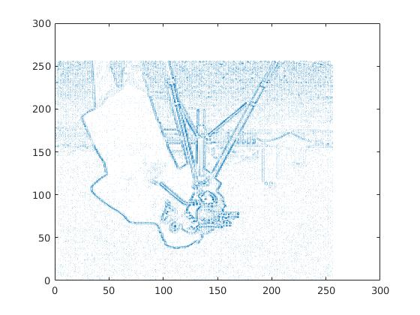
Laplacian of gaussian mask result:
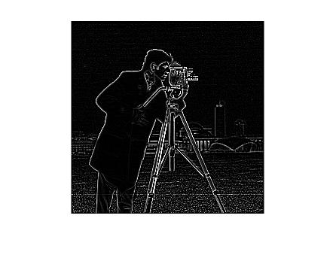
Laplacian of gaussian gradient vector display:
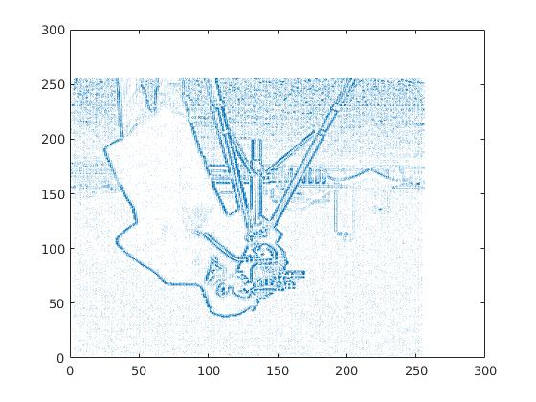
Canny mask result:
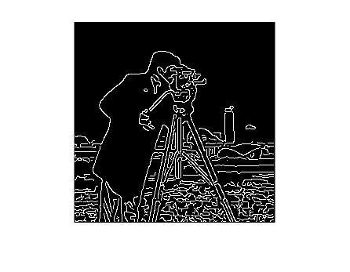
Canny gradient vector display:
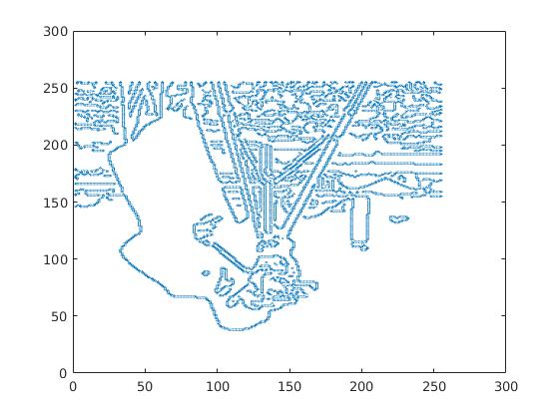
6.

Edge with edge function

Canny:
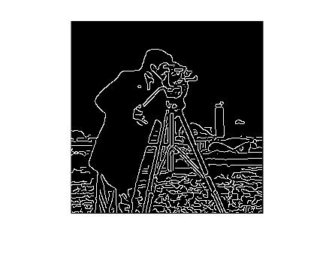
Log:
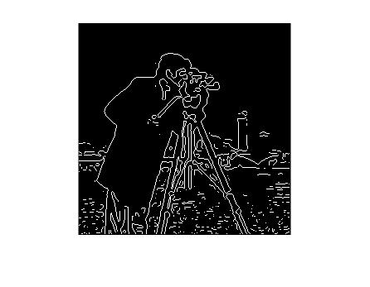
Sobel:
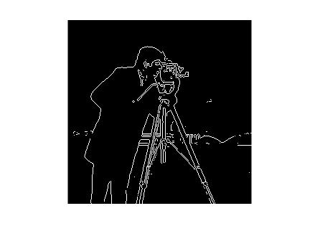
Zerocross:

Sobel algorithm:

Result: