08/03/2017
Computer Vision TP3
Detection of characteristic points in the image ("Corners, Lines and Circumferences")
Aurélien Bernier Levalois & Yoann Fleytoux
DEEC – University of coimbra

Detection of characteristic points in the image
("Corners, Lines and Circumferences")

Corner Detection

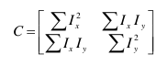

This method should be applied to the image "chess_2.png".
Consider a generic point of the image P, a neighborhood Q and a matrix C defined by

Where summations are computed in neighborhood Q. I x and I y represent respectively the
Horizontal and vertical components of the gradient calculated at point P (remember
Practical no.1 on image differentiation). The matrix C characterizes the structure of
Gray image.

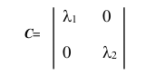

Since C is a symmetric matrix, it can be diagonalized by rotating the axes
Of coordinates, obtaining a diagonal matrix

Where lambda1 and lambda2 correspond to the eigenvalues ​​of matrix C.

The two eigenvalues ​​lambda1 and lambda2 are both positive. To understand the meaning
Associated with the lambda1 and lambda2 eigenvalues ​​and the corresponding eigenvectors, consider the following:

For a neighborhood Q where the pattern of its gray levels is uniform the gradient components tend to zero and C becomes a null matrix, resulting in lambda1 = 0 and lambda2 = 0.

For a binary pattern corresponding to a step transition between the gray and black gray level, we obtain lambda1> 0 and lambda2 = 0, and the associated vector associated with lambda1 is parallel to the image gradient.
If the Q neighborhood contains the corner of a black square on a white background there are two main gradient orientations in the neighborhood Q, obtaining lambda1> 0 and lambda2>0 corresponding to the higher values ​​of eigenvalues ​​the higher gradient transitions.

A corner (corner) is identified through the intersection of two contours with distinct orientations. As lambda1> = lambda2, a corner is defined by the location of the point P where the smallest eigenvalue lambda2 is sufficiently high.

1 - Implement a program in MATLAB that allows to detect corners in the image. For such
Analyze the algorithm that follows:

Algorithm for detection of corners
For an image I consider a neighborhood Q of dimension 2N + 1 x 2N + 1 pixels.
Define a sigma threshold value for lambda2 above which the existence of a corner is considered.
1 - Calculate the X and Y components of the gradient throughout the image.
2 - For each point of the image P:
A) Obtain the matrix C corresponding to neighborhood Q;
B) Calculate the eigenvalues ​​of C, and select the lower eigenvalue lambda2.
(Use the eig function available in Matlab.)
C) If lambda2> = sigma, save the coordinates of point P in a list L.
3 - Sort list L in descending order of lambda2 values.
Use the sort function available in Matlab.
4 - Browse the sorted list downwards and for each point P in the list,
Remove from the list all points that belong to the area of ​​your neighborhood.
This elimination ensures that vertices with common neighborhood points are not detected.

This algorithm provides a list of points with lambda2> = sigma and whose neighborhoods do not overlap.

2 - Display the lambda2 histogram along the I image. The histogram can help to define a more correct value for the sigma threshold

3 - Simulate the algorithm in a synthetic image with well defined corners. For example, an image with black squares on a white background. Use the checkerboard function (use the command to create an image where there are black squares with a white background in the middle of the image, and in the other half the background has a medium gray level (eg 128). (3) and 5 (5) for the corners that it detects also represent the own vectors of the matrix C. What conclusions do you draw about the orientation of the eigenvectors?What is the gray background efect ?

4 - Apply the algorithm to a real image. Test the algorithm with neighborhoods 3 * 3 and 5 * 5. Compare with results obtained with the following Matlab functions: detectCheckerboardPoints, corner (both options), detectHarrisFeatures, and detectMinEigFeatures.

The base will be the detectCheckerboardPoints function because it is 100% accurate :

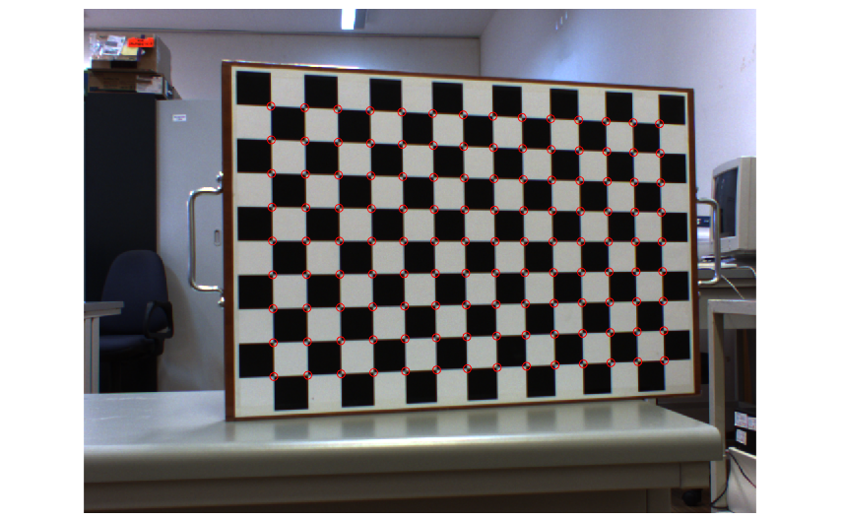
Figure 1: detectCheckerboardPoints

This is the result of our algorithm with a neighbourhood of 3x3 :

TODO INSERT

This is the result of our algorithm with a neighbourhood of 5x5 :

TODO INSERT

To compare, the corner function with Harris features :

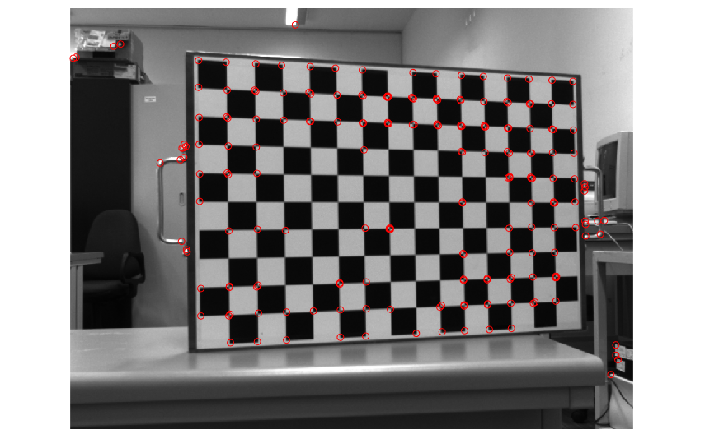
Figure 2 : Corner with Harris Features

The corner function with Min Eigen Values features :
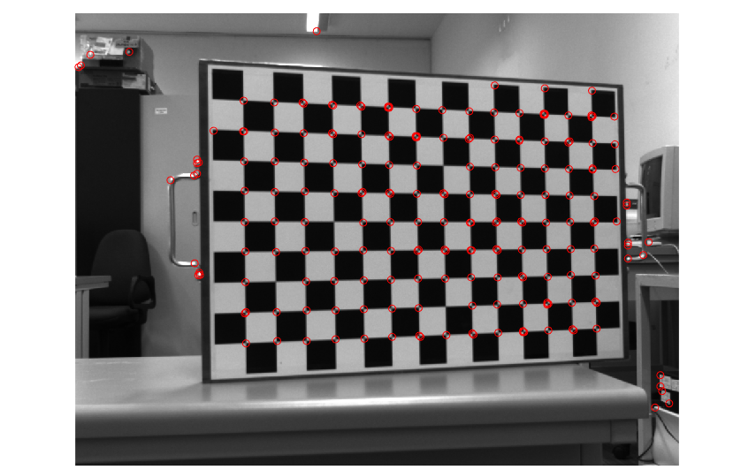
Figure 3 : Corner function with Min Eigen Values

The HarrisFeatures function :

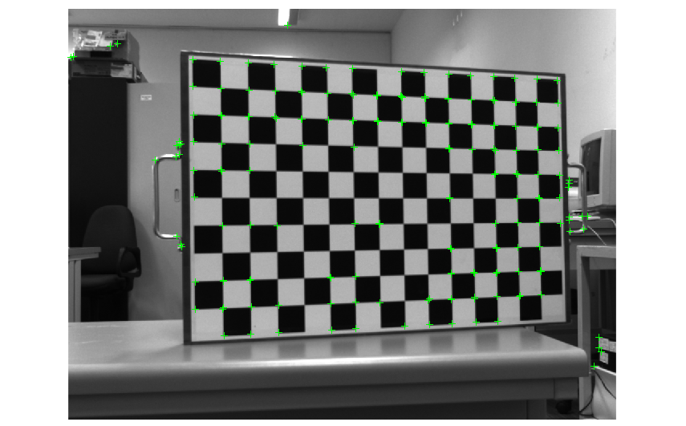
Figure 4 : HarrisFeatures function (200 strongest dots)

The MinEigenValues function :
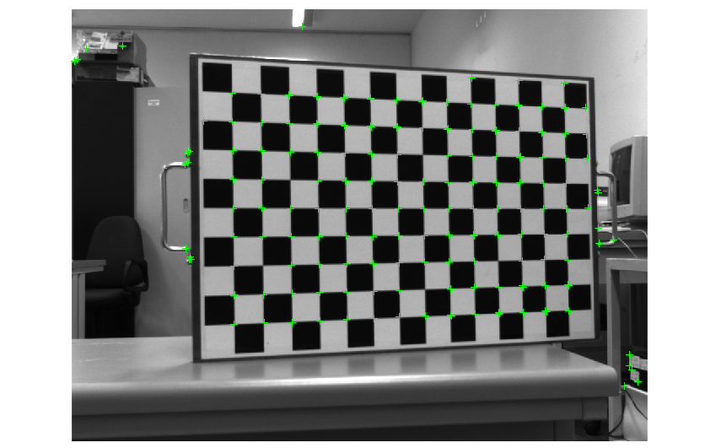
Figure 5 : MinEigenValues function (200 strongest dots)

Detection of lines and circles in an image can be a problem
complex. Several methods and processes exist to make this estimation. One of the algorithms, described in the theoretical classes, is based on the Hough transform. Write a
Program which, using the Hough transform, allows the detection of lines and
Girths in the image "lines_circles_2.jpg".

The program should display the matrices used by the Hough transform
To determine the parameters, with the levels of gray quantifying the value of the
wishes. As output of the program should also provide the parameters of the lines
(Slope and ordinate at origin) and estimated circumferences (coordinates of the center and
Radius) and trace it to an output image that must be compared to the
original. If the program is too slow you can reduce the size of the images.

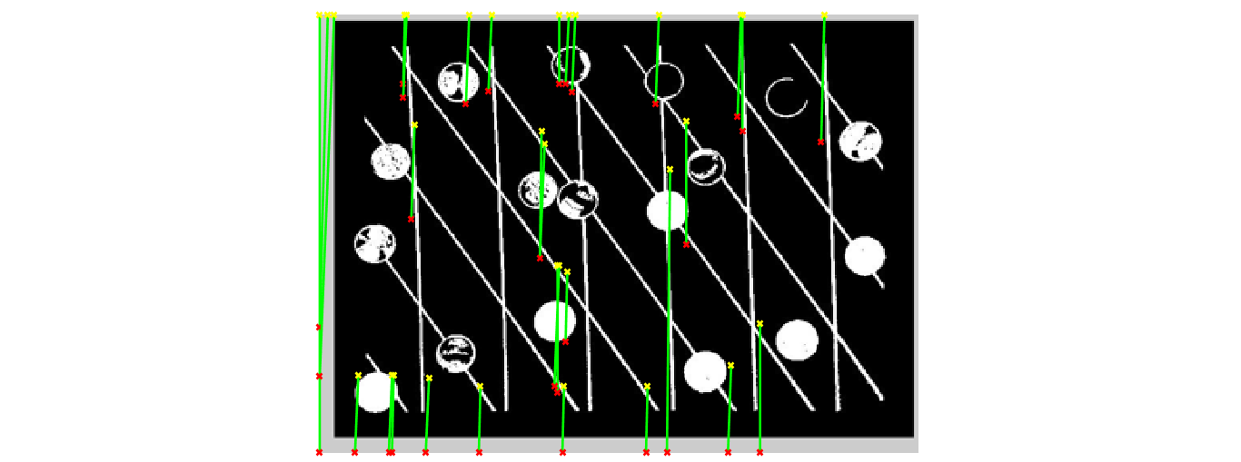
Figure 1 : Result of using our homemade hough function

Matlab has hough, houghppeaks, and houghlines functions available. Use these
Functions to detect lines in the image "chess_1.png".
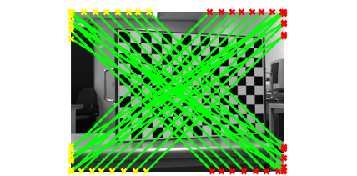

Figure 2 : Result of using MATLAB's hough function
See implementation in Tp3_2.m and myHough.m

