
Pay slip template

Who can use this template?
Employers can use this template to create pay slips for their employees.

When and how do I need to issue a pay slip?
Under the Fair Work Act, pay slips must be given to an employee within one working day of pay day, even if the employee is on leave.
Once you have filled out this pay slip you can give it to your employee electronically (by email or via a secure online portal), or give them a printed copy.
Employers can face fines or in some cases be taken to court if they do not issue pay slips in the required time frame, don’t provide them at all, or don't include the right information on a pay slip.
- For more information on pay slip requirements visit fairwork.gov.au/payslips
- Employers can only deduct money from an employee’s pay (other than relevant tax deductions) in limited circumstances. If you plan to deduct money from an employee’s pay, check if the deduction is allowed at fairwork.gov.au/deductions
- For information on tax and superannuation requirements, visit the Australian Taxation Office website at ato.gov.au

What information must not be included on a pay slip?
Pay slips must not mention paid family and domestic violence leave.
For information about how this type of leave should be recorded, see fairwork.gov.au/payslips
Instructions for completing this template
- The template on the following page is colour-coded to make it easier to complete.
- Replace the <red text inside the angle brackets> with details that are relevant to your situation. Once you’ve filled it in, remove the brackets and change the text to black.
- Extra notes and guidance are shown [in purple text inside square brackets]. Be sure to delete these notes before you finish.
- Remember to keep copy of the pay slip for your records.
Note: We update our templates from time to time. Make sure you’re using the latest version from fairwork.gov.au/templates
The Fair Work Ombudsman is committed to providing you with advice that you can rely on.
The information contained in this template is general in nature. If you are unsure about how it applies to your situation you can call our Infoline on 13 13 94 or speak with a union, industry association or a workplace relations professional.

Last updated July 2026

EXAMPLE PAY SLIP
IMPORTANT: The information contained in the below pay slip is shown as an example only. The business, superannuation fund, bank and employee details are not real.

The figures used may not accurately reflect the current award rates and entitlements. You can check current pay rates, as well as other entitlements like allowances and penalty rates, using our Pay calculator at fairwork.gov.au/pact
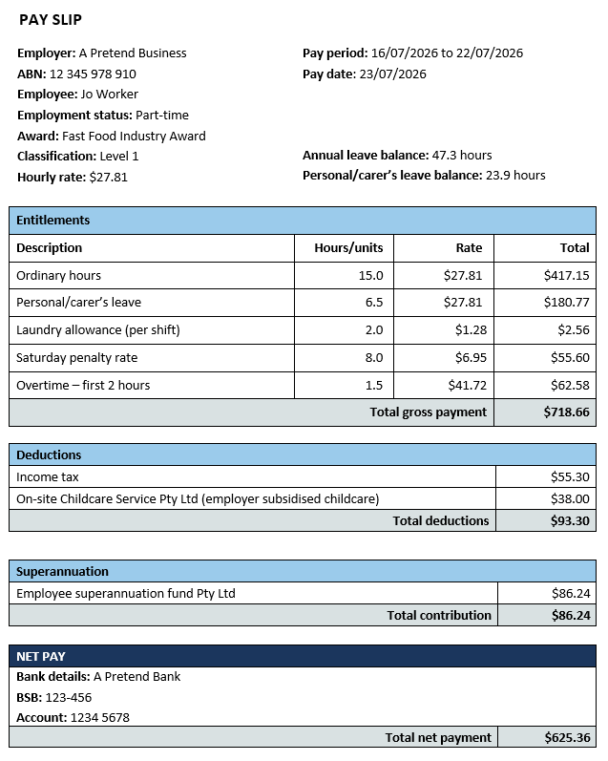
  - TEMPLATE – Pay slip
<Add your business letterhead if required>
[This template is provided as a best practice example. Information marked with an asterisk (*) must be included on a pay slip under workplace laws. Other information is optional but encouraged. You should check your award or enterprise agreement for any additional pay slip requirements.]
PAY SLIP
*Employer: <insert business name>  *ABN: 33 971 146 116  *Employee: Sarah Williams  Employment status: <full-time/part-time/ casual>  <Award/Agreement>: <insert award/agreement title, if applicable>  Classification: <insert classification>  *Hourly rate: $211.21  *Annual salary: [if applicable] $61,000 | *Pay period: <insert date> to <insert date>  *Pay date: <insert date>  [Annual and personal leave balances are not applicable to casual employees]  Annual leave balance: <xx days/hrs>  Sick/carer’s leave balance: <xx days/hrs>

Entitlements
Description | Hours/units | Rate | Total
*Ordinary hours  [This includes rostered hours worked where penalty rates apply, for example on a Saturday shift. It does not include overtime hours. You must use separate rows to record any penalty amounts paid for ordinary hours, and any overtime worked.] | *4.2 | *$374.30 | *$133.51
<insert any leave taken during the pay period>  [Important: Family and domestic violence leave and leave balances must not be identified on a pay slip.] | 6.0 | $89.42 | $272.98
<insert name of entitlement> | 17.9 | $258.84 | $448.98
<insert name of entitlement> | 16.0 | $519.22 | $568.43
<insert name of entitlement> | 12.1 | $705.66 | $333.53
Total gross payment |  |  | *$149.30
[Rows should be added or deleted as required to include any amount paid to the employee as a bonus, loading, allowance, penalty rate, incentive based payment or other separately identifiable entitlement.]

Deductions | Total
*Income tax |  | *$280.58
*<insert any other deductions>  [Each deduction needs to be listed separately. Rows may be added or deleted as required to include all deductions made. Deductions must include the name, or name and number, of the fund or account into which the deduction was paid.] |  | *$229.35
Total deductions |  | *$882.84

*Superannuation | Total
*<insert account/fund name (or name and number of fund)> |  | *$632.32
Total contribution |  | *$492.47

NET PAY
[This is the amount paid after tax and any other allowable deductions have been deducted from the total gross payment.
Use this section to confirm the details of the bank account that wages have been paid to. If the employee is paid by cash or cheque, delete the details below and enter ‘CASH/CHEQUE’.]
Bank details: <insert name of bank for employee’s bank account>
BSB: 595-968
Account: 4482 4799
Total net payment | *$622.71

