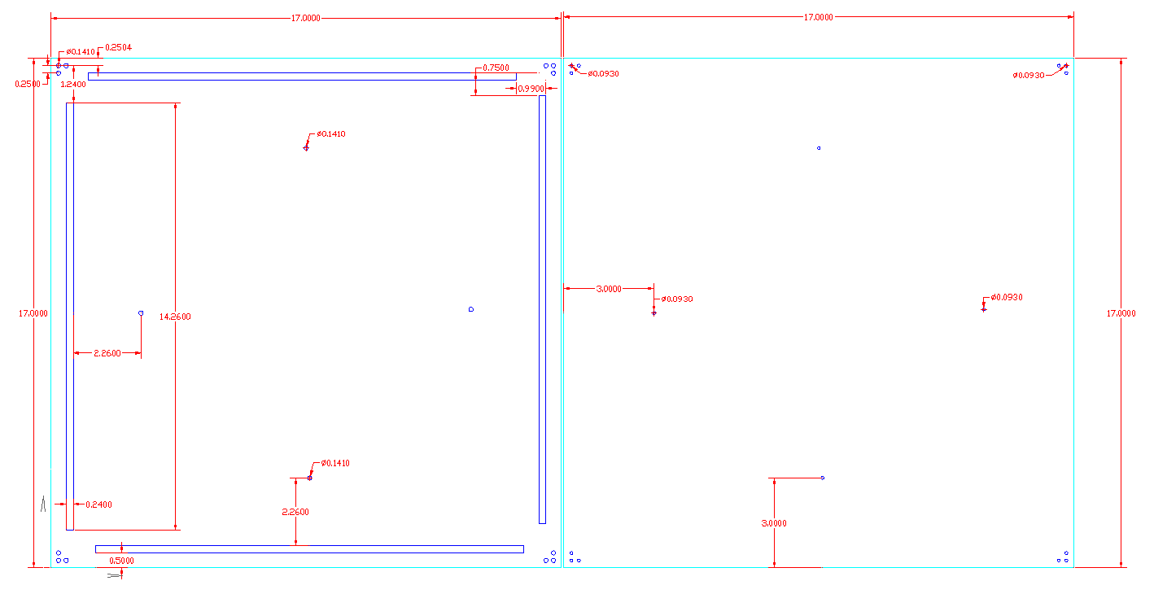
Figure 1 - 2D CAD drawing of bottom plates

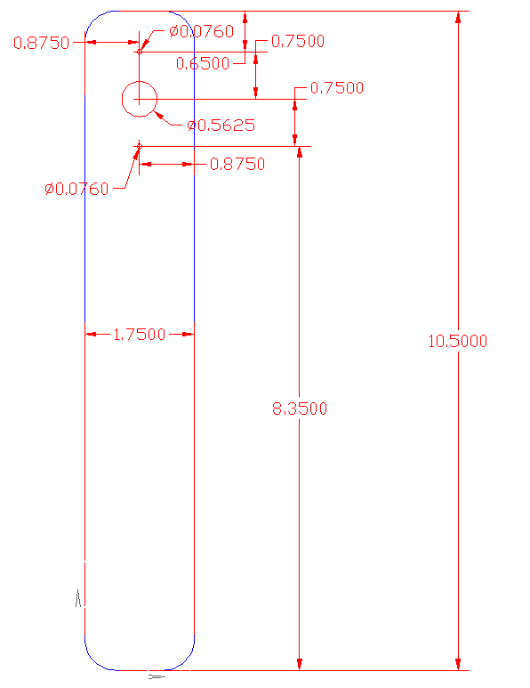
Figure 2 – 2D CAD drawing of arm of Intermediate Bin

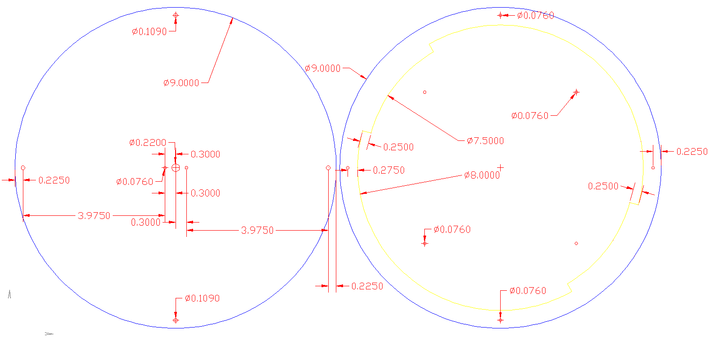
Figure 3 - 2D CAD drawing of top layer Lazy Susan

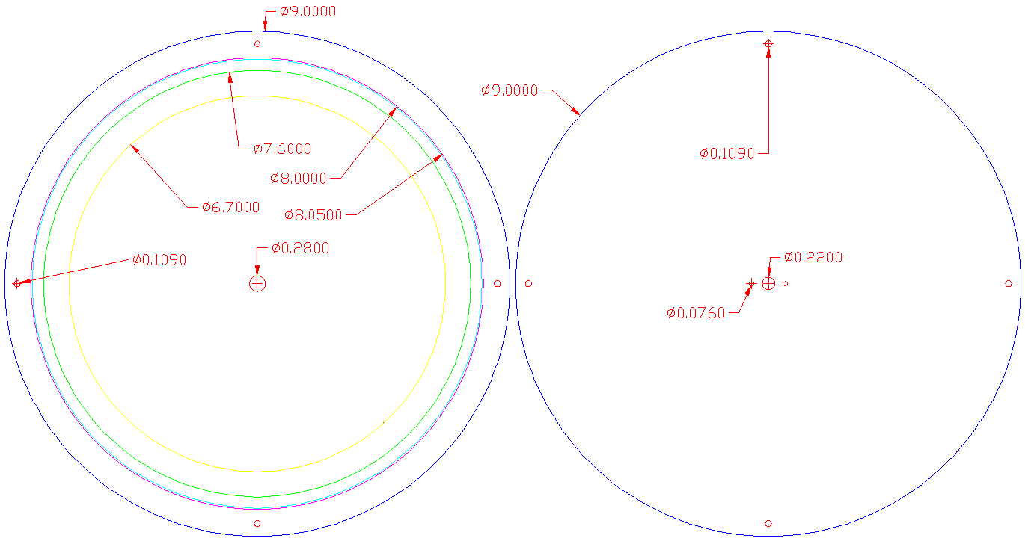
Figure 4 - 2D CAD drawing of bottom layer Lazy Susan

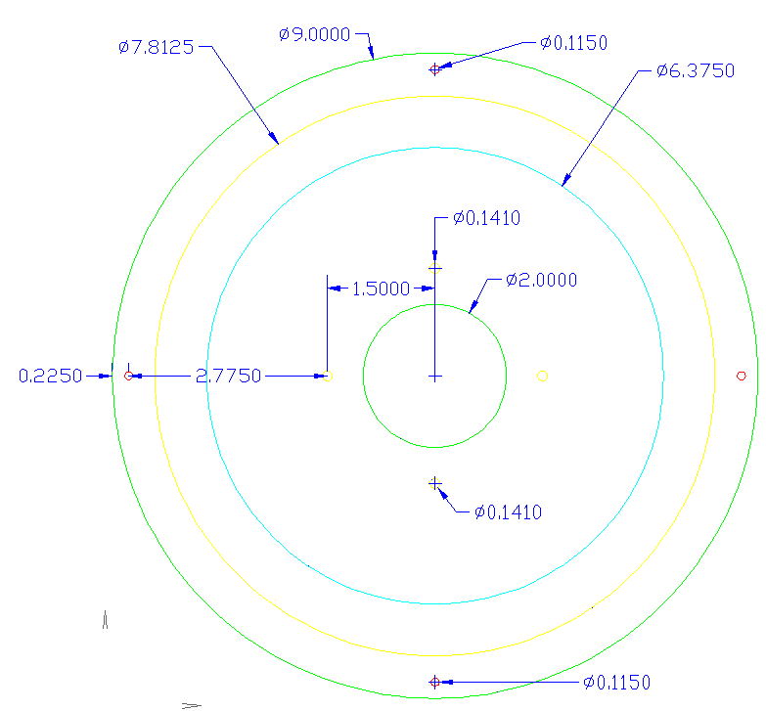
Figure 5 - 2D CAD drawing of parts for Lazy Susan securement
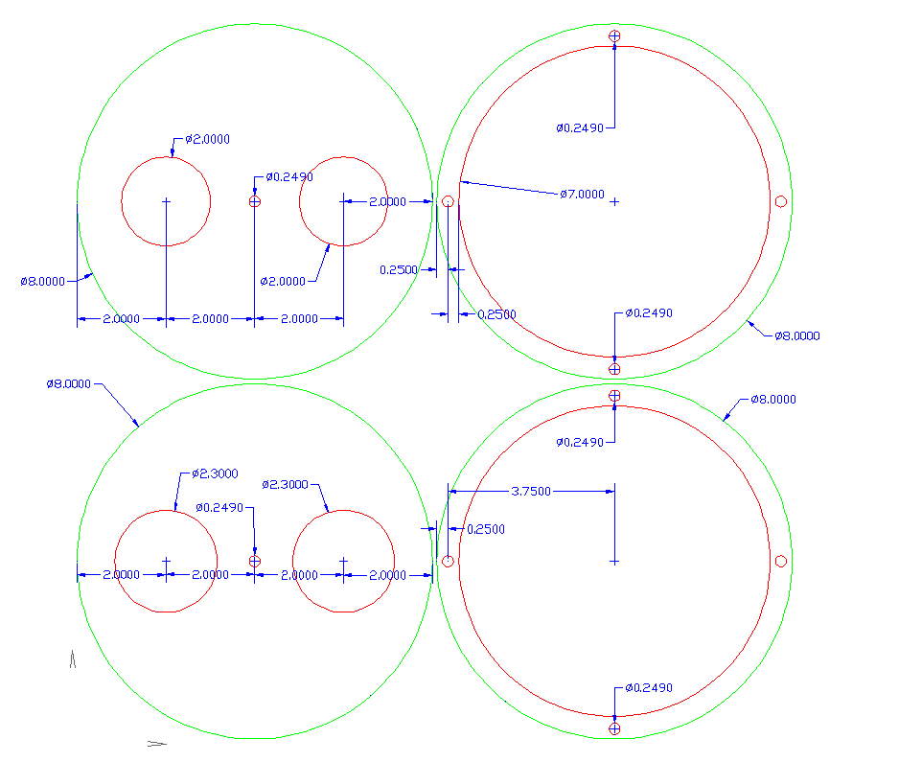
Figure 6 - 2D CAD drawing of Final Bins support.

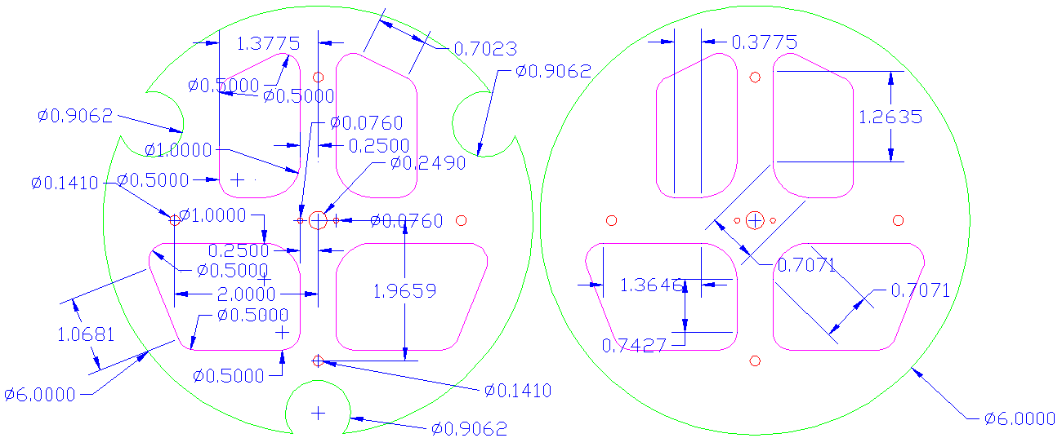
Figure 7 - 2D CAD drawing of Computer Selector

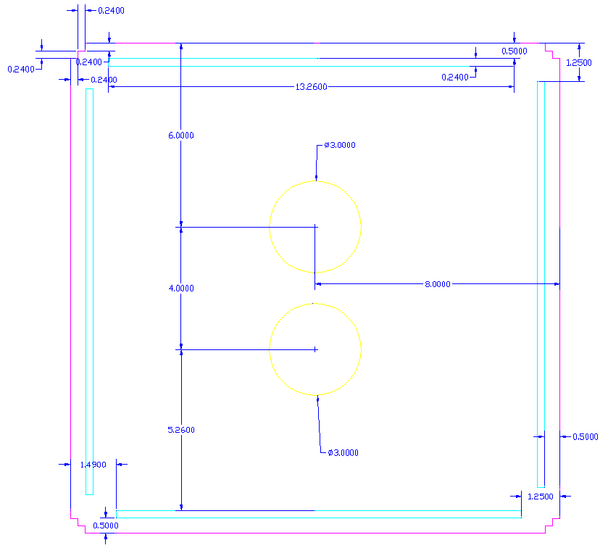
Figure 8 - 2D CAD drawing of third tier plate of scaffolding
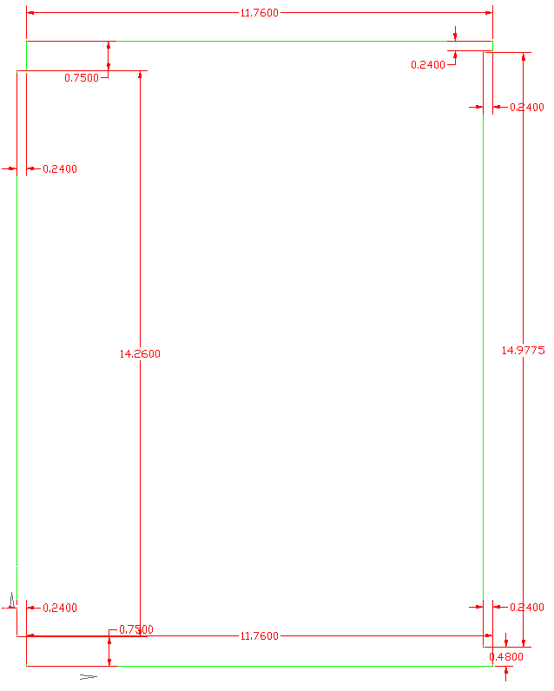
Figure 9 - 2D CAD drawing of third tier wall of scaffolding
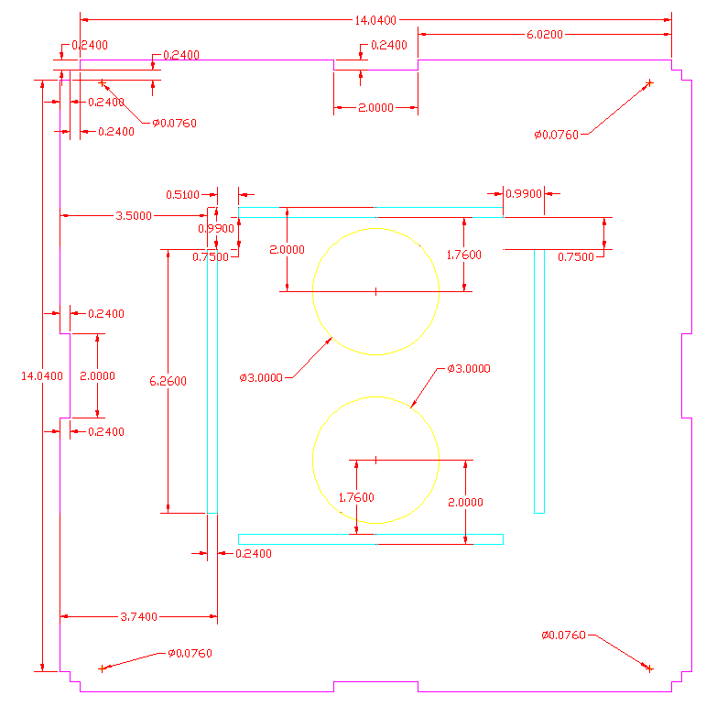
Figure 10 - 2D CAD drawing of second tier plate of scaffolding

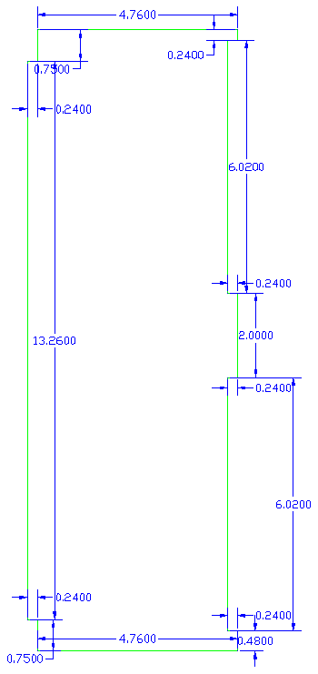
Figure 11 - 2D CAD drawing of second tier wall of scaffolding
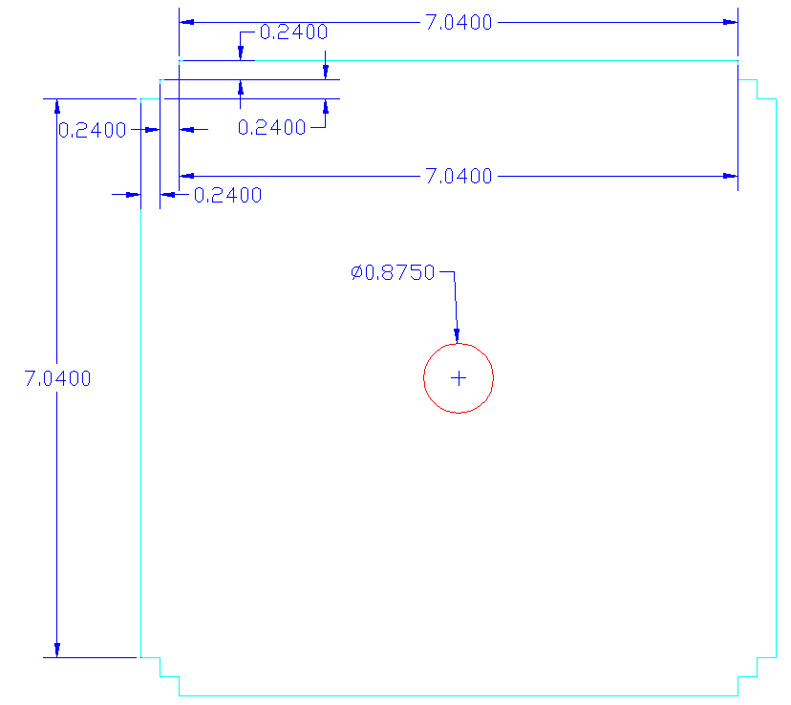
Figure 12 - 2D CAD drawing of top tier plate of scaffolding

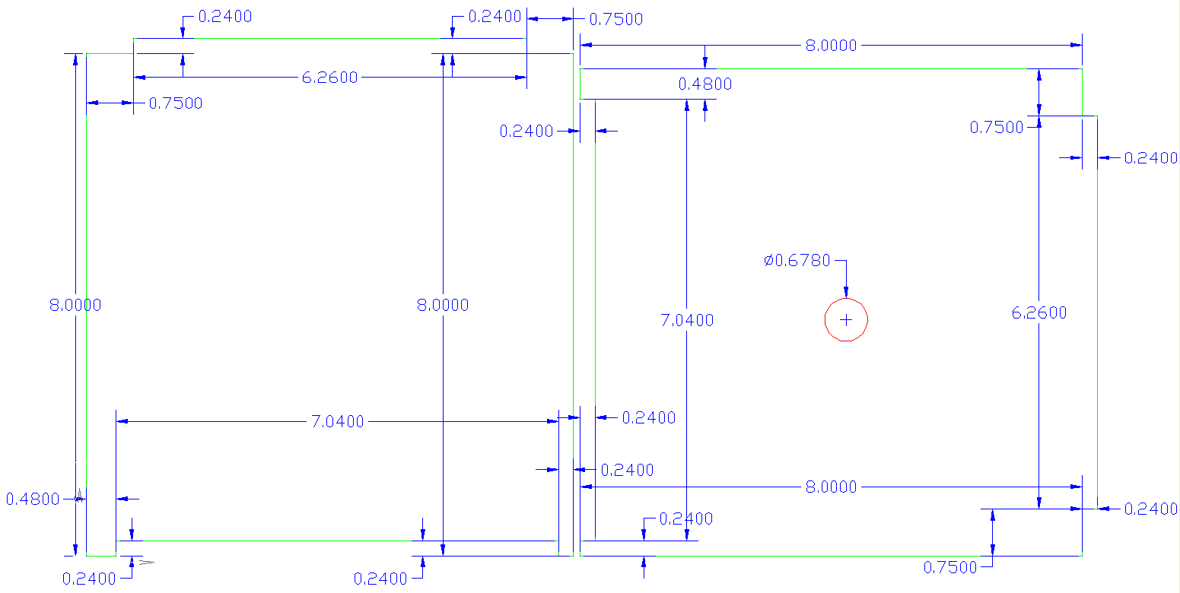
Figure 13 - 2D CAD drawing of top tier walls of scaffolding

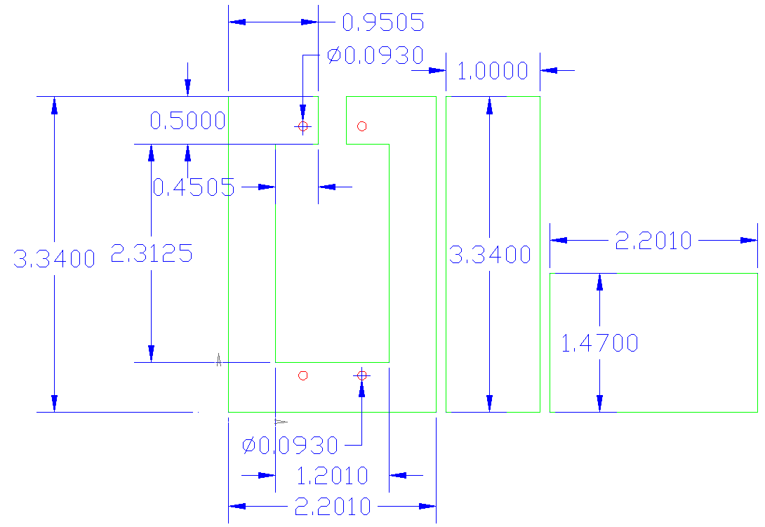
Figure 14 - 2D CAD drawing of motor mount

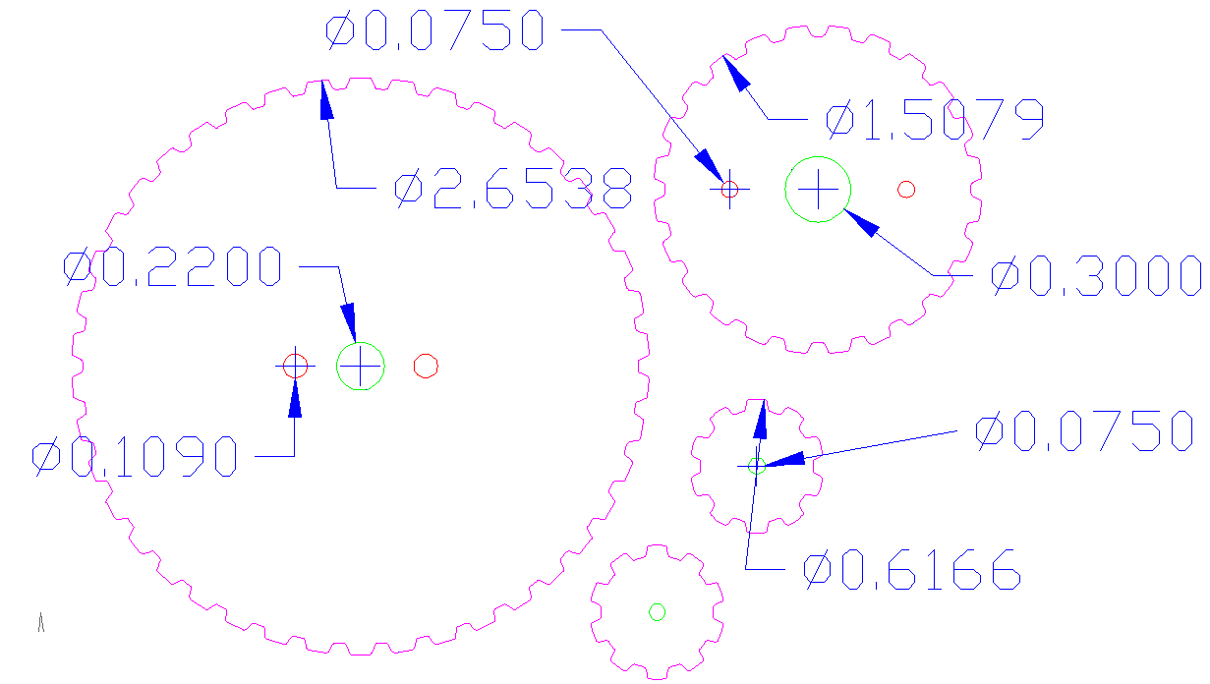
Figure 15 - 2D drawing of sprockets for motor of final bins

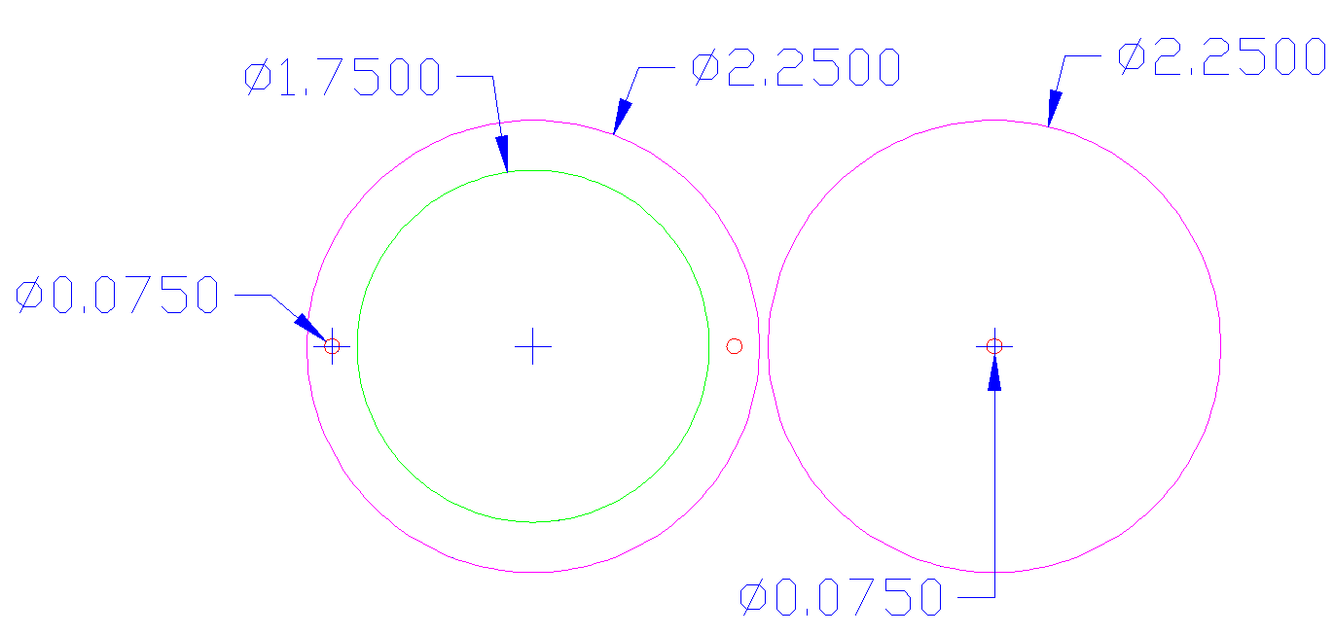
Figure 16 - 2D CAD drawing of sprocket mount
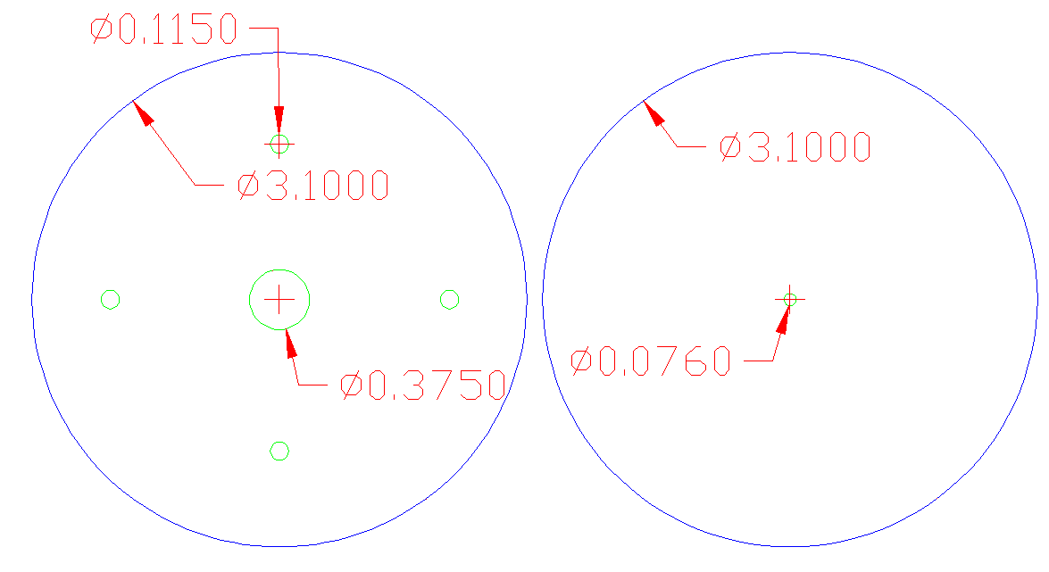
Figure 17 - 2D CAD drawing of covers for sprocket

