MAE156 Sponsored Project Description – University Projects

Project Title: A Mind Reading Machine

Contact (name, email, phone, website):
Professor Yoav Freund
yfreund@ucsd.edu
www.cse.ucsd.edu/~yfreund

Availability During Kickoff Week:
The student team will contact each sponsor to arrange for a convenient meeting time during the kickoff week, and weekly meetings thereafter. Please indicate if you will be in-town during the kickoff week
- For Fall kickoff mid November (11/13/2006 – 11/17/2006): _Yes_(yes/no)
- For Winter kickoff end of February (2/26/2007 – 3/2/2007): _Yes_(yes/no)
If not available please specify an alternate contact person for kickoff:

Project Description
Background:

The goal of this project is to design a physical version of the mind reading machine. The mind reading machine is an algorithm for playing the repeated coin matching game. See the poster attached below and the mind-reading web page: http://seed.ucsd.edu/~mindreader/
The main problem of the mind reading game in its applet version is trust-worthiness. It is hard to convince the user that the machine is actually predicting their keystrokes. It is impossible for the computer to convince the user that it has committed to it’s prediction and did not change it after the user typed the key without revealing the value to which it committed (in fact, it is not impossible, there are cryptographic techniques for doing this, but they are very involved and it is unlikely that a non-computer-nerd will have the patience to follow the details). This is where a physical implementation would provide an elegant and simple solution that is very convincing.

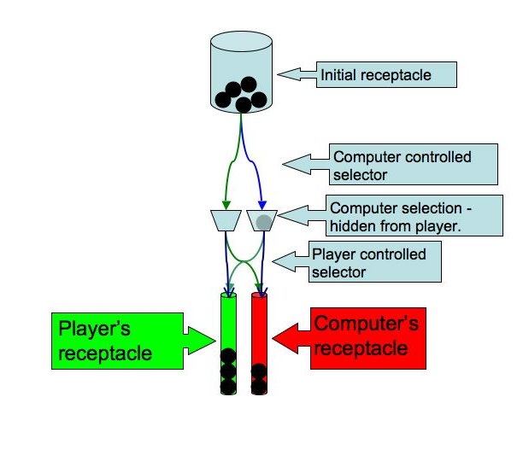
Summary of MAE156 Project Objective:
The basic idea is to use small metal balls to represent the binary predictions. The contraption consists of three receptacles that hold balls. The initial receptor which holds all of the balls at the beginning of the game. The player’s receptacle and the computer receptacle, also called the final receptors, get filled during the game. The goal of the player is to fill it’s receptacle before the computer fills it’s receptacle. The game proceeds as follows. First, the computer makes it’s choice and places a ball in one of two holding places. The player can hear that a ball has been placed in a holding place, but cannot see in which one of the two holders it is. This makes it intuitively clear that the computer has committed to it’s prediction without revealing the prediction to the player. It is then the player’s turn to guess which of the two holding places holds the ball. The player then moves it’s selector to connect the holding places to the end receptacles in either a direct connection (blue arrows) or a cross-over connection (green arrows). Once the player commits to it’s selection the ball is released from it’s holder and falls into one of the end receptacles. The computer’s goal is to predict the choice of the player and cause the ball to fall in it’s receptacle rather than in the player’s receptacle. The game ends when one of the receptacles fills up. A new game starts by poring the balls collected in the end receptacles back into the initial receptacle.

There are a number of considerations in the design of the Mind Reading Machine. First, the physical design of the machine should encourage interaction; playing should be fun and easy. The contraption should be robust, not easily breakable, and hold up with continuous use by many people. Second, the design of the machine should be straightforward and make it clear to the naïve user that no trickery involved. For example, it would be nice if a person standing across from the player could easily see which of the two holders contains the ball. Third, the choice made by the user should do two things: activate the ball release mechanism and gaming the system should be hard. For example, the sounds generated by the computer’s selection mechanism should not be perceptively different for the two receptacles, so the player would not be given a hint as to where the ball might be. Similarly, the player should not be able to feel the location of the ball through the selection mechanism. Finally, the design of the contraption should be simple enough that building new replicas would be easy. Ideally, the contraption would be constructed from components that are readily available such as lego mindstorms and popular children’s toys. The computer controlling the contraption will be a standard PC computer.

Skills Used in Project:

Human interface design. Electromechanical system involving computer controlled actuators and computer Robust design (balls should not get stuck, the computer should be able to always pick and move a single ball into the desired holder). Containment: balls should not fall out of the contraption, poring balls from the end receptacles back to the initial receptacle should be easy and straight forward.

Budget
The budget for each project is a not-to-exceed amount, and only actual parts used and machine shop expenses will be billed to sponsors’ account.
Equipment and Parts
Machine Shop Expenses (reduced from $1500 for university sponsors) | $500
Total

