Abstruct
This experiment uses a classical pulsed laser and simple optical components such as BS, PBS and HWP’s to simulate a quantum 2 photons system in order to explore quantum state tomography and Bell’s inequality test – using the CHAS test, with this system we can emulate the phenomena of quantum entanglement and explore this phenomena along with the meaning of QST and the quantum state density matrix rho using accessible classical tool. By using practical measurements on this classical setup we can reconstruct the entangled state density matrix and analyze the correlations indicative of an entangled state and explore the idea of non – locality. This experiment allows us to get an understanding of basic quantum mechanics principles and ideas by using a classical system

Experimental:

The source used a pulsed laser that generates a polarized light in the V state than the light passes through a ND that’s regulates the light intensity.
Next the pules is propagates through a half-wave plate 𝜆 (𝜆 being the light pules wavelength) which rotates the pules polarization by twice the plate’s angle withing the setup – this is used to determine the source polarization between V/H states.
The selection between this two states is selected randomly for each pules with a 50:50 chance to get each state. By randomizing each pulse polarization state we simulate the behavior of single photons with a varying polarization state while our physical system remains constant. Next the light pulse is going through a 50:50 BS that’s saperates the pulse into 2 different arm – Bob and Alice.
The pulsed laser first go through a polarized beam spliter to separate the pulses based on their polarization state – V/H. next this filtered pulses are directed towards two detectors (Logitech C270) for each arm. In this detectors the intensity of each pulse in measured as depicted in fig (i)

Both Alice and Bob use polarized beam splitters (PBS) to filter pulses
based on their polarization. The PBS separates the incoming pulses
into distinct paths according to their polarization states. These filtered
beams are then directed to two detectors (Logitech C270), where the
intensity of each beam is measured, as depicted in Figs. 1, 2.

This configuration is suitable for advanced quantum experiments, including quantum to-
mography and Bell’s test. While genuine quantum systems utilize single
photons to ensure the no-cloning theorem (Bloom et al., 2022) and to enable violations of Bell’s inequality, our use of classical laser pulses
serves as a practical and educational analogy.
Classical light can be intercepted without altering the transmitted
states in the same way as single photons, potentially allowing eaves-
dropping without detection. However, by carefully randomizing the
polarizations and employing the same sequence of operations as in true
quantum systems, we replicate the protocol flow, enabling the study of
quantum properties such as state reconstruction in tomography and the
testing of quantum entanglement through Bell’s inequalities, without
the need for complex single-photon sources.

Measurements:
QST:
In this part we want to measure two polarization state as described in equations (),()
Equation () describe the state - psy_1 - a state in witch the polarizations of both Alice and Bob are correlated meaning if the sent pulse is polarized in the H direction alice and bob will both register this exact polarization
Equation () describe the state - psy_2 - a state in witch the polarizations of both Alice and Bob are anti - correlated meaning if the sent pulse is polarized in the H direction alice will measer it as the original polarization sent while bob will measer the orthogonal polarization
we will create this state by rotating the HWP infront of bob to a 45 degrees to the optical plain.
To create this two states a shown at equations (),() we make sure the sent puleses are randomized witch ensure we get the mixed polarization states required to emulate the superposition of 2 entangled photons and measure the correct corralations required for QT and bell’s test
We capture the pulses using cemra detectors capturing the light pulses in the setup in a 30 frames per second rate, next we analize this footage with image analizing tools using Matlab. For each area the pulsed light arrive we assign a region of intrest (ROI) and measure the total intensity of the light pulse. Later we countinue analizing the date by setting a “threshold” for each camera design to eliminate back noise and make sure we only get the light pulses that fully went through, this prosses translate our intensity measerments into a 1/0 bits
Bell’s test:
In order to calculate bell’s parameter S as depicted in equation()
We remove the PBS in front of alice and bob and relace them with linear polarizers and remove one of the cameras of each of them. Alice’s polarizer angle defined as alpha and Bob’s as beta. This setup shown in figure (). With this setup we can measure the corolations between alice and Bob detections of the pulsed laser
In order to calculate N(alpha,beta) from equation () we record the intensity’s of the signals recorded by Alice and Bob in various alpha, beta angles. The cameras records the relevant pulses in a 30 fps rate. Later using Matlab we analize this footage simmiliarly to the QST part and again assight a “threshold” to filter out back noise and deficient between a 0 and 1 bits – meaning the threshold indicated whether the polarization of the sent bit matched the measured basis.

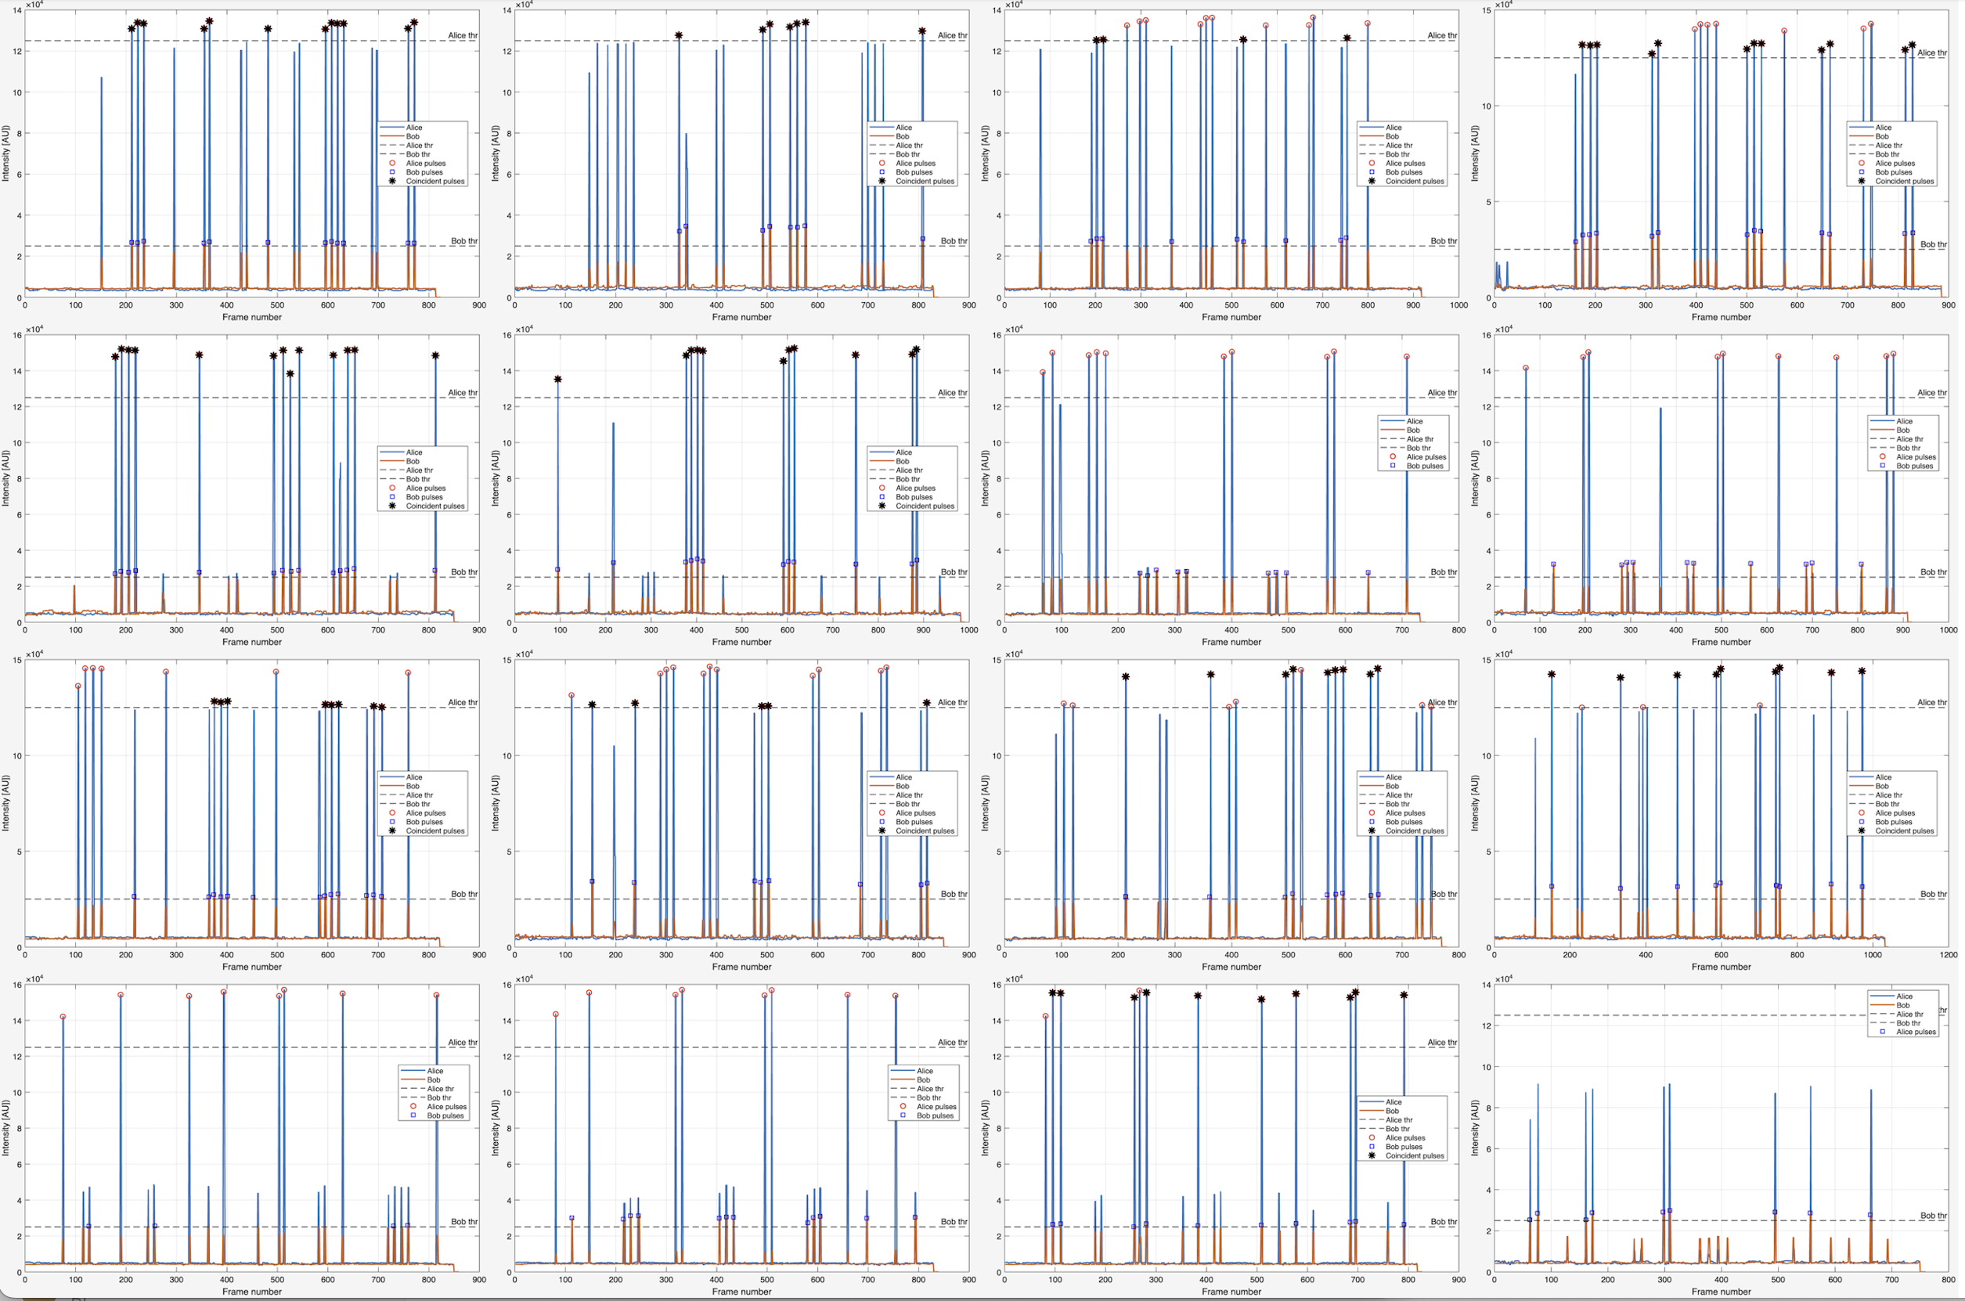
$$β= -22.5°$$
$$β= 22.5°$$
$$β= 67.5°$$
$$β= 112.5°$$
$$α= -45°$$
$$α= 0°$$
$$α= 45°$$
$$α= 90°$$

