April 27, 2021

Editorial Office

Royal Society Publishing

Dear Editors,

We are submitting a revised manuscript, “Non-Vertical Cultural Transmission, Assortment, and the Evolution of Cooperation”, by Dor Cohen, Ohad Lewin-Epstein, Marcus W. Feldman, and Yoav Ram. We believe that our responses have taken care of all the comments and suggestions from the editors and reviewers.

Please find a point-by-point response in the accompanied response letter.

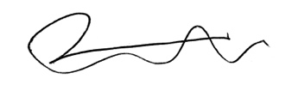 Sincerely,

Yoav Ram, PhD

Senior Lecturer, PI

School of Zoology

Faculty of Life Sciences

Tel Aviv University