Supplementary information
Revisiting Laland et al.’s Gene-Culture Model of Human Handedness
Rony Karstadt, Chloe Shiff, Tomer Oron, Nadav Ben Nun, Yoav Ram
2 January 2025

Supplementary Tables

Table S1. The probability of right-handed offspring with genotype DD, DC, and CC given RxR, RxL, and LxL parental phenotypes. Genetic effects are determined by parameters ρ (dexterity) and h₁ (allele dominance). Cultural effects are determined by α (same-hand parental effect) and β (mixed-hand parental effect).

Parental mating | Offspring genotype
Parental mating | DD | DC | CC
Right X Right | $$\frac{1}{2}+ρ+α$$ | $$\frac{1}{2}+h_{1}ρ+α$$ | $$\frac{1}{2}+α$$
Right X Left | $$\frac{1}{2}+ρ+β$$ | $$\frac{1}{2}+h_{1}-β$$ | $$\frac{1}{2}+β$$
Left X Left | $$\frac{1}{2}+ρ-α$$ | $$\frac{1}{2}+h_{1}-α$$ | $$\frac{1}{2}-α$$

Table S2. The expected true incidence of right-right, right-left, and left-left-handed twins given parental phenotypes and assuming the D allele is fixed in the population.

Parental mating |  | Twins Phenotypes
Parental mating | R-R | R-L | L-L
Right x Right | $${\left(\frac{1}{2}+ρ+α\right)}^{2}$$ | $$2\left(\frac{1}{2}-ρ-α\right)\left(\frac{1}{2}+ρ+α\right)$$ | $${\left(\frac{1}{2}-ρ-α\right)}^{2}$$
Right x Left | $${\left(\frac{1}{2}+ρ+β\right)}^{2}$$ | $$2\left(\frac{1}{2}-ρ-β\right)\left(\frac{1}{2}+ρ+β\right)$$ | $${\left(\frac{1}{2}-ρ-β\right)}^{2}$$
Left x Left | $${\left(\frac{1}{2}+ρ-α\right)}^{2}$$ | $$2\left(\frac{1}{2}-ρ+α\right)\left(\frac{1}{2}+ρ-α\right)$$ | $${\left(\frac{1}{2}-ρ+α\right)}^{2}$$

Table S3. Data and results reported by Laland et al. (1995). The frequency of left- and right-handed offspring born to different parental phenotypes in 17 studies: two right-handed parents (Right x Right), mixed-handed parents (Right x Left), and two left-handed parents (Left x Left). The model predictions from Laland et al. are shown in parentheses for parameter estimates $\hat{ρ}=0.277,\hat{ α}=0.138$, and $\hat{β}=0$. With these predictions, the model fits the data in 16 of 17 studies and across all studies combined (G= 44.33, df= 32, p>0.05).

Parental mating | Right x Right |  | Right x Left |  | Left x Left
Offspring | Right | Left | Right | Left | Right | Left | G_{df=1.82}
Ramaley (1913) | 841 (874.7) | 115 (81.3) | 113 (130.1) | 54 (36.9) | 1 (5.0) | 7 (3.0) | 31.42*
Chamberlain (1928) | 6917 (6610.9) | 308 (614.1) | 411 (361.5) | 53 (102.5) | 18 (15.5) | 7 (9.5) | 237.87*
Rife (1940) | 1842 (1823.6) | 151 (169.4) | 140 (135.5) | 34 (38.5) | 5 (6.8) | 6 (4.2) | 4.16
Merrell (1957) | 140 (159.2) | 34 (14.8) | 33 (41.3) | 20 (11.7) | 8 (6.2) | 2 (3.8) | 28.74*
Annett (1973) | 6206 (6290.6) | 669 (584.4) | 471 (464.3) | 125 (131.7) | 5 (3.7) | 1 (2.3) | 14.61*
Ferronato et al. (1947) | 154 (151.0) | 11 (14.0) | 31 (31.2) | 9 (8.8) | 0 (0.0) | 0 (0.0) | 0.77
Mascie-Taylor (unpub)^{b} | 232 (227.8) | 17 (21.2) | 41 (37.4) | 7 (10.6) | 3 (2.5) | 1 (1.5) | 3
Chaurasia & Goswani (unpub)^{b} | 1060 (1101.7) | 144 (102.3) | 122 (130.9) | 46 (37.1) | 3 (4.3) | 4 (2.7) | 20.25*
Annett (1978) | 1656 (1634.2) | 130 (151.8) | 170 (163.6) | 40 (46.4) | 4 (2.5) | 0 (1.5) | 8.6*
Carter-Saltzmann (1980) | 303 (311.1) | 37 (28.9) | 45 (46.7) | 15 (13.3) | 0 (0.0) | 0 (0.0) | 2.58
Coren & Porac (1980) | 315 (350.4) | 68 (32.6) | 57 (56.9) | 16 (16.1) | 0 (0.0) | 0 (0.0) | 33*
McGee & Cozad (1980) | 848 (969.0) | 211 (90.0) | 325 (370.0) | 150 (105.0) | 30 (32.2) | 22 (19.8) | 156.43*
McManus (1985) (ICM1) | 58 (61.3) | 9 (5.7) | 14 (14.8) | 5 (4.2) | 0 (0.0) | 0 (0.0) | 2
McManus (1985) (ICM2prop) | 134 (136.3) | 15 (12.7) | 17 (20.3) | 9 (5.7) | 1 (0.6) | 0 (0.4) | 3.53
McManus (1985) (ICM2mat) | 74 (71.4) | 4 (6.6) | 6 (6.2) | 2 (1.8) | 0 (0.0) | 0 (0.0) | 1.35
McManus (1985) (ICM2pat) | 86 (82.3) | 4 (7.7) | 8 (7.0) | 1 (2.0) | 0 (0.0) | 0 (0.0) | 3.01
Leiber & Axelrod (1981) | 1729 (1740.3) | 173 (161.7) | 281 (268.0) | 63 (76.0) | 8 (6.8) | 3 (4.2) | 4.42
^{b} These data are taken from McManus (1985).
* A significant difference between model and data at p = 0.05.

Table S4. Scenario A: Results of goodness-of-fit test without adjustment for estimates without adjustment with three parameters $\hat{ρ }$= 0.267, $\hat{α}$ = 0.148, $\hat{β}$= 0.012. Model predictions are in parentheses, and G statistics for each study are in the right column. Model predictions fit the data in 9 of 17 individual studies and do not fit for all studies combined (G=556.73, df=31, p<0.05).

Parental mating | Right x Right |  | Right x Left |  | Left x Left
Offspring | Right | Left | Right | Left | Right | Left | G_{df=1.88}
Ramaley (1913) | 841 (874.7) | 115 (81.3) | 113 (129.8) | 54 (37.2) | 1 (5.1) | 7 (2.9) | 31.72*
Chamberlain (1928) | 6917 (6610.9) | 308 (614.1) | 411 (360.5) | 53 (103.5) | 18 (16.0) | 7 (9.0) | 238.64*
Rife (1940) | 1842 (1823.6) | 151 (169.4) | 140 (135.2) | 34 (38.8) | 5 (7.0) | 6 (4.0) | 4.6
Merrell (1957) | 140 (159.2) | 34 (14.8) | 33 (41.2) | 20 (11.8) | 8 (6.4) | 2 (3.6) | 28.26*
Annett (1973) | 6206 (6290.6) | 669 (584.4) | 471 (463.1) | 125 (132.9) | 5 (3.8) | 1 (2.2) | 14.57*
Ferronato et al. (1947) | 154 (151.0) | 11 (14.0) | 31 (31.1) | 9 (8.9) | 0 (0.0) | 0 (0.0) | 0.77
Mascie-Taylor (unpub)^{b} | 232 (227.8) | 17 (21.2) | 41 (37.3) | 7 (10.7) | 3 (2.6) | 1 (1.4) | 3
Chaurasia & Goswani (unpub)^{b} | 1060 (1101.7) | 144 (102.3) | 122 (130.5) | 46 (37.5) | 3 (4.5) | 4 (2.5) | 20.29*
Annett (1978) | 1656 (1634.2) | 130 (151.8) | 170 (163.2) | 40 (46.8) | 4 (2.6) | 0 (1.4) | 8.5*
Carter-Saltzmann (1980) | 303 (311.1) | 37 (28.9) | 45 (46.6) | 15 (13.4) | 0 (0.0) | 0 (0.0) | 2.54
Coren & Porac (1980) | 315 (350.4) | 68 (32.6) | 57 (56.7) | 16 (16.3) | 0 (0.0) | 0 (0.0) | 33*
McGee & Cozad (1980) | 848 (969.0) | 211 (90.0) | 325 (369.1) | 150 (105.9) | 30 (33.2) | 22 (18.8) | 155.86*
McManus (1985) (ICM1) | 58 (61.3) | 9 (5.7) | 14 (14.8) | 5 (4.2) | 0 (0.0) | 0 (0.0) | 1.98
McManus (1985) (ICM2prop) | 134 (136.3) | 15 (12.7) | 17 (20.2) | 9 (5.8) | 1 (0.6) | 0 (0.4) | 3.39
McManus (1985) (ICM2mat) | 74 (71.4) | 4 (6.6) | 6 (6.2) | 2 (1.8) | 0 (0.0) | 0 (0.0) | 1.35
McManus (1985) (ICM2pat) | 86 (82.3) | 4 (7.7) | 8 (7.0) | 1 (2.0) | 0 (0.0) | 0 (0.0) | 3.03
Leiber & Axelrod (1981) | 1729 (1740.3) | 173 (161.7) | 281 (267.3) | 63 (76.7) | 8 (7.0) | 3 (4.0) | 4.54
^{b} These data are taken from McManus (1985).
* A significant difference between model and data at p = 0.05.
Table S5. Scenario A: Results of goodness-of-fit test without adjustment for estimates without adjustment with two parameters $\hat{ρ}$ = 0.277, $\hat{α}$ = 0.138. Model predictions are in parentheses, and G statistics for each study are in the right column. Model predictions fit the data in 9 of 17 individual studies and do not fit for all studies combined (G=556.03, df=32, p<0.05).

Parental mating | Right x Right |  | Right x Left |  | Left x Left
Offspring | Right | Left | Right | Left | Right | Left | G_{df=1.82}
Ramaley (1913) | 841 (826.7) | 115 (129.3) | 113 (123.4) | 54 (43.6) | 1 (4.7) | 7 (3.3) | 12.68*
Chamberlain (1928) | 6917 (6906.9) | 308 (318.1) | 411 (419.7) | 53 (44.3) | 18 (21.1) | 7 (3.9) | 4.65
Rife (1940) | 1842 (1838.3) | 151 (154.7) | 140 (143.8) | 34 (30.2) | 5 (7.9) | 6 (3.1) | 3.91
Merrell (1957) | 140 (137.8) | 34 (36.2) | 33 (37.3) | 20 (15.7) | 8 (6.0) | 2 (4.0) | 3.53
Annett (1973) | 6206 (6214.3) | 669 (660.7) | 471 (469.9) | 125 (126.1) | 5 (3.9) | 1 (2.1) | 1.08
Ferronato et al. (1947) | 154 (152.5) | 11 (12.5) | 31 (32.5) | 9 (7.5) | 0 (0.0) | 0 (0.0) | 0.56
Mascie-Taylor (unpub)^{b} | 232 (232.7) | 17 (16.3) | 41 (40.3) | 7 (7.7) | 3 (2.9) | 1 (1.1) | 0.11
Chaurasia & Goswani (unpub)^{b} | 1060 (1067.6) | 144 (136.4) | 122 (127.0) | 46 (41.0) | 3 (4.2) | 4 (2.8) | 2.12
Annett (1978) | 1656 (1652.5) | 130 (133.5) | 170 (174.7) | 40 (35.3) | 4 (2.9) | 0 (1.1) | 3.43
Carter-Saltzmann (1980) | 303 (301.8) | 37 (38.2) | 45 (45.5) | 15 (14.5) | 0 (0.0) | 0 (0.0) | 0.07
Coren & Porac (1980) | 315 (320.5) | 68 (62.5) | 57 (52.2) | 16 (20.8) | 0 (0.0) | 0 (0.0) | 2.21
McGee & Cozad (1980) | 848 (828.0) | 211 (231.0) | 325 (335.5) | 150 (139.5) | 30 (32.3) | 22 (19.7) | 3.81
McManus (1985) (ICM1) | 58 (58.0) | 9 (9.0) | 14 (14.0) | 5 (5.0) | 0 (0.0) | 0 (0.0) | 0
McManus (1985) (ICM2prop) | 134 (131.7) | 15 (17.3) | 17 (19.6) | 9 (6.4) | 1 (0.6) | 0 (0.4) | 2.7
McManus (1985) (ICM2mat) | 74 (73.1) | 4 (4.9) | 6 (6.9) | 2 (1.1) | 0 (0.0) | 0 (0.0) | 0.88
McManus (1985) (ICM2pat) | 86 (85.9) | 4 (4.1) | 8 (8.1) | 1 (0.9) | 0 (0.0) | 0 (0.0) | 0.01
Leiber & Axelrod (1981) | 1729 (1737.5) | 173 (164.5) | 281 (273.4) | 63 (70.6) | 8 (7.2) | 3 (3.8) | 1.8
^{b} These data are taken from McManus (1985).
* A significant difference between model and data at p = 0.05.
Table S6. Scenario B: Results of goodness-of-fit test with adjustment for estimates without adjustment with three parameters $\hat{ρ}$= 0.267, $\hat{α}$= 0.148, $\hat{β}$ = 0.012). Model predictions are in parentheses, and G statistics for each study are in the right column. Model predictions fit the data in 16 of 17 individual studies and for all studies combined (G=43.6, df= 31, p<0.05).

Table S7. Scenario B: Results of goodness-of-fit test with adjustment for estimates without adjustment with two parameters $\hat{ρ}$ = 0.277, $\hat{α}$ = 0.138. Model predictions are in parentheses, and G statistics for each study are in the right column. Model predictions fit the data in 16 of 17 individual studies and for all studies combined (G=44.4, df=32, p<0.05).
Parental mating | Right x Right |  | Right x Left |  | Left x Left
Offspring | Right | Left | Right | Left | Right | Left | G_{df=1.88}
Ramaley (1913) | 841 (826.7) | 115 (129.3) | 113 (123.3) | 54 (43.7) | 1 (4.9) | 7 (3.1) | 13.19*
Chamberlain (1928) | 6917 (6906.8) | 308 (318.2) | 411 (419.8) | 53 (44.2) | 18 (21.3) | 7 (3.7) | 5.1
Rife (1940) | 1842 (1838.3) | 151 (154.7) | 140 (143.8) | 34 (30.2) | 5 (8.0) | 6 (3.0) | 4.37
Merrell (1957) | 140 (137.8) | 34 (36.2) | 33 (37.2) | 20 (15.8) | 8 (6.1) | 2 (3.9) | 3.33
Annett (1973) | 6206 (6214.0) | 669 (661.0) | 471 (469.9) | 125 (126.1) | 5 (4.0) | 1 (2.0) | 0.91
Ferronato et al. (1947) | 154 (152.6) | 11 (12.4) | 31 (32.5) | 9 (7.5) | 0 (0.0) | 0 (0.0) | 0.54
Mascie-Taylor (unpub)^{b} | 232 (232.7) | 17 (16.3) | 41 (40.3) | 7 (7.7) | 3 (3.0) | 1 (1.0) | 0.11
Chaurasia & Goswani (unpub)^{b} | 1060 (1067.7) | 144 (136.3) | 122 (126.8) | 46 (41.2) | 3 (4.4) | 4 (2.6) | 2.27
Annett (1978) | 1656 (1652.4) | 130 (133.6) | 170 (174.7) | 40 (35.3) | 4 (3.0) | 0 (1.0) | 3.26
Carter-Saltzmann (1980) | 303 (301.8) | 37 (38.2) | 45 (45.5) | 15 (14.5) | 0 (0.0) | 0 (0.0) | 0.06
Coren & Porac (1980) | 315 (320.5) | 68 (62.5) | 57 (52.1) | 16 (20.9) | 0 (0.0) | 0 (0.0) | 2.25
McGee & Cozad (1980) | 848 (828.1) | 211 (230.9) | 325 (334.9) | 150 (140.1) | 30 (32.7) | 22 (19.3) | 3.8
McManus (1985) (ICM1) | 58 (58.0) | 9 (9.0) | 14 (14.0) | 5 (5.0) | 0 (0.0) | 0 (0.0) | 0
McManus (1985) (ICM2prop) | 134 (131.7) | 15 (17.3) | 17 (19.6) | 9 (6.4) | 1 (0.6) | 0 (0.4) | 2.61
McManus (1985) (ICM2mat) | 74 (73.1) | 4 (4.9) | 6 (6.9) | 2 (1.1) | 0 (0.0) | 0 (0.0) | 0.88
McManus (1985) (ICM2pat) | 86 (85.9) | 4 (4.1) | 8 (8.1) | 1 (0.9) | 0 (0.0) | 0 (0.0) | 0.01
Leiber & Axelrod (1981) | 1729 (1737.5) | 173 (164.5) | 281 (273.1) | 63 (70.9) | 8 (7.4) | 3 (3.6) | 1.75
^{b} These data are taken from McManus (1985).
* A significant difference between model and data at p = 0.05.

Table S8. Scenario C: Results of goodness-of-fit test with adjustment for estimates with adjustment with three parameters $\hat{ρ }$= 0.207, $\hat{α}$= 0.203, $\hat{β}$= 0.042. Model predictions are in parentheses, and G statistics for each study are in the right column. Model predictions fit the data in 16 of 17 individual studies and for all studies combined (G=36.3, df= 31, p<0.05).

Parental mating | Right x Right |  | Right x Left |  | Left x Left
Offspring | Right | Left | Right | Left | Right | Left | G_{df=1.82}
Ramaley (1913) | 841 (831.1) | 115 (124.9) | 113 (119.7) | 54 (47.3) | 1 (3.9) | 7 (4.1) | 7.1*
Chamberlain (1928) | 6917 (6908.2) | 308 (316.8) | 411 (418.7) | 53 (45.3) | 18 (20.6) | 7 (4.4) | 3.31
Rife (1940) | 1842 (1839.3) | 151 (153.7) | 140 (143.2) | 34 (30.8) | 5 (7.5) | 6 (3.5) | 2.77
Merrell (1957) | 140 (139.8) | 34 (34.2) | 33 (36.0) | 20 (17.0) | 8 (5.0) | 2 (5.0) | 4.63
Annett (1973) | 6206 (6217.8) | 669 (657.2) | 471 (467.3) | 125 (128.7) | 5 (3.7) | 1 (2.3) | 1.8
Ferronato et al. (1947) | 154 (152.7) | 11 (12.3) | 31 (32.5) | 9 (7.5) | 0 (0.0) | 0 (0.0) | 0.48
Mascie-Taylor (unpub)^{b} | 232 (232.9) | 17 (16.1) | 41 (40.2) | 7 (7.8) | 3 (2.8) | 1 (1.2) | 0.2
Chaurasia & Goswani (unpub)^{b} | 1060 (1075.0) | 144 (129.0) | 122 (123.6) | 46 (44.4) | 3 (3.5) | 4 (3.5) | 2.11
Annett (1978) | 1656 (1653.4) | 130 (132.6) | 170 (174.1) | 40 (35.9) | 4 (2.8) | 0 (1.2) | 3.59
Carter-Saltzmann (1980) | 303 (303.1) | 37 (36.9) | 45 (44.4) | 15 (15.6) | 0 (0.0) | 0 (0.0) | 0.04
Coren & Porac (1980) | 315 (322.3) | 68 (60.7) | 57 (50.6) | 16 (22.4) | 0 (0.0) | 0 (0.0) | 3.77
McGee & Cozad (1980) | 848 (840.4) | 211 (218.6) | 325 (327.0) | 150 (148.0) | 30 (28.2) | 22 (23.8) | 0.63
McManus (1985) (ICM1) | 58 (58.4) | 9 (8.6) | 14 (13.6) | 5 (5.4) | 0 (0.0) | 0 (0.0) | 0.06
McManus (1985) (ICM2prop) | 134 (132.4) | 15 (16.6) | 17 (19.1) | 9 (6.9) | 1 (0.5) | 0 (0.5) | 2.33
McManus (1985) (ICM2mat) | 74 (73.1) | 4 (4.9) | 6 (6.9) | 2 (1.1) | 0 (0.0) | 0 (0.0) | 0.83
McManus (1985) (ICM2pat) | 86 (85.9) | 4 (4.1) | 8 (8.1) | 1 (0.9) | 0 (0.0) | 0 (0.0) | 0.01
Leiber & Axelrod (1981) | 1729 (1739.1) | 173 (162.9) | 281 (272.4) | 63 (71.6) | 8 (6.7) | 3 (4.3) | 2.68
^{b} These data are taken from McManus (1985).
* A significant difference between model and data at p = 0.05.

Table S9. Scenario C: Results of goodness-of-fit test with adjustment for estimates with adjustment with two parameters $\hat{ρ}$ = 0.239, $\hat{α}$ = 0.172. Model predictions are in parentheses, and G statistics for each study are in the right column. Model predictions fit the data in 16 of 17 individual studies and for all studies combined (G=37.5, df=32, p<0.05).

Parental mating | Right x Right |  | Right x Left |  | Left x Left
Offspring | Right | Left | Right | Left | Right | Left | G_{df=1.88}
Ramaley (1913) | 841 (831.5) | 115 (124.5) | 113 (118.9) | 54 (48.1) | 1 (4.4) | 7 (3.6) | 8.29*
Chamberlain (1928) | 6917 (6908.2) | 308 (316.8) | 411 (418.5) | 53 (45.5) | 18 (21.2) | 7 (3.8) | 4.22
Rife (1940) | 1842 (1839.4) | 151 (153.6) | 140 (142.9) | 34 (31.1) | 5 (7.9) | 6 (3.1) | 3.79
Merrell (1957) | 140 (140.1) | 34 (33.9) | 33 (35.6) | 20 (17.4) | 8 (5.4) | 2 (4.6) | 3.55
Annett (1973) | 6206 (6217.9) | 669 (657.1) | 471 (466.4) | 125 (129.6) | 5 (4.0) | 1 (2.0) | 1.35
Ferronato et al. (1947) | 154 (152.8) | 11 (12.2) | 31 (32.3) | 9 (7.7) | 0 (0.0) | 0 (0.0) | 0.4
Mascie-Taylor (unpub)^{b} | 232 (233.0) | 17 (16.0) | 41 (40.1) | 7 (7.9) | 3 (2.9) | 1 (1.1) | 0.19
Chaurasia & Goswani (unpub)^{b} | 1060 (1075.9) | 144 (128.1) | 122 (122.4) | 46 (45.6) | 3 (3.9) | 4 (3.1) | 2.65
Annett (1978) | 1656 (1653.4) | 130 (132.6) | 170 (173.7) | 40 (36.3) | 4 (2.9) | 0 (1.1) | 3.04
Carter-Saltzmann (1980) | 303 (303.2) | 37 (36.8) | 45 (44.1) | 15 (15.9) | 0 (0.0) | 0 (0.0) | 0.07
Coren & Porac (1980) | 315 (322.4) | 68 (60.6) | 57 (50.3) | 16 (22.7) | 0 (0.0) | 0 (0.0) | 4.14
McGee & Cozad (1980) | 848 (841.9) | 211 (217.1) | 325 (324.0) | 150 (151.0) | 30 (29.6) | 22 (22.4) | 0.24
McManus (1985) (ICM1) | 58 (58.5) | 9 (8.5) | 14 (13.5) | 5 (5.5) | 0 (0.0) | 0 (0.0) | 0.09
McManus (1985) (ICM2prop) | 134 (132.5) | 15 (16.5) | 17 (18.9) | 9 (7.1) | 1 (0.6) | 0 (0.4) | 1.98
McManus (1985) (ICM2mat) | 74 (73.1) | 4 (4.9) | 6 (6.9) | 2 (1.1) | 0 (0.0) | 0 (0.0) | 0.81
McManus (1985) (ICM2pat) | 86 (85.9) | 4 (4.1) | 8 (8.1) | 1 (0.9) | 0 (0.0) | 0 (0.0) | 0.01
Leiber & Axelrod (1981) | 1729 (1739.5) | 173 (162.5) | 281 (271.2) | 63 (72.8) | 8 (7.3) | 3 (3.7) | 2.69
^{b} These data are taken from McManus (1985).
* A significant difference between model and data at p = 0.05.

Table S10. Twin data, model predictions, and goodness-of-fit results. In the R-R, R-L, and L-L columns (for a pair of right, mixed, and left-handed twins), the value is the data, and the value in parentheses is the model prediction. Parameters estimated without adjustment, $\hat{ρ}=0.277, \hat{α}=0.138$ (β fixed at zero). Model predictions fit the data in 27 out of the 28 individual studies and for all studies combined (G=35.68, df=28, p=0.151).

Study | MZ twins |  |  |  |  | DZ twins
Study | $$m_{o}$$ | $$R×R$$ | $$R×L$$ | $$L×L$$ | $$G$$  df=1 | $$m_{o}$$ | $$R×R$$ | $$R×L$$ | $$L×L$$ | $$G$$  df=1
Wilson & Jones (1932) | 0.1071 | 97 (97.0) | 24 (23.9) | 2 (2.0) | 0.0 | 0.1138 | 97 (97.0) | 24 (23.9) | 2 (2.0) | 0.0
Stocks (1933) | 0.0952 | 76 (75.4) | 16 (17.3) | 2 (1.4) | 0.57 | 0.1064 | 76 (75.4) | 16 (17.3) | 2 (1.4) | 0.35
Newman et al. (1937) | 0.19 | 39 (39.8) | 11 (9.4) | 0 (0.8) | 0.79 | 0.11 | 39 (39.8) | 11 (9.4) | 0 (0.8) | 1.82
Bouterwek (1938) | 0.1885 | 23 (24.2) | 12 (9.7) | 0 (1.2) | 0.19 | 0.1714 | 23 (24.2) | 12 (9.7) | 0 (1.2) | 2.86
Rife (1940) | 0.1188 | 104 (105.0) | 39 (37.0) | 3 (4.0) | 1.22 | 0.1541 | 104 (105.0) | 39 (37.0) | 3 (4.0) | 0.39
Thyss (1946) | 0.1845 | 60 (60.6) | 24 (22.8) | 2 (2.6) | 3.62 | 0.1628 | 60 (60.6) | 24 (22.8) | 2 (2.6) | 0.21
Rife (1950) | 0.1283 | 164 (165.7) | 45 (41.7) | 2 (3.7) | 0.19 | 0.1161 | 164 (165.7) | 45 (41.7) | 2 (3.7) | 1.18
Dechaume (1957) | 0.2424 | 21 (21.4) | 11 (10.2) | 1 (1.4) | 0.0 | 0.197 | 21 (21.4) | 11 (10.2) | 1 (1.4) | 0.18
Zazzo (1960) | 0.1332 | 264 (267.1) | 69 (62.8) | 2 (5.1) | 2.66 | 0.109 | 264 (267.1) | 69 (62.8) | 2 (5.1) | 3.11
Carter-Saltzmann et al. (1976) | 0.1711 | 115 (115.1) | 54 (53.7) | 7 (7.1) | 1.9 | 0.1932 | 115 (115.1) | 54 (53.7) | 7 (7.1) | 0.0
Loehlin & Nichols (1976) | 0.1411 | 261 (264.3) | 70 (63.4) | 2 (5.3) | 0.16 | 0.1111 | 261 (264.3) | 70 (63.4) | 2 (5.3) | 3.39
Springer & Searleman (1978) | 0.1667 | 35 (33.4) | 9 (12.3) | 3 (1.4) | 0.26 | 0.1596 | 35 (33.4) | 9 (12.3) | 3 (1.4) | 2.49
NCDS (unpublished) | 0.1512 | 66 (64.2) | 18 (21.5) | 4 (2.2) | 0.85 | 0.1477 | 66 (64.2) | 18 (21.5) | 4 (2.2) | 1.77
Neale (1988) | 0.122 | 626 (621.9) | 183 (191.2) | 23 (18.9) | 4.3* | 0.1376 | 626 (621.9) | 183 (191.2) | 23 (18.9) | 1.22

Table S11. Probabilities of right-handed female offspring (top) and right-handed male offspring (bottom) given offspring genotype (columns) and parental phenotypes (columns).
Parents of female offspring | DD | DC | CC
R x R | (1/2) + ρ + α_{F} | (1/2) + h₁ρ + α_{F} | (1/2) + α_{F}
R x L | (1/2) + ρ + β_{F} | (1/2) + h₁ρ + β_{F} | (1/2) + β_{F}
L x R | (1/2) + ρ + γ_{F} | (1/2) + h₁ρ + γ_{F} | (1/2) + γ_{F}
L x L | (1/2) + ρ − α_{F} | (1/2) + h₁ρ − α_{F} | (1/2) − α_{F}

Parents of male offspring | DD | DC | CC
R x R | (1/2) + ρ + α_{M} | (1/2) + h₁ρ + α_{M} | (1/2) + α_{M}
R x L | (1/2) + ρ + β_{M} | (1/2) + h₁ρ + β_{M} | (1/2) + β_{M}
L x R | (1/2) + ρ + γ_{M} | (1/2) + h₁ρ + γ_{M} | (1/2) + γ_{M}
L x L | (1/2) + ρ − α_{M} | (1/2) + h₁ρ − α_{M} | (1/2) − α_{M}

Table S12. Maximum-likelihood estimates for parameters of the extended models.
 | I | II | III | IV | V
α_{F} | 0.0656 | 0.0230 | 0.0230 | 0.0335 | 0.0335
α_{M} | α_{F} | α_{F} | α_{F} | 0.0163 | 0.0163
β_{F} | - | -0.0482 | -0.0159 | -0.035 | 0.0027
β_{M} | - | β_{F} | β_{F} | -0.058 | -0.0309
γ_{F} | - | β_{F} | -0.0918 | β_{F} | -0.085
γ_{M} | - | β_{F} | γ_{F} | β_{M} | -0.095
ρ | 0.324 | 0.3671 | 0.3671 | 0.3655 | 0.3655
S_{T}(θ|D) | -7726.3 | -7723.6 | -7710.8 | -7715.4 | -7701.9

Supplementary Figures
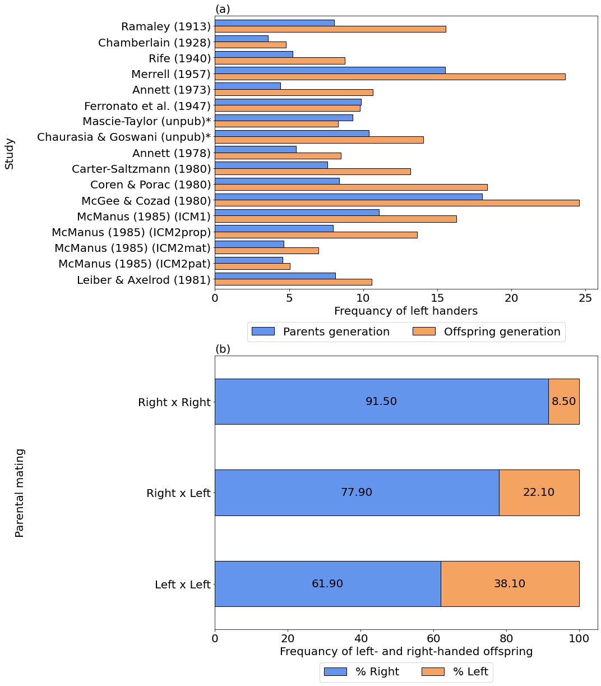
Figure S1. Frequency of left-handers reported by Laland et al. (1995). (a) The frequency of left-handers in the 17 studies by generation. (b) Frequency of left- and right-handers by parental mating.
*These data are taken from McManus (1985).
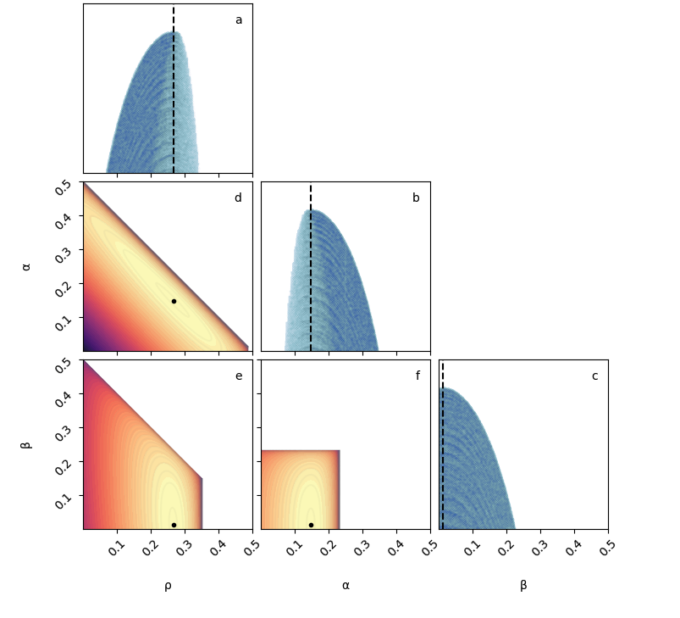
Figure S2. Scenarios A and B: Likelihood estimation of $ρ$, $α$, and $β$ without adjustment. Maximum likelihood estimates are $\hat{ρ}=0.267, \hat{α}=0.148$ and $\hat{β}=0.012$ with a log-likelihood of -8826.643. Diagonal panels (a, b, c): Markers show log-likelihood values across a range of 1,000 parameter values (1,000³ combinations of $ρ, α$ and $β$). Vertical dashed lines indicate the maximum likelihood estimates for (a) the effect of genetic transmission parameter $ρ$, (b) the effect of same-handed parents parameter $α$, and (c) the effect of mixed-handed parents parameter $β$. Corner panels (d, e, f): Contour plot shows the joint log-likelihood surfaces for pairs of parameters. Markers indicate point estimates for ρ, α, and β. Point estimates were estimated using the Nelder-Mead algorithm, while the contour plots show results of computing the log-likelihood over a grid with 1,000 values for each parameter. Point estimates obtained from both methods were effectively identical.

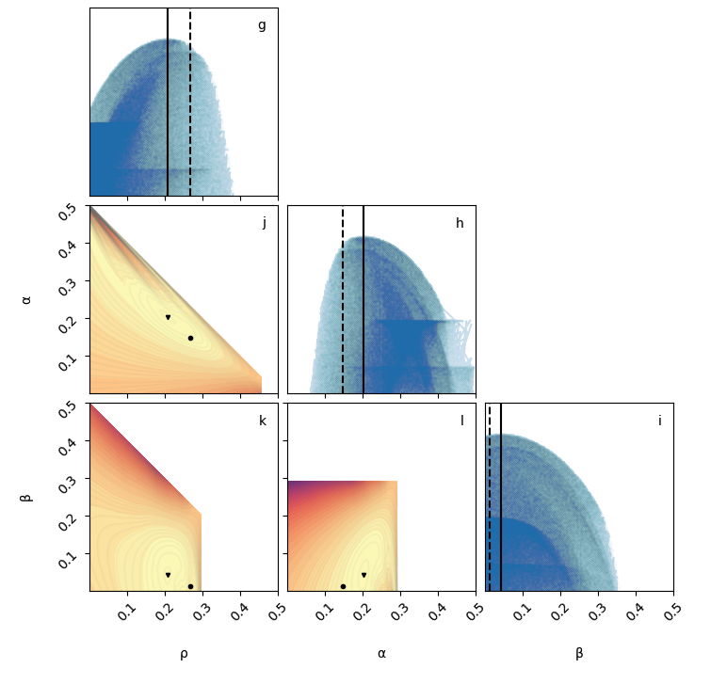
Figure S3. Scenario C: Likelihood estimation of $ρ$, $α$, and $β$ with adjustment. Maximum likelihood estimates are $\hat{ρ}=0.207, \hat{α}=0.203,$and $\hat{β}=0.042$ with log-likelihood of -8566.939. Diagonal panels (g, h, i): Markers show log-likelihood values across a range of 1,000 parameter values (1,000³ combinations of $ρ, α$ and $β$). Dashed and solid lines indicate the maximum likelihood estimates without and with adjustment, respectively, for (g) the effect of genetic transmission parameter $ρ$, (h) the impact of same-handed parents parameter $α$, and (j) the effect of mixed-handed parents parameter $β$. Corner panels: (d, e, f): Contour plot shows the joint log-likelihood surfaces for pairs of parameters. Point estimates with and without adjustment are indicated by triangles and circles, respectively. Point estimates were estimated using the Nelder-Mead algorithm, while the contour plots show results of computing the log-likelihood over a grid with 1,000 values for each parameter. Point estimates obtained from both methods were effectively identical.
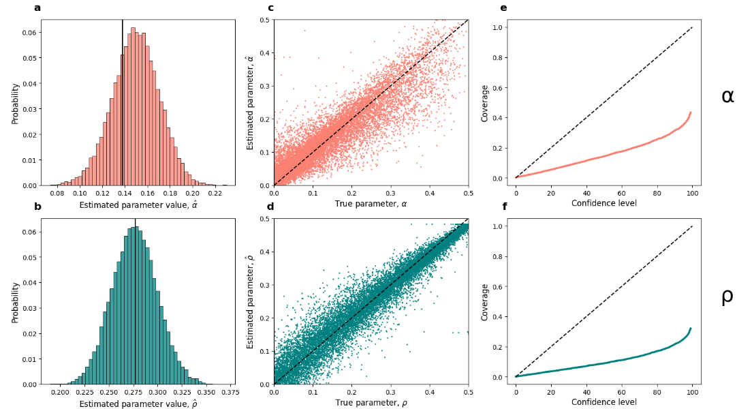
Figure S4. Performance of estimation method for Scenario B with linear regression correction.
a, b: The distribution of α and ρ values estimated from data simulated with ρ=0.277 and α=0.138, the values estimated by Laland et al. (1995) and shown in dashed lines. c, d: Scatter plot of estimated parameter values α and ρ given the true parameter value. e, f: The rate at which the true parameter value of α and ρ used to generate the data falls within the estimated confidence interval for that parameter created through bootstrapping.

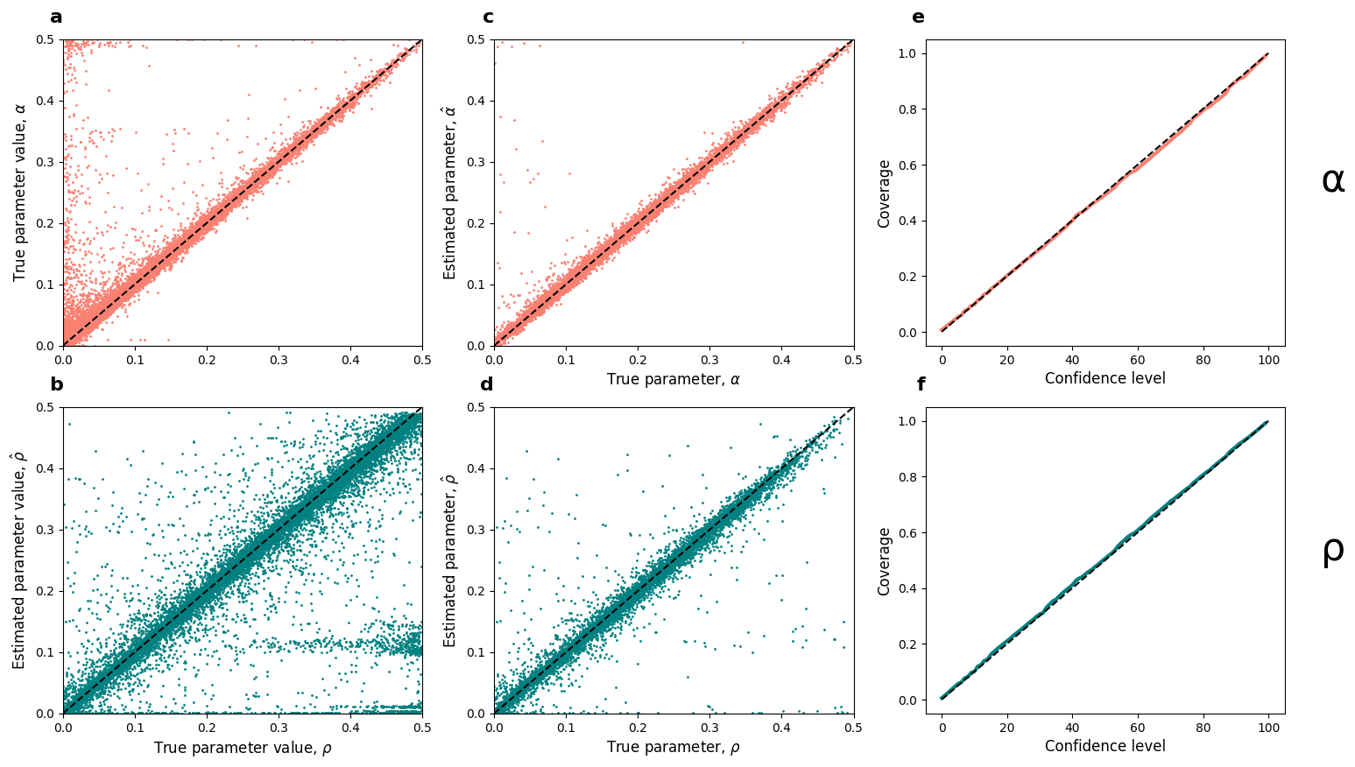
Figure S5. Performance of the parameter estimation method C.
a, b: Scatter plot of estimated parameter values α and ρ given the true parameter value. c, d: Scatter plot of estimated parameter values α and ρ given the true parameter value, after removing data where m_{o} ≤ 0.01, or m_{p}≤0.01, or |p(R|R×R) - |p(R|L×L)| <0.07 e, f: The rate at which the true parameter value of α and ρ used to generate the data falls within the estimated confidence interval for that parameter created through bootstrapping.
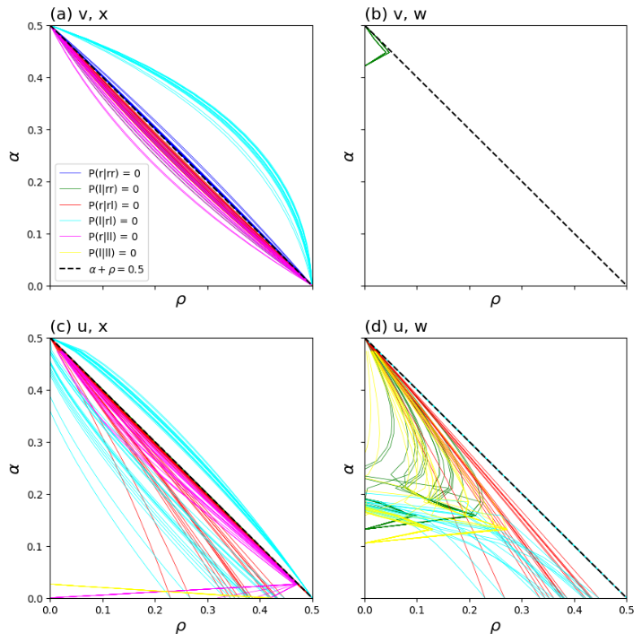
Figure S6. Ruggedness of the adjusted log-likelihood function. The figure shows the adjusted log-likelihood $S_{M}(ρ,α|D)$ (eq. 5) of the two-parameter model as a function of the model parameters. Color curves show paths in the parameter space where one of the conditional probabilities (P(offspring phenotype | parent mating type)=0, see legend) is zero. Variation between the lines is due to different m_{p} and m_{o} values for each dataset.

