May 6, 2024

**Response to Reviewers**

*Manuscript RSOS-230650*

Editorial Office

Royal Society Publishing

Dear Editor,

Our revised manuscript, “Prestige bias in cultural evolutionary dynamics,” is attached. We have made additional changes to the manuscript in response to the reviewer's comments. Details of the changes appear below, with our responses in blue. In addition, we attach a version of the revised manuscript with colored changes (red for deletions, blue for additions). We thank the reviewer for their comments and hope you find our response satisfactory.

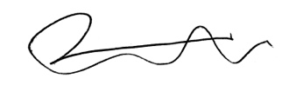Sincerely,

Yoav Ram, PhD

Senior Lecturer

School of Zoology, Faculty of Life Sciences

Sagol School of Neuroscience

Tel Aviv University

**Reviewer #3**

The article under review, "Prestige bias in cultural evolutionary dynamics", explores the impact of prestige bias on cultural evolution, shedding light on its influence independent of the fitness of choices. The manuscript delves into the complexities of human decision-making, considering various influences and their cumulative effects on societal cultural evolution. While the authors appropriately acknowledge the role of success bias, there are areas that warrant further clarification and improvement.

We thank the reviewer for his comments and suggestions.  
  
Abstract and Motivation:  
The abstract could benefit from a more general and compelling motivation for the study at the outset, setting the stage for readers.

We have revised the abstract to clearly state the knowledge gap that motivates our research (line 13): “However, it is unclear how success and prestige biases interact to determine the outcome of cultural evolutionary dynamics.”

Additionally, the authors should explicitly state the novelty of their work in the abstract, moving beyond a mere acknowledgment of improved fittings.

We have revised the abstract to emphasize the statements that describe the novel findings (line 16): “~~Analytic~~ We find analytic approximations to the stochastic role-model choice process that facilitate the mathematical analysis and reduce the computational complexity of simulations. Approximations are given to the fixation probability and the fixation time of an invading cultural trait in different environments. ~~We~~ Our results show that success bias effectively plays the role of natural selection, whereas prestige bias effectively plays the role of genetic drift. Prestige bias, which may be strong in highly social communities, also accelerates the evolutionary dynamics, as can be expected in a rich-get-richer process.”

We have not mentioned any improved fittings in the abstract.

A clearer emphasis on the broader implications of their findings for the field of cultural evolution would enhance the manuscript's impact.

We now conclude the abstract with an emphasis on the manuscript's broader impact (line 21): “These results signify a step forward in understanding how different cultural transmission biases interact.”  
  
Prestige Bias Definition:  
Addressing the referee's point on defining prestige bias as the sum of indirect success bias and conformity bias is crucial. The authors should provide a more thorough explanation or justification for this definition, considering that in the context of cultural evolution, prestige bias may align more closely with conformity bias, particularly within specific subsets of choices.

It is recommended to refer to recent studies illustrating the temporal patterns influenced by conformity bias (e.g.,<https://doi.org/10.1098/rsif.2022.0570>).

Furthermore, the authors should consider presenting time series data in their figures to provide a comprehensive understanding of temporal patterns and potential dispersion in results.

We define prestige bias thoroughly in the Introduction (line 62), with justification and references to multiple previous papers by Henrich and Gil-White, New Oxford American Dictionary, Chudek et al., and Henrich and Broesch. We have now added another reference to a recent paper by Nakata et al. (2024) that distinguishes between prestige bias based on first- and second-order cues; the latter fits our definition. In line 72, we now write: “Nakata et al. [63] define such a bias as a ‘prestige bias based on second-order cues,’ in which ‘Social learners can use the extent of attention and the amount copied from others as cues for prestige.’”

Prestige bias is different from conformity bias because conformity is a frequency-dependent bias, whereas prestige, as defined in our model, is frequency-independent, as mentioned in the Introduction (line 81) and shown in Corollary 1. We, therefore, refrain from aligning it with conformity.

We have added a supplementary figure showing time series from our model simulations (see below) and refer to it in the main text.

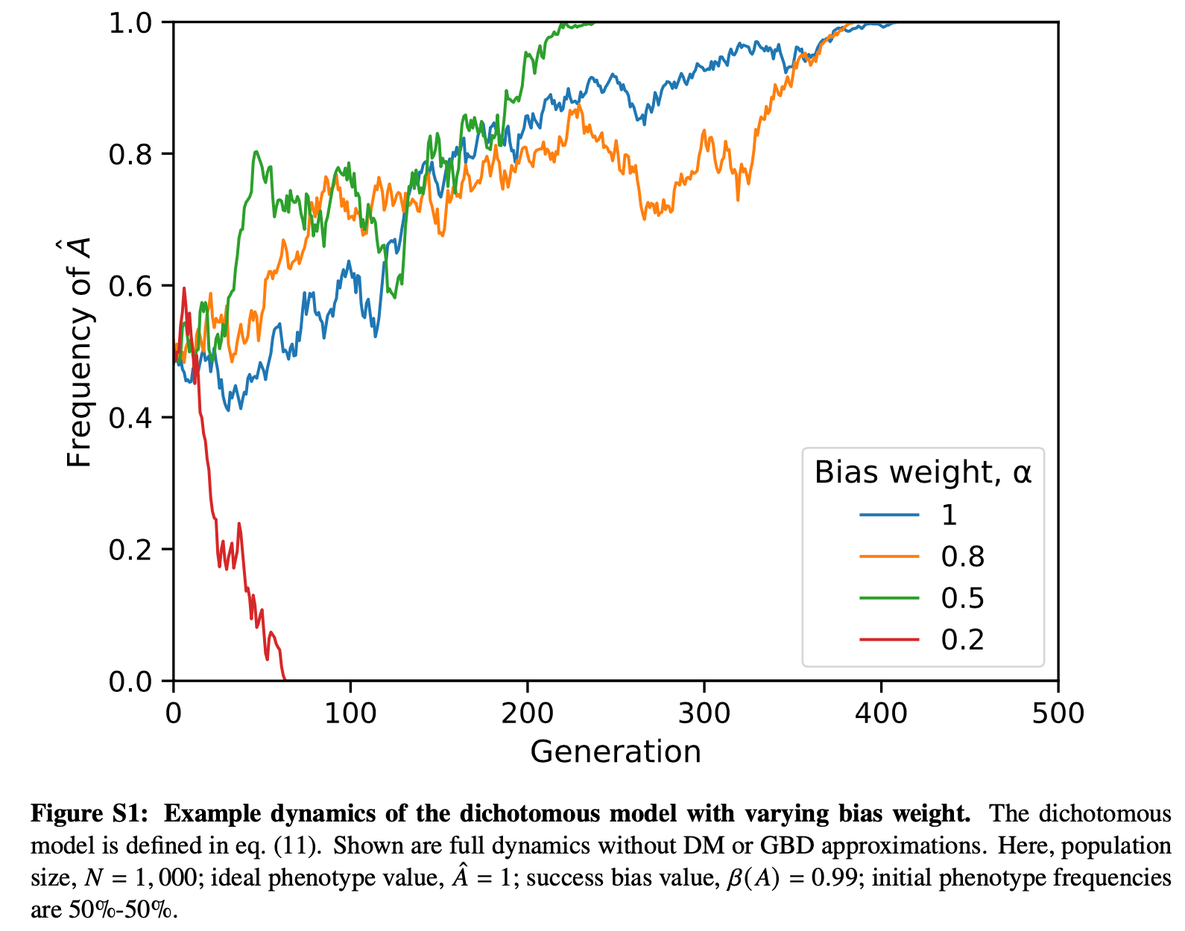  
  
Population Growth and Dispersion:  
The results indicate a decrease in dispersion as the population grows, a trend consistent with other popularity bias models. Placing the study within a broader framework of cultural evolution and exploring the temporal evolution would strengthen the authors' arguments. Consider incorporating time series data and discussing how the observed trends align with or differ from existing models.

We have added a time-series figure as suggested; see above. However, our model does not include population growth or dispersion/migration: the population size is constant at *N*, and there is a single environment/population. Moreover, our arguments mostly focus on the outcomes of the model choice process (the result of a single generation) and those of the evolutionary process (results at the end of evolution, e.g., fixation probability). Therefore, we do not believe that exploring temporal evolution will strengthen our arguments. We believe such exploration would make the manuscript harder to read without significantly adding to the manuscript.

Evolution of Success-Bias Weight:  
Provide a more precise explanation for why copiers may want to change their success-bias weight, especially when considering selectively neutral traits.

We are not dealing with the evolution of the success bias weight, as evolution occurs over multiple generations. We are dealing with the rational adjustment of the bias weight by each individual within a single generation. We now explain this in line 417: “In results 2-6, we assumed that the bias weight 𝛼 is homogeneous in the population and constant, that is, it does not depend on any specific context. However, rational individuals could potentially adjust their bias weight to balance between success and prestige bias depending on their context, such as the number of individuals who have already chosen a role model.”

Clarify the significance of success in this context, particularly if it implies popularity.

Success does not necessarily imply popularity—which we have not defined in our model—and has the same significance it has in the rest of the paper, so we did not provide additional clarification. This section only deals with adjustments made to the bias weight by individuals within a single generation.

A more explicit discussion on the rationale behind evolving to detect equal traits, given the absence of fitness considerations, is essential.

We now explicitly explain why we do not model fitness (line 107): “We follow the Boyd and Richerson model [7], assuming only oblique transmission of a single trait. This focus on oblique transmission (copying from non-parental adults) means that we can neglect fitness differences between trait values since there is no correlation between the traits of parents and offspring.”   
  
Minor Comments:  
Enlarge markers in Figure 1 for improved readability.

Done.

Avoid mixing different confidence intervals in the same figure, as it may introduce ambiguity. Provide justification if necessary.

All confidence intervals are now at 95%.

See the revised figure below.

Update the link to the source codes (<https://github.com/yoavram-lab/PrestigeBias>) to ensure accessibility for readers and reviewers.

The repository is now public and can be accessed by anyone using the above link.  
  
  
Overall Recommendations:  
While improvements have been made in response to previous reviewer comments, a new revision is advised to incorporate the suggestions provided herein. Focus on enhancing clarity regarding the novelty of the study in both the abstract and discussion, addressing the definition and implications of prestige bias, and providing additional insights through time series data.