Community Ecology: Final Project

Spring 2014

Yoav Ram

# Part 1: Community data analysis

I chose to analyze data from the Human Microbiome Project (<http://www.hmpdacc.org/>). I downloaded the Mother file of the Phase I (May 1) 16S variable regions 1-3 OTU (operational taxonomic unit) counts (<http://downloads.hmpdacc.org/data/HMMCP/finalData/hmp1.v13.hq.otu.counts.bz2>). This occurrences dataset contains 2,799 samples and 27,655 OTUs. The OTUs are described in the corresponding lookup file (<http://downloads.hmpdacc.org/data/HMMCP/finalData/hmp1.v13.hq.otu.lookup.bz2>). The samples metadata was retrieved (<http://www.hmpdacc.org/doc/ppAll_V13_map.txt>) and merged with the occurrences data. After filtering out unclassified OTUs, samples with zero counts, and OTUs with zero counts, 2,774 samples and 8,289 OTUs remained in the dataset.

The samples represent 173 individuals (85 males and 88 females), who visited between 1 and 3 times and were sampled in five major body sites (see Fig. 1), divided to up to 18 sub sites.

The analysis was performed using *R* with *vegan*. The code (analysis.R), this document (final_project.docx), and an *IPython notebook* that was used to clean and format the dataset (munge.ipynb) are available online as a *git* repository at <https://github.com/yoavram/CommunityEcologyProject>.

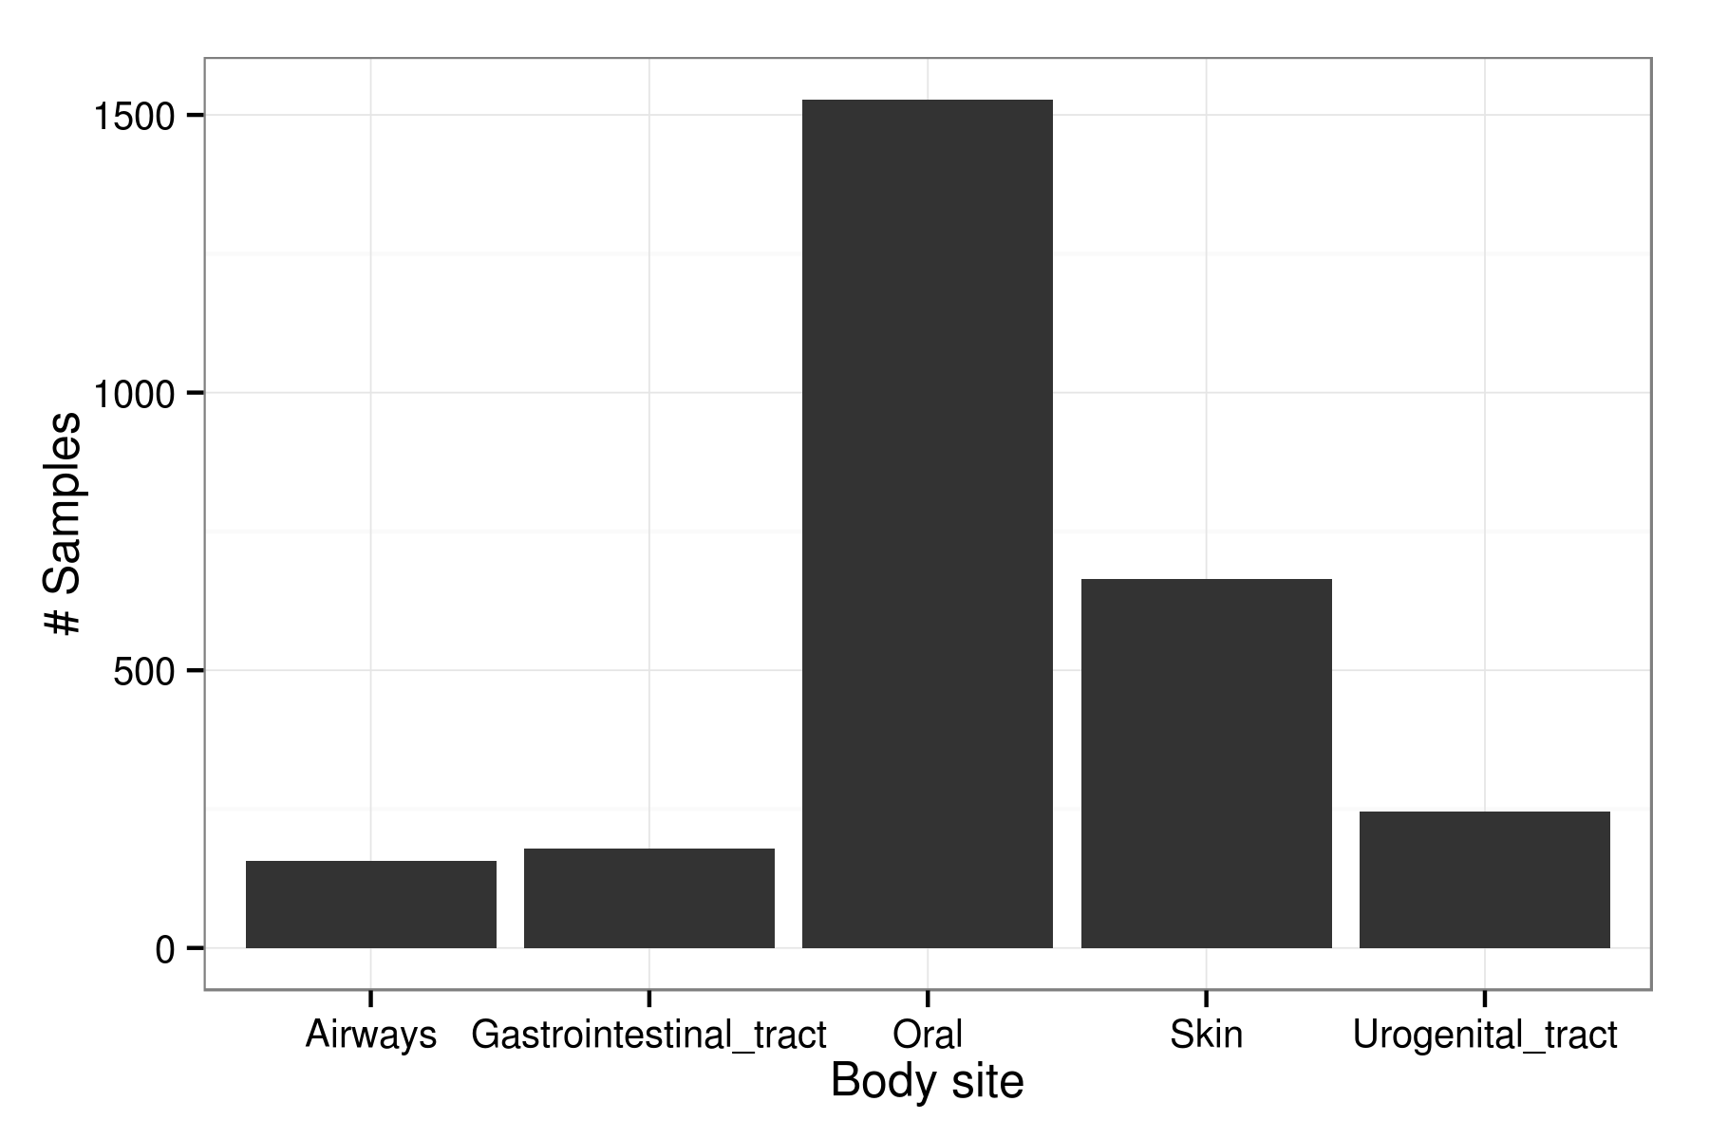

Figure 1 - # of samples per body site, summed over all sampled individuals.

## Species richness

The species richness analysis is summarized in Figs. 2-3. In general, it seems that the GI tract might have the richest community, followed by the oral, skin, airways, and finally, the UG tract. Interestingly, the two richest body sites also have the widest distribution of richness by sample.

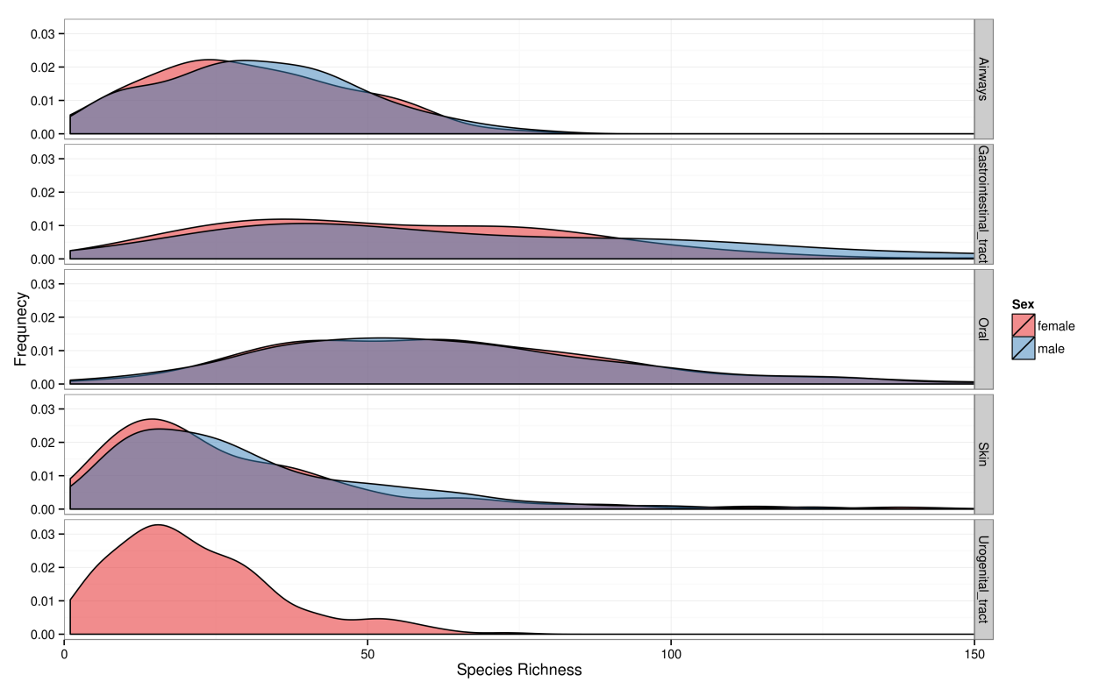

Figure 2 – Species richness distribution by sex (females in red, males in blue) and body sites (from top to bottom: airways, GI tract, oral, skin, UG tract). The richness distribution is similar between the sexes (confirmed by rarefaction which is not shown and consistent with similar number of male and female participants), but very different between body sites, where the GI tract and oral sites have a much wider distribution compared to the airways, skin and UG tract. See Fig. 3 for rarefaction curves.

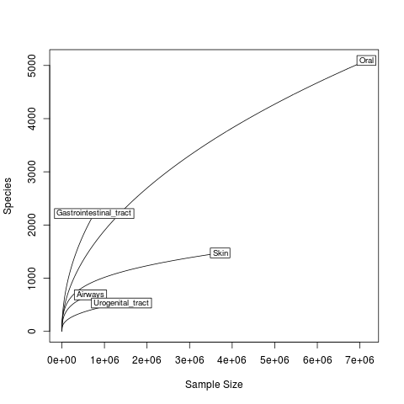

Figure 3 – Rarefaction curves for species richness by body site. This figure adds more information to Fig. 1, suggesting that the GI tract might show the highest richness if the sampling effort was increased.

## Species diversity

Fig. 4 shows the distribution of true diversity (Shannon index) by sex and body site. Similar to species richness, there seems to be little effect of sex on diversity, and a significant effect of body site, with greater diversity for the "richer" body sites (see Fig. 3) and lower diversity for the "poorer" body sites.

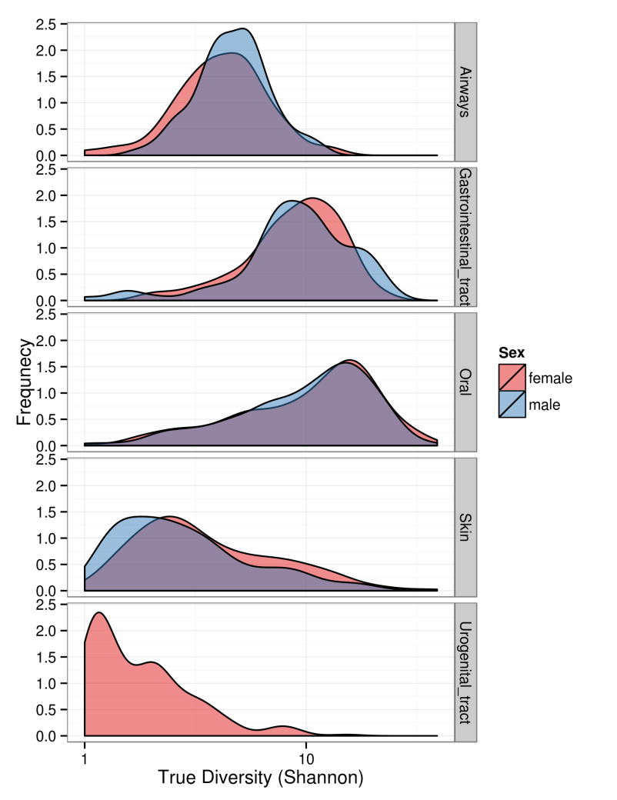

Figure 4 – species "true" diversity by body site and sex. The distribution of true diversity (Shannon index) by sex (red for female, blue for male) and body site (from top to bottom: airways, GI tract, oral, skin, and UG tract).

The diversity profile (Fig. 5) is consistent with this observation, and the trend of diversity as a function of the Hill number is similar in all body sites, rapidly declining as the effect of rare species decreases.

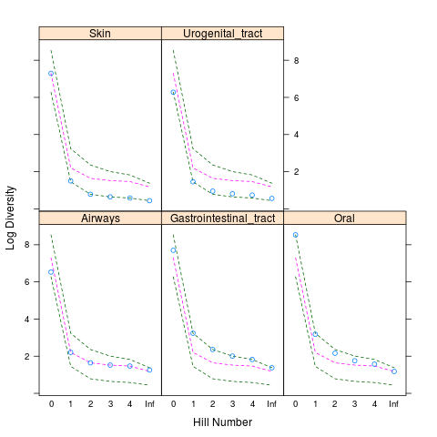

Figure 5 – Diversity profile by body site. The Log of the diversity as a function of Hill numbers for the different body sites.

## Beta diversity

First, I analyzed the beta diversity of the different body sites. From the beta diversity triplot in Fig. 6 it seems that the beta diversity is mainly influenced by species that occur in one body site but not in the other one (b and c), rather than by species that occur in both body sites (a).

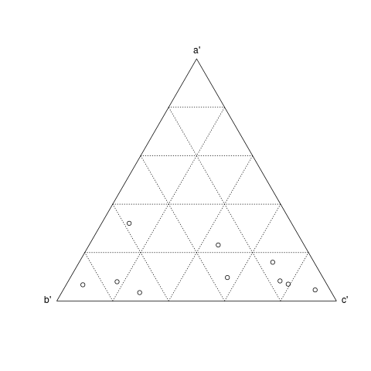

Figure 6 – Beta diversity triplot by body site.

Next, I analyzed three different beta diversity indices: Jaccard $\left(\frac{a}{a+b+c}\right)$, Simpson $\left(\frac{\min\left(b,c\right)}{\min\left(b,c\right)+a}\right)$, and Lennon $\left(\frac{2\left|b-c\right|}{2a+b+c}\right)$ (see Fig. 7). These indices were chosen because they present relatively different features. Jaccard's index (top) shows that the oral body sites share more species than the other body sites, on average, but there is a lot of variance. Simpson's index (middle) is similar, but inverse, and puts less weight on species that occur only in one person but in in another person. Lennon's index (bottom) checks the symmetry in segregation of species between two persons; the results are all around 0.5 but it seems that the oral samples have an increased variance, meaning that some persons had more unique species.

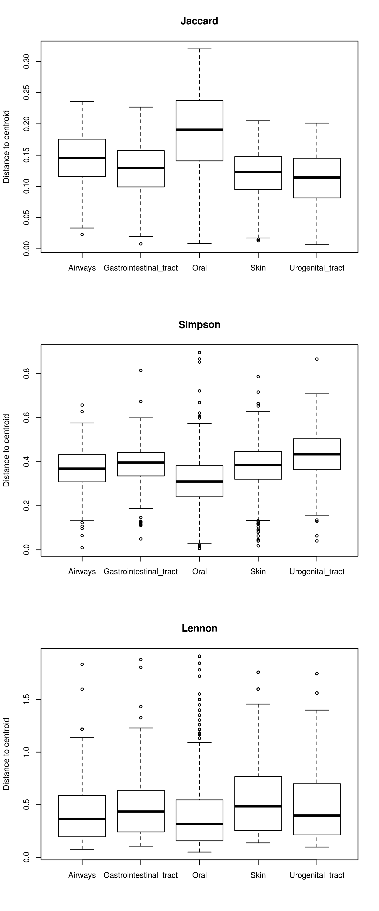

Figure 7 – Beta diversity by body site.

## Ordination

I performed nMDS on the data to find a species and sites ordination. The stress level was ~0.2.

### Sites ordination

The sites ordination (Fig. 8) clearly shows that samples are clustered by body sites, but not sex, with the only overlap between skin and airways. Consistent with our observation from the beta diversity analysis, the variance in the oral samples is larger (demonstrated by the relatively many green markers far from the centroid of the green cluster); however, this can be a result of an increased sampling effort in the oral sites (Fig. 1).

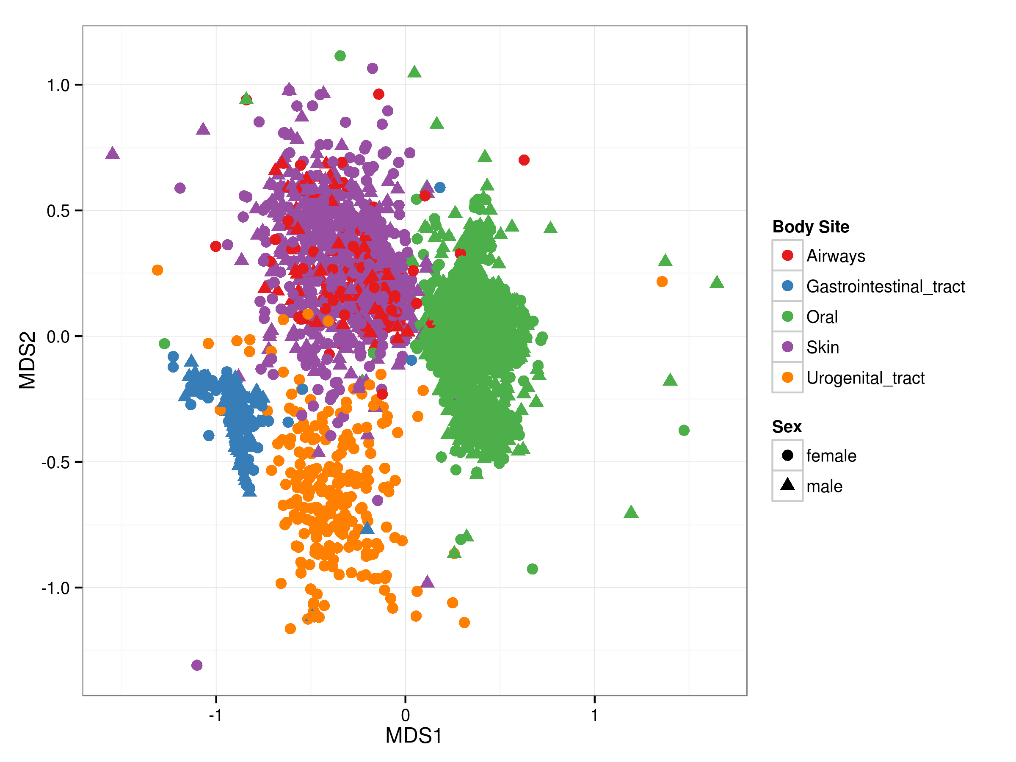

Figure 8 – Site ordination (nMDS). Sites are designated by body site (marker color) and sex (marker shape).

### Species ordination

The species ordination (Fig. 9) demonstrates that there are 3-4 distinct species cluster. The left and right clusters are composed of frequent species (species that appear in many samples); the species in the left cluster are mostly bacteroidetes, while the species in the right cluster are from all the kingdoms. There is another cluster in the middle of the ordination plot (or maybe two cluster, one in the middle and one at the bottom); this cluster is composed of rare species of all kingdoms.

It seems that the species ordination has caught something here – especially interesting is the left, homogeneous cluster – but the separation is either lacking, either due to high dimensionality of the underlying data, the complex and somewhat arbitrary concept of OUT, and the possibly messy composition of bacterial communities.

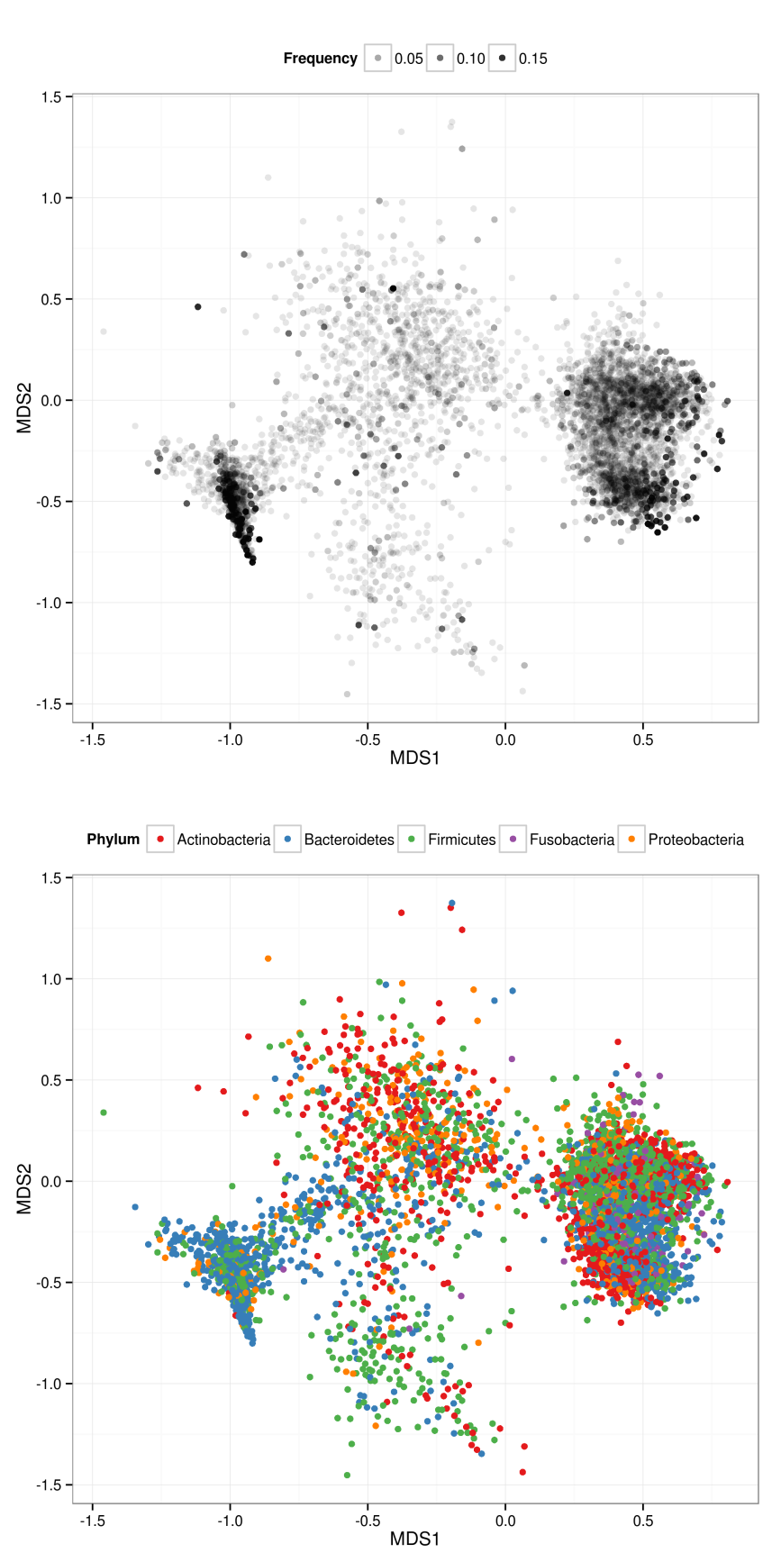

Figure 9 – Species ordination. The top panel shows the species by their frequency in the samples (the darker the marker the more frequent the species); the bottom panel shows the species by their phylum (denoted by different colors; only the five most frequent phylums are shown, see legend above panel).

## Assembly rules

I studied the correlation in the species composition between the different samples. Fig. 10 shows a correlation heatmap, where each row and column is a sample and the samples are ordered by the body sites.

First, it is clear that the main diagonal is composed of high-correlation blocks; that is, there is a high correlation between samples from the same body site. This correlation is especially strong in samples from the oral body sites (marked "O" in the bottom and right axes of Fig. 10), except for the supra- and subgingival plaque samples (the gums; marked "Sub" and "Sup" in the top axis of Fig. 10), possibly because the gums plaque are dominated by cavity causing bacteria.

Second, the airways samples (marked "A" in Fig. 10) have a relatively high correlation with the skin samples (marked "S" in Fig. 10) and to some extent with the oral and UG tract samples. This is in accordance with the overlap between the airways and skin samples in the ordination analysis (Fig. 8; red marks for airways, purple marks for skin).

Third, the GI tract samples (marked "G" in Fig. 10), despite their high diversity (Figs. 4-5), have very low correlation with samples from other body sites, in accordance with their tight grouping in the ordination analysis (Fig. 8; blue marks).

This trend can be the result of strict regulation or function of the gut microbiome, which enchances it for specific species; on the other hand, the airways and the skin are more susptible to infection by random microbes and therefore present higher correlation with other body sites.

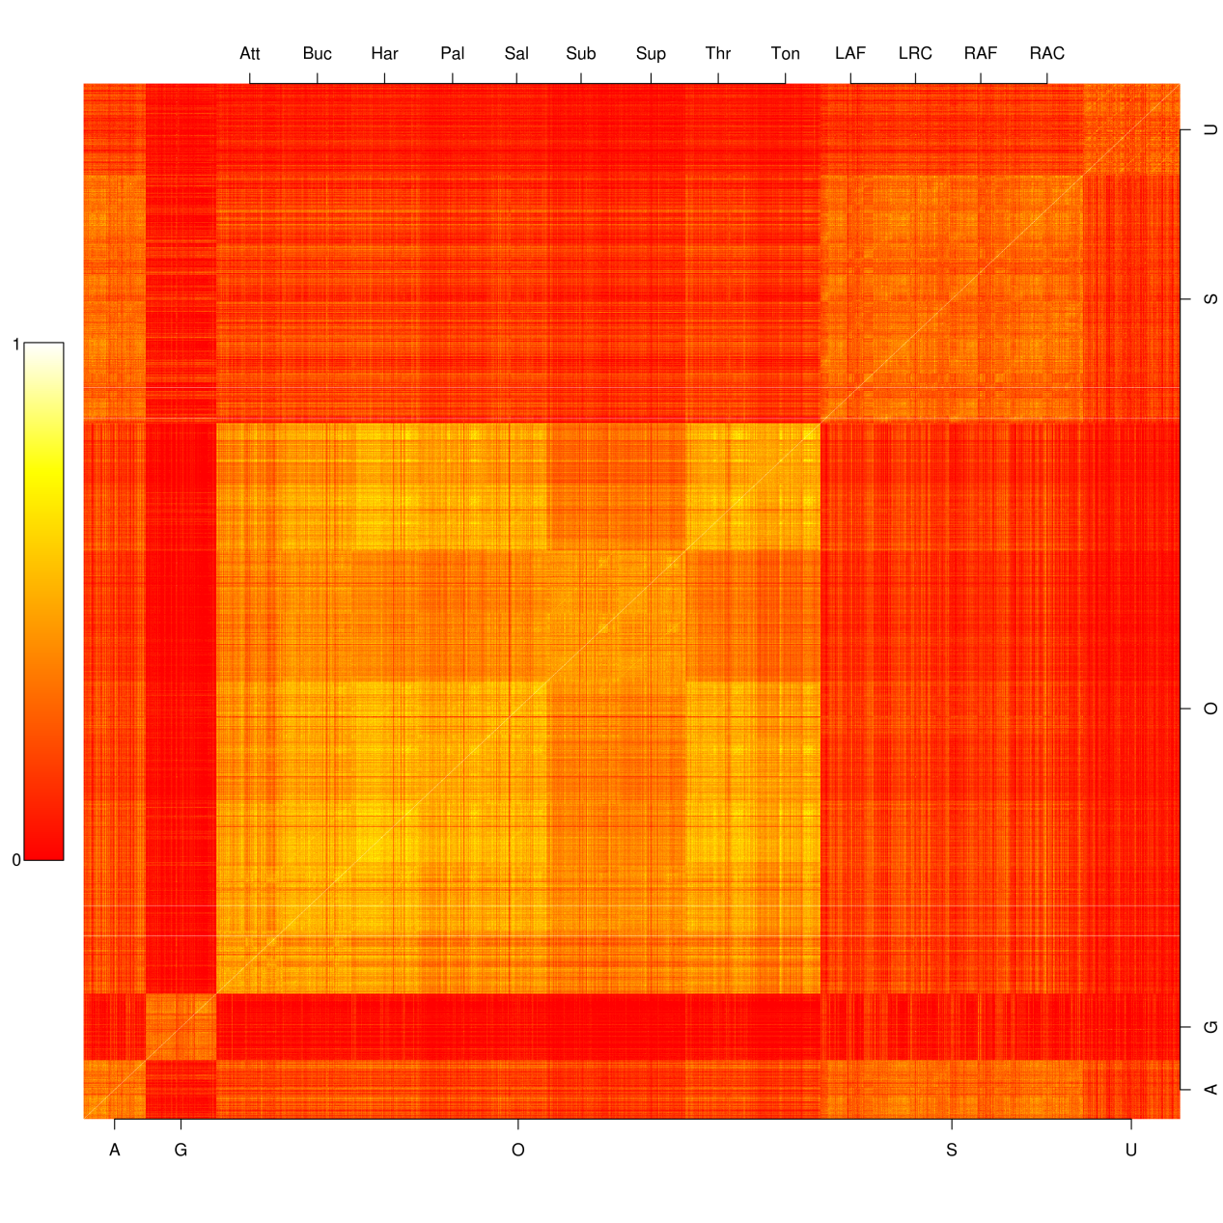

Figure 10 – Correlation between samples. Low correlation in red, high correlation in yellow (see colorbar on the left). The samples are ordered by body sites (bottom and right axes: A – airways; G – GI tract; O – oral; S – skin; U – UG tract) and sub-sites (top axis, oral: Att - Attached Keratinized gingiva; Buc - Buccal mucosa; Har - Hard palate; Pal - Palatine Tonsils; Sal – Saliva; Sub - Subgingival plaque; Sup - Supragingival plaque; Thr – Throat; Ton - Tongue dorsum; skin: LAF - Left Antecubital fossa; LRC - Left Retroauricular crease; RAF - Right Antecubital fossa; RAC - Right Retroauricular crease).

# Part 2: Open questions

## Question 4: What limits the number of mammal species in Israel?

The number of species in Israel is probably limited by several factors. In my opinion, the most important factor is the small area of Israel: with ~22,000 km2 of which 2% is water and 55% is desert [1], and a dense urban and rural population in the temperate regions, there is very limited natural landscape for wildlife. The effect of limited space is most pronounced in large mammals such as wolves, foxes, and deer.

An additional important limitation might be the dominance of human-dependent or human-facilitated species such as the house mouse, the roof rat, the mole rat, the golden jackal, the red fox, the wolf, the hyena, bats, the mountain gazelle, and of course the domestic cat and dog [2]. Such species that enjoy from a positive interaction with humans have a competitive advantage over wild species that have a negative or null interaction with humans, causing the exclusion of the latter species. In addition, the emergence of invading species due to human interference [3]: The nutria from South America [4], the Norwegian rat (the common or brown rat), and the northern palm squirrel from central Asia. However, it is not clear if invading species increase species richness by colonizing empty niches or reduce species richness by excluding native species.

On the other hand, the number of mammal species is likely enriched by the geographic and climate heterogeneity in Israel, both along the north-south temperature and precipitation gradient, and along the west-east geological and altitude gradient. This heterogeneity provides a diversity of ecological niches which can be occupied, in theory, by multiple different species. However, this occupation probably relies on migration, as the small mammal population sizes in Israel will not support a high rate of speciation.

Nevertheless, Israel is a land bridge between Africa, Arabia, and Eurasia. This location makes Israel a home for seasonal migrators, which probably doesn't affect mammal species; however, this unique location allowed many mammal species to pass through Israel while migrating between the continents, which could have facilitated a large number of mammal species. Indeed, there is evidence of species from tropical Africa and Asia, Palearctic Eurasia, central Asia, and the Sahara desert [5].

## Question 1: Deterministic or stochastic community structure?

In order to consider if the community structure of the human microbiome is deterministic or stochastic, first consider Fig. 8 above: given a sample of microbes from a random person and a random body site, one can predict which body site was sampled. This suggests a correlation between the environment (body site) and species abundance, which is indicative of a deterministic community structure.

Another perspective can be attained by studying the microbial composition of ancient human fecal matter; the oldest examples are dated to the Middle Palaeolithic, some 50,000 years ago, and are attributed to Neanderthals from Spain [6]. If the microbial composition of ancient fecal matter is similar to that of contemporary humans – taking into account a similar diet and the use of antimicrobial drugs – then it is plausible that the community structure of the GI tract is determined by deterministic processes.

Further support is given by a study from the Alm lab [7]. The researchers collected data on the food intake and other lifestyle information, as well as daily salivary and fecal samples from two individuals (the postdoc and the PI) over a period of a year. The analysis of the community structure dynamics over time demonstrates that the microbial communities are stable for months. However, drastic lifestyle events – the postdoc's travel to south east asia and the PI's Salmonella infection – rapidly changed the microbial community. However, the community rebounded after return to earlier conditions (the postdoc's return to the USA; the PI's recovery from the infection), at least to a certain degree, as some species were replaced by similar ones. These findings streghten the deterministic view: the stability to small perturbations (minor changes in diet and lifestyle over weeks and months) and the replacement of species by similar species after major perturbations both suggest that the community structure is functional and deterministic rather than stochastic.

## References

1. [Area of Districts, Sub-Districts, Natural Regions and Lakes](%22Area%20of%20Districts,%20Sub-Districts,%20Natural%20Regions%20and%20Lakes%22.%20Israel%20Central%20Bureau%20of%20Statistics.%2011%20September%202012.%20Retrieved%2013%20June%202013.). *Israel Central Bureau of Statistics*. 11 September 2012.
2. Mendelssohn H and Yom-Tov Y (1999) [A Report of Birds and Mammals Which Have Increased Their Distribution and Abundance in Israel Due to Human Activity](http://dx.doi.org/10.1080/00212210.1999.10688975), *Israel Journal of Zoology*, 45:1, 35-47.
3. [Global invasive species database](http://www.issg.org/database/species/search.asp?sts=sss&st=sss&fr=1&x=23&y=14&sn=&rn=Israel&hci=-1&ei=166&lang=EN). Retrieved 1 July 2014.
4. Carter J and Leonard BP (2002) [A Review of the Literature on the Worldwide Distribution, Spread of, and Efforts to Eradicate the Coypu (*Myocastor coypus*)](http://www.jstor.org/stable/3784650). *Wildlife Society Bulletin*, 30:1, 162-175.
5. Kolska Horwitz L and Tchernov E (1990) [Cultural and Environmental Implications of Hippopotamus Bone Remains in Archaeological Contexts in the Levant](http://www.jstor.org/stable/1357310). *Bulletin of the American Schools of Oriental Research*, 280, 67-76.
6. Sistiaga A, Mallol C, Galván B, Summons RE (2014) [The Neanderthal Meal: A New Perspective Using Faecal Biomarkers](http://www.plosone.org/article/info%3Adoi%2F10.1371%2Fjournal.pone.0101045). *PLoS ONE* 9(6): e101045.
7. David LA, Materna AC, Friedman J, Baptista MIC, Blackburn MC, Perrotta A, Erdman SE, Alm EJ (2014) [Host lifestyle affects human microbiota on daily timescales](https://trace.ddbj.nig.ac.jp/DRASearch/study?acc=ERP006059). *Submitted*.