Supporting material for

Predicting microbial relative growth in a mixed culture from growth curve data

Yoav Ram1a, Eynat Dellus-Gur1, Maayan Bibi2,

Uri Obolski1b, Judith Berman2, and Lilach Hadany1

November 23, 2017

# Supporting Text 1: Monoculture model

We derive our growth models from a resource consumption perspective (Otto and Day, 2007, 365; Gopalsamy, 1986). We denote by $R$ the density of a limiting resource, and by $N$ the density of the cell population, both in total mass per unit of volume.

We assume that the culture is well-mixed and homogeneous and that the resource is depleted by the growing cell population without being replenished. Therefore, the intake of resources occurs when cells meet resource via a mass action law with resource intake rate $h$. Once inside the cell, resources are converted to cell mass at a conversion rate of $ϵ$. Cell growth is assumed to be proportional to $R⋅N$, whereas resource intake is proportional to a power of cell density, $R⋅N^{ν}$. We denote $Y∶=N^{ν}$.

We can describe this process with differential equations for $R$ and $N$:

|  |  |  |
| --- | --- | --- |
|  | $$\left\{\begin{aligned}\frac{dR}{dt}=-hRN^{ν} \\ \frac{dN}{dt}=ϵhRN,\end{aligned}\right.$$ | [A1a]  [A1b] |

These equations can be converted to equations in $R$ and $Y$:

$$Y=N^{ν}⇒$$

$$\frac{dY}{dt}=νN^{ν-1}\frac{dN}{dt}=$$

$νN^{ν-1}⋅ϵhRN=νϵhRN^{ν}$,

which yields

|  |  |  |
| --- | --- | --- |
|  | $$\left\{\begin{aligned}\frac{dR}{dt}=-hRY \\ \frac{dY}{dt}=μhRY.\end{aligned}\right.$$ | [A2a]  [A2b] |

with $μ=ϵν$.

To solve this system, we use a conservation law approach by setting $M=μR+Y$ (Dilao and Domingos, 1999). We find that *M* is constant

$\frac{dM}{dt}=μ\frac{dR}{dt}+\frac{dY}{dt}≡0$,

and we can substitute $μR=M-Y$ in eq. A2b to get

|  |  |  |
| --- | --- | --- |
|  | $\frac{dY}{dt}=hY\left(M-Y\right)=hMY\left(1-\frac{Y}{M}\right)$. | [A3] |

Substituting again $N^{ν}=Y,\frac{dY}{dt}=νN^{ν-1}\frac{dN}{dt}$, and defining $K=M^{\frac{1}{ν}}, r=\frac{h}{ν}K^{ν}$, we get

|  |  |  |
| --- | --- | --- |
|  | $\frac{dN}{dt}=r⋅N⋅\left(1-{\left(\frac{N}{K}\right)}^{ν}\right)$, | [A4] |

which is the Richards differential equation (Richards, 1959), with the maximum population density *K* and the specific growth rate in low density $r$. To the best of our knowledge this the first derivation of the Richards differential equation from a resource consumption perspective.

We solve eq. A4 via eq. A3, which is a logistic equation and therefore has a known solution. Setting the initial cell density $N\left(0\right)=N_{0}$ we have

$N\left(t\right)=\frac{K}{{\left(1-\left(1-{\left(\frac{K}{N_{0}}\right)}^{ν}\right)e^{-rνt}\right)}^{\frac{1}{ν}}}$.

Eq. A4 is an autonomous differential equation ( ${dN}/{dt}$ doesn't explicitly depend on $t$). To include a lag phase, Baranyi and Roberts (1994) suggested to add an adjustment function $α\left(t\right)$, which makes the equation non-autonomous (explicitly dependent on $t$):

|  |  |  |
| --- | --- | --- |
|  | $\frac{dN}{dt}=r⋅α\left(t\right)⋅N⋅\left(1-{\left(\frac{N}{K}\right)}^{ν}\right)$. | [A5] |

Baranyi and Roberts suggested a Michaelis-Menten type of function (Baranyi, 1997)

$α\left(t\right)=\frac{q_{0}}{q_{0}+e^{-mt}}$,

which has two parameters: *q0* is the initial physiological state of the population, and *m* is rate at which the physiological state adjusts to growth conditions. Integrating $α(t)$ gives

$A\left(t\right)∶=\int_{0}^{t}{α(s)ds}=\int_{0}^{t}{\frac{q_{0}}{q_{0}+e^{-ms}}ds}=t+\frac{1}{m}\log\left(\frac{e^{-mt}+q_{0}}{1+q_{0}}\right)$.

Therefore, integrating eq. A5 produces eq. 2.

The term $1-{\left(N/K\right)}^{ν}$ is used to describe the deceleration in the growth of the population as it approaches the maximum density $K$. When $ν=1$, the deceleration is the same as in the standard logistic model $\left(\frac{dN}{dt}=r⋅N⋅\left(1-\frac{N}{K}\right)\right)$ and the density at the time of the maximum population growth $\left(\frac{d^{2}N}{dt^{2}}\left(t\right)=0\right)$ is half the maximum density, $\frac{K}{2}$. When $ν>1$ or $1>ν$, the deceleration is slower or faster, respectively, and the density at the time of the maximum growth rate is $K/{{\left(1+ν\right)}^{1/ν}}$ (Richards 1959, substituting $W=N,A=K,m=ν+1,k=r⋅ν$*)*.

We use six forms of the Baranyi-Roberts model (Figure S2, Table S1). The full model is described by eq. 2 and has six parameters. A five-parameter form of the model assumes $ν=1$, as in the standard logistic model, but still incorporates the adjustment function $α\left(t\right)$ and therefore includes a lag phase. Another five-parameter form has both rate parameters set to the same value ($m=r$), which was suggested to make the fitting procedure more stable (Baranyi, 1997; Clark *et al.*, 2010). A four-parameter form has both of the previous constraints, setting $m=r$ and $ν=1$ (Baranyi, 1997). Another four-parameter form of the model has no lag phase, with $1/m=0⇒α(t)≡$ 1, which yields the Richards model (Richards, 1959), also called the $θ$-logistic model (Gilpin and Ayala, 1973), or the generalized logistic model. This form of the model is useful in cases where there is no observed lag phase: either because the population adjusts very rapidly or because it is already adjusted prior to the growth experiment, possibly by pre-growing it in fresh media before the beginning of the experiment. The last form is the standard logistic model, in which $ν=1$ and $1/m=0$.

# Supporting Text 2: Mixed culture model

We consider the case in which two species or strains grow in the same culture, competing for a single limiting resource, similarly to eq. A1:

|  |  |  |
| --- | --- | --- |
|  | $$\left\{\begin{aligned}\frac{dR}{dt}=-h_{1}RN_{1}^{ν_{1}}-h_{2}RN_{2}^{ν_{2}} \\ \frac{dN_{1}}{dt}=ϵ_{1}h_{1}RN_{1} \\ \frac{dN_{2}}{dt}=ϵ_{2}h_{2}RN_{2} \end{aligned}\right.$$ | [B1a]  [B1b]  [B1c] |

We define $Y_{i}=N_{i}^{ν_{i}}$, and $M_{i}=ϵ_{i}ν_{i}R+Y_{i}+\frac{ϵ_{i}ν_{i}}{ϵ_{j}ν_{j}}Y_{j}$ (where *j* is 1 when *i* is 2 and vice versa) to find that $\frac{dM_{i}}{dt}≡0$ and $M_{i}$ is constant. We then substitute $ϵ_{i}ν_{i}R=M_{i}-Y_{i}-\frac{ϵ_{i}ν_{i}}{ϵ_{j}ν_{j}}Y_{j}$ into the differential equations for $\frac{dY_{i}}{dt}$. Denoting $K_{i}=M_{i}^{\frac{1}{ν_{i}}}$ and $r_{i}=\frac{h_{i}}{ν_{i}}K_{i}^{ν_{i}}$, we get

|  |  |  |
| --- | --- | --- |
|  | $$\left\{\begin{aligned}\frac{dN_{1}}{dt}=r_{1}N_{1}\left(1-\frac{N_{1}^{ν_{1}}}{K_{1}^{ν_{1}}}-a_{2}⋅\frac{N_{2}^{ν_{2}}}{K_{1}^{ν_{1}}}\right) \\ \frac{dN_{2}}{dt}=r_{2}N_{2}\left(1-a_{1}⋅\frac{N_{1}^{ν_{1}}}{K_{2}^{ν_{2}}}-\frac{N_{2}^{ν_{2}}}{K_{2}^{ν_{2}}}\right),\end{aligned}\right.$$ | [B2a]  [B2b] |

where $a_{j}=\frac{ϵ_{i}ν_{i}}{ϵ_{j}ν_{j}}$.

We get a similar result if each strain is limited by a different resource that both strains consume:

|  |  |  |
| --- | --- | --- |
|  | $$\left\{\begin{aligned}\frac{dR_{1}}{dt}=-h_{1}R_{1}N_{1}^{ν_{1}}-h_{2}R_{1}N_{2}^{ν_{2}} \\ \frac{dR_{2}}{dt}=-h_{1}R_{2}N_{1}^{ν_{1}}-h_{2}R_{2}N_{2}^{ν_{2}} \\ \frac{dN_{1}}{dt}=ϵ_{1}h_{1}R_{1}N_{1} \\ \frac{dN_{2}}{dt}=ϵ_{2}h_{2}R_{2}N_{2} \end{aligned}\right.$$ | [B3a]  [B3b]  [B3c]  [B3d] |

Here, we notice first that $\frac{d}{dt}\log\left(R_{1}\right)=\frac{d}{dt}\log\left(R_{2}\right)$ and therefore $ρ=\frac{R_{1}}{R_{2}}$ is a constant. We then substitute $R_{1}=R, R_{2}=ρR$ in eqs. B3 and continue as above. This changes the definition of $a_{j}=\frac{ϵ_{i}ν_{i}R_{i}}{ϵ_{j}ν_{j}R_{j}}$.

If the intake rates depend only on the resource then

|  |  |  |
| --- | --- | --- |
|  | $$\left\{\begin{aligned}\frac{dR_{1}}{dt}=-h_{1}R_{1}N_{1}^{ν_{1}}-h_{1}R_{1}N_{2}^{ν_{2}} \\ \frac{dR_{2}}{dt}=-h_{2}R_{2}N_{1}^{ν_{1}}-h_{2}R_{2}N_{2}^{ν_{2}} \end{aligned}\right.$$ | [B4a]  [B4b] |

Then we define $H=h_{1}/h_{2}$ and $ρ=\frac{R_{1}}{R_{2}^{H}}$ and again continue as above.

# Supporting figures



Figure S1. Fluorescence microscopy of *E. coli* strains carrying GFP or RFP. Image of a mixture of DH5α-GFP and TG1-RFP cells.

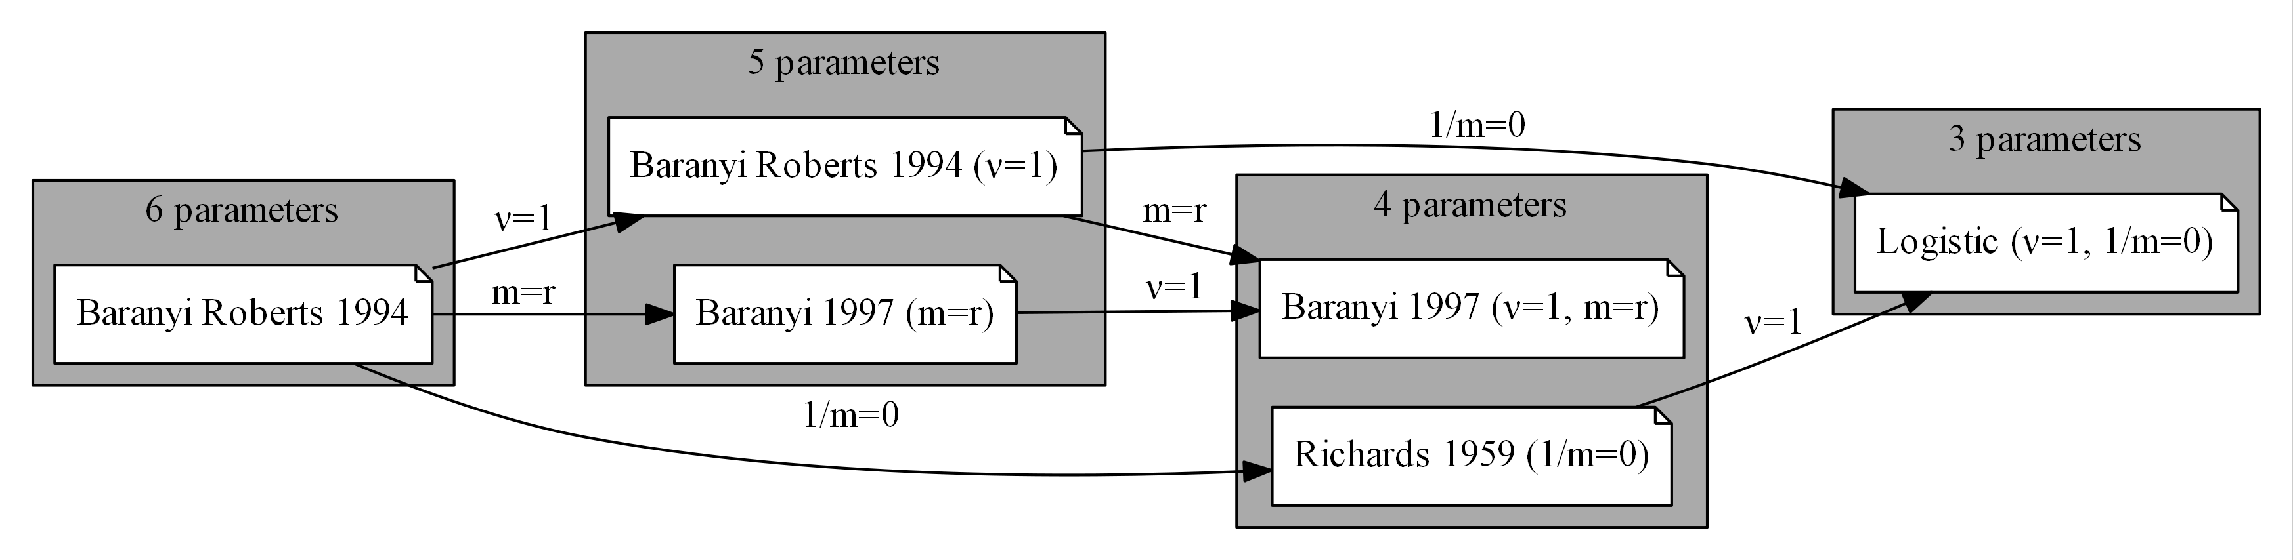

Figure S2. Growth models hierarchy. The Baranyi-Roberts model and five nested models defined by fixing one or two parameters. See Supporting Text 1 and Table S1 for more details.

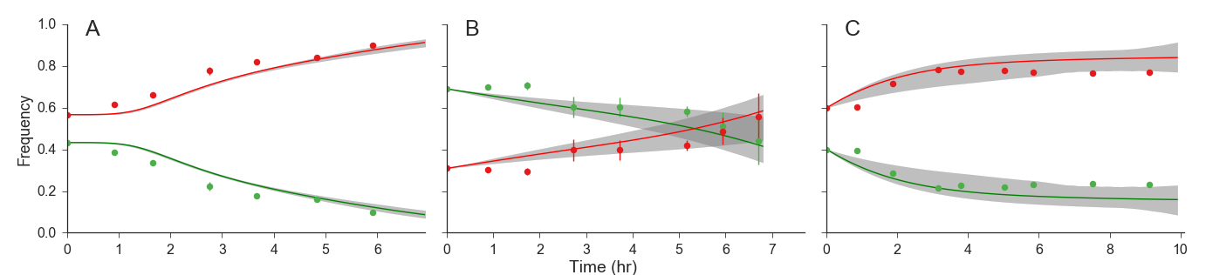

Figure S3. Mixed culture growth predictions with confidence intervals. The green and red lines and markers correspond to the dashed green and red lines and the markers in Figure 3D-F, respectively. The gray area shows the 95% confidence interval, calculated using bootstrap (1000 samples).

# Supporting tables

|  |  |  |  |  |
| --- | --- | --- | --- | --- |
| Model name | **# Parameters** | **Free Parameters** | **Fixed Parameters** | **References** |
| Baranyi Roberts 1994 | 6 | $$N_{0},K,r,ν,q_{0},m$$ | - | (Baranyi and Roberts, 1994) |
| Baranyi 1997 | 5 | $$N_{0},K,r,ν,q_{0}$$ | $$m=r$$ | - |
| Baranyi Roberts 1994 | 5 | $$N_{0},K,r,q_{0},m$$ | $$ν=1$$ | - |
| Richards 1959 | 4 | $$N_{0},K,r,ν$$ | $$\frac{1}{q_{0}}=\frac{1}{m}=0$$ | (Richards, 1959) |
| Baranyi 1997 | 4 | $$N_{0},K,r,q_{0}$$ | $$ν=1$$ $$m=r$$ | (Baranyi, 1997) |
| Logistic | 3 | $$N_{0},K,r$$ | $$ν=1$$ $$\frac{1}{q_{0}}=\frac{1}{m}=0$$ | (Verhulst, 1838) |

Table S1. Growth models. The table lists the growth models used for fitting growth curve data. All models are defined by eqs. 1 and 2, by fixing specific parameters. $N_{0}$ is the initial population density; $K$ is the maximum population density; $r$ is the specific growth rate in low density; $ν$ is the surface to mass ratio; $q_{0}$ is the initial physiological state; $m$ is the physiological adjustment rate. Note that when $1/m=0$, the value of $q_{0}$ is irrelevant. See also the hierarchy diagram in Figure S2 and a detailed discussion in Supporting text 1.

|  |  |  |  |  |  |  |  |  |
| --- | --- | --- | --- | --- | --- | --- | --- | --- |
|  | Experiment A | | | | Experiment B | | Experiment C | |
| *Strain*  *Parameter* | | **GFP** | | **RFP** | **GFP** | **RFP** | **GFP** | **RFP** |
| $$N_{0}$$ | 0.125 | | 0.124 | | 0.286 | 0.23 | 0.188 | 0.204 |
| $$K$$ | 0.528 | | 0.65 | | 0.619 | 0.628 | 0.633 | 0.741 |
| $$r$$ | 0.376 | | 0.587 | | 0.304 | 0.484 | 8 | 8 |
| $$ν$$ | 2.636 | | 1* | | 2.484 | 1.491 | 1* | 0.164 |
| $$q_{0}$$ | 0.032 | | 0.008 | | **-\*** | **-\*** | 0.039 | 0.393 |
| $$v$$ | 0.937 | | 3.735 | | **-\*** | **-\*** | 0.188 | 0.104 |

Table S2. Estimated parameters from growth model fitting. * denotes fixed parameters; - denotes invalid parameter values.