The evolution of stress-induced mutagenesis in the presence of recombination

Yoav Ram and Lilach Hadany

September 4, 2014

TODO:

1. Raynes & Sniegowski 2014

# Introduction

## Introduction to stress-induced hypermutation

For many years the mutation rate was considered constant in time and uniform within populations (Luria and Delbrück 1943). However, since the 1970s, experiments with microorganisms have revealed that various stress responses induce a state of mutagenesis in which the mutation rate is increased by several orders of magnitude – a process is called stress-induced mutagenesis (SIM) (Radman 1975; Taddei, Matic, and Radman 1995; Galhardo, Hastings, and Rosenberg 2007; Foster 2007; Heidenreich 2007; Rosenberg et al. 2012; Shor, Fox, and Broach 2013). Because mutations are the ultimate source of genetic variation, it has been suggested that SIM evolved to facilitate adaptation to novel environmental conditions and stress (Tenaillon, Denamur, and Matic 2004; Saint-Ruf and Matic 2006; Rosenberg et al. 2012; Ram and Hadany 2012) [Ram2014].

This adaptive explanation is challenged by several non-adaptive explanations. First, mutagenesis can be a by-product of stress: mutations can be generated more often during stress because there is not enough energy and resources to repair them (Tenaillon, Denamur, and Matic 2004). Second, because there is a cost for high-fidelity DNA replication, it was suggested that an optimal mutation rate will balance between this "cost of fidelity" and the mutational load due to the accumulation of deleterious mutations (Dawson 1998). This balance may change during stressful times because, for example, the "cost of fidelity" is a short-term effect whereas the mutational load is a medium-term effect. Third, Lynch proposed the "drift barrier hypothesis" (Lynch 2011). One of the implications of this hypothesis is that DNA repair proteins which are primarily expressed during stress are under weaker selection compared to DNA repair proteins that are constitutively expressed. Therefore, genetic drift can cause these stress-induced repair proteins to become error prone. Forth, stress-induced mutagenesis could have evolved due to some pleiotropic effect which can work together or in contrast with its effect on adaptation (Torres-Barceló et al. 2013; Katz and Hershberg 2013).

## The evolution of stress-induced hypermutation in asexual populations

In a previous work we have addressed the adaptive hypothesis in asexual populations (Ram and Hadany 2012). We studied the evolution of mutator alleles that induce an increased mutation rate in maladapted individuals in constant and changing environments. We demonstrated that these stress-induced mutator alleles can evolve in a wide range of conditions because they are favored by selection over mutator alleles that induce a constant rate of mutation.

## Recombination in microbial populations

Nevertheless, most microorganisms are not entirely asexual. In bacteria, horizontal gene transfer (HGT) includes three mechanisms (Miller and Day 2004): transformation, in which cells recombine foreign DNA into their genome (Avery 1944); conjugation, in which plasmids are transferred between cells (Lederberg and Tatum 1946); and transduction, in which viruses carry off DNA segments with them when infecting new cells (Zinder and Lederberg 1952). In eukaryotes, recombination is prevalent during meiosis; yeast occasionally reproduce sexually when two haploid cells (spores) mate to produce a diploid cell (Roeder 1995).

## The effect of recombination on the evolution of mutators

The rate of adaptation of asexual (non-recombining) populations is largely dependent on the mutation rate, because mutation is the sole provider of novel adaptations in clonal populations.

However, there are several factors that can lower the overall adaptation rate of this *adaptation-by-mutation* strategy. First, competition between beneficial mutations can reduce their fixation probability, thus limiting the rate of adaptation in asexual populations in a process called "clonal interference" (Gerrish and Lenski 1998). Second, if two or more beneficial mutations are needed for adaptation to environmental conditions then they must occur in sequence, rather than in parallel (Muller 1932)//Fisher?//. Third, because most mutations are deleterious, increasing the mutation rate causes a mutational load which disrupts selection for beneficial mutations (Orr 2000), can lead to a "mutational meltdown" and loss of adaptation in a process called "Muller's ratchet" (Muller 1964; Haigh 1978; Lynch et al. 1993), and can lead to the hitch-hiking of deleterious mutations with fixating beneficial mutations (Hartfield and Glémin 2014).

These issues are mitigated by recombination. Recombination reduces "clonal interference" by combining co-occurring beneficial mutations (Cooper 2007; Martens and Hallatschek 2011). Combining co-occurring beneficial mutations also reduces the waiting time for the production of an adapted genotype (Christiansen et al. 1998) – this is sometimes referred to as the "Fisher-Muller effect" (Felsenstein 1974). In addition, recombination generates less-loaded individuals that were lost due to drift, halting "Mullter's ratchet" (Lynch and Conery 1995), and helps to purge deleterious mutations more effectively, reducing the mutational load (Keightley and Otto 2006).

The fate of a mutator – an allele that increases the mutation rate – depends on the mutations associated with it. A mutator can "hitch-hike" to high frequencies with the beneficial mutations it generates in a process called "selective sweep" or "genetic hitch-hiking" (Maynard Smith and Haigh 1974; Taddei et al. 1997; Charlesworth 2007) //and this is likely to happen if the mutational supply in the mutator sub-population is larger than in the wildtype sub-population (Chao and Cox?) //, even if those mutations were originally deleterious when generated (Leigh 1970). However, a mutator may have several deleterious mutations in its genetic background together with a beneficial mutation and this deleterious background can prevent selection from effectively acting on the beneficial mutation (Orr 2000). This is called the "Hill-Robertson effect" (Hill and Robertson 1966; note that the "Hill-Robertson effect" is sometimes used in a broader sense that includes both the "Fisher-Muller effect" and "clonal interference" - see Comeron, Williford, and Kliman 2008). Recombination will have a contrasting effect on the fate of such a mutator: because recombination tends to break the linkage between the mutator and its associated mutations, it will counter both the "hitch-hiking effect" and the "Hill-Robertson effect". However, it is important to note that when recombination breaks the linkage between a mutator and its beneficial mutations, it can pass those beneficial mutations to competitor alleles – other mutator alleles or the wild-type allele. Although recombination will also pass deleterious alleles, we expect that the gain of beneficial mutations by other mutator alleles will be more significant and that the net effect of recombination on the fate of mutators will be negative (but see Orr 2000). // Background trapping (Peck 1994, Charlesworth 199X, Johnson & Barton 2002), evolutionary traction (Hadany and Feldman 200X)//

Due to this contrasting effect of recombination on the evolution of mutators, both at the population and the individual levels, it is important to examine if stress-induced mutators are limited to asexual populations or can readily evolve in the presence of recombination.

## Stress-induced hypermutation in the presence of recombination

We used simulations to study the evolution of stress-induced mutators in the presence of recombination in finite populations evolving in changing environments.

Our finding suggest that (i) mutators are favored by selection even with recombination, as long as it is not too strong; (ii) stress-induced mutators are always favorable over constitutive mutators; (iii) stress-induced mutators can be favored even when constitutive mutators cannot; (iv) recombination reduces the selection for mutators primarily by disrupting the "hitch-hiking effect" rather than by the "Fisher-Muller effect"; and (v) selection favors mutators that also increase the recombination rate.

# Model

We used stochastic Wright-Fisher simulations to model finite populations undergoing selection, mutation, recombination, and random genetic drift in changing environments.

The genome of every individual contains 1,000 fitness loci and four modifier loci. Individuals are grouped by their genotype and we keep track of the number of individuals in each group.

The fitness loci are bi-allelic and the alleles are marked by 0 and 1. The fitness of an individual is calculated by comparing the alleles at the fitness loci with the environmental optimal genome: the fitness of an individual with *x* loci in mismatch with the optimal genome is (1-*s*)*x*, where *s* is the selection coefficient. To model environmental changes, the optimal genome is altered by modifying alleles at several loci. The number of loci changed in each environmental change and the probability that an environmental change occurs are parameters of the model.

The modifier loci affect the rates of mutation and recombination. These loci are denoted by the letters π, *τ*, *ϕ*, and *ρ* and their alleles have numerical values. The basal mutation rate *µ* is measured by the number of mutations per individual per generation. If an individual has π or more mismatches with the environmental optimal genome, it increases its mutation rate *τ*-fold. The basal recombination rate is denoted by r and measured by the number of gene conversions per genome per generation; the threshold for recombination rate increase is ϕ and the rate increase is *ρ*-fold. These modifiers allow us to model different mutation and recombination strategies. See Table 1 for a full list of these strategies.

Each simulation starts with a mutation-free population (all individuals start with the optimal genome) and continues for a predefined number of generations. We model natural selection and genetic drift by sampling the number of individuals in each genotype group in the next generation from a multinomial distribution, where the probability assigned to each group is equal to its relative size (or frequency) multiplied by the fitness of the individuals in the group (individuals in the same group have the same genotype and therefore the same fitness). Mutation and recombination are modeled by randomly drawing the number of events from a Poisson distribution with the mutation and recombination rates as the means of the distribution, then randomly choosing the loci that are about to be altered from a uniform distribution (only fitness loci are subject to mutation and recombination), and finally choosing the new allele in the altered loci: mutation changes the current allele to the beneficial allele with probability β and to the deleterious one with probability 1-β (β is the probability for a beneficial mutation); recombination replaces the current allele with a randomly chosen one based on the frequency of each allele in the population.

The simulations were written in Python 2.7 (Van Rossum and others 2007) using the NumPy (van der Walt, Colbert, and Varoquaux 2011), SciPy (Jones et al. 2001), and Pandas (McKinney 2010) packages.

# Results

In a previous article we have shown that stress-induced mutators – alleles that increase the mutation rate in stressed or maladapted individuals - can evolve in asexual populations (Ram and Hadany 2012). However, many microbe populations are not entirely asexual. In this article we examine the evolution of stress-induced mutators in recombining populations.

We simulated competitions between different mutation and recombination modifier alleles (see Table 1) in populations evolving in changing environments. The fixation probability of modifier alleles was estimated from the fraction of competitions in which each allele reached fixation (100%) in the population. If an allele is neutral with respect to its competitor alleles then its fixation probability is equal to its initial frequency (50%). On the other hand, if an allele is favored or disfavored by selection over its competitors, then its fixation probability is significantly higher or lower than the initial frequency, respectively. Therefore, we tested whether the estimated fixation probabilities are significantly different from 50% using a 2-tail proportions test. In addition, we measured the adaptation time in populations homogenous at the modifier loci subject to a single environmental change.

## Evolution of SIM in the presence of recombination

Figure 1 shows the fixation probability of constitutive (CM; dashed red) and stress-induced mutators (SIM; solid blue) under a range of recombination rates, starting with the low rates measured in *E. coli* and up to the high rates measured in *H. pylori* and *S. cerevisiae* [REF]. The figure shows that recombination reduces the fixation of both mutators, as shown before for CM (Tenaillon et al. 2000). However, SIM is always more successful than CM, and it can be favored by selection in the presence of mild recombination, even when CM cannot.

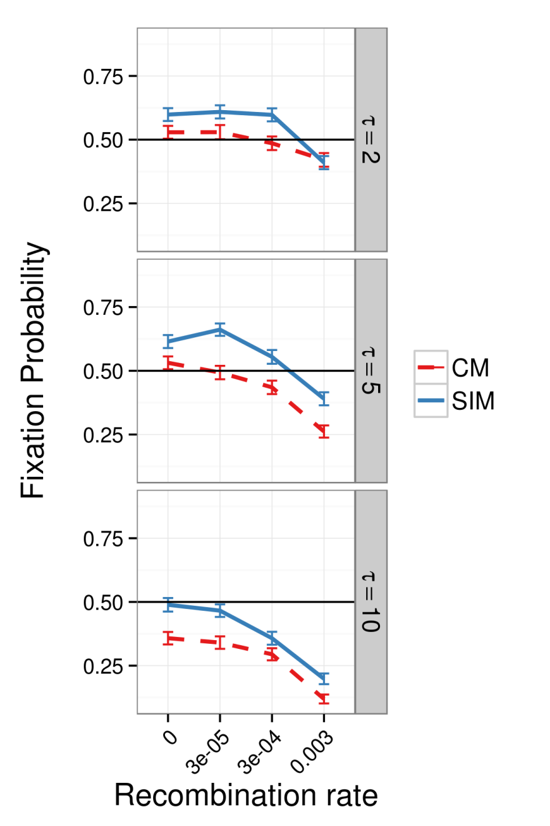

Figure 1 - invasion_SIMvsCM_pop_1e6_2014-07-22

Why is SIM advantageous when CM is not? Figure 2 shows that when 9 out of 10 mutations are deleterious (β=0.1; 1st and 3rd panels from the left) SIM fixation is more likely than CM fixation. However, when all mutations are beneficial (β=1; 2nd and 4th panels from the left), there is no difference between SIM and CM fixation. This suggests that **SIM is advantageous over CM because it generates less deleterious mutations due to lower mutation rates in adapted individuals**, especially between adaptation events. Alternatively, it could be that SIM purges deleterious mutations more efficiently than CM; however, we have previously shown (Ram and Hadany 2012) that SIM doesn't affect the purging of deleterious mutations in a constant environment.

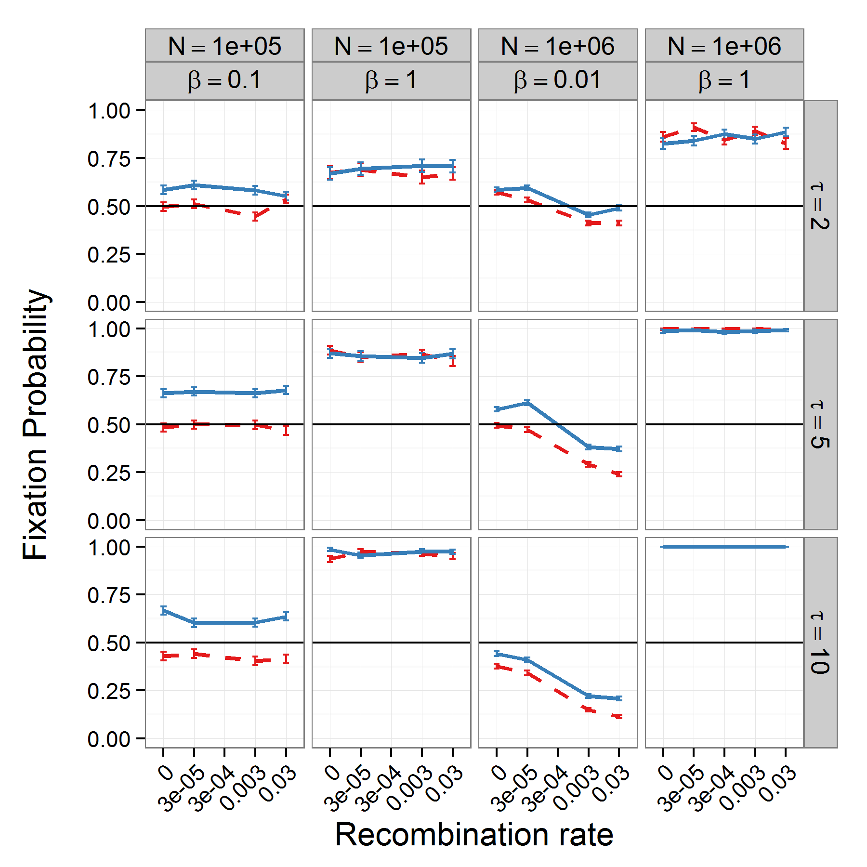

Figure 2 - invasion_SIMvsCMvsNM_pop_1e5_1e6_2014-03-09

We further studied the advantage of SIM by the introduction of "recombination barriers" (Popa and Dagan 2011), which prevent recombination between individuals with different modifier alleles; specifically, they prevent individuals with non-mutator alleles from "stealing" beneficial mutators and therefore allow mutator alleles to "hitch-hike" with their beneficial mutations (Maynard Smith and Haigh 1974). In our simulations "recombination barriers" do not have a significant effect on the dynamics (Figure S2), **suggesting that the effect of recombination on "hitch-hiking" is not very strong and that horizontal transfer of beneficial mutations between sub-populations of different modifier alleles does not have a considerable effect on the dynamics.**

The effect of population size on the dynamics is explored in Figure 3 (also see Figure S1). As the population size increases the effect of recombination on the fixation probability is stronger: with *N=*105 individuals (left column), recombination hardly affects the fixation probabilities; with *N*=107 (right column) recombination has a very significant effect. For example, the fixation probability of SIM (solid blue) with *τ*=5 (middle row) and *N*=107 (right column) decreases from ≈0.75 to ≈0.45 when the recombination rate increases from 0 to 0.003 gene conversions per individual per generation, whereas there is no significant effect with *N*=105 (left column). This effect is similar for SIM and CM and is consistent with results for CM by Tenaillon et al. (2000).

Recombination's effect on adaptation depends on the genetic variation because recombination replaces alleles with a random allele from the population. Therefore, its effect on adaptation depends on the mutational supply, which in turn depends on the population size and the mutation rate. Small populations will have a smaller number of alleles to sample from and therefore individuals will have a smaller chance of acquiring beneficial alleles by recombination.

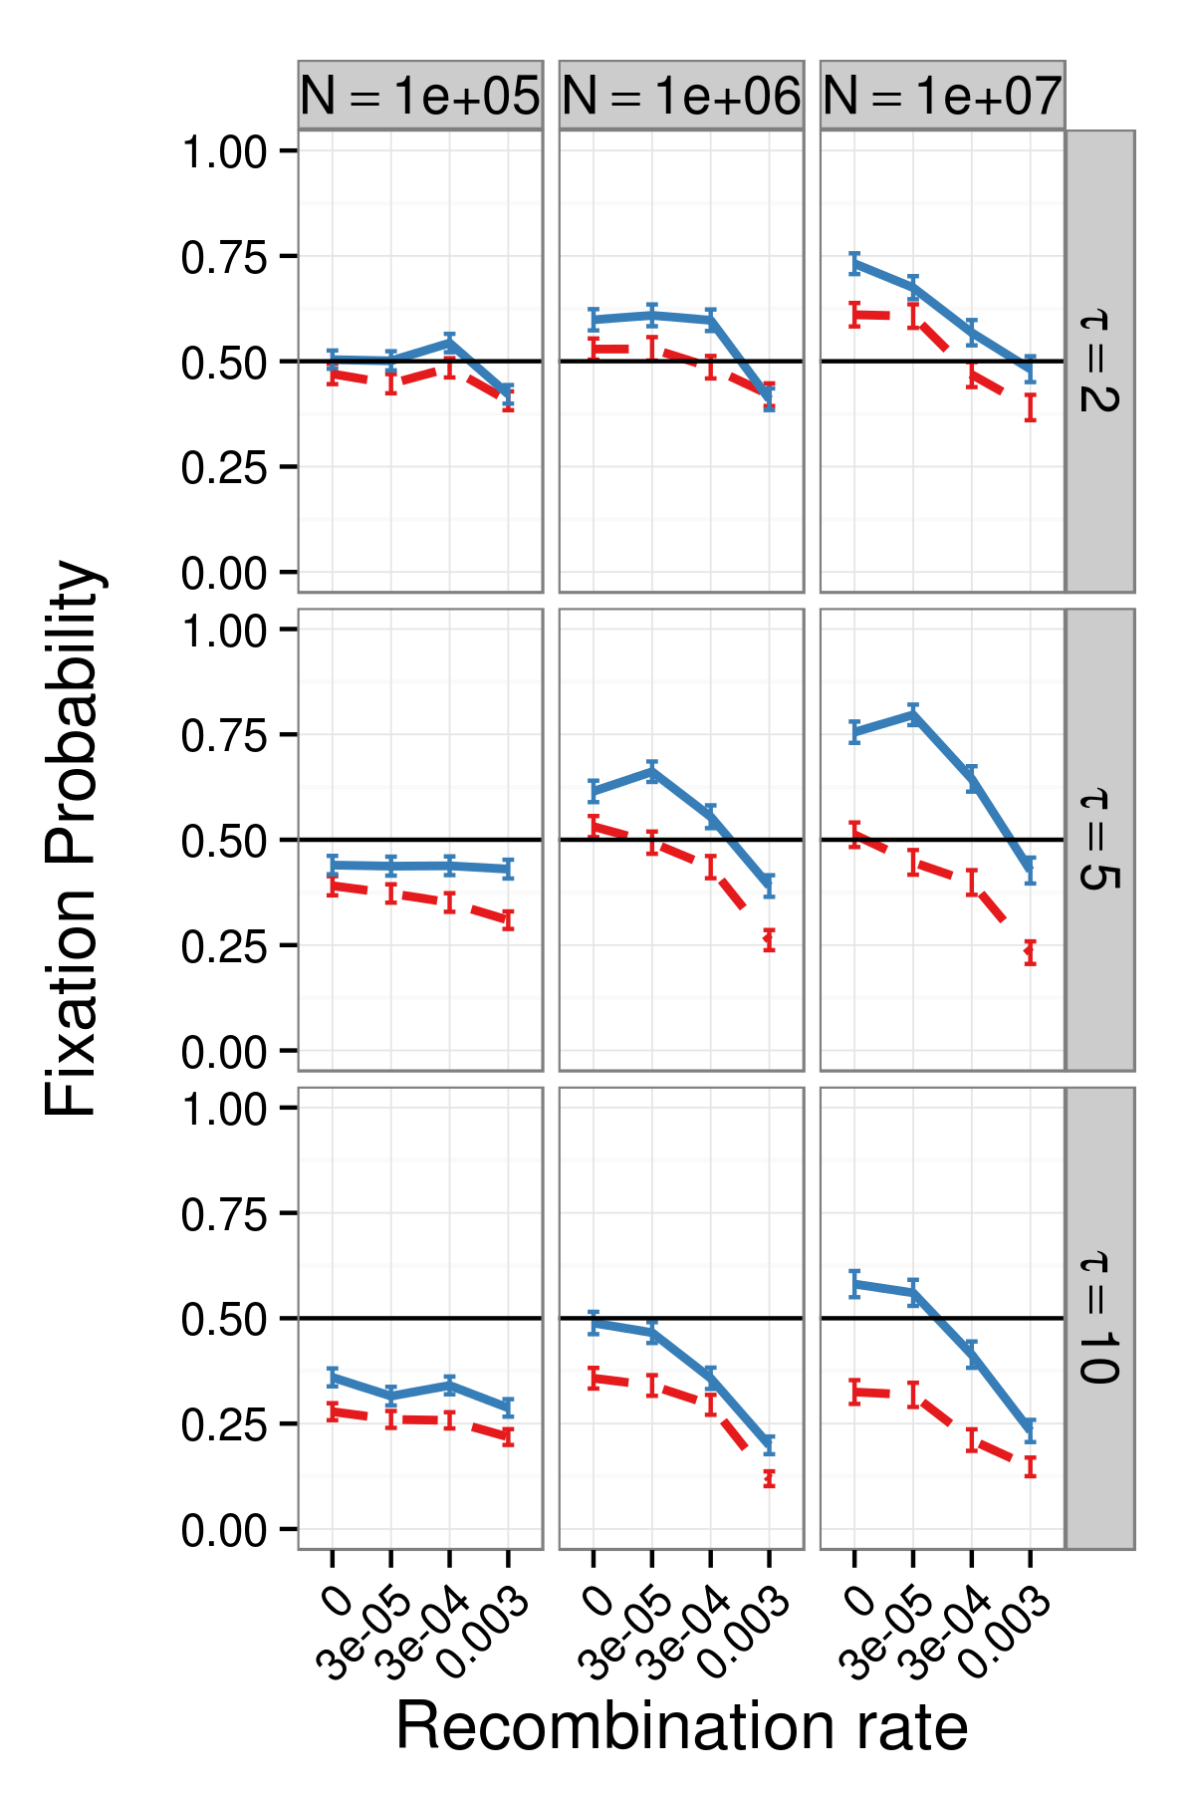

Figure 3 - invasion_SIMvsCMvsNM_pop_sizes_2014-07-22

## Co-evolution of mutators and recombination modifiers

Next, we considered the fixation of recombination modifiers – alleles that increase the recombination rate (Figure 4). Constitutive recombination modifiers (CR; dashed purple) win competitions against wildtype modifiers (NR), which have a basal rate of recombination (orange solid lines are control competitions featuring NR vs. NR). The recombination modifiers' advantage increases with the basal recombination rate (x-axis) and with the population size (panels from right to left), consistent with Figure 3: recombination modifiers depend on the population size for the generation of genetic variation.

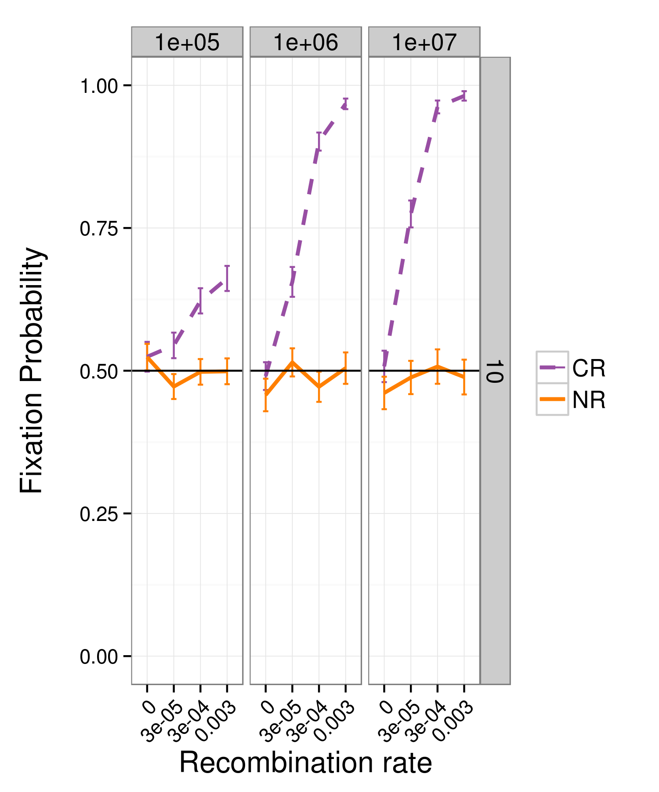

Figure 4 - invasion_NRvsCR_pop_sizes_2014-07-22 in_pi=NM / in_rho=10

When a modifier allele affects both the mutation and the recombination rate, the dynamics are more complex (Figure 5). The right panel is the middle row from Figure 3, showing that SIM is more advantageous than CM (and even NM in large population) and that mutators' success decreases with the recombination rate. The left panel integrates these results with the results of Figure 4, showing that (i) a recombination modifier is successful regardless of the interacting mutator; (ii) when mutators interact with a recombination modifier, their fixation probability does not decrease with recombination, but rather increases; (iii) a SIM-CR modifier (left panel, solid blue) is the most successful strategy in competitions with wildtype (sometimes tied with a non-mutator constitutive recombination modifier; left panel, dotted green), and (iv) CM is always less successful then both NM and SIM.

These results are doubled edged, as one can interpret them with regard to the evolution of mutation modifiers or recombination modifiers. **Mutation modifiers clearly benefit from linkage to a recombination modifier, regardless of its mode of operation (CR or SIR);** this is probably because the recombination modifiers mainly help mutation modifiers by reducing the mutational load and combining beneficial mutations from separate genotypes, and both of these processes occur in maladapted individuals in which SIR is equivalent to CR.

On the other hand, SIM facilitates the evolution of **recombination modifiers, especially when the wildtype recombination rate is low**. This indicates that stress-induced mutators can have a role in the emergence and maintenance of recombination, at least in adaptive scenarios.

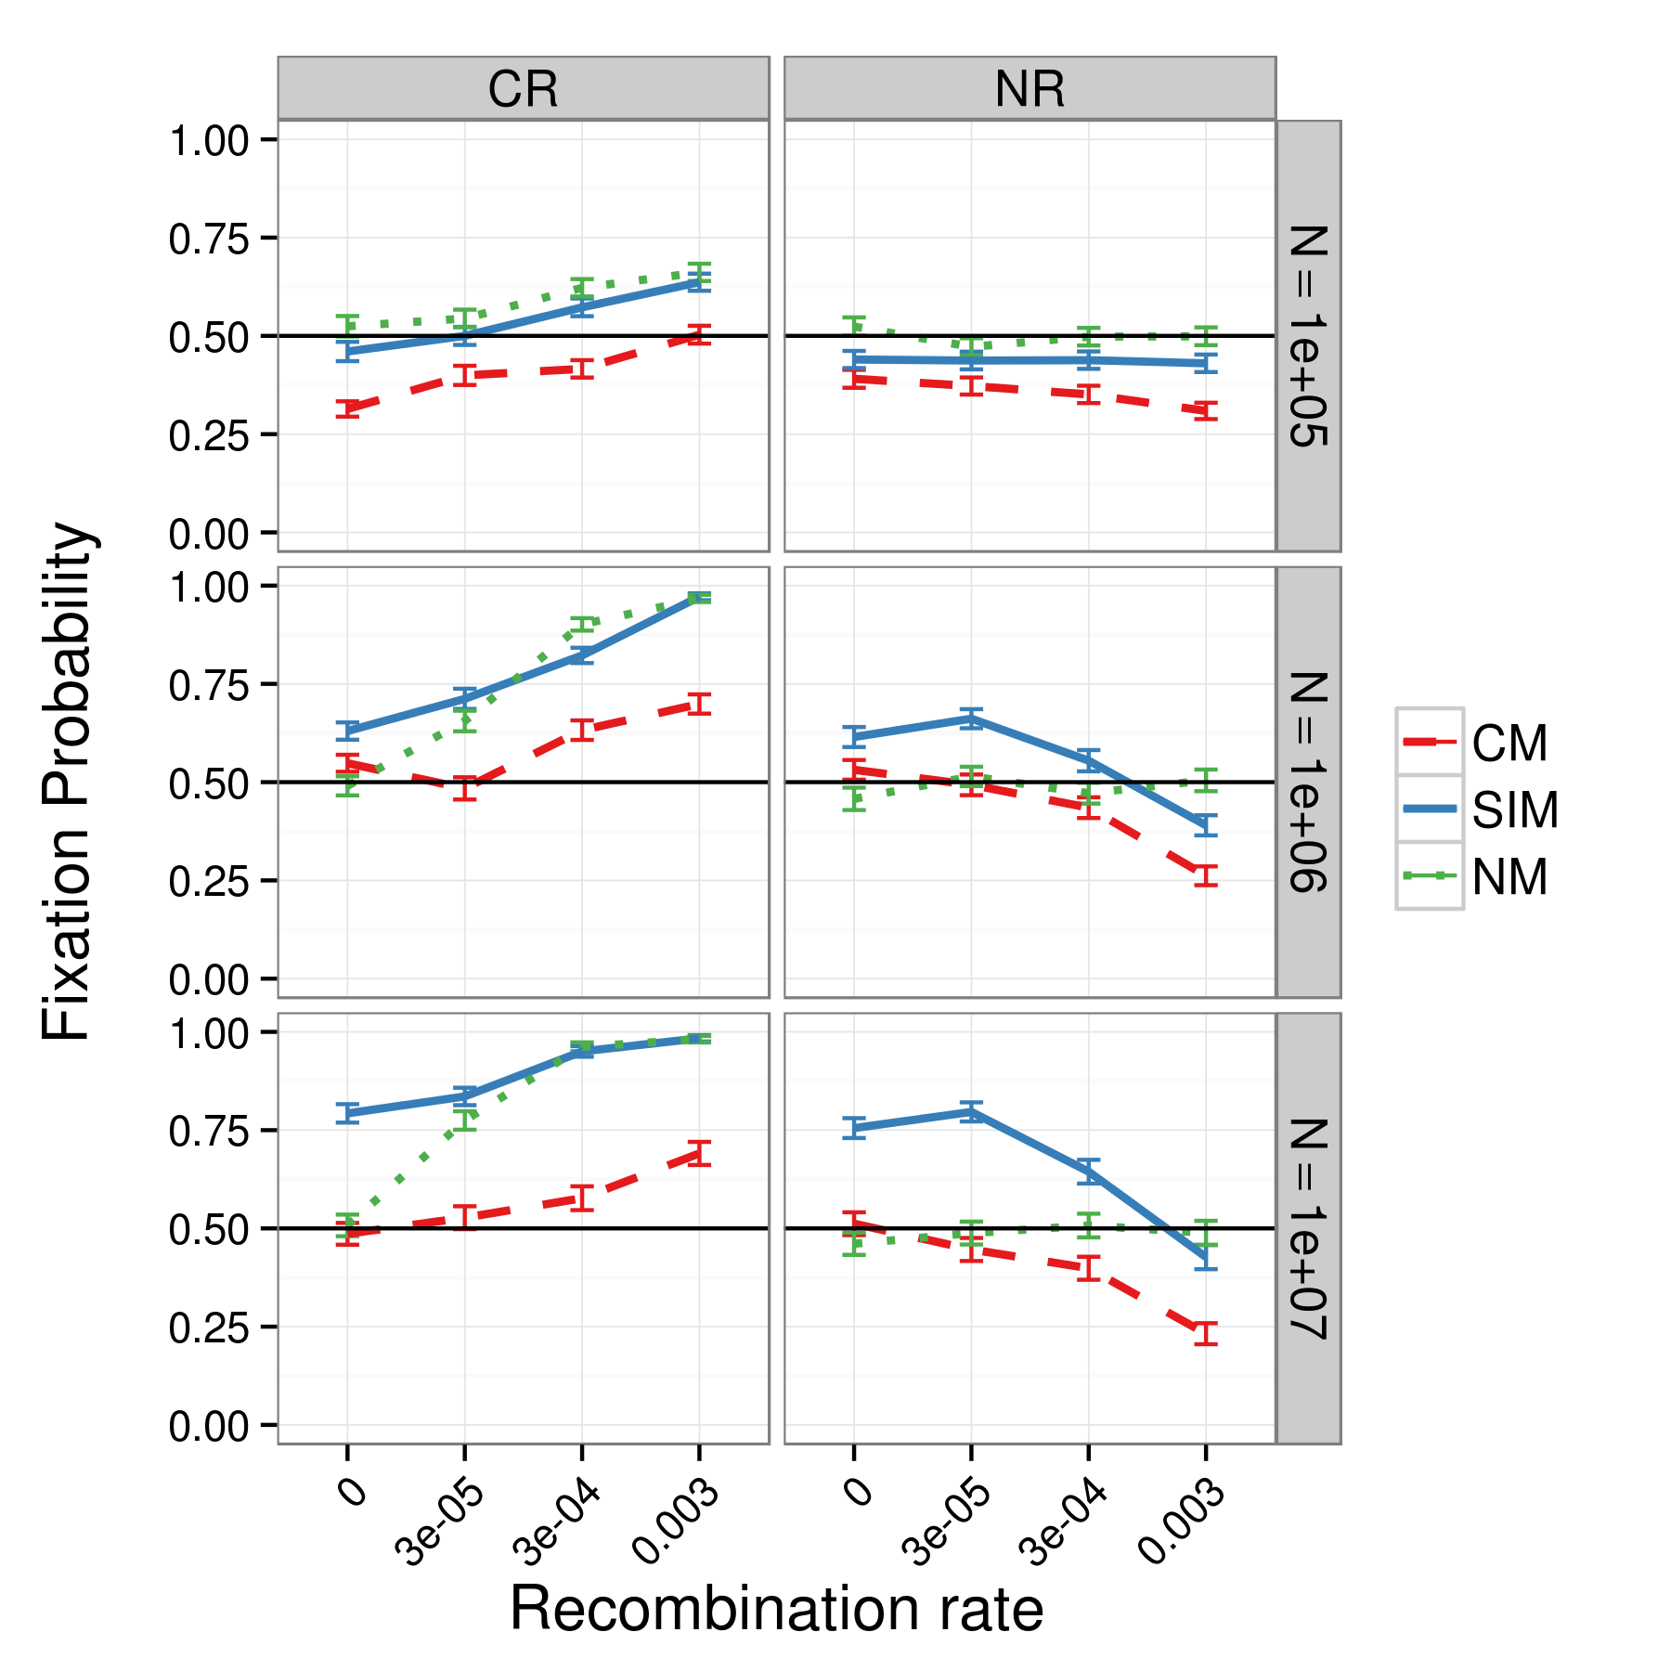

Figure 5 - invasion_combined_tau_5_pop_sizes_2014-07-22

So far we focused on scenarios in which the recombination modifier increased the recombination rate by an order of magnitude, for example, from 0.0003 to 0.003. Another type of recombination modifier may turn recombination on in an effectively asexual population; for example, increasing the recombination rate from 10-16 to 0.003. In this case, the recombination modifier effectively switches asexual individuals to obligatory (CR) or facultative (SIR) sexuals.

Competitions with this kind of recombination modifiers (Figure 6) show that SIM was always most advantageous (blue solid line, left panel); however, as the recombination rate with the recombination modifier increased, the fixation probability of all modifiers increased and the advantage of SIM over NM disappeared.

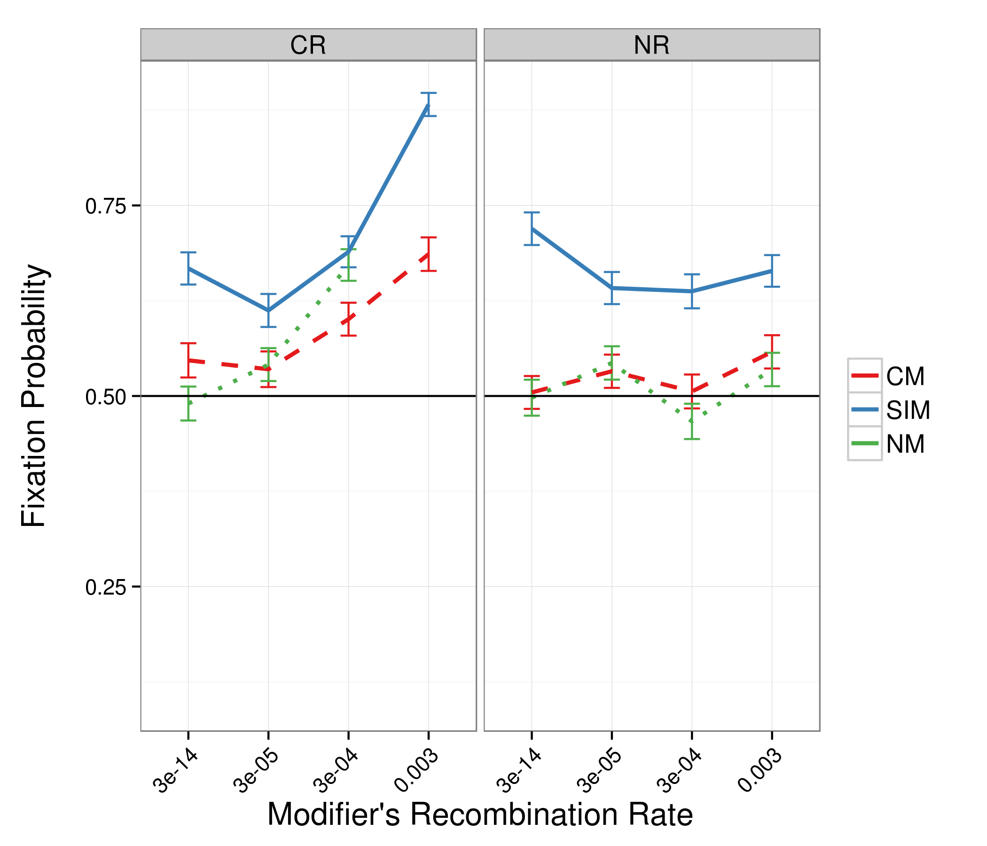

Figure 6 - invasion_SIMvsCMvsNM_asexuals_04092014

## Adaptation time

Next, we investigated a population-level trait: the adaptation time, defined as the average time until at least half of the population adapts to new environmental conditions.

Figure 7 shows the adaptation time of populations homogeneous at the modifier loci (*i.e.* the same modifiers in all individuals) with different levels of mutation rate increase *τ*, populations size *N*, and number of beneficial mutations required for full adaptation. Note that fitness effects of all mutations are equal and independent and there is no epistasis.

First, increasing the recombination rate reduces the adaptation time with two beneficial mutations (right panel) in agreement with Tenaillon et al. (2000). However, increasing the rate of recombination has no effect on adaptation with a single beneficial mutation (circles). The effect of recombination is stronger in large populations, where the mutation supply is larger and therefore recombination is more likely to recombine beneficial mutations from different backgrounds (Tenaillon et al. 2000). These observations are true for all mutational strategies.

Second, both mutator populations (SIM and CM) adapt much faster than non-mutator populations, and the larger the mutation rate increase, the shorter the adaptation time (not shown/Figure S#). Curiously, during the time a non-mutator population adapts with a single beneficial mutation, a mutator population can adapt a combination of four beneficial mutations, even without recombination.

These results show that in a complex adaptation scenario (where multiple beneficial mutations must be combined) recombination decreases the adaptation time, especially in large populations. This effect of recombination indeed makes it an alternative adaptive strategy to mutagenesis; however, the combined effect of recombination with mutagenesis is larger than either of them alone. Because SIM does not suffer from the disadvantages CM suffers from between adaptation events (reduced population mean fitness and increased sensitivity to Muller's rachet), recombination is not so much an alternative to SIM as it is an non-mutually exclusive and even complementary adaptive strategy. The bottom line, in any case, is that throughout the parameter range, SIM has adapts faster, and recombination only serves to further reduce the adaptation time with SIM.

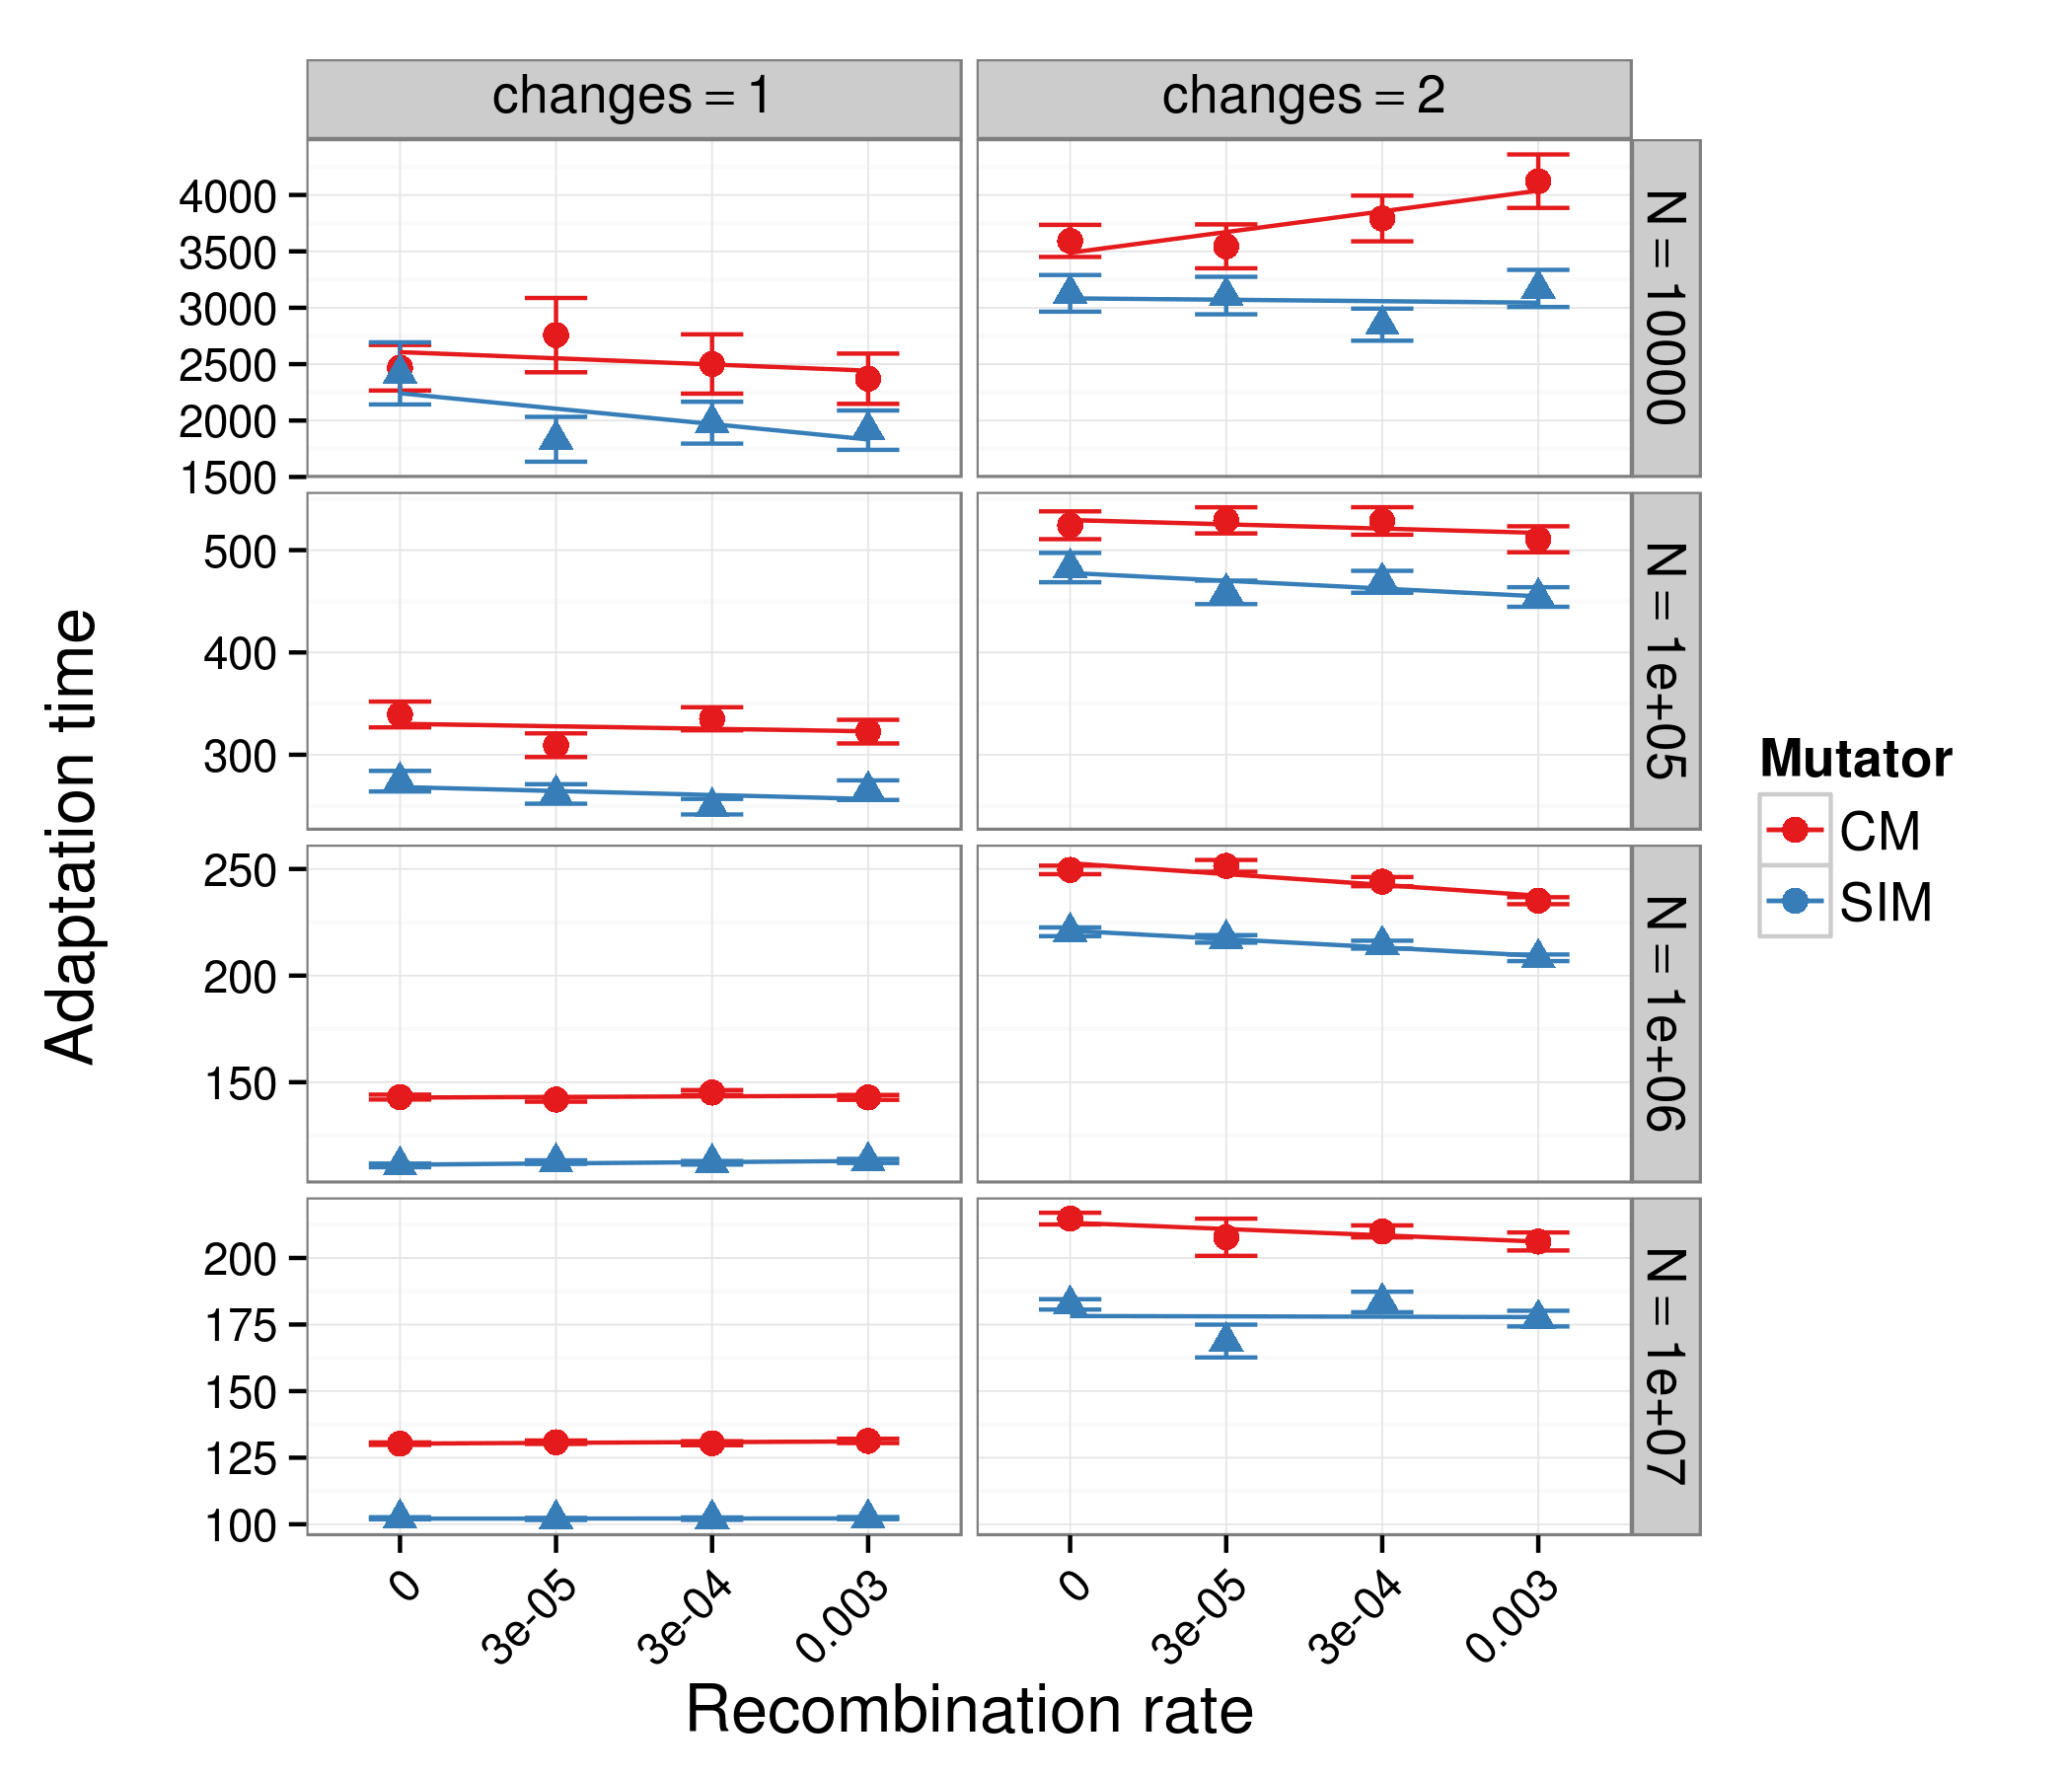

Figure 7 - adaptation_NR_2014-07-22

# Discussion

The co-evolution of the mutation and recombination received some notable theoretical treatment. Using computer simulations, Tenaillon *et al.* (2000) studied the evolution of mutator alleles in a population adapting to a new environment which requires a combination of several beneficial mutations for optimal adaptation. Their results suggest that even rate recombination can reduce the fixation probability of mutator alleles. They proposed that Hill-Robertson effects don't play an important role in this decrease and that the acceleration of adaptation rate by the Fisher-Muller effect plays a more significant role than the prevention of the hitch-hiking effect.

Levin and Cornejo (2009) used a different approach. They used computer simulations to show that recombination increases the rate of adaptation in bacterial populations and that recombining populations have a selective advantage over non-recombining populations. However, they found that this advantage is reduced if non-recombining individuals cannot serve as donors and their frequency is greater than that of recombining individuals. The same occurs when the population density is too low, because in order to recombine an individual must make physical contact with a donor or a viable DNA strand from a donor. Furthermore, they demonstrated that the advantage of recombination depends on the amount of genetic variation available in the population, because the effect of recombination on the adaptation rate depends on the availability of genetic variants that it can shuffle - the Fisher-Muller effect.

Dawson (Dawson 1998) calculated the optimal mutation rate assuming that decreasing the mutation rates incurs a fitness cost – the "cost of DNA replication fidelity" – resulting from the time and energy invested in DNA proofreading and reapir. Dawson found that the optimal mutation rate is lower in asexual populations in comparison with sexual populations. Sloan and Panjeti (2010) further studied this interaction between mutation and recombination by simulating invasions of asexual individuals into sexual populations at a mutation-selection balance, without beneficial mutations or adaptation, and with the "cost of fidelity". In their simulations, asexual reproduction successfully invaded sexually reproducing populations by evolving a lower mutation rate. They claimed that this further exacerbate the paradox of sex, as sex leads to higher mutation rates, making the population sensitive to invasion by asexuals with lower mutation rates. In terms of our study, this suggests that in stable environments modifiers that reduce both the rate of mutation and recombination will successfully invade populations. Nevertheless, we expect that if the mutation rate of the resident population is stress-induced, then the invading alleles will not be successful. This is an interesting direction for the future.

// Raynes & Sniegowski 2011 – recombination and mutation in yeast //

//Barton 2007 summarizes from Maynard Smith & High – hitch-hiking effect - that "the effect of a sweep on variability is dependent on the ratio r/s; this must be substantially less than 1 for there to be much of an effect".//

In our model, recombination occurs by bacterial transformation (Avery 1944; Redfield 1988). This mechanism allows individual cells to recombine foreign DNA into their genome. We concentrated on this mechanism because, of the three known mechanisms for bacterial horizontal gene transfer (together with conjugation and transduction), transformation is the only one actively regulated by the cells and the most likely to have evolved due to its adaptive properties (Redfield 1993; Matic, Taddei, and Radman 1996; Redfield, Schrag, and Dean 1997; Tenaillon et al. 2001). In addition, transformation has been suggested as the precursor of eukaryotic meiosis and to be regulated by stress (Bernstein and Bernstein 2010). A recent study in *Streptococcus pneumonia* (Engelmoer, Donaldson, and Rozen 2013) found that transformation is more favorable under stress; that this advantage is due to the reduction of mutational load; and that it limits the fixation of mutator alleles. Our theoretical results are in agreement with these results. However, stress-induced mutagenesis has been documents in *S. pneumonia* under similar stress conditions (Henderson-Begg, Livermore, and Hall 2006), and our results suggest that stress-induced mutators will not be limited by transformation, at least not to the extent that constitutive mutators are. // Raynes & Sniegowski 2011 ?//

In addition to stress-induced mutagenesis, which was discussed in the introduction, our model includes two more strategies for generating genetic variation: (i) stress-induced recombination has been documented in bacteria (Beaber, Hochhut, and Waldor 2004; Prudhomme et al. 2006; Maiques et al. 2006), yeast (Abdullah and Borts 2001), plants (Lucht et al. 2002; Yao and Kovalchuk 2011), and flies (Parsons 1988; Zhong and Priest 2010; Tedman-Aucoin and Agrawal 2012); (ii) simultaneous induction of both recombination and mutation by stress is supported by findings that mutation is correlated with recombination and regulated by the same mechanisms in *E. coli* (Torkelson et al. 1997; Velkov 1999; Bull et al. 2000). Together with constitutive mutation and recombination modifiers, this article includes a varied collection of variation-generating strategies (see summary in Table 1).

Stress-induced mutation and recombination have important consequences to epidemiology and to the ecology and evolution of microbes (Rosenberg and Queitsch 2014): pathogens have been shown to acquire drug-resistance (Cirz et al. 2005; Cirz and Romesberg 2007; Gutierrez et al. 2013) and virulence factors (Ubeda et al. 2005) via stress-induced mechanisms, and both stress-induced mutation and recombination have implications for designing antibiotic treatment policies (Obolski and Hadany 2012), pesticide application (Gressel 2011), and industrial fermentation processes (Machielsen et al. 2010). Similarly, chemotherapy and radiation are predicted to induce mutagenesis in cancer cells, thereby promoting the acquisition of drug-resistance, cancer progression, and metastasis (Bindra, Crosby, and Glazer 2007; Bristow and Hill 2008; Podlaha et al. 2012; Rosenberg and Queitsch 2014).

# References

# Figures

# Tables

Table 1. Evolutionary strategies summary

|  |  |  |  |  |  |  |  |  |  |  |  |
| --- | --- | --- | --- | --- | --- | --- | --- | --- | --- | --- | --- |
| Strategy | Abbr. | *π* | *τ* | *ϕ* | *ρ* | Mutation rate | | | Recombination rate | | |
| x<π | | x≥π | x<*ϕ* | | x≥*ϕ* |
| Wild-type | WT | 1 | 1 | 1 | 1 | *µ* | *µ* | | *r* | *r* | |
| Constitutive mutator | CM | 0 | >1 | >1 | 1 | *τµ* | *τµ* | | *r* | *r* | |
| Constitutive recombinator | CR | 0 | 1 | 1 | >1 | *µ* | *µ* | | *ρr* | *ρr* | |
| Constitutive mutator & recombinator | CMR | 0 | >1 | >1 | >1 | *τµ* | *τµ* | | *ρr* | *ρr* | |
| Stress-induced mutator | SIM | >0 | >1 | >1 | 1 | *µ* | | *τµ* | *r* | *r* | |
| Stress-induced recombinator | SIR | >0 | 1 | 1 | >1 | *µ* | *µ* | | *r* | | *ρr* |
| Stress-induced mutator & recombinator | SIMR | >0 | >1 | >1 | >1 | *µ* | | *τµ* | *r* | | *ρr* |

**Legend:** *µ* - basal mutation rate; *r* – basal recombination rate; *x* – number of mismatches; *π* – mutation rate threshold; *τ* – mutation rate increase; *ϕ* – recombination rate threshold*; ρ* – recombination rate increase.

Table 2. Evolutionary processes affecting the evolution of the mutation rate

|  |  |  |  |  |  |  |
| --- | --- | --- | --- | --- | --- | --- |
| *Process* | *Property* | *Context* | *Mutator effect* | | | *References* |
| *Without recombination* | *With recombination* | |  |
| Background trapping / A ruby in the rubbish | Fixation probability | Adaptation | Beneficial mutations appearing on a deleterious background are less likely to fix | | Beneficial mutations can be rescued from deleterious background by recombination | (Peck 1994; Charlesworth 1994; Johnson and Barton 2002) |
| Evolutionary traction (draft?) | Mutational load | adaptation | Hitchhiking of deleterious mutations with beneficial one reduces the population mean fitness | | Recombination reduces hitchhiking, therefore increases mean fitness | (Hadany and Feldman 2005) |
| Mutation accumulation | Mutational load  Fixation probability | MSB  Serial bottlenecks | Accumulated deleterious mutations reduce mean fitness; when occurring on the background of a beneficial mutation, this leads to decreased fixation probability | | Better purging of deleterious mutations reduces the mutational load? Depends if there is positive or negative epistasis? | (Johnson and Barton 2002; Kondrashov 1988) |
| Muller’s ratchet | Mutational load  Fixation probability | MSB  Adaptation | Accumulated mutations due to drift lead to reduced mean fitness.  At the early stages of fixation of a beneficial mutation, this reduces fixation probability | | The beneficial mutation can be rescued from deleterious mutations by recombination | (Haigh 1978; Gordo and Charlesworth 2000; Johnson and Barton 2002) |
| Appearance of beneficial mutations / Fisher-Muller effect | Adaptation time | Adaptation | Increased mutation rate reduces waiting time but mutations must be accumulated sequentialy | | If two or more beneficial mutations must occur together, recombination can combine mutations generated in separate lineages | (Christiansen et al. 1998; Felsenstein 1974; Fisher 1930) |
| Clonal interference | Fixation probability | Adaptation | Co-occurring beneficial mutations reduce the fixation probability of each other | | Co-occurring mutations can recombine to generate a superior genotype, reducing the adaptation time | (Felsenstein 1974; Gerrish and Lenski 1998; Martens and Hallatschek 2011) |
| Selective sweeps | Neutral diversity | Adaptation | Hitchhiking of neutral mutations with beneficial ones reduces the genetic diversity, which is then restored by mutation | | Recombination regenerates the genetic diversity lost by sweeps and limits the scope of these sweeps | (Maynard Smith and Haigh 1974; Hermisson and Pennings 2005) |
| Background selection | Neutral diversity | MSB | Elimination of deleterious mutations reduces the genetic diversity, which is then restored by mutation | | Recombination regenerates the genetic diversity and limits the scope of background selection | (Charlesworth 2012) |
|  |  |  |  | |  |  |

**Legend:**

# Supporting material

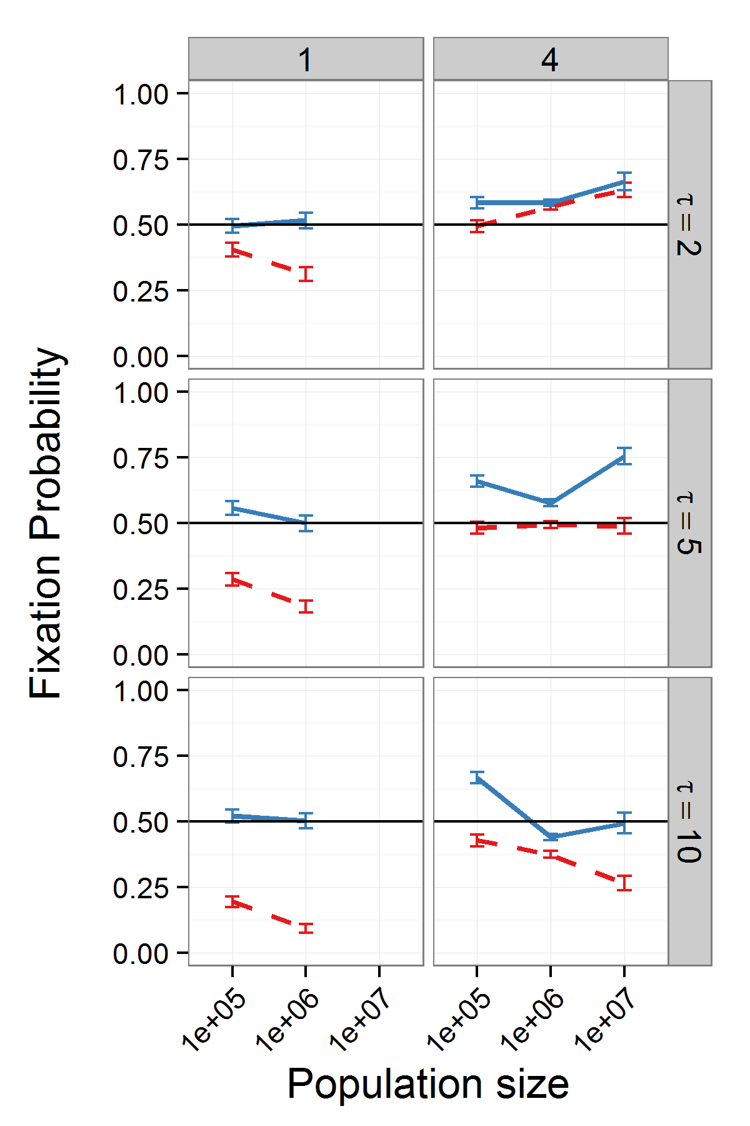

Figure S1 - invasion_SIMvsCM_r_02014-02-26

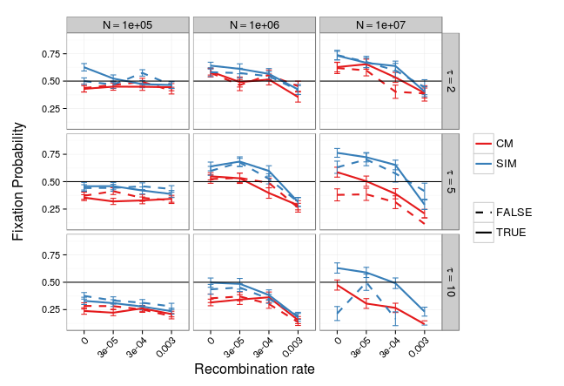

Figure S2 - invasion_RB_SIMvsCM_pop_1e6_2014-07-28