Adaptive peak shifts with stress-induced mutation

Yoav Ram - [yoavram@post.tau.ac.il](mailto:yoavram@post.tau.ac.il)

and

Lilach Hadany - corresponding author, [lilach.hadany@gmail.com](mailto:lilach.hadany@gmail.com)

Dept. of Molecular Biology and Ecology of Plants, Tel Aviv University, Tel-Aviv 69978, Israel

Last update: 23 April 2013

# Abstract

### Background

### Results

### Conclusions

### Keywords

population genetics; evolvability; stress-induced variation; adaptive landscape

# Background

In 1931, Sewall Wright presented a problem which is still an open problem in evolutionary biology [1]: given that the selective value of two or more loci are under positive epistasis, how can a population evolve from one allele combination to a fitter? Or, in terms of adaptive or fitness landscapes [2], how can a population cross a fitness valley and shift from one adaptive peak to a higher one?

The solution Wright called the "shifting-balance theory of evolution" [3] is based on the division of the population into numerous small sub-populations. At the begining of the process, genetic drift drives a sub-population away from the frequent allele combination. Next, natural selection drives the sub-population towards the fitter combination. Finally, gene flow (migration, outcrossing, etc.) and competition spread the fitter combination in the entire population. This solution appears to be valid (Crow et al., 1990; Wade and Goodnight, 1991; Coyne et al., 1997) but it seems that the range of parameters for which it works is limited (Moore and Tonsor, 1994; Gavrilets, 1996; Phillips, 1996).

Mutation is a major factor in this process - it generates new allele combinations which can then spread in the population. Of course, generation of new favorable alleles is not the only effect of mutation and deleterious mutations are much more frequent. Thus, natural selection reduces the mutation rate to its lowest possible limit [4, 5].

However, stress-induced mutation, the process in which stressed or maladapted individuals increase their mutation rate, is an exception to this rule. In a previous work we have shown that stress-induced mutation is likely to evolve due to natural selection in asexual populations and that it increases the mean fitness of populations due to the increased generation of beneficial mutations in maladapted individuals [6]. Furthermore, stress-induced mutation has been demonstrated in numerous species, both prokaryote and eukaryote [7–9].

Here, we analyze a population genetic model of an asexual population with two bi-allelic loci with positive epistasis. We derive analytical expressions that suggest that stress-induced mutation increases the population adaptation rate and show the results of stochastic simulations that validate our analytic expressions. We than discuss possible prediction of our model and how it relates to the literature.

# Methods

## Analytical model

Consider two loci with alleles *A/a* and *B/b* and a population at a mutation-selection balance (MSB) in an environment in which *ab* is the wildtype with a fitness value of *1*, single mutants (*Ab* and *aB*) have a fitness value of *1-s*, with *s* as the selection coefficient, and double mutants (*AB)* have a fitness value of *(1-s)2*. This corresponds to a multiplicative fitness function *(1-s)m* where *m* is the number of deleterious mutations the individual has.

Mutation from *a* to *A* and from *b* to *B* occurs with a probability *µ* at reproduction and we disregard back-mutation. *µ* is therefore called the site-specific mutation rate. In addition, new deleterious mutations occur across the genome at reproduction, and the number of such mutations follows a Poisson distribution with a mean *U* which is the genomic mutation rate. Although there is a direct relation between *U* and *µ* (we mostly use *µ=U/5000*), having two separate parameters helps to distinguish between the two effects of mutation - the generation of beneficial mutations (*µ*) and the generation of deleterious mutations (*U*). Individuals with stress-induced mutation and a fitness below 1 hypermutate, increasing both mutation rates *τ*-fold.

At the MSB, the frequency of wildtype (*ab*) individuals is , the frequency of single mutants (*Ab* and *aB* combined) is and the frequency of double mutants (*AB*) is .

To incorporate random sampling into the model, we denote the population size by *N*.

We are interested in the capacity of the population to adapt to an environmental change in which the fitness of the double mutant *AB* changes from *(1-s)2*  to *1+sH*, where *H* scales the advantage of *AB* in comparison with the wildtype *ab* and the selection coefficient *s*. See Figure 1 for an illustration of the fitness landscape of the new environment.

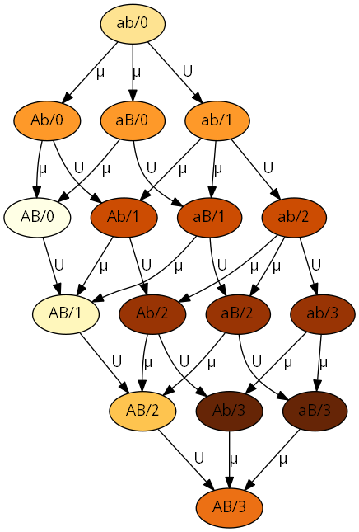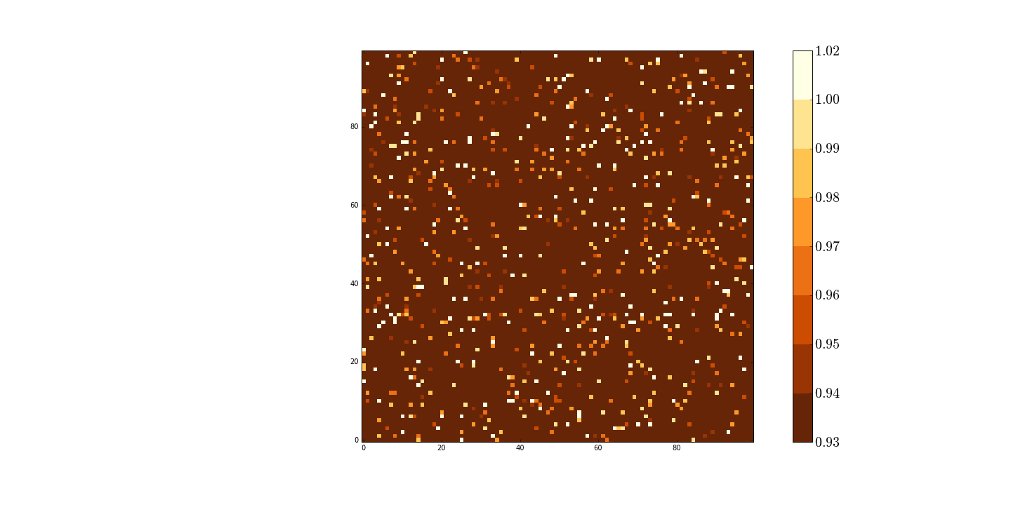

Figure 1 – Fitness landscape illustration. Each node represent a specific genotype. Node labels specify the alleles at the *A/*a and *B/*b loci and the number of additional deleterious alleles after the forward slash, but only as much as 3 deleterious mutations are shown to keep the figure simple. Arrows define the direction of mutation and their labels denote the relevant mutation rate. Node color indicates the fitness of a genotype, from pale brown for optimal fitness (*1+sH*) to dark brown for lower fitness (*(1-s)3*) – see the colorbar. Parameters used: *s=0.01*, *H=2*.

### Constrains on the parameter space

There are several constraints on the main parameters:

1. The above MSB approximations are only valid when *µ/s<1* or *µ<s*.
2. If *N*(*µ/s)2>1* there are already double mutants in the population at the time of the environmental change and therefore adaptation will be rapid and will not require new mutations.
3. If *Nµ/s<1* then there are no single mutants and the time of the environmental change and double mutatns must be generated by a double mutation in a wildtype individual. Therefore, increasing the mutation rate of individuals with fitness below 1 will have a much smaller effect than if single mutants were abundant.
4. If we assume that individuals that accumulated deleterious mutations are "evolutionary dead-ends" and cannot be the origin of adaptation, then the fraction of such individuals must be small - *U/s<1*. This replaces the first constraint above because *µ* is much smaller than *U*.

To summarize the above constraints:

|  |  |
| --- | --- |
|  | (1) |
|  | (2) |

For the bacteria species *Escherischia coli* estimations of the selection coefficient and mutation rates are *s=0.01*-*0.3* [10, 11], *U=0.003-0.0004* [12, 13] and *µ =10-6-10-9* [11]. Taking the conservative alternative, we get this constraint on the population size - *105 ≤ N ≤ 10*7.

In the following derivations we assume both of the above constraints.

### Appearance of a double mutant

Because there are no double mutants (*AB*) at the time of the environmental change, double mutants can appear either via a double mutation in a wildtype individual (*ab*) or via a single mutation in a single mutant (*Ab* or *aB*). At the MSB the number of deleterious mutations follows a Poisson distribution [14]. Therefore, the frequencies of mutation-free wildtype and single mutants are roughly and . The fitness of wildtype and single mutants is 1 and *1-s*, respectively. We assume that individuals with mutations other than in the *A/a* and *B/b* loci are "evolutionary dead ends". Assuming that mutation is a Poisson process, only a fraction of the individuals are of interest. All together, the probability that a newborn is a double mutant can be summarized by:

|  |  |
| --- | --- |
|  | (3) |

However, if mutation is stress-induced, then the mutation rate of single mutants is increased *τ*-fold and the above probability is:

|  |  |
| --- | --- |
|  | (4) |

Note that stress-induction only increases the transition from single mutants to other types, but does not change the MSB frequency of single mutants, because that is determined by the mutation rate of the wildtype.

If the mutation rate of wildtype is increased as well, as in the case of constitutive hypermutation, the probability changes to

|  |  |
| --- | --- |
|  | (5) |

because increased mutation rate in the wildtype affects the MSB frequencies.

### Fixation of a double mutant

Assuming that the advantage of the double mutant is considerable (for example, *H>1)* it has two possible fates after its appearance: fixation and extinction. Following Eshel [15] the fixation probability of the double mutant is

|  |  |
| --- | --- |
|  | (6) |

where *α* is the relative fitness of the double mutant normalized by the population mean fitness:

|  |  |
| --- | --- |
|  | (7) |

and assuming that fitness is measured by the number of progeny which is Poisson distributed.

Because the frequency of double mutants is very low at the stage where they are subject to possible extinction by drift, the population mean fitness can be calculated without considering them, so the value we use is the mean fitness of the population at the MSB. Without stress-induced mutation, this evaluates to [16]. Therefore, and

|  |  |
| --- | --- |
|  | (8) |

Assuming that is small we get

|  |  |
| --- | --- |
|  | (9) |

Which is a classic result in population genetics [REF]. Note that this value does not depend on the mutation rate, thus it is not affected by constitutive mutation.

However, as we have shown before [6], the mean fitness of a population with stress-induced mutation can be different this value if beneficial mutations are allowed. Here, the mean fitness with stress-induced can be calculated by separating the population to the wildtype fraction which has fitness 1 and the non-wildtype fraction . Within the non-wildtype subpopulation, which have at least one mutation, additional mutations are Poisson distributed with expectation because this subpopulation is hypermutating. Therefore the mean fitness of this subpopulation is . Taken together, the mean fitness of a population with stress-induced mutation is

|  |  |
| --- | --- |
|  | (10) |

Pluging this in (6) and (7) gives a different fixation probability for populations with stress-induced mutation (see ‎10.1 for full derivation):

|  |  |
| --- | --- |
|  | (11) |

Interestingly, the above can indeed be larger than . This is because the relative fitness of the double mutant in a population with stress-induced mutation is greater than without – single mutants and other individuals below both adaptive peaks (*ab* and *AB*) will hypermutate and increase their mutational load.

### Total adaptation time

From the probability that in a population without double mutants a newborn is a double mutant we can derive the probability that a double mutant would appear in the population: . The condition (2) guarantees that *Nq* is very small, hence this probability can be approximated by *Nq* using the Binomial series expansion.

Once a double mutant appears it has a probability *π* to go to fixation.

The time for adaptation *Ta* can roughly be approximated by the waiting time for a double mutant which will go to fixation *Tw*. This is true as long as fixation is a much faster process than mutation (). *Tw* has a geometric distribution with parameter *Nqπ* and therefore the expected time for adaptation can be approximated by

|  |  |
| --- | --- |
|  | (12) |

which can be evaluated with or without stress-induced mutation by using (3), (4), (9) and (11).

## Stochastic simulation

Our analytical model produces approximations for the adaptation time with and without stress-induced mutation. To facilitate these approximations several assumptions were made:

1. Mutation must be weaker than selection – Eq. (1)
2. The population size must be within a specific range, although this range may be quite large – Eq. (2)
3. Individuals with deleterious mutation, expect at the *A/a* and *B/b* loci, are "Evolutionary dead ends".

To verify that the our approximations are correct, we developed a Wright-Fisher model with mutation, selection and random drift. The main differences between the analytical model and the stochastic simulations are described here, for more details on the design of the simulations please refer to the **Error! Reference source not found.** section.

There are several advatnages to stochastic simulations: (i) The simulations incorporates genetic drift by random sampling each generation from the previous one using a multinomial distribution. (ii) Individuals with deleterious mutations are not "evolutionary dead ends" – individuals are allowed to accumulate up to *G=25* deleterious mutations. (iii) Simulations start with a wildtype, mutation-free population on a single-peak adaptive landscape and after reaching MSB a new adaptive peak is introduced for the *AB* genotype. Therefore, the stochastic model assumes nothing about the distribution of deleterious mutations at the MSB. (iv) We ran simulations in which selection and mutation were at the same order of magnitude, as well as simulations in which the population size is lower or higher than the constraints require (Eq. (2)).

Of course, an analytical model is preferable to simulations as it allows us to reach general conclusions where simulations only allow us to statistically estimate results for specific parameter sets. In addition, the simulations are computationally demanding, each running for up to several hours.

We wrote the simulations in Python (<http://www.python.org>) using NumPy (<http://www.numpy.org>) and SciPy (<http://www.scipy.org>). The source code for the simulation is available on GitHub (<https://github.com/yoavram/ruggedsim>).

# Results

## Analytical approximations

### Appearance of a double mutant

# Our analytical approximation from the Methods

Analytical model section can be further simplified by using first-order approximations (see ‎11.2).

For the probability that a newborn individual is a double mutant we get the following approximations:

|  |  |
| --- | --- |
|  | (13) |
|  | (14) |

The first term on the RHS of Eq. (14) is larger without stress-induction but the middle and last terms are both larger with stress-induction. Figure X shows that for a wide parameter range, is larger than .

### Fixation of a double mutation

The first-order approximation of the fixation probability of a double mutant with and without stress-induced mutation are (see Eq. (9) and ‎11.2):

|  |  |
| --- | --- |
|  |  |
|  | (15) |

Because and these approximations suggest that , that is, stress-induced mutation increases the fixation probability of the double mutant. This increase occurs because stress-induced mutation increases the genetic variation in the population due to higher mutation rates in maladapted individuals. This effect increases with the mutation rate *U* and with the mutation rate increase *τ* but decreases with selection *s*. Note that this effect does not depend on beneficial mutaition (*µ*).

### Adaptation rate

The analytical approximation for the expected total adaptation time (Eq. (12)) is:

The adaptation rate is the inverse of the expected adaptation time: . Without stress-induced mutation, we plug in Eqs. (9) and (13) to get:

|  |  |
| --- | --- |
|  | (16) |

With stress-induced mutation we plug in Eqs. (14) and (15) to get:

|  |  |
| --- | --- |
|  | (17) |

Comparing these two expression (see ‎11.3), a sufficient condition for faster adaptation with stress-induced mutation is

|  |  |
| --- | --- |
|  | (18) |

For example, for bacteria the genomic mutation rate *U* is estimated to be between 0.0004 [13] and 0.003 [17], which sets the upper limit on *τ* to be between 333-2,500. When *τ* is close to this limit, the mutation rate in hypermutating individuals is close to 1, which is probably much too high for single cell organism.

## Simulation results

We used stochastic simulations (see Stochastic simulation section) to check the quality of our analytical approximations.

### Adaptation rate

A comparison of the full and 1st order analytical approximations for the adaptation rate *ν* with the simulation results are given in Figure 2. For low values of the mutation rate increase *τ* the approximations fit the simulation results very well. For larger values of *τ* the approximations slightly over estimate the adaptation rate, but the general trend is consistent.

The starting point all the lines is for *τ=1* which represents populations without stress-induced mutation. Therefore, both the approximations and the simulation results agree that stress-induced mutation increases the adaptation rate, and that this effect increases with *τ*.

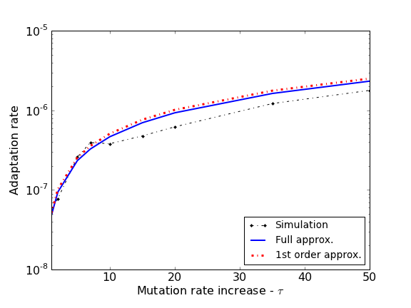

Figure 2 – Comparison of analytical approximations and simulation results - adaptation rate. The figure shows a comparison of the full analytical approximation (Eq. (12)) in a segmented red line, the 1st order approximation (Eq. (17)) in solid blue line and the simulation results (the inverse of average adaptation time) in black points and a doted line. The adaptation rate is defined as the inverse of the expected waiting time for the appearance of a double mutant that will go to fixation. Parameters used: selection coefficient *s=0.05*, double mutant advantage *H=2*, genomic mutation rate *U=0.0004*, locus specific mutation rate *µ=U/5000*, population size *N=106*.

# Discussion

# Conclusions

# Availability of supporting data

The data sets supporting the results of this article are available in the [repository name] repository, [unique persistent identifier and hyperlink to dataset(s) in http:// format]. The simulations source code, the source code used to analyse the data and generate the plots and the complete history of the manuscript are available as a *git* repository at GitHub at <https://github.com/yoavram/ruggedsim.git>.

# Author contributions

# Acknowledgments

# References

# Supporting information

## Fixation probability with stress-induced mutation

We derive the fixation probability of a double mutant *π* in a population with stress-induced mutation. The paramters are defined in the Analytical model section.

Pluging in the population mean fitness to the relative fitness of the double mutant we get

Pluging that in the fixation probability:

This gives the final result:

## First-order approximations

# Here we derive the first-order approximations from the full analytical approximations described in the Methods

Analytical model section. The term "first-order" approximations is used here to describe the approximation of analytical expressions by linear expression or polynomials of the first degree. For example, the expression can be written as a Tayloer series . Therefore, when *U* is very small – for bacteria it is estimated to be between 10-4 and 10-2­­ – the linear expression *1-U* is a good approximation for .

We will denote these first-order approximations by an asterix (*) added to the parameter symbol.

### Appearance of a double mutant

Starting with Eq. (3) for populations without stress-induced mutation:

The last step assumes that *2s* is much larger than *s2* and *sU* ismuch larger than *2µ.* Rearranging the last expression gives us

For a population with stress-induced mutation the first-order approximation is based on the full expression in Eq. (4):

The last approximation assumes that *Us* is smaller than *U* and that *τU* is much larger than *µ/s.*

The last approximation assumed that *2τ>s* and 2*τ2>1*, because *τ>1* and probably even *τ≥10*. Rearranging the last expression gives us the first order approximation for populations with stress-induced mutation:

### Fixation of a double mutant

The fixation probability without stress-induced mutation is described and approximated in Eqs. (8) and (9).

With stress-induced mutation, the fixation probability (Eq. (11)) can be approximated by:

## Comparison of adaptation rate

From Eqs. (16) and (17) we can derive the adaptation rate with stress-induced mutation in term of the rate without stress-induced mutation:

Now if and because the second term is positive then we can infer that the rate with stress-induced mutation is faster than without. This condition can ve rewritten:

Using the quadrate formula this translates to:

Because *U* is very small, *1-2U* is well apprxomated by *1*, and *1/U2* is much larger than *2*, so this can be approximated by