­Stress-Induced Mutagenesis Breaks the Trade-Off Between Adaptability and Adaptedness

Yoav Ram and Lilach Hadany

**Email**: YR - [yoavram@post.tau.ac.il](mailto:yoavram@post.tau.ac.il), LH - [lilach.hadany@gmail.com](mailto:lilach.hadany@gmail.com)

**Address**: Dept. of Molecular Biology and Ecology of Plants, Tel Aviv University

Tel-Aviv 69978, Israel. Tel. +972.3.640.6886

**Running title:** SIM, adaptability and adaptedness

**Keywords**: adaptation, fitness, models/simulations, mutations, population genetics, trade-offs

**Counts**: X words, X figures, 1 table

**Data archiving**: Dryad

# Abstract

Evolutionary theory suggests that the mutation rate must balance between *adaptability* – the ability to adapt – and *adaptedness* – the ability to remain adapted.

We model a population crossing a fitness valley and analyze the rate of complex adaptation with and without stress-induced mutagenesis - the increase of mutation rates in response to stress or maladaptation. We show that stress-induced mutagenesis breaks this evolutionary trade-off, increasing the *adaptability* of asexual populations without reducing their *adaptedness*. Our theoretical results support the hypothesis that stress-induced mutagenesis can be an adaptive trait and provide quantitative predictions about the difference between different mutational strategies in adaptive evolution.

# Introduction

There is experimental, clinical and theoretical evidence that high mutation rates increase the rate of adaptation and that during adaptive evolution, constitutive mutators - alleles that constitutively increase the mutation rate - can rise in frequency because of the beneficial mutations they generate (reviewed in Sniegowski et al. 2000; de Visser 2002; Denamur and Matic 2006). However, during evolution in a constant environment, constitutive mutators become associated with poor genetic backgrounds due to increased accumulation of deleterious mutations. Therefore, these mutator alleles are selected against, leading to "the rise and fall of the mutator allele", a phenomenon that was studied using experimental evolution (Sniegowski et al. 1997; Wielgoss et al. 2012), mathematical analysis, and simulations (Taddei et al. 1997; Kessler and Levine 1998; Tenaillon et al. 1999). Leigh (1970) suggested that the mutation rate must balance between two evolutionary traits: *adaptability* – the capacity to adapt to new environmental conditions - and *adaptedness* – the capacity to remain adapted to existing conditions.

Stress-induced mutagenesis (SIM), the increase of mutation rates in stressed or maladapted individuals, has been demonstrated in many species, including both prokaryote and eukaryote (Galhardo et al. 2007). The phenomenon was observed in *Escherichia coli* in the lab(Foster 2007; Rosenberg et al. 2012), and in natural populations (Bjedov et al. 2003); in other species of bacteria, including Pseudomonads (Kivisaar 2010), *Helicobacter pylori* (Kang et al. 2006), and *Streptococcus pneumonia* (Henderson-Begg et al. 2006). SIM was also suggested to operate in yeast (Heidenreich 2007; Rodriguez et al. 2012), algae (Goho and Bell 2000), Caenorhabditis (Matsuba et al. 2012), flies (Sharp and Agrawal 2012), and human cancer cells (Bristow and Hill 2008). Several stress responses regulate the mutation rate in bacteria by shifting replication to error-prone DNA polymerases (Ponder et al. 2005) and by inhibiting the mismatch repair system (Debora et al. 2010). In *E. coli* these stress responses include the SOS DNA-damage response, the RpoS-controlled general or starvation stress response, and the RpoE membrane protein stress response (Al Mamun et al. 2012).

In a previous work, we showed that SIM can evolve in asexual populations due to selection on the beneficial mutations it generates (Ram and Hadany 2012). This evolutionary advantage was shown at the individual level both in constant and changing environments.

It is still not clear how SIM affects evolution and adaptation. Some authors propose that SIM has a significant impact on *adaptability* or *evolvability* (Tenaillon et al. 2004; Cirz and Romesberg 2007; Rosenberg et al. 2012), but there is no theoretical treatment of this impact. On the other hand, the effect of SIM on *adaptedness* was studied with deterministic (Agrawal 2002) and stochastic (Shaw and Baer 2011) models. Both studies showed that without beneficial mutations SIM doesn't affect the mean fitness of asexual populations in constant environments. More recently, we showed that with rare beneficial mutations, if maladapted individuals increase their mutation rate, then the mean fitness of asexual populations increases (Ram and Hadany 2012).

Here, we explore the effect of stress-induced mutagenesis on the rate of fitness valley crossing by analyzing population genetic models of adaptive evolution. We develop general analytical expressions and stochastic simulations and compare normal, constitutive, and stress-induced mutagenesis. We show that stress-induced mutagenesis breaks the trade-off between *adaptability* and *adaptedness* by increasing the adaptation rate without decreasing the population mean fitness.

# Model

## Overview

We consider a population of *N* haploid asexual individuals with an infinite number of loci in full linkage. We consider the effects of mutation, selection, and genetic drift, but disregard population structure effects (*i.e.* migration, group selection) and sex-related mechanisms (*i.e.* recombination, segregation).

Deleterious mutations are Poisson distributed with an average of *U* mutations per genome per replication. The effects of these deleterious mutations on fitness are independent (*i.e.*, multiplicative) and identical, such that the fitness of an individual with *x* deleterious mutations is *ω*=(1-*s*)*x*, where *s* is the selection coefficient. In addition, we focus on two bi-allelic loci in which the wildtype genotype is *ab* and its fitness is 1. Mutations at these loci change *a* to *A* and *b* to *B* at reproduction with probability *µ* (without back-mutations) and their effect is initially deleterious, reducing the fitness by 1-*s* (similar to deleterious mutations in other loci). Therefore, every individual is characterized by its genotype in the focus loci (*ab*, *Ab*, *aB*, and *AB*) and the number of deleterious mutations it has in the rest of the genome (0 or more).

We consider three mutational strategies: normal mutagenesis (NM), where there is no increase in mutation rates; constitutive mutagenesis (CM), where all individuals always increase their mutation rate by *τ*,the mutation rate fold increase; and stress-induced mutagenesis (SIM), where only stressed or maladapted individuals increase their mutation rate by *τ*. Individuals are maladapted if their fitness is below a threshold, so stress can be caused by a deleterious mutation (both in the specific *A/a* and *B/b* loci and in the non-specific loci) or by an environmental change that changes the fitness of the different genotypes at the specific loci (*aa*, *Ab*, *aB*,and *AB*). Our main analysis assumes the threshold is the fitness of a wildtype with a genotype *ab* and 0 deleterious mutations, so that stress induced hypermutation in individuals with fitness < 1. We also study a different case – see section ‎3.3.

After the population reaches a mutation-selection balance (MSB) it undergoes adaptive evolution to an environmental change which changes the fitness of the *AB* genotype from (1-*s*)2to 1+*sH*, where *H*>0 is the double mutant relative advantage. This makes *AB* with 0 deleterious mutations the optimal genotype (Figure 1).

Our main interest is the calculation of the adaptation rate of a population homogenous for one of the above mutational strategies. We separate the adaptation process into two ­­­­distinct stages. In the first stage, a double mutant *AB* appears in the population in a single copy. In the second stage, the single copy of the double mutant avoids extinction, increases in frequency, and goes to fixation.

We analyzed this model with two methods. The first is analytic (Figure 1a), in which we assume that: (i) genotypes with deleterious alleles (except for *Ab* and *aB*) do not contribute to the adaptation process, and (ii) the number of deleterious mutations per individual at the MSB is Poisson distributed with mean U/s (Haigh 1978). These assumptions require that mutation is weaker than selection ().

The second method is a stochastic Wright-Fisher simulation with selection, mutation and drift (Figure 1b), in which we: (i) let individuals with deleterious mutations contribute to adaptation, and (ii) let the MSB evolve from a mutation-free population. We also use this simulation model to study competitions between the different mutational strategies.

Table 1 summarizes the model parameters with estimated values for *Escherichia coli*.

## Appearance of a double mutant

We are interested in the waiting time for the appearance of a double mutant either by a double mutation in a wildtype individual *ab*, or via a single mutation in a single mutant *Ab* or *aB* (see Figure 1a). Denoting the population size by *N,* we note that (i) if *N(µ*/*s*)2>1 then double mutants are already expected in the population at the MSB and adaptation will not require new mutations, and (ii) if *Nµ*/*s*<1 then no single mutants are expected at the MSB and double mutants must be generated by a double mutation in a wildtype individual. In this case, increasing the mutation rate of individuals with fitness below 1 will not have an effect on the appearance of the double mutant and there is no point in analyzing the effect of SIM.

Combining these two constraints we get the following constraint on the population size *N*: $e^{U/s}s/μ<N<e^{U/s}{\left(s/μ\right)}^{2}$. This constraint is reasonable for bacterial populations (see Table 1).

The frequencies of wildtype *ab* and single mutants *aB* and *Ab* that are mutation-free at the MSB are and . The probability that an individual does not generate new deleterious mutations in the next generation is . Therefore, the probability *q* that a random individual in the next generation is a double mutant, given there are no double mutants in the current generation, is:

|  |  |
| --- | --- |
| . | (1) |

With SIM the mutation rate of single mutants is increased *τ*-fold and the appearance probability is:

|  |  |
| --- | --- |
| . | (2) |

The right-hand sides of Eqs. (1) and (2) are 1st order approximations. Appendix 1 includes full derivations of these formulae, including a detailed description of the assumptions and simplifications. Figure S1 shows a comparison of these analytic results with the simulations results.

## Fixation probability with stress-induced mutagenesis

Assuming a considerable advantage to the double mutant (*H*>1)and a large population size (the constraint on *N* ensures that), a double mutant has two possible fates after its appearance: fixation or extinction. Following Eshel (1981), the fixation probability *ρ* of the double mutant is (see Appendix 2):

|  |  |
| --- | --- |
| . | (3) |

That is, the fixation probability of the double mutant is roughly twice its adaptive advantage. This is a classic result of population genetics theory (Fisher 1930 p. 76).

The fixation probability with SIM equals that of NM and CM because the mutation rate of the wildtype *ab* equals that of the double mutant *AB* (but see an exception in section ‎3.3).

## Adaptation rate

From the probability *q* that a random newborn is a double mutant, we can derive the probability that some double mutants appear in the next generation: . The constraint on *N* guarantees that *Nq* is very small and therefore this probability can be approximated by *Nq*. Once a double mutant appears it goes to fixation with probability *ρ*.

The time for adaptation *T* can be approximated by the waiting time for a double mutant that goes to fixation. This is true as long as fixation is much faster than mutation (guaranteed by (*τµ*)2<2). This waiting time follows a geometric distribution with rate *Nqρ* and therefore the adaptation rate is approximately:

|  |  |
| --- | --- |
| . | (4) |

## Wright-Fisher simulations

We used Wright-Fisher simulations to study the evolution of a finite asexual population under selection, mutation and drift (Figure 1b). The simulations start with a mutation-free population (*fab/0*=1) which evolves to a MSB over the first 500 generations of the simulation (with *s*=0.01-0.1, 500 generations are enough to get the average number of deleterious mutations per individual to 99.3% of its MSB value (Gordo and Dionisio 2005)).

After establishing a MSB, an environmental change occurs, altering the fitness of the *AB* genotype from (1-*s*(2 to 1+*sH* and making it the optimal genotype. The simulation then proceeds until an *AB* individual appears and either goes extinct or fixates in the population (reaching *f(AB)*=0 or *f(AB)*=1, respectively). Therefore, each simulation provides one sample of the waiting time for the appearance of a double mutant (*Nq)* and one sample of the probability of fixation of a double mutant (*ρ)*. At least 1,000 simulations were performed for each parameter set.

# Results

## Complex adaptation

In our model, adaptation is achieved by the appearance and fixation of a double mutant *AB* in the population. The rate of adaptation *ν* for the different mutational strategies is (NM – normal mutagenesis; CM – constitutive mutagenesis; SIM – stress-induced mutagenesis; see Table 1 for description of model parameters):

|  |  |
| --- | --- |
|  | (5) |
|  | () |
|  | (7) |

The right-hand sides of these equations are approximations for and (see Appendix 1) – these are the conditions required for the mutation-selection balance assumptions, but they also guarantee that the adaptation rate with CM or SIM is larger than with NM. The dynamics of the adaptation rate *ν* as a function of the mutation rate fold increase *τ* are shown in Figure 2.

We draw several conclusions from eqs. 5, 6, and 7: First, adaptation with CM is faster than with NM because of faster appearance of double mutants, and the adaptation rate increases with the square of *τ*. Second, adaptation with SIM is also faster than with NM, but not as fast as with CM because only single mutants (*aB* and *Ab*) hypermutate, so the adaptation rate increases linearly with *τ*. Third, because the fixation probability is the same for NM, CM and SIM, the difference in adaptation rate is caused by differences in the appearance probability *q* (Figure S1), but see section ‎3.3 for a different scenario in which SIM increases the fixation probability.

These conclusions depend on the constraint that hypermutation is weaker than selection (). Deleterious mutation rates in microbes are generally around 10-4-10-2 mutations per genome per generation, and selection coefficients are estimated to be between 10-1 and 10-2 (see Table 1), so the limit on *τ* is between 1 and 1,000. Figure 2 compares these analytical approximations and the results of simulations in which we do not assume that *τU<s* or that individuals with deleterious mutations don’t contribute to adaptation. When the mutation rate fold increase *τ* is high, adaptation is slightly slower in the simulations in comparison with the analytic approximations. This is because as *τ* increases the double mutant is more likely to appear on a deleterious background (*AB/1* instead of *AB/0*). This deleterious background results in lower fitness and a lower fixation probability for the double mutant (Hartfield and Otto 2011) (Figure S2).

## The trade-off between adaptability and adaptedness

We extended a previous model (Ram and Hadany 2012) to calculate the population mean fitness at the mutation-selection balance (see supporting information) and used the model presented above to calculate the adaptation rate of populations with NM, CM and SIM.

If the mutation rate is constant and uniform across the population, the population mean fitness – the *adaptedness* – only depends on the mutation rate of the fittest individuals. Therefore, the mean fitness decreases when the mutation rate increases, due to the increases generation of deleterious mutations in the fittest individuals. However, if mutation rates are not uniform across the population, increased mutation rates in unfit individuals increase the population mean fitness, as long as beneficial (compensatory) mutations are allowed (Ram and Hadany 2012). Figure 3 shows this advantage of SIM over NM in terms of the differential population mean fitness.

Figure 4 shows the *adaptedness* (rate of adaptation to environmental change) and *adaptability* (population mean fitness in a constant environment) of different mutational strategies relative to NM. Every realistic rate of adaptation *ν* can be realized using both CM and SIM. The highest mean fitness will always be attained with SIM, which has a small advantage over NM (that cannot be seen in this figure, but see Figure 3) due to the increased generation of beneficial (compensatory) mutations in individuals with deleterious mutations. If for some rate of adaptation the mutation rate fold increase *τ* required by SIM is too high (*i.e.*, *τU*>*s*), that adaptation rate could be realized by a mixed strategy (dashed green line). For example, a ~100-fold increase in adaptation rate can be achieved with CM with *τ*=10, with SIM with *τ*=100 or with a mixed strategy with *τCM*=7and *τSIM*=2 in which all individuals increase their mutation rate 7-fold and stressed individuals further increase their mutation rate 2-fold. However, these increases in adaptation rates have a price: the mutational load will decrease the population mean fitness from 0.9996 with NM to 0.996 with CM and 0.9972 with the mixed strategy. This price in not paid by populations with SIM because the mean fitness mainly depends on the mutation rate of fit individuals. In fact, with beneficial mutations the mean fitness with SIM with *τ*=100 is higher than that of NM by ~3⋅10-8.

## Effect of environmental stress

So far, we considered the case where the environmental change creates an opportunity for adaptation without affecting the absolute fitness of the population. Therefore, the wildtype *ab* wasn't under stressed and was not hypermutating. Next, we consider a different scenario in which the environmental change reduces the absolute fitness of the entire population, for example, the introduction of an antibiotic drug. In this scenario, the double mutant *AB* is resistant to the stress (*i.e.* the drug) and therefore has a higher fitness than the wildtype *ab*. Moreover, in this scenario the wildtype is also under stress: formally, individuals with fitness lower or equal to 1 increase their mutation rates, whereas in the previous sections only individuals with fitness strictly lower than 1 increased their mutation rates. We denote quantities related with this scenario by a subscript *e* – for example, SIMe

This scenario has an important biological relevance, as SIM has been implicated in the evolution of drug resistance in bacteria and yeast (Cirz and Romesberg 2007; Obolski and Hadany 2012; Shor et al. 2013).

The adaptation rate with SIM in this scenario is (see Appendix 3):

|  |  |
| --- | --- |
| , | (8) |

That is, adaptation with SIMe is faster than with CM. This is because (i) the appearance of double mutants is the same as with CM, and (ii) the fixation probability of double mutants is higher with SIMe because the mutation rate of double mutants is lower than that of the rest of the population, which confers an additional selective advantage to the double mutants:

|  |  |
| --- | --- |
| . | (9) |

This additive advantage increases linearly with *τ* with a slope of 2*U*/(1+*sH*), which can be quite small (*≈*7⋅10-4 for typical values, see Table 1). This increase in the fixation probability was verified by simulations (Figure S2).

## Relationship between stress and mutation rate

So far we used a very simple relationship between stress and mutation – once the fitness deeps below a threshold (<1 for SIM, ≤1 for SIMe), the mutation rate increases *τ*-fold. But the relationship between stress and mutation rate can be more complex. For example, Agrawal (2002) used a continuous relationship defined by a curvature parameter *k*, which defined the mutation rate for an individual with fitness *ω*, baseline mutation rate *U* and a maximal mutation rate increase *τ*:

|  |  |
| --- | --- |
| . | (10) |

When *k* approaches 0, this strategy is simply a normal mutagenesis (NM) strategy; when *k* approaches infinity this is the same SIM strategy we have used in previous sections. See Figure S3 for a visualization of these continuous relationships.

Figure 2B shows the adaptation time for four of these "continuous" strategies: k=1/10, 1, 10, and 100. Remarkably, the adaptation time with a "continuous" strategy can be roughly approximated by a "threshold" strategy in which single mutants *Ab* and *aB* have the same mutation rate as those with a "continuous" strategy. For example, the adaptation rate with "continuous" strategies with *k*=1/10, 1, 10, and 100 and *τ*=10 are approximated by "threshold" strategies with τ=1.05, 1.45, 4.61, and 9.95, respectively (Figure 2B; see Figure S3 for a comparison these strategies). The "continuous" strategies can be approximated by "threshold" strategies because, in this model, the mutation rate increase of single mutants is the primary factor, because individuals with more than a single mutation do not have a significant contribution to adaptation.

# Discussion

We studied the effect of stress-induced mutagenesis (SIM) on both *adaptability* – the capacity of populations to adapt to new conditions – and on *adaptedness* – the ability of populations to stay adapted to existing conditions (Leigh 1970). We showed that stress-induced mutagenesis breaks the trade-off between *adaptability* and *adaptedness*, allowing rapid adaptation to complex environmental changes without compromising the population mean fitness in a constant environment.

In addition to the pure strategies of constitutive mutagenesis (CM) and SIM, our model also considers a mixed mutational strategy. There are two examples of such a mixed strategy. First, if individuals have incomplete information regarding their condition (the case in most realistic biological scenarios) then we expect errors in the stress-induction of mutagenesis - induction of mutagenesis without stress and failure to induce mutagenesis under stress. In this case the population would, on average, use a mixed strategy. Second, a mutator allele can increase the mutation rate constitutively and further increase it under stress – for example, a recent study with *Pseudomonas aeruginosa* found that although the *mutS*, *mutY* and *mutM* mutator alleles always increase the mutation rate in comparison with the wildtype, the level of this increase depends on the level of stress the cell experiences (Torres-Barceló et al. 2013).

Our model does not assume direct fitness costs for any of the mutational strategies. The "cost of DNA replication fidelity" (Dawson 1998) – the energy and time expended in order to maintain a low mutation rate – could make both CM and SIM more successful. This might require further study, but empirical evidence suggest that this "cost of fidelity" doesn't play an important role in the evolution of the mutation rate (Giraud et al. 2001; Loh et al. 2010; Gentile et al. 2011; Shee et al. 2011). Another fitness cost might be associated with the regulation of the mutation rate: for individuals to determine if their condition calls for the induction of mutagenesis, they must invest resources and energy in costly sensory mechanisms. However, such mechanisms already exist for various unrelated purposes, such as the maintenance of cell cycle and homeostasis. Therefore, we consider these mechanisms are "free" in terms of fitness costs. Moreover, in *E. coli* stress is induced by several stress responses that serve several other functions (Foster 2007; Al Mamun et al. 2012), and this is probably the case is other organisms as well.

Our model focuses on asexual populations, disregarding recombination, segregation, and sexual reproduction. These mechanisms are important for adaptation on a rugged fitness landscape both because they help to cope with deleterious accumulated mutations and because they allow two separate single mutants to rapidly produce a double mutant without an increased mutation rate. Further work is needed to study how recombination and sex will affect the evolutionary advantage of SIM, but we expect this advantage to decrease in sexual populations.

Mean fitness and adaptation rate are both population-level traits. Even though SIM has the most efficient balance between these traits, it will not necessarily evolve, because individual-level selection can act in a different direction than population-level selection. Moreover, even if SIM does evolve, it may be the result of selection on *adaptability* and *adaptedness* (2nd order selection (Tenaillon et al. 2001)), or a result of other factors, such as pleiotropic effects of mutator alleles (Torres-Barceló et al. 2013; Turrientes et al. 2013), the cost of DNA replication fidelity (Dawson 1998), and the effect of drift on the fidelity of rarely expressed proteins - the "drift barrier hypothesis" (Sung et al. 2012). In a previous work we demonstrated that 2nd order selection can lead to the evolution of SIM (Ram and Hadany 2012): we showed that in an asexual population evolving in a changing environment or in a stable one, SIM is favored by selection over both NM and CM. SIM was favored in a changing environment because it balances between *adaptability* and *adaptedness* far better than mutational strategies that use a constant uniform mutation rate; in a stable environment it was favored because the population mean fitness is slightly higher than with NM and significantly higher than that with CM. In this work we showed that the trend continues: SIM is favored over both CM and NM by selection.

Complex traits, coded by multiple genes, present an open evolutionary problem, first described by Sewall Wright in 1931 (Wright 1931): if different alleles are separately deleterious but jointly advantageous, how can a population evolve from one co-adapted gene complex to a fitter one? Wright suggested the "shifting-balance theory of evolution" (Wright 1988). His solution is valid (Crow et al. 1990; Wade and Goodnight 1991; Peck et al. 2000) but is possibly limited to specific parameter ranges (Moore and Tonsor 1994; Gavrilets 1996; Coyne et al. 2000; Whitlock and Phillips 2000). As a result, other mechanisms were proposed: increased phenotypic variance after population bottlenecks (Whitlock 1995); environmental fluctuations (Whitlock 1997); environmental heterogeneity (Hadany 2003); fitness-associated recombination (Hadany and Beker 2003); and intermediate recombination rates (Weissman et al. 2010). In this work we analyzed the effect of SIM on complex adaptation (Figure 2). Our results suggest that SIM is an alternative mechanism that can help resolve the problem of fitness valley crossing or adaptive peak shifts.

Our results provide theoretical basis to the conjecture that SIM facilitates adaptation. This conjecture can be tested experimentally with, for example, *E. coli*, in which it is possible to interfere with the regulation of mutagenesis (Cirz and Romesberg 2007). The adaptation time with and without SIM can be measured in an experimental population adapting to a two-peak fitness landscape. These measurements can then be compared to our analytic approximations to determine the relative advantage and disadvantage of the different mutational strategies.

## Conclusions

Stress-induced mutagenesis has been implicated as a driver of adaptive evolution for several decades (Cairns et al. 1988; Tenaillon et al. 2004). Here we provided theoretical treatment of this concept. We showed that stress-induced mutagenesis increases the rate of complex adaptation, and that in contrast to constitutive mutagenesis it does not jeopardize the fitness of populations under stable conditions. Because mutation is a fundamental element in every biological system, these results have important implications on many fields in the medical and life sciences, including epidemiology, ecology and evolutionary biology.

# Acknowledgments

We thank the organizers of the SIDEER 2013 Symposium (<http://www.bgu.ac.il/BIDR/conf/sideergrads/SIDEER_symposium/>) for initial motivation for this project, U. Obolski for help with statistical analysis. We are grateful to A.F. Agrawal and two anonymous reviewers for their comments on earlier version of this manuscript. This research has been supported in part by the Israeli Science Foundation 1568/13 (LH) and by Marie Curie reintegration grant 2007–224866 (LH).

# Literature cited

Agrawal, A. F. 2002. Genetic loads under fitness-dependent mutation rates. J. Evol. Biol. 15:1004–1010. Wiley Online Library.

Al Mamun, A. A. M., M.-J. Lombardo, C. Shee, A. M. Lisewski, C. Gonzalez, D. Lin, R. B. Nehring, C. Saint-Ruf, J. L. Gibson, R. L. Frisch, O. Lichtarge, P. J. Hastings, and S. M. Rosenberg. 2012. Identity and function of a large gene network underlying mutagenic repair of DNA breaks. Science (80-. ). 338:1344–8.

Berg, O. G. 1996. Selection intensity for codon bias and the effective population size of Escherichia coli. Genetics 142:1379–82.

Bjedov, I., O. Tenaillon, B. Gérard, V. Souza, E. Denamur, M. Radman, F. Taddei, and I. Matic. 2003. Stress-induced mutagenesis in bacteria. Science (80-. ). 300:1404–9.

Bristow, R. G., and R. P. Hill. 2008. Hypoxia and metabolism: Hypoxia, DNA repair and genetic instability. Nat. Rev. Cancer 8:180–92. Nature Publishing Group.

Cairns, J., J. Overbaugh, and S. Miller. 1988. The origin of mutants. Nature 335:142–5.

Cirz, R. T., and F. E. Romesberg. 2007. Controlling mutation: intervening in evolution as a therapeutic strategy. Crit. Rev. Biochem. Mol. Biol. 42:341–54.

Coyne, J. A., N. H. Barton, and M. Turelli. 2000. Is Wright’s shifting balance process important in evolution? Evolution (N. Y). 54:306–317.

Crow, J. F., W. R. Engels, and C. Denniston. 1990. Phase Three of Wright’s Shifting-Balance Theory. Evolution (N. Y). 44:233.

Dawson, K. J. 1998. Evolutionarily stable mutation rates. J. Theor. Biol. 194:143–57.

De Visser, J. A. G. M. 2002. The fate of microbial mutators. Microbiology 148:1247–52.

Debora, B. N., L. E. Vidales, R. Ramírez, M. Ramírez, E. A. Robleto, R. E. Yasbin, and M. Pedraza-Reyes. 2010. Mismatch Repair Modulation of MutY Activity Drives Bacillus subtilis Stationary-Phase Mutagenesis. J. Bacteriol. 193:236–45.

Denamur, E., and I. Matic. 2006. Evolution of mutation rates in bacteria. Mol. Microbiol. 60:820–7.

Drake, J. W., B. Charlesworth, D. Charlesworth, and J. F. Crow. 1998. Rates of spontaneous mutation. Genetics 148:1667–86. Genetics Soc America.

Eshel, I. 1981. On the survival probability of a slightly advantageous mutant gene with a general distribution of progeny size - a branching process model. J. Math. Biol. 12:355–362.

Fisher, R. A. 1930. The Genetical Theory of Natural Selection. Clarendon Press, Oxford.

Foster, P. L. 2007. Stress-induced mutagenesis in bacteria. Crit. Rev. Biochem. Mol. Biol. 42:373–97.

Galhardo, R. S., P. J. Hastings, and S. M. Rosenberg. 2007. Mutation as a stress response and the regulation of evolvability. Crit. Rev. Biochem. Mol. Biol. 42:399–435.

Gavrilets, S. 1996. On phase three of the shifting-balance theory. Evolution (N. Y). 50:1034–1041. JSTOR.

Gentile, C. F., S.-C. Yu, S. A. Serrano, P. J. Gerrish, and P. D. Sniegowski. 2011. Competition between high- and higher-mutating strains of Escherichia coli. Biol. Lett. 7:422–4.

Giraud, A., I. Matic, O. Tenaillon, A. Clara, M. Radman, M. Fons, and F. Taddei. 2001. Costs and benefits of high mutation rates: adaptive evolution of bacteria in the mouse gut. Science (80-. ). 291:2606–8.

Goho, S., and G. Bell. 2000. Mild environmental stress elicits mutations affecting fitness in Chlamydomonas. Proc. R. Soc. B Biol. Sci. 267:123–9.

Gordo, I., and F. Dionisio. 2005. Nonequilibrium model for estimating parameters of deleterious mutations. Phys. Rev. E 71:18–21.

Gordo, I., L. Perfeito, and A. Sousa. 2011. Fitness effects of mutations in bacteria. J. Mol. Microbiol. Biotechnol. 21:20–35.

Hadany, L. 2003. Adaptive peak shifts in a heterogenous environment. Theor. Popul. Biol. 63:41–51.

Hadany, L., and T. Beker. 2003. Fitness-associated recombination on rugged adaptive landscapes. J. Evol. Biol. 16:862–870.

Haigh, J. 1978. The accumulation of deleterious genes in a population - Muller’s Ratchet. Theor. Popul. Biol. 14:251–267.

Hall, L. M. C., and S. K. Henderson-Begg. 2006. Hypermutable bacteria isolated from humans--a critical analysis. Microbiology 152:2505–14.

Hartfield, M., and S. P. Otto. 2011. Recombination and hitchhiking of deleterious alleles. Evolution 65:2421–34.

Heidenreich, E. 2007. Adaptive mutation in Saccharomyces cerevisiae. Crit. Rev. Biochem. Mol. Biol. 42:285–311.

Henderson-Begg, S. K., D. M. Livermore, and L. M. C. Hall. 2006. Effect of subinhibitory concentrations of antibiotics on mutation frequency in Streptococcus pneumoniae. J. Antimicrob. Chemother. 57:849–54.

Kang, J. M., N. M. Iovine, and M. J. Blaser. 2006. A paradigm for direct stress-induced mutation in prokaryotes. FASEB J. 20:2476–85.

Kessler, D. A., and H. Levine. 1998. Mutator Dynamics on a Smooth Evolutionary Landscape. Phys. Rev. Lett. 80:2012–2015.

Kibota, T. T., and M. Lynch. 1996. Estimate of the genomic mutation rate deleterious to overall fitness in E. coli. Nature 381:694–6.

Kivisaar, M. 2010. Mechanisms of stationary-phase mutagenesis in bacteria: mutational processes in pseudomonads. FEMS Microbiol. Lett. 312:1–14.

Leigh, E. G. J. 1970. Natural Selection and Mutability. Am. Nat. 104:301–305.

Loh, E., J. J. Salk, and L. A. Loeb. 2010. Optimization of DNA polymerase mutation rates during bacterial evolution. Proc. Natl. Acad. Sci. 107:1154–9.

Matsuba, C., D. G. Ostrow, M. P. Salomon, A. Tolani, and C. F. Baer. 2012. Temperature, stress and spontaneous mutation in Caenorhabditis briggsae and Caenorhabditis elegans. Biol. Lett. 8–12.

Moore, F. B.-G., and S. J. Tonsor. 1994. A Simulation of Wright’s Shifting-Balance Process: Migration and the Three Phases. Evolution (N. Y). 48:69.

Obolski, U., and L. Hadany. 2012. Implications of stress-induced genetic variation for minimizing multidrug resistance in bacteria. BMC Med. 10:1–30.

Peck, S. L., S. P. Ellner, and F. Gould. 2000. Varying migration and deme size and the feasibility of the shifting balance. Evolution 54:324–7.

Ponder, R. G., N. C. Fonville, and S. M. Rosenberg. 2005. A switch from high-fidelity to error-prone DNA double-strand break repair underlies stress-induced mutation. Mol. Cell 19:791–804.

Pupo, G. M., and B. J. Richardson. 1995. Biochemical genetics of a natural population of Escherichia coli: seasonal changes in alleles and haplotypes. Microbiology 141:1037–44.

Ram, Y., and L. Hadany. 2012. The evolution of stress-induced hypermutation in asexual populations. Evolution (N. Y). 66:2315–28.

Rodriguez, G. P., N. V Romanova, G. Bao, N. C. Rouf, Y. W. Kow, and G. F. Crouse. 2012. Mismatch repair-dependent mutagenesis in nondividing cells. Proc. Natl. Acad. Sci. 109:6153–8.

Rosenberg, S. M., C. Shee, R. L. Frisch, and P. J. Hastings. 2012. Stress-induced mutation via DNA breaks in Escherichia coli: A molecular mechanism with implications for evolution and medicine. BioEssays 1–8.

Sharp, N. P., and A. F. Agrawal. 2012. Evidence for elevated mutation rates in low-quality genotypes. Proc. Natl. Acad. Sci. 109:6142–6.

Shaw, F. H., and C. F. Baer. 2011. Fitness-dependent mutation rates in finite populations. J. Evol. Biol. 24:1677–84.

Shee, C., J. L. Gibson, M. C. Darrow, C. Gonzalez, and S. M. Rosenberg. 2011. Impact of a stress-inducible switch to mutagenic repair of DNA breaks on mutation in Escherichia coli. Proc. Natl. Acad. Sci. 108:13659–13664.

Shor, E., C. a. Fox, and J. R. Broach. 2013. The Yeast Environmental Stress Response Regulates Mutagenesis Induced by Proteotoxic Stress. PLoS Genet. 9:e1003680.

Sniegowski, P. D., P. J. Gerrish, T. Johnson, and A. Shaver. 2000. The evolution of mutation rates: separating causes from consequences. BioEssays 22:1057–66.

Sniegowski, P. D., P. J. Gerrish, and R. E. Lenski. 1997. Evolution of high mutation rates in experimental populations of E. coli. Nature 387:703–5. Nature Publishing Group.

Sung, W., M. S. Ackerman, S. F. Miller, T. G. Doak, and M. Lynch. 2012. Drift-barrier hypothesis and mutation-rate evolution. Proc. Natl. Acad. Sci., doi: 10.1073/pnas.1216223109.

Taddei, F., M. Radman, J. Maynard Smith, B. Toupance, P.-H. Gouyon, and B. Godelle. 1997. Role of mutator alleles in adaptive evolution. Nature 387:700–2.

Tenaillon, O., E. Denamur, and I. Matic. 2004. Evolutionary significance of stress-induced mutagenesis in bacteria. Trends Microbiol. 12:264–70.

Tenaillon, O., F. Taddei, M. Radman, and I. Matic. 2001. Second-order selection in bacterial evolution: selection acting on mutation and recombination rates in the course of adaptation. Res. Microbiol. 152:11–6.

Tenaillon, O., B. Toupance, H. Le Nagard, F. Taddei, and B. Godelle. 1999. Mutators, Population Size, Adaptive Landscape and the Adaptation of Asexual Populations of Bacteria. Genetics 152:485–493.

Torres-Barceló, C., G. Cabot, A. Oliver, A. Buckling, and R. C. Maclean. 2013. A trade-off between oxidative stress resistance and DNA repair plays a role in the evolution of elevated mutation rates in bacteria. Proc. Biol. Sci. 280:20130007.

Turrientes, M.-C., F. Baquero, B. R. Levin, J.-L. Martínez, A. Ripoll, J.-M. González-Alba, R. Tobes, M. Manrique, M.-R. Baquero, M.-J. Rodríguez-Domínguez, R. Cantón, and J.-C. Galán. 2013. Normal Mutation Rate Variants Arise in a Mutator (Mut S) Escherichia coli Population. PLoS One 8:e72963.

Wade, M., and C. Goodnight. 1991. Wright’s shifting balance theory: an experimental study. Science (80-. ). 253:1015–1018.

Weissman, D. B., M. W. Feldman, and D. S. Fisher. 2010. The rate of fitness-valley crossing in sexual populations. Genetics 186:1389–410.

Whitlock, M. C. 1997. Founder Effects and Peak Shifts Without Genetic Drift: Adaptive Peak Shifts Occur Easily When Environments Fluctuate Slightly. Evolution (N. Y). 51:1044.

Whitlock, M. C. 1995. Variance-Induced Peak Shifts. Evolution (N. Y). 49:252.

Whitlock, M. C., and P. C. Phillips. 2000. The exquisite corpse: a shifting view of the shifting balance. Trends Ecol. Evol. 15:347–348.

Wielgoss, S., J. E. Barrick, O. Tenaillon, S. Cruveiller, B. Chane-Woon-Ming, C. Médigue, R. E. Lenski, and D. Schneider. 2011. Mutation Rate Inferred From Synonymous Substitutions in a Long-Term Evolution Experiment With Escherichia coli. G3 Genes, Genomes, Genet. 1:183. Genetics Society of America.

Wielgoss, S., J. E. Barrick, O. Tenaillon, M. J. Wiser, W. J. Dittmar, S. Cruveiller, B. Chane-Woon-Ming, C. Medigue, R. E. Lenski, and D. Schneider. 2012. Mutation rate dynamics in a bacterial population reflect tension between adaptation and genetic load. Proc. Natl. Acad. Sci. 110:222–227.

Wright, S. 1931. Evolution in Mendelian Populations. Genetics 16:97–159.

Wright, S. 1988. Surfaces of selective value revisited. Am. Nat. 131:115–123.

# Appendices

## Appendix 1

In the following analysis we assume that – see model overview for details – which also means that . The probability *q* that a random individual in the next generation is *AB* given there are no *AB* in the current generation can be approximated by:

.

Now, we assume that and . This gives us:

.

Taking the derivative w.r.t *U*, assuming for some *g>1*:

.

This expression is positive when , which is guaranteed by the assumption $U≪s$.

For a population with SIM:

.

The last approximation assumes that $τ≥1⇒s≪2τ$*.* Rearranging the last result, we find that the first order approximation for populations with SIM is:

|  |  |
| --- | --- |
| . |  |

Taking the derivative w.r.t *τ*:

.

Because *q*, *U*, and *τ* are all positive:

.

This condition is also sufficient for , and is guaranteed by the assumption .

## Appendix 2

Following Eshel (1981), the fixation probability *ρ* of the double mutant is:

,

where *α* is the fitness of the double mutant relative to the population mean fitness $\overline{ω}$ and assuming that fitness is measured by the number of progeny which is Poisson distributed:

$α=\frac{\left(1+sH\right)e^{-U}}{\overline{ω}}$.

Here, we only consider progeny without deleterious mutations – their fraction is *e-U*. This factor cannot be ignored because there is variation in mutation rates in the population. At this stage, double mutants are still very rare, so we can use the population mean fitness at the MSB.

Without SIM and neglecting beneficial mutations, the mean fitness evaluates to (see Supporting information). Therefore:

Assuming *sH* is small () we can simplify this to:

.

## Appendix 3

With SIMe the mutation rate of *ab* is *τU* while that of *AB* is only *U*. We assume the population reached a MSB after the environmental change because convergence to MSB is much faster than adaptation (Gordo and Dionisio 2005). Following the derivation in Appendix 2, we derive the relative fitness of SIMe by:

.

Plugging that in the fixation probability:

.

This can be simplified by a 1st order approximation for $e^{-U\left(τ-1\right)}$:

$ρ_{SIM_{e}}≈ρ+2\frac{U\left(τ-1\right)}{1+sH}=ρ\left(1+\frac{U\left(τ-1\right)}{sH}\right)$.

Because $\frac{U\left(τ-1\right)}{sH}>0$, the right hand side is greater than 1 and therefore:

.

Because the appearance with SIMe is the same as with CM, the adaptation rate with SIMe can now be written as:

.

# Figures

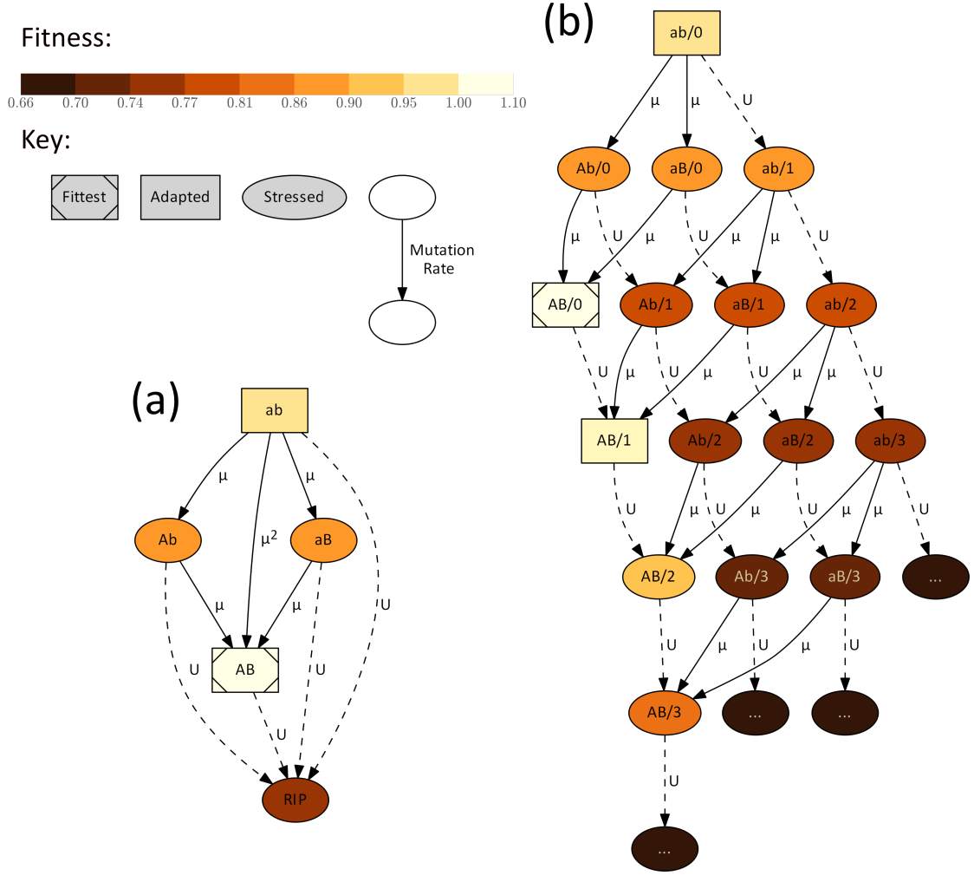

**Figure 1 – Adaptation of a complex trait.** Nodes represent genotypes: the alleles *a* or *A* and *b* or *B*. Panel b also includes the number of deleterious alleles across the genome after the forward-slash. Mutagenesis is induced in stressed genotypes (fitness <1, ellipses), and fit genotypes (fitness ≥1, squares) do not hypermutate. Solid arrows represent mutations at the *a/A* and *b/B* loci. Dashed arrows represent deleterious mutations across the genome. Arrow labels denote the rates. Node brightness represents fitness (see color bar): from white for the fittest genotype (1+*sH*, where *s*=0.05 is the selection coefficient and *H*=2 is the double mutant advantage) to dark brown for genotypes with deleterious mutations ((1-*s*)*x*, where *x* is the number of deleterious mutations). (a) In the analytic model genotypes with deleterious mutations are considered "evolutionary dead-ends" (marked with RIP) and do not contribute to adaptation. (b) In the stochastic model individuals can accumulate up to 25 deleterious mutations (the figure only shows as much as three). Multiple mutations can occur simultaneously but are not shown for simplicity of the illustration.

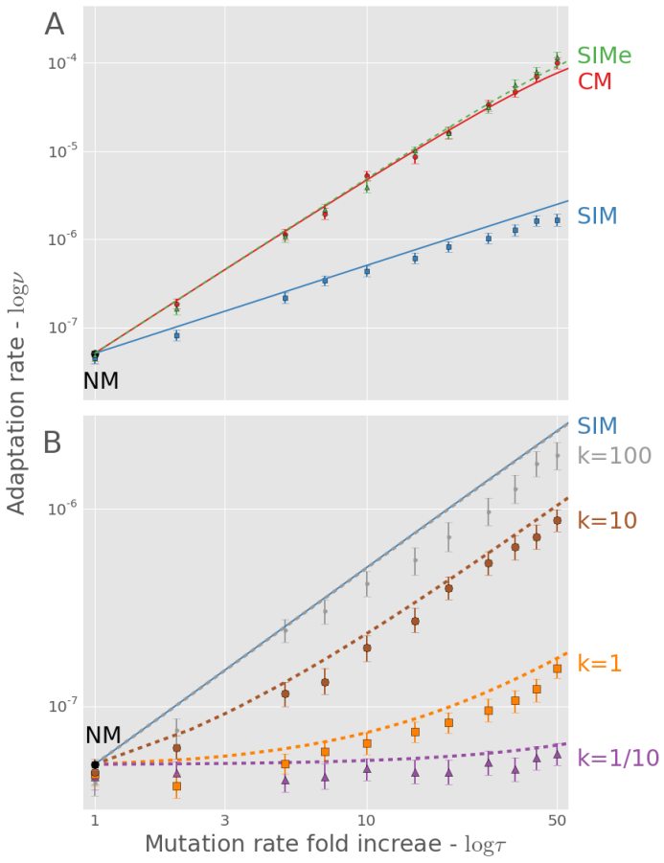

**Figure 2 – Complex adaptation with different mutational strategies.** The figure shows the adaptation rate *ν* as a function of the mutation rate increase *τ*. **(A)** NM (represented by *τ*=1) is normal mutagenesis; CM (red with circles) is constitutive mutagenesis; SIM (solid blue with squares) is stress-induced mutagenesis; SIMe (dashed green with triangles) is stress-induced mutagenesis with environmental stress (see section ‎3.3). Lines are analytic approximations; markers are the means of stochastic simulations results; error bars represent 95% confidence interval of the mean (at least 1,000 replicates per point; computed with bootstrap with 1,000 samples per point). Both axes are in log scale. Parameters (see Table 1): *U*=0.0004, *s*=0.05, *β*=0.0002, *H*=2, *N*=106. **(B)** Markers are the results of adaptation with SIM with a continuous relationship between fitness and mutation rate, defined by a curvature parameter *k* (see section XX and Fig. S3)**.** The dashed lines are analytical approximations of SIM with a threshold relationship (Eq. 7) with *τ* chosen so that single mutants will have the same mutation rate as "continuous" SIM.

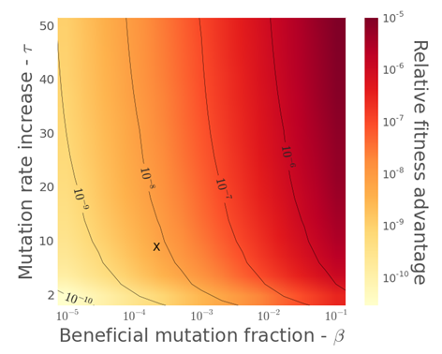

**Figure 3 – Mean fitness at the mutation-selection balance with stress-induced mutagenesis.** The figure shows the relative fitness advantage of SIM in comparison to NM at the mutation-selection balance. See The x-axis is *β,* the fraction of mutations that are beneficial and the y-axis is *τ*, the mutation rate fold increase under stress. "X" marks the point (*β*=1/5000, *τ*=10) in which the fitness advantage of SIM is ~5⋅10-9.

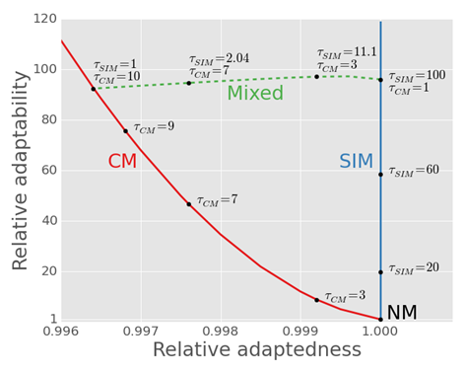

**Figure 4 – The trade-off between *adaptedness* and *adaptability*.** The figure shows the relative *adaptedness* (population mean fitness at the MSB, [see SI]; x-axis) and the relative *adaptability* (adaptation rate, [see Eq. 5-7] ; y-axis) of different mutational strategies in comparison to normal mutagenesis (NM). Constitutive mutagenesis (CM; in red) increases the mutation rate of all individuals *τCM*-fold; Stress-induced mutagenesis (SIM; in blue) increases the mutation rate of stressed or maladapted individuals *τSIM*-fold; Mixed strategies (in dashed green) increase the mutation rate of all individuals *τCM*-fold and of stressed individuals *τSIM*-fold. SIM breaks off the *adaptability-adaptedness* trade-off of CM, increasing the *adaptability* without compromising the *adaptedness* of the population. Parameters (see Table 1): *N*=106, *U*=­0.0004, *β*=0.002, *s*=0.05, *H*=2, *τ*<<1/*U*.

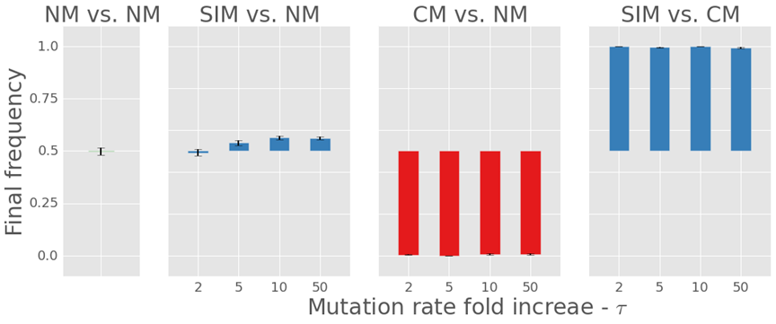

Figure 5 – Direct competitions between three mutational strategies. The figure shows the average final frequency of (from left to right): normal mutagenesis (NM; green) vs. NM (control); stress-induced mutagenesis (SIM; blue) vs. NM; constitutive mutagenesis (CM; red) vs. NM; and SIM vs. CM. For each mutagenesis strategy several mutation rate increases are shown on the x-axis. SIM defeats CM and is significantly advantageous over NM when τ>2 (2-tail t-test, P<0.0015). CM losses to both NM and SIM (P≈0). Competing strategies started with equal frequencies. Error bars represent the standard error of the mean (500 replicates per points). Parameters: see Figure 2.

# Tables

Table 1 – Model parameters and estimated values for *Escherichia coli*

|  |  |  |  |
| --- | --- | --- | --- |
| Symbol | Name | Estimate | References |
| *s* | Selection coefficient | 0.001-0.03 | (Kibota and Lynch 1996; Gordo et al. 2011) |
| *H* | Double mutant advantage | 1-10 | (Gordo et al. 2011) |
| *U* | Genomic deleterious mutation rate | 0.0004-0.003 | (Drake et al. 1998; Wielgoss et al. 2011) |
| *µ* | Site-specific beneficial mutation rate | U/5000 | (Gordo et al. 2011) |
| *τ* | Fold-increase in mutation rate | 1-100 | (Bjedov et al. 2003; Hall and Henderson-Begg 2006) |
| *N* | Population size | 105-1010 | (Pupo and Richardson 1995; Berg 1996) |