NAMA : YOBI FIRDAUS MAHFUD

KELAS : A

NRP 213040002

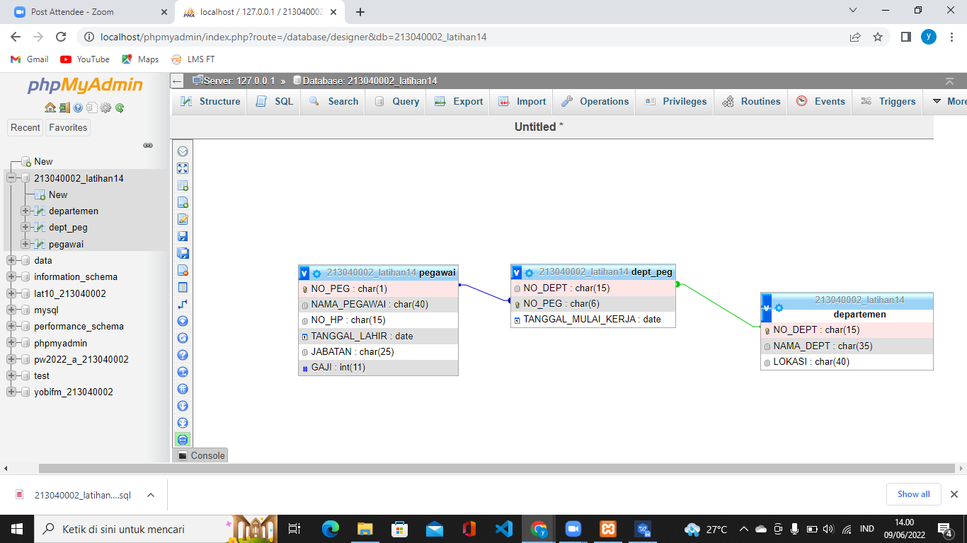

**CREATE TABLE pegawai (**

**NO_PEG CHAR(15) NOT NULL PRIMARY KEY**

**NAMA_PEGAWAI CHAR(40) NOT NULL,**

**NO_HP CHAR(15) NOT NULL,**

**TANGGAL_LAHIR DATE,**

**JABATAN CHAR(25),**

**GAJI INT(11));**

**CREATE TABLE dept_peg (**

**NO_DEPT CHAR(15) NOT NULL PRIMARY KEY**

**NAMA_DEPT CHAR(35) NOT NULL,**

**LOKASI CHAR(40);)**

**CREATE TABLE dept_peg (**

**NO_DEPT CHAR(15) NOT NULL,**

**NO_PEG CHAR(6) NOT NULL,**

**TANGGAL_MULAI_KERJA DATE);**

**ALTER TABLE'dept_peg' ADD CONSTRAINT 'dept_peg_fk0' FOREIGN KEY('NO_PEG') REFERENCES 'pegawai'('NO_PEG');**

**ALTER TABLE'dept_peg' ADD CONSTRAINT 'dept_peg_fk1' FOREIGN KEY('NO_DEPT') REFERENCES 'departemen'('NO_DEP');**

1. **ALTER TABLE'departemen' ADD CREATEDBY NAMA_PEGAWAI INT;**
2. **UPDATE pegawai SET NO_PEG = ‘P2341’ WHERE NAMA_PEGAWAI = ‘H. SYAHRONIE’**
3. **INSERT INTO pegawai * VALUES ( ‘ ‘, ‘ H. syahroni‘, ‘085692999’, ‘12 january 2022’, ‘manager’, ‘2500000’)**
4. **SELECT * FORM pegawai WHERE JABATAN = ‘supervisor’**
5. **SELECT PEGAWAI.NO_PEG,PEGAWAI.NAMA_PEGAWAI, DEPT_PEG.TANGGAL_MULAI_KERJA**

**FORM PEGAWAI NATURAL JOIN DEPT_PEG**

**WHERE PEGAWAI.JABATAN= ‘SUPERVISOR’**

1. **START TRANSACTION;**

**SELECT * PEGAWAI**

**FORM PEGAWAI NATURAL JOIN DEPARTEMEN**

**WHERE NAMA_DEPT= ‘INFORMATION TEVHNOLOGY’**

**SELECT NO_PEG, NAMA_PEGAWAI**

**FORM PEGAWAI**

**WHEREGAJI > 7500000**